# **MEMORANDUM**

|  |  |
| --- | --- |
| **To:** | Public Adult Education Directors |
| **From:** | Toby Maguire, Assistant Director, Adult and Community Learning Services |
| **Date:** | July 8, 2025 |
| **Subject:** | FY26 LACES Intake Form Update |

Dear Program Directors,

At our request, LiteracyPro Systems has added a couple of new fields to the [student intake](https://www.doe.mass.edu/acls/laces/intake-form/fy2026-intake-form.docx):

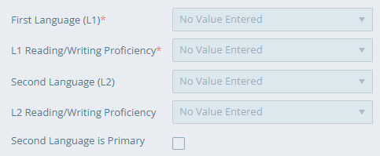

It is now required that students enter their first language. It’s a long dropdown list but data entry staff can type the first few letters of the language to quickly find it. You are also required to determine students’ first language literacy level (fluent, intermediate, basic, none). Students may identify a second language and literacy level. If the second language is the student’s primary language, check the box, otherwise the LACES will assume that L1 is the primary language.

First language, often referred to as native language, is the language that someone acquires during early childhood. The language that one uses most frequently in everyday life is their primary language. For example, Dana Varzan-Parker grew up in Romania and her first language is Romanian. English is her second and primary language. Here’s how it would look in LACES:

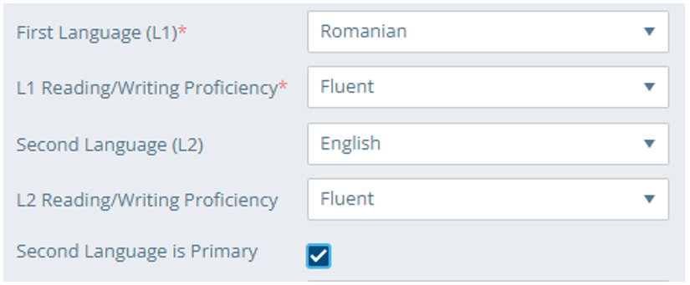

Here’s another example. Kathy Rodriguez is fluent in Spanish but she was born and raised in New York City. English is her first and primary language.

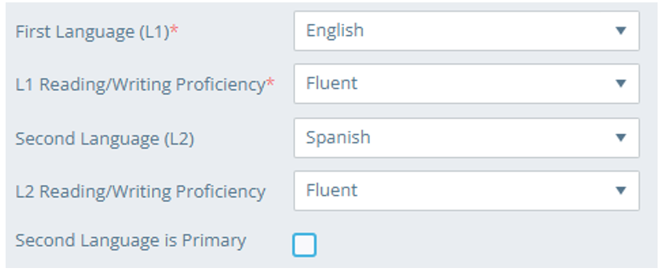

You can add additional languages in the Language panel in the Education tab and assign speaking and listening proficiency.

We added these fields to help us better understand our students. Anecdotally, we hear that a significant percentage of our newest ESOL participants have little or no literacy skills in their first language. We also know that many of the students enrolled in our ABE classes are English learners. We hope that this language data will help us develop professional development and help you adjust your programming and curriculum. As you know, the UMass Center for Education Assessment is developing the English Test for Adults (ETA) which will begin its second pilot year this fall. They will use this data to identify any cultural biases.

As they must with so many of the required data fields (e.g., barriers to employment), your staff will have to define and explain these terms to students enrolling in the fall. Please discuss your strategies with each at director and advisor sharing sessions. ACLS will host a data webinar this fall and will include an opportunity for you to share your challenges and successes collecting this information.

Here is the [FY26 intake template](https://www.doe.mass.edu/acls/laces/intake-form/fy2026-intake-form.docx). LiteracyPro anticipates releasing this [update](https://sites.google.com/literacypro.com/release-notes-laces/2025-11-0) in early July.

Thank you,

Toby