Adult Education Program Guidance – Response to COVID-19
March 27, 2020

Provide Learning Opportunities for Adult Learners
Our current priority is the health and safety of our students, staff, and communities. While practicing social distancing and following the stay at home advisory, programs are encouraged to provide adult learners with appropriate learning opportunities using online programs and/or other materials that support student engagement and learning. Please use your current grant funds to deliver services at a distance in whatever ways are possible during the period of program closure.
Provide Telework Opportunities for Full and Part-time Staff
We encourage all adult education staff to be allowed to work from home. Teachers can: provide online instruction and coaching using digital platforms; work on modifications or development of lesson, units, and/or curricula; and engage in professional development opportunities. Advisors can continue to provide supportive services to adult learners, helping them access a myriad of resources needed during this health crisis.
Similarly, in his March 23 update, Commissioner Riley strongly recommended that “school districts pay their hourly employees during the current emergency school closure. Like all of us, these employees need to follow public health directives and take care of themselves and their families. While they do so, school districts could ask them to continue their learning by reading educational articles, books, taking an online class or performing other tasks that could be a benefit to the school districts. Districts must be able to quickly resume services to students as soon as schools re-open, and in order to do that, they will need to have an available, ready workforce, including hourly employees.”

As per the ACLS Policies, programs must compensate staff for all job responsibilities including prep time for teachers. While we do not require programs to offer online instruction during closure caused by COVID-19, to avoid interruptions to students’ learning, ACLS recommends that programs offer remote support or online learning if and when they can. Programs are encouraged to work with their teachers and students to find the best format that works for their specific student population and technical and staff capacity.
If programs are unable to provide remote online learning opportunities, program leaders are encouraged to support other methods of student engagement.
Examples of student engagement activities:
- Online instruction
- Weekly/daily assignments sent to students via email or posted in Google Classroom, Moodle, or similar platform
- Online resources for learning posted on the program’s website or emailed to students.
Examples of staff telework activities:
- Participate in online PD offered by SABES or other PD providers.
- Choose one or more curriculum, instruction and assessment activities ACLS suggested in the ACLS March 19 special mailing.
- Engage with the resources and activities posted by the ELA C & I Center here, the Math C & I Center here, the ESOL C & I Center-here, and the Program Support Center-here.
- Engage in the assessment activities and resources posted on the ACLS Test Help Blog.
- Connect with a SABES ELA, Math or ESOL curriculum and instruction coach remotely to get feedback on curriculum and lesson plans.
- Review LACES data, including completing the desk review, with further analysis and reflection.
- Conduct a self-assessment using the ELA and/or the Math Proficiency Guides.

Administration and Scoring of NRS Pre- and Post-Tests
Due to program closures caused by the COVID-19 pandemic, ACLS is asking that all adult education providers put the administration of NRS pre- and post-assessments on hold until further guidance is provided by the Office of Career, Technical, and Adult Education (OCTAE) and test publishers.
ACLS understand that, where possible, programs should focus their efforts on providing remote learning or other forms of remote support to students. Because not all programs are able to provide online instruction and not all students are able to access this kind of instruction, learning cannot take place equitably across adult education providers. Without equitable access to learning, student performance, as measured by assessments, will be inevitably impacted.
Although some of the NRS assessments approved for use in Massachusetts can be administered on the computer, they are not designed for remote test administration.
To protect the health and safety of students and program staff and to comply with test administration procedures as outlined below, programs should not administer in-person assessments (including but not limited to NRS pre- and post-assessments, NRS assessments used as placement tests) or adapt ACLS NRS assessment administration policies in any way.
ACLS will continue to communicate with federal and state leaders as well as test publishers to identify potential flexibilities and solutions in the administration of NRS assessments.
The ACLS assessment manual includes details about the administration of each specific NRS approved assessment. Please see a quick summary of these test administration policies below.
- BEST Plus 2.0: computer-based, in person administration only.
- CLAS E Reading and CLAS E Writing tests: in person administration only. A CLAS E computer-based version is currently being piloted by the test publisher and it cannot be used for NRS reporting pre- and post-testing purpose.
- MAPT-CCR: computer-based administration only. A MAPT-CCR certified test administrator is required to be in the room for the duration of the test.
- TABE 11/12 and TABE Literacy: Both paper and computer-based versions can be used. Both versions require a certified TABE 11/12 administrator in the room.

BEST Plus 2.0 and CLAS E Writing Recertification
Regarding the recertification process for BEST Plus 2.0 administrators and CLAS-E Writing scorers, the UMass Center for Educational Assessment (CEA) sent an email on March 16 to all directors and practitioners about how to access recertification materials remotely, including the BEST Plus 2.0 Scoring Activity 2 video. If you have not received this email, please email Francis O’Donnell at fodonnell@educ.umass.edu.
While the ACLS and CEA would like as many practitioners as possible to complete the recertification requirements by March 31, 2020, CEA will provide program-wide extensions as needed. Program directors should contact Francis O’Donnell at fodonnell@educ.umass.edu if test administrators at their program need an extension.
Outstationing
MassHire Career Centers are closed to the public until April 7, 2020. Outstationing coordinators can use this time to follow-up on referrals to adult education programs to see if customers have been enrolled in classes or placed on waiting lists. Coordinators can also use the time to familiarize themselves with Career Center offerings and services. Any student in need of unemployment benefits can file a claim here: https://www.mass.gov/how-to/apply-for-unemployment-benefits.

Distance Learning Tracking in LACES
Report attendance in LACES. Please record all online student attendance in LACES as Instruction – Distance Learning (Local).
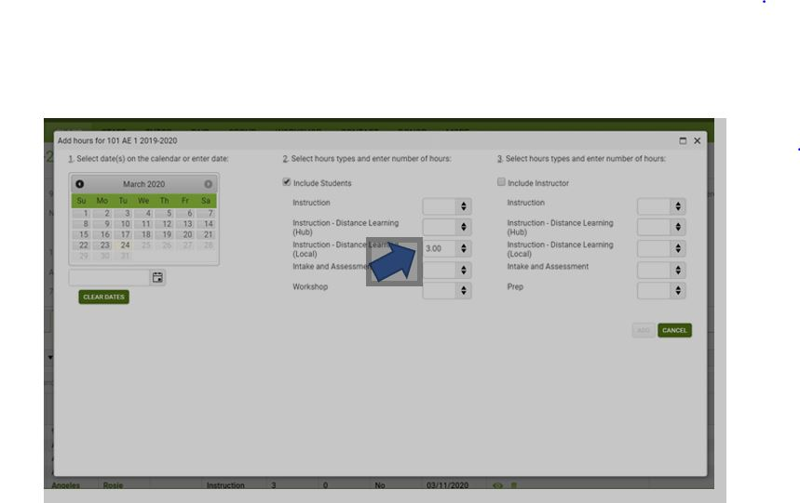
- Unless it is easier for your program, you do not have to create new classes. Just continue recording student participation.
Measuring Instructional Time for Distance Learners
Student Contact Hours
OCTAE’s 2016 NRS Implementation Guidelines state “contact hours for distance learners can be a combination of actual (face-to-face) contact and contact through telephone, video, teleconference or online communication, where student and program staff can interact and through which learner identify is verifiable.”
This allows distance education programs to count contact hours for times when a distance teacher provides instruction using the telephone, webinars, video chat technologies, or interaction in the assigned distance learning curriculum “where student and program staff can interact and through which learner identity is verifiable.”

Proxy Contact Hours
In addition to measuring student contact hours, programs have the option to report proxy contact hours for distance learners. Proxy contact hours provide an indication of how much instructional time, on average, distance students are likely to spend on specific distance learning activities. From an assessment perspective, proxy contact hours serve the same functions as contact hours: they allow adult education providers to determine when to posttest students. They also provide instructors with another way of monitoring their student’s engagement with the curriculum and help instructors determine where additional support or intervention might be warranted.
Proxy contact hours are assigned using a systematic process: this is not typically a decision that individual teachers or adult education centers make. For NRS purposes, the following three models of determining proxy contact hours are acceptable:
Clock Time Model—This model can be used with online or standalone software programs that track the time that a student is engaged with the curriculum and which log out students after a predetermined period of inactivity. Typically, one hour of time in the program is accepted to be one proxy contact hour. Examples: KET, AZTEC, USA Learns (now has this option),
Learner Mastery Model—In this model, the degree to which learners have mastered instructional content is connected to the assignment of proxy contact hours. The Learner Mastery Model assigns a fixed number of proxy contact hours based on the learner passing a test on the content of each lesson. Students must score at a predetermined level (typically 70%– 80%) to earn the credit hours attached to the material. Examples: USA Learns (still can be used)
Teacher Verification Model—This model is well suited to multimedia curricula, where students receive instruction from a variety of sources, or with distance activities developed by the instructor. In this model, a fixed number of proxy contact hours are given for completion of each instructional activity in the curriculum. The assignment of hours is based on a teacher verifying that the assignment was completed.
Support students at a distance with their educational work, even if that support involves activities that cannot be counted as contact hours per our contact hour policy.
Program Accountability
Student Outcomes
MSG
Legislation requires that states report quantitative data annually. The US Department of Education has not indicated that this will change, and we will expect to report student participation and outcomes for this challenging fiscal year. Similarly, grantees are required to enter all data that is available.

ACLS has no plans to change FY20 MSG targets. However, we do not know to the extent to which we will hold programs accountable for MSG. Please be assured that there will not be a negative effect on FY21 funding. Please continue to serve students remotely even if they are not able to post test.

ACLS encourages programs to continue to follow up with exited students. Our students are among the most vulnerable and likely to suffer as our economy slows. I am confident that your calls will communicate understanding and empathy as you seek employment outcomes.

Program Quality
Site Visits
ACLS will not conduct any onsite site visits for the remainder of FY20. Program specialists will continue to provide technical assistance to programs.
Program Quality Reviews
ACLS has suspended all PQR for the remainder of FY20. PQ visits that did not occur in FY20 will be rescheduled in FY21.
Compliance
Desk Reviews
ACLS encourages programs to submit desk reviews as close to the original April 15 deadline as possible. There will be not be any consequence for not submitting or late submissions of the workbook.

The desk review is an important activity even if it is not required. The enrollment tab will indicate the extent that students have transitioned to and persisted with remote learning. This will inform future program design. By completing the employment tab, directors and their staff will gain a deeper understanding of WIOA. In addition, by completing the financials tab, programs will be able to track any budget impact due to reduced services.

Grant Funds
General DESE guidance on use of state and federal grant funds
ACLS strongly encourages program leadership to allow staff to work flexibly from home through periods that programs services are suspended due to COVID-19 on regular activities covered by Title II funds.

Grants
At this time, the Department is providing this general guidance with respect to grant program expenditures. This information is subject to change and updated guidance will be provided as needed.
- Per Office of Management and Budget (OMB) — grant recipients may continue to charge salaries and benefits to currently active awards consistent with the recipient organization's policy of paying salaries (under unexpected or extraordinary circumstances) from all funding sources, Federal and non-Federal.
- Other costs may be charged to awards, including those necessary to resume activities supported by the award, consistent with applicable cost principles and the benefit to the project. DESE will also evaluate the recipient's ability to resume the project activity in the future and the appropriateness of future funding, as done under normal circumstances, based on subsequent progress reports and other communications with the recipient.
- EdGrants can be accessed remotely as it is a web-based application. Grantees are encouraged to continue using EdGrants as needed.
- Typically, line item amendments must be approved 30 days prior to need. However, Grants Management will temporarily lift this 30 day prior to need amendment rule. Please keep in mind that any funds spent using grant funds should still fall within the allowable costs and program parameters. If there are specific questions as to whether something is allowed, grantees should contact the DESE program personnel managing the grant. This is typically the person listed as the contact in the RFP posting.
- The payment request windows are set up at the start of the fiscal year so there will be no disruption in accessing payment windows. Payment windows remain open the 20th of the month through the end of the month. As always, you can email EdGrants@doe.mass.edu for assistance.

