DESE InSPIRED Fellows and aMAzing Educators
2018-2019

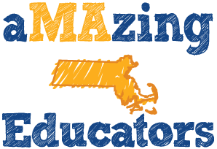
2019 InSPIRED Fellows, January 2019

Meet the Boston InSPIRED Fellows and aMAzing Educators

InSPIRED Fellows are in-service professionals working to increase the racial and ethnic diversity of the teaching workforce.

During the 2018-2019 academic year, DESE launched the InSPIRED Fellowship and was able to select 35 Fellows in total across the Commonwealth who are deeply committed to increasing the diversity of the teaching workforce through mentorship and individual conversations about what it means to be teacher in the Commonwealth. Fellows are experienced educators who also understand the value of identity and can sympathize and empathize with the experiences of individuals from underrepresented ethnic and racial backgrounds. The following Fellows were selected out of

I am: Amy Maldonado
I am doing amazing things in: 4th Grade ESL

Why I Teach:
I teach because I feel it is important that kids see themselves reflected in their teachers. Like my students, I too come from a "broken city" where the majority of my teachers did not look like me. Representation matters. I teach because kids need role models who look like them.
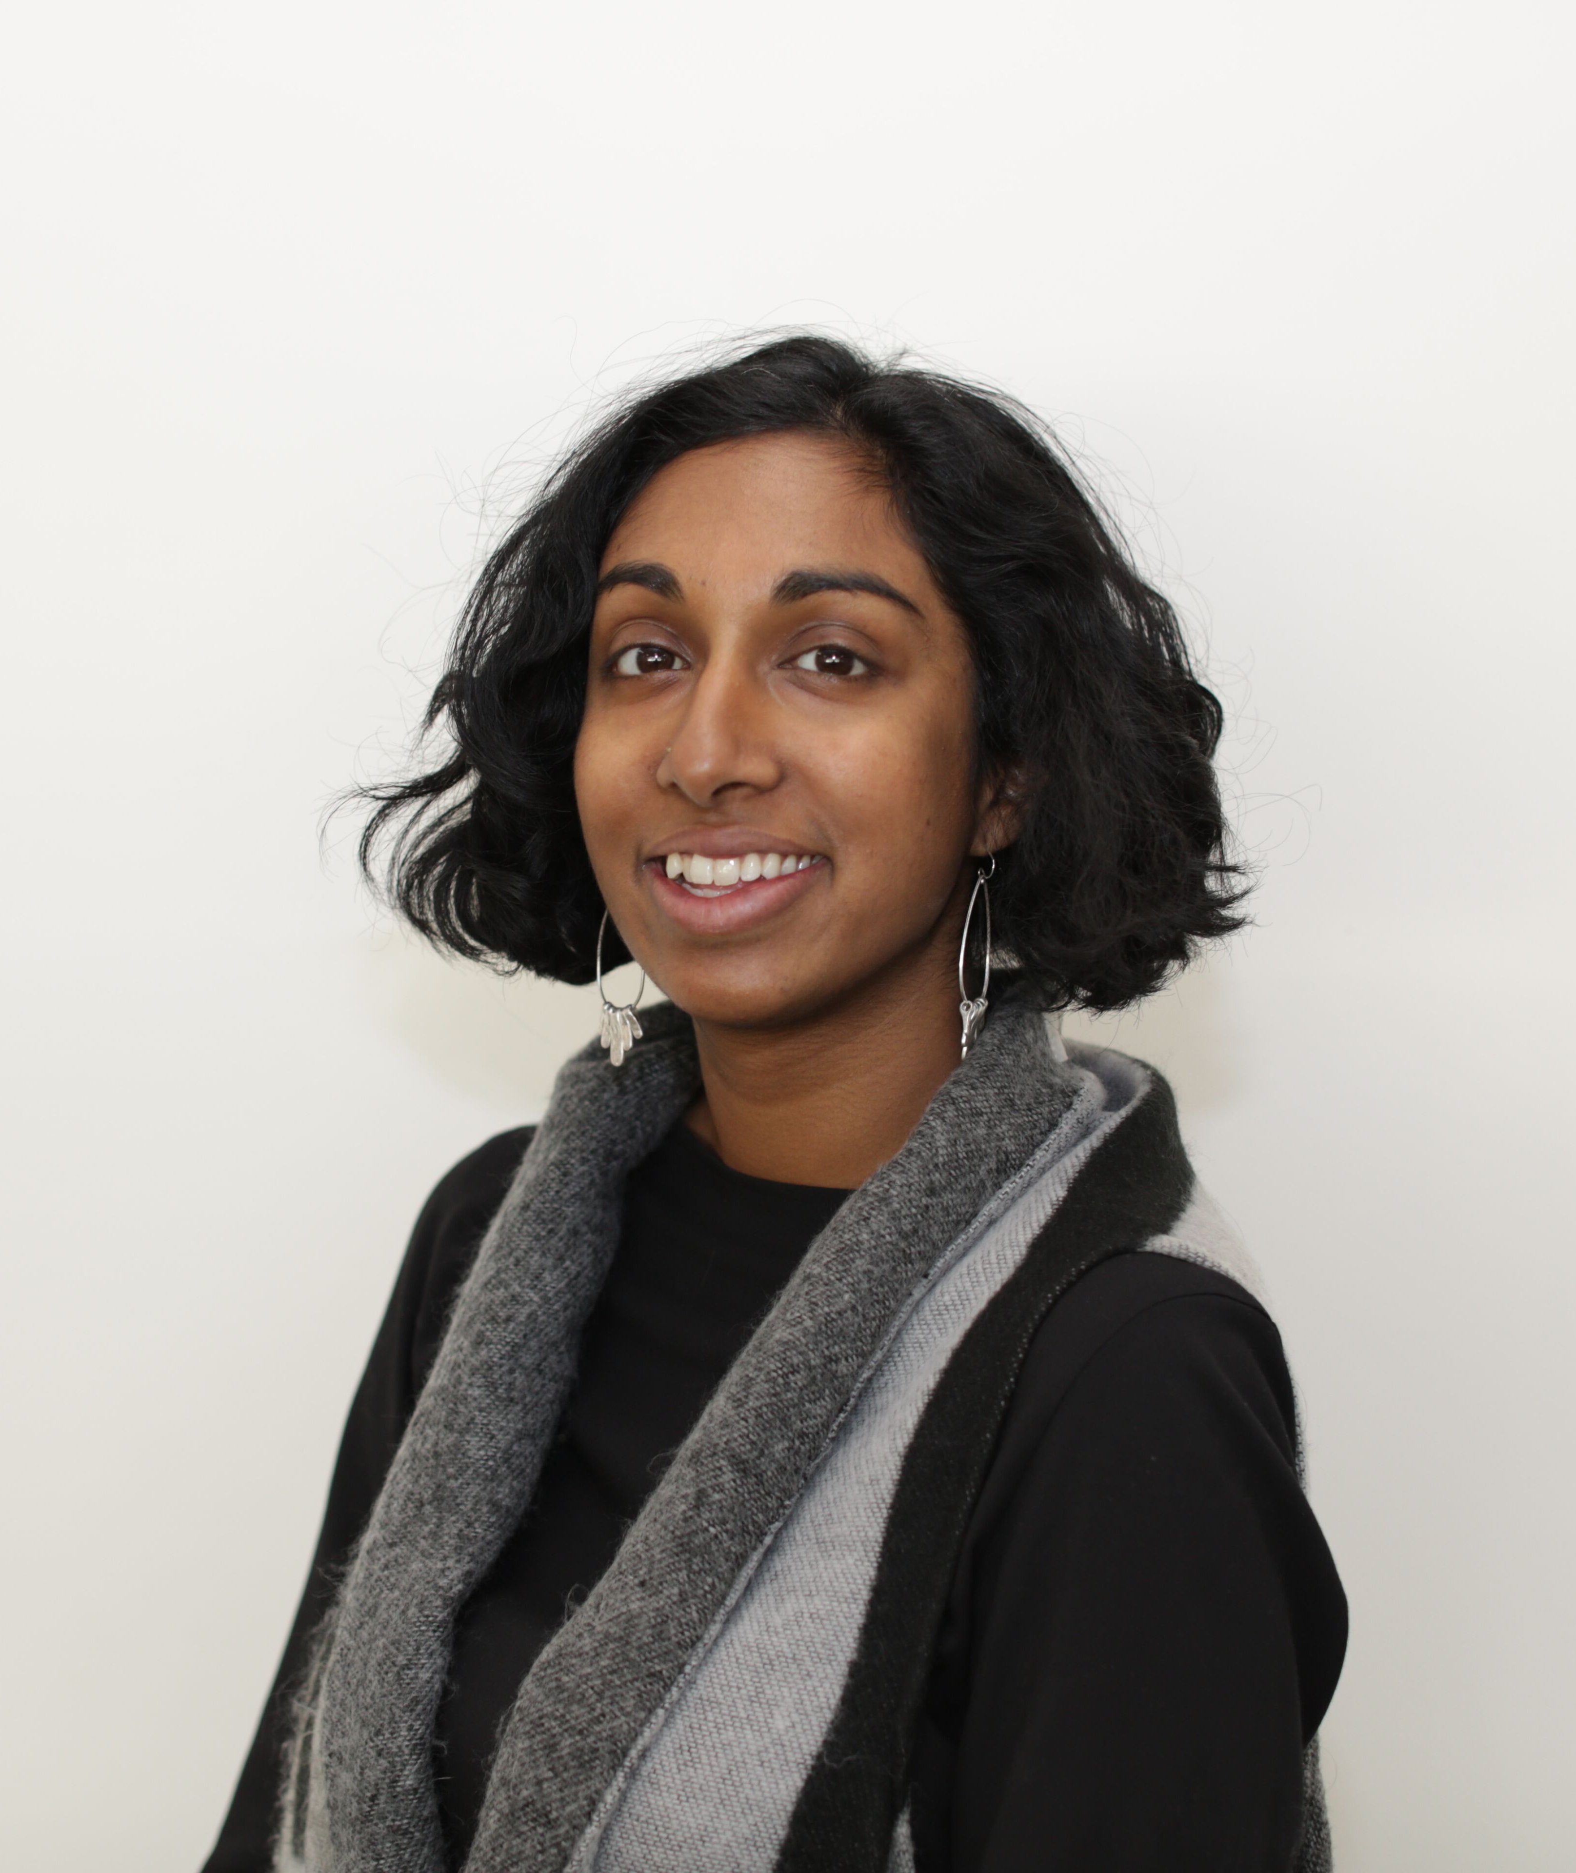 | I am: Anjali Nirmalan  I am doing amazing things in: 6th Grade ELA  Why I Teach:  As the daughter of immigrants, it was not until my undergraduate Sociology studies that I began to truly understand the opportunities offered and denied through access to education, both domestically and globally. It was in my first teaching internship that I discovered that working with adolescents was more maddening, challenging, and fulfilling than anything I'd ever done. By the end of my second internship, I knew that I could easily spend my whole life trying to get better at this work -the work of youth and ideas and what happens, most daringly and brilliantly, when they collide.  After completing a teaching residency, I became a founding teacher in the first in-district turnaround middle school in Massachusetts. I have now spent almost seven years teaching in the same two classrooms of South Boston, fielding everything from fake funny noises to four-page analyses of Maya Angelou, partnering with the families of 400 incredible 6th graders with a range of spoken languages and backgrounds, leading teams of whip-smart adults, coaching tentative first-year teachers, and re-evaluating every day what it means to be a critical reader and a writer in the 21st century.  Through the power of literature and research, I empower my students to become informed and engaged citizens, ones who are driven to implement radical and sustainable change in their local and larger communities.
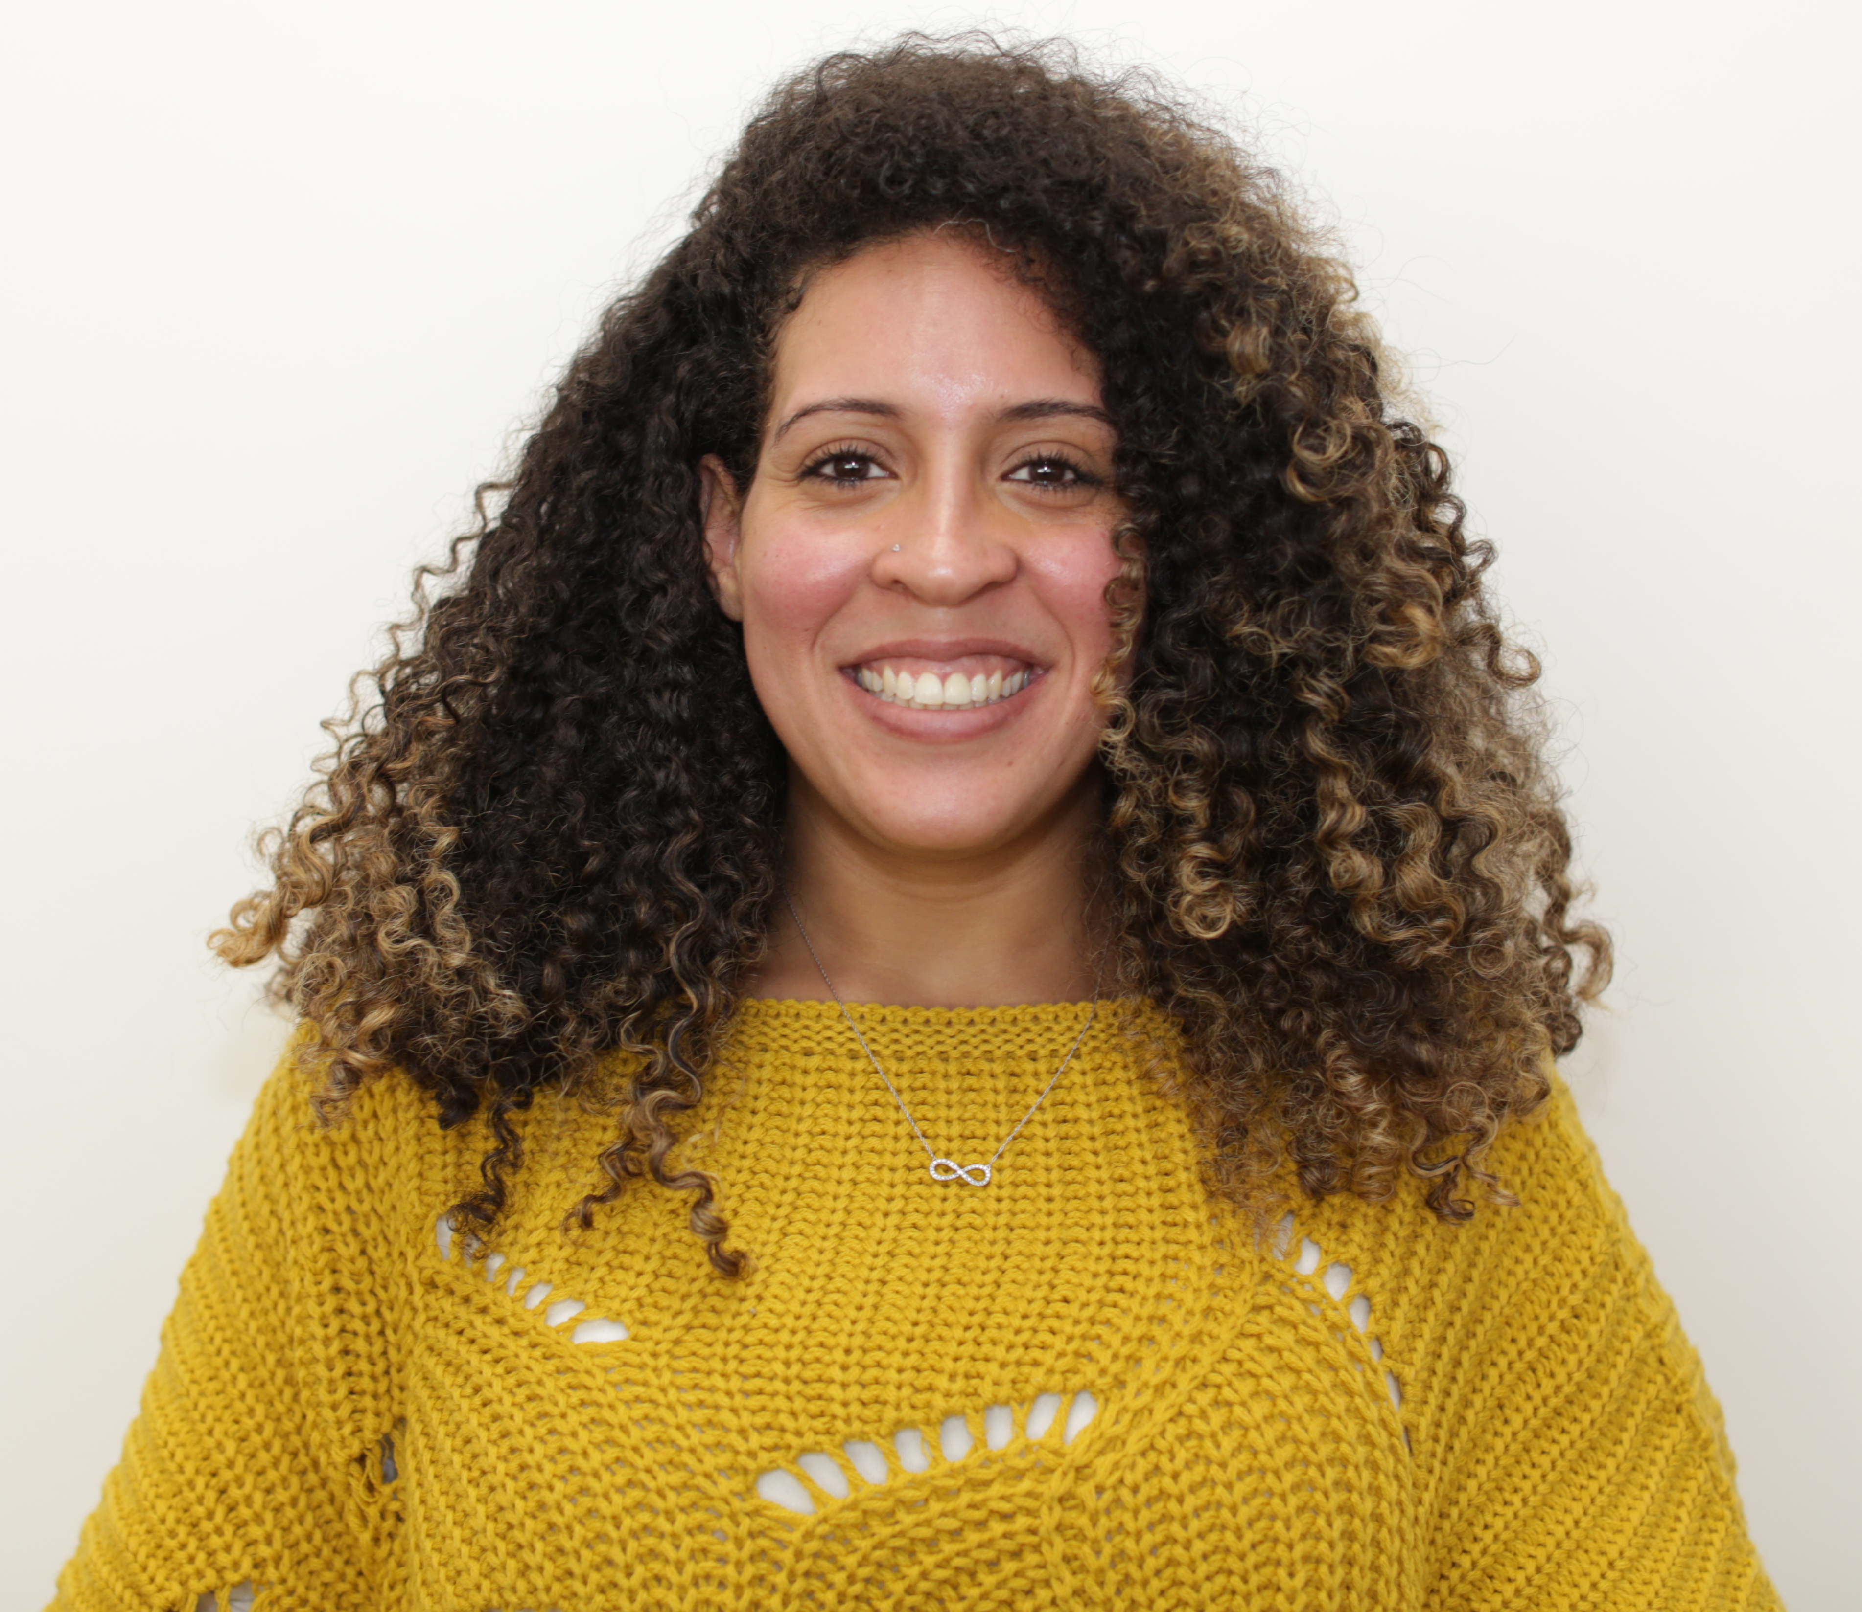 | I am: Carol Merino  I am doing amazing things in: Spanish, Grades 2 - 8  Why I Teach:  My grandmother was a teacher so you can say teaching is in my blood. I remember growing up in the Dominican Republic and having a blackboard in the living room to practice our handwriting and playing teacher with my cousin. It wasn't until after found myself teaching financial literacy to adults in my community, that my love for teaching became apparent. It was at that moment that I realized that I could make a bigger impact if I started teaching students at a younger age and enrolled in a master's in Education program. I decided to focus on Spanish because I wanted other English Language Learners like me, to understand that being in this country and having to learn English did not mean that they had to completely let go of their ow languages and cultures.  Since then, I have taught elementary, middle, and high school aged students. I have also been one of few, if not the only teacher of color in these schools. I have been able to instill in my students not only a love for the Spanish language and culture, but a love for their own languages and cultures as well as the importance of being bilingual in the United States. As a result, I have built amazing relationships with my students and their parents that will last a lifetime.
I am: Caroline Jones
I am doing amazing things in: 7th Grade Math

Why I Teach:
I teach because of Kiara. Kiara and I met in September of 2005, in Baltimore. It was my third year of teaching and I was her first and second grade teacher. Quickly, I developed a strong relationship with Kiara and her family. A few years passed and I relocated back to my hometown of Boston. The emergence of social media allowed us to stay connected in a different way. We continued to communicate as she transitioned into middle school and then high school. On a winter night in 2017, I wished her a happy birthday on Facebook. Her response read: "Thank you. Are you still coming?" Was I still coming to her high school graduation? We had discussed it many times over the years. Within a few days I booked a flight to Baltimore for a Saturday in June. Watching Kiara walk across the stage and receive her high school diploma is one of the proudest moments of my teaching career. Fast forward to today and she is thriving in college. Her most recent text read: "I can't believe I'm going to be finishing up my sophomore year."

I teach because of Kiara. Watching her grow and evolve from a first grade student into a successful college sophomore is the most incredible thing that's happened in my life.
I am: Cesar Batista
I am doing amazing things in: 7th Grade English

Why I Teach:
I teach because of my mother. Her dream as a 17-year-old mother was to have me surpass her dreams. I teach because I want to debunk the school to prison pipeline for the boys in my classrooms. I teach because it is the civil right of my students to be provided with a quality education, it should not be an option. I teach because I no longer want the narrative that Lawrence is the "City of the Damned" to permeate the tabloids. As a teacher I seek to ensure that students not only feel safe in my classroom, but also see their lives represented in a manner that the media does not always choose to shed light on. I expose them to novels, stories, and other works that celebrate their diversity and cultural beauty.

Numbers do not dictate my success. I know that I'm successful when I see former students years later and they remind me of the mantra I teach each class at the beginning of the school year: love the struggle. Although simple, I have seen students reach new heights academically because they've learned that instead of giving in to their problem, they can instead choose to believe in themselves and use that to rewrite the narrative society has placed upon them.
I am: Chakara Cardillo
I am doing amazing things in: 8th Grade Engineering

Why I Teach:
I teach because I want the community to know they are the catalyst for change. My vision for students is to inspire young leaders to have the confidence and willingness to face societal challenges head on and to create effective solutions. Education fueled by motivation comes from the difference of one.

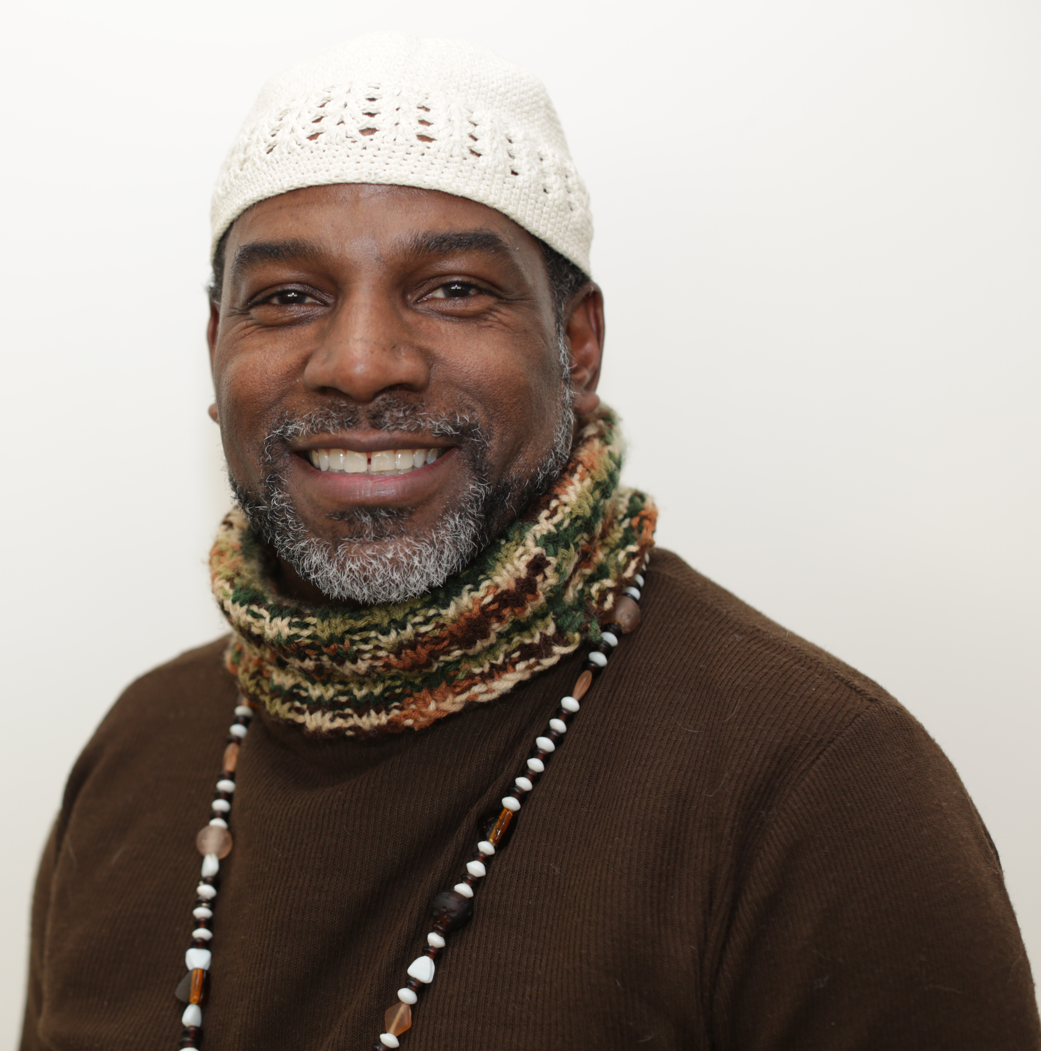 | I am: Darren Wells  I am doing amazing things in: Grades 6 – 8 Science  Why I Teach:  Since fifth grade, I had it all planned out that I would become a Gynecologist or Otolaryngologist (Eye, Ear and Nose specialist) because of my allergies and fascination with birth. However, while attending Hampton Institute, I was encouraged to take some education classes as part of my Pre-Medical/Management coursework. I took them but, I thought that I would never really use this knowledge. Upon, graduating I deferred medical school to travel and work. During that year, I became extremely enlightened. I learned I was a trainer and decided to pursue Education instead...  Today, I am not a doctor but I am a specialist. As a highly decorated Middle School Science Instructional Teacher Leader each day I: Heal Hurts, Save Self Esteems, Mold Minds, Create Characters, Build Believers, Graph Greatness, Ignite Integrity, Expand Exposure, Passionately Perform, Develop Dreams, Uplift Understanding, Welcome Weaknesses, Care Courageously, Lift Laughter, Hug Humor, Chart Creativity and Cultivate Consciousness as I acknowledge that I make Immeasurable Positive Progress - that Lingers and Last throughout a Lifetime of Love for Learning.  So, did I miss my calling for becoming a doctor, NO! I am where I am supposed to be...Simple put: I am an Educator who has  been entrusted with the lives of our future everyday; and I honored to have answered this calling to TEACH.
I am: Emily Soto
I am doing amazing things in: 5th and 6th Grade English

Why I Teach:
Education has been the foundation of my parents sacrifices. They migrated from the Dominican Republic leaving behind their dreams in exchange for opportunities for their children. Education was the most important value in my family because I knew it would unlock a world of opportunities. My experiences growing up in Boston exposed me to countless disparities in my community which encouraged me early on to become an advocate in my community. While studying Criminal Justice in college, I was steering into a career in juvenile law to be able to represent and provide legal aid to young adults in my community. Through multiple experiences, internships, and courses I discovered that the root to many social issues I was passionate about was an equal and accessible education. I knew if I wanted to be impactful in the lives of black and brown children, that meant being an advocate in the classroom instead of the courtroom and doing this work specifically in my community.

Today I inspire and teach 5th and 6th English Learners in my community. As a former ESL student, and now ELE teacher, I recognize the challenges and the blessings for this particular group of learners. Through creating a safe learning environment and focused instruction, my students feel loved, believe in themselves academically and in their values as multilingual learners in their communities.
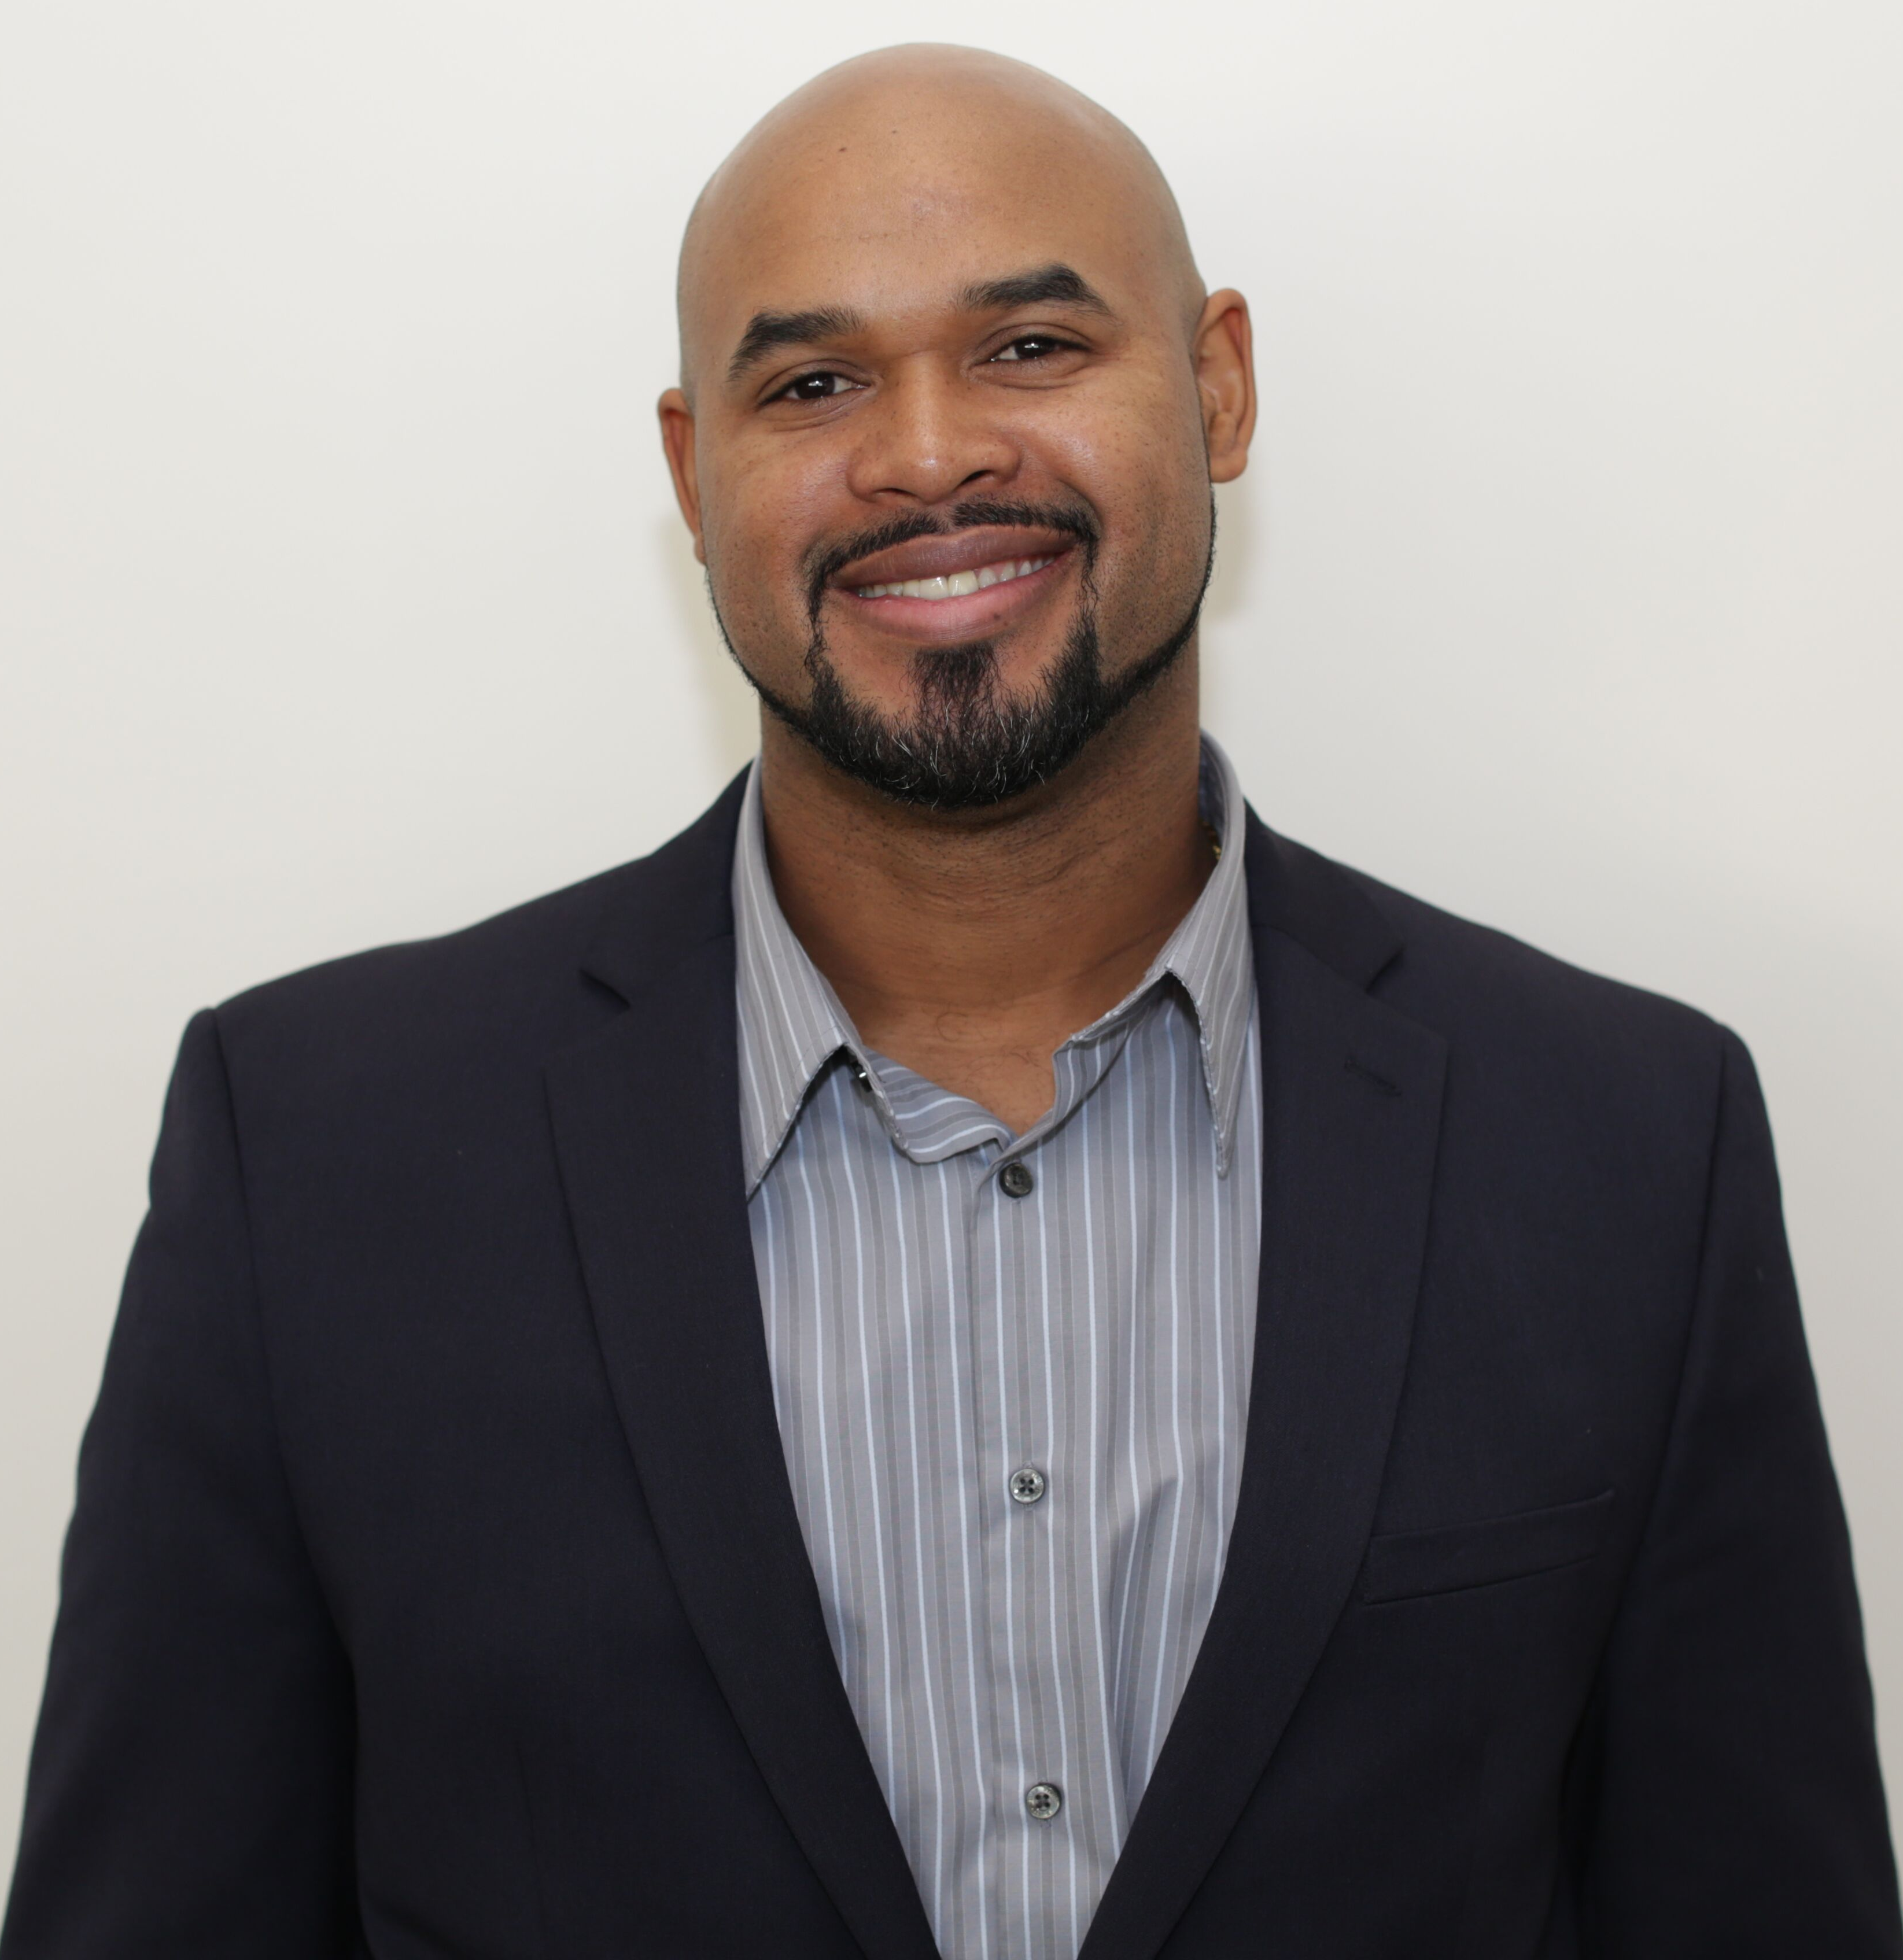 | I am: Euclides Pichardo  I am doing amazing things in: HS Anatomy, Biology and Physiology  Why I Teach:  I am currently working with new comers, (students who have been in the country for less than a year). Before I was working with them, they had a 25% passing rate on their Biology MCAS, but after working with me they increased to 75% passing rate on their Biology MCAS. Last year in a team effort, my school was able to help 90% of our seniors complete all three state-mandated MCAS to graduate 90% of our senior class with their high school diplomas.  I teach to inspire, I teach to plant seeds of curiosity in my students, I teach because I believe that my students have great potential, and are capable of accomplishing amazing things as long as they have the right motivation and guidance. I have always believed that if I can get my students curious enough to do their own searching about specific topics from my class, then the seed of curiosity is planted. I teach to inspire my students to take ownership of their education, I teach to inspire my students to question what they don't understand, but most importantly to be willing to find the answers on their own.
I am: Gavin Smith
I am doing amazing things in: Grades 7 - 12

Why I Teach:
Education uplifts people, creating opportunities for marginalized families in the United States, equipping students with the tools they need to be successful, well rounded individuals. Growing up in a community in New York that produced doctors as well people who fell victim to violence and the dangers of street and gang life, I saw the precariousness of my situation as a young black man--and yet, I always viewed education as the potential great equalizer. It was, the tool that helped my Jamaican mother become the first in her family of seven siblings to end a cycle of oppression and educational failure.

So, for me, a commitment to community and civil rights is best carried out through a career in education. It is my vessel--my connection to my past, present, and future. My commitment to social justice inspired my career, and my career continues to inspire my commitment. My imperative is based on my experiences and those who came before me.
It is not only important to nurture our youth, but to prepare them for the world that they will face. The world is not always kind to marginalized youth, and education itself can be an uphill battle due to circumstances beyond their control. In order to do so, we must hold students to their highest potentials, first helping them find those potentialities by building on their strengths and honoring their inherent wisdom--making success a reality and not just a dream.
I am: Imani Hines
I am doing amazing things in: Middle School Math

Why I Teach:
Nicholas D. Kristoff stated that "A good education is the most reliable escalator out of poverty". A quality education does not just help an individual, it impacts entire communities, raising the quality of life for all. Every year I get to be a part of making an impact in my own community, of being a step on someone's escalator out of poverty. I teach to fight for social justice. It wasn't until I reached college and really learned about the impact of education on cycles of poverty in communities that I begin to really think about what fighting for human rights meant to me. Education is a right in Massachusetts, but all students do not receive an equitable education. I can both be in front of students and help enact policies at the state level through the Teacher Advisory Cabinet and TeachPlus. Proving impact is difficult. Sometimes the proof is quantitative, my students' growth assessments constantly show that they average a year or more's growth. Sometimes its qualitative, having a student go from entering the year hating math to volunteering to explain a concept to their classmates. Most times the proof comes years later, when one of your former students is addressing the student body and mention your name as one of the people who helped them become the person they are now.
I am: Iris Febres
I am doing amazing things in: 11th and 12th grade Spanish

Why I Teach:
I've always had a passion to serve the community. Throughout high school and the years at the university in Puerto Rico, I did community service and missionary work through my local church. Along with the youth group we fed the homeless locally and traveled to different countries to help with the development of children and youth groups in churches. I also taught bible school on Sunday's. These experiences increased the desire in me to become a teacher.
Currently I teach Spanish to native speakers and AP Spanish. This has given me the opportunity to connect to students' culture and to help them improve their reading and writing skills in their native language. Having a high passing rate of students who take the AP Spanish Exam, it is always rewarding to receive e-mails from students that completed the course and earned college credits.
I believe in the students that I serve, and I believe they can achieve anything they set their mind to. Not only do I love being able to help students succeed, but I love that I learn from them every single day and that they make me a better educator. I believe that through education, they can see a whole new world and can extend their horizons to more than the city they live in and the people that surround them.
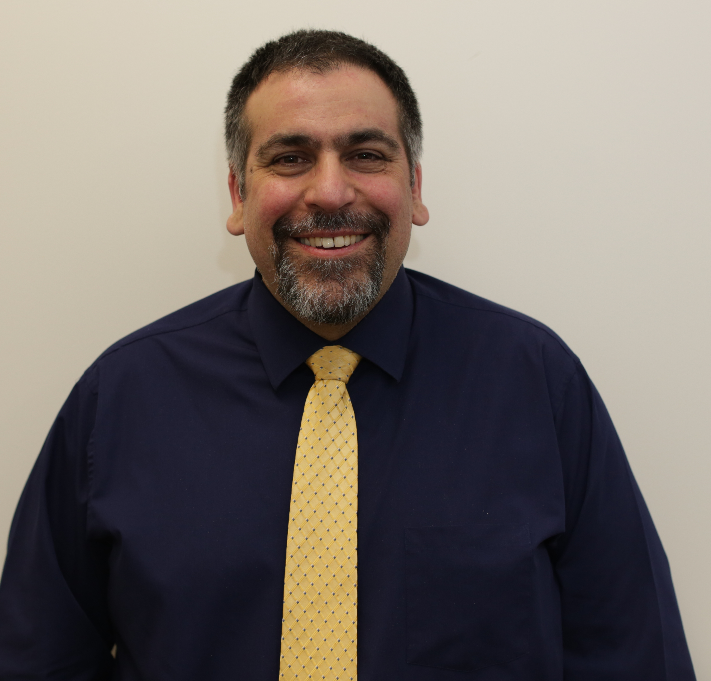 | I am: Jamil Siddiqui  I am doing amazing things in: Mathematics, Grades 9 - 12  Why I Teach:  Growing up I was good at math so I was encouraged to become an engineer. Engineers use math and they make money so it seemed to be a good idea. Early in my college career I became a tutor to make some extra money and I realized that helping people really excited me. I finished my engineering degree, but then enrolled in a Masters of Arts in teaching program. Helping people learn and grow was far more interesting to me than engineering. I have been teaching high school mathematics ever since.  Over the years I have prepared over 700 students for the AP Calculus exam. Each year it is an enjoyable challenge to get people to believe they have the ability to succeed. Watching them get better day-by-day though their hard work and commitment and building their confidence as they struggle through the material has been one of my greatest pleasures as a teacher. When students are not afraid to be wrong, when they are not afraid to fail, they can accomplish anything. I love helping others learn to love mathematics and am happy to say that 15 of my former students have decide to choose a career of helping others love mathematics as well by becoming teachers at the high school or college level.
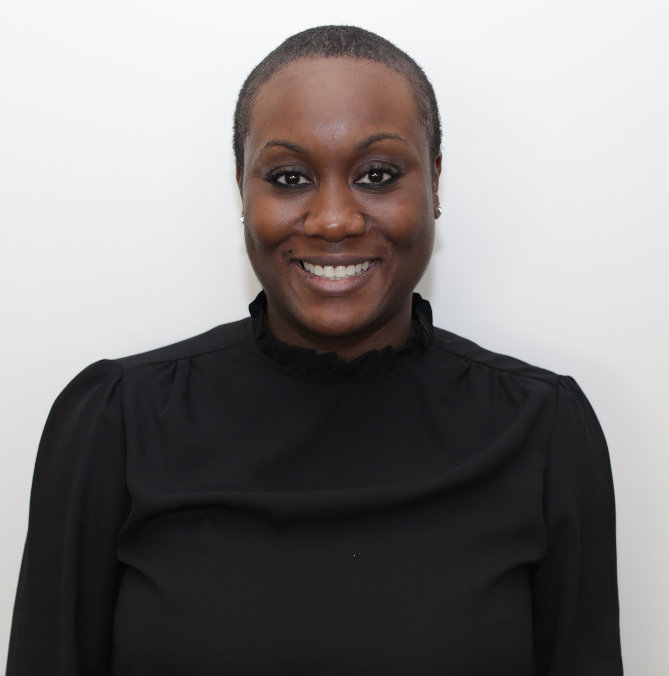 | I am: Jennifer Hedrington  I am doing amazing things in: 7th Grade Math  Why I Teach:  I did not choose the teaching profession, it chose me. Although raised in a household of college/university professors, I had no inclination to become a teacher. While in Law School the opportunity presented itself, and 15 years later, I still look forward to the first day of school.  I believe in teaching the whole child, so I go beyond my math curriculum:  - An Eye for David: Students raised $9k in two months, enlisted the free services of an ophthalmologist, and were featured on 7NEWS. All this to help a young boy in Ghana who was diagnosed with a form of cancer.  - #RepresentMe: Former students came to me expressing their painful and racial charged experiences at the hands of the adults in the school. Together we presented at the monthly School Committee meeting. This courageous act from these students has proven to be an instrumental part in the new policies and PD that have been implemented in the district.  These were not planned events, rather organic in nature and a result of an immediate need. Today, current/former students want to be part of the next “action plan", wanting to make a difference in their communities. On a few occasions the results are immediate, but I see the fruits of my labor when students come back and share their experiences and thank me for my services.
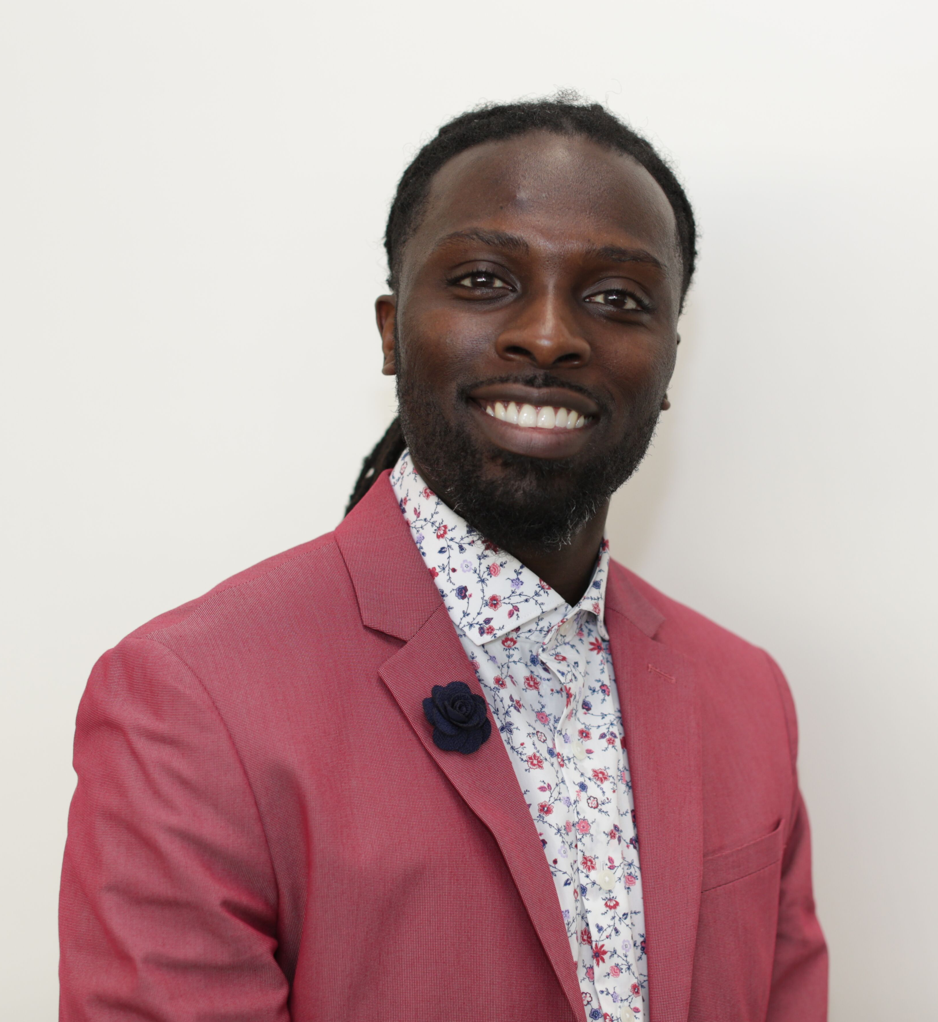 | I am: Kwame Sarfo-Mensah  I am doing amazing things in: 7th and 8th Grade Math  Why I Teach:  I decided to pursue a career in education because I was troubled by the lack of Black male representation in the teaching profession. As someone who is the son of West African immigrant parents, both of whom are college-educated, I recognized the value of a quality education at a very young age. That being said, I wanted to become an educator because I strongly believe that more young men of color will consider pursuing this career path if they are exposed to Black men who love to teach and want to have a positive impact in the classroom.  On the academic side, I joined the teacher collective, Math for Agency Caucus, whose mission is to use social justice issues as a vehicle to create culturally responsive Math tasks for students throughout the Boston Public School district. I know I've had a positive influence on my former students because they always come back to visit and say how much easier Math is in high school because of the lessons I taught them!
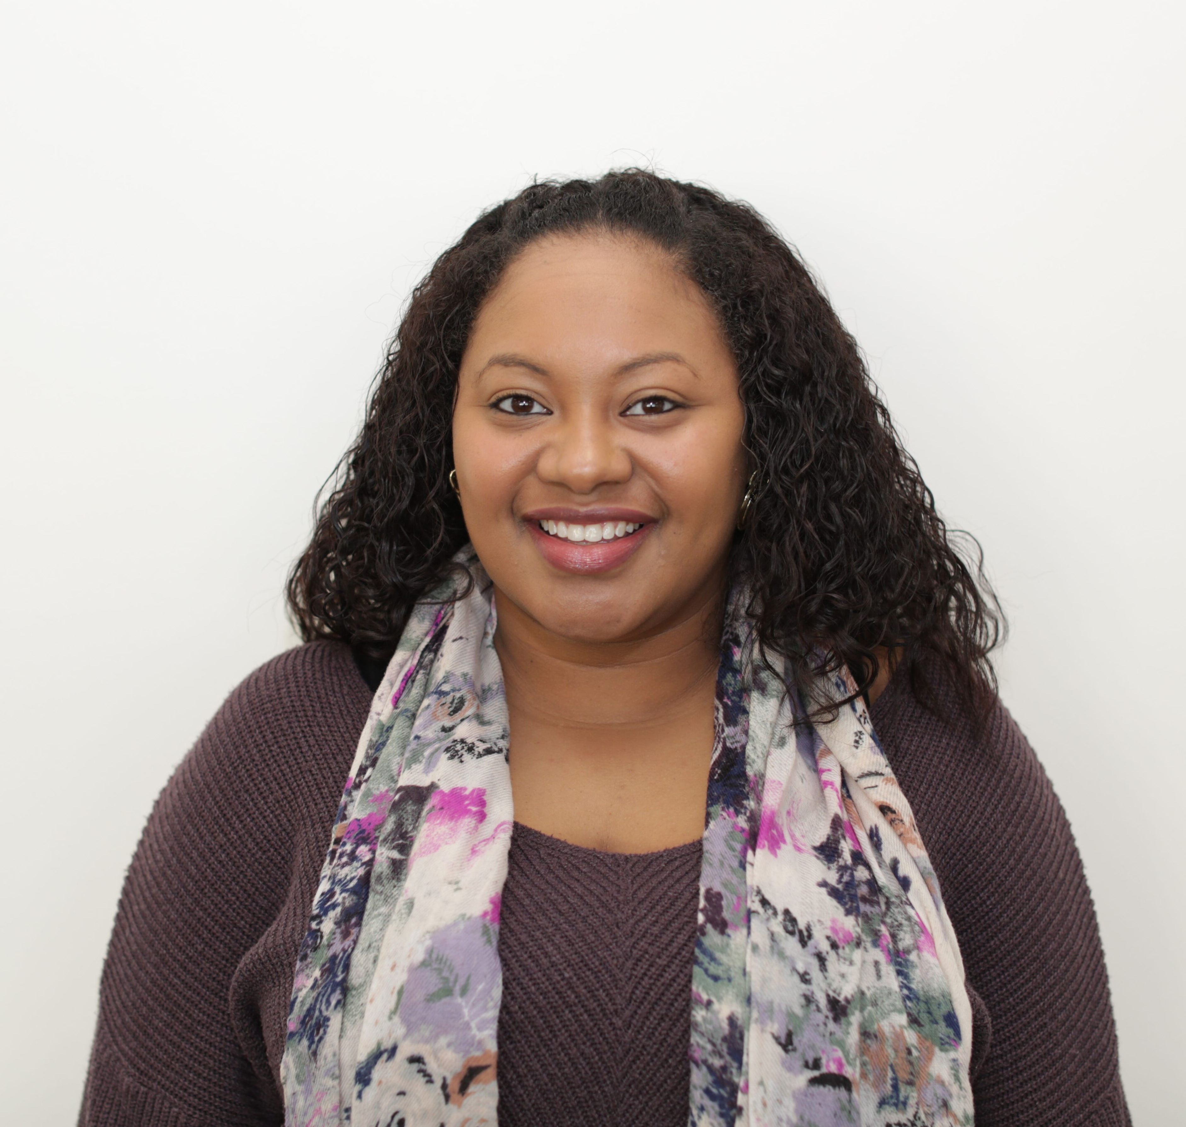 | I am: Lea Serena  I am doing amazing things in: 2nd Grade  Why I Teach:  My family immigrated to the U.S from Cape Verde 40 years ago. My mom was 1 of 6 newly immigrated children from a hardworking  single mother trying to find the "American Dream". At 18 she had two children, but still went to school and graduated from UMass Nursing School when I was 8. She always instilled in us the value of education. My mom told us daily that even if someone had the power to strip anything and everything away from you, education was not one of them! Growing up in an abusive environment and in one where I struggled with concepts of self and was overly shy, I know I relied on and grew from my 1st, 2nd, and 3rd grade teachers at the Mather Elementary School. I credit these amazing female educators of color who I so deeply connected with, with instilling confidence in me at a young age. I have lived everyday hoping to be half the educator they were. It was only right that I would go back to my old elementary school where both me and my mother and so many other family members were able to learn and grow. So why do I teach? I teach to be a constant caring adult in the lives of every child who crosses my path with and without their own struggles.
I am: Lorie Banks
I am doing amazing things in: Grade 8 Math

Why I Teach:
When I was deciding what I wanted to be, I had this community of nurturing and healing in my life that spoke to me. My mother was a nurse and my sister is a nurse, but I knew I didn't want to be in the medical field. I saw teaching as another way to be a nurturer, and middle school is the perfect age for that. They are learning who they are as individuals and beginning to express that individuality and assert their independence, all while still needing to be nurtured.
Teaching is one of only a few professions that allow you the kind of deep, lasting connection to the community you work in. It's a wonderful feeling to remain connected to so many of my students as adults. Having those strong connections to the families I've worked with over the years has been a cornerstone of my career. It is the strong bond between myself and the families that has supported student success all these years.
I have also enjoyed mentoring new teachers and helping to support their professional growth as educators. It has been especially meaningful when former students are now working in my district. I am happy that I have inspired others to pursue a path in education, and I believe they are garnering as much joy as I continue to do.
I am: Mandy Lam
I am doing amazing things in: 6th Grade Humanities and ESL

Why I Teach:
The reason why I teach is that I believe that every student has a unique attribute to bring to their community and every student deserves to have caring adults who believe and care for them. Growing up, I was always overlooked or told I was not good enough. This resulted in my insecurities as a student and as a girl. It was not until my freshman year in high school that I had a teacher who invested in my academic abilities and told me I have something to offer. Looking back, I am so grateful for my 9th grade Humanities teacher but it should not take a young girl until high school to believe she could be something.

As a teacher at my school, I am a grade level team leader where I facilitate professional development for staff and coordinate different events and field trips. I also serve on the student support team at my school, where we target students who need extra support and attention both academically and socially. I also handle discipline issues and student relations. I don't think as educators we ever feel confident about our success but I know that I am successful by the relationships and trust I have built with my students and colleagues as well as the positive culture we have in our school.
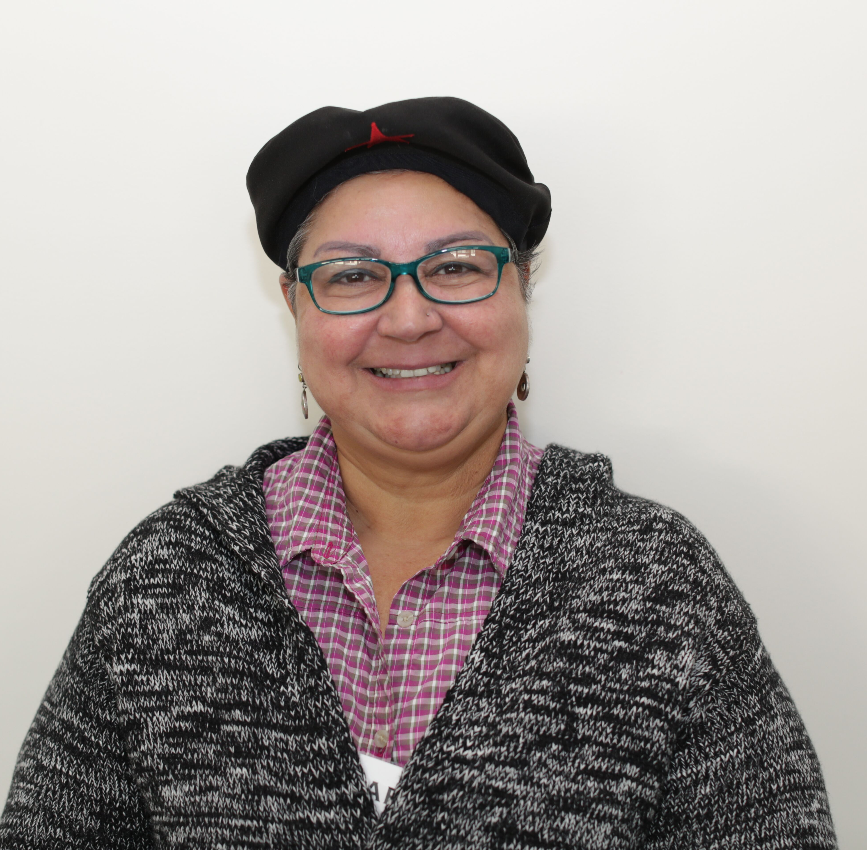 | I am: Marilu Alvarado-Hernandez  I am doing amazing things in: 11th Grade Spanish and Humanities  Why I Teach:  I started working as a paraprofessional in BPS right after I finished high school. I immigrated with my family from PR as an adolescent and lived in the projects. Living there, I got to witness the struggles of the latino families to make it in this country.  In school, the latino students struggled with their identity. Very few teachers looked like them and were not able to help them find themselves. Those experiences opened my eyes and my heart. Becoming a teacher gave me the platform I always wanted; reach out to the latino community. My goal is to teach, but it's also to encourage them to feel proud of who they are. I have become their voice. Most important helped them realize their own potential, which in turn is my greatest joy in teaching. The majority of the students in my school come from Latin America. By the time my students graduate, they understand that no one can put them down because they are immigrants or descendants of immigrants. Sometimes, I am the only person in my student's life who they can trust. There is nothing better than having my students realize they're stronger and more resilient than they ever thought possible. I can impact students from all walks of life, imparting lessons of love and freedom which will help shape the next generation.
I am: Melishia Santiago
I am doing amazing things in: Grades 10-12 Science

Why I Teach:
I believe as a science teacher I am responsible for supporting and challenging my students. I am aware that students have different needs and learning styles, so my goal is to create an atmosphere that is conducive to learning. I teach because I have a passion for the material I present, and I hope my students can realize that learning is an enriching, evolving, and ongoing process.
I create interactive lectures to reinforce the concepts learned in class with infographics, short documentaries, and online resources. I start each class with an activator to ask the students a question or analyze a picture from the topic we discussed the class before. During class, I incorporate main concepts and questions to encourage students to analyze ideas and foster critical thinking.
I want my students to leave the classroom with a new perspective on the world and the environment. As I continue to teach, I aim to improve the way I present the material in front of the classroom. Therefore, I have attended graduate TA orientations at Clark University. I have audited classes at UMass-Amherst and Springfield College. I recently completed the Diversity and Inclusion Certificate program at Clark University in the spring 2018. I also ask for students' feedback to improve my teaching skills in order to amplify their learning experience in the classroom.
I am: Melvin Murry Jr.
I am doing amazing things in: Middle School English - Special Education

Why I Teach:
I teach because it's an honor. I teach because it's my duty. I teach because it's my responsibility. I teach because it feeds my soul.
I teach because my students need a champion; someone who sees their value and celebrates their worth.
I teach because there are so few Black male teachers and it makes a difference in the lives of our students of color, particularly our young men of color. Creating that sense of community and connection is crucial.
I teach because I want our brown boys and girls to come into the classroom and tell me about the heroes they see every day, not just the ones they see on TV. I want our brown boys and girls to see models of who they can be in the rich community that is Springfield. I want them to see heroes who look like them, who share their experiences, and who show them, by living it, what is possible.
That is why I teach.
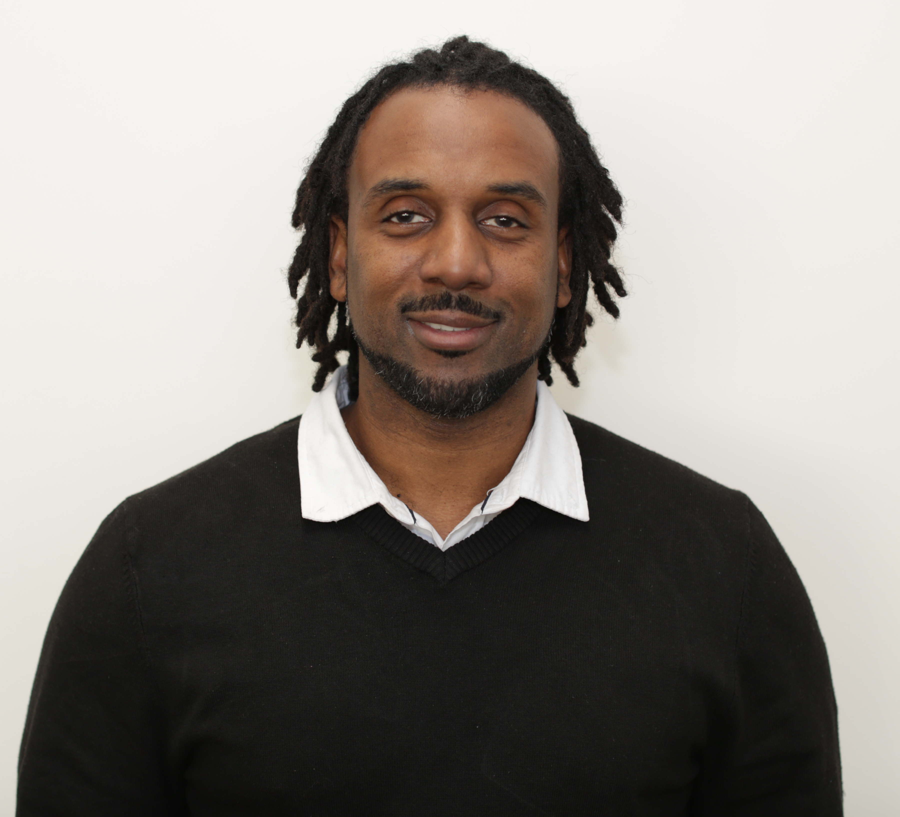 | I am: Michael Robinson  I am doing amazing things in: 8th Grade Science  Why I Teach:  I had countless teachers of color make a meaningful impact on my life and the lives of my peers. I grew up very poor and ended up homeless in middle school. I realized that the condition of my family was rooted in the low quality of education they had received. I wanted a better outcome and realized it would be possible if I fully embraced learning. It transformed my life and I share that reality with my students.  As a teacher I have been able to use my life experience and culture to connect with and motivate students to use education as a tool to break cycles of poverty and dysfunction. Throughout my tenure I have been able to assist countless students and families in working to break cycles through delivering relevant instruction, providing time to work on and discuss academics, life, and completing college admissions and scholarship paperwork with students and families.  Success has been measured through continued contact, letters, and emails from former students as they enter college and careers, graduate and continue their education and life trajectories. Living in the community I work in allows me to maintain contact with students and families as I made myself an ongoing resource to them as they explore and discover the never-ending turns in an adult's life.
I am: Nadjya Facey-Castillo
I am doing amazing things in: Algebra, Grades 10 - 12

Why I Teach:
Both of my parents were educators but I personally never saw myself teaching in a classroom. They instilled the importance of education in me from a very young age. I always enjoyed helping others, especially with math. Growing up many of my peers expressed that I would be a good teacher because I knew how to break concepts down in ways that were easy to understand. After obtaining a Masters Degree in Business Management and not achieving the success that I wanted, I decided to take a chance and change careers from Corporate America to Secondary Education.

In 2016, I graduated with a second Masters Degree in Secondary Education from the Teach Next Year program through UMass Boston and it was the best career choice I have ever made! I have taught over 500+ talented students to date who challenge me and make me smile every time I walk into the classroom. Many students who have already graduated still keep in touch and let me know how successful they are on their jobs. This speaks volumes because the impact a teacher has on a student should not only be just in the classroom but a continuous experience. The seeds that are planted will bloom in the students' success and it is heartwarming when my students want to share it with me.
I am: Natasha Polite
I am doing amazing things in: Middle School Math and Science

Why I Teach:
My family members were always strong supporters of education. Although my parents only graduated high school and never pursued college, they always made education a priority for my brother and I. After completing my bachelor's degree in Mathematics with a minor in Business, I was on a hunt for a high paying job, just like any other freshly graduated college senior. This is the time where I started my journey of being an educator. I became a teaching fellow at a charter elementary school in my hometown. I fell in love with teaching, my classroom, and my student's desire to learn! I wanted to be a part of why students learned and performed so well! I wanted to be proud of making a difference in my community.
I have taught numerous talented students who both challenge and encourage me to continue my teaching journey each day. I moved on to teaching middle school students and I enjoy working with different age groups! Each student leaves their own individual imprint in my life and confirms my need to remain an educator. My students make growth on their MCAS each year. We struggle and strive each day to accomplish our goals, and my students understand I push them to be the best they can be. My students are inspirational, and I am proud to be their teacher!
I am: Omar Longus
I am doing amazing things in: ESL and Science, Grades 9 - 12

Why I Teach:
I teach because I want my community to know the world, and that education is a key which can unlock amazing opportunities students may not even be aware of. Learning is freedom. The more you know and the more you know how to do, the more you can do and experience. I am not close to being able to properly impart this message to all of my students, but as a second year teacher, time is on my side. I have too many students who I feel are disinterested or disaffected, and I want them to know that we control the future.
I am: Phelipe Johnson
I am doing amazing things in: 2nd and 3rd Grade

Why I Teach:
I grew up in a single parent home where the importance of education was instilled in me at a young age. I was fortunate enough to have a support system of amazing family members and teachers. My current success is attributed to those people who supported my academic endeavors.
I chose to become a teacher with the hope of being an integral member in the support systems of students. It's imperative that students have people who are in their corner imparting knowledge, wisdom, and confidence in their abilities. Our commitment to students, families, and their communities extends beyond the classroom. We are not only teachers but often mentors, role models, coaches, and a never ending source of support. We embrace these challenges and relish the success of our students.
I am: Sandra Olán-Martell
I am doing amazing things in: School Counseling

Why I Teach:
Education has transformed my life. Growing up in a "barrio" where aspirations and resources were limited was a real challenge. For me, the school was a safe place. A happy place. A place where I was able to have dreams, a place of hope.
Today, after more than 15 years as an educator, I have been able to inspire and especially educate many students. As a Puerto Rican woman (latina) that has faced many obstacles, I motivate all of my students to work hard, to dream big, and to "NEVER GIVE UP- NUNCA RENDIRSE." As a counselor, I have the privilege to be a mentor and facilitate the path to success. My major satisfaction is to see my students grow academically and professionally. Their success is my success.
I am: Shakeeda Bartee
I am doing amazing things in: 6th Grade English

Why I Teach:
I teach so that I can be the person I needed in middle school. I also teach because I watched a great friend and coworker struggle with substance abuse and, as much as I love helping people I couldn't stop thinking of how I wanted to be able to help before people got to the point where they needed to depend on substance to get by and what better way to do that than through teaching. If I can change the life of one person than this journey is well worth it.
I am: Shelby Sharpe
I am doing amazing things in: Algebra 2 and AP Statistics

Why I Teach:
Teaching in the Springfield Public School system has broadened my understanding and knowledge of various racial, ethnic and socioeconomic backgrounds. I believe all students, regardless of age, gender, race and religion, have a right to learn in a supportive and encouraging environment. I set goals and expectations for my students and work with them to achieve their aspirations. I strive to teach the course materials effectively and in a manner that engages students and challenges them to think critically. I value the opportunity to educate students on the many possible career paths that are available. I do not take lightly the opportunity to be a role model for students and to encourage, advise, and mentor them as they pursue their high school diploma. I am accessible to students and am willing to take the extra time to tutor and advise whenever needed.
I am: Stephanie Byrd
I am doing amazing things in: PreK Inclusion

Why I Teach:
I teach because my experience in school didn't reflect the experience and needs that I came with. Now, as an educator, I want to use my voice to say that it STILL doesn't reflect my students. I follow those who inspire me in advocating for the needs of my students and in leading professional development because I believe that when we build an inspiring space for our students, our teachers and our families, we are creating opportunities to engage our students, our teachers and our families in the transformative experiences that empower them to use their voices to ignite change.
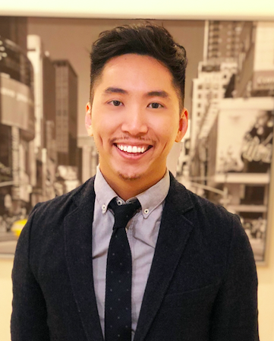 | I am: Takeru Nagayoshi  I am doing amazing things in: English and Research, Grades 9 - 12  Why I Teach:  In middle school, I told myself that I wasn't "smart enough." I struggled in class and internalized the belief that I wasn't suited  for school. I wish I told myself that it was OK to make mistakes. That success isn't linear, or that we shouldn't feel embarrassed  to ask for help. That sure, I had trouble with reading and writing, but doesn't everybody?  I work at a low-income, urban high school. Every year, I teach young adults the joys and despair of academic research. Our  work is not easy. My kids investigate real-world topics and craft 1,000-word arguments and present their findings. We write  and speak in public, a lot, and we sometimes cry. We get anxious that we can't, or that we're not capable because maybe  we're not "smart enough."  No child should let self-doubt be their limit. I teach to tell them it's OK to make mistakes, that success is never linear, and that  we all need a bit of help with our reading and writing (but seriously). I teach my kids that we're not defined by who we are right  now, but what we dream ourselves to become.  And this past year, we dreamed big. Ninety-two percent of my students, the majority of whom are freshman, passed their AP exam.  We broke the school record.
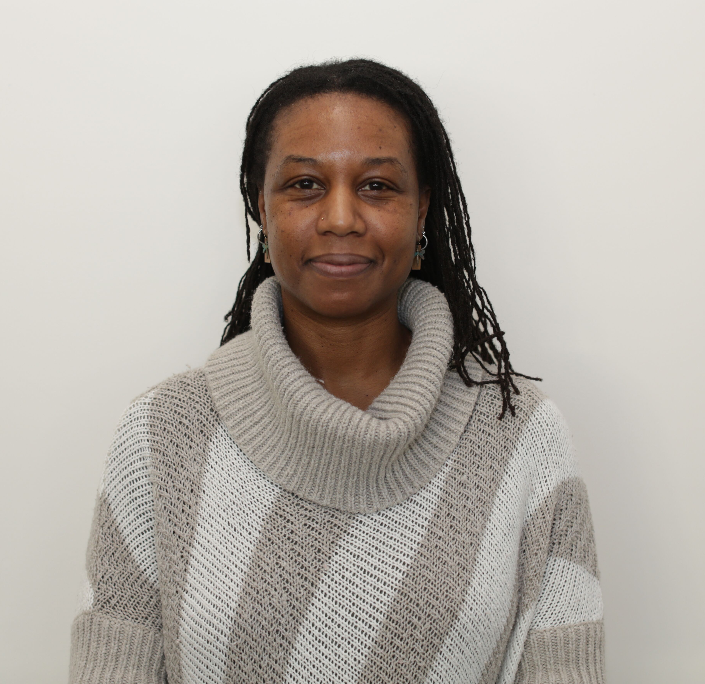 | I am: Tamisha Thompson  I am doing amazing things in: Math, PreK - 5  Why I Teach:  When I started college, I majored in math because I liked it, not knowing what I wanted to do with a math degree. A math education professor asked me if I'd ever considered teaching. I hadn't, so I took a job as a tutor in an afterschool program. I learned that I love working with kids as much as I love doing math. Kids are awesome and they love to explore and challenge themselves, and math is a great tool for exploration and challenge. I wanted to be a role model. I had few black teachers, and no black math teachers. Over the years I realized that math is often used as a tool to divide people, as early as middle school I re-evaluated systems that I thought were in place to help assess students' learning, but really just separate out students of color. Every student has the right to access a college education if they want it, and I want kids to know that being good at math is something everyone can do. So I teach to help educators change systems. I teach teachers to instruct so that interventions aren't necessary. I help struggling students learn that opportunities are there for them, too, that they have the capacity to become independent, intelligent adults who can give back to their communities.
I am: Viergeline Felix
I am doing amazing things in: 1st Grade

Why I Teach:
As a seventh grader growing up in Boston, I often woke up to the pitter-patter of raindrops and the sight of rising water in our basement apartment. But still, I grabbed my soaked backpack and rushed out to make it in time for school. For students like me, school was not just a place where we learned algebra or writing. It was a place where we unpacked the frustrations of home life and a system that failed to provide us with a quality education.

In spite of my home life, my teachers lived up to the challenging responsibility of teaching me well, so I teach to exceed that high standard. When I’m plagued with statements like "She had a very traumatic home life or he is reading 3 years below grade level, and you know they just don't care", my answer will be simple - I will teach them well. Teaching urban city children, who have fallen through the cracks of a faulty educational system, is a daunting task. Although the lives of my students may not literally change from me teaching them how to write a Haiku or do basic math, I know that once they begin to ask thoughtful questions, make connections to the world, and devise ways to improve their lives and communities, I will have succeeded as a teacher.
I am: Yahaira-Maria Frier
I am doing amazing things in: Grades 6 – 8 ELA

Why I Teach:
I teach because my students are me- first generation Americans in search of a better life. My students show me every day what it means to be resilient when the odds are stacked against you. In my classroom, we take risks, support one another, and celebrate each others' growth. In one year, my students double their language growth and in a few more years scoring proficient on standardized tests. I teach because I am shaping the leaders of our future.
I am: Yvette Joyce
I am doing amazing things in: 5th Grade ELA

Why I Teach:
When I was very young, I was the sickly child in the family. Due to this, I missed quite a bit of school, including the standardized testing of the time. By the time I arrived in high school, I had been 'tracked' into the lower of the classes. In 10th grade, my history teacher asked me why I was in his below level class. I told him I just went where they put me. He made several phone calls, and after several meetings with my parents and various administrators I was moved to Honors, Advanced and even an Advanced Placement class.

In time, I went to college, not very common for an African American young lady in 1983 and earned a Bachelor of Science degree. Over time, I realized that I wanted to be for others what my history teacher was for me so I returned to college for a second degree in education.

Since becoming a teacher, I have worked at the elementary level. My students have come from very challenging backgrounds, yet been able to make it to college, write a published play, and serve in their neighborhoods.
Talk to an InSPIRED Fellow Today!

Contact the Department of Elementary and Secondary Education:

Email: EducatorDevelopment@doe.mass.edu
Website: www.doe.mass.edu/aMAzingeducators/

