
Massachusetts Department of

Elementary and Secondary Education

75 Pleasant Street, Malden, Massachusetts 02148-4906 Telephone: (781) 338-3000

TTY: N.E.T. Relay 1-800-439-2370

A Report Comparing the
Common Core State Standards with the Working Draft Massachusetts Standards for
English Language Arts and Mathematics

July 2010

Executive Summary
Staff at the Massachusetts Department of Elementary and Secondary Education in collaboration with the staff of Achieve, Inc. (a national organization with expertise in standards and assessment alignment studies) have determined that overall 90% of the 2010 Common Core State Standards for Mathematics and 90% of the 2010 Common Core State Standards for English Language Arts are aligned with the standards of the 2010 Working Drafts of the Massachusetts state standards for Mathematics and English language arts respectively.

There is a substantial overlap in the content of the Common Core and the Massachusetts standards. Both sets of English language arts standards address reading, writing, speaking and listening, and language; both sets of mathematics standards address numbers and operations, Algebra, measurement and data, geometry, and statistics and probability. Both are organized into a progression of grade-level standards from Kindergarten through grade 8. The content of the high school standards in both sets of documents was deliberately selected to prepare students for productive work and study beyond high school, whether in college, postsecondary training, or in the workplace.

The two sets of standards differ, however, in their overall grade coverage and in their level of detail. The Massachusetts drafts have Prekindergarten standards; the Common Core does not. In mathematics, the Common Core math standards tend to be more specific and detailed than the standards in the Massachusetts draft. In English language arts, the writing standards are more detailed in the Common Core, but the standards for knowledge of characteristics of literary genres are more detailed in the Massachusetts draft.

How This Report is Organized
This report divided into four sections. Section I describes the origins of the Common Core State Standards Initiative and the concurrent development of the Massachusetts Working Drafts and the Common Core State Standards. Section II describes methods used to analyze the alignment of the Common Core and the Massachusetts standards. Section III provides the results of the alignment study for English language arts and Section IV the results for Mathematics.

I: Massachusetts and the Development of Common Core State Standards
The Common Core State Standards Initiative began in the spring of 2009, when Massachusetts (along with 47 other states, two territories, and the District of Columbia) signed a memorandum of agreement with the Council of Chief State School Officers (CCSSO) and the National Governors Association (NGA) to support a state-led process to establish a single set of clear educational standards for English language arts and mathematics that states could share and voluntarily adopt. The agreement stipulated that states adopting the Common Core Standards may add up to 15% additional standards.

The impetus for developing common standards came from evidence that state academic standards and assessments varied considerably in quality. Comparisons of proficiency ratings based on No Child Left Behind state assessment data and proficiency ratings based on the National Assessment of Educational Progress (NAEP) showed that, in some states, students who scored Proficient or above on state tests in ELA and math scored below Proficient on NAEP tests in these subjects.

Massachusetts was an exception to this pattern. Its academic standards were rated highly by Achieve, Inc., the Fordham Foundation, and the American Federation of Teachers and in general, its state testing scores mirrored its NAEP scores. Furthermore, when Massachusetts participated as a state in the Trends in International Mathematics and Science Study (TIMSS) and received data disaggregated from the total United States, its scores were higher than the United States in general and comparable to international high-performing countries.

Based on disparities in results on state tests and NAEP, the proponents of common state standards argued that common high standards were necessary to bring about equity in educational expectations and opportunity across the United States. They argued that high common standards would help to ensure that students were prepared for college or the workforce. Common standards, they said, would help parents, teachers, students and the public have a clearer understanding of educational expectations and would better serve families who moved from one state to another The proposed common standards were to be benchmarked to the standards of high-performing states and to international standards to guarantee that United States students would be competitive in the emerging global marketplace.

Roughly a year and a half before the Common Core State Standards Initiative was publicly announced, Massachusetts began a review of its own standards for English language arts (last updated in 2001) and mathematics (last updated in 2000). Because of Massachusetts’ strong reputation in standards and assessment development and its strong student performance on state assessments and on NAEP, and because it was well along in developing a “next generation” of grade-level standards, CCSSO and NGA tapped Massachusetts to be a key advisor in the Common Core standards development process. Massachusetts’ “working drafts” were available to the Common Core writing teams and Department staff members were actively involved in shaping the successive iterations of the Common Core standards from the summer of 2009 until the final versions of the Common Core Standards were published in June 2010.

II: The Process Used for Comparing the Standards
As the Common Core standards were being developed, Achieve, Inc. was designing the “Common Core Comparison Tool” software, an online process, and guidelines so that states could match their state standards with Common Core standards and evaluate the strength of the matches. The Common Core Comparison Tool’s standards database sets allow a user first to match one or more state standards to a Common Core standard and then to rate the strength of the collective match on the scale below.

Table 1: Common Core Comparison Tool Ratings Summary
3 = Excellent match between the Massachusetts standards and the Common Core
2 = Good match, with minor aspects of either the Common Core or the Massachusetts standards not addressed
1 = Weak match, with major aspects of either the Common Core or the Massachusetts standards not addressed
No Match = There is no Massachusetts match with the Common Core standard

From May through June 2010, content experts at Achieve made preliminary matches between the standards in the 2010 Massachusetts working drafts and the Common Core standards. These matches were reviewed, validated, and in some cases modified by content experts at the Massachusetts Department of Elementary and Secondary Education. Therefore, though Achieve staff designed the Common Core Comparison Tool and provided examples of possible matches, the final matches presented here rely on the judgment of the Massachusetts ELA and mathematics staff members who were knowledgeable about both sets of standards.

While use of the Tool made determining matches for more than a thousand standards in each subject area less laborious than it might otherwise have been, it could not make the process absolutely objective. ESE staff members concede that other reviewers might legitimately make different matches or come to different ratings because:
- the level of specificity in the wording of the standards varies: some are quite broad, others narrow;
- some standards address a single concept while others have several components that address multiple concepts;
- some standards are written for single grades, others for multiple grades;
- some standards in mathematics embed definitions while others do not; and
- some standards in ELA embed references to specific bodies of literature (e.g., American foundational documents) while others do not.

The matches and ratings entered into the Common Core Comparison Tool provide the quantitative data for the alignment results that follow.

III: Summary of Matches for English Language Arts
Both sets of standards present expectations for beginning reading skills, comprehension of various types of written texts, writing and research, knowledge and application of grammar, acquisition of new vocabulary through knowledge of word parts and relationships, context, and the use of references, and oral presentation and discussion.

There are some important differences in emphasis, however between the two sets of standards. While the Common Core standards are far more specific about the components of writing arguments, explanations, and narratives, the Massachusetts draft standards are more specific about knowledge of literary genres (nonfiction, fiction, poetry, drama, myths and traditional literature) and terms related to the analysis of genre characteristics. The Massachusetts standards demand a greater degree of linguistic knowledge about how English has grown and changed over the centuries through the influences of other languages, and the dynamics of formal and informal English today. The Common Core standards, on the other hand, tend to expect students to understand and apply a variety of grammatical rules at an earlier age than do the Massachusetts standards. The Common Core standards also pose a set of standards for listening comprehension that are wholly absent in the Massachusetts version. In addition, the Common Core standards are more explicit than the Massachusetts counterparts in expecting students to be conversant with multimedia technology as a tool for research, expression, collaborative writing, and the dissemination of writing.

All of the grade-level standards in the Massachusetts Working Draft (570 numbered standards) and the Common Core Standards for English Language Arts (870 numbered standards) were used in this analysis.

The 15 PreK-12 introductory standards statements in the Massachusetts draft, the 32 K-12 Common Core College and Career Readiness Anchor Standards were excluded from analysis because they are not grade-specific. The 118 Common Core Grades 6-12 Standards for Literacy in History/Social Studies and Science and Technical Subjects were also excluded from this analysis because their purpose (to provide standards for reading and writing in history and science and technology/engineering and technical subjects) is different from the purpose of the standards of the Massachusetts Working Draft.

It should also be pointed out that the resources accompanying both the Massachusetts and the Common Core standards were not analyzed because they are ancillary to the standards. These include the Guiding Principles and Appendices A and B of Recommended Authors in the Massachusetts Working Draft and the Student Practices and Appendices A (Research to Support the Standards), B (Exemplars of Text Complexity) and Appendix C (Exemplars of Student Writing) in the Common Core ELA Standards.

What percentage of the Common Core ELA standards appear in the Massachusetts Standards?
Overall, 90% of the Common Core ELA standards were matched to the Massachusetts ELA standards in the Working Draft. Conversely, 87% of the Massachusetts standards were matched to Common Core standards.
Figure 1
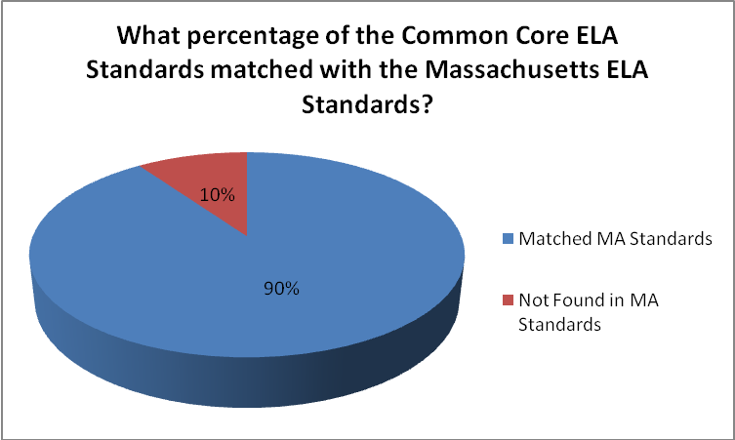
Chart Reads: 90% of the Common Core ELA Standards were matched to the Massachusetts ELA 2010 Working Draft standards. The remaining 10% of Common Core ELA standards had no identified match in Massachusetts. Note – the denominator for this data point is the total number of Common Core Standards and does not include the College and Career Readiness Anchor Standards nor the 6-12 Standards in Literacy in History/Social Studies, Science and Technical Subjects.

While 90% of the Common Core ELA standards were matched to Massachusetts standards, it is important to examine the strength of the matches. As shown in Figure 2, 72% of the matches were rated excellent, 14% good, and 5% a weak.

Figure 2
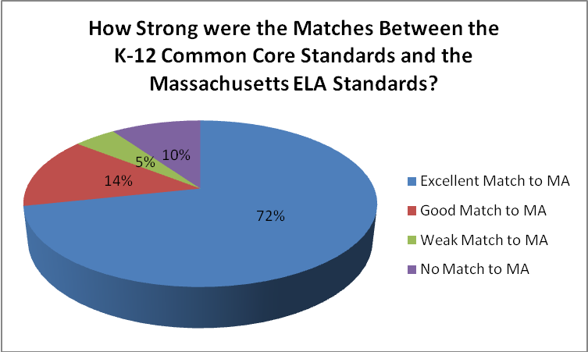

Chart Reads: 72% of the K-12 Common Core ELA Standards are excellent match to Massachusetts Working Draft standards. Note – the denominator for this data point is the total number of Common Core Standards and does not include the College and Career Readiness Anchor Standards nor the 6-12 Standards in Literacy in History/Social Studies, Science and Technical Subjects.

An Example of an “Excellent” Match in English Language Arts
An “excellent” match contains the same content, concepts, and skills at the same degree of rigor in the two sets of standards. The standards matches rated as “excellent” also were at the same grade level or one or two grades above or below.

For example, the Grade 2 reading standards below both address the comprehension of nonfiction text. Though worded differently, the Common Core and the Massachusetts standards require students to identify a main idea and to know the meaning of the concepts “topic” and “paragraph” and apply them to an interpretation of a book or passage with several paragraphs. Here, one Common Core Standard is matched by two standards from the Massachusetts Draft.

Table 2: An “Excellent” Grade 2 ELA Match
Massachusetts ELA Working Draft 2010 | ELA Common Core State Standards 2010
Grade 2, Nonfiction  MA2.N.2 Identify and explain the main idea and supporting facts.  MA2.N.3 Explain the topic of each paragraph in a multi-paragraph nonfiction text. | Grade 2, Reading Informational Text  CCRI2.2.Identify the main topic of a multi-paragraph text as well as the focus of specific paragraphs within a text.

Example of a “Good” Match in English Language Arts
The standards matches rated as “good” also addressed the same concepts and skills and were at the same grade, or one to three higher or lower. It was common to find a good match when a compound standard had several components, some of which were missing in one set of standards or the other. For example, both of the Grade 7 standards below address writing to inform, explain, or analyze and refer to the kinds of organizational patterns commonly found in informational texts (sequence, description, categorization/classification, problem-solution, cause-and-effect, comparison-contrast). Both standards also deal with the role of presenting evidence (in the form of details, reasons, examples, and data) to elaborate on a main idea.

But the standards differ in their particular emphasis. The Massachusetts Draft standard explicitly states that it applies to subjects other than English (which the Common Core does not); the Common Core adds requirements on how an introduction should be structured and how formatting or multimedia should be used to aid comprehension (which the Massachusetts standard does not specify).

Table 3: A “Good” Grade 7 ELA Match
Massachusetts ELA Working Draft 2010 | ELA Common Core State Standards 2010
Grade 7, Writing Analytical Text  MA7.WA.Write on topics drawn from what is studied in mathematics, science and technology/engineering, history/social science, foreign languages, or the arts, using an organizational form that is appropriate to the topic (e.g., sequence, description, categorization, problem-solution, cause-and-effect, comparison-contrast), logical development, and supporting details, reasons, examples, and data. | Grade 7 Writing: Text Types and Purposes  CC7.2 Write informative/explanatory texts to examine a topic and convey ideas, concepts, and information through the selection, organization, and analysis  of relevant content.  a. Introduce a topic clearly, previewing what is to follow; organize ideas, concepts, and information, using strategies such as definition, classification,  comparison/contrast, and cause/  effect; include formatting (e.g., headings),  graphics (e.g., charts, tables), and multimedia when useful to aiding comprehension.  b. Develop the topic with relevant facts,  definitions, concrete details, quotations, or  other information and examples.

Example of a “Weak” Match in English Language Arts
In a weak match, the concepts and skills in the standards are only generally related. Major aspects of one or another set of standards may be missing or the standards may be placed at very different grade levels (three grades, plus or minus).

For example, both of the Grade 5 standards below address the students’ capacity to find evidence for claims presented to them. In the Massachusetts Working Draft, the standard refers to reading comprehension; in the Common Core the standard refers to listening comprehension, yet this is the closest match that could be found between the two because Massachusetts does not address listening comprehension. While the outcome may be similar (a close appraisal of someone else’s ideas), the cognitive task is very different (reading as opposed to listening).

Table 4: A “Weak” Grade 5 ELA Match
Massachusetts ELA Working Draft 2010 | ELA Common Core State Standards 2010
Grade 5, Reading Nonfiction  MA5.N.2 Identify the type of evidence used to support a claim in a persuasive text (e.g., scientific research evidence, anecdotal evidence based on personal knowledge, or the discipline-based opinion of experts). | Grade 5, Speaking and Listening  CC5.SL.3 Summarize the points a speaker makes and explain how each claim is supported by reasons and evidence.

Examples of Unmatched Standards
Standards that were rated as not having a match contained concepts and skills in one set of standards that were largely absent in the other set. The first example below is a Grade 12 standard from the Massachusetts draft that asks for more detailed understanding of literary genres and terminology than the Common Core requires. Should the Board adopt the Common Core standards for Massachusetts, such a standard might be considered for inclusion as part of the additional 15% standards for the final Massachusetts document.

Table 5: An Unmatched Massachusetts Working Draft Standard at Grade 12
Grade 12, Reading Fiction
MA12.F.5 Identify characteristics of genres (e.g., satire, parody, allegory, pastoral) that cur across the lines of genre classifications such as fiction, poetry, and drama.

The second example is a Grade 8 reading standard from the Common Core whose content – the analysis of conflicting information in two texts – is absent from the Massachusetts Working Draft. In addition, the Common Core Standards for interpreting visual information, speeches, and other aural/multimedia communication, as well as standards for using technology for producing and distributing writing are largely unmatched in Massachusetts.
Table 6: An Unmatched Common Core State Standard at Grade 8
Grade 8, Reading Informational Text
CC8.RI.9 Analyze a case in which two or more texts provide conflicting information on the same topic and identify where the texts disagree on matters of fact or interpretation.

How do the Common Core ELA standards
compare to Massachusetts standards at each grade?
Figure 3
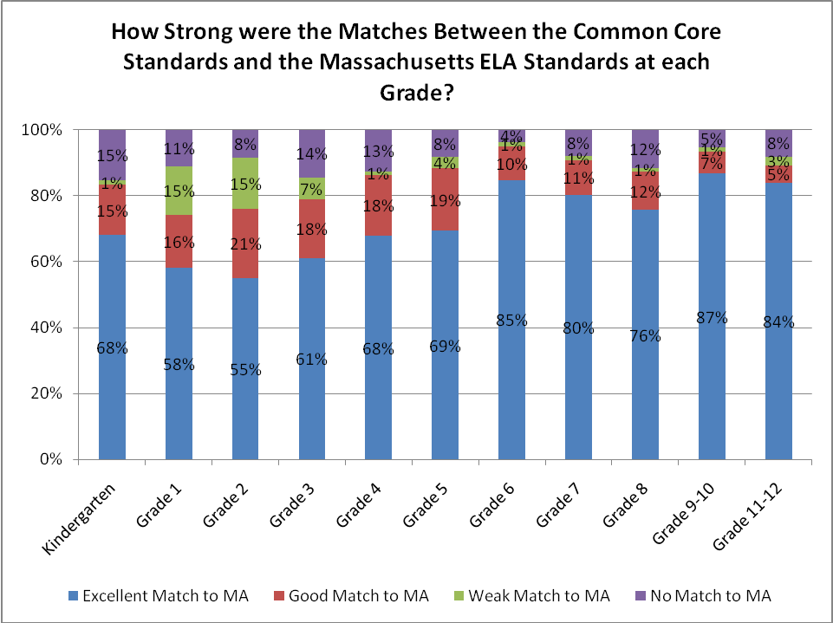
Chart Reads: Of the Common Core elementary standards in Kindergarten, 68% were rated an excellent match, 15% a good match, and 1% a weak match to Massachusetts Working Draft ELA standards with 15% having no match. Of the Common Core standards in Grade 1, 58% were rated an excellent match…etc. Note – the denominator for this data point is the total number of Common Core Standards and does not include the College and Career Readiness Anchor Standards nor the 6-12 Standards in Literacy in History/Social Studies, Science and Technical Subjects.
Standards at the grades 6 to 12 were generally well-matched. The grades in which there were the highest percentages of weakly matched or unmatched Common Core standards were Grades 1, 2, and 3. Most of the unmatched/ weakly matched Common Core standards at these grades address writing or grammar, areas in which the Common Core is more demanding in the early grades than the Massachusetts standards. This finding may signal the need for professional development in writing for elementary teachers should the Common Core be adopted by the Board.

IV. Summary of Matches for Mathematics
Overall there is a strong match between the Common Core State Standards for Mathematics and the Massachusetts Mathematics Working Draft 2010 standards, with the alignment most evident in grades K–8. The Standards for Mathematical Practice found in the K–12 Common Core State Standards for Mathematics were not included in the analysis because they are not grade-specific.

Of the 487 K-12 Common Core State Standards for mathematics, 90% were matched with the MA Working Draft mathematics standards. Conversely, of the 369 PK–12 MA Working Draft standards, 95% were matched with the Common Core State mathematics standards.

There are some important differences to note between the documents. The grade-spans differ; the MA Working Draft includes Prekindergarten standards and the CCSS does not. The MA Working Draft presents the PreK–8 standards by grade level and high school standards by course (Algebra I, Geometry, Algebra II, and Precalculus) and grade-bands (9–10, 11–12). The CCSS document presents K–8 by grade level and the high school standards by conceptual category and progressions (number and quantity, algebra, functions, modeling, geometry, and statistics and probability). The CCSS high school standards designate “college and career ready” standards and additional more advanced standards (indicated with a “+” sign).

The standards in the two documents have differing degrees of specificity. MA Working Draft standards are often broader and yet they cover the same mathematical concepts and skills as those in the CCSS. When the reviewers compared standards they often noticed that a MA Working Draft standard did not address a particular aspect of the content included in a comparable Common Core mathematics standard. Another notable difference is that the CCSS includes definitions as standards; the MA Working Draft standards do not. The different levels of specificity are most evident at the high school level. Although the mathematical topics are consistent between the two documents, the CCSS high school progressions go into more depth and demonstrate more applications of the mathematical topics than the MA Working Draft standards.

What was the rating system for the degree of match with the Common Core?
Matches were rated on a scale of 1 to 3, with 3 representing an excellent match and 1 reflecting a weak match. The reviewer could also designate No Match when there was no MA Working Draft standard that matched the Common Core standard. For grades K–8, matches were made on a grade-by-grade basis and the high school standards were treated as one grade-band (9–12).

Figure 4
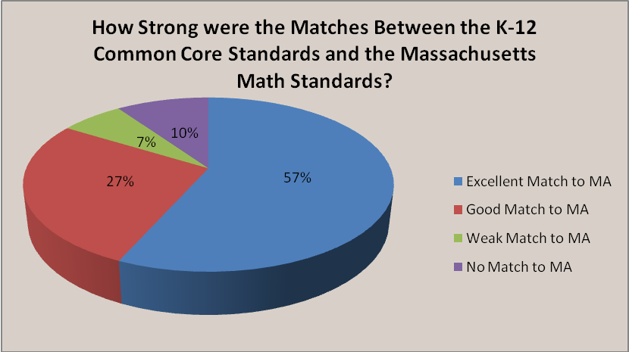
Overall, 84% of the K-12 CCSS matches were excellent or good matches (57% of the 487 CCSS standards were an excellent match, 27% were a good match). (Figure 4) The majority of the 10% of the CCSS standards in mathematics that were identified as having no match to the MA Working Draft standards were at the high school level.

An Example of an “Excellent” Match
An “excellent” match contains the same content, concepts, and skills at the same degree of rigor in the two sets of standards. In the example below, both the grade 3 CC and the MAWorking Draft present the location of fractions on a number line. The MA Working Draft standard also expects students to locate whole numbers and mixed numbers on the number line.

Table 7: An “Excellent” Grade 3 Math Match
Mathematics Common Core State  Standard 2010 | Massachusetts Mathematics Working Draft 2010
Number and Operations: Fractions; Grade 3  CC.3.NF.2b Represent a fraction a/b on a number line diagram by marking off a lengths 1/b from 0. Recognize that the resulting interval has size a/b and that its endpoint locates the number a/b on the number line. | Number Sense and Operations; Grade 3  MA.3.N.6 Locate whole numbers, fractions and mixed numbers with denominators 2, 3, or 4 on the number line. Use other concrete models and pictorial representations to represent and compare fractions and mixed numbers.

An Example of a “Good” Match
The “Good” matches addressed the same concepts and skills but with minor aspects of the Common Core not addressed. In the example below, both standards ask students to create a concrete model of the geometric concept of area. In this case a MA Working Draft grade 4 standard was matched to a CCSS grade 5 standard. The grade 5 CCSS standard has more specificity and addresses the additional aspect of side lengths, unit squares, and fractions.

Table 8: A “Good” Grade 5 Math Match
Mathematics Common Core State  Standard 2010 | Massachusetts Mathematics Working Draft 2010
Number and Operations: Fractions; Grade 5  CC.5.NF.4b Find the area of a rectangle with fractional side lengths by tiling it with unit squares of the appropriate unit fraction side lengths, and show that the area is the same as would be found by multiplying the side lengths. Multiply fractional side lengths to find areas of rectangles, and represent fraction products as rectangular areas. | Measurement: Grade 4  MA.4.M.4 Relate the area model of multiplication to the formula for the area of a rectangle.

An Example of a “Weak” Match
In a weak match, the concepts and skills in the standards may be only generally related. Major aspects of the Common Core standard may be missing or the standards may be placed at very different grade levels (three grades, plus or minus). The grade 8 Common Core standards require the comparison of the properties (i.e., rate of change/growth) of two functions expressed in different ways (algebraically, numerically, in tables, or by verbal descriptions). Five Massachusetts draft standards (from grades 7, 8, and 9-10) are matched to a single Common Core standard. Each Massachusetts standard requires a different representation of relations or functions and the ability to translate between the representations, but no Massachusetts standard requires the comparison of two functions.
Table 9: A “Weak” Grade 8 Math Match
Mathematics Common Core State  Standard 2010 | Massachusetts Mathematics Working Draft 2010
Functions; Grade 8  CC.8.F.2 Define, evaluate, and compare functions. Compare properties of two functions each represented in a different way (algebraically, graphically, numerically in tables, or by verbal descriptions). For example, given a linear function represented by a table of values and a linear function represented by an algebraic expression, determine which function has the greater rate of change. | Geometry, Grade 7  MA.7.G.4 Use a table to graph linear functions on all four quadrants of the Cartesian coordinate plane.  Algebra, Relations, and Functions; Grade 8  MA.8.A.9 Given a linear equation or graph, generate a word problem/scenario.  MA.8.A.3 Recognize, create, and translate between different representations of linear relations. Include graphs, equations, point sets, and tabular representations.  MA.8.A.8 Demonstrate an understanding of the various forms of linear equations and translate among them. Include slope/y-intercept and standard form.  Algebra, Relations, and Functions; 9–10  MA.10.A.5 Translate between different representations of functions, including graphs, equations, point sets, and tabular.

Examples of Unmatched Standards
The grade 6 Common Core State standard requires the identification of parts of an algebraic expression.

Table 10: An Unmatched Common Core State Standard at Grade 1
Expressions and Equations; Grade 6
CC.6.EE.2b Identify parts of an expression using mathematical terms (sum, term, product, factor, quotient, coefficient); view one or more parts of an expression as a single entity. For example, describe the expression 2(8 + 7) as a product of two factors; view (8 + 7) as both a single entity and a sum of two terms.

An example of a MA Working Draft standard that was not matched with a CCSS is shown below. Although there are CCSS standards that address operations with negative numbers, there is no CCSS standard that specifies this identity.

Table 11: An Unmatched MA Working Draft Standard at Grade 8
Algebra, Relations and Functions; Grade 8
MA.8.A.2 Demonstrate an understanding of the identity (-x)(-y) = xy. Use this identity to simplify algebraic and numerical expressions, for example, (-2)(-x+2) = 2x - 4; (-9)(-8) = 72.

How do the MA Working Draft mathematics standards compare to the CCSS at each grade in K–8?
The strongest matches between the MA Working Draft and the CCSS were in grades 2, 3, 4, 6, and 8 with the percent of excellent matches at or above 69%. Grades 3 and 4 had 100% of the matches in the combined excellent or good degrees of match. In addition, grade 5 had 100% match, with 89% in the combined excellent and good degrees of match.

Table 12: Degree of Match K–8
Grade (Number of CCSS standards) | # of Excellent Matches | # of Good Matches | # of Weak Matches | # of No Match
Kindergarten (25) | 15 | 4 | 4 | 2
Grade 1 (21) | 11 | 7 | 1 | 2
Grade 2 (26) | 18 | 7 | 1 | 0
Grade 3 (35) | 33 | 2 | 0 | 0
Grade 4 (35) | 24 | 11 | 0 | 0
Grade 5 (36) | 21 | 11 | 4 | 0
Grade 6 (43) | 34 | 7 | 1 | 1
Grade 7 (43) | 24 | 15 | 2 | 2
Grade 8 (33) | 23 | 8 | 1 | 1
Grade K–8 ( 297) | 203 | 72 | 14 | 8

Figure 5 illustrates the percent of degree match between the MA Working Draft standards and the CCSS standards by grade for kindergarten to grade 8.
Figure 5
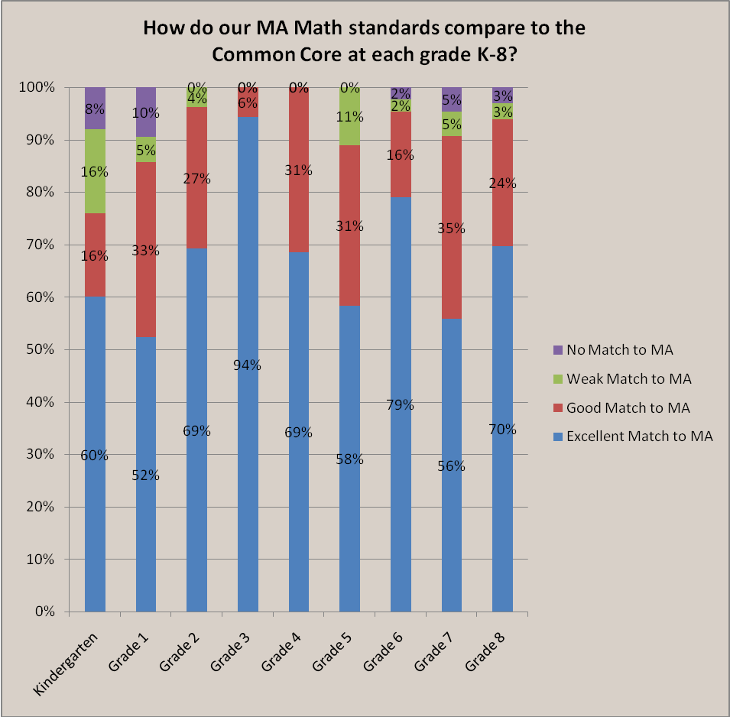

How do the MA Working Draft standards compare to the CCSS at the secondary level?
The fact that the high school standards are presented differently in the two documents made comparisons challenging. The CCSS conceptual categories (CCSS: Number and Quantity, Algebra, Functions, Modeling, Geometry, and Statistics and Probability) contain the same high school topics as the MA Working Draft strands (Number Sense and Operations; Algebra, Relations and Functions; Geometry; Measurement; and Data Analysis and Statistics). However, after completing the matching process and evaluating the matched and unmatched standards the team concluded that the CCSS high school standards are not only more specific in some areas, but also include additional subtopics that are not included in the MA Working Draft standards.

Figure 6
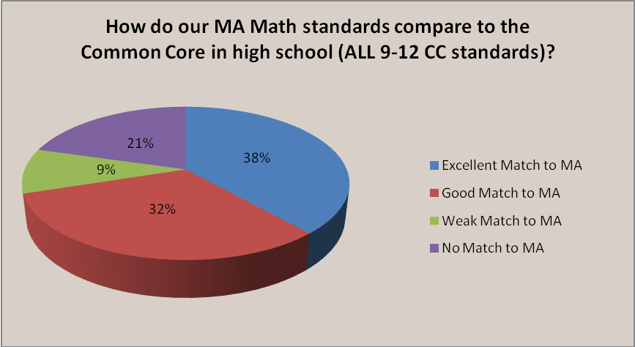

Table 13 indicates the number of excellent, good, weak, and no matches in the high school standards. Table 14 summarizes the characteristics of the high school Common Core standards not matched to the MA Working Draft.

Table 13: Degree of Match for High School
Grade | Total # of CCSS standards | # of Excellent Matches | # of  Good Matches | # of Weak Matches | # of  No Match
Grade 9–12 | 190 | 73 | 60 | 18 | 39
9–12 “college and career ready” | 135 | 64 | 41 | 14 | 16
9–12 “+” standards | 55 | 9 | 19 | 4 | 23

Table 14: Summary of Unmatched CCSS High School Standards
CCSS Conceptual Category | Topic | Unmatched content
Number and Quantity | Complex Numbers | Operations on the complex plane; Comparing the complex number system to other number systems
Number and Quantity | Vectors | Operations with vectors on the coordinate plane; representing modeling with vector quantities
Number and Quantity | Matrices | Operations on matrices; relating vectors and matrices
Algebra | Polynomials and Rational expressions | Arithmetic with polynomials and rational expressions
Functions | Linear and Exponential | Comparing functions
Statistics and Probability | Probability | Importance of sample space; independence and conditional probability; making decisions with probability

The following is an example of an unmatched CCSS high school standard. The MA Working Draft standards do not address the comparison and modeling of linear and exponential functions and do not expect students to prove that these functions grow differently over the same interval.

Table 15: Unmatched Common Core Standards at the High School Level
Functions: Linear and Exponential Functions; grades 9–12
CC.9-12.F.LE.1 Construct and compare linear, quadratic, and exponential models and solve problems. Distinguish between situations that can be modeled with linear functions and with exponential functions.*
CC.9-12.F.LE.1a Prove that linear functions grow by equal differences over equal intervals and that exponential functions grow by equal factors over equal intervals.*

The following MA Working Draft standard requires the use of the Pythagorean Theorem to derive the formula for the absolute value of a complex number and the CCSS does not.

Table 16: Unmatched MA Working Draft Standard at the High School Level
Geometry; grades 9–10
MA.12.G.2 Use the Pythagorean Theorem to derive the formula for finding the absolute value of a complex number.

Conclusions
The specificity of the Common Core’s presentation of the arithmetic and pre-algebraic concepts and skills is a key feature. The Common Core State Standards present topics such as place value, fractions, proportionality and linearity in greater detail than the draft Massachusetts standards, and includes more precise mathematical terminology and explanations. In many cases there were more standards in each of these topics in the CCSS than in the MA Working Draft. The percentage of Common Core standards presented before or after MA Working Draft standards varied by grade. At each grade level, K–6, the majority of matched standards were presented at the same grade level in the CCSS as in the MA Working Draft standards (ranging from 51%–73%). Grade 5 had the highest percentage of matched standards (73%) at the same grade level.

Both documents provide a strong foundation for arithmetic computation and preparation for algebra, although the pacing differs. For example, MA Working Draft K–6 standards show a pattern of introducing aspects of arithmetic computation earlier and expecting mastery somewhat earlier than in the CCSS. There are exceptions to this pattern, however. In the CCSS some concepts and skills such as the division of fractions and in later grades topics in statistics are introduced earlier and expected to be mastered earlier than they are in the MA Working Draft standards. The comparison study showed that both the CCSS and the MA Working Draft lead students to similar levels of understanding by the end of grade 5 and again by the end of grade 8. The analysis also revealed that there are differences in the pacing of the standards, most notably in grade 7. For example, the MA Working Draft presents the concepts of proportionality and linearity in grades 5–7, earlier than the CCSS. The CCSS develops the concept of proportional reasoning through a series of detailed standards in grades 6–8.

Overall the analysis shows that there is a high degree of consistency between the two documents.

Common Core State Standards for Mathematics page 6
Note: the grade 8 CCSS standard begins by stating the cluster heading (in italics) followed by the specific standard.
Common Core State Standards p.57
Note: CCSS standard begins with the cluster heading (in italics), followed by the specific standard.

