CHELSEA PUBLIC SCHOOLS:
Building a professional learning system for all

Mary M. Bourque, Ed.D.
Superintendent
December 12, 2018

The Chelsea Public Schools has a student population of approximately 6500 students.
- 87% Hispanic
- 83% First Language Not English
- 40% Limited English Proficient (the highest student percentage of any school district in the State)
- Of the 40%,--37% have been in the country less than three years (federal SIMS definition of immigrant)
- 70% students of poverty (we believe it is closer to 86%)
- 81% High Needs

For Chelsea, deep transformational change began around our vision of building a professional learning system vertically and horizontally, grade to grade, school to school across the district. Our lever to begin this work was the intentional support each educator would receive to be the best they can be on behalf of student learning.
In the early years, we first identified three strategies to focus on 1) Align our curriculum to the revised Massachusetts State Standards released during the RTTT years; 2) Build Professional Learning Communities to support a culture shift from a status mindset to a growth mindset and where high level professional and collegial conversations around the new Massachusetts Standards and student performance could take place; and finally, 3) use the Educator Evaluation system to provide consistent and coherent feedback to educators in a growth mindset toward improved instruction for students.
As early as 2012 we knew our educator evaluation system was not moving us toward the more specific and pedagogical conversations needed to promote a growth mindset as professionals. As a school district our work was premised on the belief that we are not in the business of perfection, but we are in the business of eternal revision, refinement, and improvement of ourselves as professionals on behalf of our students. Ultimately, this is also the mindset shift we want to trickle down to students -- there is always another chance, another test or quiz, another chance at revision, don’t give up.

Another key piece in this work was the relationship building that was essential among all educators and across authority lines. By 2015 we realized we were struggling with alignment classroom to classroom, school to school, and observer to observer --- the pervasive question kept coming up --what constitutes good instruction? Despite shared professional development, without focused conversations about alignment and shared goals, we were not in synch. The lack of calibration impacted relationships and trust as well as our growth.
In 2016 and 2017 we expanded professional development, training and began a certification process for classroom observation; we included instructional coaches and department lead teachers alongside administrators in most schools; our vision is to expand this model to all schools. In 2017-2018 we completed 425 observations together in each of the three rounds for a total of 1,275 twenty-minute observations. The coherent observation data that now is part of who we are as educators helps inform individual educator practice as aligned to the teacher rubric but also allows us to look at patterns and trends across the school district and identify needs on behalf of teachers and administrators.
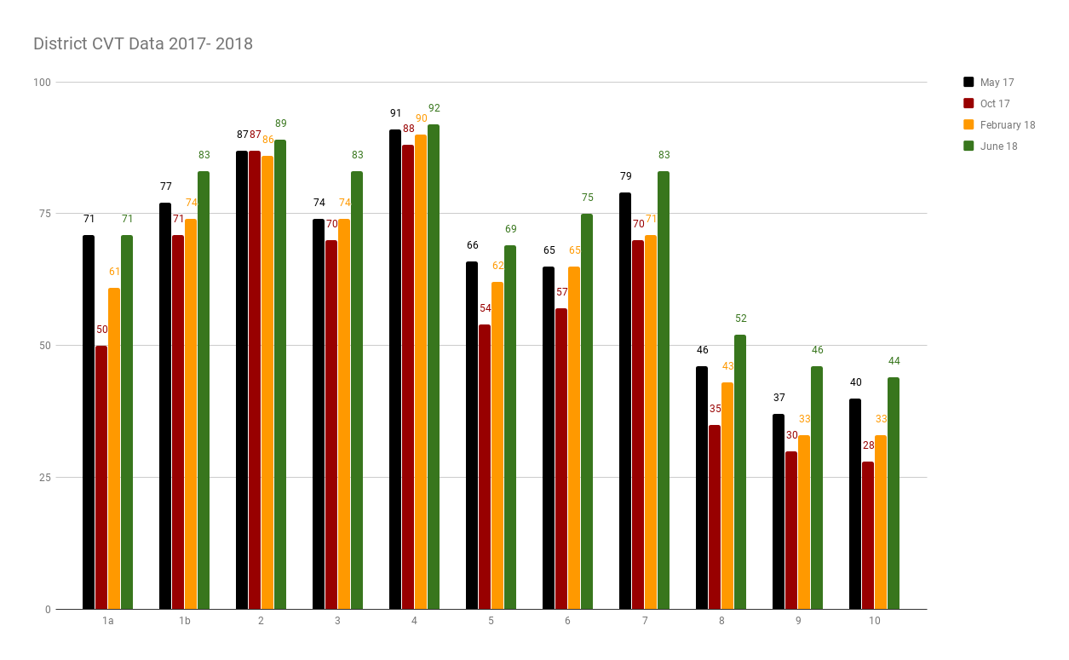

In Chelsea, we know that building a professional learning system is really deeply holistic and multifaceted work that it takes time—it needs to evolve layer by layer, year after year to be transformational and to have cultural “stick-” our cultural stick is known as the "Chelsea Way." It starts with a collective vision, but most of all it takes collective belief. Belief in ourselves that we are professionals and belief that our work matters for our students and their futures.
We continue to work at all of this, together.

