Helen Y. Davis Leadership Academy Charter Public School
Summary of Review
Boston, MA
February 2018
Massachusetts Department of Elementary and Secondary Education
75 Pleasant Street, Malden, MA 02148-4906
Phone 781-338-3000 TTY: N.E.T. Relay 800-439-2370
www.doe.mass.edu

This document was prepared by the
Massachusetts Department of Elementary and Secondary Education
Jeff Wulfson
Acting Commissioner

The Massachusetts Department of Elementary and Secondary Education, an affirmative action employer, is committed to ensuring that all of its programs and facilities are accessible to all members of the public.
We do not discriminate on the basis of age, color, disability, national origin, race, religion, sex, gender identity, or sexual orientation.
Inquiries regarding the Department’s compliance with Title IX and other civil rights laws may be directed to the
Human Resources Director, 75 Pleasant St., Malden, MA 02148-4906. Phone: 781-338-6105.

© 2017 Massachusetts Department of Elementary and Secondary Education
Permission is hereby granted to copy any or all parts of this document for non-commercial educational purposes. Please credit the “Massachusetts Department of Elementary and Secondary Education.”

This document printed on recycled paper

Massachusetts Department of Elementary and Secondary Education
75 Pleasant Street, Malden, MA 02148-4906
Phone 781-338-3000 TTY: N.E.T. Relay 800-439-2370
www.doe.mass.edu

Table of Contents

I. Introduction 1
II. Executive Summary of Charter School Performance 1
III. School History 4
IV. Areas of Accountability 5
A. Faithfulness to Charter 5
B. Academic Program 13
C. Organizational Viability 16
Appendix A: Accountability Plan Objectives and Measures (Criterion 1: Mission and Key Design Elements) 19
Appendix B: CHART (Criterion 2: Access and Equity) 20
Appendix C: Academic Data (Criterion 5: Student Performance) 27
Appendix D: Financial Dashboard (Criterion 10: Finance) 33
Helen Y. Davis Leadership Academy Charter Public School Response to Summary of Review and Attachments 36

I. Introduction
The charter school regulations state that “the decision by the Board [of Elementary and Secondary Education] to renew a charter shall be based upon the presentation of affirmative evidence regarding the faithfulness of the school to the terms of its charter, including the extent to which the school has followed its recruitment and retention plan and has disseminated best practices in accordance with M.G.L. c. 71, § 89(dd); the success of the school's academic program; and the viability of the school as an organization” 603 CMR 1.11(2). Consistent with the regulations, recommendations regarding renewal are based upon the Department of Elementary and Secondary Education’s (Department) evaluation of the school’s performance in these areas. In its review, the Department has considered both the school’s absolute performance at the time of the application for renewal and the progress the school has made during the first four years of its charter. Performance is evaluated against both the Massachusetts Charter School Performance Criteria and the school’s accountability plan. The evaluation of the school has included a review of various sources of evidence.
The following sections present a high-level summary from various sources regarding the school’s progress and success in fulfilling the terms of its charter, raising student achievement, and establishing a viable organization over the past charter term. Specific details about each criterion have been well-documented in the sources listed below.

II. Executive Summary of Charter School Performance

Helen Y. Davis Leadership Academy Charter Public School (DLA)
Type of Charter  (Commonwealth or Horace Mann) | Commonwealth | Location | Boston, MA
Regional or Non-Regional | Non-Regional | Districts in Region  (if applicable) | N/A
Year Opened | 2003 | Year(s) Renewed  (if applicable) | 2008, 2013
Maximum Enrollment | 216 | Current Enrollment | 214
Chartered Grade Span | 6-8 | Current Grade Span | 6-8
Students on Waitlist | 210 | Current Age of School | 15 years
Mission Statement

Our school develops high-achieving students of good character who use problem solving, communication, and interpersonal skills to inspire others and to catalyze educational, economic, and political advancement within their communities and the broader nation.

Demographic Data 2016-2017
 | Enrollment by Race/Ethnicity
 |  | Number of Students | Percentage of Student Body
 | African-American | 173 | 80%
 | Asian | 1 | 0%
 | Hispanic | 38 | 18%
 | Native American | 1 | 0%
 | White | 0 | 0%
 | Native Hawaiian, Pacific Islander | 4 | 2%
 | Multi-Race, Non Hispanic | 0 | 0%
 | Selected Populations
 |  | Number of Students | Percentage of Student Body
 | First Language not English | 38 | 18%
 | English Language Learner | 27 | 12%
 | Students with Disabilities | 60 | 28%
 | High Needs | 154 | 71%
 | Economically Disadvantaged | 113 | 52%

Helen Y. Davis Leadership Academy Charter Public School (DLA)
● Exceeds |  | The school fully and consistently meets the criterion and is a potential exemplar in this area.
● Meets |  | The school substantially meets the criterion and/or minor concern(s) are noted.
● Partially Meets |  | The school meets some aspects of the criterion but not others and/or moderate concern(s) are noted.
● Falls Far Below |  | The school falls far below the criterion and/or significant concern(s) are noted.
Massachusetts Charter School Performance Criteria |  |  | Rating
Faithfulness to Charter | - Mission and Key Design Elements: The school is faithful to its mission, implements the key design elements outlined in its charter, and substantially meets its accountability plan goals. |  | ● Meets
 | - Access and Equity: The school ensures access and equity for all students eligible to attend the school. |  | ● Partially Meets
 | - Compliance: The school is in compliance with the terms of its charter and applicable state and federal laws and regulations. |  | N/A
 | - Dissemination: The school provides innovative models for replication and best practices to other public schools in the district where the charter school is located. |  | ● Meets
Academic Program Success | - Student Performance: The school consistently meets state student performance standards as defined by the statewide accountability system. |  | Level: N/A  Percentile: N/A
Organizational Viability | - Governance: Members of the board of trustees act as public agents authorized by the state and provide competent and appropriate governance to ensure the success and sustainability of the school. |  | ● Falls Far Below

III. School History

Helen Y. Davis Leadership Academy (DLA) Charter Public School received its charter in 2003 and opened in Fall 2003, serving 78 students in grade 6. The school expanded by one grade level during the next two years and served its full grade span (6-8) during the 2005-06 school year. The school currently has 214 students enrolled, with 249 students on the waitlist.

In 2013, the school was granted renewal with a set of three conditions related to governance. During the 2013-14 school year, after submitting monthly board minutes, conducting a board self-evaluation, undergoing governance training, and a site visit conducted by the Department, the school was found to have met the conditions. The Commissioner released the school from conditions in January 2014.

The school was formerly known as Smith Leadership Academy Charter Public School, but requested, and was granted, a name change amendment that took effect during the 2014-15 school year. The school has operated as Helen Y. Davis Leadership Academy Charter Public School since the summer of 2014. In 2014, the school sought to regionalize, increase its maximum enrollment, and begin serving grades K-12; this amendment request was not approved. The school sought to increase its maximum enrollment and its grade span to add grade 5 and a high school in 2015, but the amendment request was not approved. The school has made amendments to its enrollment policy and expulsion policy during the charter term.

In 2012 and 2013, based on academic results from the statewide assessment, DLA was commended for high progress and narrowing proficiency gaps.

The school’s long-serving executive director, who was also the school’s founding principal, retired in summer 2017. The retired executive director continues to work for the school as a consultant. DLA hired an interim executive director before the retirement of the executive director. Subsequently, the school hired a different individual for that role. DLA is currently led by an interim executive director (in his ninth year of employment at the school) who reports to the board of trustees. The school’s director of teaching and learning resigned in August 2017. The administrative team, overseen by the acting interim executive director, includes the director of teaching and learning (a former DLA teacher), dean of student affairs, dean of student support, and the business manager. The director of teaching and learning oversees teachers, the English language learner (ELL) coordinator, and the special education coordinator.

In July 2017, DLA staff and administrators shared concerns with the Department regarding the school’s use and oversight of public funds. Due to the nature of the information shared, the Department referred the matter to the Massachusetts Office of the State Auditor (OSA) and the Massachusetts Office of the Inspector General (OIG). The Department met with representatives from the OSA and the OIG to discuss the concerns. The OSA is presently engaged in a review of DLA that will evaluate the extent that the school’s board and management provide proper governance and administration of financial activities to protect public funds and best serve the students. Fieldwork for this review is presently scheduled through March 2018 and subsequently, a report will be issued. Additional information about facts that led to the OSA’s review is described below, in Criterion 9: Governance.

IV. Areas of Accountability

A. Faithfulness to Charter
Criterion 1: Mission and Key Design Elements
The school is faithful to its mission, implements the key design elements outlined in its charter, and substantially meets its accountability plan goals.
(Please refer to Appendix A for the school’s accountability plan.)
Finding: Throughout the charter term, DLA has operated in a manner that is faithful to its charter. The school has structures to support its mission and key design elements. Stakeholders have generally shared a common and consistent understanding of the school’s mission and key design elements.  Throughout the charter term, site visitors found that while stakeholders have not consistently reported on each aspect of Helen Y. Davis Leadership Academy Charter Public School’s (DLA) mission, the school has operated in a manner that is consistent with its charter. DLA’s mission states:  Our school develops high-achieving students of good character who use problem solving, communication, and interpersonal skills to inspire others and to catalyze educational, economic, and political advancement within their communities and the broader nation.  In Year 13, stakeholders reported that the school’s mission was to foster high achieving students of good character and noted themes of academic success, leadership, a culturally relevant school community, and community service. In Year 15, stakeholders reported that the school’s mission is to develop high-achieving students who will impact their communities and the broader nation and noted that the mission also includes character development. Site visitors reported that only some stakeholders identified problem-solving, communication, and interpersonal skills as elements of the mission; and also reported that stakeholders identified elements not explicitly documented in the mission, such as college-and-career-readiness and teaching the whole child.  A review of the school’s 2017 Next Generation MCAS assessment results, as well as performance on the Legacy MCAS during the charter term, indicate that student performance in English language arts, mathematics, and science is well below statewide averages. Please see Criterion 5: Academic Performance for detailed academic performance throughout the charter term.  In Year 15, stakeholders reported the following key design elements: modes of instruction; differentiation; service learning program; | Rating:  Meets
Sources:
- Renewal Inspection Report (2017)
- Renewal Application (2017)
- Year 13 Check-in Site Visit Report (2015)
- Annual Reports (2014-2017)
- Summary of Review (2013)

developing leadership skills; extended time in learning and professional development; counseling; and culture and heritage. Site visitors reported that the key design elements as described in the application for renewal and during the renewal inspection remain faithful to the original charter and generally align to what was described in Year 13. Evidence of the implementation of the mission and key design elements are detailed below.

Modes of instruction
DLA implements various modes of instruction to meet the needs of students. In Year 15, stakeholders reported and a review of the 2016-2017 annual report confirms that teachers are expected to implement a range of instructional modes such as: cooperative group learning, Socratic seminar, interdisciplinary instruction, direct instruction, and reported that teachers incorporate project-based and experiential learning into instruction. The renewal inspection team observed an instance of Socratic seminar. The school’s accountability plan includes a measure related to students’ participation in Socratic seminars, debates, or STEM/current events Projects that utilize problem-solving and interpersonal skills. The school met this measure each year of the school’s charter term with the exception of 2016-17.

Differentiation
Stakeholders reported that DLA utilizes student performance data to differentiate instruction to meet the needs of all learners. In Year 10, stakeholders reported the use of response to intervention (RTI) to inform instruction and to improve the school’s academic program. In Years 13 and 15, stakeholders reported the development of RTI blocks to provide data-based interventions to students in English language arts and mathematics. In Year 15, stakeholders reported that differentiated instructional strategies include: reference sheets, glossaries, guided notes, extra time, assistive technology, strategic seating, and student choice. During classroom observations in Year 15, site visitors observed a variety of supports for students such as: instruction adapted to support and challenge all learners; co-teaching; word walls; a black board configuration; sentence starters; vocabulary definitions; and graphic organizers.

Service learning program
Throughout the charter term, stakeholders reported and a review of annual reports confirms that DLA requires all students to complete community service, community initiatives, and/or service projects. A review of the school’s 2017 application for charter renewal states that the goal of the service learning program is to, “connect students to DLA’s Core Values of leadership, personal excellence, respect, intellectual curiosity, integrity, compassion, and community citizenship through meaningful and concrete experiences at Davis Leadership Academy and through partnerships with community organizations.” Throughout the charter term, stakeholders have reported projects such as: fundraisers to provide supplies to impoverished schools in Africa; participation in Lupus and Breast Cancer walks; student participation in a fair housing protest; mentoring elementary school students; supporting urban farming; visiting nursing homes; volunteering in shelters; organizing canned food drives; and collecting and distributing blankets for the elderly and less fortunate. In Year 15, stakeholders also reported that some students participated in international service learning trips.

Developing leadership skills
DLA provides opportunities for all students to develop leadership skills. In Years 13 stakeholders reported that students practice leadership skills during class debates, community circle, and through the Rites of Passages programming (programming developed to support the self-confidence and self-esteem of students of color). In Year 15, stakeholders reported that in addition to opportunities listed above, students also have the opportunity to serve on the student council, homecoming committee, and submit proposals through their ethics to effect change in their communities.
Extended time in learning and professional development
In Year 13, site visitors reported that the school implements an extended day (8 hours) four days per week and half day (once per week) for all students. They further reported that the school implements an extended year (191-days) for students in grades 6 and 7, and noted that students in grade 8 attend for 180-days as required by regulations. A review of the school’s 2017 application for charter renewal and 2016-2017 annual report indicates that the school continues to implement an extended day and year model.

In Year 13 site visitors reported that while the school offered a twice monthly Saturday school described as mandatory, stakeholders noted that less than half of all required students actually attend the half-day Saturday school due to other obligations or religious observances. In Year 15, stakeholders reported that the school continues to offer Saturday tutoring for students in need, but did not describe the support as mandatory.

Throughout the charter term, stakeholders have reported that teachers and staff participate in weekly professional development sessions and noted that the weekly professional development is scheduled on the half days. Stakeholders reported that weekly professional development includes grade-level and content-area meetings that allow teachers to collaborate, review student progress, analyze assessment data, and make instructional decisions.

Counseling
In Year 15, site visitors reported that DLA offers boys and girls groups to help students develop social skills and support students with specific social-emotional needs and transitions. Stakeholders reported that the data collected through the school’s administration of the Partnerships in Education and Resilience’s (PEAR) Holistic Student Assessment (HSA) allows the school to monitor the social-emotional development and growth of students. A review of the school’s 2017 application for charter renewal notes that the school partners with external agencies to provide counseling support for students as needed.

Culture and heritage
Throughout the charter term, DLA continued to embed a cultural approach to its academic program as a way to validate students’ cultures and heritages. In Years 13 and 15, site visitors observed posters throughout the school in recognition and celebration of African-American culture. In Year 13, site visitors reported that many of the school’s “rituals” allow students to learn about and reflect upon cultural identity, such as the “Blacks in wax” project, African American History Month celebrations, and Rites of Passage programming. Stakeholders, including parents, reported that the school created a familial environment that reflected, embraced, and celebrated their culture. Additionally, site visitors reported that DLA employed one of the highest percentages of African-American staff in Massachusetts. In Year 15, site visitors reported on the school’s use of Swahili call-and-response and the delivery of content that focuses on African Americans, Caribbean Americans, and individuals of Latin decent.

Finding: DLA met a majority of the measures in its accountability plan.

DLA’s approved accountability plan includes 3 objectives and 5 related measures. DLA met 3 out of 5 measures. DLA met measures related to annual percentage of students accepted and/or enrolled in high performing area high schools; annual percentage of students that received a passing grade on three oral exhibitions; and percentage of students that completed community advocacy projects. DLA did not meet measures related to the annual percentage of students that completed ten Socratic seminars, debates, or STEM/current event projects, and the percentage of students that successfully performed thirty hours of community service over the course of three years. Please see Appendix A for full details.

Criterion 2: Access and Equity
The school ensures access and equity for all students eligible to attend the school.
(Please refer to Appendix B for demographic and attrition data.)
Finding: DLA has an approved Recruitment and Retention Plan. Over the course of its charter term, the school’s attrition rate for all students has varied, and in 2017 is above the rate of comparison schools. DLA continues to make efforts to enroll a student demographic that is comparable to comparison schools.  DLA has received approval from the Department for its Recruitment and Retention plan every year over the course of the charter term.  DLA experienced varied attrition rates over the course of the charter term for all students and was above the third quartile in 2013; attrition remains above the third quartile for all students in 2017. The variation in rates of attrition is similar for the English learner, students with disabilities, low income, and the high needs subgroups. Attrition rates for all subgroups remain above the third quartile in 2017. Stability rates for all subgroups; including all students and high needs subgroups have remained high, though variable, during the charter term, with rates fluctuating above and below the first quartile or median.  DLA has made efforts to enroll a student population that is demographically comparable to comparison schools. Over the course of the charter term, DLA enrolled students in the low income and students with disabilities (with the exception of 2015) subgroups above the comparison index. The school met its gap narrowing targets for the English learners subgroup (with the exception of 2013) over the course of the charter term. Please see the data in Appendix B for more information about enrollment, attrition, and stability rates.  Finding: DLA continues to work towards eliminating barriers to program access. The school’s website and community handbook includes information related to its special education and English learner programming and services.  DLA translates a variety of documents for families whose first language is not English including its enrollment application, enrollment materials and parent notification letters. The school’s website and community handbook includes information related to special education and English learner programming and services.  Finding: DLA’s in-school suspension rate is below the statewide average of 1.9 percent; the school’s out-of school suspension rate is above the statewide average of 2.9 percent. The school’s in-and-out of school suspension rates vary by subgroup.  In 2015-16, DLA had an in school suspension rate of 1.3 percent for all students. The following subgroups had higher rates of in-school suspension: economically disadvantaged (2.1 percent), students with disabilities (3.6 percent), high needs (1.7 percent), female (2.7 percent), and African American/Black students (1.6 percent). Additionally, in 2015-16, DLA had an out-of school suspension rate of 11.4 percent for all students. The following subgroups had higher rates of out-of school suspension: students with disabilities (14.3 percent), high needs (11.5 percent), male (14.6 percent), and African American/Black (12.0 percent). Please see here for more details as well as historical data from 2012-13 to 2015-16: http://profiles.doe.mass.edu/ssdr/default.aspx?orgcode=04190000&orgtypecode=5&=04190000& | Rating: Partially Meets
Sources:
- ESE Charter Analysis and Review Tool (CHART)
- DLA Translated Documents
- DLA Recruitment Materials
- DLA Handbooks
- Annual Reports and Recruitment and Retention Plans (2014-17)

Criterion 3: Compliance
The school is in compliance with the terms of its charter and applicable state and federal laws and regulations.
Finding: The school is out of compliance with state and federal regulations regarding teacher licensure.  Per state regulations (603 CMR 1.06 (4)), all teachers beyond their first year of employment must have taken and passed the Massachusetts Test for Educator Licensure (MTEL). As of the renewal inspection, three teachers beyond year one of employment have not passed the required MTELs. Additionally, one of the three teachers’ pending licenses does not reflect the current teaching assignment.  Of the five staff assigned to special education support, three are qualified to independently deliver services. The school reports that supervision of non-qualified staff is provided by a qualified special education administrator and this supervision is documented on IEPs.  Similar to what the site visit team found in 2015, the school nurse is not licensed as required, but the degree is pending. Schools must appoint one or more school physicians and registered nurses and provide students with access to at least one physician and one registered nurse. Charter schools may meet this requirement in various ways, including hiring a part-time physician or sharing a physician with other charter schools or with the public school system in their community. School physicians must be a doctor of medicine or hold a license of osteopathy, while school nurses must be currently licensed as a registered nurse” M.G.L. c. 71 Section 53.  Finding: The school is in compliance with program requirements as measured by the Coordinated Program Review (CPR).  The school last received a CPR visit from the Office Public School Monitoring in December 2016. The school had seven findings in special education, eight findings for civil rights, and two findings for English Learner Education. DLA completed and submitted its required progress report on December 5, 2017. | N/A
Sources:
- DLA Teacher Roster
- DLA Name Nonteaching Staff
- 2016 Coordinated Program Review

Criterion 4: Dissemination
The school provides innovative models for replication and best practices to other public schools in the district where the charter school is located.
Finding: Over the course of the charter term, DLA has completed various dissemination activities.  Administrators, the school’s renewal application, and charter term annual reports confirm that DLA has completed dissemination activities over the course of the charter term. Dissemination activities throughout the charter term included but were not limited to:  - DLA participated in Boston Education Action Network’s panel discussion with teachers, parents, and school leaders to discuss building equity within schools. Participants shared best practices related to the recruitment and retention of staff of color; developing social and emotional supports for students; and Boston’s housing crisis.  - DLA participated in a workshop with the Coalition of Schools Educating Boys of Color related to the development of a rubric to assess schools culturally responsive environments for male students of color.  - DLA participated in a panel discussion with UMASS Boston and the Collaborative Parent Leadership Action Network focused on how schools can redesign school culture to better reflect an understanding of the students they teach. | Rating:  Meets
Sources:
- Renewal Application (2017)
- School’s Website
- Annual Reports (2014-17)
- Interview with Executive Director

B. Academic Program

Criterion 5: Student Performance
The school consistently meets state student performance standards as defined by the statewide accountability system.
(Please refer to Appendix C for academic data.)
Level: N/A  Percentile: N/A | Sources:  ESE Website

Finding: Over the course of the charter term DLA has not consistently met state student performance standards for academic growth and proficiency.

2017 Assessment Results (Next Generation MCAS)

In 2017, the Next Generation MCAS was administered statewide for the first time. As such, a majority of schools did not receive Accountability Levels.

In 2017, in grades 6 through 8, 34 percent of students met or exceeded expectations on the Next Generation MCAS assessment in English Language Arts, below the state average of 49 percent. In mathematics in grades 6 through 8, 19 percent of students met or exceeded expectations on the Next Generation MCAS assessment, below the state average of 48 percent.

2017 Assessment Results (Legacy MCAS)

In 2017, DLA administered the legacy MCAS in science and technology/engineering for grade 8. In science and technology/engineering, 6 percent of students earned proficient or advanced on the legacy MCAS assessment, below the state average.

2014-2016 Assessment Results (MCAS)

Level and Percentile

From 2014 to 2015, the school was in Level 1. In 2016, the school was in Level 2 due to not meeting gap narrowing targets, low assessment participation rates, and a focus on English learners and former English learners. From 2014 to 2016, the school has performed at the following percentiles: 35th in 2014, 36th in 2015, and 25th in 2016. Please refer to Appendix C for detailed student academic performance data over the charter term.

Cumulative Progress and Performance Index (PPI)

From 2014 to 2016 the school had a Cumulative Progress and Performance Index (PPI) of 80, 81, and 56 for all students. In 2016, the school did not meet proficiency gap narrowing targets for English language arts (ELA), mathematics, and science and technology/engineering. From 2014 to 2016 the school had a PPI of 83, 77, and 53 for the high needs subgroup. Further, in 2016 the school did not meet targets for narrowing proficiency gaps for students with disabilities, African American/Black, all students, and high needs subgroups.

Composite Performance Index (CPI)

DLA’s composite performance index (CPI) over the course of the charter term (2014-2016) demonstrated declines in ELA; declined in mathematics; and declined in science and technology/engineering. Over the course of the charter term, the school’s CPI for the high needs subgroup demonstrated declines in ELA; declined in mathematics; and declined in science and technology/engineering. Please see Appendix C for CPI trends over time.

Growth

The school’s historical SGP data for years 2014 through 2016 for all students and high needs students is displayed in the chart below.
DLA Median Student Growth Percentile
Year |  | 2014 | 2015 | 2016
ELA SGP | All | 58.0 | 53.5 | 42.0
 | High needs | 58.0 | 54.0 | 42.0
Math SGP | All | 63.0 | 63.0 | 47.0
 | High needs | 64.0 | 65.5 | 49.0

Criterion 6: Program Delivery
The school delivers an academic program that provides improved academic outcomes and educational success for all students.
Key Indicator: Assessment and Program Evaluation
Finding: This charter term, DLA did not conduct an annual self-evaluation of its special education program.  In Year 10, site visitors reported that subsequent to the renewal inspection the school provided the site visit team with a special education program self-evaluation that contained a thorough analysis of student outcomes, conclusions based on the analysis, and recommendations for program improvements. However, in Year 15 site visitors reported that while the school conducted a self-evaluation of its ESL program, the school had not yet conducted a self-evaluation of its special education program. | Sources:  - Summary of Review (2013)  - Renewal Inspection Report (2017)

C. Organizational Viability
Criterion 9: Governance
Members of the board of trustees act as public agents authorized by the state and provide competent and appropriate governance to ensure the success and sustainability of the school.
Finding: Throughout the charter term, the board of trustees has not consistently reflected a clear understanding of its role and responsibilities. The board has worked to improve its governance practices, but has not consistently provided competent stewardship and oversight of the school, particularly in the area of financial oversight. The board has not yet engaged in strategic planning. The board’s oversight of public funds is currently under review by the Massachusetts Office of the State Auditor (OSA).  The DLA board of trustees meets monthly. The bylaws stipulate that no fewer than seven and no more than fifteen board members may be elected to three-year terms and may not serve more than three successive terms. In Year 15, board members reported the board consists of eight members; however, a review of the board member management system indicates the board consists of eleven members. Board members also reported that one member is an alumnus of the school and a review of the school’s website indicates that the interim executive director serves as an ex-officio member of the board. The board officers include a chair, vice chair, treasurer, and secretary. The board has a committee structure and trustees reported that the four committees: governance, finance, development, and academic excellence meet monthly.  As described in the school setting section above, in 2013, DLA was renewed with a set of conditions related to governance; the conditions were subsequently removed in February 2014. However, in Year 13 (2015-16), site visitors reported that a review of board meeting minutes and board member reports indicated instances of non-compliance with Open Meeting Law and reported that the board did not enter into executive session correctly in at least seven instances during the 2014-15 academic year. In Year 15, board members reported, and a review of board meeting minutes confirms that full board meetings adhere to Open Meeting Law and all meetings are posted to the school’s website. However, the board did not submit committee minutes prior to the renewal inspection visit in Year 15. | Rating:  Falls Far Below
Sources:
- Renewal Inspection Report (2017)
- Renewal Application (2017)
- Year 13 Check-in Site Visit Report (2015)
- Year 11 Targeted Site Visit Report (2013)
- Annual Reports (2014-2017)
- Summary of Review (2013)
- Board Minutes (2015-2017
DLA Bylaws
Throughout the charter term, board members have engaged in trainings to develop an understanding of their roles and responsibilities. In Year 11, site visitors reported that the board engaged in governance trainings in the two years preceding the site visit. In Years 13 and 15, site visitors reported that the board continued to develop its understanding of its role and responsibilities with stakeholders reporting that the board’s role is to provide oversight of the school leader; oversee the financial health of the school; and academic progress while remaining a governing authority.

While the board has reported an understanding of its oversight responsibilities, board meeting minutes, site visit reports, and financial audits throughout the charter term demonstrate that the board of trustees has not consistently engaged in oversight or proper stewardship of the school. In Year 15, board members reported that the finance committee provides oversight of the school’s finances and reported that in addition to developing an annual budget, the finance committee approves monthly expenditures and brings all recommendations related to the school’s finances to the full board for a vote. As noted in the school’s fiscal year 2017 (FY17) financial audit, however, the board reported that its own decision making in FY17 had a “negative impact” on the school’s 2017 budget. This is further described below. In Year 15, stakeholders also reported that the board receives monthly updates related to the school’s academic progress from both the academic committee and school leadership and noted the board’s ongoing contractual relationship to review and analyze ANet and MCAS results twice per year with an external consultant. In Year 15, stakeholders reported that communication between the board and school leadership occurs between board meetings on an as-needed basis and noted that decision making begins at the committee level. However, in Years 11 and 13, site visitors reported varying degrees in levels of activity between committees and reported that committees did not routinely report to the full board at each meeting.

In Year 15, board members reported that it uses the Board On Track program to evaluate the interim executive director, but did not note if this program is currently used by the board to conduct self evaluations as reported in Year 13. In Years 11 and 15, site visitors reported that the board has not engaged in long-term strategic and continuous improvement planning, and did not identify specific goals aligned to the school’s mission, vision, and core values. As noted by site visitors in Year 13, trustees reported that in the past, the board focused on short-term goals and reported in Year 15 that the development committee set short-term fundraising goals. Additionally, trustees reported, and a review of a board planning document confirms that the board is in the process of hiring a consultant to support a long-term goal setting and strategic planning process.

In Year 15, the board continues to maintain a process for recruiting and selecting new members and trustees reported that the board intends to reinstate annual board retreats to support continued board development and effectiveness.

As mentioned above in the School History section, in July 2017, DLA staff and administrators shared concerns with the Department regarding financial decisions made by the school’s board of trustees. Due to referral of such concerns to other state agencies, the Massachusetts Office of the State Auditor (OSA) is presently engaged in a review of DLA that will evaluate the extent that the school’s board and management provide proper governance and administration of financial activities to protect public funds and best serve the students. One of the concerns shared with the Department in July 2017 was confirmed by DLA’s FY17 fiscal audit. As noted above, the school’s longtime executive director retired in August 2017. In June 2017, as documented in board minutes and the audit, the board voted to “buy back” the retiring executive director’s accumulated sick time. It is unclear if the decision to grant a sick time “buy back” aligned with the former executive director’s contracts. The former executive director’s contracts from FYs12-14 include the statement that “sick days may not be carried over.” The contract from FYs 15-16, which was discussed multiple times by board members during those years, is silent on the issue. DLA’s board of trustees included a statement in the FY17 audit which noted that: “In this audit, it has been made clear that the Academy [DLA] will end the fiscal year 2017 school year with a shortfall of $99,011 due to a one-time payment for unused sick time; which was part of an agreement reached during negotiations with our now retired Executive Director.” The board’s statement continues, by noting that if the board had received better advice from its consultants the sick time pay out would not have had a “negative impact on the bottom-line.” The audit confirms that DLA contained a deficit of approximately $99,011 during FY17.

Appendix A: Accountability Plan Objectives and Measures (Criterion 1: Mission and Key Design Elements)
Faithfulness to Charter
 | Charter Term Performance  (Met/Not Met) |  |  |  | Evidence
 | Year 1 | Year 2 | Year 3 | Year 4
Objective: DLA students will have the opportunity to attend the best area high schools.
Measure: Annually, 90% of DLA students  will be accepted in or enrolled in high  performing area high schools, meaning  schools that are Performance Level 1 or 2,  parochial schools, or private schools, not  including students who are moving out of the  sending district. | Met | Met | Met | Met | A review of the school’s 2014-2017 annual reports reflects the following:  2013-14: 92% of students were accepted or enrolled in high performing area high schools.  2014-15: 98% of students were accepted or enrolled in high performing area high schools.  2015-16: 96.6% of students were accepted or enrolled in high performing area high schools.  2016-17: 100% of students were accepted or enrolled in high performing area high schools.
Objective: DLA students will demonstrate strong problem-solving, communication, and interpersonal
skills.
Measure: Annually, 95% of DLA students  will complete 10 Socratic Seminars, Debates,  or STEM/Current Events Projects that utilize  problem-solving and interpersonal skills.  Completion will be measured by a rubric  developed and implemented by teachers. The  rubric will have criteria for completion (a  passing score) and for higher-level skills  demonstrated by students. | Met | Met | Met | Not Met | A review of the school’s 2014-2017 annual reports reflects the following:  2013-14: 99% of students in grades 6-8 completed 10 Socratic seminars.  2014-15: 100% of students in grades 6-8 completed 10 Socratic seminars.  2015-16: 100% of students in grades 6-8 completed 10 Socratic seminars.  2016-17: 95% of 7th and 8th grade students completed 10 Socratic seminars; 87 percent of 6th grades completed 10 Socratic seminars.
Measure: Annually, 95% of students will  prepare, present, and receive a passing grade  on three oral exhibitions graded through a  rubric for effective communication. | Met | Met | Met | Met | A review of the school’s 2014-2017 annual reports reflects the following:  2013-14:100%, 95%, and 96% of 6th, 7th, and 8th graders, respectively, completed and passed at least 3 oral exhibitions.  2014-15: 100% of students in grades 6-8 completed and passed at least 3 oral exhibitions.  2015-16: 100% of students in grades 6-8 completed and passed at least 3 oral exhibitions.  2016-17: 96%, 100%, and 97% of 6th, 7th, and 8th graders, respectively, completed and  passed at least 3 oral exhibitions.
Objective: DLA students will have a strong understanding of educational, economic, and political
influences within communities.
Measure: Over the course of their three  years at DLA, 100% of DLA students will  successfully perform 30 hours of community  service. Students will be assessed based on  hours completed. | Met | Met | Met | Not Met | A review of the school’s 2014-2017 annual reports reflects the following:  2013-14: The school reported that 2013-14 was the first year that data was collected and noted that 100% of student students were on track to meet this measure.  2014-15: 100% of grade 8 students completed at least 30 hours of community service.  2015-16: 100% of grade 8 students completed at least 30 hours of community service.  2016-17: 6th grade average of 17 hours; 7th grade average of 19 hours; 8th grade average of 10 hours.
Measure: Annually, 95% of DLA students  will complete a project focused on the  importance of advocacy in communities.  Students will be assessed through  participation and completion. | Met | Met | Met | Met | A review of the school’s 2014-2017 annual reports reflects the following:  2013-14: Between 95% and 100% of DLA students completed advocacy projects.  2014-15: 100% of DLA students completed  advocacy projects.  2015-16: 100% of DLA students completed  advocacy projects.  2016-17: 100% of DLA students completed  advocacy projects.

Appendix B: CHART (Criterion 2: Access and Equity)
All data displayed in these graphs are derived from ESE District and School Profiles (http://profiles.doe.mass.edu/).
The longitudinal demographic comparison data presented in the graphs of student enrollment is intended to provide context for the charter school’s recruitment and retention efforts. The set of displayed comparison schools includes the charter school of interest, and all of the public schools in the charter school’s region that serve at least one grade level of students which overlaps with the grade levels served by the charter school. The graphs provide comparison enrollment percentages for four different subgroups of students: low income /economically disadvantaged*, students with disabilities, English language learners, and first language not English. Each line on the graph represents the percentage of total school enrollment for a given school or set of schools during the most recent five years. If available, data listed is displayed longitudinally across multiple years in line graph form, with:
- a solid bold black line representing subgroup enrollment in the charter school of interest;
- a solid green line for the statewide average;
- a solid blue line for the comparison district average;
- a dotted orange line for the median enrollment percentage of all comparison schools;
- a dotted dark orange line for the first quartile enrollment percentage of all comparison schools;
- a dotted red line for the comparison index;
- a dotted pink line for the Gap Narrowing Target (GNT); and
- solid gray lines for enrollment percentage in each individual comparison school (darker gray for charter schools, and lighter gray for district schools).
Student attrition rates are provided for all students and for the high needs subgroup. Please note that district percentages are not included since attrition at the district-level cannot be reasonably compared to attrition at the school-level. In addition, stability rates are provided for all students and for the high needs subgroup.
Note: New statutory provisions related to Criterion 2 were established in 2010, and as specified in regulation, charter schools were first required to implement recruitment and retention plans in 2011-2012. Charter schools are required to receive Department approval for a recruitment and retention plan to be reported on and updated annually. When deciding on charter renewal, the Commissioner and the Board must consider the extent to which the school has followed its recruitment and retention plan by using deliberate, specific strategies to recruit and retain students in targeted subgroups, whether the school has enhanced its plan as necessary, and the annual attrition of students.
Though comparisons of subgroup enrollment data in a charter school to that of other public schools in a geographic area as provided in Appendix B can provide some information regarding comparability of student populations, it is presented for reference only and primarily to determine trends within the charter school itself and to guide further inquiry. The subgroup composition of a charter school is not required to be a mirror image of the schools in its sending districts and region. The Department urges caution in drawing any conclusions regarding comparability of subgroup populations between schools and districts based on aggregate statistics alone. Enrollment of students in traditional public schools differs significantly from enrollment of students in charter schools. In particular, charter schools are required by law to use a lottery process when admitting students; traditional public schools must accept all students that live within the municipality or region that they serve. Specific caution should be used for special education enrollment data, as research by Dr. Thomas Hehir (Harvard Graduate School of Education) and Associates (Review of Special Education in the Commonwealth of Massachusetts: A Synthesis Report (August 2014) found that low-income students were identified as eligible for special education services at substantially higher rates than non-low-income students. Further, across districts with similar demographic characteristics, district behavior differed for special education identification, placement, and performance. Finally, it is important to note that student demographics for a charter school, particularly in the aggregate, will not immediately reflect recruitment and retention efforts; charter school must give preference in enrollment to siblings of currently attending students and are permitted to limit the grades in which students may enter the school.
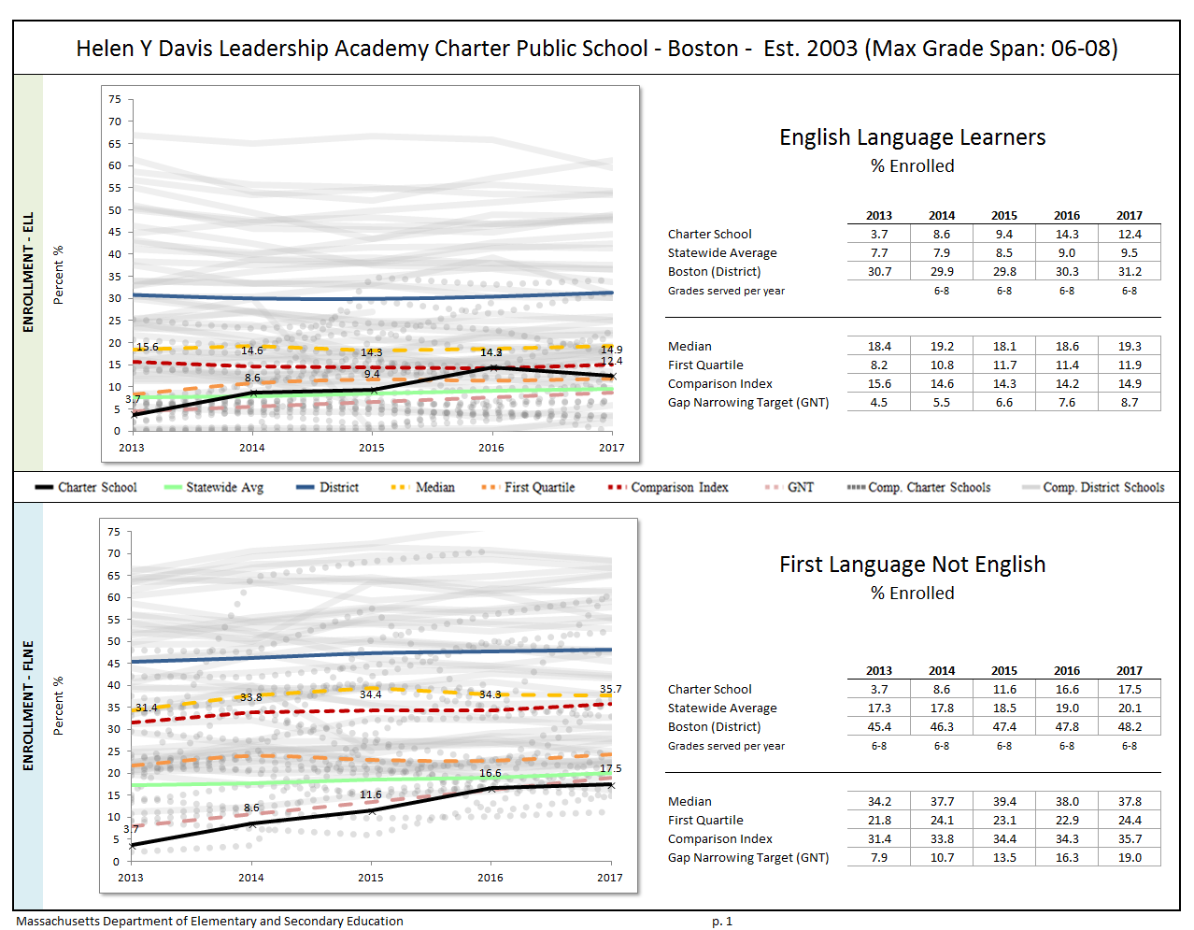
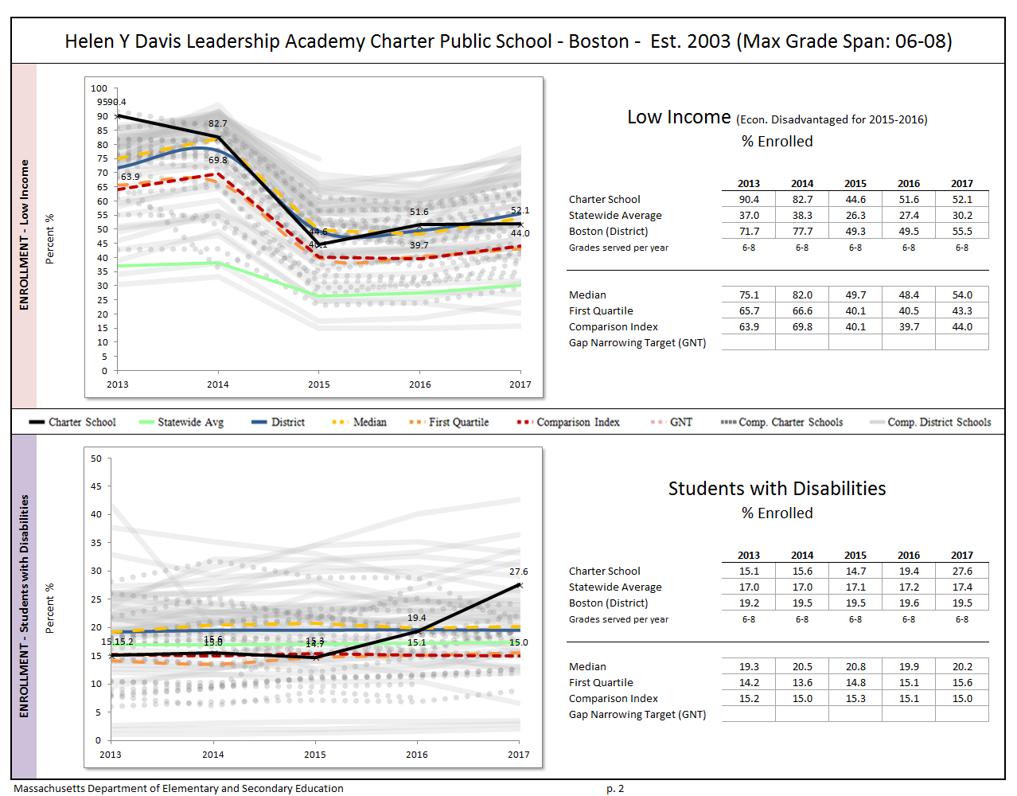
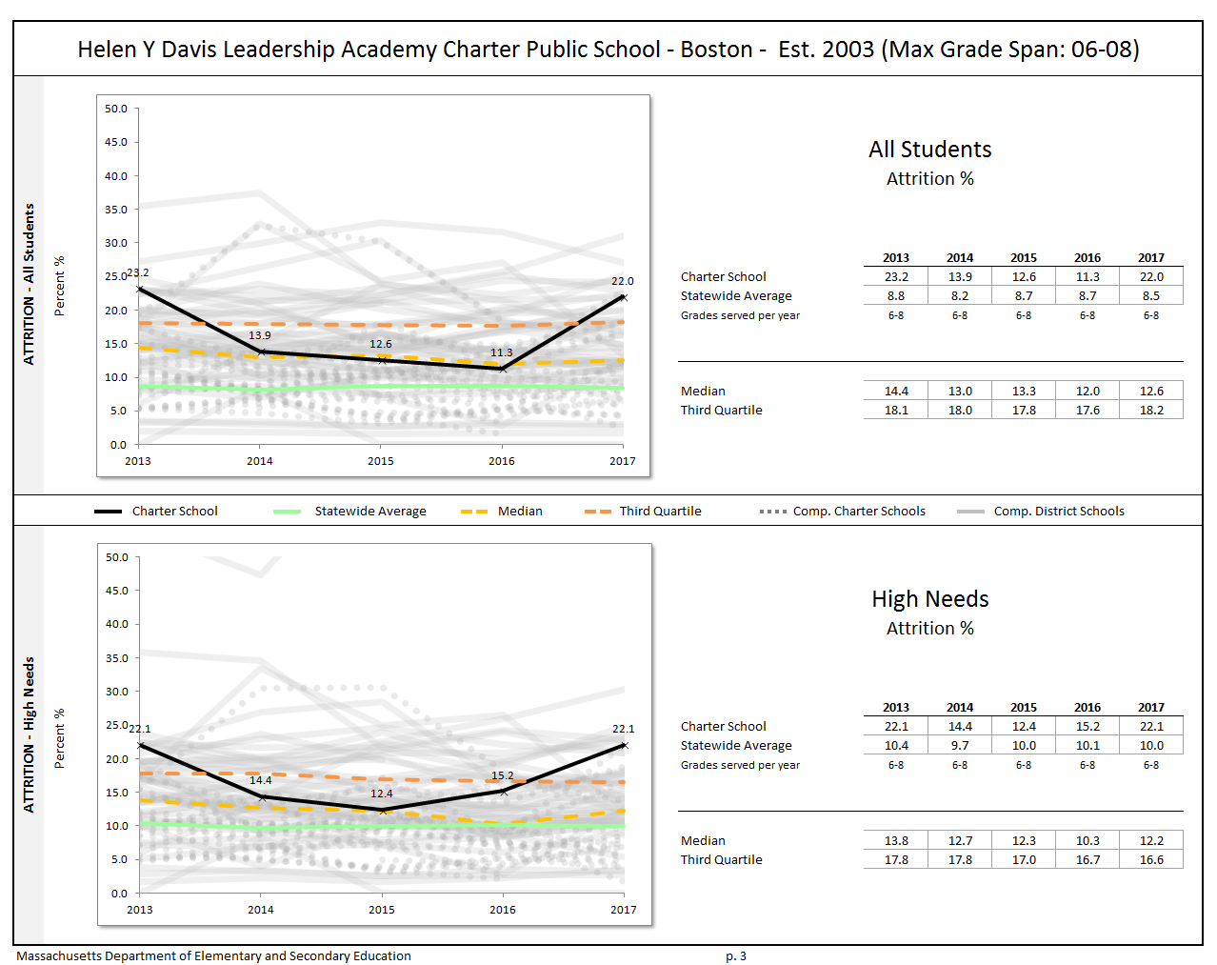
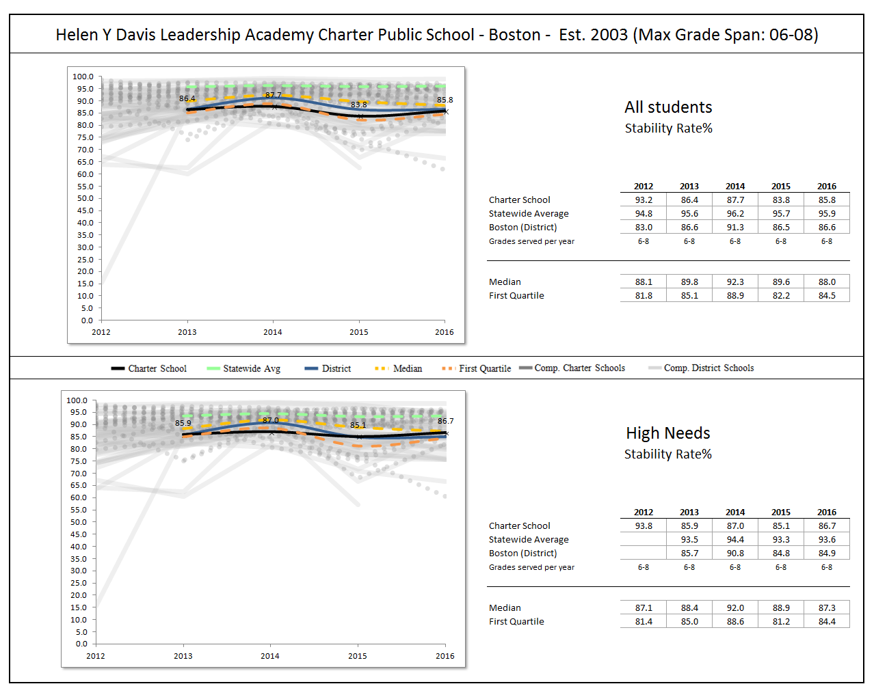

Appendix C: Academic Data (Criterion 5: Student Performance)

The charter accountability table (below) provides several sets of data relative to charter school performance on statewide assessments as well as student indicators. The percent of students scoring proficient or advanced (P/A), the composite performance index (CPI), the percent of students scoring warning or failing (W/F), and the student growth percentile (SGP) are all displayed in the aggregate over the term of the charter. For schools participating in PARCC in 2015 and 2016, the percent of students who met or exceeded expectations (Level 4 and 5) and those who did not meet expectations (Level 1) are displayed. Because these are not exact equivalents to MCAS proficient/advanced or warning/failing, these figures are not included in the graph. A Transitional Composite Performance Index (Trans. CPI) and Transitional Student Growth Percentile (Trans. SGP) generated using current PARCC and prior MCAS scores are displayed as equivalents to MCAS CPI and SGP. These figures are included in the graphs. The school’s accountability level, percentile, English Language Arts (ELA) and math percentiles for the aggregate and targeted subgroups, and cumulative progress and performance index (PPI) for the aggregate and targeted subgroups are shown if available (this depends on the size and the age of the school). When applicable, the 4-year and 5-year graduation rates as well as the annual dropout rate are also provided for the available years of the charter term. For detailed definitions of accountability terms, please visit this URL: http://profiles.doe.mass.edu/accountability/report/aboutdata.aspx#AccountabilityInformation.

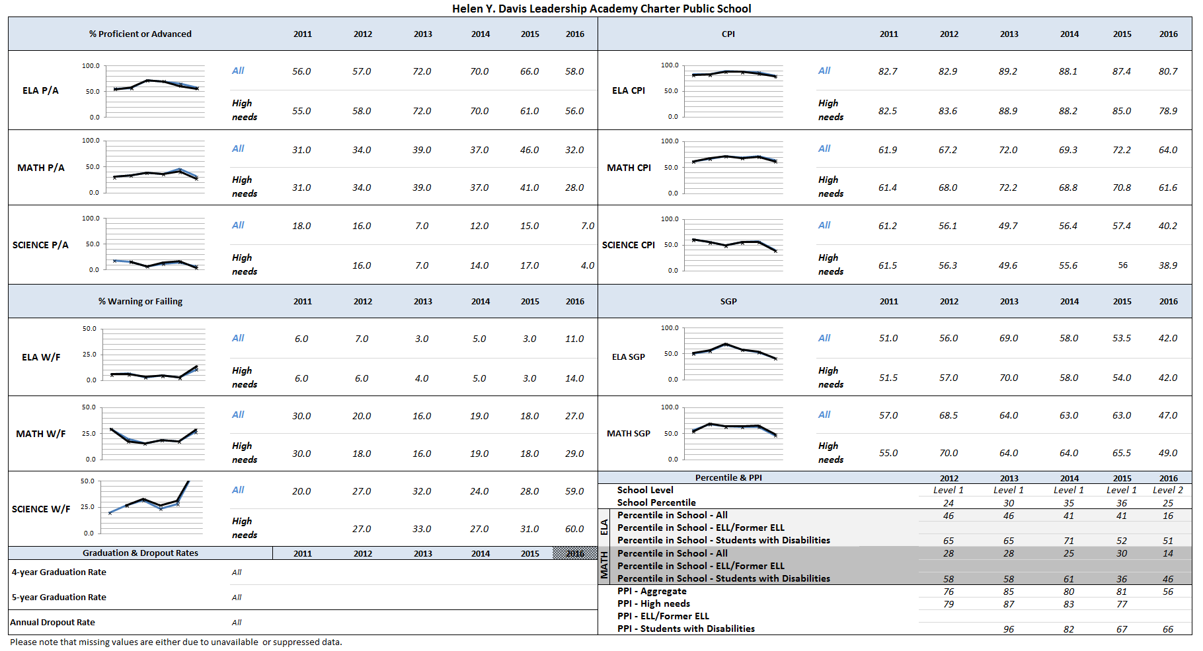

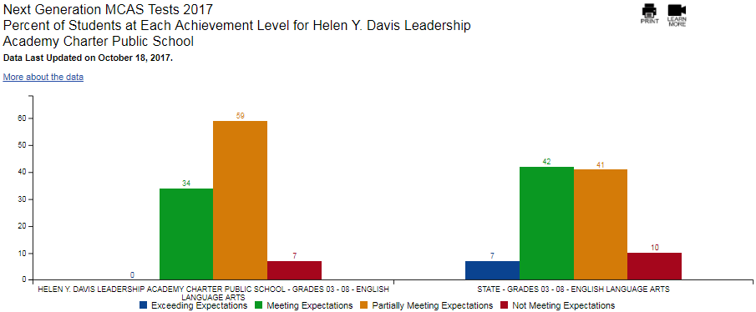

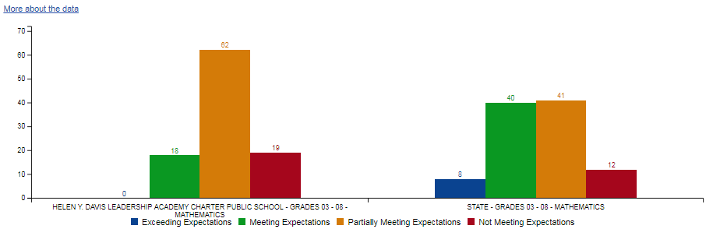
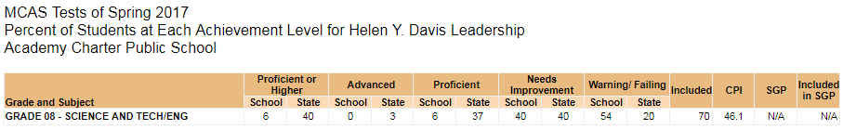
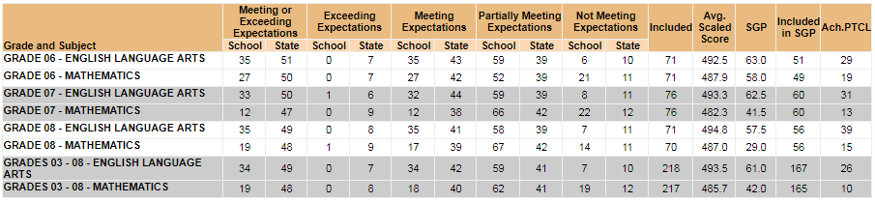

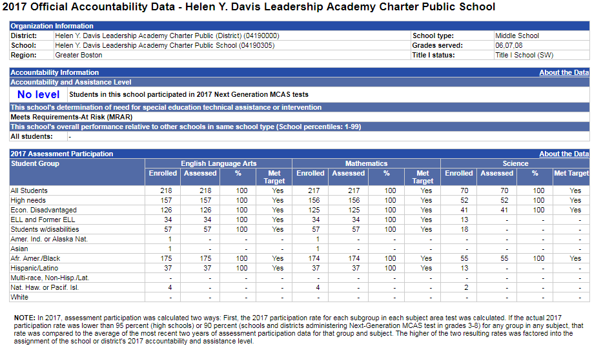
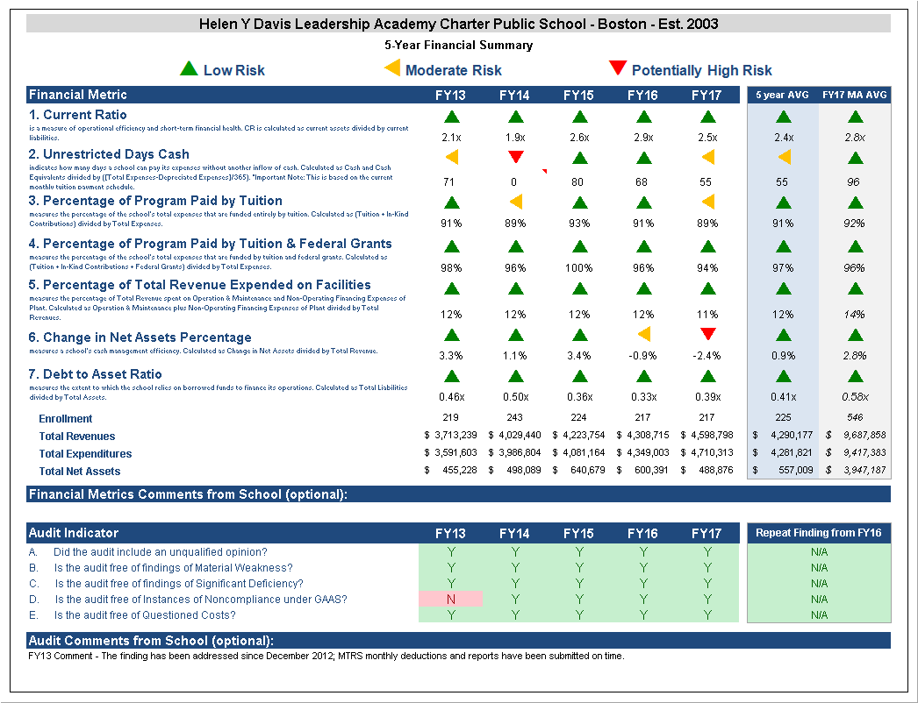

Appendix D: Financial Dashboard (Criterion 10: Finance)

Financial Metric Definitions |  | Low Risk | Moderate Risk | Potentially High Risk
1. Current Ratio | Current Ratio is a measure of operational efficiency and short-term financial health. CR is calculated as current assets divided by current liabilities. | >= 1.5 | Between 1.0 (inclusive) and 1.5 | < 1.0
2. Unrestricted Days Cash (Prior to FY14)  Applies to 5-year average | The unrestricted days cash on hand ratio indicates how many days a school can pay its expenses without another inflow of cash. Calculated as Cash and Cash Equivalents divided by ([Total Expenses-Depreciated Expenses])/365).  Note: This is based on quarterly tuition payment schedule. | >= 75 days | Between 45 (inclusive) and 75 days | < 45 days
2. Unrestricted Days Cash (FY14 forward) | 4th quarterly tuition payments to Commonwealth charter schools in FY14 were made after June 30, 2014, which resulted in lower-than-typical cash at fiscal year end, affecting the risk levels for the current ratio and unrestricted days cash indicators for FY14 on a one-time basis. Payments for FY15 and after are made on a monthly basis, and parameters for risk have been adjusted accordingly. | >= 60 days | Between 30 (inclusive) and 60 days | < 30 days
3. Percentage of Program Paid by Tuition | This measures the percentage of the schools total expenses that are funded entirely by tuition. Calculated as (Tuition + In-Kind Contributions) divided by Total Expenses (expressed as a percentage). Note: In-Kind Contribution are added to the numerator in this ratio to balance out In-Kind Expenditures which will be captured in the Total Expenses in the denominator, and ratios over 100% are set to 100%. | >= 90% | Between 75% (inclusive) and 90% | < 75%
4. Percentage of Program Paid by Tuition & Federal Grants | This measures the percentage of the schools total expenses that are funded by tuition and federal grants. Calculated as (Tuition + In-Kind Contributions + Federal Grants) divided by Total Expenses (expressed as a percentage). Note: In-Kind Contribution are added to the numerator in this ratio to balance out In-Kind Expenditures which will be captured in the Total Expenses in the denominator, and ratios over 100% are set to 100%. | >= 90% | Between 75% (inclusive) and 90% | < 75%
5. Percentage of Total Revenue Expended on Facilities | This measures the percentage of Total Revenue that is spent on Operation & Maintenance and Non-Operating Financing Expenses of Plant. Calculated as Operation & Maintenance plus Non-Operating Financing Expenses of Plant divided by Total Revenues (expressed as a percentage). | <= 15% | Between 15% and 30% (inclusive) | > 30%
6. Change in Net Assets Percentage | This measures a school's cash management efficiency. Calculated as Change in Net Assets divided by Total Revenue (Expressed as a percentage). | Positive % | Between -2% (inclusive) and 0% | < -2%
7. Debt to Asset Ratio | Measures the extent to which the school relies on borrowed funds to finance its operations. Calculated as Total Liabilities divided by Total Assets. | <= .9 | Between .9 and 1 (inclusive) | > 1
FY16 MA AVG Column | All financial metrics indicated in this column are a result of each ratio calculated using statewide totals. For Enrollment, Total Net Assets and Total Expenditures rows, these numbers are averages calculated using the statewide totals of all charter schools’ data.

Helen Y. Davis Leadership Academy Charter Public School Response to Summary of Review and Attachments
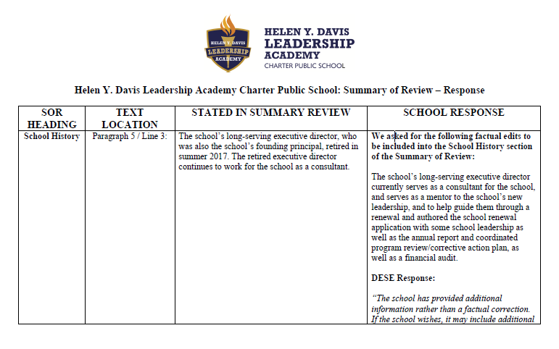

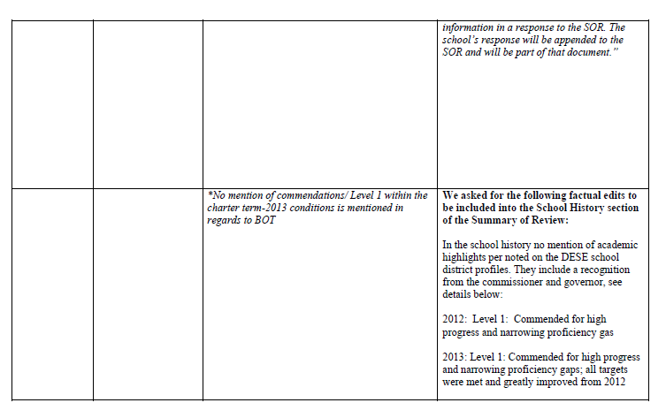

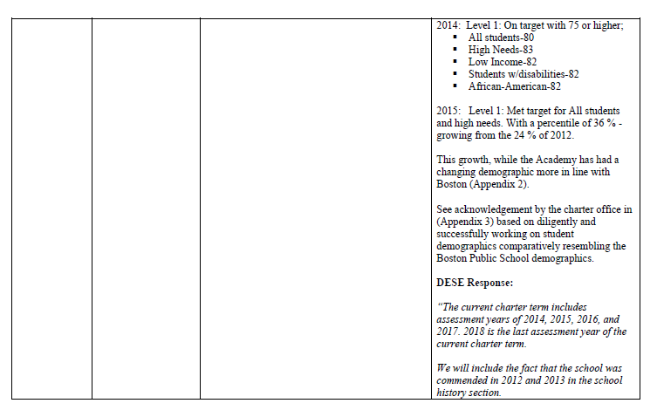

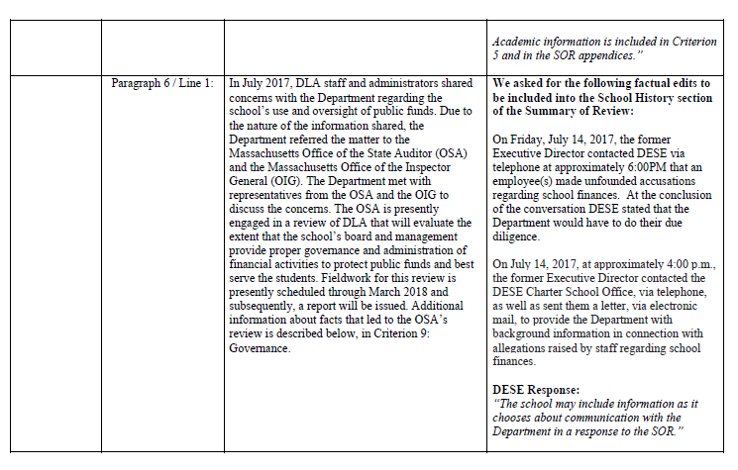

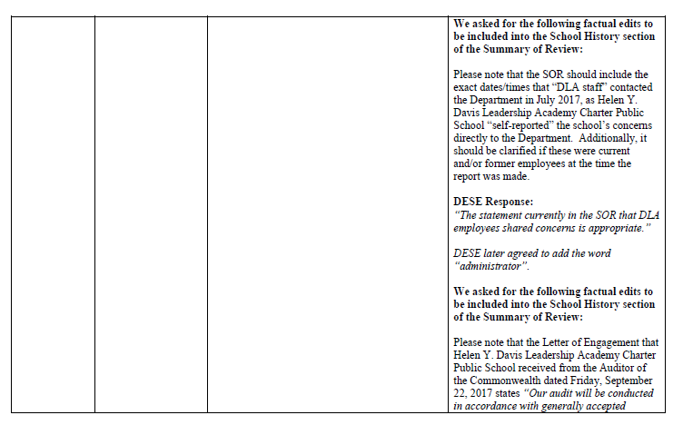

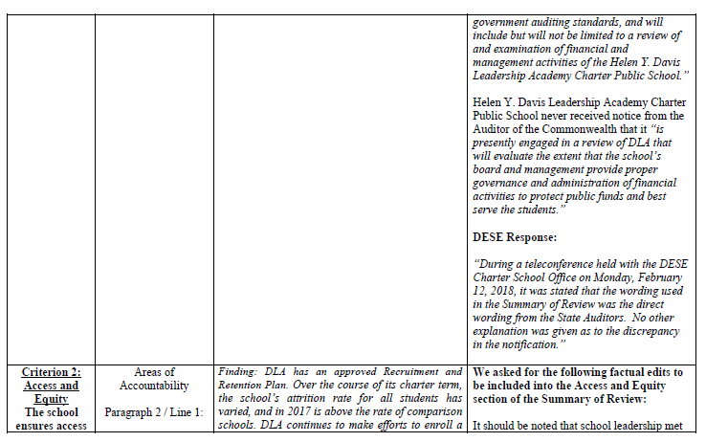

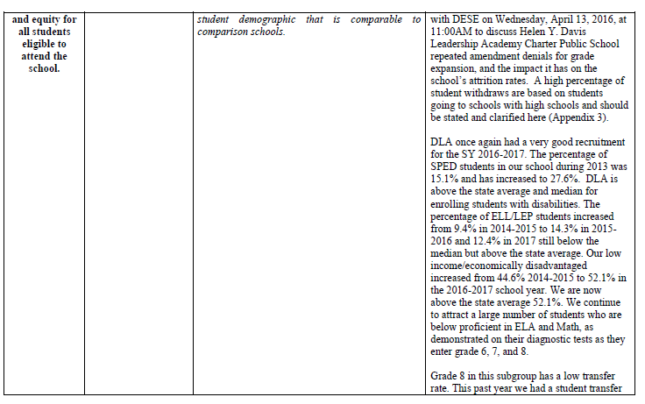

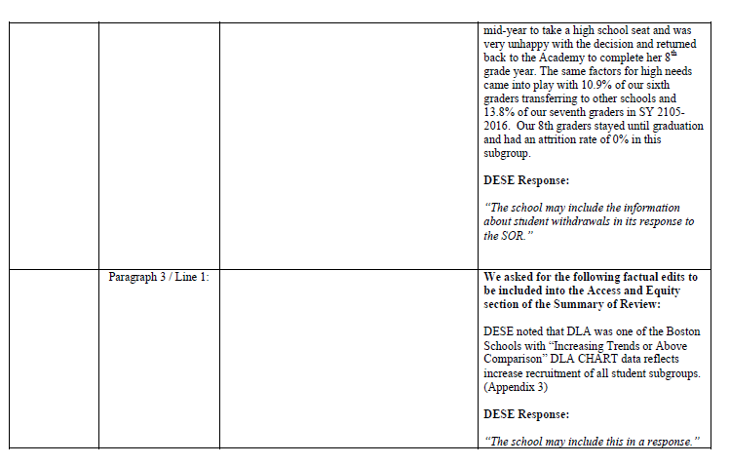

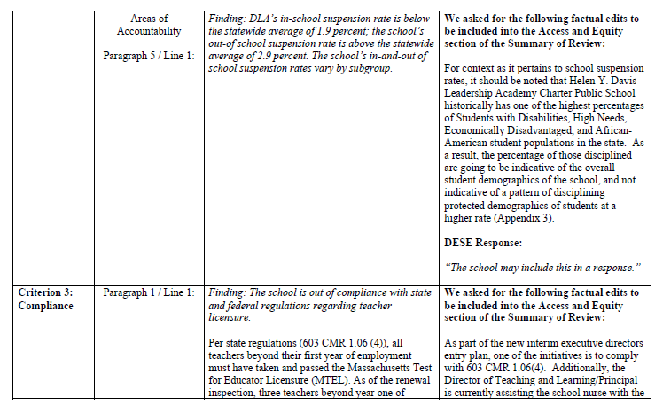

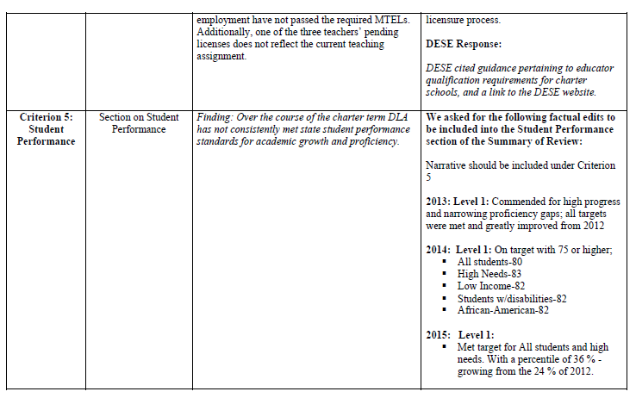

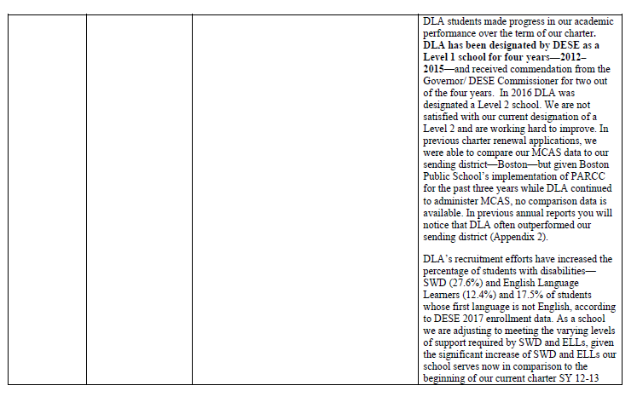

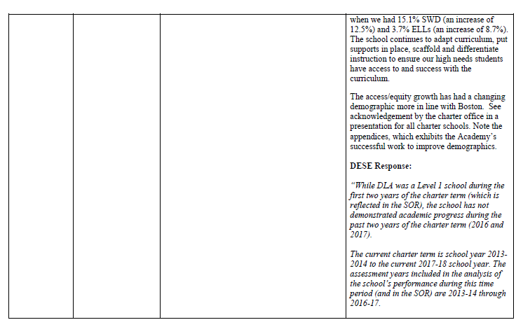

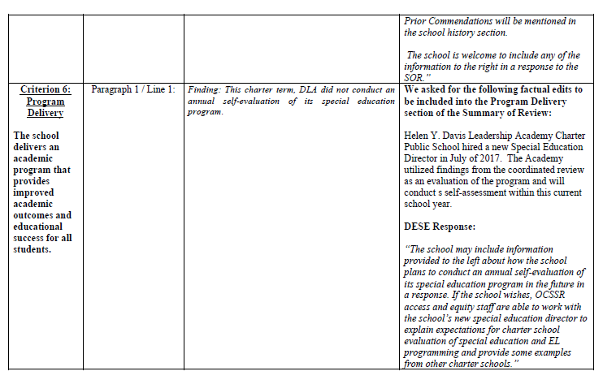

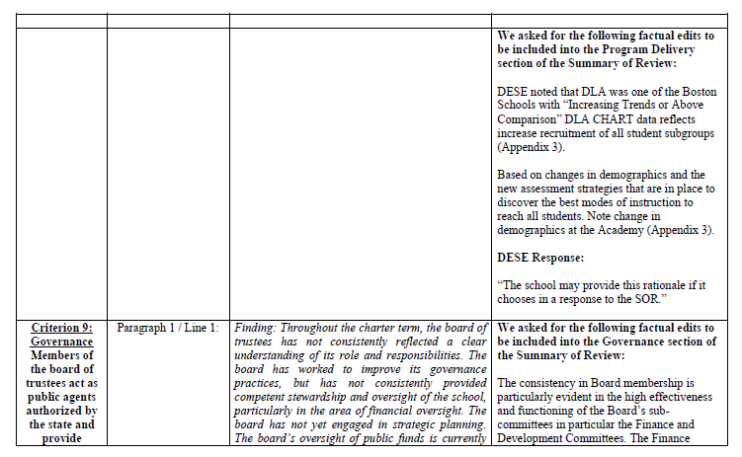

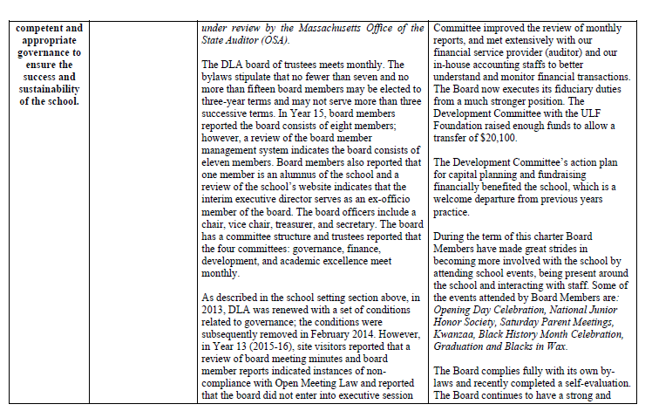

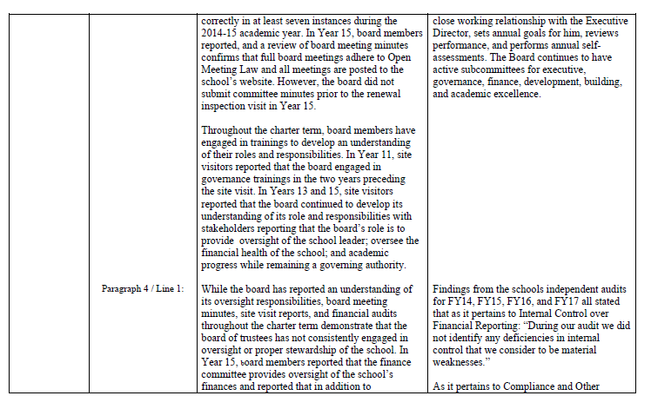

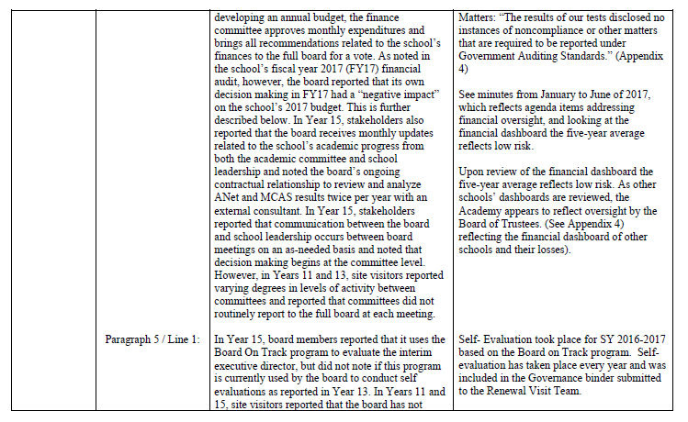

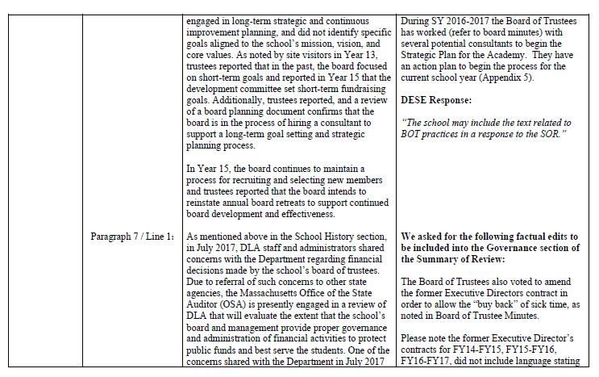

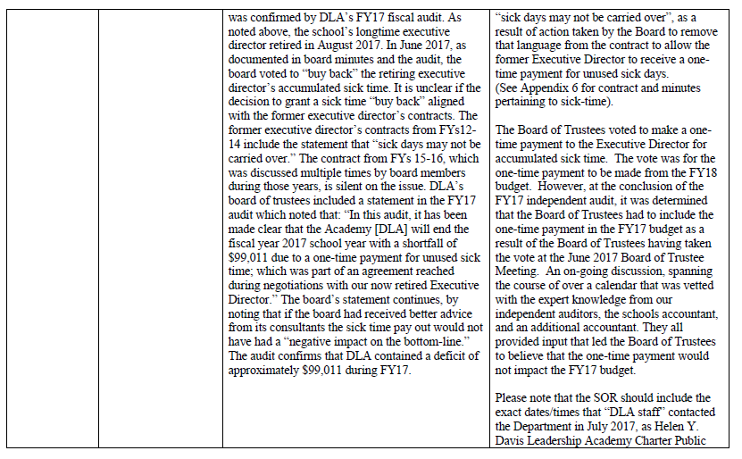

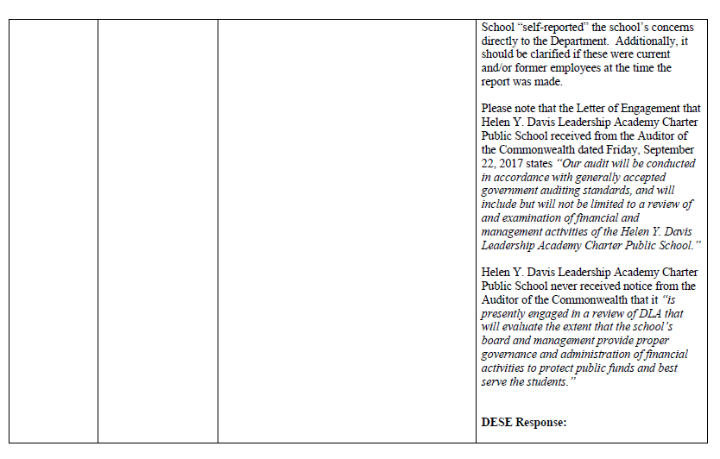

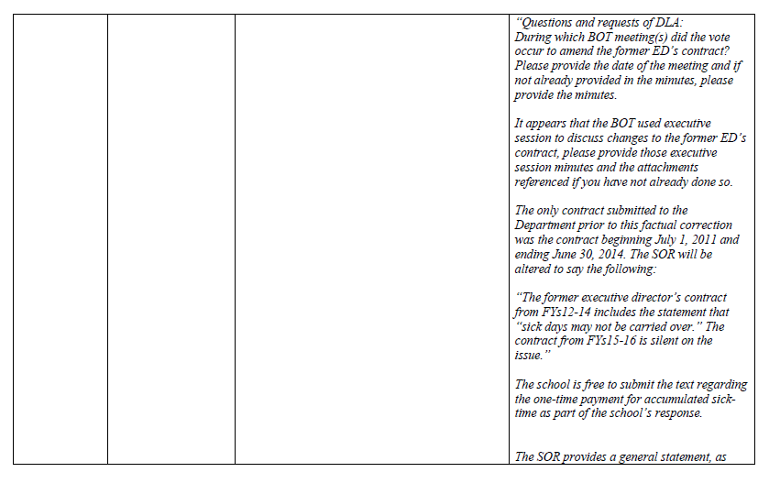

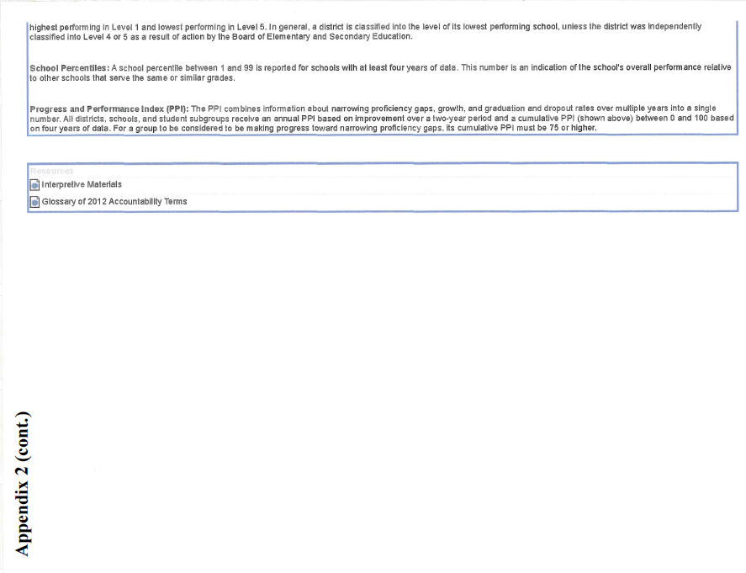
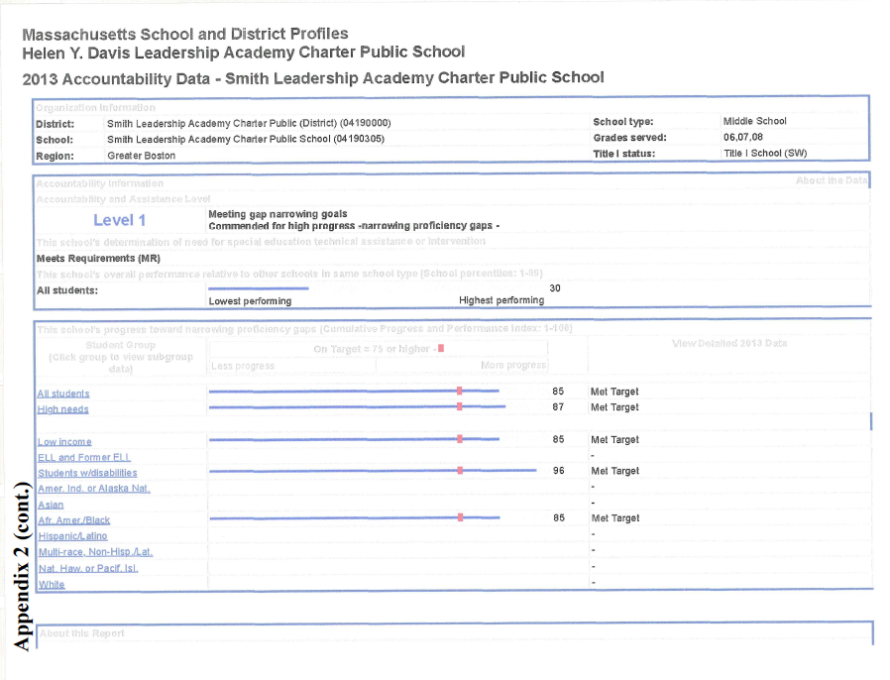
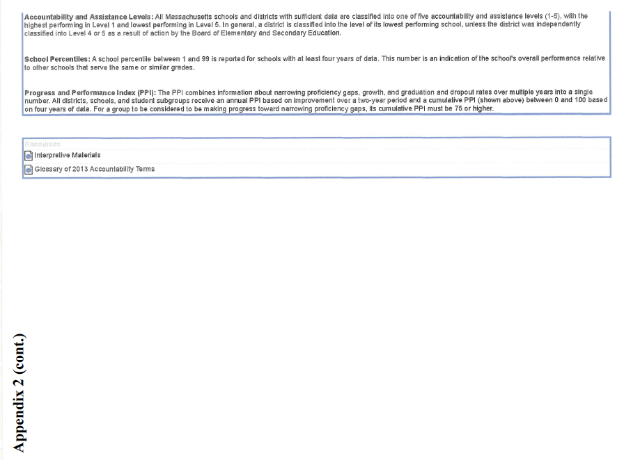
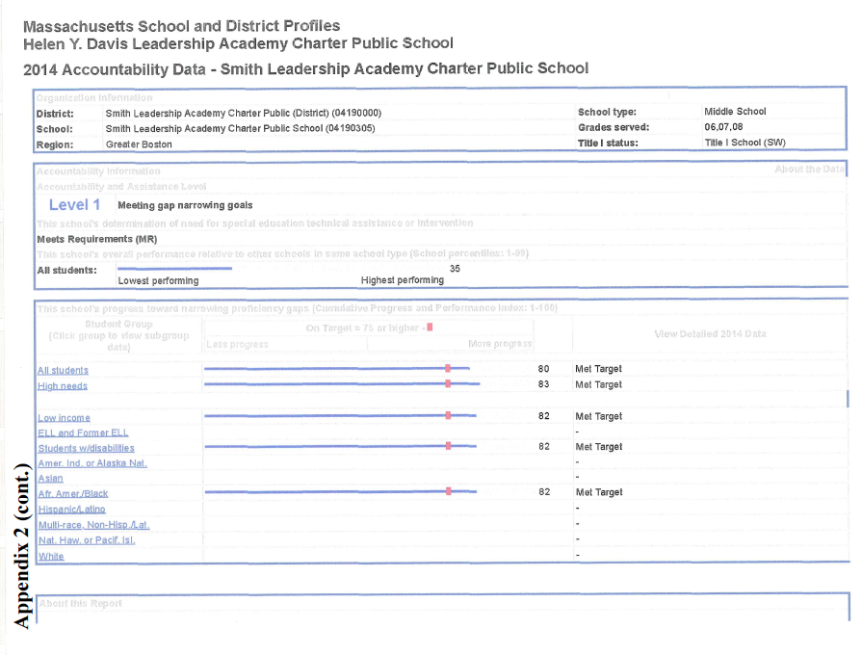
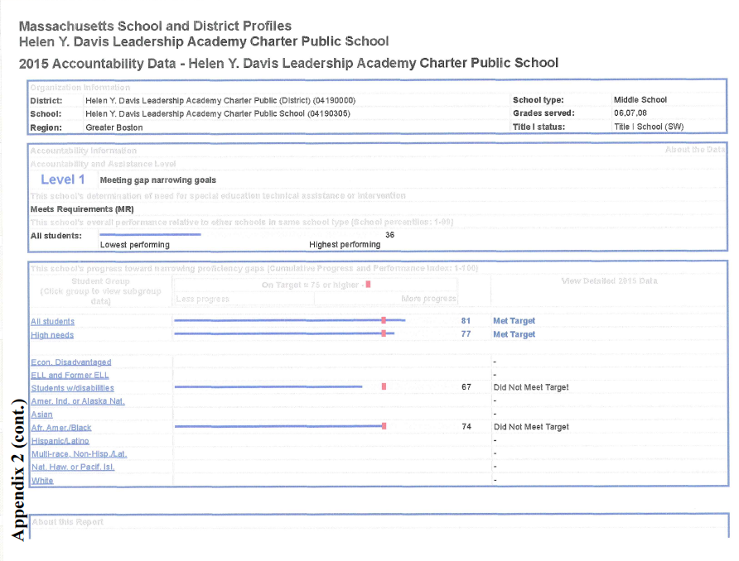
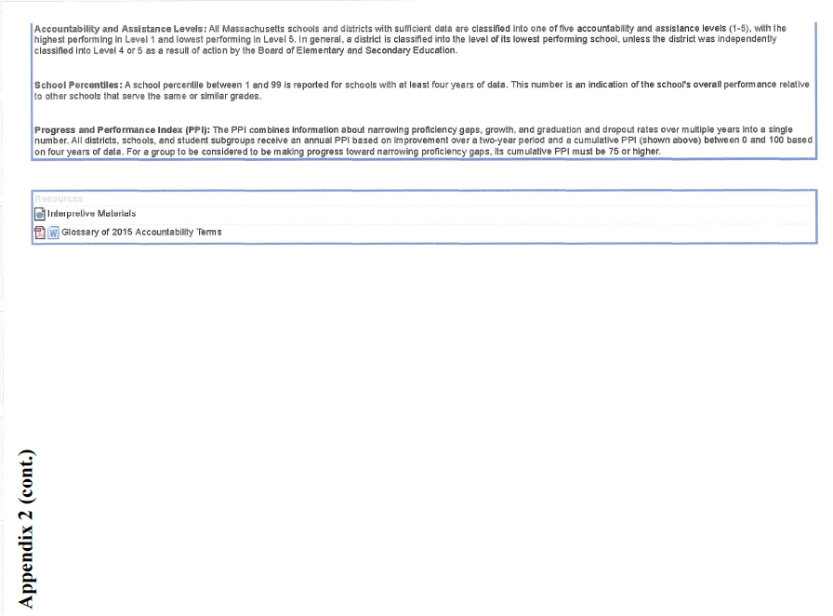
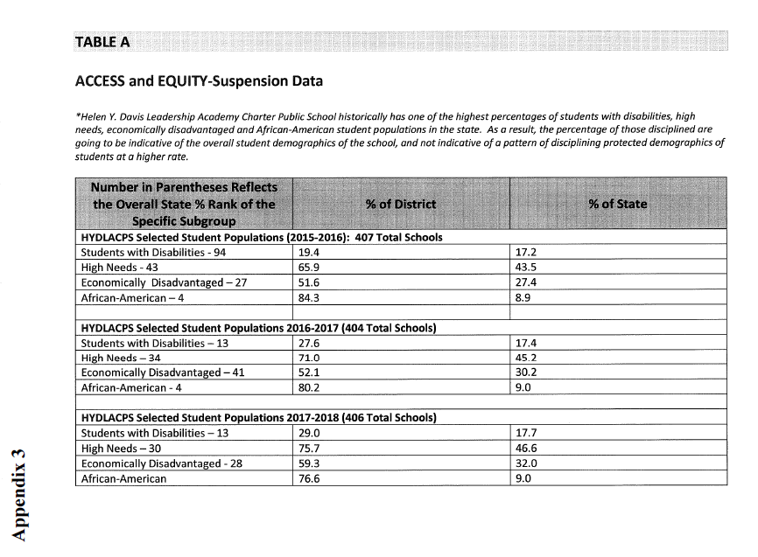
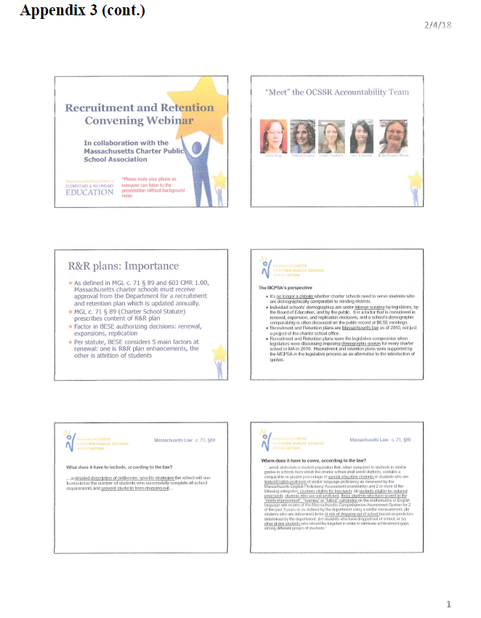
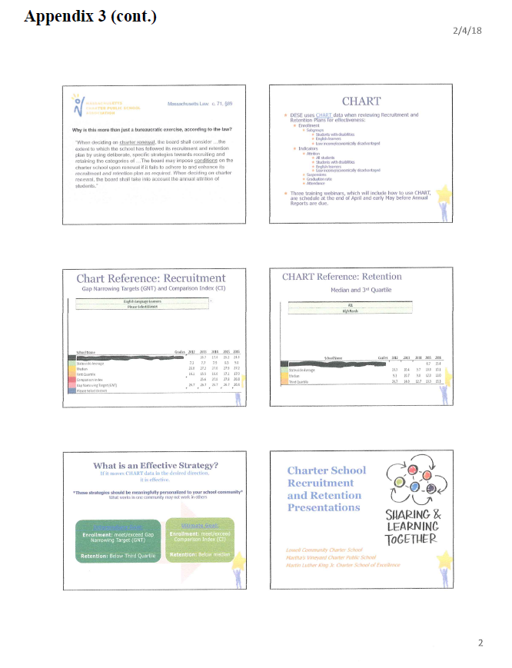
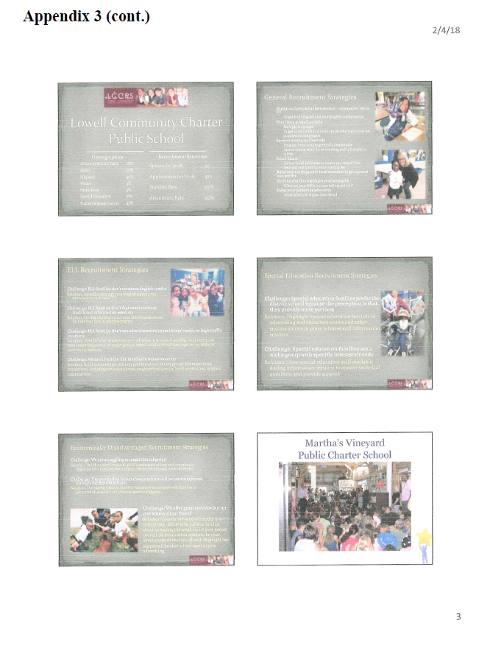
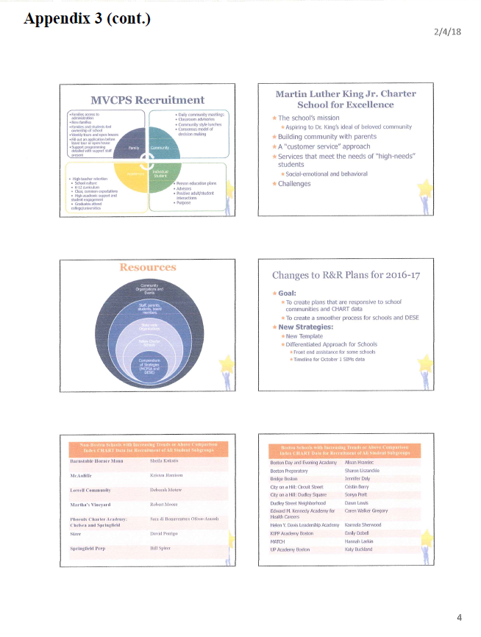
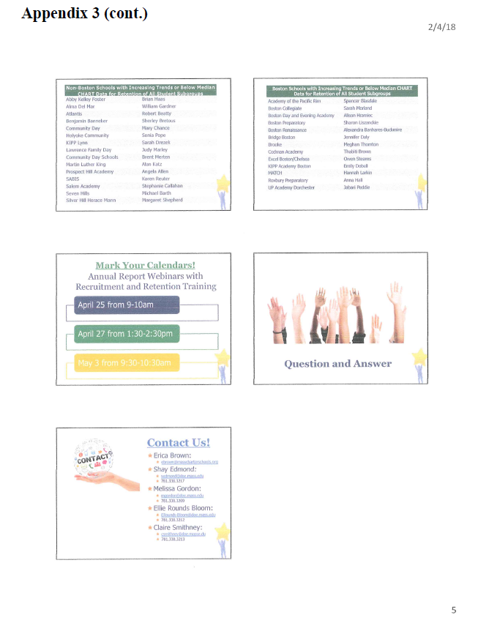
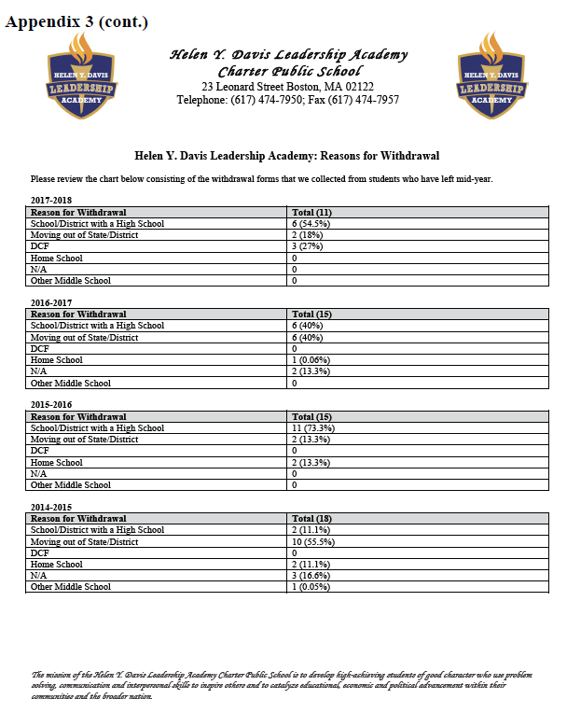

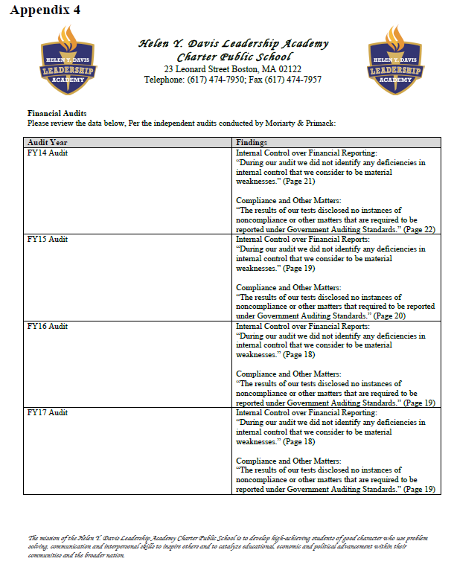
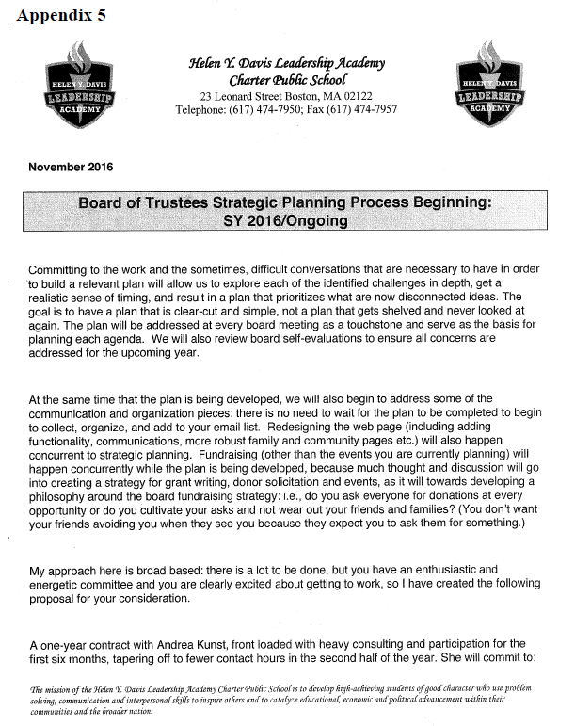
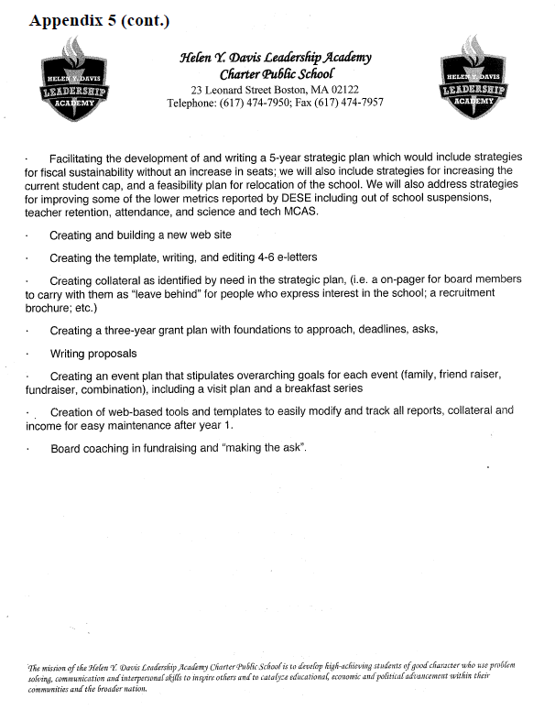
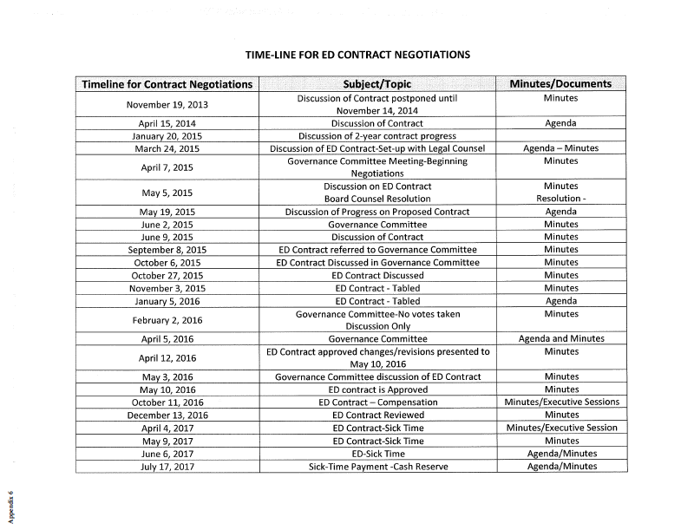

As reported on March 15, 2017 in the Massachusetts Charter School Waitlist Initial Report for 2017-2018 (FY18).
Criterion 2 evaluates the school’s rates of enrollment, attrition, and stability of various subgroups. Stability rate measures how many students remain in a district or school throughout the school year.
In November 2015, the Board of Elementary and Secondary Education ("Board") voted to approve the development of Massachusetts's next-generation MCAS assessment. In the spring of 2017, schools administered the first next-generation MCAS assessment to grades 3 through 8. Schools serving grade 10 continued to administer the legacy MCAS. Anticipating the shift to the next-generation MCAS, the Board voted in November 2015 that districts and schools administering the next-generation MCAS assessment in grades 3-8 in spring 2017 would not have their accountability results negatively impacted based on those test scores. In the fall of 2017, the Department will not use Levels 1-3 for any school that enrolls students in grades 3-8, so long as the school has a participation rate of at least 90 percent in the administration of the spring 2017 MCAS tests and does not have a persistently low graduation rate.
1 The names of each of these schools and additional subgroup detail can be found in the Charter Analysis and Review Tool (CHART), http://www.doe.mass.edu/charter/chart/.
The midpoint value of all comparison schools. This is derived using Microsoft Excel's MEDIAN function.
The first quartile is the middle number between the smallest number and the median of all comparison schools. This is derived using Microsoft Excel's QUARTILE function.
The comparison index provides a comparison figure derived from data of students who reside within the charter school’s sending district(s). The comparison index is a statistically calculated value designed to produce a fairer and more realistic comparison measure that takes into account the charter school’s size and the actual prevalence of student subgroups within only those grade levels in common with the charter school.
The Gap Narrowing Target (GNT) refers to the halfway point between the school’s baseline rate (which is the rate in the 2010-11 school year, or the first year enrollment data is collected if after 2010-11,) and the current Comparison Index (the “target”). The object is to meet this halfway point by the 2016-17 school year (or in a later year if baseline is after 2010-11), giving the school six years to do so. For a school to be on schedule to meet its GNT, an incremental increase must be met annually. To determine this increment, the following equation is used: [(Comparison Index – Baseline) / 2] / 6 years = Annual GNT.
The percentage of attrition, or rate at which enrolled students leave the school between the end of one school year and the beginning of the next.
A student is high needs if he or she is designated as either low income, or ELL, or former ELL, or a student with disabilities. A former ELL student is a student not currently an ELL, but had been at some point in the two previous academic years. 8the Stability Rate measures how many students remain in a district or school throughout the school year. * 2014-2015 is the first year for which the category “Economically Disadvantaged” is being reported, replacing the “Low-income,” “Free Lunch” and “Reduced Lunch” categories used in 2013-2014 and earlier. It is important for users of this data to understand that enrollment percentages and achievement data for "economically disadvantaged" students cannot be directly compared to "Low-income" data in prior years. Please see http://www.doe.mass.edu/infoservices/data/ed.html for important information about the new “Economically Disadvantaged” category.

