

Evaluation of Administrators and Teachers: an overview of proposed new regulations
The Massachusetts Board of Elementary and Secondary Education is soliciting public comment on proposed amendments to 603 CMR 35.00, Regulations on Evaluation of Educators. The proposed regulations are designed to:
  - Link educator practice and student learning, so that student learning is central to the evaluation and continuous development of administrators and teachers.
  - Provide educators with more specific and comprehensive feedback for improvement and enhanced opportunities for professional growth.
  - Promote recognition of excellence in teaching and administration.
  - Assist schools and districts to create a record of facts for personnel decisions.
  - Shorten the time for experienced educators performing below proficiency to achieve proficiency.
  - Raise standards by creating a presumption that professional teacher status (tenure) will be granted only to educators who have demonstrated proficient performance.
The Department of Elementary and Secondary Education (ESE) is committed to supporting effective implementation. ESE will develop a model system for evaluating administrators and teachers that districts can choose to adopt or adapt. ESE is using federal Race to the Top grant funds to develop the model system, along with training materials, resources, and networks designed to support districts in implementing the new regulations. Similarly, ESE is developing guidelines and resources for identifying and using multiple measures of student performance. Districts participating in Race to the Top will have additional resources to help support implementation.
Implementation timeline for the new educator evaluation requirements:
For 2011-12: All 34 Level Four schools and identified “early adopters”
For 2012-13: All Race to the Top Districts
For 2013-14: All other Districts
In addition, by September 2013, all districts are to have adopted a district-wide set of student performance measures for each grade and subject that permit comparison of student learning gains.
The Proposed regulations include a set of principles at the state level that establish:

- A 5-step Evaluation Cycle starting with educator self-reflection and goal setting:

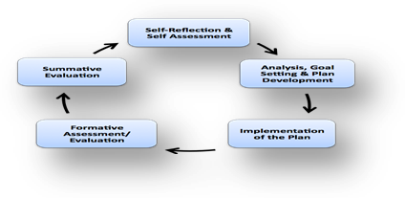

- Statewide standards with “core” indicators for administrators and teachers:

ADMINISTRATORS
Curriculum, Instruction and Assessment
Management and Operations
Family and Community Partnerships
Professional Culture

TEACHERS
Curriculum, Planning and Assessment
Teaching all Students
Family and Community Engagement
Professional Culture

- A statewide rating scale for all educators that identifies four levels of performance:

Exemplary, Proficient, Needs Improvement, Unsatisfactory

- Categories of required evidence to be used in determining performance ratings:
  - Multiple measures of student learning, growth and achievement (including classroom-based and, potentially, group or team-based measures).
  - Announced and unannounced observations and products of practice.
  - The educator’s collection of other evidence, including analysis of feedback from students, parents and (for administrators) staff.

- A separate rating of teacher and administrator impact on student learning at three levels (high, moderate, low), using a combination of statewide, where available, and district-based measures:

- Different paths and plans for growth and improvement depending on educator career stage and performance as determined by overall rating of practice and educator impact on student learning and growth based on multiple measures:

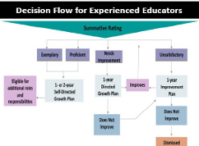

Obtain a copy of the proposed new regulations at: http://www.doe.mass.edu/lawsregs/

Find online comment forms for the proposed new regulations at: http://www.doe.mass.edu/news/news.aspx?id=6169

