Dorchester Collegiate Academy Charter School
Summary of Review
Boston, MA
February 2014
Massachusetts Department of Elementary and Secondary Education
75 Pleasant Street, Malden, MA 02148-4906
Phone 781-338-3000 TTY: N.E.T. Relay 800-439-2370
www.doe.mass.edu

This document was prepared by the
Massachusetts Department of Elementary and Secondary Education
Mitchell D. Chester, Ed.D.
Commissioner

The Massachusetts Department of Elementary and Secondary Education, an affirmative action employer, is committed to ensuring that all of its programs and facilities are accessible to all members of the public.
We do not discriminate on the basis of age, color, disability, national origin, race, religion, sex, gender identity, or sexual orientation.
Inquiries regarding the Department’s compliance with Title IX and other civil rights laws may be directed to the
Human Resources Director, 75 Pleasant St., Malden, MA 02148-4906. Phone: 781-338-6105.

© 2014 Massachusetts Department of Elementary and Secondary Education
Permission is hereby granted to copy any or all parts of this document for non-commercial educational purposes. Please credit the “Massachusetts Department of Elementary and Secondary Education.”

This document printed on recycled paper

Massachusetts Department of Elementary and Secondary Education
75 Pleasant Street, Malden, MA 02148-4906
Phone 781-338-3000 TTY: N.E.T. Relay 800-439-2370
www.doe.mass.edu

Table of Contents

I. Introduction 1
II. Executive Summary of Charter School Performance 1
III. School Amendments, History, and Demographics 4
IV. Areas of Accountability 5
A. Faithfulness to Charter 5
B. Academic Program 8
C. Organizational Viability 15
Appendix A: Accountability Plan Objectives and Measures (Criterion 1: Mission and Key Design Elements) 19
Appendix B: Enrollment and Attrition Data (Criterion 2: Access and Equity) 22
Appendix C: Academic Data (Criterion 5: Student Performance) 26
Appendix D: Financial Dashboard (Criterion 10: Finance) 30
Appendix E: Dorchester Collegiate Academy Charter School Response To Summary of Review 32

I. Introduction

The charter school regulations state that “[t]he decision by the Board [of Elementary and Secondary Education] to renew a charter shall be based upon the presentation of affirmative evidence regarding the success of the school’s academic program; the viability of the school as an organization; and the faithfulness of the school to the terms of its charter” 603 CMR 1.12(3). Consistent with the regulations, recommendations regarding renewal are based upon the Department of Elementary and Secondary Education’s (Department) evaluation of the school’s performance in these areas. In its review, the Department has considered both the school’s absolute performance at the time of the application for renewal and the progress the school has made during the first four years of its charter. Performance is evaluated against both the Massachusetts Charter School Performance Criteria and the school’s accountability plan. The evaluation of the school has included a review of the following sources of evidence, including but not limited to:

- the application for renewal submitted by the school,
- the school’s annual reports for the term of the charter,
- site visit reports generated by the Department in the second and third years of the school’s charter,
- independent financial audits,
- Coordinated Program Review reports,
- the year five Renewal Inspection Report, and
- other documentation, including amendments to the school’s charter.

The following sections present a summary from all of these sources regarding the school’s progress and success in fulfilling the terms of its charter, raising student achievement, and establishing a viable organization.

II. Executive Summary of Charter School Performance

Dorchester Collegiate Academy Charter School (DCACS)
Type of Charter  (Commonwealth or Horace Mann) | Commonwealth | Location | Boston
Regional or Non-Regional? | Non-Regional | Districts in Region  (if applicable) | N/A
Year Opened | 2009 | Year(s) Renewed  (if applicable) | N/A
Maximum Enrollment | 238 | Current Enrollment | 192
Chartered Grade Span | 4-12 | Current Grade Span | 4-8
Students on Waitlist | 912 | Current Age of School | 5 years
Mission Statement
Dorchester Collegiate Academy Charter School will be a rigorous middle and high school whose mission is to prepare for college those students who exhibit the primary indicators that portend poor achievement and eventually dropping out of school – chronic absenteeism, consistent disciplinary issues, and unsatisfactory academic performance. DCACS students will pursue an intellectual and ethical education in a learning community, combining high expectations with personalized academic and non-academic support systems. DCACS success will be measured by students’ high school and college graduation rates, as well as their ability to consistently think and act, using ethical foundations.

Racial and Ethnic Composition and Selected Populations
Subgroup | Number of Students | Percentage of Student Body
African American | 133 | 69.3
Asian | 1 | 0.5
Hispanic | 45 | 23.4
Native American | 0 | 0.0
White | 7 | 3.6
Native Hawaiian, PI | 5 | 2.6
Multi-race, non-Hispanic | 1 | 0.5
Total Students | 192 | 100.0
Special education | 18 | 9.4
Limited English proficient | 1 | 0.5
Low income | 68 | 35.4
High Needs | 101 | 52.6

Dorchester Collegiate Academy Charter School
Exceeds |  | The school fully and consistently meets the criterion and is a potential exemplar in this area.
Meets |  | The school generally meets the criterion and/or minor concern(s) are noted.
Partially Meets |  | The school meets some aspects of the criterion but not others and/or moderate concern(s) are noted.
Falls Far Below |  | The school falls far below the criterion and/or significant concern(s) are noted.
Massachusetts Charter School Performance Criteria |  |  |  | Rating
Faithfulness to Charter | - Mission and Key Design Elements: The school is faithful to its mission, implements the key design elements outlined in its charter, and substantially meets its accountability plan goals. |  |  | ● Falls Far Below
 | - Access and Equity: The school ensures program access and equity for all students eligible to attend the school. |  |  | ● Meets
 | - Compliance: The school compiles a record of compliance with the terms of its charter and applicable state and federal laws and regulations. |  |  | ● Meets
 | - Dissemination: The school provides innovative models for replication and best practices to other public schools in the district where the charter school is located. |  |  | ● Partially   Meets
Academic Program Success | - Student Performance: The school consistently meets state student performance standards for academic growth, proficiency, and college and career readiness. |  |  | ● Partially   Meets
 | - Program Delivery: The school delivers an academic program that provides improved academic outcomes and educational success for all students. |  | Curriculum | ● Partially   Meets
 |  |  | Instruction | ● Partially   Meets
 |  |  | Assessment/Program Evaluation | ● Partially   Meets
 |  |  | Supports for Diverse Learners | ● Meets
 | - Culture and Family Engagement: The school supports students’ social and emotional health in a safe and respectful learning environment that engages families. |  |  | ● Meets
Organizational Viability | - Capacity: The school sustains a well-functioning organizational structure, and clearly delineates roles for staff, administration, and board members. |  |  | ● Partially   Meets
 | - Governance: The board of trustees acts as public agents authorized by the state and provides competent stewardship and oversight of the school while maintaining policies, establishing and monitoring progress toward performance goals, and implementing governance systems to ensure the success and sustainability of the school. |  |  | ● Falls Far Below
 | - Finance: The school maintains a sound and stable financial condition and operates in a financially sound and publicly accountable manner. |  |  | ● Partially   Meets

III. School Amendments, History, and Demographics
Major Amendments
DCACS currently has the following pending amendment(s):
- In May of 2013, DCACS submitted a request for an amendment to change the grades served: from 4-12 to 4-8. At the time of the request, DCACS was serving grades 4-7. If granted the request, DCACS would not expand its grade offerings to include 9-12 and would remain a middle school.

School History
DCACS currently serves students in grades 4-8 and is located in Dorchester, Massachusetts. DCACS was founded and chartered in 2008 with a maximum enrollment of 238 students in grades 4-12. The school opened in 2009 with one class of grade 4 students and added one grade each subsequent year. After three years of operation, the school realized significant and unanticipated costs in overhead and support – costs that would increase proportionally as the school adds grades. As noted above, in 2013, DCACS requested an amendment change to the charter to serve grades 4-8 and not expand to a high school.
In December 2012, DCACS secured a Qualified Zone Academy Bond in the amount of $1.65 million from Boston Private Bank. The school’s facility is owned by the school and underwent first floor renovations in the summer of 2013 resulting in additional classroom space. The basement renovations are scheduled for the summer of 2014 and will result in upgraded classroom space, office space, restrooms, a multi-purpose room, and a server room.

IV. Areas of Accountability

A. Faithfulness to Charter
Criterion | Rating
1. Mission and Key Design Elements  The school is faithful to its mission, implements the key design elements outlined in its charter, and substantially meets its accountability plan goals. | ● Falls Far Below

Finding: Over the charter term, the school has not provided an academic program that is faithful to its mission. Key design elements of the charter are not fully embedded in the school’s program. The school has been providing students with social-emotional supports as envisioned in its charter.
Throughout the charter term, all stakeholders have described the school’s mission in a similar manner: emphasizing a college preparation education with social-emotional supports.

In the school’s fifth year, DCACS is not yet providing an educational program in line with its mission or charter. The school’s academic results do not demonstrate a program that aligns to a college preparatory mission. DCACS’s academic results are provided in the Student Performance section of this report. During the charter term, site visitors in year two, three, and during the renewal inspection have found that the school has not fully embedded the key design elements promised in its charter. The charter included seven elements to achieve academic excellence: a standards-based curriculum; interdisciplinary themes and inquiry based projects; an Aristotelian approach; project oriented cooperative learning; small classes and differentiated instruction; a focus on literacy; and performances of genuine understanding. With the exception of a standards-based curriculum and small class sizes of under 20 students, these elements are not fully embedded.

Currently, DCACS is working to better implement the academic components of its mission. School leaders have articulated four charter-driven initiatives for the current year: literacy, cooperative learning, differentiation, and genuine assessment. DCACS teachers have had training on cooperative learning and differentiation, but the renewal inspection team observed little evidence of practices being embedded in daily lessons. In order to emphasize literacy and love of reading there are two additional programmatic efforts this year – added assessment of all students through Fountas and Pinnel and an accompanying sustained silent reading period for 30 minutes at the end of each day. Additionally, the school supports an after-school tutoring and homework center provides remediation in mathematics and English language arts. Additionally, the school has sought external assistance to improve its academic program to better support its mission. The school has partnered with the Neighborhood House Charter School (NHCS) for academic coaching/instructional support. Teachers are receiving instructional coaching, observe practices at NHCS and participate in co-planning with NHCS teachers.

Throughout the charter term, site visitors have noted that DCACS provides many supports for its at-risk population. In its fifth year, the school provides a range of social-emotional supports to serve its population. Throughout the charter term, DCACS has worked collaboratively with the Children’s Hospital Neighborhood Partnership (CHNP). During the first four years of the charter term, CHNP provided a licensed counselor to meet with students as needed, facilitated social skills groups, and assisted staff in problem solving students’ social-emotional challenges through staff training and real-time consultation for individual students. In the current year, the school has increased its social-emotional supports by hiring two full-time guidance counselors (a high school transition counselor for grades 6-8 and a grades 4-6 counselor), and maintains CHNP as a referring agency/provider for outside support. The guidance counselors provide small group sessions, co-teach in mathematics classes, manage the after-school detention program, work with parents to ensure that all students have access to supports, and provide professional development to support teachers and students. The school’s advisory program pairs teachers or counselors with small groups (8-10 students) to address their social-emotional needs and keep parents informed of any issues that may arise.

Finding: DCACS did not meet a majority of the measures in its accountability plan.
DCACS’s approved accountability plan includes 9 objectives and 15 related measures. DCACS met 6 out of 15 measures. Please see Appendix A for full details.

2. Access and Equity  The school ensures program access and equity for all students eligible to attend the school. | ● Meets

NOTE: New statutory provisions related to Criterion 2 were established in 2010. As specified in regulation, charter schools were first required to implement recruitment and retention plans in 2011-2012. This year, one of the Department’s key priorities with respect to charter schools is to develop and pilot new tools and processes for robustly assessing this criterion, and to support schools in meeting this criterion. Because this represents the most prominent shift in the 2013 revisions to the Charter School Performance Criteria and is based on requirements that were newly established in the middle of the school’s current charter term, the Department has evaluated school performance in this area accordingly.

Finding: The availability of programs and services for students with disabilities and English language learners is provided in the school’s recruitment activities, but is not available on the website.
Information about the availability of special education and ELL services is made available at the Charter School Showcase, through notices and advertisements translated into the predominant languages of the community and sharing information about the school and how to apply with the Department of Children and Families and local housing agencies, the Department of Transitional Assistance, and other local community and cultural groups.

Information pertaining to the availability of special education and ELL services is not made available on the school’s website although the school has indicated that the website will soon be revised and this information is scheduled to be included. Although the school publishes several non-discrimination statements, none contain all required information fields. Parents of enrolled students are informed about available support services in weekly newsletters, and through visits to all classrooms during parent open house events by the special education director. ELL students receive a notice letter about what services are available. Parents interviewed indicated that they receive information about available services from teachers and office staff.

Finding: The school’s recruitment and retention plan was received and approved following revisions.

The recruitment and retention plan submitted by the school required revision in all areas. The requested changes were made, and the plan has been approved.

As of the current school year, (2013-2014), the enrollment of students enrolled in special education and English language learners has grown significantly to 18.2% and 20.8% of the overall population of the school, respectively. These enrollment rates are comparable for students with disabilities. For English language learners, current enrollment is still below most comparison schools, but is much closer to comparability. Enrollment of students with disabilities, and of the English language learner subgroup were consistently below the rate of enrollment of these subgroups within Boston comparison schools during prior years of the charter term (more specifically, enrollment was below the rate in most comparison schools for enrollment of students with disabilities, and below all comparison schools for enrollment of English language learners). The school reported zero enrollment of English language learners or students whose families speak a first language that is not English (FLNE) between 2009 and 2012. The school’s enrollment of low income students has been more variable, with a fluctuating up and down enrollment trend. Enrollment of this subgroup was higher than the majority of Boston comparison schools in 2011 and 2012, but lower than the majority of comparison schools in 2010 and 2013. The school’s attrition rates have shown an increasing trend across the charter term for both all students and for the high needs subgroup; attrition became higher than most comparison schools for both overall attrition and attrition of high needs students in 2013. See Appendix B for demographic comparison graphs.

3. Compliance  The school compiles a record of compliance with the terms of its charter and applicable state and federal laws and regulations. | ● Meets

Finding: The school is presently working with the Department as part of the Coordinated Program Review process. In other areas, the school has compiled a record of compliance.
DCACS underwent a Coordinated Program Review in December 2012 which reviewed the school’s programs of special education, English language learner education and implementation of civil rights requirements. Pursuant to issuance of the special education and civil rights components of the final report in May, 2013 the school submitted a corrective action plan which was reviewed and approved by the Department. Progress reports have been regularly submitted by the school to document the steps taken to address the issues identified. The English language education component of the CPR has not yet been issued by the Department.

4. Dissemination  The school provides innovative models for replication and best practices to other public schools in the district where the charter school is located. | ● Partially   Meets

Finding: Over the course of the charter term, the school has not provided innovative models for replication and best practices to other schools, district, or organizations. In the current year DCACS is partnering with a Boston Public School to share practices.
School leaders reported that the first four years of the charter have been focused on building the infrastructure of the school and dissemination was put on hold. However, in the current school year, the school will partner with the Boston Public Schools’ Maurice Tobin K-12 School. At the time of the renewal inspection visit, the school had begun to finalize the Tobin partnership through a Gates-funded initiative – $50,000.00 per school year – to support and provide collegial connections with the ELL staff and replicate the school culture practices that are manifested as a result of the implementation of advisory.

B. Academic Program
Criterion | Rating

5. Student Performance  The school consistently meets state student performance standards for academic growth, proficiency, and college and career readiness. | ● Partially   Meets

Finding: DCACS does not consistently meet state student performance standards for academic growth, proficiency, and college and career readiness.
In 2013, DCACS’s MCAS results placed it in Level 2; DCACS is in the 23rd percentile relative to other schools in the same school type. The school’s Composite Performance Index (CPI) for 2013 is 68.3 in ELA, 62.0 in mathematics, and 62.5 in science and technology. The school’s student growth percentile (SGP) for 2013 is 40.0 in ELA, and 39.5 in mathematics. Please see the data charts below to see historical trends in CPI and SGP. Please refer to Appendix C for detailed student academic performance data over the charter term.

Growth |  | 2010 | 2011 | 2012 | 2013
ELA SGP | All | 30.5 | 60.0 | 63.5 | 40.0
 | High needs | 26.0 | 62.0 | 63.5 | 38.0
Math SGP | All | 14.5 | 76.0 | 65.0 | 39.5
 | High needs | 13.0 | 76.0 | 66.0 | 37.0

English Language Arts Proficiency Gap Narrowing

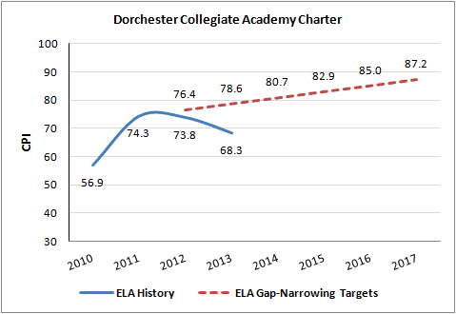

Mathematics Proficiency Gap Narrowing

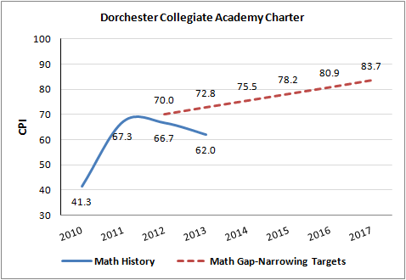

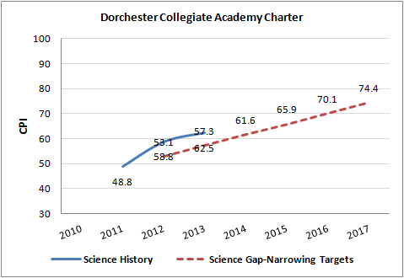
Science Proficiency Gap Narrowing

6. Program Delivery  The school delivers an academic program that provides improved academic outcomes and educational success for all students. | Curriculum
 | Instruction
 | Assessment/Program Evaluation
 | Supports for Diverse Learners

Curriculum  The school’s curriculum is aligned to state curriculum frameworks and the Common Core standards; is aligned vertically between grades and horizontally across classrooms at the same grade level; and supports opportunities for all students to master these skills and concepts. | ● Partially   Meets

Finding: The school is developing curricular materials aligned to the 2011 Massachusetts Frameworks and Common Core State Standards. This work is not yet completed. Curriculum documents are not consistently accommodated to support opportunities for all students to master skills and concepts.
During each visit of the charter term, including the renewal inspection, visitors have found that the school was working to align its curriculum to the Massachusetts Frameworks and Common Core standards. This work is not yet completed. Instructional staff develop annual curricular plans (scope and sequence documents), unit plans, and weekly lesson plans; however, the renewal inspection team discovered that the quality of these plans varies. Review of sample annual plans revealed that they are all aligned to the Massachusetts Curricular Frameworks (MCF). In addition to these annual plans, teachers develop unit plans and weekly lesson plans. A majority of these plans follow a similar format: an objective, Do Now, mini-lesson, and additional learning activities for each day. However, the level of detail in the plans varies. For example, some, but not all, weekly lesson plans included references to exit tickets and/or differentiation strategies. Similarly, some, but not all, unit plans included explicit references to the Common Core State Standards.

Although instructional staff are developing curricular materials aligned to the state frameworks, it is not yet clear that the curriculum is meeting the needs of all learners. The majority of weekly lesson plans do not refer to differentiation or accommodations for diverse learners. School leaders stated that the school is just beginning to investigate the adoption of the World-Class Instructional Design and Assessment (WIDA) standards for English Language Learner (ELL) students.

School leaders and instructional staff work collaboratively to develop the school’s curricular materials. Teachers receive feedback on lesson plans from the school’s academic coach. In addition, an instructional coach from NHCS has provided teachers with both professional development related to key Common Core curricular shifts and ongoing support with curriculum development.

Instruction  The school staff has a common understanding of high quality instruction for all students. Instructional practices are consistently aligned to this common understanding and foster student engagement. Classroom environments are conducive to learning. | ● Partially   Meets

Finding: DCACS’s school staff share a common understanding of elements of high quality instruction, however, observed instructional practices have not been consistently aligned to this understanding.
Over the charter term, site visit teams have not observed consistent implementation of expected instructional practices in all classrooms (practices described below). During year two and three, site visitors observed elements of the expected instructional practices in a majority of classes with some variation between classrooms. During the renewal inspection, the team observed that a majority of teachers, but not all, employ the school’s instructional format. According to the school’s description of high quality instruction, instructional staff use a consistent lesson format that includes a clear and measurable objective, Do Now, learning activities (in which students extend and apply their knowledge), and an opportunity for students to reflect on the lesson. The team observed that 75 percent (n=21) of observed lessons sufficiently or consistently adhered to the school’s instructional model.

The renewal inspection team found that opportunities for cooperative learning (an instructional practice outlined in the school’s charter) are rare and opportunities for student voice are inconsistent. According to the school’s description of high quality instruction, instructional staff use formal cooperative group activities that include a group goal, individual accountability, positive interdependence, equitable participation, and a closing activity. However, the site visit team observed students working in groups in just 10 percent of observed lessons, and did not observe any lessons in which students engaged in formal cooperative group activities. In contrast, the team observed teacher-led instruction in 85 percent of observed lessons and independent work in 25 percent of observed lessons. In addition, the site visit team observed that student engagement and opportunities for student voice were inconsistent. When asked to describe what the team would see in classrooms, school leaders explained that the staff was working towards limiting teacher talk and encouraging high levels of student voice. However, the team observed that student voice was rare or occasional in 60 percent of observed lessons.

Finding: Over the charter term, DCACS classrooms have become more orderly. A majority of classrooms are conducive to learning.
According to site visit observations, DCACS classrooms have become more orderly during the charter term. In year two site visitors found that classrooms exhibited a range of orderliness. In year three site visitors observed a generally orderly environment in classrooms with a few exceptions. The renewal inspection team found that the majority of instructional staff use school wide routines and procedures to create safe, predictable learning environments. The site visit team observed that the majority of lessons were orderly and efficient. Teachers used several school wide techniques – voice-volume guidelines and a “1, 2, 3, eyes on me” chant – to manage student behavior. Although the site visit team observed that learning time was maximized in the majority of observed lessons, it observed limited or no evidence that learning time was maximized in 30 percent of observed lessons. In these classes, teachers used school wide behavior management techniques, but these techniques proved ineffective; significant instructional time was lost due to classroom management challenges.

Finding: Over the charter term, site visitors have only observed limited evidence that instruction is differentiated to meet the needs of all learners.
In the school’s charter, a key instructional methodology is differentiated instruction. Throughout the charter term, however, site visit teams have not seen consistent evidence of differentiation. The renewal inspection team found that core instruction is not consistently differentiated. According to the school’s description of high quality instruction, instructional staff differentiate learning activities to allow students to access the curriculum. That description also states that teachers will engage in team teaching and multi-modal instruction to better meet the needs of all learners. While the renewal inspection team observed some evidence of team-teaching and multi-modal instruction, the team observed evidence of differentiation in only 20 percent of observed lessons. In the majority of observed lessons, students were working on the same tasks with the same levels of support.

School leaders reported that although differentiation is a school wide priority this year, new staff have not yet received professional development related to differentiation. In addition, they stated that the school has made the strategic decision not to differentiate texts in ELA classes but, instead, to differentiate texts in the school’s Silent Sustained Reading program.

Assessment and Program Evaluation  The school uses a balanced system of formative and benchmark assessments. The school regularly and systematically analyzes the quality and effectiveness of the program in serving all students using qualitative and quantitative evidence and modifies the program accordingly. | ● Partially   Meets

Finding: The school is developing a balanced system of assessments; however, school leaders do not consistently use data to evaluate the school’s programming.
In the school’s second year, DCACS began to administer the Achievement Network (ANet) assessments to track student performance. The renewal inspection team found that, currently, instructional staff use ANet and exit tickets to monitor student progress. The school’s formative and summative assessments include A-Net assessments, exit tickets, and assessments of genuine understanding. Students take ANet benchmark assessments in mathematics and ELA four times each academic year. The school awards certificates to students who attain 80 percent mastery or improve by 10 percent on each ANet assessment. Teachers are expected to include exit tickets in their weekly lesson plans; review of sample weekly lesson plans revealed that some, but not all, of these plans include exit tickets. The team observed teachers using exit tickets in their lessons.
Although instructional staff administer A-Net assessments and exit tickets to monitor student progress, there is less evidence that they administer assessments of genuine understanding. School leaders explained that assessments of genuine understanding required students to apply information in a new, unfamiliar way. However, the renewal inspection team team did not observe any assessments of genuine understanding during classroom observations.

The renewal inspection found that instructional staff are beginning to use data to modify instruction and drive timely interventions. Instructional staff participate in a data analysis cycle following each ANet assessment. This cycle includes both analysis of students’ performance and the development of action plans to address students’ weaknesses. Although instructional staff participate in the ANet data analysis cycle, teachers do not consistently use checks for understanding to modify instruction. Finally, although the school’s tutoring program is designed to provide a timely academic intervention for students in need of additional support, the process of assigning students to tutoring is not yet data-driven. Review of a PowerPoint presentation summarizing the tutoring program revealed that individual teachers assign students to tutoring based on their holistic knowledge of a students’ grades and standardized assessment results, but neither instructional staff nor the presentation referred to school wide thresholds to guide teachers’ selections.

School leaders do not yet use quantitative data to evaluate the effectiveness of the school’s programming. When asked to describe how the school uses data to evaluate the school’s programming, school leaders described the school’s ANet data cycle, but did not refer to systematic efforts to review the effectiveness of its programs. In addition, review of the school’s ELL and special education self-assessments revealed that these assessments refer to a wide range of processes and structures, but not student outcomes. School leaders acknowledged that the school was still developing a way to evaluate the ELL program, and that this was an area for growth. Furthermore, there is little evidence that the board has used quantitative data to systematically evaluate the school’s programming. As noted below, the board has not formally evaluated the overall performance of the school or its headmaster since 2011.

Supports for Diverse Learners  The school provides supports to meet the academic needs for all students, including but not limited to students with disabilities and English language learners. | ● Meets

Finding: The school has experienced a significant increase in both its special education and ELL populations, and staffing levels have been increased accordingly. General education academic support mechanisms are in place, but in some cases lack clear procedures.
The school makes academic supports available to student with diverse learning needs who require additional academic support to be successful in the general education classroom. Those supports include tutoring blocks built into the school schedule four times weekly and the addition of a second adult to many of the general education classrooms. The tutorial sessions occur four times weekly in 45 minute sessions, but for whatever reason the student is originally assigned to attend the tutorial program, students are placed into both the ELA and the Mathematics components, whether their performance has been low in that particular area or not. Tutorial groups consist of four to eight students and convene for six-to-eight week blocks after which students can exit the program if their performance has improved, but there are no quantitative thresholds in place for either program entry or exit. A Child Study Team is in place, meeting monthly to consider methods of addressing student needs. Examples of accommodations provided to students include use of graphic organizers, manipulatives and breaking down assignments into smaller tasks.

The population of ELL students has increased significantly, now standing at 41 students, or 20.8 percent of the overall enrollment of the school. The increase in enrollment is attributed by the school to increased overall enrollment number at the school, improved identification and assessment procedures and word of mouth among the community. ELL staffing has been increased on account of the expanded population, and now consists of one full-time program coordinator and a part-time ELL teacher. Sheltered English immersion is not uniformly available at the school from fully trained teachers, however 14 teachers have received some training under the former Category model of trainings and the school has indicated that their instructional staff are scheduled to participate in additional trainings during the current and upcoming school years. The state is presently in transition in regard to the training programs for teacher endorsement to provide sheltered instruction content. ELL students are supported both on an inclusion and a pull-out basis, with ELL staff going into the classroom to provide content support and language clarification. ELL students are pulled out of the classroom to receive direct and explicit instruction in the English language including vocabulary, grammar and usage.

There has also been a significant increase in the enrollment of special education students at DCACS to 36, or 18.2 percent of the overall population of the school, which represents approximately a doubling over the 2012-13 school year. The increase is attributed by the school to the increase in overall student enrollment. The school has responded to the increase with additional staff which now number a full-time special education administrator and two full-time special education teachers, one of whom specializes in reading and the other in mathematics. A full-time reading specialist, a part-time occupational therapist, and a part-time speech pathologist are also on the DCACS staff.

Clearly defined and well-understood assessment and identification procedures are in place for students who are potentially in need of special education. This process includes discussion of a student at a grade-level team meeting, referral to the school’s child study team, and then, if necessary, referral for a special education evaluation. Teachers and school leaders stated that once a student is identified as qualifying for special education services, that student can receive a range of push-in and/or pull-out support. For example, special education teachers push in to general education classes to provide a range of accommodations and support, depending on the needs of the student. Services are delivered to students on both a push-in and a pull-out basis. Special education teachers have access to the general education teachers lesson plans online and can access the general education staff directly at bi-weekly department meetings.

7. Culture and Family Engagement  The school supports students’ social and emotional health in a safe and respectful learning environment that engages families. | ● Meets

Finding: The school provides a safe learning environment and has increased staffing to provide social-emotional supports for students.
The school has developed a safe school environment through the implementation of a consistent discipline system and frequent student recognition. Students, parents, and teachers reported that the school is safe. School leaders conduct classroom observations at the beginning of the year focused on teachers’ use of praise and positive narration in the classroom. The school employs other incentives to reinforce positive behavior such as dress-down days and pizza parties.
The school has hired two guidance counselors who provide individual and group counseling, coordinate the school’s advisory program, and serve on the child study team. The guidance counselors provide students with a range of internal counseling services, such as individualized counseling, social skills groups, self-regulation groups, and a peer lunch group. The guidance counselors also coordinate the school’s advisory program that started at the beginning of the 2013-14 academic year. Each advisor is responsible for approximately 10 students and meets with those students twice a week for 50 minutes. The goal of advisory is to help provide students with social-emotional supports, monitor students’ academic performance, and coordinate communication between the school and family. Advisory topics have included anti-bullying, community building, and forming positive, peer relationships, depression and stress management. A Dean of Students collaborates with students and their families to provide external counseling, particularly through a partnership with the South Bay Mental Health Center.

Finding: The school has developed systems to promote strong, two-way communication in order to build relationships with families.
The school communicates regularly with parents/guardians including by email, telephone calls, and newsletters. Parents reported that they receive frequent telephone calls from teachers to discuss student needs, as well as to share successes or good things. They also reported that receiving a quick response when contacting the school and that when problems arise involving their children, teachers call them immediately to settle the situation.
The school is working to develop relationships with families/guardians. In focus groups, parents reported that, last year, there were few opportunities for families to build relationships with teachers and leaders because structures were not fully developed; however, the school has put several structures in place in the current year including an expanded and active Parent Teacher Organization, volunteer opportunities and a Culture Fest event that drew over 100 parents.

C. Organizational Viability
Criterion | Rating

8. Capacity  The school sustains a well-functioning organizational structure, and clearly delineates roles for staff, administration, and board members. | ● Partially   Meets

Finding: Over the charter term, the board has engaged in ongoing, informal communication with the school leader. The board has not regularly or systematically assessed his performance.
Throughout the charter term, site visitors have noted that the board engages in ongoing, informal communication with the school leader. The following board activities are influenced and shaped by information communication: creation of the board meeting agendas, recruitment efforts, and orientation of new members. Also, board members reported that the school business manager and board treasurer have begun to meet this school year and are planning to meet regularly. Over the past five years, the number of times the full board has met has fluctuated. Prior to the summer of 2013, the board met quarterly; however, since the summer of 2013, the board has met approximately once each month.

The board does not regularly or systematically assess the performance of the school leader. Similar to what was reported in year three, the board chair told the renewal inspection team that systematic processes are being developed to assess the school leader. The most recent evaluation of the school leader was facilitated by The High Bar, a board consulting group, in August 2011. The board reported that it is now planning on using the Massachusetts administrator evaluation tool to evaluate the school leader; he reported that, this year, he plans on using this to evaluate other administrators. The school leader reported that no formal administrative evaluations were completed during the 2012-13 school year. Despite the board’s plans to develop processes to assess the school leader’s performance, there is insufficient evidence to suggest that clearly-defined goals exists by which the school leader’s performance will be measured. The school has yet to begin implementation of the new system.

Finding: Over the charter term, DCACS has improved its practice of providing frequent feedback to teachers. In the current school year, DCACS has a professional climate providing collaboration time, instructional coaching, and frequent observation.
Over the charter term, DCACS has not consistently provided adequate observation, feedback, or evaluation to teachers. In the school’s third year, the mid-year departure of the teacher coach led to a decrease in observation and feedback practices. In its fifth year, the renewal inspection team found that DCACS has developed a system for monitoring instructional practices. Teachers are observed regularly and are provided with feedback to improve their instructional practices. An observation calendar is followed to ensure consistent and systematic support with immediate feedback. The school employs its own academic coach in addition to the NHCS instructional coach. DCACS’s academic coach observes instruction and follows a discrete format offering observer comments/questions and suggestions and rating the effectiveness of teacher performance. The school leader also conducts two-to-three formative evaluations, a summative evaluation, and mini-observations every two weeks and gives immediate feedback. The academic coach and the Headmaster share observation data with one another.

The school provides teachers with structures for frequent collaboration and peer support. Each Wednesday students are dismissed at noon and teachers participate in professional development sessions until 4:30 p.m. These sessions may include a compendium of topics, ranging from academics to school culture and protocols. In addition, the instructional coach from NHCS facilitates some professional development sessions on reading strategies, test taking strategies, and data analysis. Teachers also have a weekly three-hour planning block for grade-level and department meetings; as well as frequent informal meetings. These team meetings are structured and focused on teacher development, instructional practices, and student achievement.

Finding: The school has developed clear and well-understood systems for decision making, collaboration, and communication.
DCACS has established a collaborative professional environment in which school leaders are open to input and feedback. School leaders created a new leadership team beginning in the 2012-13 academic year; members include: the school leader, the school’s academic coach, the NHCS instructional coach, the dean of students, the special education director, and five grade-level team leads. This leadership team has increased teacher voice in school decision making. The leadership team has focused on a wide range of topics, including the school’s literacy initiative, student celebrations, dismissal procedures, and the tutoring program. Concerns or suggestions discussed among staff can be brought to the leadership team by grade-level representatives.

9. Governance  The board of trustees acts as public agents authorized by the state and provides competent stewardship and oversight of the school while maintaining policies, establishing and monitoring progress toward performance goals, and implementing governance systems to ensure the success and sustainability of the school. | ● Falls Far Below

Finding: Throughout the charter term, the board of trustees has not provided adequate oversight of the school. The board has not implemented governance systems to ensure the success and sustainability of the school.
Over the charter term, the board has not adequately developed its capacity. During the year two visit, the board reported it was working to develop its capacity with a consultant. In year three, site visitors found that the board had done little to develop additional governance structures and systems to provide oversight or develop its capacity. In the current year, the renewal inspection team found that the board provides informal oversight of the school, it has not yet developed systems and tools to provide thorough, competent stewardship.

The board consists of eight members, including the school’s headmaster. The board’s bylaws state that the board includes four leadership positions: a chair, vice-chair, treasurer, and secretary; however, the board currently has two leadership positions – a chair and a treasurer.

The board engages in informal communication and decision making with school leaders outside regularly held meetings. While board meeting minutes include discussion of the school’s academics, finances and renovations, the minutes do not include references to the board’s formal approval of the school’s budget or changes to school policies. When asked about the board’s role in the school’s decision to hire an instructional coach from Neighborhood House, board members reported that they provided input regarding that decision via e-mail; board minutes do not include references to the school’s decision to hire that coach. Furthermore, there is little evidence that the board has used quantitative data to systematically evaluate the school’s programming or to make a decision to not expand into a high school.

The board has taken steps to increase its effectiveness. In January 2013, the board set a goal of adding at least four trustees to the board by the end of 2013. The board met this goal and added four new members with a variety of professional backgrounds - including social work, academic administration, and finance - thus increasing the range of expertise on the board. The board has recently revived a committee structure that includes five committees: academic affairs, fundraising, governance, finance, and strategic planning; the committees have not yet begun to meet. Finally, the board intends to develop a strategic plan during the 2013-14 academic year.

10. Finance  The school maintains a sound and stable financial condition and operates in a financially sound and publicly accountable manner. | ● Partially   Meets

Finding: DCACS maintains a sound and stable financial condition.
As evidenced by the fiscal dashboard in Appendix D, DCA’s key financial indicators are mostly at low risk levels. The school has run operating surpluses in recent years and budgeted close to actual revenue and expenditures. The school has clear purchasing procedures and has secured a line of credit. DCA purchased its facility in 2011 for $1.1 million, financed through a loan. In this past fiscal year DCA has obtained restricted cash through the purchase of Qualified Zone Academy Bonds (QZAB) in order to conduct facility improvements.

Finding: DCACS operates in a somewhat financially sound and publicly accountable manner, with some concerns noted.
Although DCACS has a process for developing and monitoring the budget, there is limited board oversight. The part-time business manager develops the budget and meets with the headmaster monthly to oversee the budget’s execution. Recently, the board treasurer has joined these meetings. The renewal inspection team’s review of board meeting minutes suggests that the board discusses the school’s finances at some of its meetings. However, board meeting minutes do not include references to the board’s formal approval of the budget.

DCACS had findings in their audits for fiscal year 2010 (FY10), FY12, and FY13. In FY13, the auditors made a finding of significant deficiency because the auditor had to do numerous general ledger adjustments that, in the aggregate, were material to the financial statements. When noting the cause for this deficiency, the audit reported that the school did not have the internal controls in place to do proper financial reconciliations. The school’s response was that most of the adjusted ledger entries had to do with the QZAB, which is a newer and more complex source of funding. In FY13, DCACS’s audit also had a finding of noncompliance. The school did not withhold the appropriate MTRS amount for all employees.

Appendix A: Accountability Plan Objectives and Measures (Criterion 1: Mission and Key Design Elements)

Faithfulness to Charter
 | Performance  (Met/Not Met) | Evidence
Objective: The school is faithful to the mission, vision, and educational philosophy defined in the charter application and any subsequent approved amendment(s).
Measure: Annually, 100% of Dorchester Collegiate Academy’s instructional staff will attend at least three Health and Wellness trainings conducted by the Children’s Hospital Neighborhood Partnership (CHNP). | Met | All staff have attended at least three annual CHNP trainings. All staff attended three CHNP trainings during the 2012-2013 academic year.
Measure: Annually, at least 90% of DCACS staff will “Agree” or “Strongly Agree” with the workshop effectiveness assessment questions presented on the CHNP “Training and Professional Workshop Survey.” | Not Met | Review of 2012-2013 CHNP training survey data revealed that less than 90% of DCACS staff “Agreed” or “Strongly Agreed” with some of the workshop effectiveness questions.
Objective: The school establishes an academic program that includes the pedagogical approach, curriculum, assessment, and other unique elements defined in the charter application and any subsequent approved amendment(s).
Measure: Starting in the 2011-2012 AY, students that attend the after school tutoring program will master at least 70% of the standards for which they are referred. | Met | Review of the 2012-2013 tutoring tracker shows that students in the school’s tutoring programming met 70% of the standards for which they were referred.

Academic Program Success
 | Performance  (Met/Not Met) | Evidence
Objective: Students at the school demonstrate proficiency, or progress toward meeting proficiency on state standards, as measured by the Massachusetts Comprehensive Assessment System (MCAS) exams in all subject areas and at all grade levels tested for accountability purposes.
Measure: The school shows an annual increase in the CPI in ELA and mathematics in the aggregate and for all statistically significant groups. | Not Met | The school did not consistently show an annual increase in the CPI in ELA and mathematics. For example, the school’s aggregate CPI in both English Language Arts and mathematics declined from 2012 to 2013.
Measure: The school shows an annual decrease in the percentage of students scoring Warning/Failing on standard MCAS tests in ELA and mathematics in the aggregate and for all statistically significant subgroups. | Not Met | The percentage of students scoring Warning/Failing on standard MCAS in English Language Arts and mathematics increased in the aggregate from 2012 to 2013. For example, 55% of DCACS scored Warning/Failing in ELA in 2012, but 65% of DCACS scored Warning/Failing in ELA in 2013.
Measure: The school achieves and maintains a median student growth percentile (SGP) of 40 or higher in the aggregate and for all statistically significant sub-groups in all subject areas tested for accountability purposes. | Not Met | In 2013, the school achieved a median SGP of 40 for some sub-groups, but not all sub-groups. For example, in 2013 the school achieved an SGP of 42 for African-American students, but its SGP for English Language Learners was only 37. In addition, in 2013 its aggregate SGP in mathematics was 39.
Objective: If externally developed assessments other than the MCAS are administered, student performance is strong and demonstrates improvement over time on those assessments.
Measure: Starting in 2011-2012 AY, each year, in the 4th, 5th and 6th grades, at least 55% of students will score 65% or higher on the final A-Net interim ELA and mathematics assessments. | Not Met | Review of the school’s A-Net performance data revealed that students did not consistently meet this threshold. For example, school leaders reported that in 2013 approximately 50% - not 55% -- of students scored 65% or higher on the ELA and mathematics final assessment.
Measure: Starting in 2011-2012 AY, each year, in the 7th and 8th grades, at least 65% of students will score 65% or higher on the final ANet interim ELA and mathematics assessments. | Not Met | Review of the school’s A-Net performance data revealed that students did not consistently meet this threshold. For example, school leaders reported that in 2013 approximately 45% - not 65% -- of students scored 65% or higher on the ELA and mathematics final assessment.
Objective: The school’s curriculum is documented, articulates the skills and concepts that all students must know and be able to do to meet state standards, is aligned horizontally and vertically, and supports opportunities for all students to master these skills and concepts.
Measure: 100% of teachers will develop annual plans that align with the MA Common Core Standards and MA Standards. The Headmaster will review and assess each plan during August orientation to determine 100% of plans are aligned. | Met | Review of annual plans revealed that all instructional staff have created annual plans aligned to the MA Common Core Standards and MA Standards. Teachers and school leaders confirmed that school leaders reviewed and assessed these plans at the beginning of the academic year.

Organizational Viability
 | Performance  (Met/Not Met) | Evidence
Objective: The school develops an annual budget that can be sustained by enrollment and is in support of student academic achievement.
Measure: The school’s annual budget is sustained by its enrollment. | Met | Review of recent audits confirmed that the school’s annual budget is sustained by its enrollment. Review of audits also revealed that the school has run an annual surplus throughout its charter term and has not engaged in fundraising to sustain its budget.
Objective: The school demonstrates a history of positive net assets, adequate cash flow to sustain operations and support the academic program, and consistently operates within budget.
Measure: Each year, the school demonstrates a history of positive net assets, adequate cash flow to sustain operations and support the academic program, and consistently operates within budget. | Met | Review of financial audits confirmed that the school has met this measure. For example, the school ran a surplus of $108,000 in the 2012-2013 academic year and has run annual surpluses since the beginning of its charter term.
Objective: The school’s annual independent audit is free of material or repeated findings.
Measure: There is an absence of material or repeated findings in annual audits by a qualified independent auditor. | Met | Review of financial audits confirmed that the school has received unqualified audits throughout its charter term. The school did have a significant deficiency in FY13, but it was not material.
Objective: The school involves parents/guardians as partners in the education of their children. Families and students are satisfied with the school’s program.
Measure: At least 80% of parents will respond to the Academy’s annual Parent Survey. | Not Met | Although the school reported that at least 80% of parents responded to its annual parent survey in each of the past three years, the school was unable to provide documentary evidence to support this measure.
Measure: At least 90% of Dorchester Collegiate Academy families responding to the annual survey will report that they agree that DCACS teachers are effective and set high academic expectations for students. | Not Met | Although the school reported that for each of the last three years at least 90% of parents responding to the annual survey agreed that DCACS teachers are effective and set high academic expectations for students, the school was unable to provide documentary evidence to support this measure.
Measure: At least 90% of Dorchester Collegiate Academy families responding to the annual survey will report that they agree that DCACS provides effective social and emotional support for students. | Not Met | Although the school reported that for each of the last three years at least 90% of parents responding to its annual parent survey agreed DCACS provides effective social and emotional support for students, the school was unable to provide documentary evidence to support this measure.

Appendix B: Enrollment and Attrition Data (Criterion 2: Access and Equity)

The longitudinal demographic comparison data presented in the following four graphs is intended to provide context for the charter school’s recruitment and retention efforts. The set of displayed comparison schools includes the charter school of interest, and all of the public schools (district and charter) in the charter school’s region that serve at least one grade level of students which overlaps with the grade levels served by the charter school. All data displayed in these graphs is derived from ESE District and School Profiles (http://profiles.doe.mass.edu/).

The first four graphs provide comparison enrollment percentages for four different subgroups of students: first language not English, English language learners, low income, and students with disabilities. Each line on the graph represents the percentage of total school enrollment from 2010 to 2013 for a given school or set of schools. Data listed is displayed longitudinally across multiple years in line graph form, with:
- a solid bold black line representing subgroup enrollment in the charter school of interest;
- a dotted green line for the statewide average;
- a blue line for the district in which the charter school is located;
- a dotted orange line for the median enrollment percentage of the comparison schools; and
- gray lines for enrollment percentage in each individual comparison school (darker gray for charter schools, and lighter gray for district schools).

The next two graphs summarize attrition rates in the aggregate and for the high needs subgroup. Please note that district percentages are not included since attrition at the district-level cannot be reasonably compared to attrition at the school-level.

Important Notes: Though comparisons of subgroup enrollment in a charter school to that of other public schools in a geographic area can provide some information to assess comparability of student populations, the subgroup composition of a charter school is not required to be a mirror image of its sending districts and region. Students choose to enroll or are assigned to the schools in a geographic region due to a variety of reasons and factors, including: the random lottery admissions requirement for charter schools, district assignment and programmatic placement decisions, parent choice, uneven distribution of families within a geographic region due to housing or wealth distribution patterns, and natural population variation, among many others. Charter schools are mandated to receive Department approval for a recruitment and retention plan to be reported on and updated annually. When deciding on charter renewal, the Commissioner and the Board of Elementary and Secondary Education must consider the extent to which the school has followed its recruitment and retention plan, using deliberate, targeted strategies to recruit and retain students in subgroups where enrollment has not been comparable, and whether the school has enhanced its plan as necessary. It is also important to note that it may take time for a charter school’s recruitment and retention efforts to be reflected in the aggregate demographic percentages given sibling preference for admission and a limited number of entry grades.

Enrollment Demographics
Number of Comparison Schools for Dorchester Collegiate Academy Charter School: 120

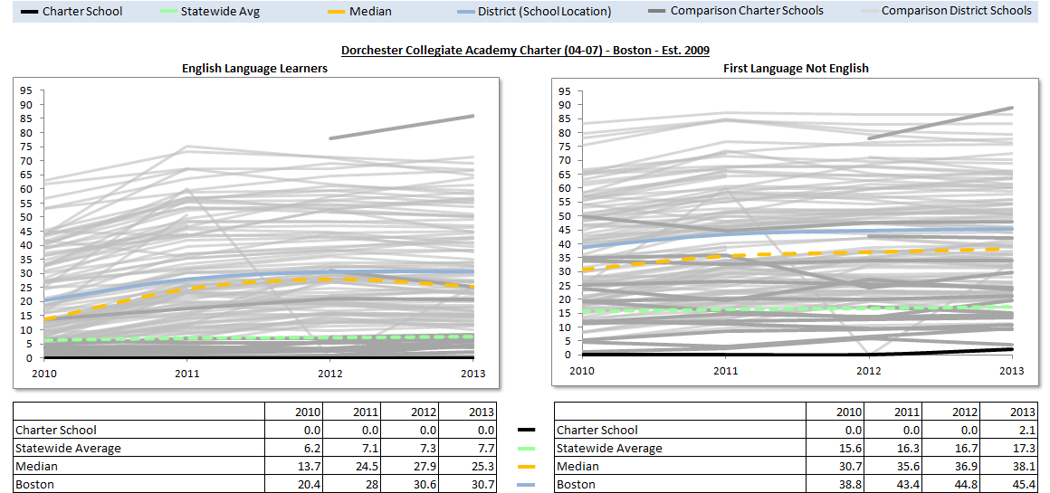

Enrollment Demographics
Number of Comparison Schools for Dorchester Collegiate Academy Charter School: 120

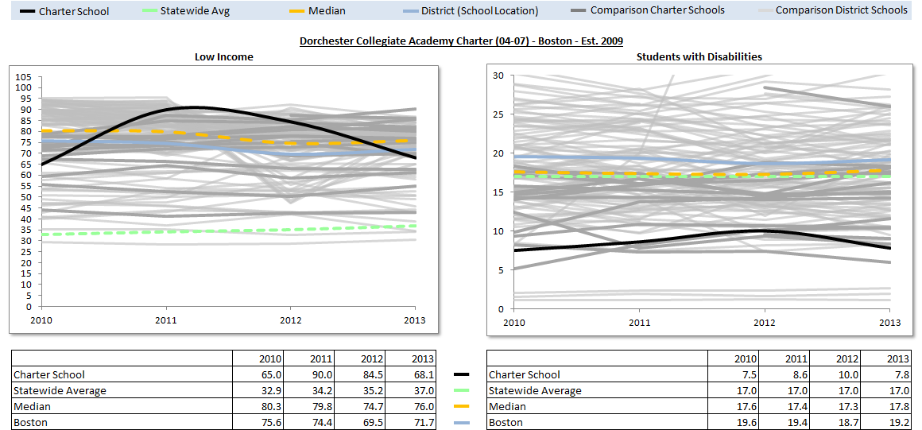

Attrition Rates

Number of Comparison Schools for Dorchester Collegiate Academy Charter School: 120
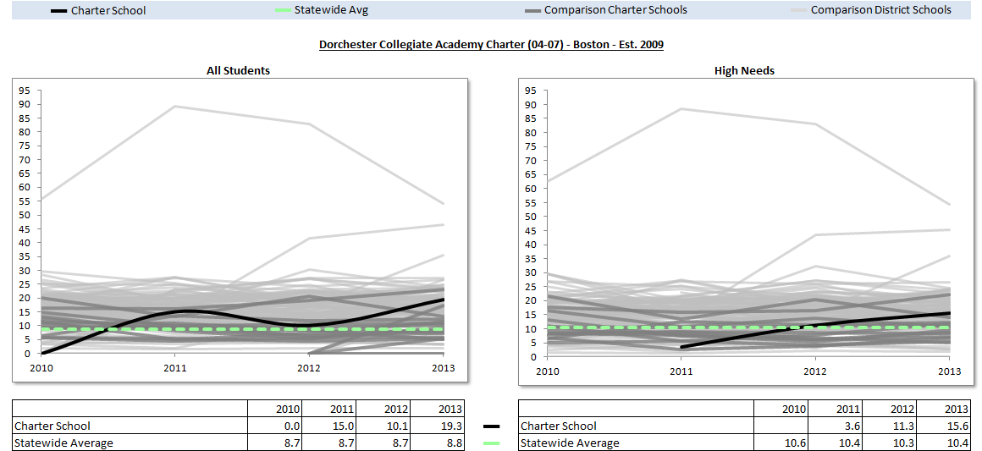

Appendix C: Academic Data (Criterion 5: Student Performance)
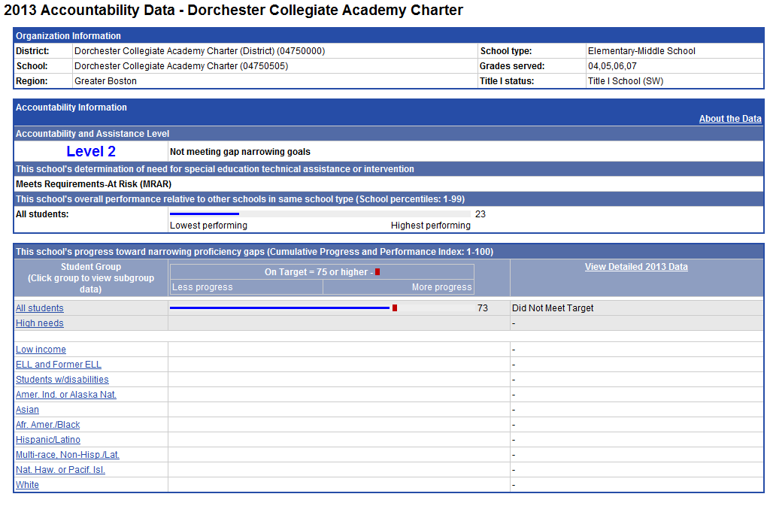
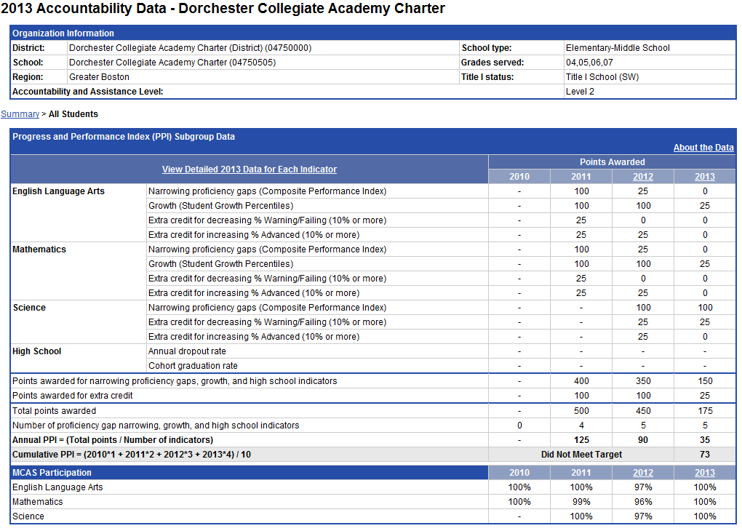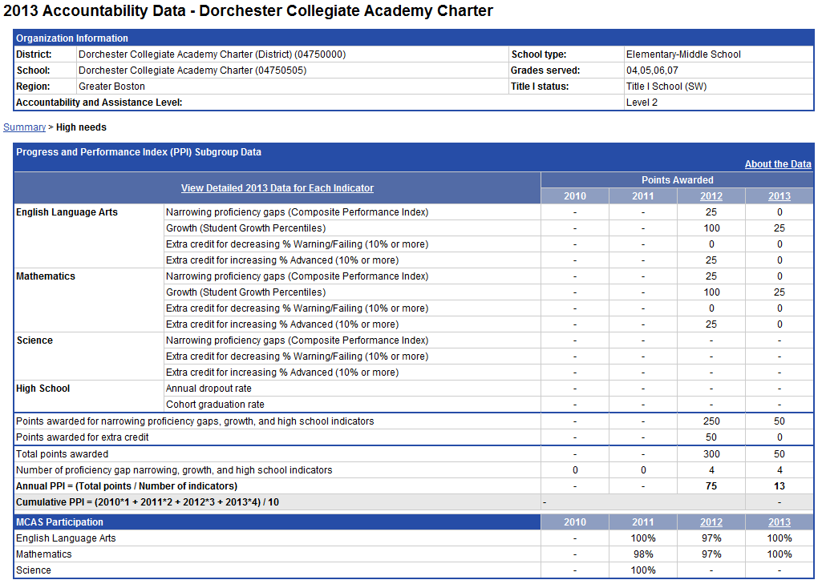
The charter accountability table (below) provides several sets of data relative to charter school MCAS performance as well as student demographics and indicators. The composite performance index (CPI) and the student growth percentile (SGP) are provided in the aggregate over the term of the charter. The school’s accountability level and cumulative progress and performance index (PPI) are shown if available (this depends on the size and the age of the school). Student enrollment and demographic data are also provided for the available years of the charter term. For detailed definitions of accountability terms, please visit this URL: http://profiles.doe.mass.edu/accountability/report/aboutdata.aspx#AccountabilityInformation

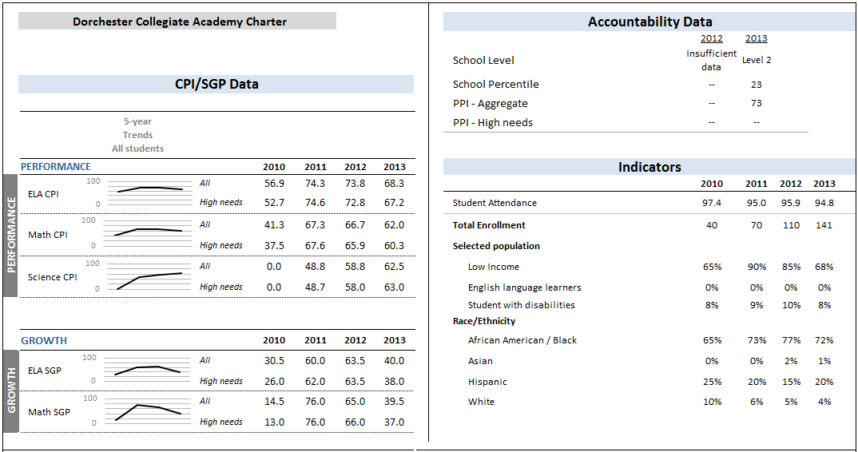

Appendix D: Financial Dashboard (Criterion 10: Finance)
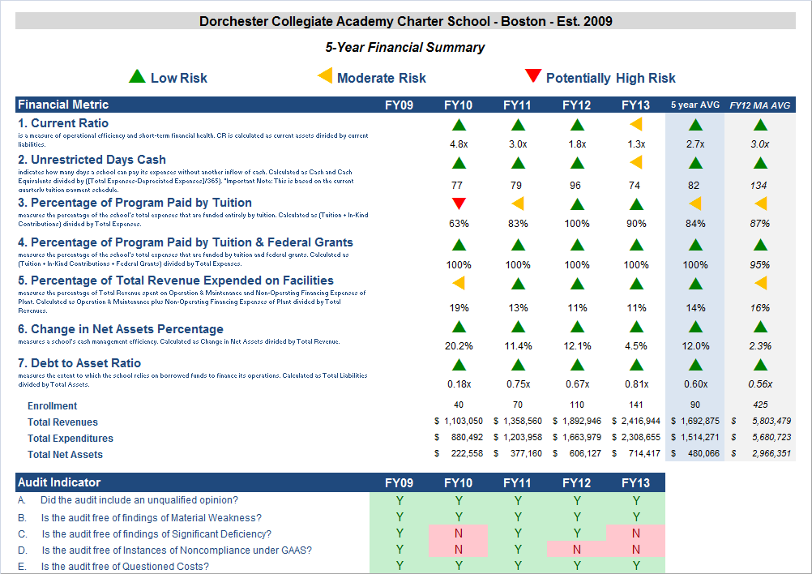

Appendix E: Dorchester Collegiate Academy Charter School Response To Summary of Review

Dorchester Collegiate Academy Charter School (DCACS) welcomes the Charter School Renewal process and believes the Renewal Inspection Report and the Summary of Review present an overall accurate picture of the current state of DCACS.

In addition, DCACS believes that the findings in the Mission and Key Design Elements section do not accurately reflect the implementation of several of the DCACS’s key design elements. DCACS believes the majority of the Mission and Key Design Elements are fully embedded (while also acknowledging that there are areas to improve in the implementation of these elements).

As a result, DCACS respectively requests the Summary of Review revise its rating of Falls Far Below in the Mission and Key Design Elements section to a rating of Partially Meets.

Below are specific findings and DCACS’s response to these findings to support DCACS’s request for this revision:

Response #1: Page 5, Paragraph 2:
“The charter included seven elements to achieve academic excellence: a standards-based curriculum; interdisciplinary themes and inquiry based projects; an Aristotelian approach; project oriented cooperative learning; small classes and differentiated instruction; a focus on literacy; and performances of genuine understanding. With the exception of a standards-based curriculum and small class sizes of under 20 students, these elements are not fully embedded.”

In addition, to a standards-based curriculum and small class sizes of under 20 students, DCACS believes that differentiated instruction, cooperative learning, a focus on literacy, and performances of genuine understanding are fully embedded.

Differentiated Instruction
DCACS teachers differentiate instruction on a daily basis in the following ways:
- providing students appropriately leveled Do Nows, homework, and classwork
- providing students annotated texts
- teaching a skill, concept, or idea in multiple modalities

DCACS believes the SchoolWorks site visitors did not observe these practices for 2 primary reasons:

- The Site visitors did not circulate throughout the classroom to review differentiated work. All DCACS teachers reported that site visitors observed classes by remaining in their seats for the duration of the observation, which did not provide them the opportunity to observe work that is differentiated for specific students.

- The SchoolWorks Site Visit Report noted that site visitors observed 20-30 minutes of a 50 minute class (which would have been 40%-60% of a class). However, the super-majority of DCACS classes are 90 minutes in duration. Consequently, site visitors observed only 22%-33% of an entire class. It is probable that the site visitors missed important components of classes where work might have been differentiated and observable from a seat, specifically, teaching the same skill, concept or idea in multiple modalities.

Cooperative Learning and Performances of Genuine Understanding

- DCACS would like to clarify that these two elements are not integrated everyday into every class but are fully embedded. For instance, performances of genuine understanding are used to assess student learning at the end of each unit and formal cooperative learning is selectively used in each grade based on the content being taught, pacing of a unit, and the sequence of the unit.

DCACS provided SchoolWorks with a schedule that noted when site visitors could observe cooperative learning and performances of genuine understanding. However, this schedule was not utilized and it is likely the site visitors were not present in classes that implemented cooperative learning and performances of genuine understanding. For example, the 8th grade math instructor planned a cooperative group lesson during the second day of the site visit. She reported, however, that the site visitors were not in class during this activity.

- Site visitors observed only 22%-33% of an entire class. It is possible that the site visitors were not present for the implementation of cooperative learning activities or performances of genuine understanding.

Focus on Literacy

- The following are practices that highlight DCACS’s Focus on Literacy and are evidence that a Focus on Literacy is fully embedded in DCACS’s academic program:

  - DCACS English Language Arts classes involve students reading and writing every day using a Readers and Writers Workshop model, which consistently engages students in high-interest reading and writing assignments.

  - DCACS non-English Language Arts teachers utilize common reading practices (e.g., Control the Game).

  - DCACS assesses the reading level of every student using the Fountas and Pinnell assessment system. The assessment data is used to inform classroom instruction (e.g., students receive leveled readers in science class that align with their reading level and annotated texts are provided in ELA classes for students reading below grade level).

  - DCACS implemented a Sustained Silent Reading block, where all students and teachers read for 30 minutes at the same time 4 days per days. To increase student interest in their books, students are allowed to select books at their reading level (reading levels determined by Fountas and Pinell assessment data).

- It is possible site visitors did not observe some these practices because they were in classes for 22%-33% of a class.

Response #2: Page 10-11, Paragraph 1
“Instructional staff develop annual curricular plans (scope and sequence documents), unit plans, and weekly lesson plans; however, the renewal inspection team discovered that the quality of these plans varies. Review of sample annual plans revealed that they are all aligned to the Massachusetts Curricular Frameworks (MCF). In addition to these annual plans, teachers develop unit plans and weekly lesson plans. A majority of these plans follow a similar format: an objective, Do Now, mini-lesson, and additional learning activities for each day. However, the level of detail in the plans varies. For example, some, but not all, weekly lesson plans included references to exit tickets and/or differentiation strategies. Similarly, some, but not all, unit plans included explicit references to the Common Core State Standards.”

The above language implies that the more detail in a lesson plan equates to higher quality instruction. However, DCACS allows selected teachers to vary the level of detail in their plans. More seasoned teachers are permitted to provide less detail in their plans if their instruction is consistently observed by the Headmaster and/or Instructional Coach to be of high quality. The rationale is that these more seasoned teachers do not need to spend time noting specific details in their lesson because they have a level of automaticity with their instruction that allows them to implement high quality lessons without these notations. Less seasoned teachers are expected to provide a higher level of detail so that their lessons can be reviewed and commented on before implementation.

Response #3: Page 11, Paragraph 1
“Although instructional staff are developing curricular materials aligned to the state frameworks, it is not yet clear that the curriculum is meeting the needs of all learners. The majority of weekly lesson plans do not refer to differentiation or accommodations for diverse learners.”

The above language implies that differentiation and accommodations need to be noted in lesson plans in order to be implemented in the classroom. However, DCACS teachers have a note regularly-implemented differentiation and accommodations on a separate document or, for more seasoned teachers, they implement differentiation and accommodations in the classroom without needing to document because they have developed a level automaticity (document attached).

Response #4: Page 11, Paragraph 3
“According to the school’s description of high quality instruction, instructional staff use a consistent lesson format that includes a clear and measurable objective, Do Now, learning activities (in which students extend and apply their knowledge), and an opportunity for students to reflect on the lesson. The team observed that 75 percent (n=21) of observed lessons sufficiently or consistently adhered to the school’s instructional model. “

The School’s instructional model notes that there is an overall lesson planning format that teachers use. However, this instructional model also notes that this lesson planning format is not inflexible and that teachers have the discretion to alter the model to meet learning objectives (e.g., teachers may decide to not implement a mini-lesson in order provide more time for learning activities). The above language implies that teachers are not in compliance with the instructional model, when, in fact, they are meeting expectations.

Response #5: Page 11, Paragraph 4
“The renewal inspection team found that opportunities for cooperative learning (an instructional practice outlined in the school’s charter) are rare and opportunities for student voice are inconsistent. According to the school’s description of high quality instruction, instructional staff use formal cooperative group activities that include a group goal, individual accountability, positive interdependence, equitable participation, and a closing activity. However, the site visit team observed students working in groups in just 10 percent of observed lessons, and did not observe any lessons in which students engaged in formal cooperative group activities. In contrast, the team observed teacher-led instruction in 85 percent of observed lessons and independent work in 25 percent of observed lessons.”

Please see section on cooperative groups in Response #1.

Response #6: Page 12, Paragraph 2
Finding: Over the charter term, site visitors have only observed limited evidence that instruction is differentiated to meet the needs of all learners.

In the school’s charter, a key instructional methodology is differentiated instruction. Throughout the charter term, however, site visit teams have not seen consistent evidence of differentiation. The renewal inspection team found that core instruction is not consistently differentiated. According to the school’s description of high quality instruction, instructional staff differentiate learning activities to allow students to access the curriculum. That description also states that teachers will engage in team teaching and multi-modal instruction to better meet the needs of all learners. While the renewal inspection team observed some evidence of team-teaching and multi-modal instruction, the team observed evidence of differentiation in only 20 percent of observed lessons. In the majority of observed lessons, students were working on the same tasks with the same levels of support.“

Please see section on differentiation in Response #1

1 The names of each of these schools and additional subgroup detail can be found in the CHART (CHarter Analysis and Review Tool), expected to available early in 2014 and upon request. For a charter school that draws more than 20% of its students from a district outside the districts specified in its charter, comparison schools from these districts are also included. This only occurs with two schools located in Cambridge which draw more than 20% of their students from Boston.
The midpoint value of all the comparison schools for the percent of students enrolled.
³ The percentage of attrition, or rate at which enrolled students leave the school between the end of one school year and the beginning of the next.
4 A student is high needs if he or she is designated as either low income, or ELL, or former ELL, or a student with disabilities. A former ELL student is a student not currently an ELL, but had been at some point in the two previous academic years.

