7/8/14

The Massachusetts Foundation Budget

In Massachusetts, the definition of an adequate spending level for a school district is called its “foundation budget.” It is a statistical measure that was developed by a group of superintendents and an economist in the early 1990s. They developed a “model school budget” which quantified “for the average school district what constitutes an adequate—but not excessive—level of funding.” The goal of the Chapter 70 formula is to ensure that every district has sufficient resources to meet its foundation budget spending level, through an equitable combination of local property taxes and state aid.

Each district’s foundation budget is updated each year to reflect inflation and changes in enrollment. Enrollment plays an important role not just because of the total number of pupils, but also because there are differences in the costs associated with various educational programs, grade levels, and student needs. Districts differ greatly in the percentages of their student population that fall into these enrollment categories. As a result, when districts’ foundation budgets are presented in per pupil terms, there is considerable variation. The FY15 statewide average is $10,486 per pupil, but the range for academic districts is from $8,608 in Carlisle to $12,376 in Boston. Vocational districts, whose programs are more expensive, range from $14,672 to $19,394.

The FY15 foundation budget continues the major changes to the calculations first implemented in FY07. The changes directly aligned the foundation budget categories with the chart of accounts which schools use to track how they spend their money.

It is notable that since FY05, charter school tuition rates have relied upon foundation budgets calculated for each sending district’s pupils at each charter school.

How the Foundation Budget Is Calculated

A district’s foundation budget is derived by multiplying the number of pupils in fourteen enrollment categories by cost rates in eleven functional areas. Any district’s FY15 calculations can be seen on the “foundation budget” link available in the FY15 Chapter 70 formula spreadsheet. Here we use the Marshfield school district’s calculations as an example.

Foundation Enrollment

Any given year’s foundation enrollment is a count of the number of pupils for whom a school district is financially responsible, on October 1st of the previous year. It is comprised primarily of local resident school-children attending their community’s local or regional school district. However, the measure also includes students for whom the district is paying tuition, at Commonwealth charter schools, other school districts, special education schools and other settings. It does not include tuitioned-in students from other districts, because their home districts are paying for those students’ costs.

The columns going across the page are the fourteen enrollment categories used in the foundation budget calculation.

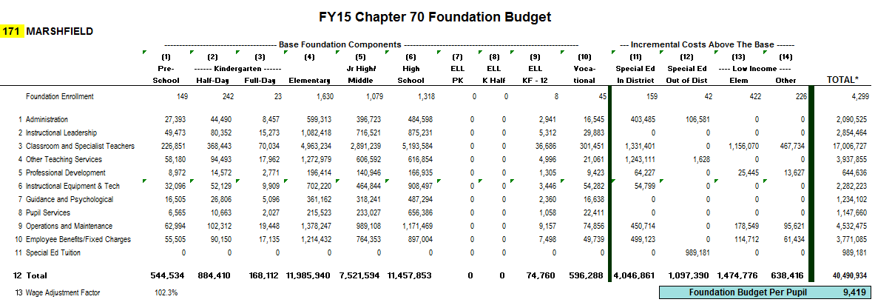

Based upon the pupil-specific information submitted by each school district to the Massachusetts Department of Elementary and Secondary Education, a student is classified as being in one of the following categories, which appear in columns 1 through 10 of the report.

Column | Description
1 | regular education or special education pre-kindergarten
2 | regular or special education half-day kindergarten
3 | regular or special education full-day kindergarten
4 | regular or special education elementary (grades 1-5)
5 | regular or special education junior high/middle (grades 6-8)
6 | regular or special education senior high (grades 9-13)
7 | limited English pre-kindergarten
8 | limited English half-day kindergarten
9 | limited English (grades 1-12)
10 | vocational education (grades 9-12)

These headcounts are used to compute total foundation enrollment at the far right of the report. Note that for the purpose of computing this total, pre-school and half-day kindergarten categories count as .5 full-time equivalent pupils because they typically attend for half the school day. For example, Marshfield’s total foundation enrollment of 4,299 (shown in the last column on the right) counts its 149 pre-schoolers (columns 1 and 7) as 75 pupils; and its 242 half-day kindergartners (column 2) count as 121 pupils.

In columns 11 through 14 there are four cost increment categories that are intended to reflect the additional resources needed to educate special education and low-income students. These students have already been counted in columns 1 through 10, and are therefore not added to total enrollment.

- Assumed in-district special education enrollment (column 11) is set at 3.75 percent of foundation enrollment (not including pre-kindergarten and vocational pupils) and 4.75 percent of vocational enrollment. These headcounts are “assumed” rather than actual counts of pupils, an approach which is practiced in other states around the country.

- Assumed out-of-district special education enrollment (column 12) is set at one percent of total foundation enrollment (again not including pre-kindergarten and vocational pupils).

- Low-income status is reported on the basis of eligibility for free and reduced lunch programs. The FY15 increment for grade 1 to 8 low income students (column 13) is $3,422 per pupil. The FY15 increment for grade 9 to 12 low income students is $2,767 (column 14). Massachusetts has been ranked as having the highest such poverty factors in the nation.

Associating a cost with each enrollment category and function

Each pupil generates a specific cost in each functional category. The costs are higher at the upper grades. They are also higher in the limited English and vocational programs. Special education and low-income increments add substantial costs as well.

A summary of the assumptions underlying foundation rates describes how all eleven categories are derived. The largest dollar amount is represented by the class size and salary assumptions for teachers. The statutory class sizes of 22 for elementary, 25 for junior high/middle, and 17 for high school remain in effect. The FY94 teacher salary of $38,000 has been factored up by inflation so that in FY15 it stands at $65,929.

The Wage Adjustment Factor

The “wage adjustment factor” gives a district credit for having higher school costs if it is located in a geographic area where average wages are higher than in other areas of the state. In theory it is more expensive for them to attract teachers and other staff to come to work there, because the cost of living is higher. Massachusetts is one of the few states in the country to use such a factor.

The wage factor is calculated using the latest available average wage data supplied by the state’s Department of Employment. The factor reflects a town’s own average, but is much more heavily weighted to the average of the “labor market area” the town is located in. There are 23 labor market areas used. There are real differences in these averages, which represent the combined total for all industries both private and public.

 | CY12 | CY12 | CY12
Labor Market Area | Wages | Employment | LMA Avg
unassigned | 157,958,280 | 4,644 | 34,013
Great Barrington, MA LMA | 478,595,587 | 13,437 | 35,618
Tisbury, MA LMA | 348,462,856 | 8,038 | 43,352
Nantucket County/town LMA | 291,026,431 | 6,031 | 48,255
Amherst Center, MA Micropolitan NECTA | 750,266,716 | 16,825 | 44,592
Athol, MA Micropolitan NECTA | 201,688,512 | 5,688 | 35,459
Barnstable MA Metropolitan NECTA | 4,038,219,422 | 98,679 | 40,923
Boston-Cambridge-Quincy, MA NECTA Division | 120,703,890,349 | 1,698,769 | 71,054
Brockton-Bridgewater-Easton, MA NECTA Division | 3,971,479,991 | 88,138 | 45,060
Framingham, MA NECTA Division | 11,206,128,705 | 156,599 | 71,559
Greenfield, MA Micropolitan NECTA | 575,553,829 | 16,028 | 35,909
Haverhill-North Andover-Amesbury, MA-NH NECTA Division | 2,103,685,946 | 45,772 | 45,960
Lawrence-Methuen-Salem, MA-NH NECTA Division | 1,810,794,105 | 40,891 | 44,283
Leominster-Fitchburg-Gardner, MA Metropolitan NECTA | 1,892,391,706 | 47,708 | 39,666
Lowell-Billerica-Chelmsford, MA-NH NECTA Division | 7,388,311,923 | 115,169 | 64,152
Nashua, NH-MA NECTA Division | 133,268,880 | 3,322 | 40,117
New Bedford, MA Metropolitan NECTA | 2,835,052,240 | 67,163 | 42,212
North Adams, MA-VT Micropolitan NECTA | 456,097,071 | 11,820 | 38,587
Peabody, MA NECTA Division | 4,841,946,848 | 101,072 | 47,906
Pittsfield, MA Metropolitan NECTA | 1,495,032,346 | 35,344 | 42,299
Providence-Fall River-Warwick, RI-MA Metropolitan NECTA | 3,715,017,352 | 95,182 | 39,031
Springfield, MA-CT Metropolitan NECTA | 10,683,509,401 | 246,823 | 43,284
Taunton-Norton-Raynham, MA NECTA Division | 2,080,051,913 | 43,637 | 47,667
Worcester, MA-CT Metropolitan NECTA | 11,255,369,843 | 232,594 | 48,391
State Total | 193,413,800,252 | 3,199,373 | 60,454

A district’s wage factor is a percentage that is applied to the eight salary-related functional categories in the foundation budget. The labor market area for a district is compared to the state average and weighted at 80 percent. The town’s own factor is weighted at 20 percent. The distance above or below the state average is then divided by three to determine the wage adjustment factor.

Prior to FY2000, districts in lower-wage areas saw significant reductions in their foundation budgets, by as much as ten percent. Since then, annual budget language has cushioned districts from these reductions, to the point where beginning in FY04, only those with above-average wages have been affected by the wage adjustment factor. Those below the average are set to 100 percent. In FY15, 115 municipalities in just three labor market areas are affected:

Boston/Cambridge/Quincy NECTA division
Framingham
Lowell/Billerica/Chelmsford NECTA division

A district’s wage factor appears at the bottom left of its foundation budget report. Marshfield’s wage factor is 102.3 percent.

FY15 Foundation Budget: Massachusetts State Totals

After applying the wage factor, the statewide total for all school districts in FY15 is $9,866,011,311. Teaching makes up 45 percent. The six instructional categories (instructional leadership, teachers, other teaching services, professional development, instructional materials/technology, and guidance/psychological) account for a combined 70 percent.

FY15 Foundation Budget by Category
Category | Dollars | Pct of Total
Administration | 457,847,083 | 4.6
Pupil Services | 242,076,375 | 2.5
Maintenance | 1,132,013,033 | 11.5
Benefits | 917,613,023 | 9.3
Special Education Tuition | 207,845,782 | 2.1
Instructional Leadership | 624,728,305 | 6.3
Teachers | 4,472,408,521 | 45.3
Other Teaching Services | 866,293,117 | 8.8
Professional Development | 160,033,777 | 1.6
Instructional Materials | 514,461,912 | 5.2
Guidance/Psych Services | 270,690,383 | 2.7
Total | 9,866,011,311 | 30.0

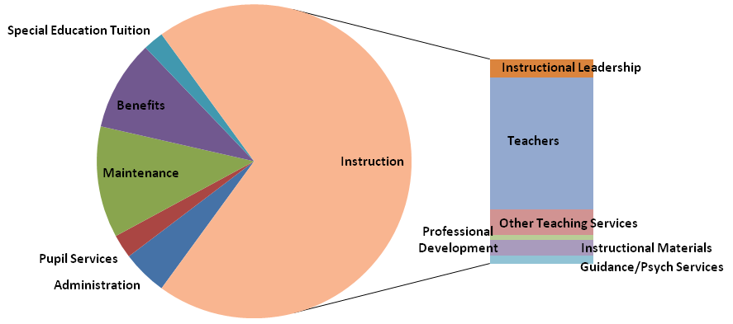

FY15 Foundation Budget: District Results

When presented in per pupil terms there is considerable variation among districts in their foundation budgets. After separating out vocational districts as a separate category, urbanized centers are higher than other types of districts by more than $1,400 per pupil.

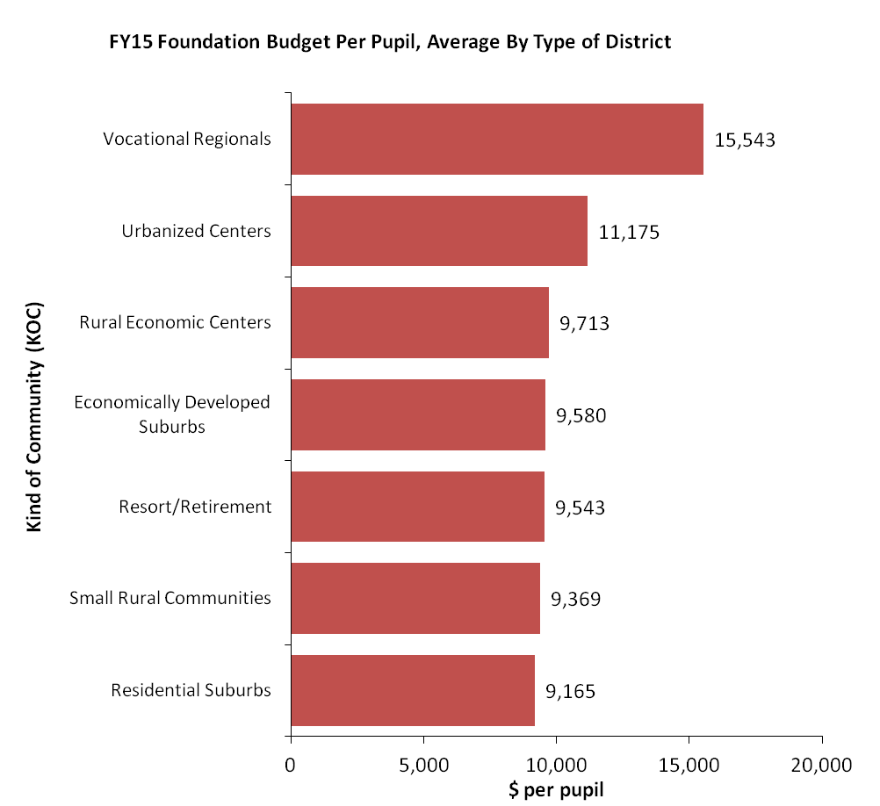

Contacts

Melissa King | 781-338-6532 | mking@doe.mass.edu | Chapter 70
Roger Hatch | 781-338-6527 | rhatch@doe.mass.edu | Chapter 70
Hadley Cabral | 781-338-6586 | hcabral@doe.mass.edu | Charter School Finance

Edward Moscovitch, “Model School Budget”. Cape Ann Economics, Rockport, Massachusetts, 1992, p1.
For example, FY15 foundation enrollment is based upon Oct 1, 2013 headcount. The one-year lag is necessary because the next year’s enrollment is not known until after the state budget is finalized.
If a town is a member of a regional vocational district, its resident pupils at that district are not counted in local district enrollment. The vocational district reports those pupils and Chapter 70 aid goes directly to the vocational district. Post-graduate and post-secondary pupils in programs run by vocational districts may be counted if they pay less than the state-approved tuition rate.
Verstegen, D. A. (2011) “Public education finance systems in the United States and funding policies for populations with special educational needs”. Education Policy Analysis Archives, 19 (21). Retrieved 7/5/2012, from http://epaa.asu.edu/ojs/article/view/769. As of 2011, 5 states used a “census-based approach” similar to Massachusetts.
Kevin Carey, “The Funding Gap 2004.” The Education Trust, Special Report: Washington, DC. 2005, p.13.
The wage factor is not applied to instructional equipment, employee benefits, or special education tuition.

