Global Learning Charter Public School
Year 8 Site Visit Report

New Bedford, MA
February 12, 2015

Massachusetts Department of Elementary and Secondary Education
75 Pleasant Street
Malden, MA 02148
Phone: (781) 338-3227
Fax: (781) 338-3220

This document was prepared by the
Massachusetts Department of Elementary and Secondary Education
Mitchell D. Chester, Ed.D.
Commissioner

The Massachusetts Department of Elementary and Secondary Education, an affirmative action employer, is committed to ensuring that all of its programs and facilities are accessible to all members of the public.
We do not discriminate on the basis of age, color, disability, national origin, race, religion, sex, gender identity, or sexual orientation.
Inquiries regarding the Department’s compliance with Title IX and other civil rights laws may be directed to the
Human Resources Director, 75 Pleasant St., Malden, MA 02148-4906. Phone: 781-338-6105.

© 2015 Massachusetts Department of Elementary and Secondary Education
Permission is hereby granted to copy any or all parts of this document for non-commercial educational purposes. Please credit the “Massachusetts Department of Elementary and Secondary Education.”

This document printed on recycled paper

Massachusetts Department of Elementary and Secondary Education
75 Pleasant Street, Malden, MA 02148-4906
Phone 781-338-3000 TTY: N.E.T. Relay 800-439-2370
www.doe.mass.edu

Table of Contents

Charter School Performance Criteria: Global Learning Charter Public School 1
Introduction 2
Findings: Charter School Performance Criteria 5
Faithfulness to Charter 5
Mission and Key Design Elements 5
Access and Equity 6
Academic Program Success 6
Program Delivery 7
Curriculum 7
Instruction 8
Culture and Family Engagement 12
Organizational Viability 13
Capacity 13
Governance 15
Appendix A 16
Accountability Plan Performance 16
Appendix B 19
Criterion 2: Access and Equity 19
Appendix C 24
Criterion 5: Student Performance 24
Appendix D 28
Criterion 10: Finance 28

Charter School Performance Criteria: Global Learning Charter Public School

● Exceeds | ● Meets | ● Partially Meets | ● Falls Far Below

Massachusetts Charter School Performance Criteria |  |  | Rating
Faithfulness to Charter | - Mission and Key Design Elements: The school is faithful to its mission, implements the key design elements outlined in its charter, and substantially meets its accountability plan goals. |  | ● Meets
 | - Access and Equity: The school ensures program access and equity for all students eligible to attend the school. |  | ● Partially Meets
Academic Program Success | - Student Performance: The school consistently meets state student performance standards for academic growth, proficiency, and college and career readiness. |  | ● Partially Meets
 | - Program Delivery: The school delivers an academic program that provides improved academic outcomes and educational success for all students. | Curriculum | ● Partially Meets
 |  | Instruction | ● Partially Meets
 |  | Assessment and Program Evaluation | ● Partially Meets
 |  | Supports for Diverse Learners | ● Meets
 | - Culture and Family Engagement: The school supports students’ social and emotional health in a safe and respectful learning environment that engages families. | Social, Emotional and Health Needs | ● Meets
 |  | Family Engagement | ● Meets
Organizational Viability | - Capacity: The school sustains a well-functioning organizational structure and creates a professional working climate for all staff. | School Leadership | ● Meets
 |  | Professional Climate | ● Meets
 |  | Contractual Relationships (If applicable) | N/A
 | - Governance: Members of the board of trustees act as public agents authorized by the state and provide competent and appropriate governance to ensure the success and sustainability of the school. |  | ● Meets

Introduction

School Profile

Global Learning Charter Public School (GLCPS)
Type of Charter  (Commonwealth or Horace Mann) | Commonwealth | Location | New Bedford
Regional or Non-Regional? | Non-Regional | Districts in Region  (if applicable) | N/A
Year Opened | 2007 | Year(s) Renewed  (if applicable) | 2012
Maximum Enrollment | 500 | Current Enrollment | 508
Chartered Grade Span | 5-12 | Current Grade Span | 5-12
Students on Waitlist |  | Current Age of School | 8 years old
Mission Statement
The mission of Global Learning Charter Public School is to ensure that all students achieve academic excellence, are ready for the rigors of higher education, and master essential skills that prepare them for the economic, social, and civic challenges of a 21st century, global society. Our central mission is to teach and inspire the mind, body, and spirit of our students so that they can succeed in any cultural or academic setting.

School Setting
GLCPS opened as a Commonwealth charter school in 2007. Previously, GLCPS operated as a Horace Mann charter school from 2002-2007. In January 2012, the Commissioner of Elementary and Secondary Education (Commissioner) renewed the charter of GLCPS with conditions. In January 2014, the Board of Elementary and Secondary Education determined that the school had not met conditions related to academic performance and placed the school on probation, directing it to meet a set of three conditions. The school has received a number of targeted site visits since its renewal in 2012 to monitor progress on conditions. The school’s performance on the conditions is noted below. GLCPS operates two campuses in New Bedford.

Demographics (2014-2015)
The school reports the following racial and ethnic composition and percentages of selected populations of the student body as of the date of the site visit:
 | Number of Students | Percentage of Student Body
African American | 64 | 12.6%
Asian | 9 | 1.8%
Hispanic | 144 | 28.3%
Native American | 4 | 0.8%
White | 266 | 52.4%
Native Hawaiian, Pacific Islander | 0 | 0%
Multi-race, non-Hispanic | 21 | 4.1%
Special education | 69 | 13.6%
Limited English proficient | 36 | 7.2%
Low income | 325 | 64.0%
The following participants conducted the site visit on February 12, 2015:
- Alison Bagg, Department of Elementary and Secondary Education (DESE), Office of Charter Schools and School Redesign (OCSSR)
- Puja Garg, DESE, OCSSR
- Melissa Gordon, DESE, OCSSR
- Eleanor Rounds, DESE, OCSSR
- Maureen Chapman, Rising Tide Charter Public School
Before the visit, the site visit team reviewed the school’s 2013-14 annual report, Year Seven site visit report and the Year Five Summary of Review, the school’s accountability plan, board materials and minutes, and recent internal and external assessment data. On site, the team reviewed curricular documents and other information provided by the school. The team conducted approximately 29 classroom observations and interviewed trustees (7), administrators (9), special education/ELL administrators (2), general education teachers (10), special education/ELL teachers (5), families (14), and students (10).

The Charter School Performance Criteria (Criteria) are presented in the three guiding areas of charter school accountability defined in the current regulations, 603 CMR 1.00: academic program success, organizational viability, and faithfulness to charter. The purpose of this visit was to:
- corroborate and augment the information contained in the school’s annual report,
- assess the school’s progress relative to its accountability plan goals,
- collect information that will help the Commissioner and Board of Elementary and Secondary Education make a renewal recommendation for the school’s charter, and
- gather evidence and create findings that represent the school’s performance in relation to the Criteria; and
- review the progress that the school has made in meeting the conditions imposed.

This report contains evidence relating to a sub-set of the Criteria; Criterion 1 (Mission and Key Design Elements), Criterion 2 (Access and Equity), Criterion 5 (Student Performance), Criterion 6 (Program Delivery), Criterion 7 (Culture and Family Engagement), Criterion 8 (Capacity), and Criterion 9 (Governance). Ratings that encapsulate a school’s performance in terms of these criteria are found on the first page this report. Evidence related to Criteria 2, 5, and 10 is appended to this report. Evidence for all other criteria is contained below in the narrative site visit report. The report on probationary conditions begins on the next page.

Review of Progress Made Towards Meeting the Conditions Imposed

As noted above, GLCPS is currently on probation and must meet three conditions. This section of the report lists the conditions and GLCPS’s progress towards meeting the conditions.

Condition 1: No later than April 30, 2014, the school shall submit to the Office of Charter Schools and School Redesign a comprehensive evaluation of the school’s mathematics and English language arts programs conducted by an external consultant, accepted and approved in advance by the Department.

Status: Met
On April 7, 2014, GLCPS submitted a comprehensive evaluation conducted by an external consultant group that had been accepted and approved by the Department in advance. The results of the comprehensive evaluation have driven changes in governance, professional development, use of assessment data, and created an emphasis on vertical alignment of the curriculum.

Condition 2: No later than June 15, 2014, the school shall submit to Department, and receive approval from the Department for, an action plan that specifies strategies to improve mathematics and English language arts performance. The action plan must include a timetable for the implementation of actions, must set deadlines for the completion of key tasks, and must set clear and specific implementation benchmarks to allow the school’s board of trustees and the Office of Charter Schools and School Redesign to monitor implementation.

Status: Met
GLCPS submitted an action plan on June 2, 2014. The school has worked with the firm hired to conduct the comprehensive evaluation to create the action plan. After feedback from the Department, the action plan was finalized on June 11, 2014.

Condition 3: The school must demonstrate that it is an academic success by September 30, 2015, by providing evidence that the school has met or is making substantial progress toward meeting benchmarks in its approved Accountability Plan and, in particular, has demonstrated significant and sustained academic improvement in mathematics and English language arts.

Status: Ongoing
In 2012 and 2013, GLCPS’s MCAS scores placed the school in Level 3. In 2014, GLCPS’s performance improved to place it in Level 2. In 2014, GLCPS is in the 27th percentile when compared to other middle/high schools statewide. While the school did not meet a majority of its gap narrowing targets in 2014, the school’s median student growth percentiles (SGPs) were above the state median of 51. The school’s academic data are found in Appendix C of this report.

Findings: Charter School Performance Criteria

Faithfulness to Charter

Criterion 1 | Rating
Mission and Key Design Elements  The school is faithful to its mission, implements the key design elements outlined in its charter, and substantially meets its accountability plan goals. | ● Meets

Finding: Stakeholders reported a generally consistent understanding of the school’s mission. GLCPS has implemented a number systems and structures to support the school’s mission.

In Year Eight, a majority of stakeholders shared a generally consistent understanding of the school’s mission: college and career readiness and 21st century skills. Some stakeholders mentioned other aspects as well that were considered key design elements, such as: arts exploration, a community feel where all students are known, global citizenship, and student centered teaching. The two most common mission-driven elements mentioned by stakeholders are discussed in greater detail below.

College and Career Readiness
Board members, administrators, students, and parents identified college and career readiness as the school’s primary goal. Stakeholders defined college and career readiness as students’ preparation for the rigors of college. Administrators noted that the school’s high school program has more requirements than the Mass Core. Board members and administrators pointed to recent and proposed changes to the high school program to promote academic excellence, such as the addition of more Advanced Placement courses. While the school aims to prepare students for college, stakeholders emphasized that they recognize that college is not the ultimate goal for all students. Administrators noted that the school helps students to identify goals beginning in 7th grade to determine if a vocational program, the district high school, or GLCPS would be a good fit. To support college preparation, stakeholders reported that the school provides rigorous instruction that aims to equip students with 21st century skills (see below). Teachers (including regular education, special education, and ELL teachers) did not refer to this component of the school’s mission in their description of the broader school goals.

21st Century Skills
Administrators stated that they aim to teach students five key components of 21st century skills: public speaking, technological literacy, arts exploration, global citizenship, and academic excellence. The school has systems and structures in place to teach 21st century skills on a daily and ongoing basis. Students prepare for interdisciplinary presentations of learning (POLs) throughout the year in which they must publically present a project. Additionally, the school implements an advisory program, offers advanced placement (AP) courses, provides students with access to laptops, encourages citizenship through community service work, and includes daily exploratory periods (art, music, PE, martial arts) in students schedules.

In addition to the mission driven aspects described above, all stakeholders identified the safe and supportive culture and community at GLCPS as one of the school’s key design elements. All stakeholders reported that the school provides a safe environment where all students are well known by all teachers and their classmates. Parents and guardians praised the school for its “small community feel” and reported that the school provides lots of academic and social-emotional supports for the students.

Finding: GLCPS met a majority of the measures contained in its accountability plan.

The school’s approved accountability plan includes 3 objectives and 15 measures. GLCPS met 8 out of 15 measures. More information about the school’s success in meeting the objectives and measures contained in its accountability plan can be found in Appendix A, Accountability Plan Performance, of this report.

Criterion 2 | Rating
Access and Equity  The school ensures program access and equity for all students eligible to attend the school. | ● Partially Meets

Finding: The school ensures program access and equity for all students eligible to attend the school, with a few limitations.

GLCPS communicates with families to ensure access and equity for all students. While the school’s website has the ability to be translated into a wide variety of languages, it lacks information regarding the availability of services for special education and English language learner (ELL) students. The school provides a variety of translated documents including, but not limited to, admissions applications and recruitment information. Additionally, oral interpreters are available as needed for families.

Enrollment of students in the low income, ELL, and students with disabilities subgroups are at or above the comparison schools. Attrition for all students and high needs students is below the median of comparison schools. The school has received Department approval for their recruitment and retention plan for the current school year.

Academic Program Success

Criterion 5 | Rating
Student Performance  The school consistently meets state student performance standards for academic growth, proficiency, and college and career readiness | ● Partially Meets

Finding: In 2014, GLCPS’s MCAS scores did not meet state student performance standards for academic growth and proficiency.

In 2014, GLCPS’s MCAS results placed it in Level 2; GLCPS is in the 27th percentile relative to other schools statewide. The school’s CPI for 2014 was 87.2 in ELA, 74.9 in mathematics, and 70.6 in science and technology. In 2014, 67 percent of GLCPS students scored in the Proficient and Advanced categories on the ELA assessment, below the state average. In mathematics, 47 percent scored Proficient and Advanced, below the state average. The school’s SGP for 2014 was 55.0 in ELA, above the state median of 50, and 56.0 in mathematics, above the state median of 50. Please refer to Appendix C for detailed student academic performance data over the charter term.

Criteria 6

Program Delivery
The school delivers an academic program that provides improved academic outcomes and educational success for all students.

Key Indicators | Rating
Curriculum  The school’s documented curriculum is aligned to state curriculum frameworks and expectations; is aligned vertically between grades and horizontally across classrooms at the same grade level; is fully implemented in classrooms; and supports opportunities for all students to master these skills and concepts. The curriculum is regularly reviewed and revised. | ● Partially Meets

Finding: As directed by the school’s action plan, GLCPS has worked for the past year to document a curriculum that is aligned with the 2011 MCF. This work appears to still be in process, as documentation viewed by the team did not align with administrator expectations. There are systems in place to review and revise the curriculum; however, teachers have not yet received feedback on the newly created curriculum documentation.

During the past year, the school has taken steps to align and document its curriculum. A major goal of the school’s current action plan is to redevelop “the curriculum to serve needs of all students” in both ELA and math. The action plan lists the following steps as complete: 1. Redevelop curriculum maps to ensure alignment to 2011 Frameworks, 2. Construct model curriculum units based on newly designed maps. Based on site visitor review of documentation provided, it is unclear if these steps have been accomplished to meet the expectations of the action plan.

Currently, an administrator reported that the curriculum binders are expected to include several teacher-created documents: a course/unit overview, a curriculum map showing alignment to the MCF, supporting materials, and sample student work. Upon reviewing the curriculum binders, the site visit team found inconsistent documentation; all binders did not include each of the expected elements. Further, while vertical alignment was not apparent or documented, curriculum documentation showed horizontal alignment at each grade level. The school is currently in the process of developing an ESL curriculum and has a WIDA implementation plan in place.

According to school’s action plan and all stakeholders, school staff collaborate to review and revise the curriculum formally during the summer and informally during the school year. Teachers and administrators reported that expectations for curriculum documentation are created and overseen by the director of curriculum. Teachers reported that they spent a significant amount of time in the beginning of the year developing curriculum documents, per the action plan, however, they have not yet received feedback on their work.

Instruction  The school staff has a common understanding of high-quality instruction. Instructional practices are aligned to this common understanding and are based on high expectations for all students. Instruction fosters student engagement. Classroom environments are conducive to learning. | ● Partially Meets

Finding: Not all staff members have a common understanding of school instructional expectations. Site visitors saw a range of implementation of the administration’s expected instructional expectations.

GLCPS staff members did not have a common understanding of the school’s instructional expectations. Administrators and general education staff shared a common approach to and philosophy about instruction, including: posted objectives/clear expectations, differentiation, and the gradual release of responsibility model. The school’s special education and ELL teachers’ approach to and philosophy about instruction included project-based lessons, higher order thinking and differentiation in every lesson. The above groups reported a variety of high quality instructional strategies; the only common strategy mentioned was differentiation.

In preparation for the visit, the school created a written description of the school’s instructional philosophy and expectations. On the day of the visit, the principal narrowed the expectations to the following: posted objectives; formative assessments; gradual release of responsibility model; technology and differentiation. Site visitors observed 29 lessons. The degree to which each of the expected elements was observed is presented below.

Posted objectives
Over half of all classrooms observed had objectives posted that related to the instruction in the classroom. Approximately 12 classrooms did not have a posted learning objective or posted an agenda of topics rather than a clear learning outcome for the class.

Formative Assessments
Site visitors observed a minority of classrooms using formative assessments to check student understanding during classroom observations. The two types of formative assessments viewed in classrooms were a multiple choice and short answer assessment and electronically submitting class work to the teacher at the end of class.

Gradual Release of Responsibility Model
The principal described elements site visitors should observe in the Gradual Release of Responsibility Model, including: direct instruction, guided practice, collaborative practice and independent practice. Site visitors observed at least one aspect of the model being implemented in eleven classrooms. Of the eleven classrooms using elements of the model, over half utilized independent practice and guided practice; direct instruction and collaborative practice were utilized in the remaining five classrooms.

Technology
In over half of the classrooms viewed, site visitors observed teachers and/or students using technology. These classrooms used technology to present material by using the document camera, SMART board or through a video clip or Powerpoint presentation. In a minority of classrooms students used laptops or computers to complete work.

Differentiation
All stakeholders reported an instructional shift towards co-teaching in ELL or special education classrooms to support all learners and the principal emphasized differentiation was essential to reach all learners. Based on classroom observations, site visitors viewed supports for all learners in the majority of classrooms. The majority of classrooms provided visual supports, such as typed notes, graphic organizers and word banks. In the minority of classrooms, students and teachers used technology (as described above) and there was more than one adult in the classroom. In three classrooms, the additional adult was not utilized effectively. Other methods teachers used to differentiate lessons include providing extension activities, modeling, small group work with a teacher, and teachers assisting struggling students individually. Students also participate in FOCUS group blocks, which are individualized to match student needs in ELA and math.

Finding: Approximately less than half the observed classes reflected high expectations for all students.

As noted above, in Curriculum, the school is taking steps to align and document its curriculum. Curriculum binders are teacher created and contained inconsistent documentation. As implemented, less than half of all classes observed provided grade-level standards and instructional practices that allowed students to engage with academic content by interacting, creating or analyzing content. Over half of all classes did not reflect high expectations for students or objectives for learning. In these classes, teachers prompted students for factual answers, students were not asked to support their answers with evidence, students responded to open-ended writing prompts with 1-2 sentence written answers, students were not encouraged to speak the language during language class, and students read below grade level texts. The student focus group reported the level of rigor in the classroom varied according to the teacher.

Finding: A majority of classrooms were found to provide environments conducive to learning. Student engagement with academic content varied between classes.

The majority of classrooms have established environments conducive to learning. These classrooms reflected the school’s vision of a safe and supportive classroom and school culture. Classes were characterized by respectful interactions between all members and calm, organized environments. A casual environment or lack of respectful student behavior impacted the learning environment in approximately seven classrooms.

Site visitors observed that student engagement with academic content varied from class to class. During half of classroom observations, students were observed to be on task (listening, taking notes, participating in discussions or working collaboratively) and in the other half of classrooms, students were observed to be off-task (not following teacher directives, engaging in off-topic conversations and activities or delayed initiation of work).

Assessment and Program Evaluation  The school uses a balanced system of formative and benchmark assessments. The school uses qualitative and quantitative data to improve student outcomes as well as to evaluate the quality and effectiveness of the program in serving all students and modifies the program accordingly. | ● Meets

Finding: Beginning last year, the school implemented a benchmark assessment system. The school is in the formative stages of using assessment data to improve student outcomes.

A major component of the school’s action plan is to identify and support students who are struggling or at risk. An action step for this strategy is to implement the school’s assessment and data tracking system. Last year, GLCPS began implementing benchmark testing using STAR assessments in both math and ELA. At the time of the site visit, the school had administered both subjects twice and planned to do 4 total math and 3 total ELA testing sessions by the end of the year. Administration reported the school uses STAR assessments as a predictor of student CPI on MCAS tests. In addition, all stakeholders reported the school uses data from teacher created assessments, such as exit tickets, projects, quizzes and tests, previous student report cards, MCAS results, current classroom grades and ACCESS tests to measure student growth.

During the fall of 2014, teachers received professional development on how to implement and understand data to improve classroom instruction. Teachers reported analyzing STAR and exit ticket data to create small, flexible student groupings and to inform differentiated instructional content in class for both math and ELA. Site visitors, however, did not see further evidence of this in classrooms. In ELA, STAR assessments provide individualized Lexile reading levels to assist teachers with selecting appropriate texts for student. All teachers reported reviewing STAR and in class assessment data to tailor instruction for intervention FOCUS block groupings. FOCUS periods are built into grade level schedules in grades five through eight and are utilized for special education pull out services, remedial skill building and general curriculum reinforcement. The after school homework club also uses the STAR data to target specific skills. During professional development, teachers are learning about communicating with students about the importance of data and using data with students to reinforce and show improvement with student goals.

Assessment data is accessible online through Google Drive. Administrators reported that for the past two to three years, the school has been collectively working towards documenting student achievement on state standards and recording this data in a shared Google document. There have been varying levels of teacher buy-in for its implementation.

Currently, there are mixed systems of assessment in use that vary by department. Additionally, use of data to inform instruction varies by department. Teachers reported the report card is non-standards based, but ELA and math teachers have created standards-based assessments. The high school is beginning to do standards-based grading and grade books and rubrics are organized by standard. History and science are not standards-based. Use of assessment data to inform instruction also varies by department. Math teachers reported a consistent system of using formative assessments, such as projects and exit tickets, to inform classroom instruction. ELA teachers reported using rubrics to evaluate student writing. However, using data to inform instruction does not yet appear to be integrated into the school-wide culture. Site visitors saw minimal evidence in classrooms of small group instruction based on assessment data.

Special education administrators reported using data from previous report cards, school reports, STAR results, MCAS and current grades to move towards a co-teaching instructional model. Special Education administrators reported substantial increases in student performance from 2013 winter data to 2014 fall STAR data by adding additional teacher supports in each grade level. ELL administration reported positive student progress in STAR data, MCAS, WIDA, ACCESS grades and ELA program standards; however, teachers reported that they have not seen adequate gains in ELL student progress. Based on this data, the school plans to integrate WIDA standards into the curriculum and create more planning time between ELL and general education teachers. Teachers reported STAR data will be used in the future to modify the general education curriculum.

Supports for Diverse Learners  The school provides supports to meet the academic needs for all students, including but not limited to students with disabilities and English language learners. | ● Meets

Finding: The school provides supports to meet the academic needs for all students. The school has continued to implement its English as a Second Language (ESL) program with fidelity.

GLCPS has a well-understood referral process for students. Stakeholders described a Response to Intervention (RTI) process that aligns with the school’s Student Support Team (SST). The SST meets bi-weekly and is composed of a range of staff members including the social workers, grade level teachers, and dean of students. Teachers are able to share concerns with the SST and then work together to develop intervention plan for the student. Students’ are monitored for a period of time before a referral for a special education evaluation is made. This process also includes the ESL teachers for any students who may have second language concerns.

GLCPS has recently refined its system of interventions for students. The school currently offers a focus block in middle school in either ELA or mathematics and an academic support class in the high school. Stakeholders report that teachers use the data from STAR assessments to target instruction for students in these classes.

GLCPS offers a wide range of supports for students including after-school and before school tutoring, homework club, peer tutoring, MCAS prep after school sessions, and a summer academy for incoming 5th graders. Site visitors observed students using technology in classes appropriately, including laptops; although classrooms experienced technical difficulties and visitors observed students struggling to get the technology to work. Site visitors also observed a wide range of accommodations in classes including graphic organizers, differentiation of materials, and visuals to support students. Additionally, GLCPS has placed renewed emphasis on a co-teaching model this school year. In grades 5-8, there is either a special education teacher or paraprofessional in either math and/or ELA classes. Although all stakeholders praised the co-teaching model, site visitor observed inconsistent and occasional ineffective use of the second adult in some classrooms. The school provides all required related services via contracted providers. GLCPS has continued to implement its ESL program with fidelity. The school provides both push and pull out ESL instruction. As of the site visit, 22 teachers have completed the Sheltered English Immersion (SEI) teacher endorsement course. Site visitors did not observe consistent implementation of SEI techniques across SEI classrooms.

Criterion 7

Culture and Family Engagement
The school supports students’ social and emotional health in a safe and respectful learning environment that engages families.

Key Indicators | Rating
Social, Emotional and Health Needs  The school creates a safe school environment and addresses the physical, social, emotional, and health needs of its students. | ● Meets

Finding: GLCPS creates a safe school environment and addresses the physical, social, emotional, and health needs of its students.

GLCPS has created a safe school environment for its students. The school employs two social workers, as well as a college and career counselor for grades 9-12, and a newly created dean of students position. The school contracts with Bay Coast Behavioral for functional behavior assessments and with an outside provider for psychological testing. Stakeholders described that the size of the school and the staff members’ ability to get to know families allows them to tackle issues as a team. Additionally, the school works with counselors from Child and Family Services in New Bedford for in school counseling for families who cannot access services outside of the school setting. Students and parents praised the school’s advisory system, noting that they appreciate having the direct connection to one adult.

All stakeholders reported, and site visitors observed, a safe and respectful learning environment. Site visitors observed respectful and caring interactions between teachers and students. Stakeholders also noted that the school has attempted to be more proactive and preventative with behavioral concerns. Administrators cited that the professional development offered last year on teaching urban learners has helped staff members establish better preventative measures for dealing with student behaviors.

GLCPS has a full time nurse on staff. The school also offers a martial art-tang so do class, and students are able to earn a black belt by the time they graduate. The building is safe and secure, with locked outside entrances.

Family Engagement  The school develops strong working relationships with families/guardians in order to support students’ academic progress and social and emotional well-being. | ● Meets

Finding: The school develops strong working relationships with families/guardians in order to support students’ academic progress and social and emotional well-being.

GLCPS has established strong working relationships with families and guardians. Stakeholders reported that this relationship begins with the 5th grade summer academy and continues throughout the year with multiple events and opportunities for families to engage with the school. Some of these events include back to school nights, cultural bazaar, exploratory extravaganza, and the global gala for scholarships. There is also a parent teacher organization (PTO) and a special education advisory council (SEPAC) that meet monthly. Additionally, this year GLCPS has begun to hold periodic ELL family gatherings in order to create more of a community and hear what their needs are for supports. GLCPS has employs a director of students, family, and community, who oversees the after-school and enrichment programs, implementation of the school’s recruitment and retention plan, provides students and family supports like the back to school night, and runs the student family life team (nurse, home school liaison, and two social workers).

Parents noted that the school staff is available and willing to communicate about concerns. Multiple stakeholders noted that parents feel welcomed in the school and that there are multiple modes of communication, including phone calls and email. Parents described the parent portal, which provides access to student grades and assignments as convenient.

Organizational Viability

Criterion 8

Capacity
The school sustains a well-functioning organizational structure, and clearly delineates roles for staff, administration, and board members.

Key Indicators | Rating
School Leadership  The school has an effective school leadership team that obtains staff commitment to improving student learning and implements a clearly defined mission and set of goals; The school defines and delineates clear roles and responsibilities among leaders, staff, management and board members, reflecting a culture of shared accountability; The school has clear and well-understood systems for decision-making and communication processes among all members of the school community. | ● Meets

Finding: Stakeholders reflected a common goal of meeting the school’s probationary conditions. Teachers expressed some concerns about shifting roles for staff and the school’s current decision-making processes.

During the visit, all stakeholders shared a common goal of meeting the conditions of probation and having probation lifted. Teachers and administration reported an emphasis on teacher community and shared accountability for all students this year. This year, the school has created a collaborative morning meeting structure during which teachers record meeting notes on a shared Google document. Teachers reported the administration is responsive to concerns and questions and supportive of first year teachers. Board members and administrators noted that they have had to balance their focus on the conditions as well as the mission. One teacher expressed uncertainty around the current vision of the school, noting that the global aspect of the mission had been deemphasized after the school began to focus on improving achievement scores.

Teachers reported some uncertainty and dissatisfaction with the changing roles of various staff. They were unclear if a recently retired high school principal would be replaced. A math coach position was not filled at the middle school this year. For instructional support in the middle school, teachers reported they refer to the director of curriculum and principal (of the middle and high schools), who are responsive to these requests. Teachers reported dissatisfaction with the elimination of the department head positions and continue to seek out former department heads for support.

Teachers reported changes in decision making over the years. According to teachers, originally decision-making was a collaborative process, then moved to a top down configuration. This year the decision making has a shifted back to a more collaborative approach, but teachers reported not always feeling included in the decision making process. Teachers reported not always knowing about changes that had been made and that their opinion was sought after decisions were made. School administrators started to use the TELL Massachusetts teacher survey to gather information regarding communication issues and is taking steps to address concerns.

Professional Climate  The school has structures for regular, frequent collaboration and professional development to improve implementation of the curriculum and instructional practice; A system is in place for monitoring instructional practice for consistency, which includes a formal process of teacher evaluation. | ● Meets

Finding: The school has daily structures for collaboration by grade level, content area, or co-teaching level. Professional development has been focused on curriculum development and the new co-teaching model. The school implements a formal process of teacher evaluation.

GLCPS has established daily staff meetings each morning, all of which provide teachers time to collaborate or receive professional development. Teachers and administrators reported meeting daily for the following meeting schedule (Monday-Friday): Professional Learning Community (PLC), grade level team, mentor, PLC, and department, respectively. During department meetings, teachers look at student work, review curricula, and scaffold lessons for all students. All stakeholders reported these morning meetings as being more formalized, with a clear agenda, than in previous years. Administrators reported, and teachers confirmed, a push towards integrating special education and ELL staff and paraprofessionals weekly into grade level meetings to support the co-teaching focus. Special education teachers reported between two to three days of professional development for co-teachers at the beginning of the year and monthly follow up co-teacher meetings, which mirror PLC groups. Teachers and administration reported that co-teaching collaboration time is prioritized during scheduling conflicts.

For a week over the summer, staff reviewed curricula and integrated supplemental materials. Additional summer work including integrating new textbooks or aligning curriculum maps to the MCF. Based on a survey of teacher needs, whole and a half days of internal professional development is offered by administration. External professional development is also encouraged. The school’s focus this year is on co-teaching and some stakeholders participated in a visit to Boston Renaissance Charter School to view their model of co-teaching. Other instructional and curricular focuses were the gradual release of responsibility model, strategies for diverse learners, SEI endorsement, and WIDA standards. ELL administrators reported next year’s focus is increasing the number of teachers with SEI endorsement and devoting more time and support structures for SEI endorsed teachers to develop SEI strategies in their classrooms. This year, the ELL administrator sends out weekly emails with helpful hints and resources for teachers to utilize in addition to professional development.

Teachers reported the evaluation process was more comprehensive and clearly defined this year. Staff members are evaluated by administrators using the Massachusetts Model Educator Evaluation System. New staff members receive three formal observations (two announced and one unannounced) and reported high levels of support from administration. Returning staff receive two observations and reported lower levels of feedback from team leaders. School administrators reported they participate in team and content meetings and use tangible evidence for feedback as well as frequent walkthroughs (mentioned by all stakeholders) using an observation template. ELL and special education teachers reported creating yearly goals with their supervisors and administration reported final evaluations are structured as conversations with staff.

Criterion 9 | Rating
Governance  Members of the board of trustees act as public agents authorized by the state and provide competent and appropriate governance to ensure the success and sustainability of the school. | ● Meets

Finding: Board members are committed to the success and sustainability of the school. The board of trustees is developing its capacity to provide competent stewardship and oversight of the school. During the past year the board has increased its efforts to provide oversight of the academic program while continuing to provide oversight of the school’s fiscal health.

In accordance with the bylaws, according to the board’s roster, GLCPS’s board of trustees is composed of 11 members. The board implements five committees: executive, governance, finance, education, and development. Trustees reported that they are committed to the success of the school and that their primary areas of oversight are finances and academic performance. Over the past year, trustees reported that they have been developing their ability to provide strong oversight of the school. The board has participated in a retreat, increased the level of detail they require in school data reports, and have raised their expectations of the administrators and academic program. Board meeting minutes indicate, however, that trustees have spent minimal time monitoring the school’s improvement action plan.

Since being placed on probation in 2014, trustees reported that they have had to balance their focus between the conditions on their charter and remaining faithful to the school’s mission. Additionally, the board reported that they have increased their level of oversight of the school’s academic program. While they have received school-level data in the past, trustees reported that they have begun to review the provided data more thoroughly. Trustees stated that they receive reports on academic performance prior to each board meeting and are expected to discuss student achievement data as a whole group. The board reported that they rely solely on the academic reports and information provided by the director of curriculum. Prior to being placed on probation, the board focused all of their efforts on the school’s financial viability with very limited involvement in academic achievement.

As indicated by the board meeting minutes, the use of executive session in the past year has not followed the expectations of the Open Meeting Law.

Appendix A

Accountability Plan Performance

Faithfulness to Charter
 | 2014 Performance  (Met/Not Met) | Evidence
Objective: Objective: GLCPS Students will achieve Academic Excellence to be ready for the rigors of higher education.
Measure: By the end of grade 12, 100% of all GLCPS seniors will have completed Mass Core requirements for entry into a four‐year college program. These requirements include: four years of English, four years of Math, three years of a lab‐ based Science, three years of history, two years of the same foreign language, one year of an arts program and five additional "core" courses such as business education, health, and/or technology. | Met | According to the school’s 2013-14 annual report, course transcripts and GLCPS course requirements indicate that 100% of all GLCPS seniors will have completed Mass Core requirements
Measure: By the end of SY ’14 and subsequent ends of school years, 85% of all students will show proficiency on 2011 Massachusetts writing frameworks by achieving a minimum score of 75 on each portfolio component assessed. | Not Met | As reported in the school’s 2013-14 annual report, the percent of students scoring greater than 75 are as follows: Expository: 73%; Response to Literature: 79% Personal; Narrative: 81%; Research Paper: 71%; Creative Piece: 80%
Measure: By the end of SY ’14 and subsequent ends of school years, 85% of all students will show proficiency of Massachusetts Social Studies Standards and 2011 Massachusetts Writing Standards for Social Studies by achieving a minimum score of 75 on each portfolio component assessed. | Partially Met | As reported in the school’s 2013-14 annual report, the percent of students scoring greater than 75 is as follows: Document Essay: 67%; Hand‐Drawn Map: 85%; Oral History: 97%; Research Paper: 78%; Timeline: 90%
Measure: By the end of SY ’14 and subsequent ends of school years, 85% of all students will show proficiency of 2011 Massachusetts Mathematics Standards by scoring a minimum score of 75 on End of the Year Final Summative Assessments OR scoring "At/Above Benchmark" on the STAR Mathematics Test. | Not Met | As reported in the school’s 2013-14 annual report, grade level results from the STAR math assessment are as follows:  - 5th: 75%  - 6th: 57%  - 7th: 55%  - 8th: 64%  - 9th: 64%  - 10th: 79%  - 11th: 69%
Measure: By the end of SY ’14 and subsequent ends of school years, 85% of all students will show proficiency of Massachusetts Science Standards and 2011 Massachusetts Writing Standards for Science by scoring a minimum score of 75 on a Standards‐Based Research Project. | Met | According to the school’s 2013-14 annual report, 85% of students showed proficiency as demonstrated by teacher assessments in grade books
Objective: Objective: GLCPS Students will show mastery of the following 21st Century Essential Skills: Public Speaking, Global Citizenship, Technology Literacy, and Arts Exploration
Measure: By the end of each school year, 99% of students will participate in 3 public presentations of learning to demonstrate academic growth and improvement public speaking skills. | Met | As reported in the school’s 2013-14 annual report, GLCPS’s Presentations of Learning (POL) Rubric and individual teacher grade books indicate that the school has met the measure
Measure: By the end of each school year, 95% of students will show proficiency in public speaking as measured by the GLCPS Public Speaking Rubric. | Met | As reported in the school’s 2013-14 annual report, 98.75% of students scored proficient on at least one presentation as measured by the presentation rubric
Measure: By the end of each school year, 97% of GLCPS students in grades 7‐12 will show proficiency in Fine Arts and Physical Education standards as measured by course competency rubrics. | Met | As reported in the school’s 2013-14 annual report, 98.2% met proficiency as demonstrated by course marks.
Measure: By the end of SY ’14 and subsequent ends of school years, 85% of students will show proficiency on select grade‐level Massachusetts Technology Standards as measured by the GLCPS Technology competency rubric. | Partially Met | As reported in the school’s 2013-14 annual report, grade level results from the GLCPS Technology Rubric are as follows:  - 5th grade: 87%  - 6th grade: 80%  - 7th grade: 81%  - 8th grade: 78%  - High School: 87%  - Total School: 82.6%
Measure: By the end of SY ’14 and subsequent ends of school years, 95% of all GLCPS students will participate in at least one field study, research project, or community/service learning program focusing on Global Citizenship. To measure this, students, will write a narrative reflection of their experiences and learning. | Met | GLCPS school leaders reported that 100% of students participated in a global citizenship initiative.
Objective: GLCPS will ensure a student‐centered education for all students.
Measure: Annually, 90% of GLCPS teachers will be rated as Proficient or Exemplary on Standard II (Teaching All Learners) as measured by the Massachusetts Model Rubric for Teachers. | Not Met | According to the 2013-14 annual report, 86% of GLCPS teachers were rated as Proficient or Exemplary as measured by staff evaluations.
Measure: Twice per school year, 100% of teachers will have unit plans and corresponding student work reviewed by Principals and/or Director of Curriculum to ensure instructional practices align with the major school design elements of student‐ centered instruction, project‐based learning and use of Understanding by Design. | Met | According to the 2013-14 annual report, the school has documented meeting this measure in individual staff evaluations. During the Year 8 site visit, however, stakeholders reported that the school leader and/or director of curriculum have not consistently worked with teachers to refine curriculum documents and instructional practices.
Measure: By November 1st of each school year, the Director of Curriculum, Principals, and Math Coach will use assessment data to generate an Individual Student Support Plan for all students scoring below proficient in core academic areas. | Met | The school leader reported that ISSPs have been created and are located in individual students’ Focus period folders
Measure: By the end of SY ’14 and subsequent ends of school years, 70% of students on Individual Student Support Plans will make progress in targeted areas as measured by MCAS scaled scores. | Partially Met | As reported in the school’s 2013-14 annual report, the percent of students making progress in targeted areas is as follows:  - ELA: 78%  - Math: 56%

Appendix B

Criterion 2: Access and Equity

All data displayed in these graphs are derived from ESE District and School Profiles (http://profiles.doe.mass.edu/).
The longitudinal demographic comparison data presented in the graphs of student enrollment is intended to provide context for the charter school’s recruitment and retention efforts. The set of displayed comparison schools includes the charter school of interest, and all of the public schools in the charter school’s region that serve at least one grade level of students which overlaps with the grade levels served by the charter school. The graphs provide comparison enrollment percentages for four different subgroups of students: low income, students with disabilities, English language learners, and first language not English. Each line on the graph represents the percentage of total school enrollment for a given school or set of schools during the most recent five years. If available, data listed is displayed longitudinally across multiple years in line graph form, with:
- a solid bold black line representing subgroup enrollment in the charter school of interest;
- a solid green line for the statewide average;
- a solid blue line for the comparison district average;
- a dotted orange line for the median enrollment percentage of all comparison schools;
- a dotted dark orange line for the first quartile enrollment percentage of all comparison schools;
- a dotted red line for the comparison index;
- a dotted pink line for the Gap Narrowing Target (GNT); and
- solid gray lines for enrollment percentage in each individual comparison school (darker gray for charter schools, and lighter gray for district schools).
Student attrition rates are provided for all students and for the high needs subgroup. Please note that district percentages are not included since attrition at the district-level cannot be reasonably compared to attrition at the school-level.
Important Notes:
New statutory provisions related to Criterion 2 were established in 2010. Though comparisons of subgroup enrollment data in a charter school to that of other public schools in a geographic area can provide some information regarding comparability of student populations, it is presented for reference only and primarily to determine trends within the charter school itself and to guide further inquiry. The subgroup composition of a charter school is not required to be a mirror image of the schools in its sending districts and region. The Department urges extreme caution in drawing any conclusions regarding comparability of subgroup populations between districts and schools based on aggregate statistics alone. Students choose to enroll or are assigned to the schools in a geographic region due to a variety of reasons and factors, including: the random lottery admissions requirement for charter schools, district assignment and programmatic placement decisions, parent choice, uneven distribution of families within a geographic region due to housing or wealth distribution patterns, and natural population variation, among many others. In specific caution should be used for special education enrollment data, as new research by Dr. Thomas Hehir (Harvard Graduate School of Education) and Associates (Review of Special Education in the Commonwealth of Massachusetts: A Synthesis Report (August 2014) found that low-income students were identified as eligible for special education services at substantially higher rates than non-low-income students and that across districts with similar demographic characteristics, district behavior differed for special education identification, placement, and performance. Finally, it is also important to note that it may take time for a charter school’s recruitment and retention efforts to be reflected in the aggregate demographic percentages given sibling preference for admission and a limited number of entry grades.
Charter schools are required to receive Department approval for a recruitment and retention plan to be reported on and updated annually. When deciding on charter renewal, the Commissioner and the Board must consider the extent to which the school has followed its recruitment and retention plan by using deliberate, specific strategies towards recruit and retain students in targeted subgroups, whether the school has enhanced its plan as necessary, and the annual attrition of students. As specified in regulation, charter schools were first required to implement recruitment and retention plans in 2011-2012. One of the Department’s key priorities with respect to charter schools is to continue to utilize new tools and processes for robustly assessing this criterion, and to support schools in meeting this criterion.

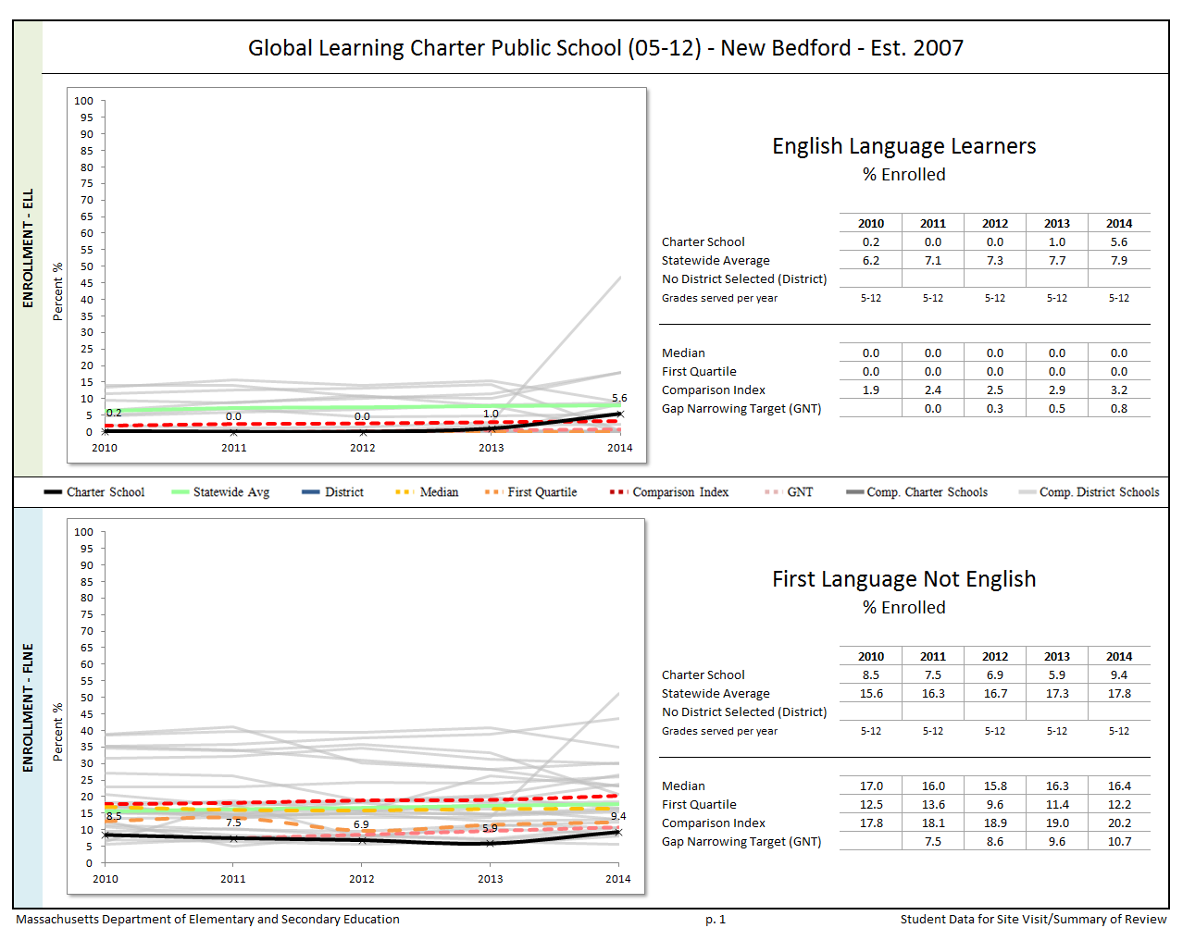
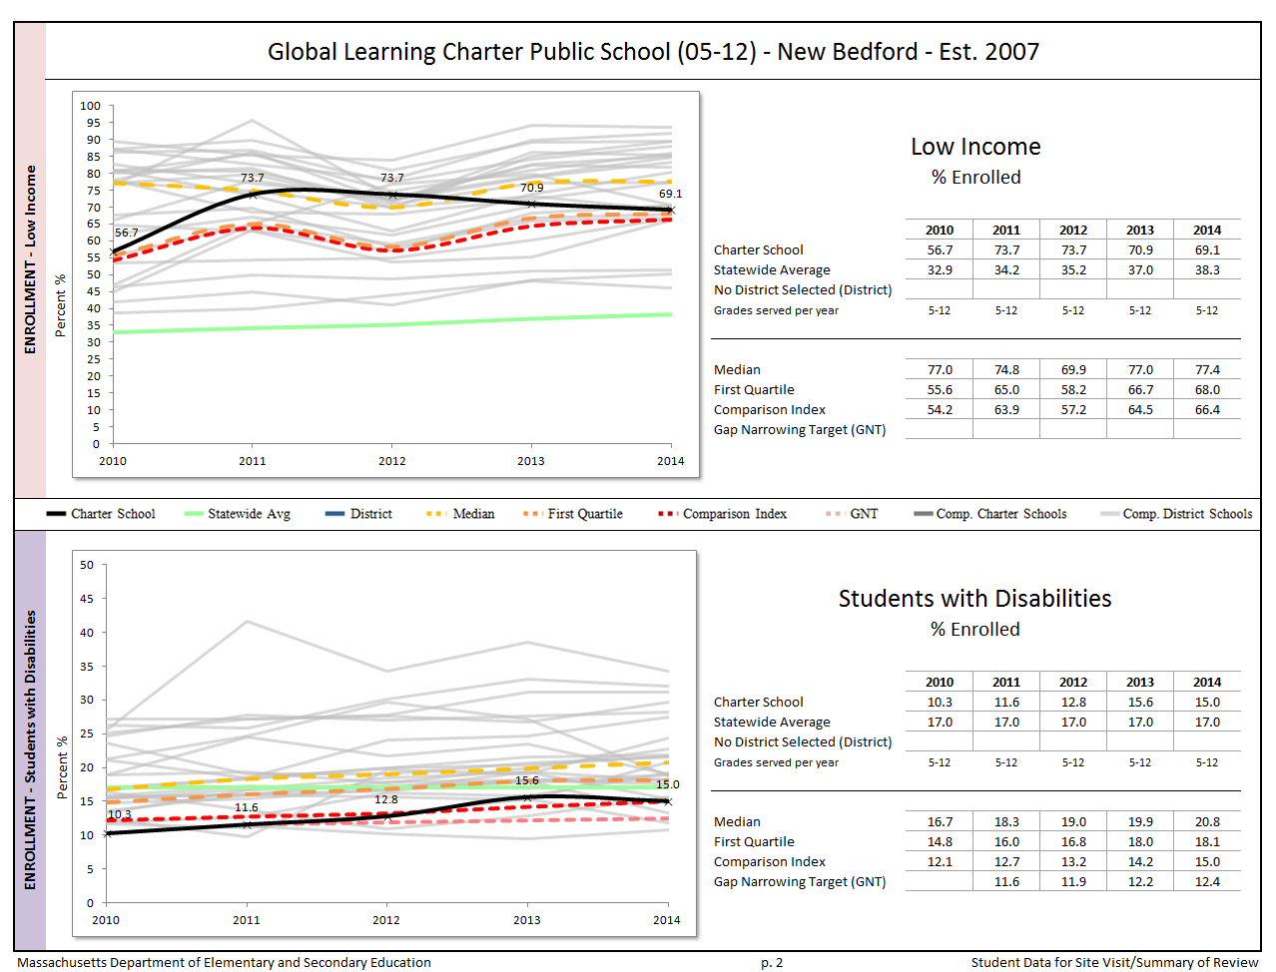
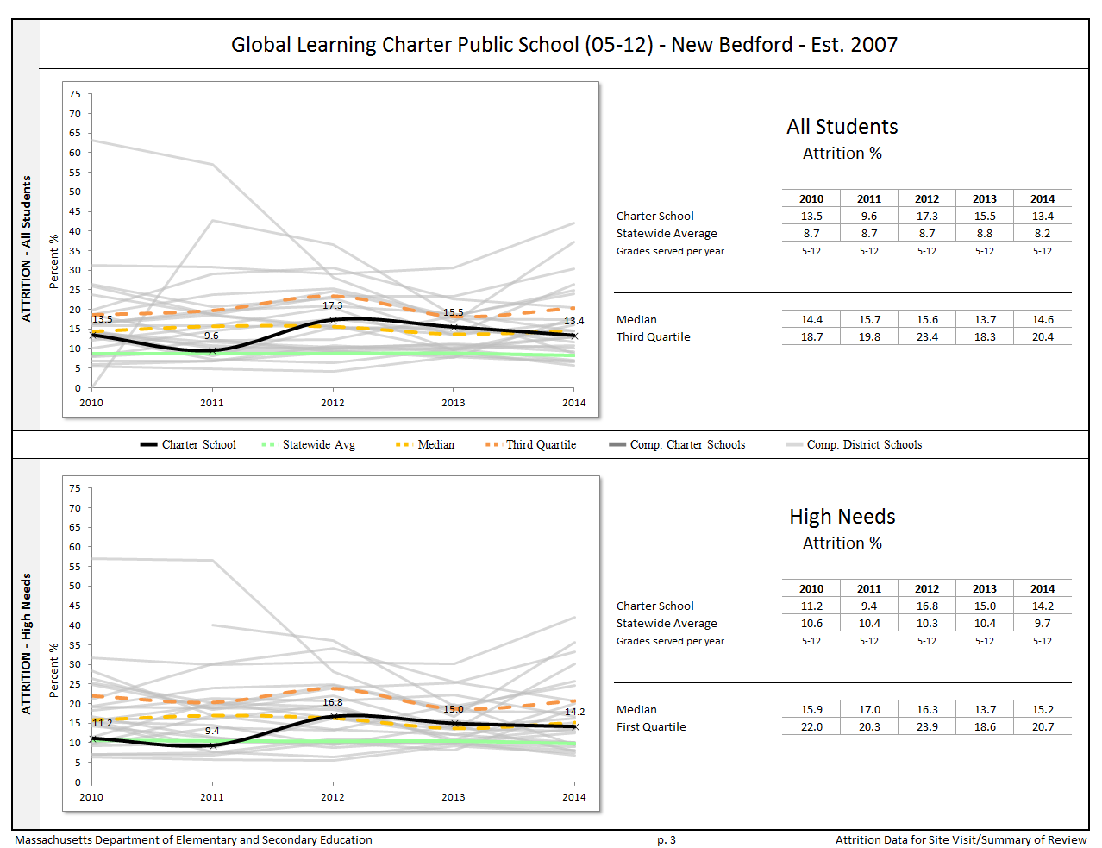

Appendix C

Criterion 5: Student Performance

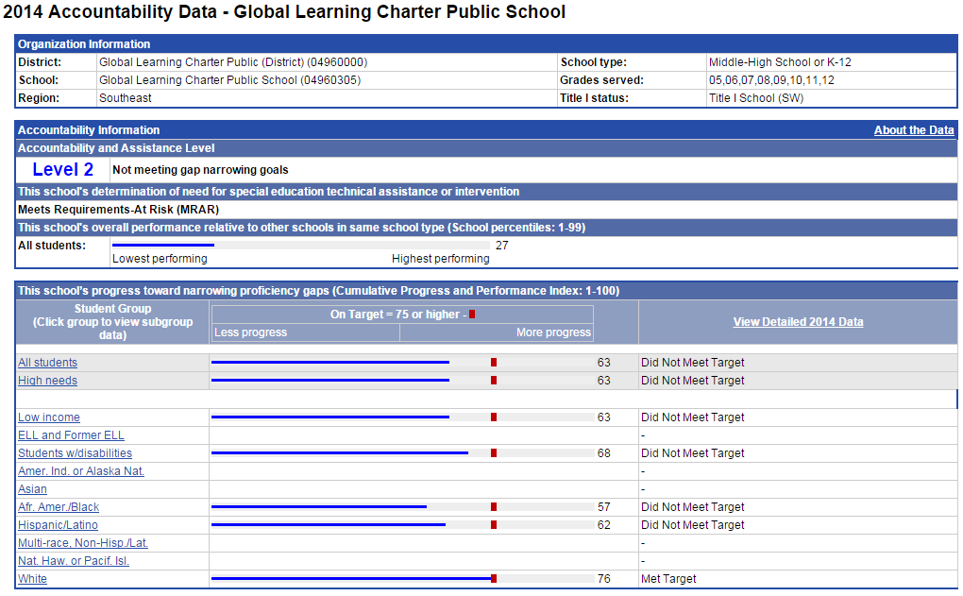

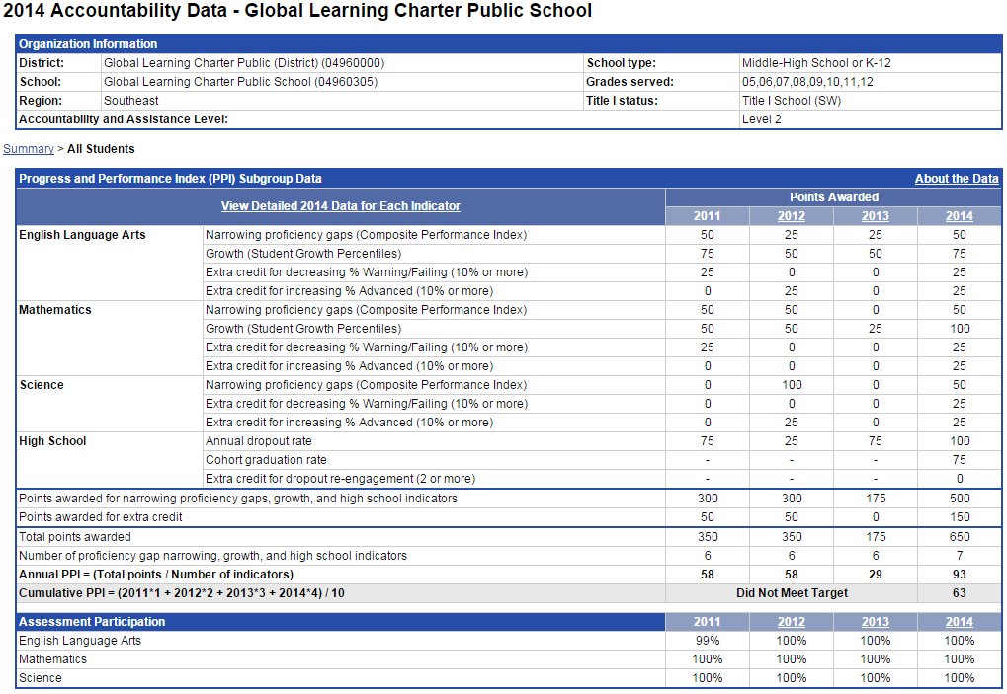
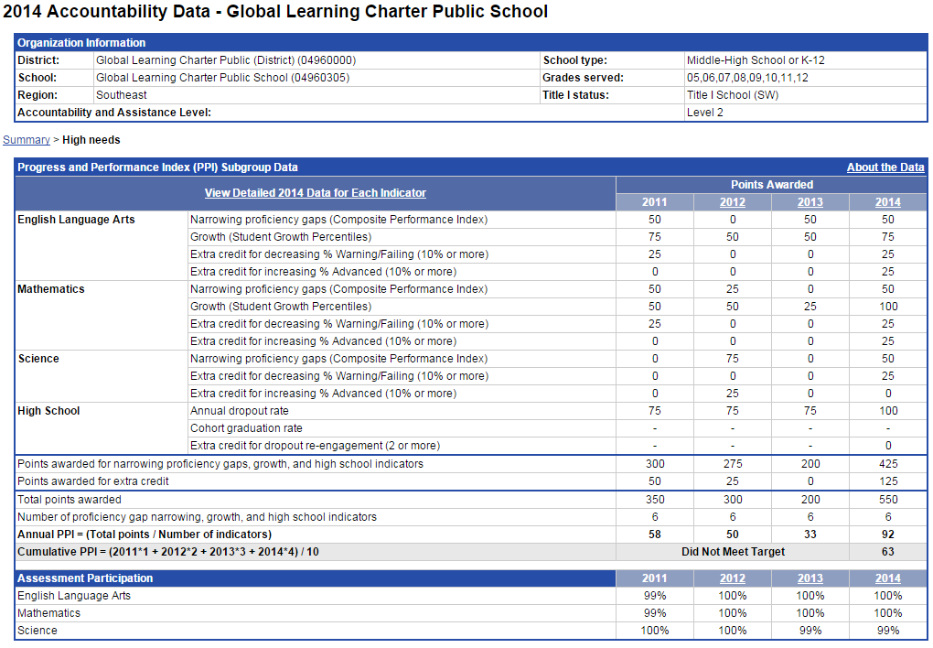
The charter accountability table (below) provides several sets of data relative to charter school MCAS performance as well as student indicators. The percent of students scoring proficient or advanced (P/A), the composite performance index (CPI), the percent of students scoring warning or failing (W/F), and the student growth percentile (SGP) are all displayed in the aggregate over the term of the charter. The school’s accountability level, percentile, English Language Arts (ELA) and math percentiles for the aggregate and targeted subgroups, and cumulative progress and performance index (PPI) for the aggregate and targeted subgroups are shown if available (this depends on the size and the age of the school). When applicable, the 4-year and 5-year graduation rates as well as the annual dropout rate are also provided for the available years of the charter term. For detailed definitions of accountability terms, please visit this URL: http://profiles.doe.mass.edu/accountability/report/aboutdata.aspx#AccountabilityInformation.

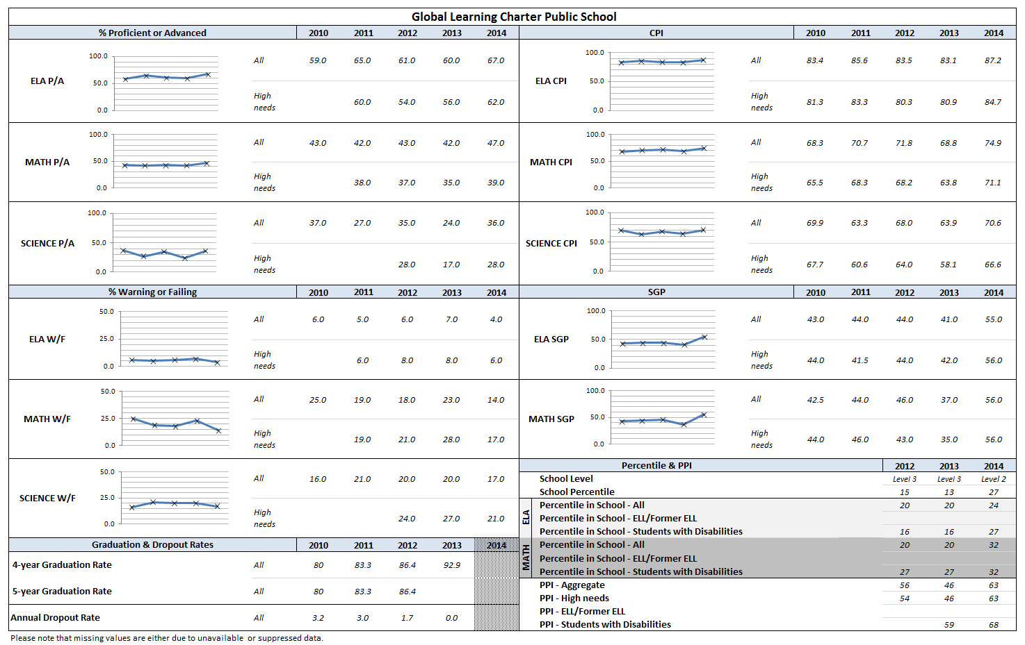

Appendix D

Criterion 10: Finance
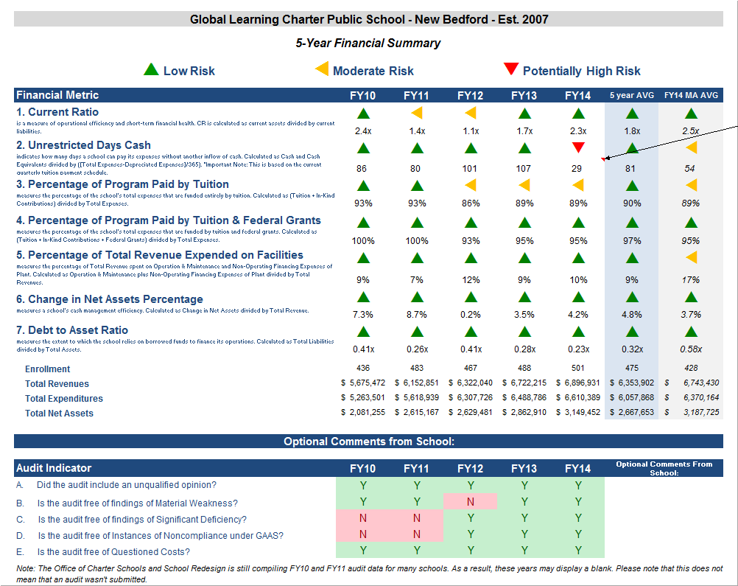

Financial Metric Definitions |  | Low Risk | Moderate Risk | Potentially High Risk
1. Current Ratio | Current Ratio is a measure of operational efficiency and short-term financial health. CR is calculated as current assets divided by current liabilities. | >= 1.5 | Between 1.0 (inclusive) and 1.5 | < 1.0
2. Unrestricted Days Cash (Prior to FY14)  Applies to 5-year average | The unrestricted days cash on hand ratio indicates how many days a school can pay its expenses without another inflow of cash. Calculated as Cash and Cash Equivalents divided by ([Total Expenses-Depreciated Expenses])/365).  Note: This is based on quarterly tuition payment schedule. | >= 75 days | Between 45 (inclusive) and 75 days | < 45 days
2. Unrestricted Days Cash (FY14 forward) | 4th quarterly tuition payments to Commonwealth charter schools in FY14 were made after June 30, 2014, which resulted in lower-than-typical cash at fiscal year end, affecting the risk levels for the current ratio and unrestricted days cash indicators for FY14 on a one-time basis. Payments for FY15 and after are made on a monthly basis, and parameters for risk have been adjusted accordingly. | >= 60 days | Between 30 (inclusive) and 60 days | < 30 days
3. Percentage of Program Paid by Tuition | This measures the percentage of the schools total expenses that are funded entirely by tuition. Calculated as (Tuition + In-Kind Contributions) divided by Total Expenses (expressed as a percentage). Note: In-Kind Contribution are added to the numerator in this ratio to balance out In-Kind Expenditures which will be captured in the Total Expenses in the denominator, and ratios over 100% are set to 100%. | >= 90% | Between 75% (inclusive) and 90% | < 75%
4. Percentage of Program Paid by Tuition & Federal Grants | This measures the percentage of the schools total expenses that are funded by tuition and federal grants. Calculated as (Tuition + In-Kind Contributions + Federal Grants) divided by Total Expenses (expressed as a percentage). Note: In-Kind Contribution are added to the numerator in this ratio to balance out In-Kind Expenditures which will be captured in the Total Expenses in the denominator, and ratios over 100% are set to 100%. | >= 90% | Between 75% (inclusive) and 90% | < 75%
5. Percentage of Total Revenue Expended on Facilities | This measures the percentage of Total Revenue that is spent on Operation & Maintenance and Non-Operating Financing Expenses of Plant. Calculated as Operation & Maintenance plus Non-Operating Financing Expenses of Plant divided by Total Revenues (expressed as a percentage). | <= 15% | Between 15% and 30% (inclusive) | > 30%
6. Change in Net Assets Percentage | This measures a school's cash management efficiency. Calculated as Change in Net Assets divided by Total Revenue (Expressed as a percentage). | Positive % | Between -2% (inclusive) and 0% | < -2%
7. Debt to Asset Ratio | Measures the extent to which the school relies on borrowed funds to finance its operations. Calculated as Total Liabilities divided by Total Assets. | <= .9 | Between .9 and 1 (inclusive) | > 1
FY12 MA AVG Column | All financial metrics indicated in this column are a result of each ratio calculated using statewide totals. For Enrollment, Total Net Assets and Total Expenditures rows, these numbers are averages calculated using the statewide totals of all charter schools’ data.

The Charter School Performance Criteria v. 3.1 is found at: http://www.doe.mass.edu/charter/acct.html?section=criteria
1 The names of each of these schools and additional subgroup detail can be found in the Charter Analysis and Review Tool (CHART), http://www.doe.mass.edu/charter/chart/.
The midpoint value of all comparison schools. This is derived using Microsoft Excel's MEDIAN function.
The first quartile is the middle number between the smallest number and the median of all comparison schools. This is derived using Microsoft Excel's QUARTILE function.
The comparison index provides a comparison figure derived from data of students who reside within the charter school’s sending district(s). The comparison index is a statistically calculated value designed to produce a fairer and more realistic comparison measure that takes into account the charter school’s size and the actual prevalence of student subgroups within only those grade levels in common with the charter school.
The Gap Narrowing Target (GNT) refers to the halfway point between the school’s baseline rate (which is the rate in the 2010-11 school year, or the first year enrollment data is collected if after 2010-11,) and the current Comparison Index (the “target”). The object is to meet this halfway point by the 2016-17 school year (or in a later year if baseline is after 2010-11), giving the school six years to do so. For a school to be on schedule to meet its GNT, an incremental increase must be met annually. To determine this increment, the following equation is used: [(Comparison Index – Baseline) / 2] / 6 years = Annual GNT.
The percentage of attrition, or rate at which enrolled students leave the school between the end of one school year and the beginning of the next.
A student is high needs if he or she is designated as either low income, or ELL, or former ELL, or a student with disabilities. A former ELL student is a student not currently an ELL, but had been at some point in the two previous academic years.

