Massachusetts Department of

Elementary and Secondary Education

75 Pleasant Street, Malden, Massachusetts 02148-4906 Telephone: (781) 338-3000

TTY: N.E.T. Relay 1-800-439-2370

Mitchell D. Chester, Ed.D.
Commissioner

MEMORANDUM

To: | Members of the Board of Elementary and Secondary Education
From: | Mitchell D. Chester, Ed.D., Commissioner
Date: | December 9, 2015
Subject: | Charter Schools – Recommendation and Report on Probation for Global Learning Charter Public School

In keeping with past accountability decisions, I recommend that Global Learning Charter Public School (GLCPS) be removed from probation but operate under a continuing condition designed to ensure sustained academic progress.

The Board of Elementary and Secondary Education (Board) placed GLCPS on probation in January 2014 and imposed conditions designed to improve the school’s academic program and results. As summarized below, GLCPS largely met the conditions imposed by the Board. The school received a comprehensive school evaluation, implemented an action plan, and met academic measures established by the Department of Elementary and Secondary Education (Department). The conditions also required GLCPS to demonstrate significant and sustained academic progress by September 2015. As shown in the data charts below, GLCPS’s achievement and growth scores have improved since 2013, most notably in mathematics, and I commend the school for its progress.

Global Learning Charter Public School
Type of Charter  (Commonwealth or Horace Mann) | Commonwealth | Location | New Bedford
Regional or Non-Regional | Non-Regional | Districts in Region  (if applicable) | N/A
Year Opened | 2007 | Year(s) Renewed  (if applicable) | 2012
Maximum Enrollment | 500 | Current Enrollment | 508
Chartered Grade Span | 5-12 | Current Grade Span | 5-12
Students on Waitlist | 331 | Current Age of School | 9 years old
Mission Statement
The mission of Global Learning Charter Public School is to ensure that all students achieve academic excellence, are ready for the rigors of higher education, and master essential skills that prepare them for the economic, social, and civic challenges of a 21st century, global society. Our central mission is to teach and inspire the mind, body, and spirit of our students so that they can succeed in any cultural or academic setting.

GLCPS opened as a Commonwealth charter school in 2007. Previously, the board of trustees of GLCPS operated a Horace Mann charter school from 2002-2007. In January 2012, pursuant to delegated authority, I renewed the charter of GLCPS with conditions related to academic performance. In January 2014, the Board of Elementary and Secondary Education determined that the school had not met conditions related to academic performance and placed the school on probation, directing it to meet a set of three conditions. The school has received a number of targeted site visits to monitor progress on conditions since its renewal in 2012. The most recent site visit was conducted in February 2015. That site visit report, from the 2014-15 school year, is attached to this memorandum. The school’s performance is noted below with respect to the conditions imposed when the Board placed the school on probation.

Progress Toward Meeting Conditions

Condition 1: No later than April 30, 2014, the school shall submit to the Office of Charter Schools and School Redesign a comprehensive evaluation of the school’s mathematics and English language arts programs conducted by an external consultant, accepted and approved in advance by the Department.

Status: Met
On April 7, 2014, GLCPS submitted a comprehensive evaluation conducted by an external consultant group that had been accepted and approved by the Department in advance. The results of the comprehensive evaluation have driven changes in governance, professional development, use of assessment data, and created an emphasis on vertical alignment of the curriculum.

Condition 2: No later than June 15, 2014, the school shall submit to Department, and receive approval from the Department for, an action plan that specifies strategies to improve mathematics and English language arts performance. The action plan must include a timetable for the implementation of actions, must set deadlines for the completion of key tasks, and must set clear and specific implementation benchmarks to allow the school’s board of trustees and the Office of Charter Schools and School Redesign to monitor implementation.

Status: Met
GLCPS submitted an action plan on June 2, 2014. The school has worked with the firm hired to conduct the comprehensive evaluation to create the action plan. After feedback from the Department, the action plan was finalized on June 11, 2014.

Condition 3: The school must demonstrate that it is an academic success by September 30, 2015, by providing evidence that the school has met or is making substantial progress toward meeting benchmarks in its approved Accountability Plan and, in particular, has demonstrated significant and sustained academic improvement in mathematics and English language arts.

Status: Met
In 2012 and 2013, GLCPS’s MCAS scores placed the school in Level 3. In 2014, GLCPS’s performance improved to place it in Level 2 in the 27th percentile when compared to other middle-high and K-12 schools statewide. In 2015, GLCPS remains in Level 2, but has risen to the 32nd percentile.

While the school’s improvement in mathematics is clear, English language arts (ELA) and science scores have not yet demonstrated consistent gains. The school’s Composite Performance Index (CPI) for 2015 is 86.8 in ELA, 80.5 in mathematics, and 69.8 in science and technology. In 2015, 68 percent of GLCPS students scored in the Proficient and Advanced categories in the ELA assessment, below the state average. In mathematics, 60 percent scored Proficient and Advanced, also below the state average. Please see the data charts below to see historical trends in SGP and CPI. See the school’s full 2015 Accountability Data report here: http://profiles.doe.mass.edu/mcas/achievement_level.aspx?linkid=32&orgcode=04960305&orgtypecode=6&

Student Growth Percentile
 |  | 2012 | 2013 | 2014 | 2015
ELA SGP | All | 44.0 | 41.0 | 55.0 | 40.0
 | High needs | 44.0 | 42.0 | 56.0 | 39.0
Math SGP | All | 46.0 | 37.0 | 56.0 | 56.5
 | High needs | 43.0 | 35.0 | 56.0 | 55.5

ELA CPI Chart
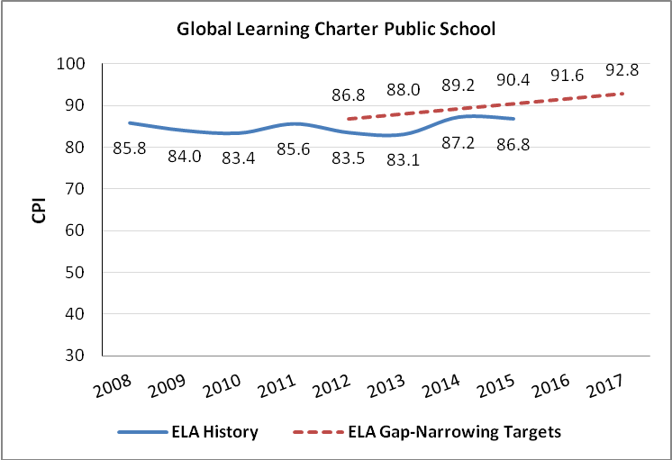
Mathematics CPI Chart

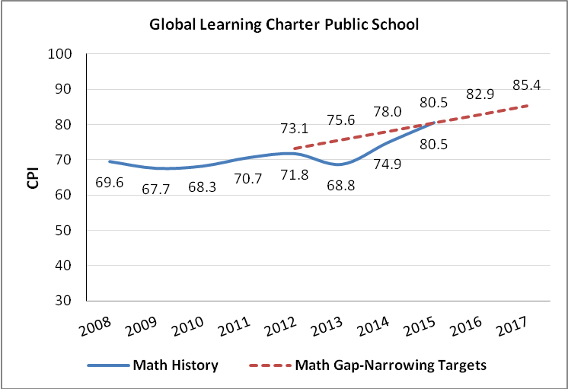

Science CPI Chart

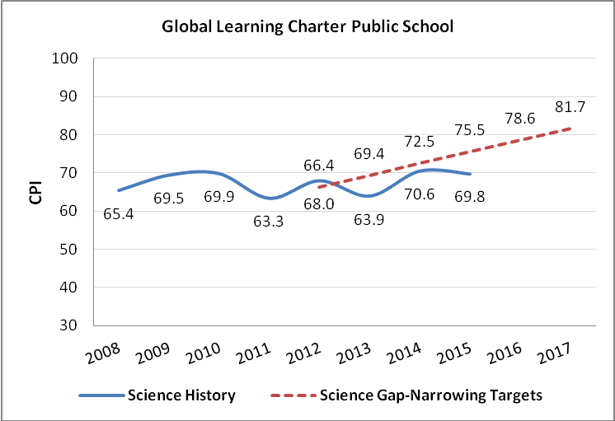

Recommendation

Given this evidence, further detailed in the attached Site Visit Report from the 2014-15 school year, I recommend that the Board remove the school from probation. I further recommend that the Board keep the following academic condition in place, extending the timeline:

Global Learning Charter Public School must demonstrate that it is an academic success by September 2016 by providing evidence that the school has met or is making substantial progress toward meeting the benchmarks in its approved Accountability Plan and, in particular, is demonstrating continuous and sustained academic improvement.

The school’s current charter expires on June 30, 2017. I will review the progress the school has made in order to inform a renewal decision early in 2017.

**********************

If you have any questions regarding this recommendation or require additional information, please contact Cliff Chuang, Associate Commissioner (781-338-3222); Jeff Wulfson, Deputy Commissioner (781-338-6500); or me.

Attachments: Year 8 Site Visit Report
Motion

