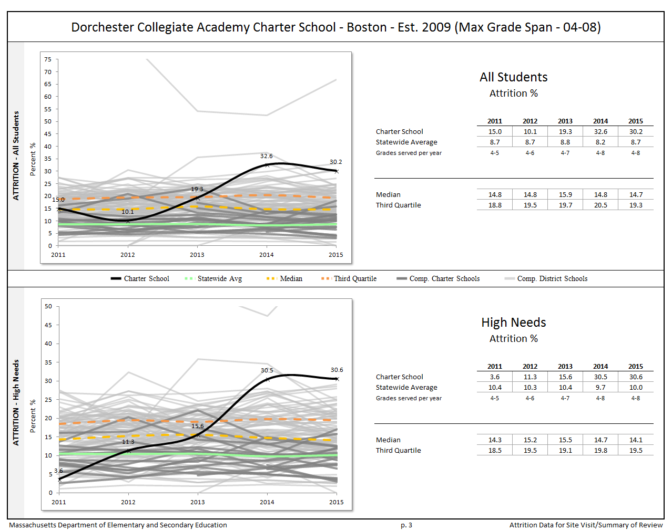

English Language Learners:
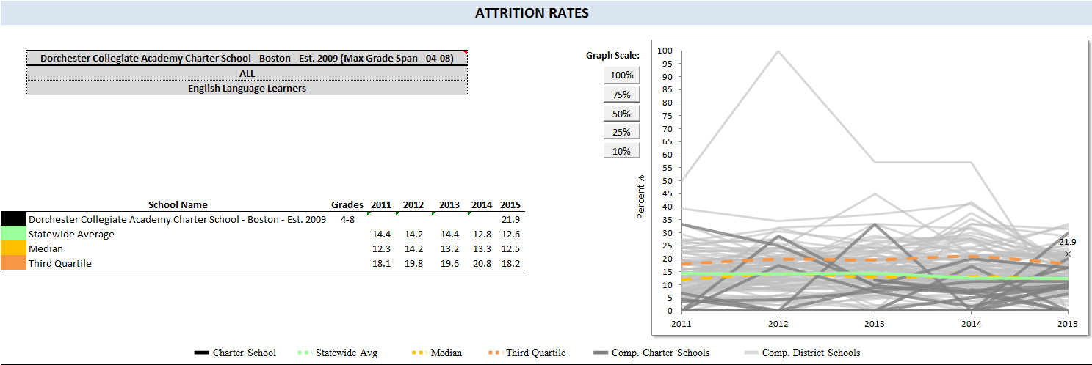

Students with Disabilities:
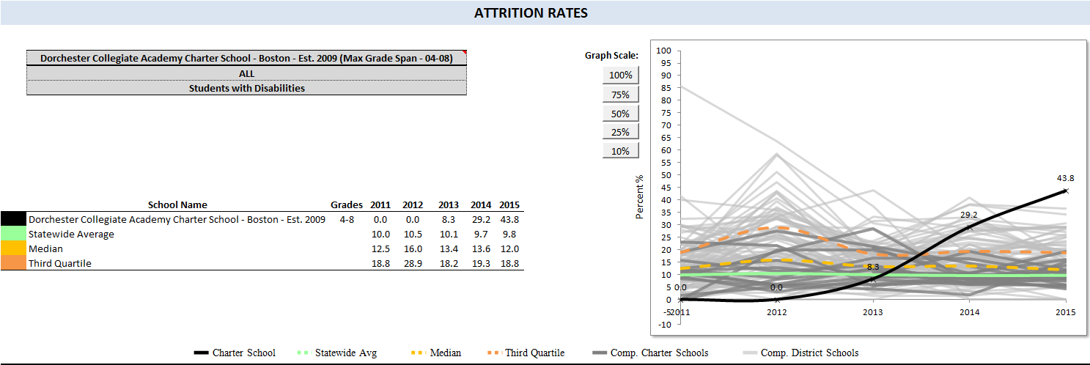

Low Income:
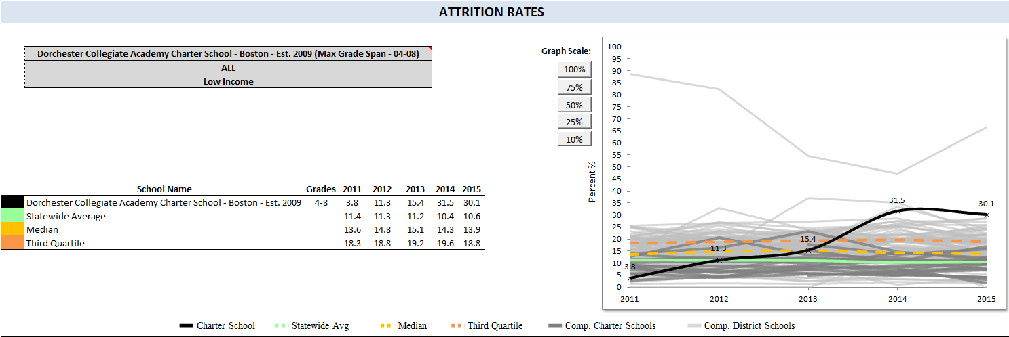
Grade by Grade Attrition for 2013-2014 (students who were enrolled in June 2013 but not in fall 2013):

Student Group | 4 | 5 | 6 | 7 | All
All Students | 25.7 | 27.3 | 53.1 | 25.0 | 32.6
Female | 27.8 | 27.8 | 53.8 | 28.6 | 33.3
Male | 23.5 | 26.7 | 52.6 | 22.2 | 31.9
High needs | 15.0 | 21.4 | 53.6 | 27.6 | 30.5
Low income | 0.0 | 24.0 | 56.0 | 29.6 | 31.5
Students w/disabilities | 28.6 |  |  | 28.6 | 29.2
Afr. Amer./Black | 34.6 | 32.0 | 52.0 | 20.0 | 35.4
Asian
Hispanic/Latino |  | 16.7 |  | 36.4 | 25.0

Grade by Grade Attrition for 2014-2015 (students who were enrolled in June 2014 but not in fall 2014):

Student Group | 4 | 5 | 6 | 7 | All
All Students | 33.3 | 38.9 | 31.4 | 17.9 | 30.2
Female | 26.7 | 44.4 | 31.6 | 18.2 | 29.7
Male | 37.5 | 33.3 | 31.3 | 17.6 | 30.7
High needs | 33.3 | 37.1 | 33.3 | 18.9 | 30.6
ELL | 15.4 | 30.0 |  | 28.6 | 21.9
Low income | 33.3 | 37.1 | 31.3 | 18.9 | 30.1
Students w/disabilities | 80.0 | 28.6 | 28.6 | 25.0 | 43.8
Afr. Amer./Black | 35.5 | 33.3 | 34.6 | 14.8 | 29.5
Asian
Hispanic/Latino | 16.7 | 45.5 | 16.7 | 28.6 | 30.0

Grade by Grade Attrition for 2015-2016 (students who were enrolled in June 2015 but not in fall 2015)
Student Group | 4 | 5 | 6 | 7 | All
All Students | 7.5 | 17.5 | 10.7 | 21.1 | 14.4
Female | 0 | 13.3 | 10 | 21.1 | 11.7
Male | 12.5 | 20 | 11.1 | 21.1 | 16.3
High needs | 9.1 | 16.1 | 10 | 15.4 | 12.7
Economically Disadvantaged | 11.1 | 16.7 |  | 9.1 | 10.7
ELL | 28.6 | 12.5 |  | 33.3 | 19.2
Students w/disabilities | 11.1 |  | 0 | 0 | 3.3
Afr. Amer./Black | 7.7 | 16.7 | 5.3 | 23.3 | 14.3
Asian
Hispanic/Latino | 7.7 | 22.2 | 14.3 | 16.7 | 14.3

Additional Information:
Please note, incorrect data for low income enrollment for the 2013-14 school year was certified by Dorchester Collegiate Academy Charter School (DCACS). DCACS made errors in its Oct. 2013 SIMS data submission and subsequently certified a count of 71 out of 195 students being identified as low income, a significant underreporting of low income students. A subsequent unsuccessful attempt was made to submit and certify the appropriate data, which came to light when the school submitted its March 2014 SIMS data, which accurately reflected 182 of 191 (95 percent) students as free-lunch students.

