

Paulo Freire Social Justice Charter School

Summary of Review

Holyoke, MA

January 2018

**Massachusetts Department of Elementary and Secondary Education**

Office of Charter Schools and School Redesign

75 Pleasant Street

Malden, MA 02148

Phone: (781) 338-3227



This document was prepared by the   
Massachusetts Department of Elementary and Secondary Education

Jeff Wulfson

Commissioner

The Massachusetts Department of Elementary and Secondary Education, an affirmative action employer, is committed to ensuring that all of its programs and facilities are accessible to all members of the public.

We do not discriminate on the basis of age, color, disability, national origin, race, religion, sex, gender identity, or sexual orientation.

Inquiries regarding the Department’s compliance with Title IX and other civil rights laws may be directed to the

Human Resources Director, 75 Pleasant St., Malden, MA 02148-4906. Phone: 781-338-6105.

© 2018 Massachusetts Department of Elementary and Secondary Education

Permission is hereby granted to copy any or all parts of this document for non-commercial educational purposes. Please credit the “Massachusetts Department of Elementary and Secondary Education.”

This document printed on recycled paper

Massachusetts Department of Elementary and Secondary Education

75 Pleasant Street, Malden, MA 02148-4906

Phone 781-338-3000 TTY: N.E.T. Relay 800-439-2370

www.doe.mass.edu



Table of Contents

I. Introduction 1

II. Executive Summary of Charter School Performance 1

III. School History 4

IV. Areas of Accountability 5

A. Faithfulness to Charter 5

B. Academic Program 19

C. Organizational Viability 27

Appendix A: Accountability Plan Objectives and Measures (Criterion 1: Mission and Key Design Elements) 33

Appendix B: CHART (Criterion 2: Access and Equity) 37

Appendix C: Academic Data (Criterion 5: Student Performance) 43

Appendix D: Financial Dashboard (Criterion 10: Finance) 48

## 

|  |
| --- |
| I. Introduction |

The charter school regulations state that “the decision by the Board [of Elementary and Secondary Education] to renew a charter shall be based upon the presentation of affirmative evidence regarding the faithfulness of the school to the terms of its charter, including the extent to which the school has followed its recruitment and retention plan and has disseminated best practices in accordance with M.G.L. c. 71, § 89(dd); the success of the school's academic program; and the viability of the school as an organization” 603 CMR 1.11(2). Consistent with the regulations, recommendations regarding renewal are based upon the Department of Elementary and Secondary Education’s (Department) evaluation of the school’s performance in these areas. In its review, the Department has considered both the school’s absolute performance at the time of the application for renewal and the progress the school has made during the first four years of its charter. Performance is evaluated against both the [Massachusetts Charter School Performance Criteria](http://www.doe.mass.edu/charter/acct.html?section=criteria) and the school’s accountability plan. The evaluation of the school has included a review of various sources of evidence.

The following sections present a high-level summary from various sources regarding the school’s progress and success in fulfilling the terms of its charter, raising student achievement, and establishing a viable organization over the past charter term. Specific details about each criterion have been well-documented in the sources listed below.

|  |
| --- |
| II. Executive Summary of Charter School Performance |

|  |  |  |  |
| --- | --- | --- | --- |
| **Paulo Freire Social Justice Charter School** | | | |
| **Type of Charter**  (Commonwealth or Horace Mann) | Commonwealth | **Location** | Holyoke |
| **Regional or Non-Regional** | Regional | **Districts in Region**  (if applicable) | Chicopee, Holyoke, Northampton, South Hadley, West Springfield, and Westfield |
| **Year Opened** | 2013 | **Year(s) Renewed**  (if applicable) | N/A |
| **Maximum Enrollment** | 500 | **Current Enrollment** | 270 |
| **Chartered Grade Span** | 9-12 | **Current Grade Span** | 9-12 |
| **Students on Waitlist** | 0[1] | **Current Age of School** | 5 years |
| **Mission Statement**  The Paulo Freire Social Justice Charter School (PFSJCS) is a public high school preparing students for college success while inspiring them to be active and effective citizens. We achieve educational excellence and social responsibility for all our students through high expectations and a rigorous academic and social justice curriculum. Our students graduate with strong intellectual and ethical foundations necessary for future leaders of a global society. | | | |

**Demographic Data 2016-2017**

|  |  |  |  |  |
| --- | --- | --- | --- | --- |
|  | **Enrollment by Race/Ethnicity** | | |  |
|  |  | **Number of Students** | **Percentage of Student Body** |  |
|  | **African-American** | 17 | 5% |  |
|  | **Asian** | 0 | 0% |  |
|  | **Hispanic** | 287 | 88% |  |
|  | **Native American** | 0 | 0% |  |
|  | **White** | 23 | 7% |  |
|  | **Native Hawaiian, Pacific Islander** | 1 | 0% |  |
|  | **Multi-Race, Non Hispanic** | 0 | 0% |  |
|  |  |  |  |  |
|  | **Selected Populations** | | |  |
|  |  | **Number of Students** | **Percentage of Student Body** |  |
|  | **First Language not English** | 123 | 38% |  |
|  | **English Language Learner** | 34 | 10% |  |
|  | **Students with Disabilities** | 58 | 18% |  |
|  | **High Needs** | 256 | 78% |  |
|  | **Economically Disadvantaged** | 228 | 70% |  |
|  |  |  |  |  |

|  |  |  |  |
| --- | --- | --- | --- |
| **Paulo Freire Social Justice Charter School** | | | |
| ** Exceeds** | | The school fully and consistently meets the criterion and is a potential exemplar in this area. | |
| ** Meets** | | The school substantially meets the criterion and/or minor concern(s) are noted. | |
| ** Partially Meets** | | The school meets some aspects of the criterion but not others and/or moderate concern(s) are noted. | |
| ** Falls Far Below** | | The school falls far below the criterion and/or significant concern(s) are noted. | |
| **Massachusetts Charter School Performance Criteria** | | | **Rating** |
| **Faithfulness to Charter** | 1. **Mission and Key Design Elements:** The school is faithful to its mission, implements the key design elements outlined in its charter, and substantially meets its accountability plan goals. | | ** Partially Meets** |
| 1. **Access and Equity:** The school ensures access and equity for all students eligible to attend the school. | | ** Partially Meets** |
| 1. **Compliance:** The school is in compliance with the terms of its charter and applicable state and federal laws and regulations. | | N/A |
| 1. **Dissemination:** The school provides innovative models for replication and best practices to other public schools in the district where the charter school is located. | | ** Meets** |
| **Academic Program Success** | 1. **Student Performance:** The school consistently meets state student performance standards as defined by the statewide accountability system. | | **Level: 3**  **Percentile: 22nd** |
| **Organizational Viability** | 1. **Governance:** Members of the board of trustees act as public agents authorized by the state and provide competent and appropriate governance to ensure the success and sustainability of the school. | | ** Falls Far Below** |

Please note: This report contains evidence, but no ratings, for other areas of the Charter School Performance Criteria.

|  |
| --- |
| III. School History |

Paulo Freire Social Justice Charter School (PFSJCS) was granted a charter in 2012 and planned to open the subsequent school year. The founding group did not secure a proper facility in time to open for the 2012-13 school year. In June 2012 the school requested, and was granted, amendments to its charter: to reset its charter term to 2013-18 and to revise its growth plan (to enroll grades 9 and 10 during its initial year of operation). The school opened during the 2013-14 school year, and served grade 9 and 10 students, per its revised growth plan, which is included below.

The school was under-enrolled in Year 4 with 328 students attending the school rather than the 410 envisioned by the growth plan (see below). Additionally, in Year 5, the school remains under-enrolled; as of October 2017, the school enrolls 270 students rather than the 465 outlined in the approved growth plan. Please see information contained below, in Criterion 10, Finance, for organizational viability issues related to under-enrollment.

| **School Year** | **Year 1** (13-14) | **Year 2** (14-15) | **Year 3** (15-16) | **Year 4** (16-17) | **Year 5** (17-18) |
| --- | --- | --- | --- | --- | --- |
| Planned Total Student Enrollment | 145 | 255 | 355 | 410 | 465 |
| 2012 Approved Amendment Request By Grade | **Grade 9**: 73  **Grade 10**: 72 | **Grade 9**: 125  **Grade 10**: 65  **Grade 11**: 65 | **Grade 9**: 125  **Grade 10**: 110  **Grade 11**: 60  **Grade 12**: 60 | **Grade 9**: 145  **Grade 10**: 110  **Grade 11**: 100  **Grade 12**: 55 | **Grade 9**: 145  **Grade 10**: 125  **Grade 11**: 100  **Grade 12**: 95 |

The school’s facility includes a section of a retrofitted warehouse space and a newly constructed modular unit housing 10 additional classrooms.

Over the course of the charter term, the school went through multiple transitions at the leadership and board level.

Board: The board composition varied from a high of 21 board members to a low of 11 board members over the past year. During the past two years, board membership turnover has increased, such that nearly half of the members have departed each school year. During the charter term, the board has been led by three different chairs. The board elected a new board chair in October 2016 and again in November 2017.

School Leadership:

* Principal:
  + Four different individuals have served in the role of principal since the school’s opening in 2013.
  + At the end of the 2015-16 school year, the person who served as PFSJCS’s founding principal remained at the school, but was no longer serving as principal.
  + The school hired an interim principal for the 2016-17 school year.
  + The interim principal began a medical leave in February 2017 and the school did not fill the position in her absence.
  + The new executive director appointed a temporary principal on May 22, 2017 and a new principal began July 2017.
* Executive Director:
  + Three individuals have served in the executive director/school leader role since the school’s opening in 2013.
  + The founding executive director served from the school’s opening until November 2016.
  + In November 2016, the school’s executive director went on medical leave. In December of 2016, the school appointed an interim executive director, who was a board member at that time. This transition did not comply with Massachusetts laws (Massachusetts General Law c. 268A, § 8A), since the board member did not wait 30 days after terminating membership from the board to take on a leadership role at the school.
  + The school then appointed a “school caretaker” while it began a search for a new executive director.
  + PFSJCS hired a new executive director who began on May 10, 2017.

Currently, the executive director oversees a principal, a director of special education and academic support services, a director of management information systems, a district management of employee and student services, a development director, a business management, an enrollment coordinator and several other positions. The principal in turn oversees a dean of culture and climate and a dean of students, among other roles. The executive director and principal co-supervise the academic team leaders.

On July 26, 2017, the Acting Commissioner of Elementary and Secondary Education notified the Board of Elementary and Secondary Education (Board) of his intention to place PFSJCS on conditions. He presented the Board with a memorandum regarding concerns about the school’s organizational viability with proposed conditions. The Board did not request to discuss the matter at an upcoming meeting and the Acting Commissioner subsequently imposed the conditions on the charter of PFSJCS. The school’s progress in terms of the conditions will be addressed in a separate memorandum to the Board.

|  |
| --- |
| IV. Areas of Accountability |

|  |
| --- |
| **A. Faithfulness to Charter** |

| **Criterion 1: Mission and Key Design Elements**  **The school is faithful to its mission, implements the key design elements outlined in its charter, and substantially meets its accountability plan goals.**  (Please refer to Appendix A for the school’s accountability plan.) | |
| --- | --- |
| *Finding*: *Over the course of the charter term, stakeholders at the school have shared a consistent understanding of the school’s mission to prepare students for college through rigorous academics, and to promote active citizenship through social justice. In its fifth year, the school has not fully implemented its mission and key design elements.*  The mission of PFSJCS is to prepare students for college through rigorous academics, and to inspire them to be active citizens and future leaders through a focus on social justice. Visitors in Years 2, 3, 4, and 5 of the charter term found that stakeholders at PFSJCS shared a common understanding of the school’s mission, primarily focusing on social justice and college preparation. The school has identified five key design elements that work to support the school’s mission.  During the charter term, however, visitors found that the school’s mission and key design elements have not been fully implemented. The implementation of each key design element is described in detail below.  *Students successfully complete a rigorous academic program focusing on academic excellence in preparation for a four-year college program.*  The key design element regarding college preparation and a rigorous academic program is directly linked to the school’s mission. Stakeholders throughout the charter term identified this key design element as being critical to the school. However, visitors throughout the charter term found that this key design element has not been fully implemented.  The school works to prepare students for college. Visitors in Years 3, 4, and 5 heard about the school’s partnership with Holyoke Community College (HCC) that allows students the opportunity to have dual enrollment. The program has become more robust over time. The College Success Program allows students to earn college credit by fulfilling some of their graduation requirements through college-level coursework taken on the HCC campus. In Year 5, the school employs a dual enrollment coordinator to help facilitate this process. In addition, students and parents in Year 5 cited numerous additional supports given by the school to encourage students to leverage this opportunity, including the provision of financial aid for tuition and books, as well as transportation to the campus. The school also employs college advisors to support students and their families in the college application process.  Visitors in Years 3, 4, and 5 found that the school has implemented an internship program to prepare students for college. All upperclassmen are required to participate in 50 hours of a career internship in order to graduate. Teachers in Year 5 noted that internships are often connected to local social justice organizations or community partners.  Visitors throughout the charter term found varied evidence of rigorous academics. While stakeholders spoke to the rigor of the curriculum in Year 3, visitors in Year 3 noted that the curriculum did not appear to be aligned to state standards. Visitors in Years 2, 3, 4 and 5 noted that the rigor of instruction varied. This is discussed further in Key *Indicator 6.2: Instruction* below. The school’s accountability plan reflects that the school has not yet implemented additional academic excellence elements that were outlined in the school’s original charter such as the creation of student success plans or the consistent use of formative assessments.  Academic outcome evidence does not demonstrate that the school’s academic program is preparing students for college. The average scores for students on the SAT in 2015-2016 were 413 in reading, 410 in writing, and 410 in mathematics. The school’s 4-year graduation rate for the 2016 cohort was 77.6 percent, below the state’s target of 80 percent, but above the sending district of Holyoke. However, in Year 4, the school did not have clear graduation standards for students and were unable to report the status of some students regarding their graduation progress. The Department does not yet have data on student college enrollment, but the school reported in its 2016-2017 annual report that 77 percent of students who participated in the dual enrollment program with HCC are now attending college. In 2017, the school’s performance on the legacy MCAS assessment reflected achievement below or significantly below statewide averages for 10th graders in ELA, mathematics and science and technology/engineering. More information about the school’s academic achievement can be found in *Criterion 5: Student Performance* below.  *Students are prepared to be active and effective citizens, graduating with strong intellectual and ethical preparation with a firm foundation deeply rooted in the concept and ideology of social justice.*  The school has worked to develop its implementation of the social justice aspect of its programming throughout the charter term. In Years 2, 3 and 4, visitors noted that the social justice aspect of the mission was still in progress, and the school had developed some systems and structures to implement it. By Year 5, visitors found that it was a robust component of the school. The board has a social justice committee, which is a group that is tasked with examining what it means to be a social justice school. The school employs a dean of climate and culture to help facilitate the infusion of social justice themes into the school’s curriculum. Teachers in Year 5 reported that they are able to develop their curricula with a focus on social justice, with an emphasis in the English and humanities departments, although they are infused in other areas as well. Visitors throughout the charter term observed classes with social justice themes  The school regularly engages in social justice-themed all-school activities including weekly community circles, in which students meet in their small advisory groups to discuss current community issues, and the annual Social Justice symposium, in which upperclassmen present on the social justice components of their internship experiences. Visitors throughout the charter term noted that the commitment to social justice, and particularly the ideology of Paulo Freire, are visible throughout the school’s campus, with numerous classroom and hallway bulletin boards dedicated to relevant quotes, photographs, and informational posters.  *Delivery of an academic program that provides improved academic outcomes and educational success for all students utilizing individual instruction and small classes.*  As of Year 5, the school had not yet defined its definition of improved academic outcomes. The school has exhibited declining Student Growth Percentiles (SGP) in ELA and low SGPs in mathematics. More information about the school’s academic achievement can be found in *Criterion 5: Student Performance* below. In Year 4, visitors found that the school had not yet developed a systematic way to track and report data on academic outcomes to the school’s board.  Visitors throughout the charter term found that the school maintained its commitment to small class sizes of 16 or less students. The site team did observe PFSJCS’s commitment to small class-size. The school’s District Curriculum Accommodation Plan (DCAP) also includes small class size as a strategy to support students. In Year 5, parents and teachers reported that the low student-to-teacher ratio plays a primary role in student achievement and the supportive school culture at PFSJCS. However, visitors during the charter term did not find increased evidence of individualized instruction based on the small classes.  *Creation of a school community that supports a student’s physical, emotional and social health in a safe and respectful learning environment that engages families.*  Visitors in Years 2, 3, and 4 of the charter term found that the implementation of this key design element varied, with concerns raised about communication and classroom environments. However, in Year 5, visitors found that the school community supports students’ physical, emotional, and social health in a variety of ways, including the facilitation of a safe and respectful learning environment that engages families. In Year 5, multiple stakeholders cited highly positive student-staff relationships as a primary strength of the school. All students are assigned to teacher-led advisory groups that meet for approximately 15 minutes daily and for a longer period on Fridays. Teachers explained that the purpose of the advisory group is to develop interpersonal relationships and provide person-specific support to students. Teachers stay with their advisories groups all four years. Similarly, students and parents also commented on the supportive school culture at PFSJCS. Students noted that there are many adults to talk with in the staff, and that adults notice and offer to help when students are struggling. Teachers, school leadership, parents, and students all referenced the school’s frequent efforts to engage families in day-to-day functioning. For example, all stakeholders mentioned the school’s Open-Door Policy that allows parents to visit during the school day, supporting regular in-person meetings with staff. Others described the school’s frequent communications with families, using a variety of media – telephone calls, texting, newsletters, email, the school webpage, and social media.  Visitors in Year 5 observed that most teachers had social compacts posted in their rooms. Throughout the charter term, stakeholders identified restorative justice as the school’s governing philosophy for managing conflict. In Year 5, classrooms were found to be conducive to learning.  *The board of trustees provides competent stewardship and oversight of the school that is built upon an inclusive governance model for all community stakeholders which will maintain policies, establish and monitor progress towards performance goals to ensure the school’s success and sustainability.*  As of Year 5, the board does not yet provide competent stewardship and oversight of the school. The school is currently on conditions for governance. The school has structures in place to provide an inclusive governance model which incorporates teachers and staff, parents, and students; however these structures have not been consistently upheld. According to the school’s bylaws, the board should be comprised of the following representatives: two teachers, two parents, and two students. However, these stakeholder numbers have not been consistently met over the charter term. In Year 5, board members, school leaders, and parents all reported that plans are currently underway to fill all required seats via an upcoming election, in order to meet the inclusive governance model criteria. The board noted that one member of the committee is tasked with working collaboratively with the parent, student, and staff candidates, while others have the responsibility of recruiting members from the Holyoke community. At the time of the renewal inspection visit, the board also stated that it is currently reviewing applications for three potential candidates. More information can be found in *Criterion 9: Governance* below.  *Finding:**PFSJCS did not meet a majority of the measures in its accountability plan.*  PFSJCS’s approved accountability plan includes 4 objectives and 12 related measures. The school inconsistently reported on the accountability plan. PFSJCS met 5 out of 12 measures. The school did not meet measures related to survey collection and the school’s behavioral incentive system. Please see Appendix A for full details. | **Rating:  Partially Meets** |
| **Sources**:   * Renewal Inspection Report (2017) * Renewal Application (2017) * Year 4 Targeted Site Visit Report (2017) * Year 3 Site Visit Report (2016) * Year 2 Site Visit Report (2014) * Year 1 Site Visit Report (2013) * Annual Reports (2014-2017) |

| **Criterion 2: Access and Equity**  **The school ensures access and equity for all students eligible to attend the school.**  (Please refer to Appendix B for demographic and attrition data.)[2] | |
| --- | --- |
| *Finding: The school has received approval from the Department for its recruitment and retention plan each year of the charter term. The school enrolls a population that is comparable to comparison schools. Attrition rates for subgroups of students have varied, with a high rate of attrition in the summer of 2017.*  PFSJCS has submitted a recruitment and retention plan to the Department each year of this charter term which subsequently received approval.  The school’s attrition rates for all students have been lower than the third quartile of comparison schools. The attrition rates for subgroups, including students with disabilities, English learners (ELs) and economically disadvantaged students have varied. In the 2016-2017 school year, the attrition rate for all students was 10.5 percent, lower than the third quartile of comparison schools (13 percent). Attrition rates for students with disabilities and economically disadvantaged students were also lower than the third quartile; the rate of attrition for students with disabilities was 10.9 percent versus the third quartile of comparison schools of 13.6 percent; the rate of attrition for economically disadvantaged students was 11.4 percent versus the third quartile of comparison schools of 16.2 percent. However, the rates of attrition for ELs were higher than the third quartile of comparison schools (18.2 percent versus 17.6 percent). Based on data submitted during the October 2017 SIMS collection (and not included in this report’s appendices), the school had an attrition rate of 20 percent for all students. The attrition rate for rising 10th grade students was 27.7 percent. Further, for 2017-2018, the 9th grade cohort is 66 students, down from the 2016-2017 cohort of 103.  The school’s stability rate for 2015-2016 was 87.9 percent, below the median of 91.9 of comparison schools; with an 86.8 percent rate for ELs which was above the median of 80.2 of comparison schools, 85 percent for students with disabilities which is below the median of 86.2 of comparison schools; and 86.7 percent for economically disadvantaged students which is equal to the median.  PFSJCS has consistently maintained a subgroup population that is comparable to, or higher than its sending district. In 2016-2017, the school enrolled 17.7 percent students with disabilities versus 12.9 percent in comparison schools; 10.4 percent ELs versus 3.4 percent in comparison schools; and 69.5 percent economically disadvantaged students versus 33.8 percent in comparison schools.  *Finding: PFSJCS works to eliminates barriers to program access in a variety of ways; however several submitted documents reflect information that is out of compliance with state guidance and regulations.*  PFSJCS provides some information to students and parents that eliminates barriers to program access. The school provides some information regarding special education programming in its student handbook, but information about special education and EL programming is not available on the school’s website. Further, some of the webpages such as “academic support” include pictures but no programmatic descriptions, or include the name of the former executive director as a contact for questions. The school’s application is available on its website in English, Spanish, Arabic, and Khmer. The school submitted some translated materials in Spanish and Arabic, and a list of translated documents provided by the school. However, several submitted recruitment documents reflected information that is out of compliance with state guidance and regulations. This will be discussed further in the *Compliance* section below.  Over the course of the charter term, PFSJCS has had zero in-school-suspensions and seen an overall decline in out-of-school suspension rates, with some variance. The school reported zero suspensions in 2013 and 2015, 6.4 percent of students were suspended in 2014, and 1.5 percent of students were suspended in 2016. The school had a slightly higher suspension rate than all students for economically disadvantaged students and Hispanic students in 2016 of 2.2 percent and 1.8 percent respectively. Please see here for more details as well as historical data from 2012-13 to 2015-16: <http://profiles.doe.mass.edu/ssdr/default.aspx?orgcode=35010000&orgtypecode=5&=35010000&> | **Rating:  Partially Meets** |
| **Sources:**   * [ESE Charter Analysis and Review Tool (CHART)](http://www.doe.mass.edu/charter/finance/chart/) * PFSJCS Translated Documents * PFSJCS Recruitment Materials * PFSJCS Handbooks * Annual Reports and Recruitment and Retention Plans (2014-17) |

| **Criterion 3: Compliance**  **The school is in compliance with the terms of its charter and applicable state and federal laws and regulations.** | |
| --- | --- |
| *Finding: The school’s recruitment materials are out of compliance with Departmental guidance and regulations.*  The school’s submitted recruitment materials include a question regarding the student’s and parent’s native language which is against Departmental guidance. The school also offers a prize in one of its recruitment materials, against guidance and regulations.  *Finding: The school is in compliance with state and federal regulations regarding teacher licensure.*  The school is in compliance with state and federal regulations regarding teacher licensure. All of the school’s 22 teachers have passed the appropriate Massachusetts Tests for Educator Licensure (MTEL) or are licensed.  *Finding: The school was out of compliance with program requirements as measured by the Coordinated Program Review (CPR). The school’s corrective action plan (CAP) is currently pending.*  The school last received a CPR visit from the Office Public School Monitoring in September 2016. The school had four findings in special education, seven findings for civil rights, and zero findings for English Learner Education. PFSJCS’s corrective action plan (CAP), is currently pending. As one of the conditions placed on the school in July 2017, PFSJCS was required to submit complete and comprehensive Coordinated Program Review Progress Reports for special education and civil rights. The school has submitted the first set of these reports. PFSJCS submitted the second set of progress reports on November 3, as required. With the submission of these progress reports, the school came into compliance with the requirements of all of the special education criteria, and all but one civil rights criterion. On November 30, the Department provided additional technical assistance for the civil rights criterion, and will review the final requirement with the third progress report due on December 15, 2017.  *Finding: The board of trustees has been out of compliance with Open Meeting Law during the charter term.*  Visitors throughout the charter term found multiple instances where the board had not adhered to Open Meeting Law regarding posting meetings, going into executive session and voting without a quorum. Due to the board’s lack of adherence to Open Meeting Law, among other things, the school was placed on a condition that required the board to engage in training conducted by an external consultant, acceptable to and approved in advance by the Department, on the roles and responsibilities of a board of trustees for a charter school and on the Open Meeting Law. The board has engaged in this training and it was completed by an attorney who was approved by the Department and subsequently contracted by the school on September 18, 2017. Recent minutes submitted to the Department, however, reflect that the board minutes are not in full compliance with the Open Meeting Law. Board minutes submitted for September reflect that the board had a technical issue with their June minutes and they were unable to vote on them. Committee minutes are limited, and often include only an agenda. | **N/A** |
| **Sources:**   * PFSJCS Teacher Roster * PFSJCS Nonteaching Staff * 2016 Coordinated Program Review |

| **Criterion 4: Dissemination**  **The school provides innovative models for replication and best practices to other public schools in the district where the charter school is located.** | |
| --- | --- |
| *Finding: Over the course of the charter term, PFJCS has completed dissemination activities.*  Administrators, the school’s renewal application, and charter term annual reports confirm that PFSJCS has completed dissemination activities over the course of the charter term. Dissemination activities throughout the charter term include:   * Each year of the charter term, staff members from PFSJCS, including the former principal presented at a number of local colleges and organizations on the school’s pedagogy, including specifically the work that the school is doing on social justice. These presentations have included lectures and discussions groups. Staff have presented at Amherst College, Smith College, Bay Path University, the Holyoke Better Business Bureau, Leadership Pioneer Valley, Holyoke Community College’s adult learning center and a transition center at the Hampden County jail. * In 2015, the social worker at PFSJCS organized a forum to bring together Holyoke area service providers to identify needs and available resources for Holyoke students, and to build partnerships and network. The forum was held at the school. The social worker gave a presentation to other area social workers, counselors, doctors and health administrators during this forum and developed a PowerPoint presentation that could be shared. * In 2017, the school’s dean of school climate and culture gave a presentation at Holyoke High on the restorative justice practices implemented at PFSJCS to local area teachers and administrators. * The school has established a community garden in partnership with Nuestras Comida and participates in a network of schools implementing gardening programs. * In addition, the school has organized conferences and workshops in cooperation with local organizations like Peace Jam, Leadership Pioneer Valley, the Gay Lesbian Straight Education Network (GLSEN), Massachusetts Farm and Sea to School and It Takes a Region. | **Rating:  Meets** |
| **Sources:**   * Renewal Application (2017) * School’s Website * Annual Reports (2014-17) * Interview with the executive director and the district manager of employee and student services |

|  |
| --- |
| B. Academic Program |

| **Criterion 5: Student Performance**  **The school consistently meets state student performance standards as defined by the statewide accountability system.**  **(Please refer to Appendix C for academic data.)** | |
| --- | --- |
| **Level and Percentile: 3 and 22nd** | **Sources:**  [ESE Website](http://profiles.doe.mass.edu/mcas/achievement_level.aspx?linkid=32&orgcode=04870550&orgtypecode=6&) |

*Finding: The school received a level for the first time in 2017. In 2017, PFSJCS is in Level 3 for very low assessment participation. The school is not meeting state standards in 2017; academic results have not demonstrated improvement during the charter term.*

**Graduation and Dropout Rates**

The school’s 2016 four year graduation rate is 77.6 percent, below the state target of 80 percent. The school’s 2015 five year graduation rate is 25 percent, below the state target of 85 percent, however, the cohort was 8 students, 4 of whom remained in school. In 2016, the school’s dropout rate was 0.6, below target for all students, and below the statewide average. The dropout rate for high needs students was 0.9, below target and below the statewide average.

**2014-2017 Assessment Results**

*Level and Percentile*

PFSJCS first received a level in 2017. Prior to this year, it had insufficient data. The school is in Level 3 in 2017 for very low assessment participation (less than 90 percent). In 2017, the school is in the 22nd percentile when compared to other high schools statewide. Please refer to Appendix C for detailed student academic performance data over the charter term.

*Cumulative Progress and Performance Index (PPI)*

From 2014 to 2016 the school had insufficient data for a Cumulative Progress and Performance Index (PPI). In 2017, the PPI was 51 for all students. In 2017, the school saw no change in proficiency gap narrowing targets for English language arts (ELA), declined in mathematics, and improved below target in science and technology/engineering. In 2017 the school had a PPI of 50 for the high needs subgroup. Further, in 2017 the school did not meet targets for narrowing proficiency gaps for all students and high needs subgroups.

**Grade 10 Academic Achievement**

Students in the class of 2020 and prior classes continue to take Massachusetts’ grade 10 legacy MCAS assessments in English language arts, mathematics, and science and technology/engineering.

*Proficiency*

In 2017, 84 percent of PFSJCS grade 10 students scored in the Proficient and Advanced categories on the ELA assessment. In mathematics, 49 percent scored Proficient and Advanced. In science and technology/engineering, 37 percent scored Proficient and Advanced. Data is unavailable for the high needs subgroup at the school.

*Composite Performance Index (CPI)*

PFSJCS grade 10 CPIs varied over the course of the charter term (2014-2017) in ELA, demonstrated declines in mathematics, and varied in science and technology/engineering. The grade 10 CPIs varied from 2016, with a 1.1 point decline in ELA, a 7 point decline in mathematics, and a 6.3 point increase in science and technology/engineering. The CPIs for grade 10 students in the high needs subgroup demonstrated varied over the course of the charter term (2014-2017) in ELA, declined in mathematics, and varied in science and technology/engineering. The grade 10 CPIs for high needs students varied from 2016, with a 0.7 point decline in ELA, a 7.7 point decline in mathematics, and a 5.4 point increase in science and technology/engineering.

**Grade 10 ELA CPI Chart**

Paulo Freire Social Justice Charter School
Grade 10 ELA CPI Chart

2014 CPI: 98.3
2015 CPI: 98.9
2016 CPI: 96.0
2017 CPI: 94.9

**Grade 10 Mathematics CPI Chart**

Paulo Freire Social Justice Charter School
Grade 10 Mathematics CPI Chart

2014 CPI: 86.7
2015 CPI: 86.8
2016 CPI: 80.6
2017 CPI: 73.6

**Grade 10 Science CPI Chart**

*
Paulo Freire Social Justice Charter School
Grade 10 Science CPI Chart

2015 CPI: 78.8
2016 CPI: 66.5
2017 CPI: 72.8*

*Growth*

The school’s historical SGP data for grade 10 MCAS is displayed in the chart below.

|  |  |  |  |  |  |
| --- | --- | --- | --- | --- | --- |
| **PFSJCS Median Student Growth Percentile for grade 10** | | | | | |
| **Year** | | **2014** | **2015** | **2016** | **2017** |
| **ELA SGP** | All | 77 | 70.5 | 64.5 | 49.5 |
| High needs | NA | NA | NA | NA |
| **Math SGP** | All | 26 | 35.5 | 47 | 29.5 |
| High needs | NA | NA | NA | NA |

| **Criterion 6: Program Delivery**  **The school delivers an academic program that provides improved academic outcomes and educational success for all students.** | |
| --- | --- |
| **Key Indicator: Instruction** | |
| *Finding: School staff has a generally common understanding of high quality instructional practices and classroom environments are conducive to learning, however, visitors throughout the charter term found that instruction did not consistently reflect high expectations for students, and student engagement varied.*  Visitors throughout the term found that staff shared a common understanding of instructional practices which were generally reflected in classrooms with some variability.  Visitors in Years 2, 3, and 5 found that instruction did not consistently reflect high expectations for students. In Year 2, visitors found that approximately half of the observed classes reflected high expectations for all students. In Year 3, visitors found that the quality of instruction, levels of differentiation, and scaffolding, which enable students to engage in higher order thinking, varied across classrooms. In Year 4, visitors observed high expectations for students in the majority of classrooms.  In Year 5, visitors found that fewer than a quarter of classrooms met or exceeded criteria for high expectations for all students. In three-quarters of classrooms, visitors observed instructional practices that did not provide high expectations for all students. Visitors observed high levels of scaffolding to direct student responses, teachers providing answers to their own questions, no new content, students completing tasks that had been previously mastered, a low-level matching activity and students not being held to high standards in their responses to teacher questions.  Throughout the charter term, visitors found that student engagement varied across classrooms. Visitors consistently found that classroom environments were conducive to learning in a majority of classrooms. | **Sources:**   * Renewal Inspection Report (2017) * Renewal Application (2017) * Year 4 Targeted Site Visit Report (2017) * Year 3 Site Visit Report (2016) * Year 2 Site Visit Report (2014) |
| **Key Indicator: Assessment and Program Evaluation** | |
| *Finding: Visitors throughout the charter term have found inconsistent evidence related to the school’s implementation of assessment and program evaluation.*  Visitors in Year 2 found that the school was in the process of creating formative and benchmark assessments, but had not developed systems to evaluate the quality or effectiveness of the school program and was not using data to inform instruction. However, in Year 3, visitors found that the school was using internally created and external formative and benchmark assessments and had begun to establish a review process for ELA and mathematics data. The school was found to be using data to improve classroom instruction. The Year 4 visit did not address assessment and program evaluation.  In Year 5, the renewal inspection team found that the school does not systematically use qualitative and quantitative data to improve student outcomes or to evaluate the quality and effectiveness of the program. While the school administers assessments to monitor student progress, the school is in the early stages of using data to improve student outcomes. While the school collects data on students’ reading levels via the Achieve 3000 program, stakeholders did not report using the data to inform instruction. Both school leaders and teachers reported that the school hired a Title One teacher this year, and that this teacher used Achieve 3000 data, as well as anecdotal evidence, to identify a cohort of students in need of intervention. However, according to school leaders, only eight students have been identified and begun to receive services at this time. Stakeholders did not identify a process for utilizing data in other content areas to monitor or assess student progress.  The school does administer stakeholder surveys but according to annual reports and the renewal application, response rates have been low. | **Sources:**   * Renewal Inspection Report (2017) * Renewal Application (2017) * Year 4 Targeted Site Visit Report (2017) * Year 3 Site Visit Report (2016) * Year 2 Site Visit Report (2014) |
| **Key Indicator: Supports for Diverse Learners** | |
| *Finding: The school’s supports for diverse learners have been impacted by staff turnover. During the renewal inspection, the team found that the school did not have a consistently understood universal screening system or process to identify EL students, and only had some supports, interventions and resources in place. The school has not consistently engaged in self-evaluations of its special education and EL programs. It is unclear whether the school has a WIDA aligned ESL curriculum.*  Visitors in Years 4 and 5 identified concerns with the school interventions and resources to support diverse learners. In Year 5, visitors further identified that the school does not have a consistent system to identify students in need of support and does not provide consistent supports to meet the academic needs for all students. Stakeholders described different methods and protocols for identifying students in need of support. The school holds “students of concern” meetings, but responses varied regarding their composition and frequency. In addition, teachers and support staff stated that because PFSJCS is a high school, most newly-entering students have already been identified.  Teachers and support staff described components of a process for identifying ELL students; however, the criteria for screening students for ELL services was unclear. Additionally, staff noted that there are times when students are not administered the WIDA Model when staff anecdotally determine it is not needed. Stakeholders did not describe a clear protocol for when this determination is made. Stakeholder descriptions of the school’s Response to Intervention (RtI) approach were also somewhat inconsistent.  While in Year 4, visitors had observed supports for diverse learners in the majority of classrooms, in Year 5, the site visit team observed that limited use of instructional practices to meet the needs of diverse learners, such strategies were only seen in over a quarter of classrooms.  The school has resources in place to support students including two teachers and two paraprofessionals to provide push-in and pull-out special education services, two AmeriCorps volunteers who help provide services to IEP students, a full-time guidance counselor, and the dean of students. The school also had relationships with a nearby behavioral health clinic.  School leaders and support staff stated that special education services have been somewhat in flux this year as the previous special education director left the school. A consultant has been brought in to work with the newly hired special education director to determine and remedy the gaps in service.  The school is working to consistently self-evaluate its special education and EL programs. Prior to the renewal inspection visit, the school presented visitors with a copy of the 2015-16 special education self-evaluation, but a self-evaluation for the 2016-17 school year was not available. However, the school has solicited the services of an independent consultant to help the newly-hired special education director assess and triage the current gaps in special education services. The ELL coordinator reported completing the three-pronged Castañeda evaluation for the school’s ELL program; however, this document was not presented in evidence by the school. A separate, but less-extensive, self-evaluation conducted in October 2016 was provided by the school; stakeholders did not reference plans to conduct a similar evaluation in 2017.  The school is currently on a condition that requires it to integrate World-class Design and Assessment English Language Development (WIDA ELD) into its English as a Second Language curriculum and content area curricula as needed. In a letter provided November 9th, the school stated that it had accomplished this alignment as of October 1st and documentation submitted to the Department reflects that they have a WIDA aligned scope and sequence. | **Sources:**   * Renewal Inspection Report (2017) * Renewal Application (2017) * Year 4 Targeted Site Visit Report (2017) * Year 3 Site Visit Report (2016) * Year 2 Site Visit Report (2014) |

|  |
| --- |
| C. Organizational Viability |

| **Criterion 8: Capacity**  **The school sustains a well-functioning organizational structure and creates a professional working climate for all staff** | |
| --- | --- |
| **Key Indicator: School Leadership** | |
| *Finding: The school has experienced leadership turnover that has impacted the clarity of roles and responsibilities and decision-making. The new leadership team has taken steps to address these issues.*  As described in the *School History* section above, during the charter term, the school went through multiple leadership transitions. The school has had three executive directors and three principals during the first charter term.  In Year 5, the renewal inspection team found that the school’s new leadership team is working to achieve the mission of the school and to develop a set of clearly articulated goals.  The school has worked to overcome the leadership transitions and to establish clear roles and responsibilities. In Year 5, multiple stakeholders identified the lack of continuity as a major source of past confusion as to the roles and responsibilities of relevant stakeholders. Teachers noted a past lack of understanding as to whom they would approach for various issues and about who evaluates them. Evaluations occurred inconsistently in the past. However, while stakeholders continue to define the school’s structure and protocols as a work in progress, interviewees in Year 5 stated that there has been considerable improvement in organizational and structural clarity since the current executive director and principal were hired in the Spring of 2017. School leaders have rewritten job descriptions, during which most staff members received a description specific to their teaching assignment and developed an improved system for parents to communicate grievances with school leadership.  Stakeholders in Year 4 expressed concerns about the lack of transparency in decision-making at the school at both the leadership and board level. Stakeholders in Year 5 reported considerable improvements in the transparency of the school’s decision-making process and the communication between stakeholders since the new administration was hired. Furthermore, staff, parents, and students all credited the current executive director and principal as being extremely responsive to their concerns regarding school policy. | **Sources:**   * Renewal Inspection Report (2017) * Renewal Application (2017) * Year 4 Targeted Site Visit Report (2017) * Year 3 Site Visit Report (2016) * Year 2 Site Visit Report (2014) |

| **Criterion 9: Governance**  **Members of the board of trustees act as public agents authorized by the state and provide competent and appropriate governance to ensure the success and sustainability of the school.** | |
| --- | --- |
| *Finding: The Department has documented concerns with the governance of PFSJCS throughout the charter term. The school is currently on conditions, with several conditions related to the governance of the school. The board does not yet provide appropriate oversight to the school and due to instability of the school’s leadership has not been able to focus on the school’s success and sustainability.*  Visitors throughout the charter term have noted consistent issues with the governance of the school. In reports for Years 2 and 3, the school received ratings of Partially Meets in Governance, and in Year 4, the school was assigned a rating of Falls Far Below.  In July 2017, the school was placed on conditions, due in part, to a lack of appropriate governance by the school’s board. Highlighted concerns outlined the board’s inability to oversee and govern the school due to a lack of communication and information from prior school leadership; an inability to obtain requested data to monitor academic success, finances and enrollment; issues with adherence to the Open Meeting Law and the school’s bylaws; and issues with the school’s cash flow. The conditions related to governance include requirements to submit board agendas, materials and minutes prior to each board meeting, for the board of trustees to engage in a training conducted by an external consultant, and to complete a comprehensive self-evaluation of its practices and capacity.  During the renewal inspection in Year 5, the team found that while members of the board were committed to building their capacity to provide competent and appropriate governance to ensure the success and sustainability of the school, at the time of the visit, the board did not demonstrate evidence of providing appropriate oversight of the school’s programs and operations.  In Year 5, the board continues to be out of compliance with its bylaws and the Open Meeting Law. For example, the board currently consists of 9 members when the minimum membership set by the bylaws is 11. In addition, in Year 4, visitors found board members reported on the challenges of governing and being independent from the school when almost half (5) of the voting board members were paid employees of the school at that time. Several board positions – including teacher and student representatives – were supposed to be elected in the spring of 2017, but were unfilled at the time of the renewal inspection visit. Visitors throughout the charter term also noted that the board was not consistently in compliance with the Open Meeting Law (OML).  The board does not fully oversee the school’s financial health, academic success, and faithfulness to the charter. Visitors throughout the charter term found that the board has not established systems or structures to adequately oversee the school’s finances, academics, and mission. Additionally, the treasurer of the board resigned in October of 2017. During the renewal inspection, in Year 5, the board reported that throughout last year, there was considerable confusion among their members, as well as among members of the community, as to the board’s role and responsibility in relation to the school. They cited the inexperience of the members and the high member turnover rate as the cause of the confusion and of the lack of consistent high-quality oversight. This was further complicated by the absence of a consistent school leadership team. Board members reported that at different times throughout the year, they functioned primarily as the school’s proxy administrator, rather than as a governance committee. The board and school leadership reported that they have since taken steps to remedy the member misconceptions through trainings.  Further, in Years 4 and Year 5, visitors found that the board did not evaluate school leaders. In Years 4 and 5, multiple stakeholders stated that the school was without adequate leadership at the executive director and principal level for much of Spring 2017. However, stakeholders did articulate that the board initiated a collaborative, community-involved process to select the current leadership that included candidate feedback from teachers, parents, support staff, and students. The board also expressed that the hiring of the current executive director and principal has allowed them to return to their intended responsibilities.  The board has not engaged in strategic and continuous improvement planning throughout the charter term. During the renewal inspection, board members expressed the belief that improved school function under the new administration will allow them to focus on establishing clear strategic goals. During Year 5, board members reported that part of their improved functioning will need to be the recruitment of new members with specific expertise and that they had disseminated letters of intent to three community members. | **Rating:  Falls Far Below** |
| **Sources:**   * Renewal Inspection Report (2017) * Renewal Application (2017) * Year 4 Targeted Site Visit Report (2017) * Year 3 Site Visit Report (2016) * Year 2 Site Visit Report (2014) * Year 1 Site Visit Report (2013) * Annual Reports (2014-2017) * Board Minutes (2016-2017) * Committee Minutes (2016-2017) * PFSJCS Bylaws * PFSJCS Strategic Plan (if applicable) |

| **Criterion 10: Finance**  **The school maintains a sound and stable financial condition and operates in a financially sound and publicly accountable manner.**  (Please refer to Appendix D for a financial data.) | |
| --- | --- |
| *Finding: The school’s audits have reflected ongoing concerns throughout this charter term, including a going concern in fiscal year 2016.*  The school’s fiscal audits contained findings every year of the charter term. In fiscal year 2014 (FY14), the audit reflected significant deficiencies regarding allowable costs related to the Charter School Program (CSP) grant requirements and lack of timely submission of employees’ Massachusetts Teacher Retirement System (MTRS) payroll deductions. The school had instances of noncompliance regarding MTRS payments again in FY15 and questioned costs regarding CSP grant expenditures in FY15. In FY16, there was a significant deficiency related to internal control over financial reporting regarding credit card procedures. The FY17 audit contained a significant deficiency finding related to internal control over financial reporting regarding a dual signature policy.  In FY16, the audit also contained the finding of a going concern. The school incurred a loss of $303,984 in fiscal year 2016 and had a deficit net position balance of $169,921, which consisted of a deficit in unrestricted net position of $409,244 and net investment in capital assets of $240,323. Also at June 30, 2016, current liabilities exceeded current assets by $411,777. In the aggregate, these factors raised substantial doubt for the auditors about the school’s ability to continue as a going concern, i.e., to be able to continue to operate. In the audit, school leadership acknowledged that without significant changes, the school would not be able to meet its financial obligations. Auditors reported that school leaders, along with the board of trustees had taken steps including revising control procedures, hiring a director of development to meet the board’s fundraising goals, closely monitoring future expenses, enrollment goals and the current financial position, which management believed would enhance the school’s ability to continue as a going concern. The school’s FY17 audit did not include a going concern; however, based on under-enrollment in FY18, the school again faces potential insolvency.  *Finding: As described in the School History section above, the school has been consistently under-enrolled compared to its growth plan. Between FY15 and FY18 the school has pre-enrolled more students than it has served, thereby having to adjust its tuition calculations mid-year and creating financial instability.*  The school was under-enrolled in FY15-FY18 according to its growth plan. In FY18 the school remains under-enrolled and as of October 2017, the school enrollment is 270 students rather than the 465 outlined in the approved growth plan. Of particular concern, the school enrolled only 66th ninth-graders as of October 1, 2017, compared to 103 ninth-graders as of October 1, 2016, both significantly below the expected enrollment of 145 ninth-graders.  In FY18, the school pre-enrolled 340 students and therefore had budgeted for tuition payments of $427,000 per month. However, the October 2017 SIMS submission reflects that the school is only serving 270 students, which caused a tuition adjustment to $237,000 a month starting in December 2017. This adjustment will continue through the rest of the school year to adjust for the accurate enrollment and the overpayment the school received for the first five months of the year.  *Finding: The school has had indicators that qualify as both moderate and high-risk in the financial dashboard from FY14-FY16. Though the indicators improved in FY17, the under-enrollment and budget constraints mentioned above will most likely result in moderate and high risk indicators in FY18*.  From FY14-FY16, the school had a potentially high risk current ratio, and has similarly been moderate or high risk for its unrestricted days cash. The school showed moderate risk related to the percentage of the school’s total expenses that are funded entirely by tuition in FY14 and FY16. In FY16, the school also showed potentially high risk concerns regarding its change in net assets percentage and its debt to asset ratio. | **Sources:**   * Financial Dashboard * FY14-FY17 Audits |

|  |
| --- |
| Appendix A: Accountability Plan Objectives and Measures (Criterion 1: Mission and Key Design Elements) |

**Faithfulness to Charter**

|  |  |  |  |  |  |  |
| --- | --- | --- | --- | --- | --- | --- |
|  | **Charter Term Performance**  **(Met/Not Met)** | | | | **Evidence** | |
| **Year 1** | **Year 2** | **Year 3** | **Year 4** |  | |
| **Objective: Students successfully complete a rigorous academic program, which prepares them for a four-year college program** | | | | | | |
| **Measure: The Board will assess data on an annual basis, including graduation rates, college acceptance, dropout rate and MCAS results. Data will reflect an improvement as compared with the aggregate sending district data.** | **N/A** | **N/A** | **Not Met** | **Not Met** | The school’s renewal applications and annual reports provided conflicting information in these areas. In the school’s annual reports, the information was not reported in the first year of the charter term, was reported as not yet applicable in the second year, was reported as not met in the third year, and as met in Year 4. The school’s renewal application stated that this measure had been met in the first three years and was “TBD” in Year 4. Throughout the charter term, visitors have recorded issues with the board’s oversight of the school’s academic program. | |
| **Measure: 100% of PFSJCS graduates will have completed requirements for entry into a four-year college program.** | **N/A** | **N/A** | **Not Met** | **Met** | According to the school’s annual reports and renewal application, the school has met this measure for the last two years. However, during the Year 4 site visit, site visitors documented that the school had not yet set clear expectations for graduates in Year 3. | |
| **Objective: Students learn to be active and effective citizens within the school community.** | | | | | | |
| **Measure: 100% of students will participate in the annual development, review and ratification of the school’s Code of Conduct as a part of a social justice curriculum.** | **Met** | **Met** | **Met** | **Met** | All of the school’s annual reports and the school’s renewal application reflect that the school has met this measure. According to the school, this is an annual activity for all students during the first week of school. The Code of Conduct is reviewed, affirmed, and signed by students. | |
| **Measure: Students who perform in positive ways and enhance the quality of life to the community are awarded “Purple Panther Points”. The number of students cited in the Purple Panther Points will increase annually.** | **N/A** | **Not Met** | **Not Met** | **Met** | The school’s annual reports and renewal application provide conflicting information regarding this measure. The renewal application reflects that the measure has been met throughout the charter term, with the exception of the first year where it had not yet been established. Annual reports only reflect that this measure was met in 2016-2017. In 2014-2015 and 2015-2016, the measure was reported as partially met, and the report stated that the collection efforts were not consistent, but improved over the course of each year. In Year 4, the school held a celebration for the students’ Purple Panther Point achievements. | |
| **Measure: 100% of students will successfully complete career or community service internship by the end of their graduation year.** | **N/A** | **N/A** | **Met** | **Not Met** | The school’s 2015-2016 annual report and the school’s renewal application reflect that the school met this measure in Year 3. However, the school’s renewal application states that it was partially met in Year 4, while the 2016-2017 annual report stated that it was met. The renewal application states that in year three, the school had its first graduating class and 100 percent of the graduates completed this goal. In the fourth year, over 90 percent graduates reached this goal, but under 10 percent were unable to complete their full internships prior to graduation. | |
| **Objective: PFSJCS will create a community that is a safe and respectful learning environment that engages families.** | | | | | | |
| **Measure: Community members will complete surveys to evaluate the overall health of the community from their specific perspectives.** | **Not Met** | **Not Met** | **Not Met** | **Not Met** | The school’s renewal application and annual reports reflect that the school has not implemented this measure. In years one and two, the school reported that it started to develop and address surveys. In years three and four, the school administered some surveys, but did not reach enough stakeholders. | |
| **Measure: Students will complete self-evaluations focused on achievement, opportunities for improvement and goal setting. Initial goal is 80% compliance with a five-year goal of 100%.** | **Not Met** | **Not Met** | **Not Met** | **Not Met** | The school’s annual reports and renewal application provide conflicting information about this measure. The annual reports in 2014-2015 and 2015-2016 reflect that this measure was met, while the renewal application states that they were partially met. However, the evidence provided to support that the school met this goal in the annual reports does not align to the measure. The information provided in the renewal application states that in years one and two, students completed success plans for self-evaluations and goal setting with their advisors. In years three and four, students continued to do success plans, but have not reached the 80% goal. | |
| **Measure: Students will complete course evaluations focused on learning objectives, delivery of materials and instructor effectiveness. Initial goal is 80% compliance with a five-year goal of 100%.** | **N/A** | **N/A** | **Not Met** | **Not Met** | The renewal application states that this measure was not reported on in years one and two. Year three was the beginning of planning for this objective and year four it was implemented, however the school has not fully achieved this measure at this time. | |
| **Measure: Teachers/Instructors: Will complete self-evaluations focused on achievement, opportunities for improvement and goal setting. Initial goal is 80% compliance with a five-year goal of 100%.** | **Not Met** | **Not Met** | **NotMet** | **Not Met** | The school’s renewal application states that this measure was partially met throughout the charter term. During the four years, teachers set personal and professional goals and the school added more in-depth self-evaluations. However, due to a lack of leadership, the 80 percent rate was not met. | |
| **Measure: Parents/Guardians: On a survey administered to parents/guardians with a response rate with an initial goal of 25% compliance with a five-year goal of 100%. 75% of survey participants will strongly agree with the statement: “The school is a positive community for my child.** | **Not Met** | **Not Met** | **Not Met** | **Not Met** | The renewal application reports that parent/guardian surveys have been conducted each year of the charter term, however the response rates have not been met. The school did not report on this measure in its 2013-2014 annual report. In 2014-2015, the initial response to the survey was 26 respondents (below the target percentage of 25% compliance target) Of those who did respond, 75% did agree with the community statement. In 2015-2016, the annual report stated that the number of respondents was well below the stated goal, and that the responsibility for administering the survey had been reassigned. In 2016-2017, the school did not provide specific data, but the annual report stated that it was partially met. | |
| **Objective: PFSJCS will share innovative best practices with school systems in our district.** | | | | | | |
| **Measure: PFSJCS will facilitate an annual symposium for interested teachers from our region on topics that may include: The Integration of Social Justice in Curriculum, Diverse Learning Styles, Thematic Integration, Differentiated Instruction, Brain-Based Learning and Motivational Exercises.** | **Met** | **Met** | **Met** | **Met** | In the school’s renewal application, the school reported that it partnered with organizations to hold symposiums in the first, second, and fourth years of its charter term in combination with local organizations. In year three, the school held a forum related to social services on its own, bringing together local social workers. counselors, doctors and health administrators. | |
| **Measure: Each year PFSJCS will provide information sessions, workshops, and presentations of best practices at local, state and/or national venues.** | **Met** | **Met** | **Met** | **Met** | In the school’s annual reports and renewal application the school reported that it met this measure each year of the charter term. Some examples include workshops each year of the school’s charter term in PFSJCS’s pedagogy, curriculum, community development and social justice focus at the local colleges, the Holyoke Better Business Bureau, MA High Green Performance Center, and in cooperation with Leadership Pioneer Valley and Peace Jam. | |
| **Appendix B: CHART (Criterion 2: Access and Equity)** | | | | | | |

All data displayed in these graphs are derived from ESE District and School Profiles (<http://profiles.doe.mass.edu/>).

The longitudinal demographic comparison data presented in the graphs of student enrollment is intended to provide context for the charter school’s recruitment and retention efforts. The set of displayed comparison schools includes the charter school of interest, and all of the public schools in the charter school’s region that serve at least one grade level of students which overlaps with the grade levels served by the charter school.[3] The graphs provide comparison enrollment percentages for four different subgroups of students: low income /economically disadvantaged*, students with disabilities, English language learners, and first language not English. Each line on the graph represents the percentage of total school enrollment for a given school or set of schools during the most recent five years. If available, data listed is displayed longitudinally across multiple years in line graph form, with:

* a solid **bold black** line representing subgroup enrollment in the charter school of interest;
* a solid **green** line for the statewide average;
* a solid **blue** line for the comparison district average;
* a dotted **orange** line for the median[4] enrollment percentage of all comparison schools;
* a dotted **dark orange** line for the first quartile[5] enrollment percentage of all comparison schools;
* a dotted **red** line for the comparison index[6];
* a dotted **pink** line for the Gap Narrowing Target (GNT)[7]; and
* solid **gray** lines for enrollment percentage in each individual comparison school (darker gray for charter schools, and lighter gray for district schools).

Student attrition rates[8] are provided for all students and for the high needs[9] subgroup. Please note that district percentages are not included since attrition at the district-level cannot be reasonably compared to attrition at the school-level. In addition, stability rates[10] are provided for all students and for the high needs subgroup.

**Note:** New statutory provisions related to Criterion 2 were established in 2010, and as specified in regulation, charter schools were first required to implement recruitment and retention plans in 2011-2012. Charter schools are required to receive Department approval for a recruitment and retention plan to be reported on and updated annually. When deciding on charter renewal, the Commissioner and the Board must consider the extent to which the school has followed its recruitment and retention plan by using deliberate, specific strategies to recruit and retain students in targeted subgroups, whether the school has enhanced its plan as necessary, and the annual attrition of students.

Though comparisons of subgroup enrollment data in a charter school to that of other public schools in a geographic area as provided in Appendix B can provide some information regarding comparability of student populations, it is presented for reference only and primarily to determine trends within the charter school itself and to guide further inquiry. The subgroup composition of a charter school is not required to be a mirror image of the schools in its sending districts and region. The Department urges caution in drawing any conclusions regarding comparability of subgroup populations between schools and districts based on aggregate statistics alone. Enrollment of students in traditional public schools differs significantly from enrollment of students in charter schools. In particular, charter schools are required by law to use a lottery process when admitting students; traditional public schools must accept all students that live within the municipality or region that they serve. Specific caution should be used for special education enrollment data, as research by Dr. Thomas Hehir (Harvard Graduate School of Education) and Associates ([*Review of Special Education in the Commonwealth of Massachusetts: A Synthesis Report (August 2014*)](http://www.doe.mass.edu/sped/hehir/) found that low-income students were identified as eligible for special education services at substantially higher rates than non-low-income students. Further, across districts with similar demographic characteristics, district behavior differed for special education identification, placement, and performance. Finally, it is important to note that student demographics for a charter school, particularly in the aggregate, will not immediately reflect recruitment and retention efforts; charter school must give preference in enrollment to siblings of currently attending students and are permitted to limit the grades in which students may enter the school.

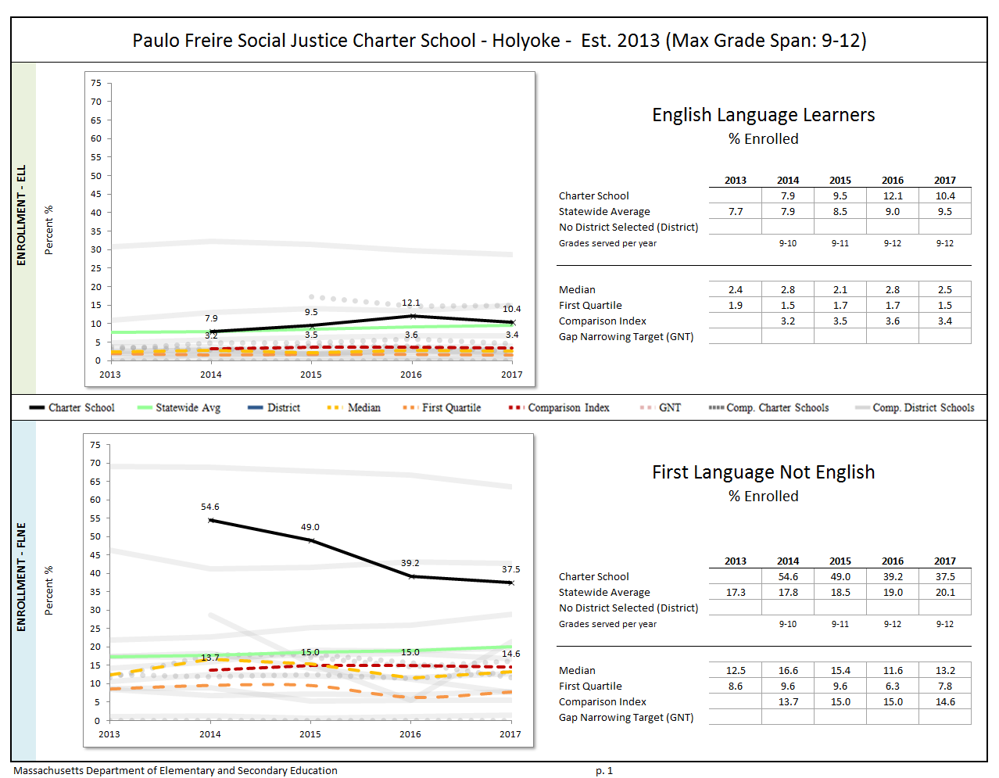

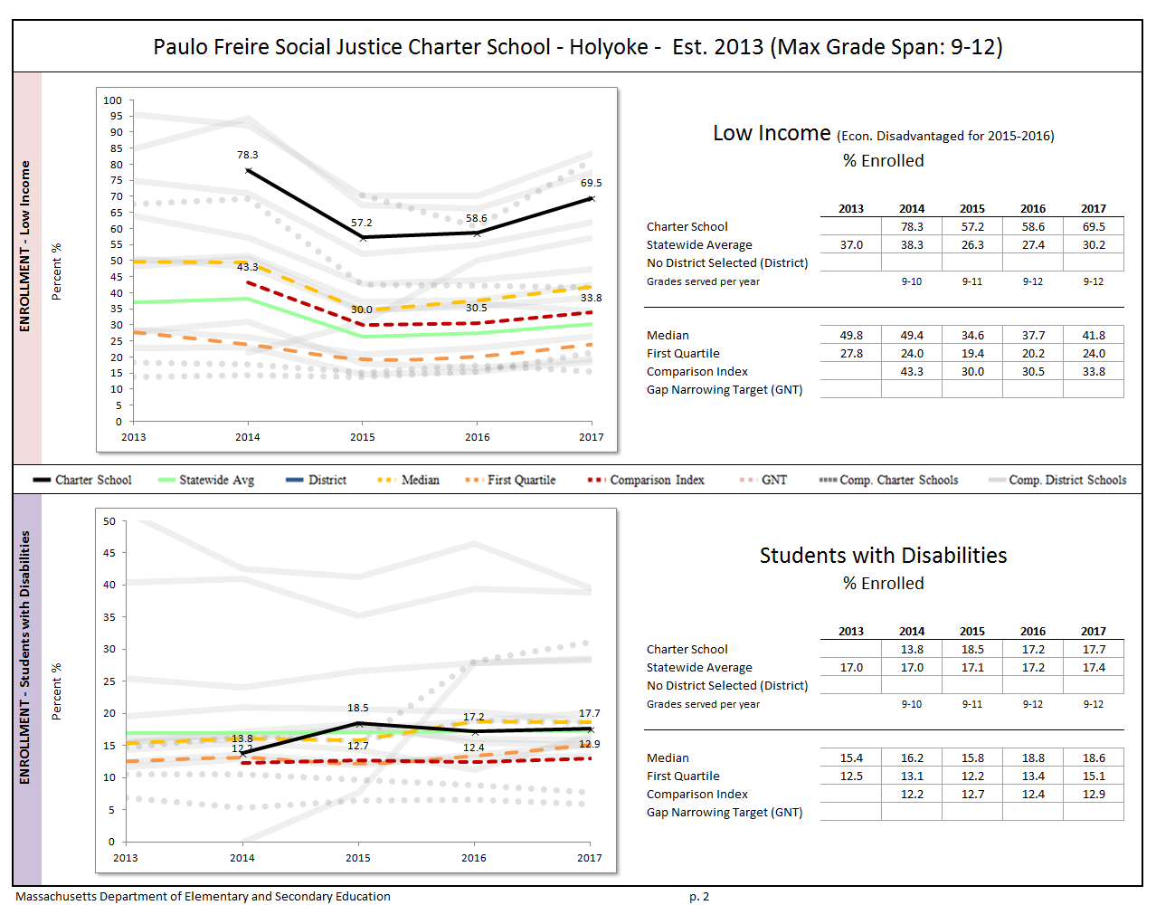

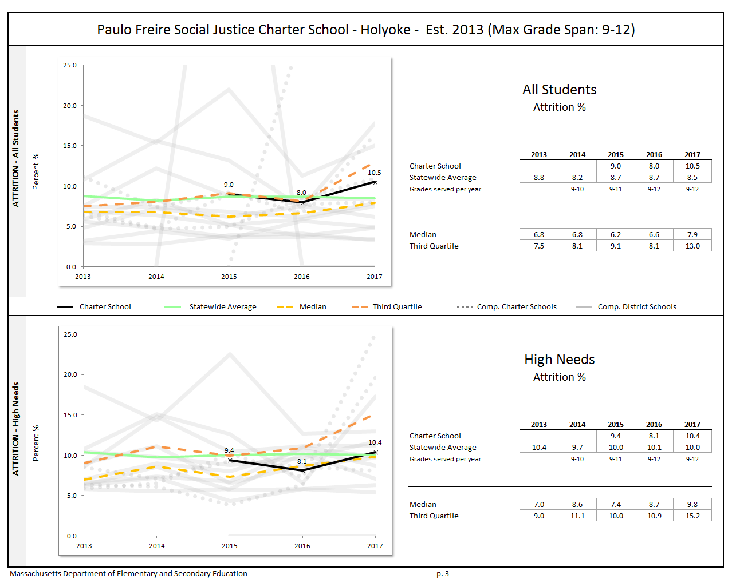


Paulo Freire Social Justice Charter School -Holyoke - Est.2013 (Ma Grade Span: 912) All students Stabiligy Rate% and Hign Needs Stability % erollment data.


|  |
| --- |
| **Appendix C: Academic Data (Criterion 5: Student Performance)** |

The **charter accountability table** (below) provides several sets of data relative to charter school performance on statewide assessments as well as student indicators. The percent of students scoring proficient or advanced (P/A), the composite performance index (CPI), the percent of students scoring warning or failing (W/F), and the student growth percentile (SGP) are all displayed in the aggregate over the term of the charter. For schools participating in PARCC in 2015 and 2016, the percent of students who met or exceeded expectations (Level 4 and 5) and those who did not meet expectations (Level 1) are displayed. Because these are not exact equivalents to MCAS proficient/advanced or warning/failing, these figures are not included in the graph. A Transitional Composite Performance Index (Trans. CPI) and Transitional Student Growth Percentile (Trans. SGP) generated using current PARCC and prior MCAS scores are displayed as equivalents to MCAS CPI and SGP. These figures are included in the graphs. The school’s accountability level, percentile, English Language Arts (ELA) and math percentiles for the aggregate and targeted subgroups, and cumulative progress and performance index (PPI) for the aggregate and targeted subgroups are shown if available (this depends on the size and the age of the school). When applicable, the 4-year and 5-year graduation rates as well as the annual dropout rate are also provided for the available years of the charter term. For detailed definitions of accountability terms, please visit this URL: <http://profiles.doe.mass.edu/accountability/report/aboutdata.aspx#AccountabilityInformation>.

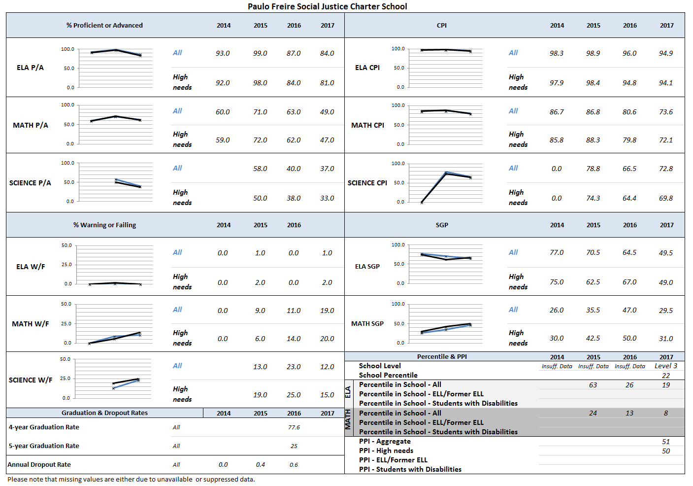

MCAS Test of Spring 2017
Percent of Students at Each Achievemnet Level for Paulo Freire Social Justice Charter School (District)

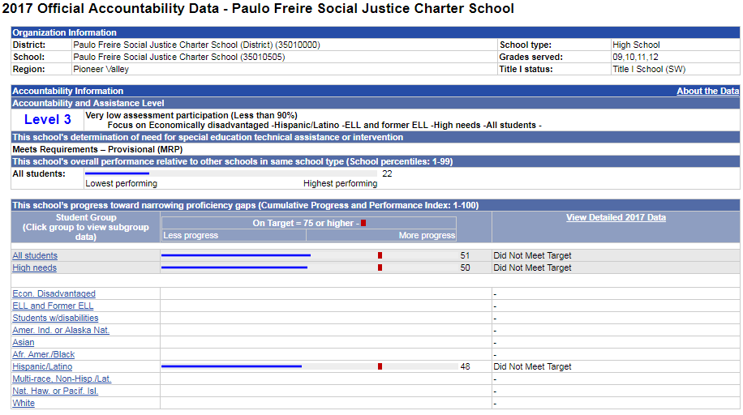

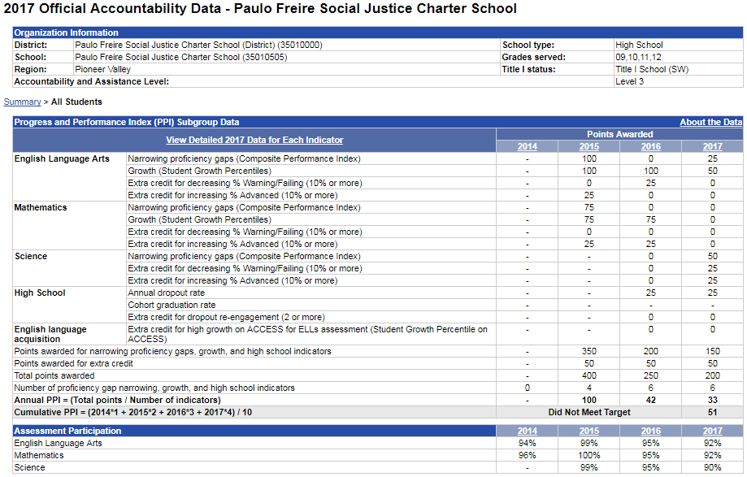

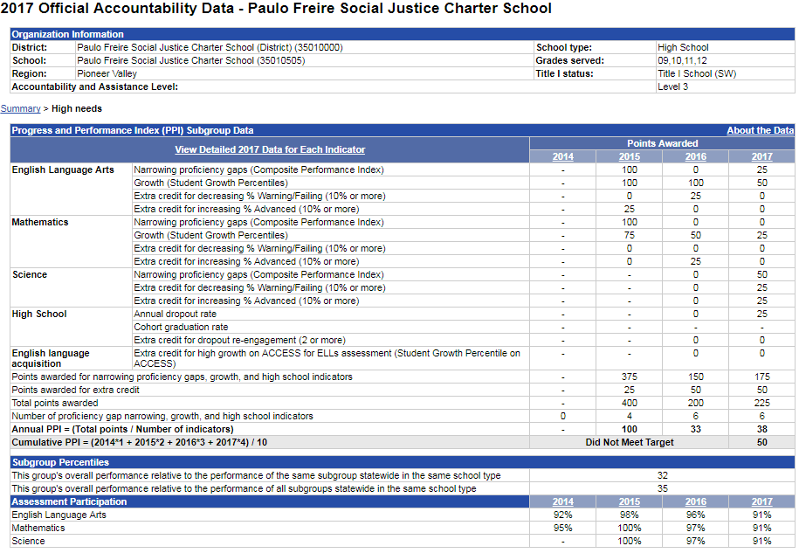

|  |
| --- |
| **Appendix D: Financial Dashboard (Criterion 10: Finance)** |

Paulo Freire Social Justice Charter School - Holyoke - Est. 2013
5-Year Financial Summary

|  |  |  |  |  |
| --- | --- | --- | --- | --- |
| **Financial Metric Definitions** | | **Low Risk** | **Moderate Risk** | **Potentially High Risk** |
| **1. Current Ratio** | *Current Ratio is a measure of operational efficiency and short-term financial health. CR is calculated as current assets divided by current liabilities.* | >= 1.5 | Between 1.0 (inclusive) and 1.5 | < 1.0 |
| **2. Unrestricted Days Cash (Prior to FY14)** Applies to 5-year average | *The unrestricted days cash on hand ratio indicates how many days a school can pay its expenses without another inflow of cash. Calculated as Cash and Cash Equivalents divided by ([Total Expenses-Depreciated Expenses])/365).  Note: This is based on quarterly tuition payment schedule.* | >= 75 days | Between 45 (inclusive) and 75 days | < 45 days |
| **2. Unrestricted Days Cash (FY14 forward)** | *4th quarterly tuition payments to Commonwealth charter schools in FY14 were made after June 30, 2014, which resulted in lower-than-typical cash at fiscal year end, affecting the risk levels for the current ratio and unrestricted days cash indicators for FY14 on a one-time basis. Payments for FY15 and after are made on a monthly basis, and parameters for risk have been adjusted accordingly.* | >= 60 days | Between 30 (inclusive) and 60 days | < 30 days |
| **3. Percentage of Program Paid by Tuition** | *This measures the percentage of the schools total expenses that are funded entirely by tuition. Calculated as (Tuition + In-Kind Contributions) divided by Total Expenses (expressed as a percentage). Note: In-Kind Contribution are added to the numerator in this ratio to balance out In-Kind Expenditures which will be captured in the Total Expenses in the denominator, and ratios over 100% are set to 100%.* | >= 90% | Between 75% (inclusive) and 90% | < 75% |
| **4. Percentage of Program Paid by Tuition & Federal Grants** | *This measures the percentage of the schools total expenses that are funded by tuition and federal grants. Calculated as (Tuition + In-Kind Contributions + Federal Grants) divided by Total Expenses (expressed as a percentage). Note: In-Kind Contribution are added to the numerator in this ratio to balance out In-Kind Expenditures which will be captured in the Total Expenses in the denominator, and ratios over 100% are set to 100%.* | >= 90% | Between 75% (inclusive) and 90% | < 75% |
| **5. Percentage of Total Revenue Expended on Facilities** | *This measures the percentage of Total Revenue that is spent on Operation & Maintenance and Non-Operating Financing Expenses of Plant. Calculated as Operation & Maintenance plus Non-Operating Financing Expenses of Plant divided by Total Revenues (expressed as a percentage).* | <= 15% | Between 15% and 30% (inclusive) | > 30% |
| **6. Change in Net Assets Percentage** | *This measures a school's cash management efficiency. Calculated as Change in Net Assets divided by Total Revenue (Expressed as a percentage).* | Positive % | Between -2% (inclusive) and 0% | < -2% |
| **7. Debt to Asset Ratio** | *Measures the extent to which the school relies on borrowed funds to finance its operations. Calculated as Total Liabilities divided by Total Assets.* | <= .9 | Between .9 and 1 (inclusive) | > 1 |
| **FY16 MA AVG Column** | *All financial metrics indicated in this column are a result of each ratio calculated using statewide totals. For Enrollment, Total Net Assets and Total Expenditures rows, these numbers are averages calculated using the statewide totals of all charter schools’ data.* |  |  |  |

1. As reported on March 15, 2017 in the Massachusetts Charter School Waitlist Initial Report for 2017-2018 (FY18).
2. Criterion 2 evaluates the school’s rates of enrollment, attrition, and stability of various subgroups. Stability rate measures how many students remain in a district or school throughout the school year.
3. 1 The names of each of these schools and additional subgroup detail can be found in the Charter Analysis and Review Tool (CHART), <http://www.doe.mass.edu/charter/chart/>.
4. The midpoint value of all comparison schools. This is derived using Microsoft Excel's MEDIAN function.
5. The first quartile is the middle number between the smallest number and the median of all comparison schools. This is derived using Microsoft Excel's QUARTILE function.
6. The comparison index provides a comparison figure derived from data of students who reside within the charter school’s sending district(s). The comparison index is a statistically calculated value designed to produce a fairer and more realistic comparison measure that takes into account the charter school’s size and the actual prevalence of student subgroups within only those grade levels in common with the charter school.
7. The Gap Narrowing Target (GNT) refers to the halfway point between the school’s baseline rate (which is the rate in the 2010-11 school year, or the first year enrollment data is collected if after 2010-11,) and the current Comparison Index (the “target”). The object is to meet this halfway point by the 2016-17 school year (or in a later year if baseline is after 2010-11), giving the school six years to do so. For a school to be on schedule to meet its GNT, an incremental increase must be met annually. To determine this increment, the following equation is used: [(Comparison Index – Baseline) / 2] / 6 years = Annual GNT.
8. The percentage of attrition, or rate at which enrolled students leave the school between the end of one school year and the beginning of the next.
9. A student is *high needs* if he or she is designated as either low income, or ELL, or former ELL, or a student with disabilities. A former ELL student is a student not currently an ELL, but had been at some point in the two previous academic years.

   8the Stability Rate measures how many students remain in a district or school throughout the school year.

   * 2014-2015 is the first year for which the category “Economically Disadvantaged” is being reported, replacing the “Low-income,” “Free Lunch” and “Reduced Lunch” categories used in 2013-2014 and earlier. It is important for users of this data to understand that enrollment percentages and achievement data for "economically disadvantaged" students cannot be directly compared to "Low-income" data in prior years. Please see <http://www.doe.mass.edu/infoservices/data/ed.html> for important information about the new “Economically Disadvantaged” category.
10.