Massachusetts Department of

Elementary and Secondary Education

75 Pleasant Street, Malden, Massachusetts 02148-4906 Telephone: (781) 338-3000

TTY: N.E.T. Relay 1-800-439-2370

Jeff Wulfson
Acting Commissioner

MEMORANDUM

To: | Members of the Board of Elementary and Secondary Education
From: | Jeff Wulfson, Acting Commissioner
Date: | January 12, 2018
Subject: | Charter Schools – Report on Conditions for Paulo Freire Social Justice Charter School and Recommendation to Renew Charter with Probation

This month, the Board of Elementary and Secondary Education (Board) will discuss and vote on the charter renewal application for Paulo Freire Social Justice Charter School (PFSJCS). I recommend that the Board renew the school’s charter and place it on probation with the conditions described later in this memorandum.

Paulo Freire Social Justice Charter School
Type of Charter  (Commonwealth or Horace Mann) | Commonwealth | Location | Holyoke
Regional or Non-Regional | Regional | Districts in Region  (if applicable) | Chicopee, Holyoke, Northampton, South Hadley, West Springfield, and Westfield
Year Opened | 2013 | Year(s) Renewed  (if applicable) | N/A
Maximum Enrollment | 500 | Current Enrollment | 270
Chartered Grade Span | 9-12 | Current Grade Span | 9-12
Students on Waitlist | 0 | Current Age of School | 5 years
Mission Statement
The Paulo Freire Social Justice Charter School (PFSJCS) is a public high school preparing students for college success while inspiring them to be active and effective citizens. We achieve educational excellence and social responsibility for all our students through high expectations and a rigorous academic and social justice curriculum. Our students graduate with strong intellectual and ethical foundations necessary for future leaders of a global society.

Basis of Recommendations Regarding the Renewal of Charters

The charter school regulations state that “[t]he decision by the Board to renew a charter shall be based upon the presentation of affirmative evidence regarding the success of the school’s academic program; the viability of the school as an organization, including the extent to which the school has followed its recruitment and retention plan; and the faithfulness of the school to the terms of its charter.” 603 CMR 1.11(2). Consistent with the regulations, recommendations regarding renewal are based upon the Department of Elementary and Secondary Education’s (Department) evaluation of the school’s performance in these areas as outlined in the Charter School Performance Criteria and Commissioner Chester’s memorandum dated October 7, 2013, regarding Considerations for Charter School Renewal. In its review, the Department has considered the school’s absolute performance at the time of the application for renewal and the progress the school has made during the past four years of its charter. The accountability process for charter schools recognizes that in exchange for increased freedom, a school must demonstrate results within the term of its five-year charter or risk non-renewal or other possible sanctions, including revocation.

The superintendents of the public school districts served by PFSJCS were invited to submit written comment to the Department regarding the renewal of PFSJCS’s charter. The Department did not receive any comments.

Recommendation for Board Action

Based upon the evidence described in the attached Summary of Review, the progress on conditions, and other information further summarized below, I recommend that the Board renew the school’s charter and place it on probation with conditions requiring major improvements to governance, financial oversight, and the school’s academic program and performance. I am not recommending non-renewal at this time because the school is making efforts to address these deficiencies.

My recommendation to place the school on probation with conditions is based on a lack of financial oversight and mismanagement of the charter school by the board of trustees. Additionally, the school has not yet demonstrated promising academic results. Paulo Freire Social Justice Charter School is in its fifth year of operation, and I expect a school of this age to be organizationally viable and to be delivering a robust program of study.

Due to a lack of capacity, turnover, and mismanagement, the board of trustees has not demonstrated the ability to successfully govern a charter school. Six months ago, on July 26, 2017, I placed a set of conditions on the school’s charter related, in part, to my concerns about governance. While the school has met the conditions, three conditions, were met after the deadline. Additionally, the school has not consistently demonstrated academic program success. To the contrary, the school’s MCAS scores have declined during its first charter term. In 2017, the school was in the 22nd percentile overall and in Level 3 for very low participation rates of less than 90 percent. The hiring of a new executive director in May 2017 and the election of a new board chair give me hope that the school will be able to address these issues.

I have serious concerns about the school’s financial solvency due to persistent under-enrollment and high rates of student attrition. If the school remedies concerns about governance and the academic program, my hope is that PFSJCS will be able to address the underlying causes of the under-enrollment and attrition. While the school has taken steps to increase enrollment and improve attrition rates, the school must improve holistically to attract students and gain financial stability and sustainability. The Department will need to monitor the school closely. A report on conditions as well as additional evidence related to my concerns follows.

Report on Conditions

On July 26, 2017, I notified the Board of my intention to place PFSJCS on conditions. I presented the Board with a memorandum regarding concerns about the school’s organizational viability, with proposed conditions. The Board did not request to discuss the matter at an upcoming meeting, and I subsequently imposed seven conditions on the charter of PFSJCS. On November 9, 2017, the school’s executive director notified the Department that its compliance with the fourth condition would be late due to membership turnover on the board. The school’s progress in meeting the conditions follows.

Condition 1: Beginning on August 15, 2017, and until further notice, PFSJCS must submit to the Department of Elementary and Secondary Education (Department), at charterschools@doe.mass.edu or 75 Pleasant Street, Malden, MA, 02148, board meeting agendas, materials, and minutes prior to each board meeting at the same time that these items are sent to the school’s board members. Additionally, if board materials do not already include this information, the school must also submit monthly financial statements.

Status: Ongoing
The school has submitted board meeting agendas, materials, and minutes for August, September, October, and November of 2017, as well as for committee meetings. Committee meeting minutes, however, are limited and often only include agenda items, rather than a record of the committee meeting. Likewise, full board meeting minutes are not robust and do not appear to comply fully with the Open Meeting Law. Submitted board materials include financial statements. Board minutes submitted for September reflect that the board had a technical issue with their June minutes, and the board was unable to vote on them.

Condition 2: By August 25, 2017 and November 3, 2017, PFSJCS will submit complete and comprehensive Coordinated Program Review (CPR) Progress Reports for special education and civil rights, respectively.

Status: Met
The school last received a CPR visit from the Department’s Office of Public School Monitoring in September 2016. The school had four findings in special education, seven findings for civil rights, and zero findings for English Learner Education. Paulo Freire Social Justice Charter School’s corrective action plan (CAP), is currently pending. The school has submitted the first set of the reports referenced in the condition. Paulo Freire Social Justice Charter School submitted its second set of progress reports on November 3rd, as required. With the submission of these progress reports, the school came into compliance with the requirements of all of the special education criteria and all but one civil rights criterion. On November 30th, the Department provided additional technical assistance for the civil rights criterion, and PFSJCS submitted the third and final progress report as required on December 15, 2017.

Condition 3: By September 30, 2017, the school’s board of trustees must engage in training conducted by an external consultant, acceptable to and approved in advance by the Department, on the roles and responsibilities of a board of trustees for a charter school and on the Open Meeting Law.

Status: Met
The school requested, and the Department approved, Mirick O’Connell, Attorneys at Law, to provide a board of trustees training on the board’s roles and responsibilities and the Open Meeting Law. This training occurred on September 18, 2017.

Condition 4: By October 30, 2017, the school’s board of trustees must have completed a comprehensive self-evaluation of its practices and its capacity.

Status: Met after deadline
On November 9, 2017, the Department received a letter from PFSJCS stating that the school had contracted with BoardOnTrack for support in completing a self-assessment. The executive director of the school notified the Department that the self-assessment would be submitted after the deadline due to recent board turnover. At the school’s board meeting on November 13, 2017, the executive director introduced the self-assessment and BoardOnTrack to board members and instructed them on how to complete the self-assessment.

The Department received a copy of the board’s self-assessment on December 14, 2017. The assessment results reflected the raw data of the board’s self-assessment on topics including board meetings, board structure, board composition, board recruitment, board goals and accountability, finance, development, academic oversight, and other areas. The results reflect cumulative ratings of the board’s performance in each category on a scale of 1 (strongly disagree) to 5 (strongly agree). Each question was framed in the positive so that agreement (higher numbers) indicated that the board thought it was doing well in a given area. The assessment also included the executive director’s ratings of the board. The board cumulatively gave itself “3s” in most categories; the board cumulatively gave itself “2s” in board recruitment, board goals and accountability, finance, and the support and evaluation of the executive director; the board cumulatively gave itself a “1” in development.

Condition 5: By November 30, 2017 the school will integrate World-class Design and Assessment English Language Development (WIDA ELD) into its English as a Second Language curriculum and content area curricula as needed.

Status: Met
On November 21, 2017, the school submitted a WIDA-aligned English as a Second Language program curriculum. The school is using Hampton-Brown’s EDGE reading, writing and language curriculum and has developed a WIDA-aligned scope and sequence based on the units available in that resource.

Condition 6: By December 30, 2017, the school’s board of trustees will revise its bylaws, aligning them with current laws and regulations, and submit them to the Department for approval.

Status: Met after deadline
On December 31, 2017, the Department received draft bylaws from the school for review. The Department is currently reviewing the draft.

Condition 7: By December 30, 2017, the school will submit a plan to the Department to come into compliance with applicable state and federal laws and regulations, including, but not limited to, those related to the Open Meeting Law and ESL curriculum requirements.

Status: Met after deadline
On December 31, 2017, the school submitted a plan to the Department to bring itself into compliance with applicable state and federal laws and regulations. The plan includes steps to establish four sub-committees of the board of trustees; to establish regular status reports to the board and to the community regarding financial, academic, and instructional data; to create board agendas more collaboratively; to create and post committee minutes using the BoardOnTrack website; to implement an orientation for new board members; to review the Open Meeting Law as a full board annually; to complete program assessments; and to establish a professional development plan for staff. As noted above, the school has developed a WIDA-aligned ESL curriculum.

Additional Evidence

As noted in the attached summary of review and data charts, the Department has concerns regarding financial oversight and management by the board of trustees and regarding the school’s academic results.

Enrollment Concerns and Financial Issues

During the charter term, the school’s low enrollment has created persistent financial concerns.
The school is consistently under-enrolled compared to its growth plan, and student attrition has increased during the charter term.

- Between FY15 and FY18 the school pre-enrolled more students than it served, requiring the school to adjust its tuition calculations and make financial adjustments mid-year.
- Each year, PFSJCS has recruited an additional 30 to 50 students during the year and ended each school year with more students than were enrolled at the beginning of the year.
- In FY18, the school remains under-enrolled; as of October 2017, the school enrollment is 270 students, 70 students fewer than the school reported pre-enrolled (340 students in March 2017), and 195 students fewer than the school’s approved growth plan (465 students).
- In FY18, because the school pre-enrolled 340 students, the school budgeted for tuition payments of $427,000 per month. Because the school is serving only 270 students, however, the school’s tuition will decrease by $190,000 per month to $237,000 per month for December 2017 through the remainder of the school year. This adjustment is necessary to correct the overpayment the school received for the first five months of the year based upon its pre-enrollment report. As with all Massachusetts charter schools, the school’s annual tuition will be adjusted again in June to reflect the total number of students served during the school year.
- The school’s attrition of students has also increased throughout the charter term. During the charter term, attrition rates have been slightly higher than the median of comparison schools and statewide averages. In the summer of 2017, the school had an attrition rate of 20 percent for all students. The attrition rate for rising grade 10 students was 27.7 percent. Further, for 2017-2018, the grade 9 cohort is 66 students, significantly below the 103 students in grade 9 for 2016-2017 and well short of the 145 students in grade 9 outlined in the school’s growth plan.
- In an interview with the school’s executive director and the newly appointed board chair, they stated that the school has altered its staffing to accommodate these changes to the budget. The school also hired an enrollment coordinator to improve recruitment for the school. The executive director cited the school’s previous instability as the main cause of student attrition in recent years.

The school’s audits have reflected ongoing concerns throughout this charter term, including a finding for not meeting the criteria of a going concern in fiscal year 2016. Going concern refers to a business or organization that has the funds to remain open for at least twelve months. The school’s fiscal audits contained findings every year of the charter term.

- In FY16, the school incurred a loss of $303,984 and had a deficit net position balance of $169,921.
- As of June 30, 2016, the school’s liabilities exceeded assets by $411,777. Coupled with the school’s losses and deficits noted above, these factors raised substantial doubt for the auditors about the school’s ability to continue as a going concern.
- The school’s audit for FY17 did not include a finding of going concern. Based on under-enrollment in FY18, however, the school has adjusted its budget and has developed two financial scenarios based on potential enrollment of additional students.

As reflected in Appendix D of the attached Summary of Review, the school’s Financial Dashboard displays moderate and high-risk indicators from FY14-FY16. Though the indicators improved in FY17, the under-enrollment and budget constraints mentioned above will most likely result in moderate and high risk indicators for FY18.

Mismanagement of the Charter School

As noted in the attached Summary of Review, throughout the charter term PFSJCS experienced turnover in leadership and board membership that impacted the ability to effectively manage the school.

- Since its founding in 2013, the school’s board has had three different chairs and additional turnover in the board’s membership.
- Since opening, over four years ago, PFSJCS has employed three executive directors and three principals.
- In Year 5, during the renewal inspection visit, stakeholders identified the lack of continuity as a major source of confusion as to the roles and responsibilities of administrators.
- While stakeholders continue to define the school’s structure and protocols as a work in progress, stakeholders in Year 5 stated that there has been improvement in organizational and structural clarity since the current executive director and principal were hired in the spring of 2017.

Evidence collected by the Department during the charter term demonstrates that the school’s board is still working to develop the systems, structures, or capacity to effectively govern the school. In July 2017, I placed conditions upon the school’s charter due in part to my concerns regarding a lack of effective governance practices.

- The board had demonstrated an inability to oversee and govern the school due to a lack of effective communication between the board and school leadership; an inability to obtain requested data to monitor academic success, finances, and enrollment; issues with adherence to the Open Meeting Law and the school’s bylaws; and an inability to properly monitor the fiscal health of the school.
- While the board has met some of the conditions imposed in July 2017, as documented by the renewal inspection team, board members continue to struggle to govern the school effectively as of October 2017. The renewal inspection team found that the board has failed to provide appropriate oversight to the school and focus on the school’s success and sustainability. The renewal inspection team noted that the board’s ongoing issues include compliance with the Open Meeting Law; membership below the requirements set by the bylaws; lack of adherence to the bylaws in terms of parent and student representation on the board; lack of evaluation of the school’s leaders; high member turnover; lack of strategic planning; and lack of oversight of the charter school’s mission, academics, and finances. Further, as noted above, while some aspects of the school’s conditions were met on time, several conditions were met late due to instability in the board’s membership.
- Additionally, in the school’s final charter application, PFSJCS promised to locate in downtown Holyoke; the board has been unable to secure a facility in the promised location. Charter school statute, however, requires that a charter school locate in the municipality specified in its final application.
- The board has recently elected a new board chair, who reports that he is committed to ensuring that the board will comply with the Open Meeting Law and other regulatory and statutory requirements and will provide more appropriate oversight.

Lack of Evidence of Academic Success

As a grade 9-12 school, PFSJCS students have taken the grade 10 Legacy MCAS in English language arts (ELA), mathematics, and science and technology/engineering every year of the charter term. Performance on the MCAS has not improved but, rather, shown a decline in scores during the charter term.

- In 2017, the school is in Level 3 for very low assessment participation of less than 90 percent.
- In 2017, the school is in the 22nd percentile when compared to other high schools statewide.
- From 2014 to 2016, the school had insufficient data for a Cumulative Progress and Performance Index (PPI). In 2017, the PPI was 51 for all students, signaling that the school is not meeting its gap-narrowing targets. In 2017, the school had a PPI of 50 for the high needs subgroup.
- As shown in the table below, in 2017, PFSJCS students performed below state averages for proficiency.
- Data are unavailable for the high needs subgroup at the school.

As shown in the displays below, PFSJCS grade 10 Composite Performance Index (CPI) scores have declined over the course of the charter term (2014-2017) in ELA and mathematics.

ELA CPI Chart

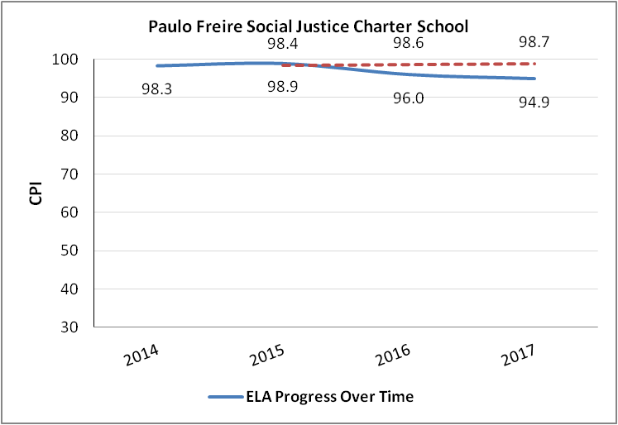

Mathematics CPI Chart

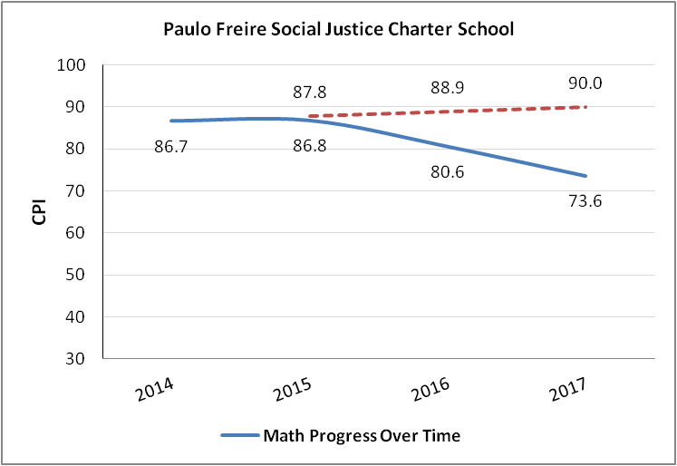

Science CPI Chart

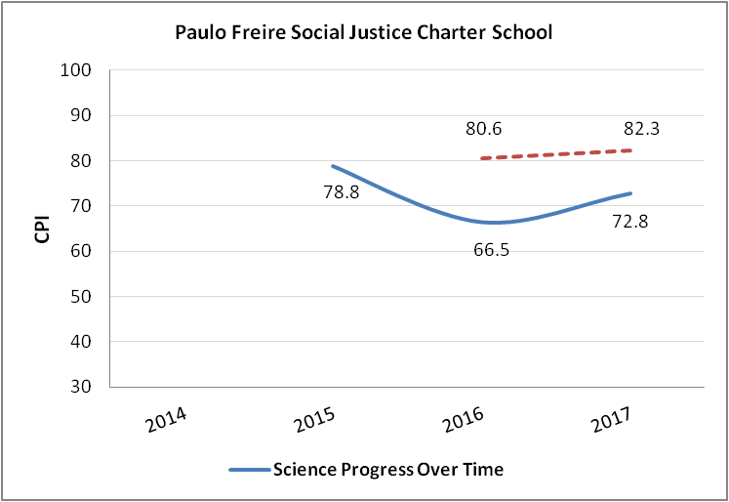

Historical student growth percentile (SGP) data for grade 10 MCAS is displayed in the chart that follows. The school’s SGP has declined over time for ELA. The school’s SGP data for mathematics show that a majority of students are not from grade 8 to grade 10 when compared to peers statewide. The mathematics growth target is 51.

PFSJCS Median Student Growth Percentile for grade 10
Year |  | 2014 | 2015 | 2016 | 2017
ELA SGP | All | 77 | 70.5 | 64.5 | 49.5
 | High needs | NA | NA | NA | NA
Math SGP | All | 26 | 35.5 | 47 | 29.5
 | High needs | NA | NA | NA | NA

The school’s four year graduation rate from 2016 is lower than the state average. The five year graduation rate is lower than the state average; however, the cohort size was 8 students and 4 remained in school.

 | PFSJCS | State Average
4 Year Graduation Rate 2016 | 77.6% | 87.5%
5 Year Graduation Rate 2015 | 25% | 89.4%
Drop Out Rate | 0.6% | 1.9%

Conditions Imposed with Probation and Charter Renewal

I recommend that the Board vote to place PFSJCS on probation and impose the conditions that follow on the school’s charter:

- Until further notice, PFSJCS must submit to the Department of Elementary and Secondary Education (Department), at charterschools@doe.mass.edu or 75 Pleasant St., Malden, MA, 02148, board and committee meeting agendas, materials, and minutes prior to each board meeting at the same time that these items are sent to the school’s board members. Additionally, if board materials do not already include this information, the school must also submit monthly financial statements. The documents must reflect adherence to the Open Meeting Law.
- Until further notice, the school must submit weekly enrollment updates to the Department.
- By February 28, 2018, the school must establish an escrow account in an amount determined by the Department in consultation with the school to pay for any potential closing, legal, and audit expenses associated with closure, should that occur.
- By February 28, 2018, the school must submit financial planning documents for FY19 and FY20 using enrollment projections that take into account the school’s historical enrollment trends.
- By April 1, 2018, the school must assess its enrollment trends over time and actual levels of demand and submit an amendment request to address, as appropriate, the school’s maximum enrollment including enrollment by grade, a growth plan if needed, and any changes in the districts in the school’s region.
- By April 18, 2018, all members of the board of trustees must participate in training on the Open Meeting Law offered by the Office of the Attorney General.
- By May 31, 2018, the board of trustees will work with the Department to obtain approval of its bylaws.
- By June 1, 2018, the school must submit to the Department a comprehensive evaluation of its mathematics, English language arts, and science programs. Such comprehensive evaluation must be conducted by an external consultant(s) acceptable to and approved in advance by the Department.
- By June 29, 2018, the school must submit to the Department for approval an action plan to improve academic performance. Such action plan must specify the strategies to improve mathematics, English language arts, and science performance for all student groups. The action plan must set clear and specific implementation benchmarks, with a clear timetable and deadlines for completion of key tasks sufficient to allow the school's board of trustees and the Department to monitor implementation.
- By November 1, 2018, the school must demonstrate actual enrollment sufficient to meet its budget, maximum enrollment, and any approved growth plan for enrollment. Should the school fail to do so, the Commissioner and the Board of Elementary and Secondary Education will consider revoking the school’s charter during the 2018-2019 school year, with the revocation to take effect by the end of the 2018-2019 school year based on failure to meet this single condition alone.
- By December 31, 2019, the school must demonstrate that it is an academic success by providing evidence that the school has exhibited significant and sustained academic improvement in mathematics, English language arts, and science.

In addition to meeting the terms of probation, PFSJCS, like all charter schools, must also comply with the terms of its charter. Failure of PFSJCS to meet the conditions placed on renewal of its charter within the timelines specified may result in immediate suspension and revocation of the school’s charter.

I will review and report to the Board on PFSJCS’s success or lack of success in meeting the terms of probation. Based upon this review, I will recommend that the Board take action as appropriate with respect to the school’s charter including, but not limited to, removal of probation, continuation of conditions, or suspension and revocation of the school’s charter.

*****

If you have any questions regarding this recommendation or require additional information, please contact Alison Bagg, Director (781-338-3218); Cliff Chuang, Senior Associate Commissioner (781-338-3222); or me.

Attachments: PFSJCS Summary of Review
Memorandum: PFSJCS Notification of Intention to Place Conditions on the
Charter of Paulo Freire Social Justice Charter School, July 2017

While a majority of PFSJCS’s students reside in the districts in its region, in 2016-2017, nearly 19 percent of the school’s total enrollment was from a district outside of its region: Springfield. While schools are permitted to enroll outside of their regions, in accordance with M.G.L. c. 71 § 89(n), if more than 20 percent of the school's total enrollment for two consecutive years comes from school districts not included in its original charter, the school's board of trustees must file an amendment request to reflect its actual enrollment patterns.
As reported on March 15, 2017, in the Massachusetts Charter School Waitlist Initial Report for 2017-2018 (FY18).

