Massachusetts Department of

Elementary and Secondary Education

75 Pleasant Street, Malden, Massachusetts 02148-4906 Telephone: (781) 338-3000 TTY: N.E.T. Relay 1-800-439-2370

Jeffrey C. Riley
Commissioner

MEMORANDUM

To: | Members of the Board of Elementary and Secondary Education
From: | Jeffrey C. Riley, Commissioner
Date: | October 18, 2019
Subject: | Update on Chronically Underperforming Schools: FY2020 Quarter 1 Reports

This month, I am presenting the first of four FY2020 quarterly progress updates to the Board of Elementary and Secondary Education (Board) on the four chronically underperforming schools’ implementation of their school turnaround plans, focusing on activities from July-October 2019. This memo also provides an update on the new progress monitoring process for schools in the Strategic Transformation region. Future quarterly updates for FY2020 will be presented in December 2019 and March 2020, and a final annual review in June 2020.

FY2019 accountability data as well as comparative FY2018 assessment data has been included for your reference.

Chronically Underperforming Schools

In the fall of 2013, four schools were designated as chronically underperforming schools in response to their low performance and lack of improvement while in underperforming status: John P. Holland Elementary School (UP Academy Holland) and Paul A. Dever Elementary School (Dever) in Boston, Morgan Full Service Community School (Morgan) in Holyoke, and John Avery Parker Elementary School (Parker) in New Bedford.

New Progress Monitoring Partner: School Empowerment Network
Historically, chronically underperforming schools have received annual progress monitoring reviews by a third party vendor, focused on the presence of research-based turnaround practices and the implementation of each school’s turnaround plan. This year, the School Empowerment Network (SEN), will organize and lead all progress monitoring visits on behalf of the four chronically underperforming schools.
About SEN: SEN works with local education agencies to improve school performance by offering building- and district-level diagnostics and evaluations, school design and redesign support, and assistance building robust leadership pipelines. The School Empowerment Network has developed tools, processes, and protocols that position school reviews (e.g., site visits) as a performance management framework that diagnoses problem areas to help drive action planning for improvement. For the remainder of the year, the quarterly reports will focus on the results from the site visits at each of the four chronically underperforming schools.
Updates on the Chronically Underperforming Schools
Paul A. Dever Elementary School, Boston Public Schools. The Paul A. Dever Elementary (Dever) school community enjoyed a smooth opening of school with Michael Contompasis returning as receiver for the second year and Dr. Todd Fishburn in his fourth year as principal. The Dever began school with all staff positions filled, which greatly supported a positive launch of the school year. Additionally, 450 families attended the first family night. Overall, the school team reported a palpable sense of high energy and readiness for a strong start to the school year.

A major focus for the year will be continuing to align and improve instructional supports for students. During the summer, the Dever team used professional development time to define learning priorities and better understand how to increase instructional rigor by meeting grade-level standards. The school is utilizing supports from the Department of Elementary and Secondary Education (Department), Boston Public Schools, and the University of Massachusetts Boston to provide additional instructional supports.

UP Academy Holland, Boston Public Schools. Victoria Thompson is in her first year as principal of UP Academy Holland (UAH). UP Education Network continues to be the receiver for the school. Ms. Thompson came to UAH six years ago after having been an English as a Second Language instructor in Arizona. For the past three years, she was UAH’s Director of Curriculum and Instruction under the leadership of the previous principal, Hillary Casson. Last spring, Ms. Casson was promoted to Managing Director of Academic Leadership for UP Education Network where she continues to support UAH as part of her new role.

The UAH administrative team spent the summer reflecting on the 2018-2019 school by analyzing data from walkthroughs, assessments, surveys, and recommendations. Based on the findings from this analysis and the work of the school’s strategic planning committee, a strategic plan for the 2019-2020 school year was crafted. Components of this plan include focusing on the following priorities in the school’s turnaround plan: 1) addressing academic gaps uncovered by data analysis (Priority Area 2); 2) ensuring instruction involves increasing the cognitive lift by students (Priority Area 2); 3) improving reading scores (Priority Area 1); and 4) improving speaking scores on the ACCESS assessment (Priority Area 3).

In addition, the goals include continuing to build teachers’ social emotional learning (SEL) skills and competencies to improve beyond their current level of knowledge and abilities, in order to better address the needs of students. The UAH team is confident the school will be able to sustain academic gains and progress, given the strong retention rate of staff from 2018 to 2019.

Morgan Full Service Community School, Holyoke Public Schools. Led by principal Steven Moguel and receiver Steve Zrike, Morgan Full Service Community School (Morgan) provided six full days of summer professional development to all returning staff. The sessions supported the Morgan priorities outlined in the 2019-2019 School Improvement Plan which include providing strong tier 1 instruction to all students using consistent and highly rated curriculum resources, developing strong and authentic relationships with students, and providing opportunities for active family and educator voice.

Several sessions supported teachers in preparing to deliver strong tier 1 instruction to all students, including training for new curricula such as Engage NY, REACH, STMath, Do the Math, Making Meaning, Fundations, and Orton-Gillingham. Similarly, several sessions supported Morgan staff in preparing to implement Positive Behavioral Intervention and Supports (PBIS) and to learn effective classroom strategies around engagement and relationship building. The culminating event for this professional learning was a barbecue for school staff, students, and families at Morgan the day before school began, which was a great opportunity to build school-family connections and kick off the start of school.

Because of these six full days of work and preparation, Morgan had a seamless start to the school year. Morgan leadership has systems and structures in place to remain focused on their strategic priorities working in tandem with the district academic team as well as partner consultants.

John Avery Parker Elementary School, New Bedford Public Schools. The John Avery Parker Elementary (Parker) opened school successfully with a strong first few weeks with students. The receiver, School and Main Institute (SMI), returned for a second year with Dr. Fran Roy as the point-person on the ground and Jennifer Mainelli as the returning principal. New this year is a weekly one-hour early release schedule for students, enabling teachers to receive more consistent professional development to bolster their instructional practice.

The Parker staff spent the summer preparing for the school year by participating in professional development around creating safe and supportive school climates such as developing responsive classrooms, trauma-informed classrooms, and preparing for a well-organized building-based student support team. Instructionally, the staff continued to build upon their work with mathematical thinking and creating tiered supports for students. For the 2019-2020 school year, the Parker will focus on implementing a workshop model for instruction and ensuring teachers spend quality time planning for rigorous learning. During their planning time, teachers will develop complex tasks and problems that students should productively struggle to solve. Additionally, Parker is working to create strong systems that target the needs of academically at-risk students. This includes a careful data analysis of student progress and supporting foundational skill-building as students reach grade-level standards.

MCAS and Accountability Data 2018 and 2019

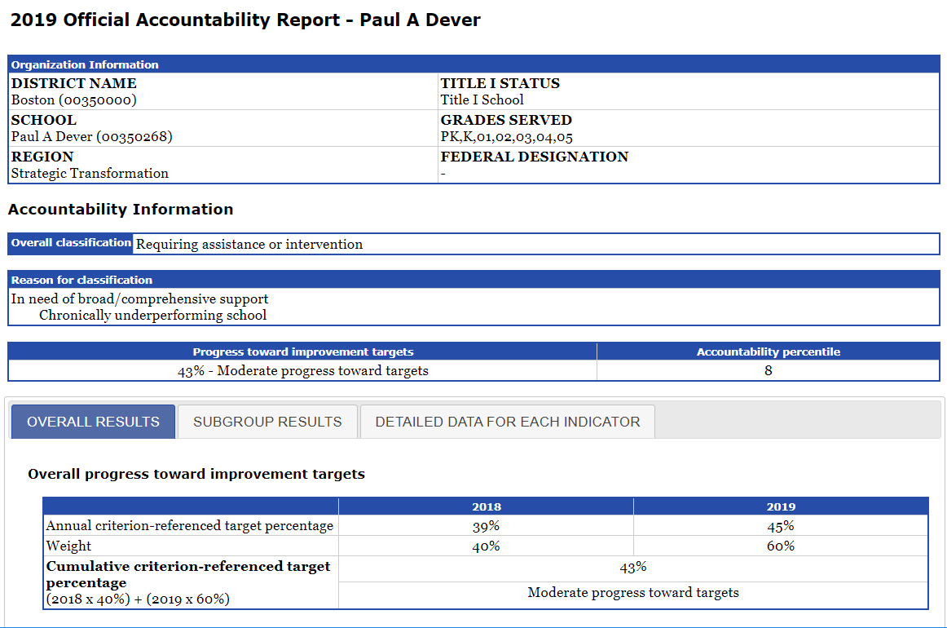
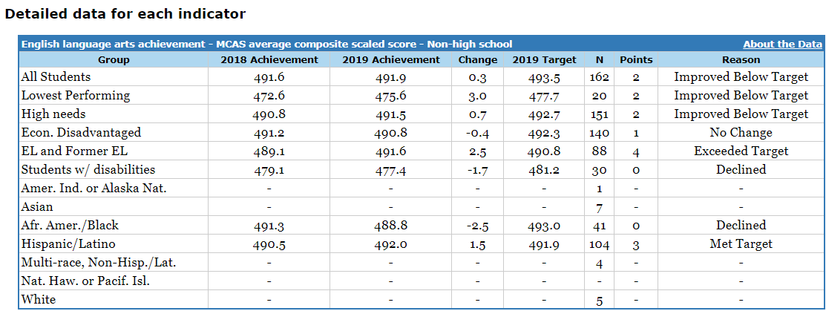

Paul A. Dever Elementary School
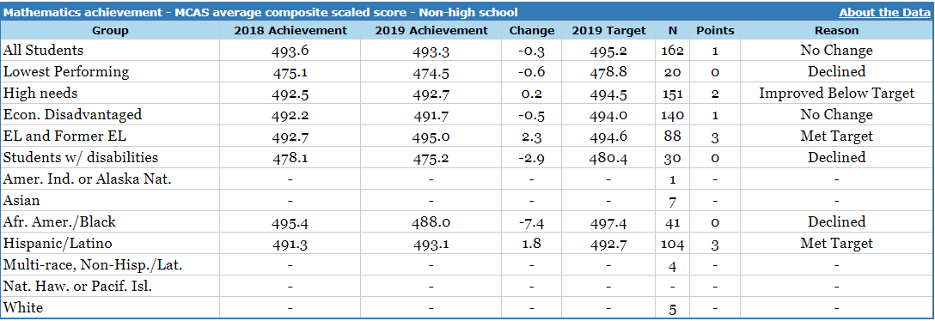
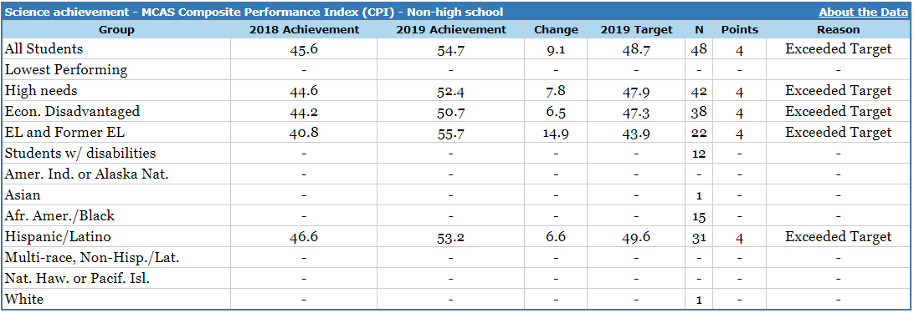

Paul A. Dever Elementary School
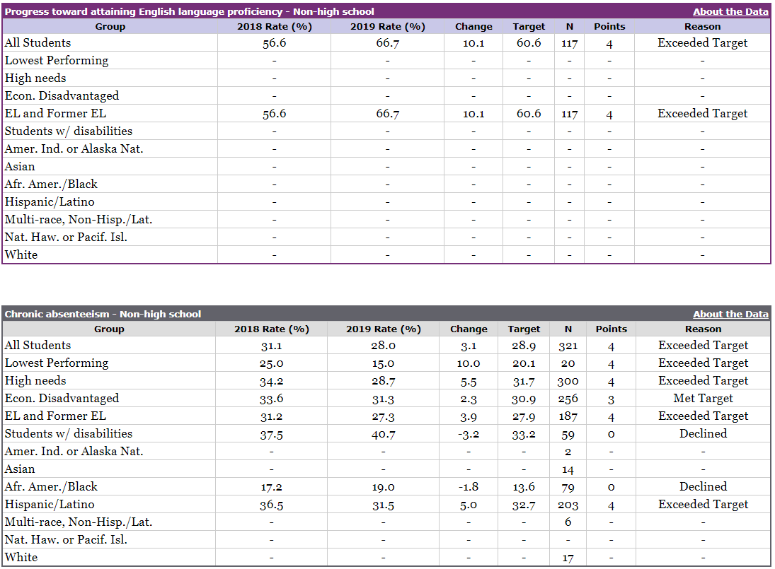
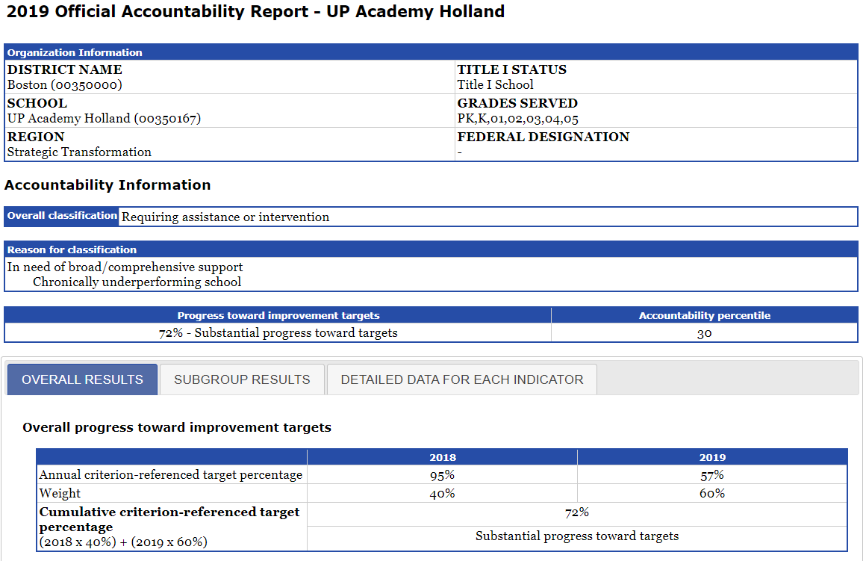

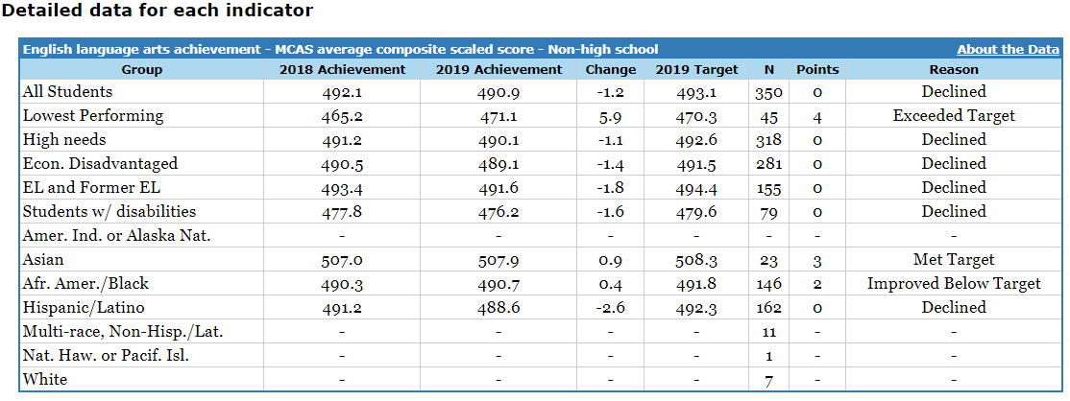

UP Academy Holland
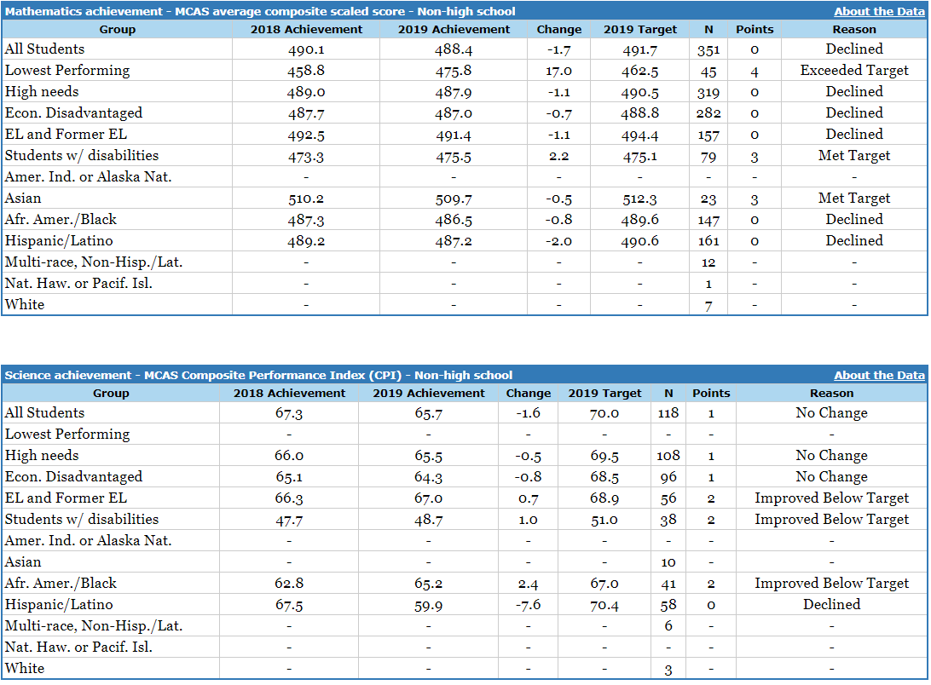

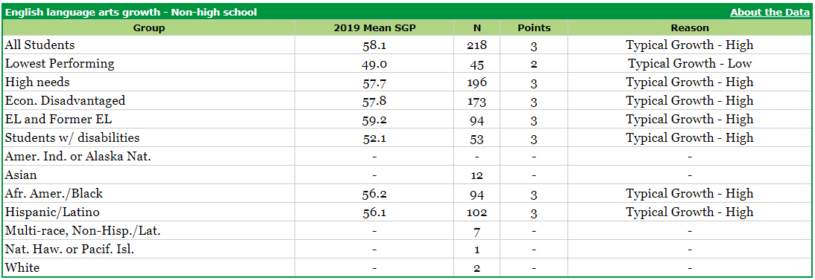

UP Academy Holland
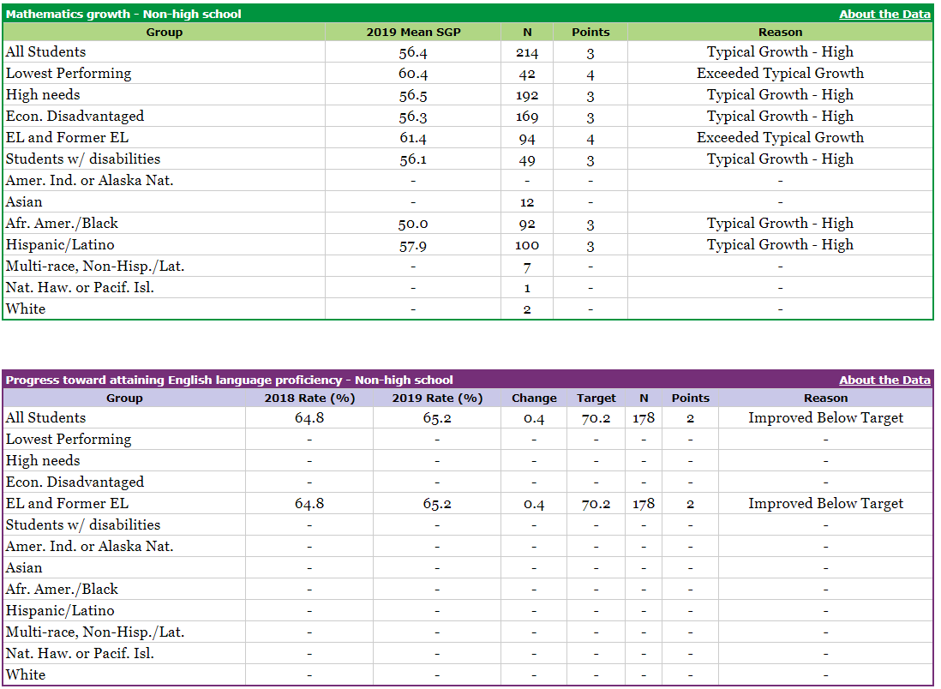

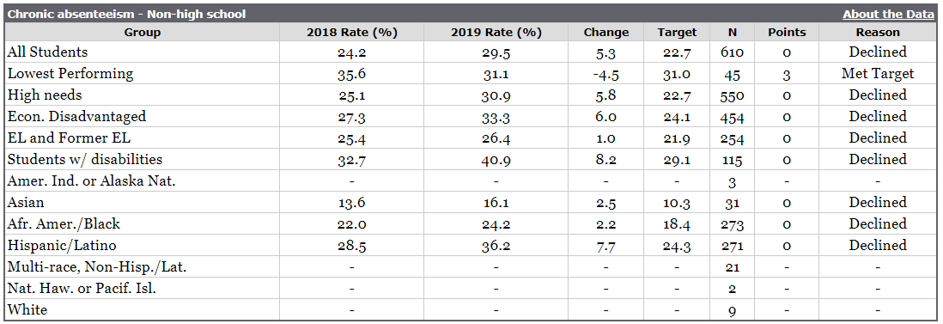
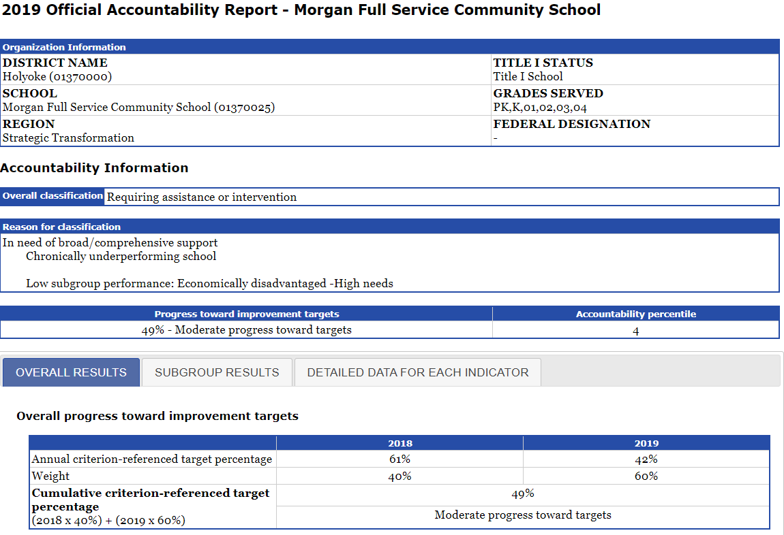

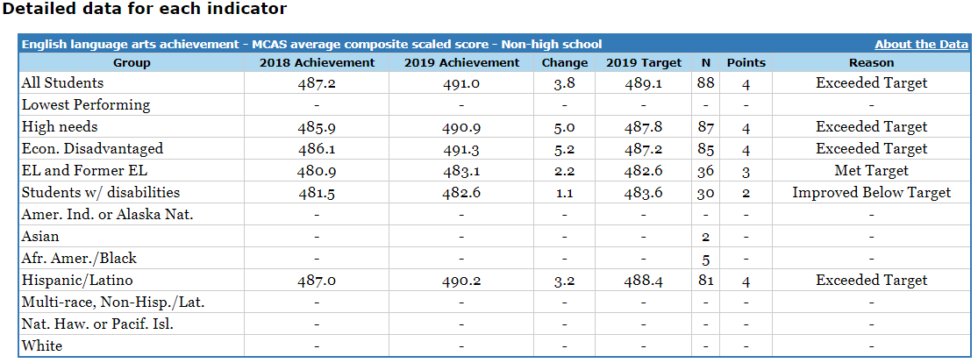

Morgan Full Service Community School
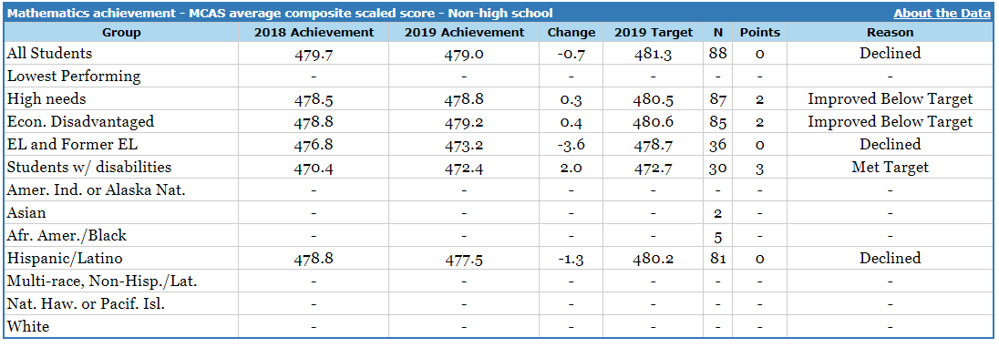

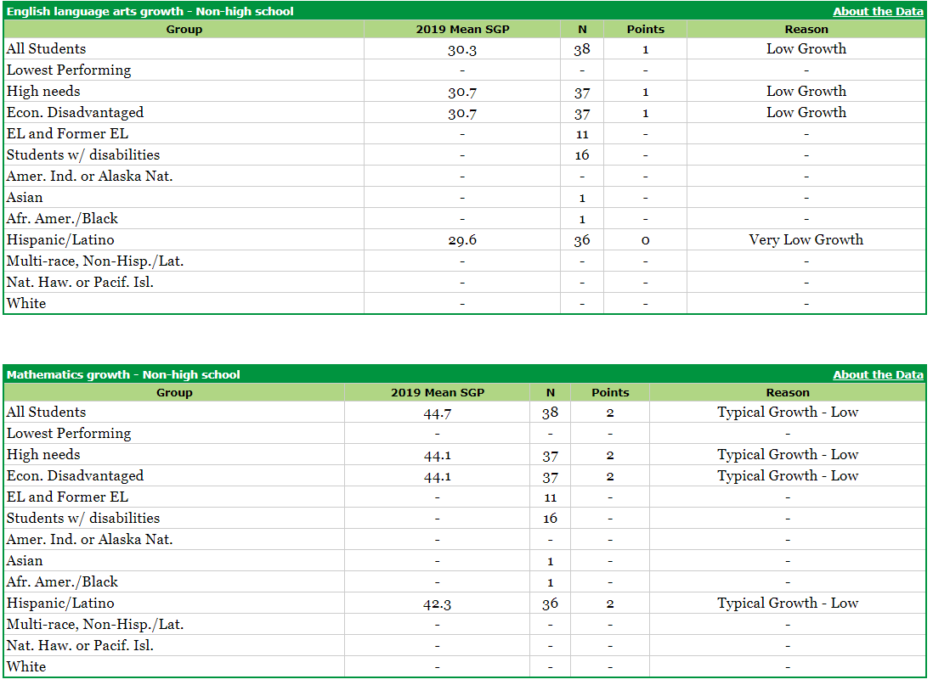

Morgan Full Service Community School
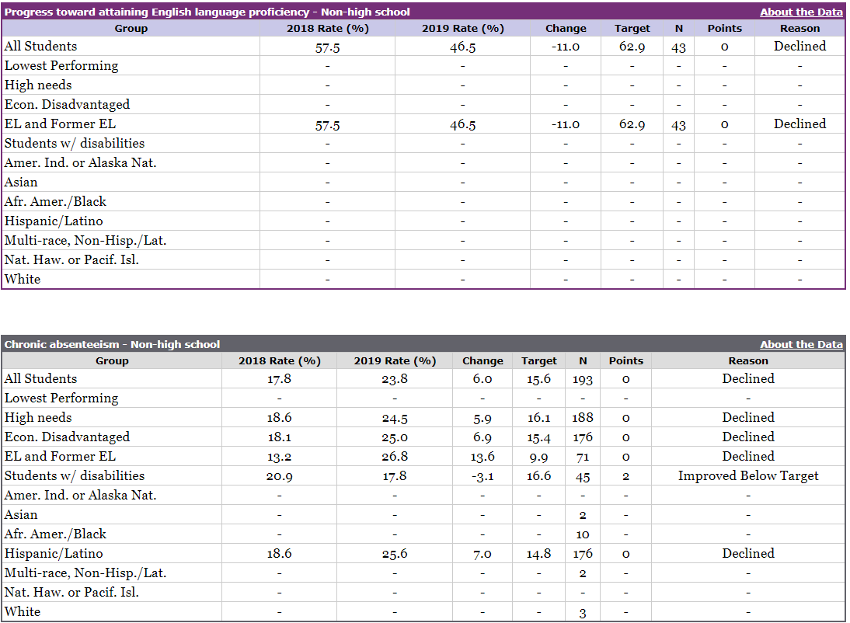

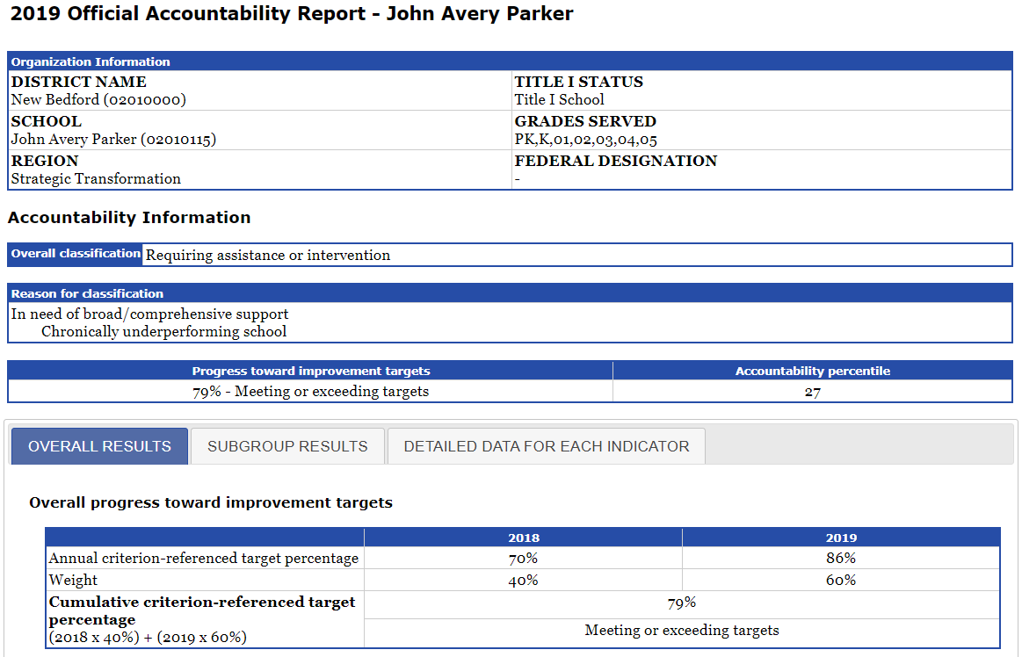

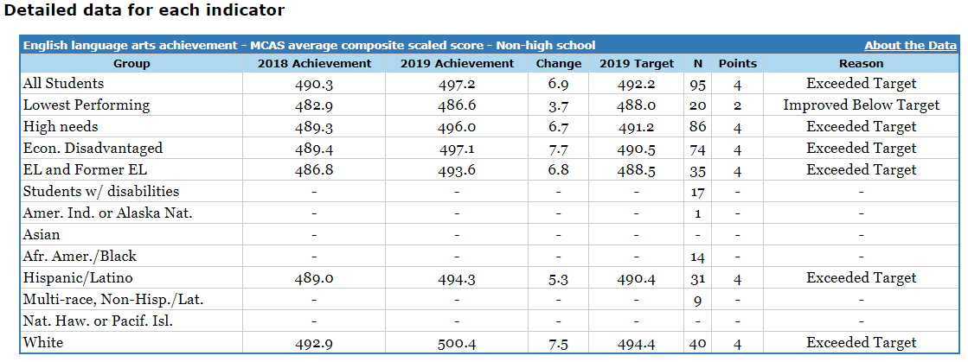

John Avery Parker Elementary School
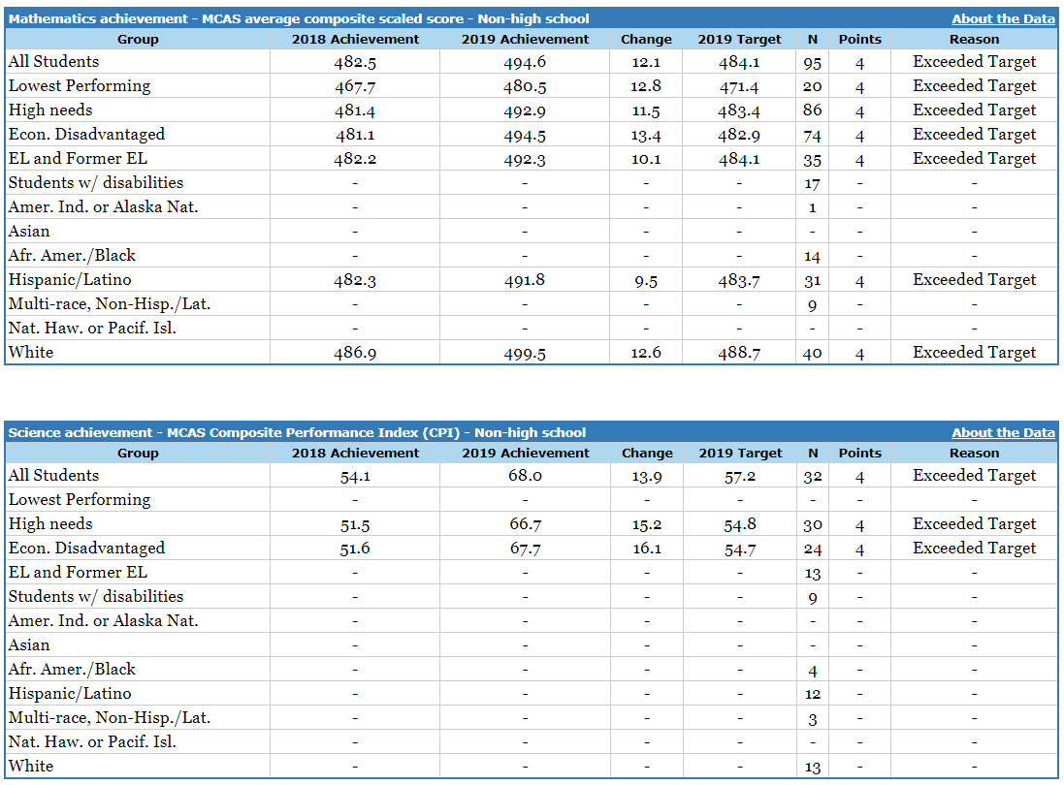

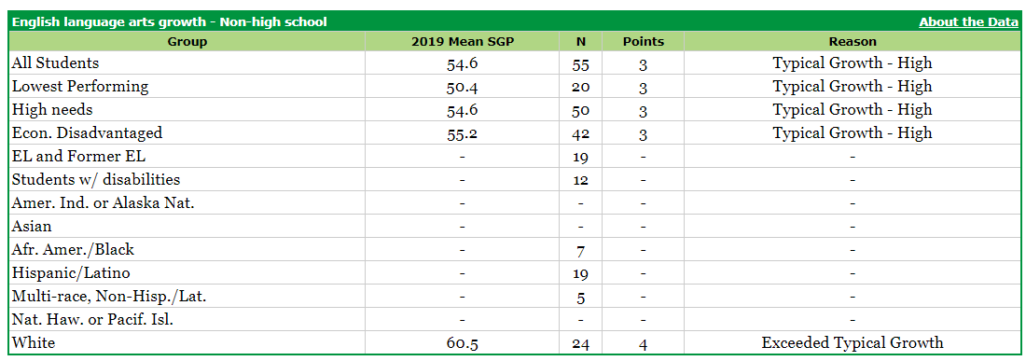

John Avery Parker Elementary School
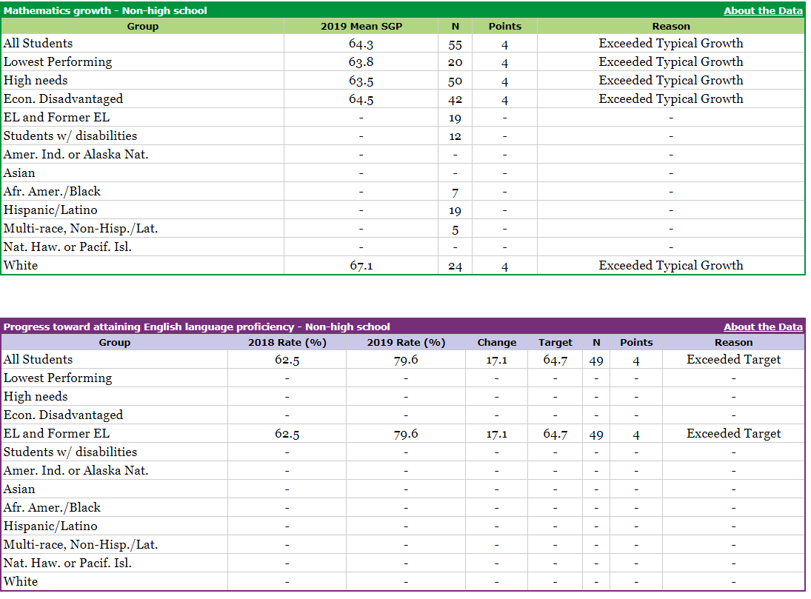

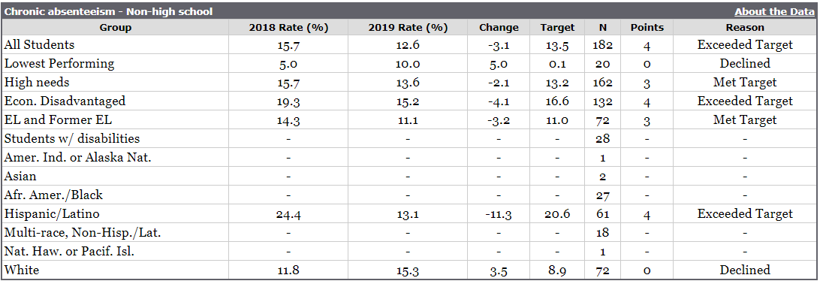

UP Academy Holland’s turnaround plan can be found here: http://www.doe.mass.edu/level5/schools/holland.html
Staff and student retention data will be provided for each school in the second quarterly report.
For more information about multi-tiered systems of support, click here: https://matoolsforschools.com/mtss-overview

