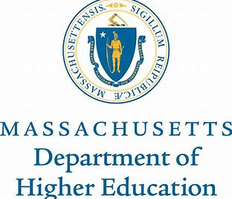
MEMORANDUM
To: Members of the Board of Elementary and Secondary Education and Board of Higher Education
From: Kristin Hunt, Director of Early College Programs
Date: December 13, 2019
Re: Update on Early College Programs
______________________________________________________________________________
Introduction
The Department of Elementary and Secondary Education (DESE) and Department of Higher Education (DHE) are committed to supporting the work of the Early College Joint Committee and the programs designated by them. According to fall 2019 data, over 2000 students are participating in the 17 currently designated programs. These partnerships are comprised of 34 high schools and 10 of the 15 community colleges, as well as five of the nine state universities. Five of the seven Workforce Investment Regions are represented by the partnerships and 13 of 27 Gateway Cities are included. Further, 22 new partnerships have applied for the Early College Designation. They are going through a two part designation review process and those that are approved will be granted their designation status in the spring of 2020.

The focus of the Early College initiative this year is promoting scale and sustainability. In a recent report, MassInc estimates that in order to increase equitable access to higher education for low-income students in Massachusetts, approximately 16,000 students statewide should be enrolled in Early College programs. The report emphasizes, however, that increasing enrollment numbers is not sufficient to guarantee students’ success, and suggests that programs must build an organized infrastructure that provides intensive support.

Goal 1: Supporting Designees through Designation Criteria
Early College requires new ways of envisioning both high school and postsecondary programming. The Designation Criteria for the Early College programs were specifically designed to promote five Guiding Principles: equitable access; guided academic pathways; enhanced student support; connections to career; and robust partnerships. It is the responsibility of the Early College staff to assist programs in designing and implementing programs which embody the Designation Criteria and Guiding Principles. To better understand how to do this well, we are surveying the field, talking with other staff at DESE and DHE, and synthesizing the results so we can use them to inform our work. In addition, we are securing a technical assistance partner to provide more robust and consistent communication through subject-based webinars and an online toolkit for applicants and designees to address questions concerning designation. The goals of these efforts are to assist new designation applicants in building strong programs and setting appropriate benchmarks; to inform an effective evaluative model for current designated programs; and ultimately to determine to what extent the statewide initiative is making a substantial difference for underserved students.

Goal 2: Assessing Programs through Data Analysis and Performance Agreements
In determining an appropriate evaluation plan for Early College, we consulted with staff at DESE to learn how they currently evaluate programs, such as Chapter 74 vocational-technical programs, Innovation Pathways, and charter schools. Based on this information, it was proposed to the Early College Joint Committee in November 2019 that the five-year review plan should include analysis of: applications on file; initial agreements between the state and designated partnerships, as well as between the partners themselves; SIMS, SCS and HEIRS data reports; annual designee surveys; annual summary reports; site visits and corresponding reports in year 3; and an application for continued designation in year 5. The ECJC preliminarily approved this plan and the Early College staff is currently working with DESE and DHE to develop a more detailed plan for each component. This plan will include initial benchmarks where appropriate, to assist in ascertaining whether programs are meeting commonly understood outcomes associated with Early College. Although we are early in the data collection process, it is important that we use the data we have to begin to determine program effectiveness.

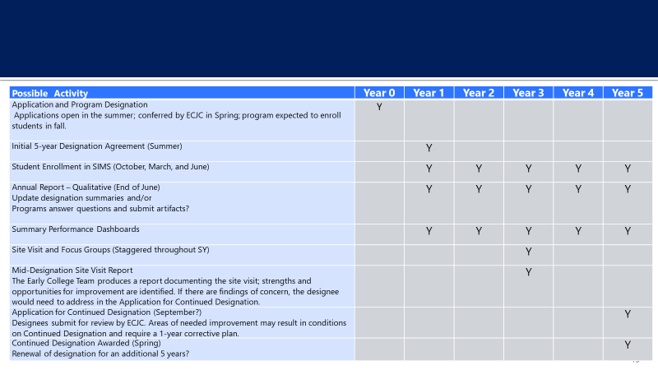

In partnership with the Smith Family Foundation, DESE is supporting a Strategic Data Program Fellow, Pierre Lucien, to focus on analyzing Early College program data. Working closely with both DESE and DHE datasets, Pierre is developing performance dashboards to be shared with the Early College designated programs this spring. These data dashboards will present visual summaries of each Early College program compared to other EC programs as well as statewide measures. Additionally, the dashboards will provide indicators to allow program coordinators to understand whether their programs are meeting the guiding principles and reaching intended outcomes. These indicators are related to common outcome measures associated with Early College programs nationwide and have also been informed by a Massachusetts Early College data advisory committee comprised of designated partners and other stakeholders.

Next Steps
In February 2020, we will share with the Early College Joint Committee proposed language to solidify performance agreement expectations and benchmarks, along with guidance on how programs can amend their original approved plans.

Introducing college early to more high school students will only help close equity gaps if it intentionally targets and supports students from underserved populations. This requires a shift in how high schools and higher education institutions approach education. By building robust guidance and support to the programs, along with a community of practice and an evaluation plan, we can help Early College programs make a positive difference in the lives of students who historically have been underserved in higher education.

