
Massachusetts Department of

Elementary and Secondary Education

75 Pleasant Street, Malden, Massachusetts 02148-4906 Telephone: (781) 338-3000 TTY: N.E.T. Relay 1-800-439-2370

Jeffrey C. Riley
Commissioner

MEMORANDUM

To: | Members of the Board of Elementary and Secondary Education
From: | Jeffrey C. Riley, Commissioner
Date: | May 14, 2021
Subject: | Advancing Deeper Learning: Update on the Kaleidoscope Collective for Learning

This memorandum updates the Board of Elementary and Secondary Education (Board) on initiatives undertaken by the Department of Elementary and Secondary Education (Department) to support the implementation of Deeper Learning in the Commonwealth.

Background and Context
In November 2019, the Board received an update on the launch of the Kaleidoscope Collective for Learning. The update focused on the goals of the pilot program and the upcoming launch of the first cohort of schools in March 2020.

I proposed Kaleidoscope in 2019 in the guiding document Our Way Forward, which was grounded in four themes: Deeper Learning for All; Holistic Support and Enrichment; Innovation and Evidence-Based Practices; and The State as a Partner. The initial goals for the Kaleidoscope Collective are:
- Create a research and development (R&D) hub of educators, schools, and districts focused on incubating and assessing innovative approaches to deeper learning, including standards-aligned instruction and assessment (Theme I)
- Form a highly engaged network of practitioners, through which holistic support (wraparound) and enrichment efforts and evidence-based practices can be identified and shared (Themes II and III)
- Model a new approach for how DESE can partner with the field to support adoption of promising practices, especially those shown to close achievement gaps, while respecting and learning from each community’s context (Theme IV)

Deeper Learning refers to grade-level work that is interactive and relevant, which leads to the outcomes of mastery of standards and practices, affirming and fostering a strong sense of academic and social identity, and developing student creativity. A focus on “just-in-time" scaffolding that provides access for all students is part of the work of supporting all students to achieve mastery. Although there are misconceptions that these three outcomes are mutually exclusive, we believe that our schools and students will be more successful if we acknowledge the need for a “balanced diet” that promotes deep content mastery, applied in tasks that are anchored in real-world contexts and the authentic work of the discipline.
Deeper Learning builds on the ongoing work of the Department focusing on high quality instructional materials and culturally responsive practice. In all professional learning sessions, the Kaleidoscope team encourages use of high quality instructional materials as a starting place for launching a school-wide focus on Deeper Learning. A focus on equity, particularly racial equity, and implementation of culturally responsive practice, has been a defining feature of the work on Deeper Learning.

Overview of Cohort 1
With the goal of establishing “DESE as partner,” Kaleidoscope aims to create a meaningful professional learning partnership with schools and districts. Cohort 1 was designed as a 1.5-year long fellowship for a deliberately diverse group of schools that were engaging in innovative practices related to Deeper Learning. Through participating in professional learning experiences (“convenings”) and coaching with the Kaleidoscope staff, teachers and leaders would expand their ability to create Deeper Learning experiences for their students and share promising practices with the state. By engaging with these leaders and teachers, Kaleidoscope would build a “Task Gallery” of exemplar Deeper Learning tasks for the field, anchored in coherent, standards-aligned curriculum, as well as build a “Continuum of Practices” that lead to effective implementation. Cohort 1 aimed to focus on the school as the unit of change; Cohort 2 and 3 would focus on the district as unit of scale. DESE will identify learnings and best practices from these cohorts to shape statewide implementation.

Nearly 500 schools, districts, and collaboratives expressed early interest in the pilot program, and 21 schools were selected for the inaugural cohort. These schools had already begun innovative work involving Deeper Learning and were eager to build upon that work. The cohort includes schools of varying types, grade spans, and geographical areas. Fourteen of the schools are classified as Title 1 schools.

The schools participating in the inaugural cohort of the Kaleidoscope Collective for Learning are:
- Academy of the Pacific Rim Charter Public School (Boston)
- Andover: Andover High School and High Plain Elementary School
- Berkshire Hills Regional: W.E.B. Du Bois Middle School (Great Barrington)
- Boston: Eliot K-8 Innovation School and TechBoston Academy
- Essex North Shore Agricultural & Technical School District (Danvers)
- Fitchburg: South Street School
  - Lawrence: ENLACE Academy at Lawrence High School and UP Academy Leonard
- Lincoln: K-4 Lincoln School
- Mendon-Upton Regional: Nipmuc Regional High School (Upton)
- Monomoy Regional: Chatham Elementary School
- Nauset: Orleans Elementary School
  - North Attleborough: Amvet Boulevard School and North Attleborough Middle School
- Randolph: Randolph Community Middle School
- Revere: Abraham Lincoln Elementary School and Rumney Marsh Academy
  - Springfield: Chestnut Talented and Gifted Middle School and Mary M. Walsh Elementary School
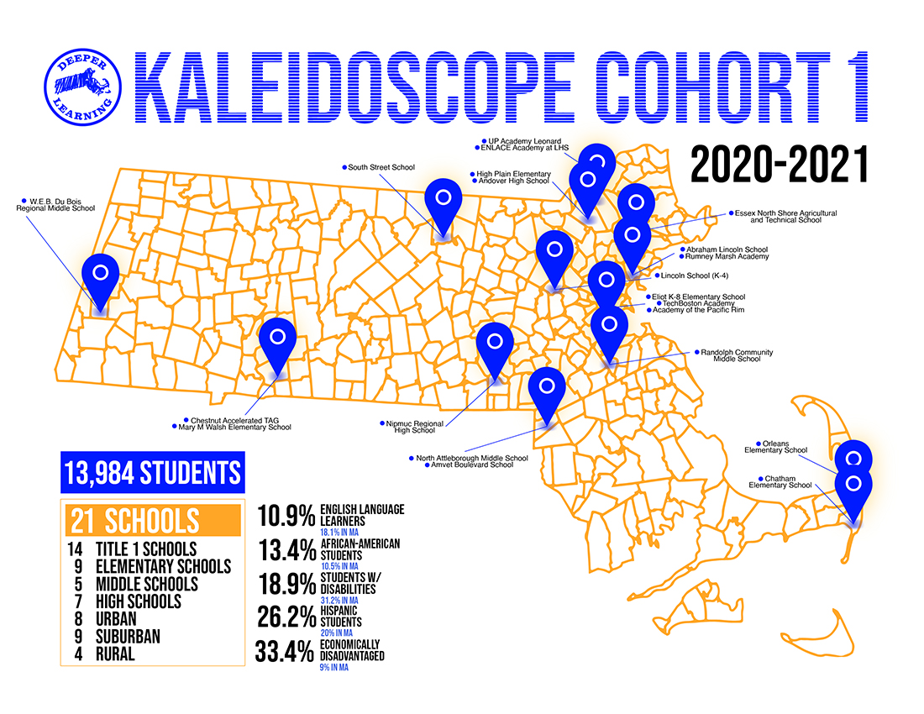
In January and February 2020, the Kaleidoscope team visited each cohort school to observe instruction, meet with students and community stakeholders, and meet with educators and school leaders. In March, Cohort 1 programming launched with a convening in Fitchburg. As schools closed due to the Covid-19 pandemic, the program pivoted to a completely remote experience for participants, continuing to provide professional learning sessions as scheduled, based on the encouragement of participants.

Through the summer and 2020-21 academic year, pilot teams from each school participated in full-cohort professional learning sessions (convenings), smaller role-alike professional learning sessions (referred to as “mini-cohorts”), and monthly school-based meetings that provided technical assistance with implementation. Convenings were 3-day professional learning experiences led by the Kaleidoscope staff, which took place in alternate months throughout the academic year. School-based “pilot teams” from each school and district attended each convening, with an average of 110 participants participating in each session throughout the year. Mini-cohorts and school-based meetings provided implementation support for content provided in the convenings, as well as feedback on Deeper Learning experiences designed for students. DESE allocated grants of $12,000 – $25,000 to each school, based on school size and demographics, to provide stipends for educator work, professional learning, and materials for Deeper Learning experiences.

Additional Kaleidoscope work has included supporting the development of the Innovative Science Assessment. Kaleidoscope staff participate in the Innovative Assessment planning process, serve as members of the steering committee, and contribute to the design of assessment items with a focus on Deeper Learning. The Kaleidoscope team has also provided monthly professional learning sessions open to all educators in the state on elements of Deeper Learning. In January 2021, the team began work with Cohort 2, focused on 15 Boston Public Schools in the Charlestown, East Boston, and North End neighborhoods, which will launch formally in the fall of 2021. In January 2021, Kaleidoscope also launched a Community Council, consisting of a racially diverse group of educators, students, and community members from across the state, who meet regularly to provide feedback on Kaleidoscope tools.

Program tools and evaluation
The Kaleidoscope team has developed several research-based tools, including the Deeper Learning Guidance Tool; a task adjustment protocol; a task facilitation protocol; a task reflection (looking at student work); and an “Equity Pause” protocol. The team is continuing work on a Task Gallery, which includes exemplar tasks from each grade level and core content area, and a “Deeper Learning Continuum,” a guide for schools at a variety of entry points to self-diagnose and identify their key levers and action steps to implement Deeper Learning school-wide.

Through program evaluation efforts supported by DESE’s Office of Planning, Research, and Evaluation, the team has collected input from the pilot use of these tools to validate and increase the effectiveness of the tools and protocols. The team is in the process of validating tools (student survey, teacher and district survey) that can be used in evaluation in the coming years.

Senior Associate Commissioner Komal Bhasin and other members of the Kaleidoscope team will be present at the May 25 Board meeting to answer your questions.

