Alternative Assessment Pilot Evaluation

Interim Assessment

James Cowan, Dan Goldhaber, Roddy Theobald
National Center for the Analysis of Longitudinal Data in Education Research (CALDER), American Institutes for Research
October 2022

Alternative Assessment Pilot Evaluation
Interim Assessment

James Cowan, Dan Goldhaber, Roddy Theobald
October 2022

AIR® Headquarters
1400 Crystal Drive, 10th Floor
Arlington, VA 22202-3289
+1.202.403.5000 | AIR.ORG

Notice of Trademark: “American Institutes for Research” and “AIR” are registered trademarks. All other brand, product, or company names are trademarks or registered trademarks of their respective owners.
Copyright © 2022 American Institutes for Research®. All rights reserved. No part of this publication may be reproduced, distributed, or transmitted in any form or by any means, including photocopying, recording, website display, or other electronic or mechanical methods, without the prior written permission of the American Institutes for Research. For permission requests, please use the Contact Us form on AIR.ORG.

Contents

Executive Summary 1
Key Findings 2
1. Introduction 3
1.1. Background 3
1.2. Data Collection 6
1.3. Methods 7
1.4. Future Reports 9
2. CLST Alternatives 9
2.1. Submissions 10
2.2. Candidate Performance 13
3. MTEL Flex 14
3.1. Assessment Overview 14
3.2. Eligible Participants and Submissions 16
3.3. Candidate Performance 21
4. Preparation Program Attestation 22
5. Discussion 24
References 26

Figures

Figure 1. Cumulative MTEL Alternatives Submissions by Date and Type 6
Figure 2. CLST Alternative Submissions by Date and Test Series 11
Figure 3. Frequency of MTEL-Scaled Scores and MTEL Flex Eligibility 17
Figure 4. MTEL Flex Submissions by Date 19

Tables

Table 1. First-Time Pass Rates by MTEL, 2016-2019 5
Table 2. CLST Alternatives Test Characteristics 12
Table 3. CLST Alternatives Candidate Outcomes 14
Table 4. MTEL Flex Test Objectives 15
Table 5. MTEL Flex Test Choice 18
Table 6. MTEL Flex Test Characteristics 20
Table 7. MTEL Flex Candidate Outcomes 22

Executive Summary

Teacher licensure is one of the primary mechanisms through which states ensure that new teachers have the requisite subject matter knowledge for classroom instruction. Basic skills and subject matter tests required of prospective teachers are a key component of licensure in nearly every state (National Council on Teacher Quality, 2020). Ample evidence shows these tests are predictive of teachers’ contributions to student learning (Clotfelter et al., 2007, 2010; Cowan et al., 2020; Goldhaber, 2007; Goldhaber et al., 2017; Sass, 2015). However, there are also unresolved academic debates about the extent to which testing requirements exclude potentially effective teachers (Gershenson, 2021; Gitomer et al., 2011) or limit the diversity of the teacher workforce (Angrist & Guryan, 2004, 2008; Bennet et al., 2006; Rucinski & Goodman, 2019).
In 2020, the Massachusetts Board of Elementary and Secondary Education (BESE) authorized a pilot of alternatives to the Massachusetts Tests for Educator Licensure (MTEL) requirements for select groups of teacher candidates. The pilots were intended to expand access to the teaching profession, allowing prospective teachers to demonstrate their capacities in different ways while maintaining high standards for subject matter knowledge. They were also designed to reduce barriers for teacher candidates of color, teachers already in the workforce, and out-of-state teachers to earn licensure in Massachusetts (Massachusetts Department of Elementary and Secondary Education, 2021; Riley, 2020).
The National Center for Analysis of Longitudinal Data in Education Research at the American Institutes for Research is engaged with the Massachusetts Department of Elementary and Secondary Education (DESE) in a multiyear evaluation of MTEL Alternative pilots. In this report, we describe the implementation to date of three models of alternative assessments currently in the field. We focus primarily on eligibility for these tests and candidates’ testing outcomes so far. Future reports will consider implementation, teacher candidate diversity, and workforce outcomes.
This report focuses on three MTEL Alternatives currently enrolling participants:
- Communication and Literacy Skills Test (CLST) Alternatives: Candidates submit a qualifying score on one of five standardized tests to satisfy CLST requirements.
- MTEL Flex: Candidates who nearly pass an MTEL subject test submit a written analysis of the topic for review.
- Preparation Program Attestation: Candidates submit materials documenting their understanding of content knowledge for review by a preparation program coordinator.
We describe key findings below and then discuss the timeline of the implementation of the MTEL Alternatives and the structure of this interim report.

Key Findings

Candidate Background
- MTEL Alternatives disproportionately serve candidates holding emergency licenses issued during the COVID-19 pandemic. Twenty-four percent of candidates for CLST Alternatives and 36% of candidates for the MTEL Flex held an emergency license at the time of submission. Similar proportions of candidates worked as teachers at the time.
- Participants in the MTEL Alternatives are similarly diverse as those submitting traditional MTEL. Although we present demographic information on participants in this report, we are waiting until we have larger samples of participants and more information on test performance to assess the effects of the pilots on teacher diversity.

CLST Alternatives
- By June 25, 2022, 429 teacher candidates had submitted 637 CLST Alternatives. About 6% of candidates submitting a CLST during the pilot used at least one of these tests.
- Two national assessment series (Praxis Core and Essential Academic Skills) were the most common options, followed closely by the Indiana Core Academic Skills Assessment. Tests from Missouri and Washington state were less commonly submitted.
- Pass rates on the reading and writing subtests for the CLST Alternative (63%) are similar to a matched sample taking the traditional CLST MTEL (64%).

MTEL Flex
- Depending on the test, between 13% and 22% of all submissions since October 20, 2020, were eligible for the MTEL Flex option.
- By July 24, 2022, 372 teacher candidates had completed 437 total MTEL Flex submissions. Since the start of the pilot, about 7% of all candidates submitting an MTEL and 18% of all eligible candidates have participated.
- About 81% of MTEL Flex submissions eventually result in a passing score, compared to 72% in a matched sample of candidates retaking the MTEL.

Preparation Program Attestation
- Implementation of the Preparation Program Attestation option has been slower than the other alternatives. By July 5, 2022, 28 teacher candidates had submitted 29 assessments to three providers.
- Almost all submissions (28 submissions, or 97%) received passing scores.

1. Introduction

1.1. Background
Massachusetts currently requires candidates for teaching licenses to demonstrate content knowledge through the Massachusetts Tests of Educator Licensure (MTEL). Candidates are required to pass a series of tests before they obtain a teaching license. Every candidate must take the Communication and Literacy Skills Test (CLST), a two-part test that covers reading comprehension and writing proficiency. In addition, the MTEL include a variety of subject tests that are required to obtain teaching licenses in specific fields and grade levels. The subject tests are aligned with the state curricular frameworks and Subject Matter Knowledge Guidelines, and the tests are designed to ensure that candidates for licensure can demonstrate a functional level of understanding of the content knowledge required for the license.
Teacher content knowledge is one of many teaching skills that contribute to student learning. Researchers have demonstrated in a variety of contexts that students who are assigned to teachers with higher mastery of the curriculum, as measured by licensure tests, perform better on standardized assessments (Clotfelter et al., 2007, 2010; Goldhaber, 2007; Goldhaber et al., 2017; Sass, 2015). Cowan et al. (2020) have documented similar patterns for the MTEL in Massachusetts. At the same time, there is a lengthy debate about the role of standardized tests in qualifying teacher candidates for licensure. Because many candidates struggle to complete licensure testing requirements, they may exclude some teachers who would become effective educators (Gershenson, 2021). Passing rates on licensure tests also tend to be lower for teacher candidates of color, raising concerns that testing requirements may limit the diversity of the teacher workforce (Nettles et al., 2011; Rucinski & Goodman, 2019).
The Massachusetts Board of Elementary and Secondary Education (BESE) authorized the MTEL Alternatives pilot on October 20, 2020, to study different methods for demonstrating teacher content knowledge. The alternative assessments are intended to increase accessibility for strong educators while maintaining standards for teacher content knowledge (Department of Elementary and Secondary Education [DESE], 2021; Riley, 2020). There are currently four alternative assessment models included in the pilot:
- CLST Alternatives: The Massachusetts Department of Elementary and Secondary Education (DESE) has approved five alternatives to the CLST. CLST Alternatives are standardized assessments offered by Pearson or the Educational Testing Service (ETS) for licensure in other states. Each of the alternatives includes a reading and writing subtest, similar to the CLST, and candidates can substitute a passing score on these tests for the CLST requirements.
- MTEL Flex: MTEL Flex is offered by the Evaluation Systems group of Pearson (ES) to candidates receiving a near-passing score on one of six MTEL subject tests (General Curriculum [Elementary and Early Childhood], Foundations of Reading, English, History, Spanish, and English as a Second Language). Candidates submit a written analysis of a topic covered by the relevant test.
- Preparation Program Attestation: The Preparation Program Attestation option is currently approved for candidates taking the Foundations of Reading, English as a Second Language, or Music MTEL at Bridgewater State University, Fitchburg State University, Merrimack College, and Westfield State University. Candidates submit a variety of materials documenting their understanding of content knowledge for review by a program coordinator.
- Performance Review Program for Initial Licensure (PRPIL) Expansion: The PRPIL Expansion route is intended for candidates already working in the field on a teaching waiver. Candidates would submit a portfolio documenting their content knowledge for external review. The Department recently approved two ETS Praxis assessments: English to Speakers of Other Languages and Physical Education.
The pilots include the CLST, required of all candidates, and MTEL subject tests required for most of the shortage areas in Massachusetts. In Table 1, we show the first-time pass rates for each of the MTEL involved in the pilot. We examine data from 2016 through 2019 because there were significant and temporary changes to testing requirements introduced during the pandemic, which may influence who decides to take the tests. Pass rates vary significantly by field, but on some tests, nearly half of all candidates fail the test on the first attempt.
This report covers submissions under the three operational MTEL Alternatives. Although candidates with qualifying MTEL submissions after the October 20, BESE vote are eligible to participate in the MTEL Alternatives, most of the options have only become available more recently and the majority of the submissions considered in this report are from the first half of 2022. We show cumulative submissions for each of the three MTEL Alternatives by date in Figure 1. The longest running option, CLST Alternatives, began registering candidates in August 2021 and has recorded 637 submissions across five test series by June 2022. The MTEL Flex, which became available earlier this year, had recorded 637 submissions across the six tests by July 2022. Finally, the Preparation Program Attestation route first became available in February 2021 and has had 29 submissions to date.
Table 1. First-Time Pass Rates by MTEL, 2016-2019
Test | License Fields | First-Time Pass Rate
CLST: Reading | All Fields | 84%
CLST: Writing |  | 84%
General Curriculum: Multi-Subject | Elementary (Grades 1–6)  Moderate Disabilities  Severe Disabilities  Deaf & Hard of Hearing (Foundations of Reading for Oral/Aural only)  Visually Impaired (General Curriculum only) | 69%
General Curriculum: Mathematics |  | 53%
Foundations of Reading |  | 56%
English | English (Grades 5–12) | 81%
History | History (Grades 5–12) | 77%
English as a Second Language | English as a Second Language | 51%
Spanish | Spanish | 84%
Notes: The license field indicates the fields for which the MTEL is the primary testing requirement. All fields apply to all grade levels unless noted otherwise. Bolded entries indicate licensure shortage areas for the 2022–23 school year (U.S. Department of Education, 2022).
Figure 1. Cumulative MTEL Alternatives Submissions by Date and Type
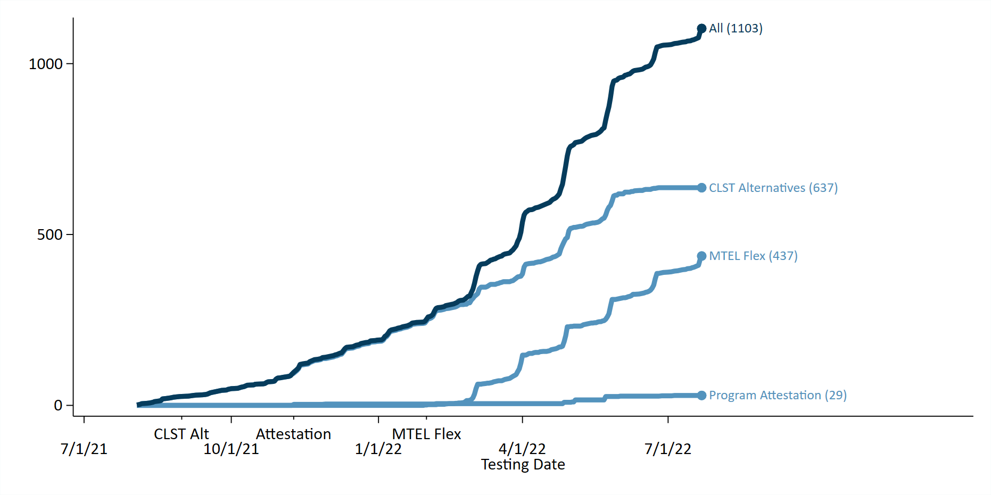
In this report, we discuss the enrollment in these pilots through July 2022. In Sections 1.2 and 1.3, we discuss the data collection and analytical methods used in this report. We then outline in Section 1.4 the research questions to be considered in future reports, which will focus on workforce outcomes for participants in the pilots and implementation of the Preparation Program Attestation option. We then consider enrollment and performance for each of the pilots in turn. We discuss the CLST Alternatives option in Section 2, the MTEL Flex option in Section 3, and the Preparation Program Attestation option in Section 4. We summarize the main findings in Section 5.

1.2. Data Collection
This report focuses primarily on participation in MTEL Alternatives and pass rates on the tests. We focus on these outcomes because the MTEL Flex and Preparation Program Attestation options were first offered near the beginning of this year and many submissions are quite recent. Therefore, we would not necessarily expect many participants to have already completed preparation programs or licensure requirements. Many candidates take the MTEL shortly before they enroll in a preparation program or begin their preservice field-based teaching experiences. Although we do include some statistics on program completion and licensure thus far, we stress that these results should be considered preliminary. In future reports, we will assess more comprehensive data on program completion, licensure, and employment as it becomes available.
For this interim report, the state collected data on participation in MTEL Alternatives between October 20, 2020, and July 24, 2022. These data files were provided by Pearson (MTEL, MTEL Flex, and CLST Alternatives), ETS (CLST Alternatives), and three teacher preparation providers offering the preparation program review option (Bridgewater State University, Merrimack College, and Westfield State University). These data files include candidate performance and demographics.
DESE also provided data on traditional MTEL participants through July 24, 2022. These data are usually not available until October each year, and we therefore rely on preliminary data for recent MTEL participants. Because these data are preliminary, they are currently missing information on candidate demographics. Candidate demographic information will be provided by ES for all MTEL participants for future reports. In most cases, we were able to match candidates to other administrative data sources to obtain demographic information. But there are many MTEL participants for which we were not able to obtain this information. We therefore stress that the statistics we report on candidate gender and race/ethnicity are preliminary and may change as we obtain more complete data.

1.3. Methods
In this report, we assess the characteristics and pass rates of teacher candidates participating in the MTEL Alternatives pilots so far. For each pilot, we compare submissions for MTEL Alternatives to submissions on the corresponding traditional MTEL during the pilot window (since October 30, 2020). Comparison of pass rates is complicated by the fact that pilot participants have very different testing histories than typical candidates for the traditional MTELs. Pilot participants disproportionately failed the MTEL on a previous attempt. This is an explicit requirement for the MTEL Flex and Preparation Program Attestation options, but many CLST Alternatives participants also previously received a failing score on the traditional CLST. Because of these differences in the composition of the participant pool, we would expect to observe lower passing rates on MTEL Alternatives, even if they were no more difficult than the traditional MTEL.
In order to construct a more informative comparison group, we reweight the sample of submission on the traditional MTEL to match the testing histories of pilot participants, using a statistical technique called propensity score weighting. First, we construct an estimate of the probability that a candidate participates in the specific MTEL Alternative pilot, given the test and number of prior MTEL submissions made by the candidate. We then reweight the sample of traditional MTEL submissions so that the type of test and number of prior submissions matches those in the pilot sample.
Under strong assumptions, this analysis corresponds to an estimate of the causal effect of assigning candidates to MTEL Alternatives rather than the traditional MTEL on passing rates and other outcomes. However, we caution that these assumptions likely do not hold and that the analyses in this report are not likely to reflect the causal effects of taking one of the pilot tests on candidate pass rates. The comparisons are likely confounded by candidates’ decisions to take one test rather than another. For instance, candidates who know about the pilots may have better information about the testing process or more support from program faculty than candidates who retake the traditional MTEL. These candidates might also be expected to perform better on the traditional MTEL retest, which would tend to artificially inflate the pass rates on MTEL Alternatives relative to our reweighted comparison sample. Nonetheless, by adjusting the naïve comparisons for candidates’ prior testing histories, these comparisons are likely closer to the causal effects of assigning a candidate to a pilot test relative to the traditional MTEL. We therefore view them as a more informative point of comparison for pass rates among the early submissions.
In this report, we also provide the demographic composition of the candidate pools participating in the pilots. As noted in the initial proposed amendment, one objective of the MTEL Alternatives was to expand access to licensure for teachers of color (Riley, 2020). We provide similar comparisons of pilot participants to traditional MTEL test takers throughout; however, we caution that these results do not yet provide evidence on whether MTEL Alternatives are likely to increase diversity in the Massachusetts teacher workforce. There are two reasons for this caution.
First, as we discuss in Section 1.2, currently available data on MTEL participation is missing some data on teacher race/ethnicity. These missing data are disproportionately among those taking the traditional MTEL. Although the overall percentage of missing data is relatively small, it is substantial relative to the number of non-White candidates overall. Thus, future reports may include revisions to the proportion of candidates of color taking the traditional MTEL.
Second, understanding whether the pilots improve licensure outcomes for candidates of color requires knowing their likelihood of participating in the pilot assessments and their effects on the relevant licensure or employment outcomes. In this study, we provide some initial evidence on the first of these questions, but the samples of pilot participants are currently too small to provide reliable evidence about differences in pass rates for teachers of color.

1.4. Future Reports
This interim report is the first of several planned reports on candidates’ experiences with MTEL Alternatives. Future reports will provide a more complete assessment of program implementation and teacher candidate workforce outcomes. As shown in Figure 1, the Preparation Program Attestation option is currently ramping up implementation. As this option matures, we plan to interview program administrators and survey teacher candidates. These will be the subject of a future report.
Future research will also assess workforce outcomes, including employment and teaching effectiveness. Given the recency of most submissions, it is currently too early to examine these outcomes. For those participants already in the workforce, data on teaching effectiveness during the 2021–22 school year will become available in early 2023. For those completing preparation programs or earning licensure this year, we expect to have employment and performance data by early 2024 (for the 2022–23 academic year). Under the original project timeline, we expected these cohorts to inform the analyses of teacher workforce outcomes for the final report. The proposed extension would provide time to incorporate data from the 2023–24 school year, which would add candidates licensed between summer 2022 and fall 2023. Given that the MTEL Flex, Preparation Program Attestation, and PRPIL options, in particular, are still scaling up, we expect that the extension would provide a meaningful increase in the sample size for this project.

2. CLST Alternatives

The CLST is a two-part test in reading and writing required of all candidates in Massachusetts, including those seeking administrative, specialist, or professional support licenses. Candidates must earn a passing score on each of the two subtests to advance to licensure. Like MTEL subject tests, the CLST is a Massachusetts-specific test. Many other states also require tests of reading and writing skills for teacher licensure (National Council on Teacher Quality, 2020). As part of the CLST Alternatives pilot, DESE is allowing candidates to take assessments offered in other states to satisfy CLST requirements. To date, DESE has approved five alternatives to the CLST. Each of these tests includes a reading and writing subtest, like the CLST, and candidates can submit a passing score on either of these subtests to meet their licensure requirements.
All CLST Alternatives pilot test series are offered by Pearson and ETS. These include two national assessment series accepted in several states: the Praxis Core Communication and Literacy test (offered by ETS) and the National Evaluation Series Essential Academic Skills test (offered by Pearson). In addition, DESE has accepted three assessments of communication and literacy skills offered by Pearson for other states: the Missouri General Education Assessment (MoGEA), the Washington [state] Educator Skills Test-Basic (WEST-B), and the Indiana Core Academic Skills Assessment (CASA).
In this section, we discuss participation in CLST Alternatives through June 2022. CLST Alternatives were the first tests to become operational in Massachusetts and, therefore, have had the most participants so far. Since the CLST Alternatives pilot began, about 6% of candidates who have submitted a test meeting the CLST requirements have submitted one of the alternative assessments. We then compare the characteristics and outcomes of teacher candidates taking the CLST Alternatives to those who have taken a traditional CLST since the October 2020 board vote. Pass rates on the CLST Alternatives are currently almost exactly in line with what we would expect on the traditional CLST, given candidates’ prior testing histories.

2.1. Submissions
In Figure 2, we show the cumulative number of CLST Alternatives taken since October 20, 2020. The first assessments were recorded in August 2021 and the number of submissions accelerated during 2022. By June 25, 429 candidates had submitted 637 total assessments through the five tests included in the pilot. These 429 candidates represent about 6% of the approximately 7,500 candidates who have submitted a CLST or CLST Alternative since the pilot began. Candidates most commonly submitted the Praxis Core (175 submissions) and the Essential Academic Skills (172 submissions), followed closely by the Indiana CASA (169). The two other state assessments received far fewer submissions (100 through MoGEA and 21 through WEST-B).
Figure 2. CLST Alternative Submissions by Date and Test Series
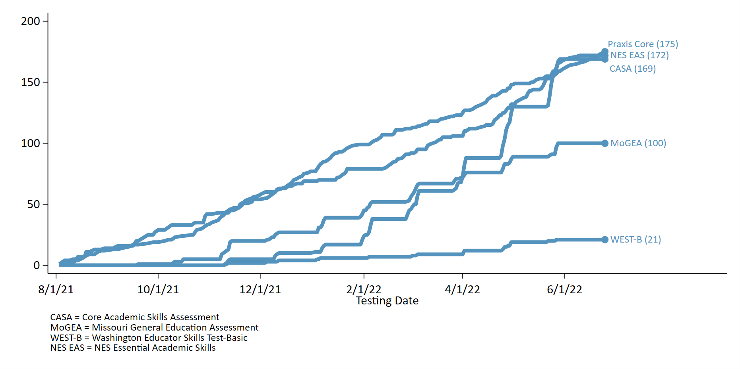
In Table 2, we compare the test histories of CLST Alternative submissions to traditional CLST submissions since October 20, 2022. Submissions for CLST Alternatives are summarized in the first column. We construct two comparison groups in the second and third column. In the second column, we show submissions for only the traditional CLST. In the third column, we reweight this sample so that it matches the CLST Alternatives sample on the subtest (reading or writing) and the number of prior submissions. The third column can be interpreted as an estimate of the average characteristics of the traditional CLST sample if it had the same average prior testing history and test type as the pilot sample. We describe the procedure in more detail in Section 1.3.
Many of the candidates participating in CLST Alternatives have previously taken the traditional CLST. Specifically, about 39% of submissions on CLST Alternatives come from candidates with at least 1 prior submission; only 21% of all submissions on the traditional CLST come from candidates who have previously taken the test. On average, candidates participating in CLST Alternatives have attempted the test 1.5 times (column 1), compared to 0.4 attempts on the traditional CLST (column 2). Notably, this is not true of the Praxis Core, where only 18% of submissions come from candidates with prior submissions. The Praxis Core is the most widely accepted of the CLST Alternatives and this could indicate that it is taken disproportionately by out-of-state candidates. Submissions are also more common on the writing subtest, which has had a slightly lower pass rate than the CLST reading subtest during the pilot period. Writing tests account for 55% of CLST Alternative submissions compared to 49% among the traditional CLST.
Table 2. CLST Alternatives Test Characteristics
 | CLST Alternatives | Traditional CLST | Traditional CLST (Weighted)
Testing Information
Reading Test | 44.7 | 50.5 | 44.7
Prior Attempts | 1.5 | 0.4 | 1.3
Career Stage
Holds Emergency License | 23.5 | 15.0 | 18.3
Enrolled in Program | 8.8 | 12.8 | 13.7
Employed as Educator | 22.0 | 17.9 | 21.0
Candidate Demographics
Race Not Reported | 2.5 | 7.7 | 6.0
Native American | 0.6 | 0.3 | 0.4
Black | 8.6 | 6.4 | 8.1
Asian | 4.7 | 4.2 | 4.3
Hispanic | 12.1 | 8.9 | 10.8
White | 68.1 | 70.9 | 68.6
Other Race/Ethnicity | 3.3 | 1.7 | 1.8
Gender Not Reported | 0.6 | 8.2 | 6.4
Male | 21.8 | 19.2 | 18.7
Female | 77.6 | 72.5 | 74.9
Number of Submissions | 637 | 29,103 | 29,103
As shown in column 3 of Table 2, the reweighted sample is closer to the pilot sample on the proportion of writing tests (both 55%) and the number of prior submissions (1.3 compared to 1.5). This reweighted sample forms the basis of our comparisons in the discussion of pass rates (Section 2.2).
Teachers with emergency licenses are overrepresented among the pilot submissions. About 24% of submissions for CLST Alternatives come from teachers on an emergency license, compared to 15% among all teachers submitting the traditional CLST and 18% in the reweighted traditional sample. Teachers in CLST pilots are also less likely to be recorded as enrolled in a teacher preparation program at the time of the test (9% in the pilot sample compared to 14% in the reweighted CLST sample). Overall rates of employment are similar between the two groups: 22% of pilot participants and 21% of participants in the reweighted traditional MTEL sample were employed at the time of the test.
Demographically, teacher candidates submitting one of the CLST Alternatives are similar to those submitting a traditional CLST, particularly once we account for test history. About 68% of candidates submitting a CLST Alternative identify as White compared to 71% among all CLST submissions and 69% in the reweighted CLST sample. One caveat is that we currently have more complete information on teacher candidate race for the CLST Alternatives sample (3% fail to report race/ethnicity compared to 6% in the CLST sample). Thus, even though the percentage of White teachers is similar, teachers in the CLST Alternatives sample are slightly more likely to identify as Black or Hispanic than candidates in the weighted traditional CLST sample. Men participate at a slightly higher rate among the pilot submissions (22%) than among the traditional CLST submissions (19%).

2.2. Candidate Performance
As shown in Table 3, candidates participating in the CLST Alternatives pilot have very similar passage rates compared to traditional CLST test takers with similar testing histories. The pass rate on CLST Alternatives is 63% compared to 73% on the traditional CLST and 64% on the reweighted traditional CLST sample. So far, about 47% of pilot submissions eventually result in a passing score on both subsections of the CLST, which is slightly higher than the rate of 45% among the weighted traditional CLST sample. On the other hand, rates of licensure (19% compared to 25%) and program completion (3% compared to 10%) are currently lower among pilot participants.
Despite attempts to reweight traditional CLST submissions to better match pilot submissions, we caution that these patterns do not necessarily indicate that taking a CLST Alternative rather than the traditional CLST causes worse outcomes among teacher candidates. Candidates who choose to take one of the national assessment series over the Massachusetts option, for instance, may be more likely to attend a teacher preparation program in another state even if they pass the test. We plan to investigate these issues further in subsequent reports as additional information on teacher candidates’ progress through the licensure system becomes available.
Table 3. CLST Alternatives Candidate Outcomes
 | CLST Alternatives | Traditional CLST | Traditional CLST (Weighted)
Passes Current Attempt | 63.4 | 73.4 | 64.0
Passes Both CLST Subtests | 46.8 | 58.3 | 44.8
Obtains Nonemergency License | 18.8 | 27.5 | 24.8
Completes Preparation Program | 3.1 | 10.2 | 10.2
Number of Submissions | 637 | 29,103 | 29,103

3. MTEL Flex

The MTEL Flex alternative is offered by ES to candidates who score close to the minimum passing score on six MTEL subject tests: Foundations of Reading, English, English as a Second Language, General Curriculum (Mathematics and Multi-Subject subtests), History, and Spanish. Instead of retaking the traditional test, candidates can submit a written assessment of a topic on the MTEL to demonstrate their content knowledge. In this section, we discuss the implementation of the MTEL Flex from January 30, 2022, through July 24, 2022. We first provide some background on the structure of the assessment. We then describe the group of candidates eligible to take the MTEL Flex based on their performance on the traditional test. In some cases, eligibility for MTEL Flex is as high as 20% of all submissions since October 20, 2020. We also describe the characteristics of candidates taking the MTEL Flex. Finally, we discuss candidate performance on the submissions to date.

3.1. Assessment Overview
Eligibility for the MTEL Flex option is based on a candidate’s score on their initial MTEL subject test submission. The eligible pool includes candidates who received a failing score on the subject test within 1 standard error of measurement (SEM) of the minimum qualifying score. Candidates who are eligible for the MTEL Flex based on their prior submission will have the option to register when they log into the ES website to register for the test (DESE, 2022). The DESE and ES websites also provide information about the MTEL Flex assessment.
Candidates select one of two objectives on each test to assess for their MTEL Flex submission (DESE, 2022). The qualifying objectives for each of the MTEL Flex assessments are listed in Table 4. Each corresponds to a broad strand of knowledge within the curricular frameworks. For example, the first objective for the History MTEL is “understand the causes and key events of the Revolutionary War and major political, economic, social, and cultural developments that shaped the course of U.S. history through the Jacksonian era.” Within each objective are a set of descriptive statements covering more specific topics under the broader test objective. For instance, one of the options under the early United States history objective is “the debate over the ratification of the U.S. Constitution.” Candidates select a set of statements and prepare a four-page written assessment that provides an analysis of these narrower topics. The submission identifies the relevant portion of the state curricular framework and analyzes the historical topic. Test takers are directly instructed to provide an analysis and not merely list facts.
Table 4. MTEL Flex Test Objectives
MTEL Flex Assessment | Objectives
History | Understand the causes and key events of the Revolutionary War and major political, economic, social, and cultural developments that shaped the course of U.S. history through the Jacksonian era.
 | Understand the major physical features of the world and the effects of geographic factors on the development of human societies.
Spanish | In response to the given prompt, write a well-organized, multiparagraph passage in the target language for the specified audience and purpose.
 | In response to the given prompt, communicate an effective oral message in the target language for the given audience and purpose.
English as a Second Language | Apply knowledge of aural and oral language instruction and assessment for English language learners.
 | Apply knowledge of writing instruction and assessment for English language learners.
English | Prepare an organized, developed written analysis of a literary or informational text.
 | Prepare an organized, developed written analysis of an argument.
Foundations of Reading | Prepare an organized, developed analysis on a topic related to the development of foundational reading skills.
 | Prepare an organized, developed analysis on a topic related to the development of reading comprehension.
General Curriculum Mathematics | Understand operations on numbers.
 | Understand algebra as generalized arithmetic.
General Curriculum Multi-Subject | Understand major developments in the history of the United States and the Commonwealth of Massachusetts from precolonial times to the present.
 | Understand and apply basic concepts and principles of life science to interpret and analyze phenomena.
Candidates submit the MTEL Flex assessments as a portfolio through the ES website. The MTEL Flex assessment is less expensive ($49–$69) than retaking the corresponding MTEL subject tests ($94–$139). The evaluators are Massachusetts educators or preparation program faculty qualified in the relevant field. At least two evaluators score each submission according to a standardized rubric for each assessment. Candidates who fail the assessment are provided with a scoring report and feedback and may resubmit the test (DESE, 2022).

3.2. Eligible Participants and Submissions
Before describing the characteristics of candidates participating in the pilot, we first describe the sample of candidates eligible for the MTEL Flex. We illustrate the extent of this group in Figure 3. This figure plots the histogram of scaled scores for all MTEL submissions in the testing window; that is, each bar represents a score on the MTEL and the height of the bar indicates the number of submissions receiving that score. Candidates receiving a score of 240 or higher pass the test. The MTEL Flex eligible group—those scoring within 1 SEM of 240—are illustrated as the dark blue band on the plot. The exact eligibility window varies by test, but it is typically between 230 and 239 points.
There are a few notable features regarding the distribution of MTEL-scaled scores in Figure 3. First, for several of the tests, the passing score on the MTEL is near the median (middle) and mode (most frequent score) of the distribution (the mode is the tallest bar in the figure). This is consistent with the discussion of pass rates in Table 1; for some tests, particularly the General Curriculum assessments, about half of all candidates fail on the first attempt. This means that the MTEL Flex eligible group is typically near the middle of the testing distribution. Second, the 1 SEM range sometimes includes a relatively wide band of scores. One SEM is generally about 10 points on the assessment; as shown in Figure 3, this range may include a significant proportion of all candidates receiving a failing score.
Depending on the test, between 13% and 22% of all MTEL submissions (or between 33% and 47% of all submissions receiving failing scores) would have qualified for the MTEL Flex option. The eligible sample is largest for the General Curriculum (required for elementary, special education, and early childhood licenses) and the English as a Second Language MTEL (21% and 22%, respectively). For these tests, the minimum qualifying score (240) is at or near the median of test score distribution, passing rates are relatively low, and the 1 SEM region encompasses a relatively large proportion of the total distribution of scores. Eligibility rates for the Foundations of Reading, History, and Spanish tests are somewhat lower because the passing rates are higher. Nonetheless, between 13% and 14% of all candidates would have qualified on these tests.
Figure 3. Frequency of MTEL-Scaled Scores and MTEL Flex Eligibility
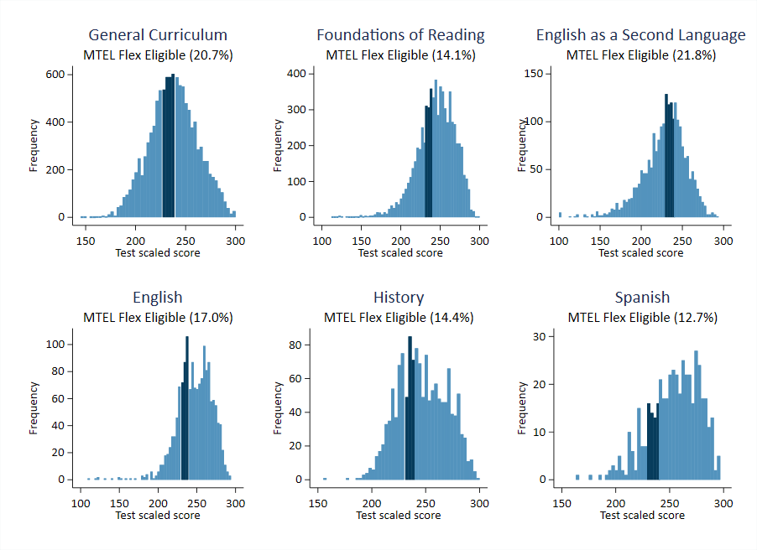
Note: Histograms of traditional MTEL subject test submissions between October 20, 2020, and July 24, 2022. The minimum qualifying score is 240 on all subject tests. The group of MTEL Flex eligible submissions is indicated in dark blue. General Curriculum includes submissions on both subtests.
The full sample of candidates qualifying for the MTEL Flex between October 20, 2020, and July 24, 2022, includes 6,596 test submissions and 3,080 candidates. However, the MTEL Flex first became available in January 2022, and many candidates who would have been eligible for the pilot had already retested through the traditional MTEL subject tests. In Table 5, we show retesting decisions for candidates who received a qualifying score on the MTEL subject test. We split the group into “Early Qualifiers” (those receiving a qualifying score on MTEL subject tests before January 30, 2022) and “Late Qualifiers” (those receiving a qualifying score on MTEL subject tests taken January 30, 2022, or later). We also split the sample by MTEL subject test (the Spanish test is omitted due to small sample size).
Participation in the MTEL Flex pilot is higher among candidates receiving qualifying scores after the start of the pilot. Among those receiving a qualifying score before the MTEL Flex option was available, 70% have retaken the traditional MTEL subject test and 9% have taken the MTEL Flex. The remaining candidates have not resubmitted the subject test prior to July 24, 2022. These resubmission rates are consistent with historical patterns on these tests. Late Qualifiers are less likely to have made any resubmission (49%), which likely reflects the lesser amount of time elapsed from their initial submissions. Of these candidates, 31% have retaken the traditional MTEL subject test and 18% have submitted an MTEL Flex test. Thus, over the first 6 months of the pilot, nearly 20% of candidates who became eligible after implementation of the MTEL Flex participated in the pilot.
Candidates taking the specialized subject tests are more likely to have participated in the MTEL Flex pilot. The rates of participation for the History, English as a Second Language, and English tests are all between 16% and 20% of the eligible sample. On the other hand, participation rates for the generalist tests for the elementary, moderate disabilities, and severe disabilities licenses are all around 10%. Candidates taking these tests were somewhat more likely than those taking the subject specialist tests to retake the traditional MTEL (about 60% compared to 40%–50%). The patterns of participation across subject tests are similar among Late Qualifiers only, although all groups have higher MTEL Flex participation during this window.
Table 5. MTEL Flex Test Choice
 | Total Candidates | Retake MTEL | Take MTEL Flex
Early Qualifiers (10/30/2020–1/29/2022) | 2,497 | 1,736 (70%) | 222 (9%)
Late Qualifiers (After 1/30/2022) | 1,175 | 364 (31%) | 211 (18%)
History | 165 | 85 (52%) | 24 (16%)
Spanish | 49 | NA | NA
English as a Second Language | 378 | 157 (42%) | 60 (16%)
English | 211 | 100 (47%) | 42 (20%)
Foundations of Reading | 829 | 505 (61%) | 68 (8%)
General Curriculum Multi-Subject | 904 | 511 (57%) | 100 (11%)
General Curriculum Mathematics | 946 | 541 (57%) | 97 (10%)
Note: Spanish test participants suppressed due to small sample size.
We now turn to an examination of MTEL Flex participants. In Figure 4, we plot the total number of submissions by date. Candidates have been submitting MTEL Flex assessments at a nearly constant rate since the introduction of the assessment at the beginning of 2022. By July 24, 2022, 372 candidates had submitted a total of 437 MTEL Flex submissions across the six tests. The most common submissions are on the tests required for the elementary, special education and early childhood licenses: General Curriculum (217 total submissions across the Multi-Subject and Mathematics tests) and Foundations of Reading (74 submissions). Although this may seem to contradict the discussion above, where we show that these tests have lower MTEL Flex participation rates, this discrepancy merely reflects the fact that these assessments are by far the most commonly submitted subject tests.
Figure 4. MTEL Flex Submissions by Date
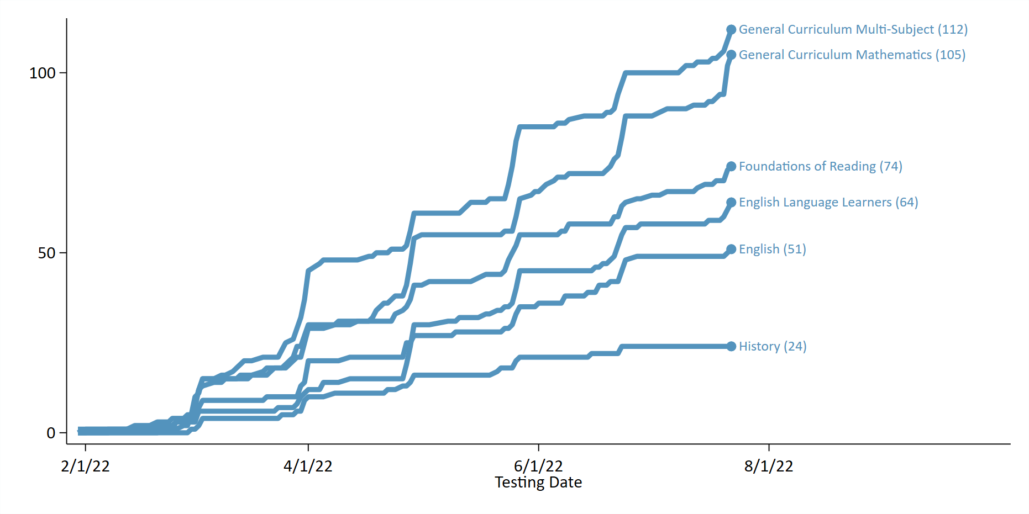
In Table 6, we compare MTEL Flex submissions to submissions of traditional MTEL subject tests since the October 2020 authorization. We provide submission information for three groups: MTEL Flex submissions (column 1), all traditional MTEL subject test submissions (column 3), and traditional MTEL subject test submissions among those eligible for the MTEL Flex based on prior MTEL results (column 3). We also construct a reweighted sample of the MTEL Flex eligible group to match the MTEL Flex sample more closely on the assessment taken and prior submission history (column 4). We discuss the construction of this reweighted sample in Section 1.3, but it can be interpreted as the average characteristics of traditional MTEL submissions if they had the same test types and prior submissions as the MTEL Flex group.
Table 6. MTEL Flex Test Characteristics
 | MTEL Flex | All MTEL Subject Tests | MTEL Flex Eligible | MTEL Flex Eligible (Weighted)
Testing Information
History | 5.5 | 6.0 | 4.7 | 5.5
Spanish | 1.6 | 2.0 | 1.0 | 1.7
English as a Second Language | 14.6 | 9.1 | 8.6 | 14.3
English | 11.7 | 6.6 | 5.2 | 11.7
Foundations of Reading | 16.9 | 29.1 | 23.8 | 17.0
General Curriculum Multi-Subject | 25.6 | 22.2 | 28.2 | 25.9
General Curriculum Mathematics | 24.0 | 25.0 | 28.5 | 23.9
Prior Attempts | 3.0 | 0.9 | 2.6 | 3.0
Career Stage
Holds Emergency License | 35.5 | 22.9 | 31.7 | 34.0
Enrolled in Program | 52.2 | 44.6 | 59.2 | 58.0
Employed as Teacher | 34.1 | 26.3 | 28.8 | 33.5
Candidate Demographics
Race Not Reported | 1.4 | 3.8 | 1.3 | 1.4
Native American | 0.7 | 0.1 | 0.0 | 0.0
Black | 4.3 | 4.7 | 3.6 | 3.8
Asian | 2.5 | 3.1 | 2.6 | 3.0
Hispanic | 5.0 | 6.8 | 5.7 | 6.9
White | 84.4 | 80.3 | 86.0 | 84.3
Other Race/Ethnicity | 1.6 | 1.2 | 0.8 | 0.7
Gender Not Reported | 1.4 | 3.9 | 1.2 | 1.2
Male | 10.5 | 13.9 | 11.4 | 12.0
Female | 88.1 | 82.2 | 87.3 | 86.8
Number of Submissions | 437 | 23,732 | 2,671 | 2,671
On average, candidates taking the MTEL Flex assessment have made 3 prior attempts on the subject test (including any prior MTEL Flex submissions). This is higher than both the full sample of submissions during this window (1 prior submission) or the sample of submissions eligible for the MTEL Flex (about 2.6 prior submissions). MTEL Flex submissions are disproportionately likely to come on the English as a Second Language and English assessments, and somewhat less likely to come on the Foundations of Reading test. Both assessments are among the MTEL with the largest eligible populations based on the SEM cut score. As anticipated, the reweighted sample (column 4) better matches the prior testing history of MTEL Flex submissions than the full sample or the eligible sample. The distribution of MTEL test types is more similar to column 1 and both groups had about 3 prior submissions on the subject test.
As is the case with CLST Alternatives, participants in the MTEL Flex pilot are disproportionately likely to have an emergency license. About 36% of MTEL Flex submissions come from teachers on an emergency license compared to 23% among all submissions. However, the frequency of teachers on emergency licenses is similar to other teachers with similar assessment histories as those participating in the MTEL Flex. We estimate that about 34% of teachers in the reweighted eligible sample have an emergency license. The rates of current program enrollment are somewhat higher in the traditional MTEL group (58% compared to 52% for the MTEL Flex).
Demographically, teachers taking the MTEL Flex are slightly less diverse than those submitting traditional MTEL subject tests. Among MTEL Flex submissions, 84% come from White teacher candidates and 88% come from women. These rates are higher than the full sample of MTEL submissions (80% and 82%, respectively). But the racial/ethnic diversity of the MTEL Flex group is about the same as those who resubmit MTEL subject tests; in both groups, the proportion of White teacher candidates is about 84%. We note that even if teacher diversity is similar in the MTEL Flex group and the group retaking the traditional MTEL, the MTEL Flex option could still improve diversity in the teaching workforce if pass rates are higher on the MTEL Flex than on the traditional option. We discuss test performance in Section 3.3 below and plan to consider licensure and employment outcomes in more detail in future reports.

3.3. Candidate Performance
In Table 7, we show subsequent career progression for candidates taking the MTEL Flex. Test passage rates are higher on the MTEL Flex than on MTEL subject tests as a whole: 74% of MTEL Flex submissions receive passing scores compared to 52% of all other submissions. This may understate differences in performance, however, because candidates taking the MTEL Flex have received a prior failing score on the subject test. Nonetheless, differences are similar when we compare MTEL Flex submissions to other submissions from eligible candidates (columns 3 and 4). About 50% of all resubmissions eligible for the MTEL Flex result in a passing score; in the sample weighted to match MTEL Flex candidates’ prior submission histories, about 46% achieve a passing score.
The higher passing rates on MTEL Flex submissions may not necessarily translate into differences in longer run outcomes because candidates can retake the MTEL as many times as necessary. In row 2 of Table 8, we identify candidates who received a passing score on the MTEL subject test before July 24, 2022. The overall passing rate on the MTEL Flex is slightly higher when we take resubmissions into account: 81% of all submissions eventually result in a passing score. However, as expected, focusing on eventual passing status somewhat reduces the difference between the MTEL Flex and the traditional MTEL. Among eligible candidates resubmitting a traditional MTEL, about 72% eventually pass the test even though the passing rate is lower on each individual submission. In other words, the overall pass rate among MTEL Flex candidates is currently about 9 percentage points higher than candidates submitting the traditional MTEL with similar testing histories. The difference between current and eventual pass rates suggests that the MTEL Flex option may reduce the number of attempts for some candidates who would have eventually passed in the absence of the pilot option.
Table 7. MTEL Flex Candidate Outcomes
 | MTEL Flex | All MTEL Subject Tests | MTEL Flex Eligible | MTEL Flex Eligible (Weighted)
Passes Current Attempt | 74.1 | 52.2 | 50.2 | 46.3
Passes Subject Test | 81.0 | 68.0 | 74.1 | 71.6
Obtains Nonemergency License | 45.1 | 46.4 | 51.2 | 53.1
Completes Preparation Program | 36.8 | 35.6 | 45.8 | 45.6
Number of Submissions | 437 | 23,732 | 2,671 | 2,671
Despite the differences in test passing rates, traditional MTEL candidates currently have higher licensure and program completion rates. Of MTEL Flex submissions, 45% have so far resulted in a nonemergency license and 37% have resulted in completion of a preparation program. Among eligible participants submitting traditional MTEL subject tests, 53% have advanced to licensure and 46% have completed a program. The discrepancy between pass rates and licensure outcomes may partially reflect the different timeline of the assessments. Although MTEL tests submitted after October 20, 2020, were eligible for the MTEL Flex, the assessment was not offered until early 2022. The MTEL Flex eligible sample, therefore, disproportionately includes those with earlier testing dates. Future analyses will use a longer timeline between testing and licensure outcomes, which should be less sensitive to this possibility.

4. Preparation Program Attestation

The Preparation Program Attestation option is an assessment offered by preparation providers to document teacher candidates’ content area knowledge. DESE released Guidelines for proposals for providers in February 2021. Four providers (Bridgewater State University, Fitchburg State University, Merrimack College, and Westfield State University) have been approved to implement the Program Attestation option.
The providers developed their own assessment procedures and submitted them for review. Future reports will provide an in-depth assessment of the implementation of the Preparation Program Attestation option based on interviews with program administrators, surveys, and a review of submissions. In this interim report, we describe program procedures at a high level based on their applications to DESE.
Each provider designed their attestation procedures, and while these vary to a certain extent by provider and subject area, there are many commonalities. The providers generally have eligibility requirements that depend on performance on the initial MTEL assessment and, in some cases, other academic factors. For instance, three of the four programs have minimum GPA requirements to participate in the Program Attestation option. Candidates are generally required to first take the relevant MTEL, although one program does not require this of all candidates. Candidates then typically meet with a content expert to discuss their performance on the MTEL or complete a preliminary diagnostic assessment aligned to the test objectives. Most programs require at least some candidates to complete some additional coursework or online modules related to sections of the test on which they performed poorly. Candidates then usually take an assessment at the end of these modules. In some cases, satisfactory performance of these assessments can qualify a candidate for attestation. More typically, candidates submit written responses to prompts aligned with the MTEL that are then scored by content experts in the program. One program (Merrimack College) additionally requires videotaped lessons.
The Preparation Program Attestation option has the fewest submissions to date. Westfield State University has been operating its Preparation Program Attestation option the longest, with its first submissions dating to November 2021. Thus far, it has received 11 submissions for the Foundations of Reading MTEL. Bridgewater State University and Merrimack College both began accepting submissions for the Preparation Program Attestation option in May 2022. They have processed 18 submissions between the two providers. At the time of this analysis, the research team had not yet received data from Fitchburg State University. Most of the submissions have come on the Foundations of Reading (21) MTEL. The remainder have come on the English as a Second Language (8) MTEL. To date, there have not been any submissions through the Music MTEL. We do not break out statistics separately in this section, given the small number of participants so far. In most cases, cell size for any subcategory of Preparation Program Attestation participants is less than 10, which is the minimum DESE requires for disclosure in public reports. However, we do describe implementation to date.
As with the other pilots, Preparation Program Attestation candidates tend to have prior submissions before attempting the pilot. On average, candidates made 2.5 prior attempts on the MTEL. Most candidates have 1 or 2 prior submissions, although a few have made many prior attempts. Among the set of traditional Foundations of Reading and English as a Second Language submissions, candidates have attempted the MTEL an average of 1 prior time. Unlike the other options, teachers participating in the Preparation Program Attestation option are less likely to hold an emergency license, perhaps because they are enrolled in a preparation program. About 21% of candidates for Preparation Program Attestation have an emergency license, compared to 24% among all MTEL subject tests. Preparation Program Attestation candidates tend to be more racially and ethnically diverse than other candidates submitting MTEL subject tests. Of those participating in the Preparation Program Attestation option, 72% are White and 97% are women (the remaining candidate did not report a gender).
The Preparation Program Attestation option has significantly higher pass rates than the other pilots so far. Of the 29 submissions recorded by July 5, 2022, 28 (97%) were approved by preparation providers. By contrast, 44% of candidates resubmitting the traditional MTEL with similar prior testing histories passed the test.

5. Discussion

The three MTEL pilot alternatives were introduced between February 2021 through January 2022. By July 24, 2022, 824 teacher candidates had made 1,103 submissions across the three options. Out of these submissions, 626 teacher candidates had successfully completed at least one MTEL testing requirement. Of these teachers, 165 held an emergency license at the time of their assessment. Most of the remainder were in various stages of preservice preparation.
Pass rates vary considerably across the three options. Candidates on the CLST Alternatives perform similarly as candidates with similar prior testing histories taking the traditional CLST subtests. Pass rates are about 28 percentage points higher on the MTEL Flex than for resubmissions of MTEL subject tests, but differences in eventual pass rates are currently only about 9 percentage points. This suggests that, for some candidates who would have eventually passed under the traditional requirements, the MTEL Flex option may reduce the number of attempts needed to pass the test. Finally, pass rates are significantly higher on the Preparation Program Attestation route (97%) than on the other two options. However, there have been few submissions to date, and the high pass rate may partially reflect an early adopter effect.
The candidate outcomes in this report represent an early examination of teacher experiences with the MTEL pilots. There are a few important caveats, some of which will be the focus of future reports. First, many participants have taken the MTEL Alternatives quite recently. Early data on passing rates and licensure or completion outcomes may not be representative of longer run outcomes. As some of the statistics on testing history demonstrate, many candidates retake the MTEL several times to satisfy licensure requirements. We also expect that the licensure and program completion data for this cohort are not yet complete; candidates will continue to file applications for licensure over the summer. The completeness of the data will become less of a concern with future analyses examining a longer time horizon.
Second, the differences in candidate outcomes are not necessarily representative of the causal effects of taking one assessment over another. Although we have adjusted many of our comparisons for prior testing histories, this may not be sufficient to account for selection biases arising from candidates’ choices among licensure test options. For instance, as we discussed in the section on CLST Alternatives, candidates choosing to take a licensure test that qualifies them for licensure in several states may have a weaker attachment to working in Massachusetts than a candidate taking the traditional CLST. As more data becomes available, future analyses will provide more refined analyses of candidate outcomes.
In addition, a series of qualitative analyses will provide additional context about the assessment procedures and how these may relate to candidate outcomes. The planned qualitative work includes interviews with program administrators working on the Preparation Program Attestation option, surveys of teacher candidates participating in MTEL Alternatives, and a review of documents, rubrics, and submissions for the Preparation Program Attestation assessment. We expect that this qualitative work will complement the quantitative analyses.
Finally, as administrative data for the 2022–2023 school year begins to become available, we plan to expand the focus to include teacher workforce outcomes. Teachers who have participated in the pilot as part of the 2021–22 cohort of teacher candidates would be expected to enter the workforce this academic year. Data on employment outcomes for this cohort would typically begin to become available in early 2023; data on outcomes such as performance evaluations or student achievement would not be expected to become available until late 2023. Thus, we anticipate incorporating this data into the analysis beginning in 2024. These analyses will provide important evidence about the extent to which MTEL Alternatives balance the twin objectives of expanding access to licensure and ensuring high standards for teachers (DESE, 2021). Importantly there is a proposal being presented to the BESE to extend the pilot by 1 year to ensure adequate evidence for a recommendation to make the availability of alternative assessments for licensure permanent.

References

Angrist, J. D., & Guryan, J. (2004). Teacher testing, teacher education, and teacher characteristics. American Economic Review, 94(2), 241–246. https://doi.org/10.1257/0002828041302172
Angrist, J. D., & Guryan, J. (2008). Does teacher testing raise teacher quality? Evidence from state certification requirements. Economics of Education Review, 27(5), 483–503. https://doi.org/10.1016/j.econedurev.2007.03.002
Bennett, C. I., McWhorter, L. M., & Kuykendall, J. A. (2006). Will I ever teach? Latino and African American students’ perspectives on PRAXIS I. American Educational Research Journal, 43(3), 531–575. https://doi.org/10.3102/00028312043003531
Busso, M., DiNardo, J., & McCrary, J. (2014). New evidence on the finite sample properties of propensity score reweighting and matching estimators. Review of Economics and Statistics, 96(5), 885–897. https://doi.org/10.1162/REST_a_00431
Clotfelter, C. T., Ladd, H. F., & Vigdor, J. L. (2007). Teacher credentials and student achievement: Longitudinal analysis with student fixed effects. Economics of Education Review, 26(6), 673–682. https://doi.org/10.1016/j.econedurev.2007.10.002
Clotfelter, C. T., Ladd, H. F., & Vigdor, J. L. (2010). Teacher credentials and student achievement in high school: A cross-subject analysis with student fixed effects. Journal of Human Resources, 45(3), 655–681. https://doi.org/10.3368/jhr.45.3.655
Cowan, J., Goldhaber, D., Jin, Z., & Theobald, R. (2020). Teacher licensure tests: Barrier or predictive tool? (CALDER Working Paper No. 245–1020). National Center for the Analysis of Longitudinal Data in Education Research. https://caldercenter.org/publications/teacher-licensure-tests-barrier-or-predictive-tool
Gershenson, S. (2021). Identifying and producing effective teachers (EdWorkingPaper No. 21–351). Annenberg Institute at Brown University. https://www.edworkingpapers.com/ai21-351
Gitomer, D. H., Brown, T. L., & Bonett, J. (2011). Useful signal or unnecessary obstacle? The role of basic skills tests in teacher preparation. Journal of Teacher Education, 62(5), 431–445. https://doi.org/10.1177/0022487111412785
Goldhaber, D. (2007). Everyone’s doing it, but what does teacher testing tell us about teacher effectiveness? Journal of Human Resources, 42(4), 765–794.
Goldhaber, D., Gratz, T., & Theobald, R. (2017). What’s in a teacher test? Assessing the relationship between teacher licensure test scores and student STEM achievement and course-taking. Economics of Education Review, 61, 112–129. https://doi.org/10.1016/j.econedurev.2017.09.002
Massachusetts Department of Elementary and Secondary Education. (2021, October 7). Pilot of alternative assessments to the MTEL. https://www.doe.mass.edu/mtel/alt-assess/default.html
Massachusetts Department of Elementary and Secondary Education. (2022). MTEL-Flex assessment handbook [Version 1.0]. Massachusetts Department of Elementary and Secondary Education.
National Council on Teacher Quality. (2020). Licensure requirements [national results]. State Teacher Policy Database. [Data set]. https://www.nctq.org/yearbook/national/Licensure-Requirements-90
Nettles, M. T., Scatton, L. H., Steinberg, J. H., & Tyler, L. L. (2011). Performance and passing rate differences of African American and White prospective teachers on Praxis examinations: A joint project of the National Education Association (NEA) and Educational Testing Service (ETS). ETS Research Report Series, 2011(1), 1-82. https://doi.org/10.1002/j.2333-8504.2011.tb02244.x
Riley, J. C. (2020, January 17). Proposed amendment: Educator licensure and preparation program approval regulations, 603 CMR 7.00—Alternative assessment pilot. Massachusetts Department of Elementary and Secondary Education.
Rucinski, M., & Goodman, J. (2019). Racial diversity in the teacher pipeline: Evidence from Massachusetts [Policy brief]. Harvard Kennedy School.
Sass, T. R. (2015). Licensure and worker quality: A comparison of alternative routes to teaching. The Journal of Law and Economics, 58(1), 1–35. https://doi.org/10.1086/682904
U.S. Department of Education. (2022). Teacher shortage areas. https://tsa.ed.gov/#/reports

AIR® Headquarters
1400 Crystal Drive, 10th Floor
Arlington, VA 22202-3289
+1.202.403.5000 | AIR.ORG
About the American Institutes for Research
Established in 1946, with headquarters in Arlington, Virginia, the American Institutes for Research® (AIR®) is a nonpartisan, not-for-profit organization that conducts behavioral and social science research and delivers technical assistance to solve some of the most urgent challenges in the U.S. and around the world. We advance evidence in the areas of education, health, the workforce, human services, and international development to create a better, more equitable world. The AIR family of organizations now includes IMPAQ, Maher & Maher, and Kimetrica. For more information, visit AIR.ORG.

These licensure requirement have been temporarily relaxed during the COVID-19 pandemic. DESE offers an emergency license option that temporarily exempts teachers from completing certain licensure requirements. Teachers will have to advance their license to an initial or preliminary type by completing the relevant licensure tests.
The research team originally requested data on participation in MTEL Alternatives and background information on participants (including race/gender). Some providers were unable to submit complete evaluation files in time to be included in this analysis. Where possible, the research team has linked the submitted data to other administrative records on teachers and teacher candidates in Massachusetts to provide the most comprehensive look at MTEL Alternatives so far. However, some of the analyses of candidate background, demographics, and eligibility for the MTEL Flex option should be considered preliminary.
Formally, we implement this analysis via a propensity score weighting procedure. We estimate the probability that an assessment offered during the pilot window is one of the alternatives based on whether it is a reading or writing test and the number of prior tests submitted by the candidate. We then reweight the traditional sample so that it more closely resembles the pilot sample (Busso et al., 2014). We use the normalized weights $w_{i}=\frac{p(x_{i})/(1-p\left(x_{i}\right))}{\sum_{j}{p(x_{j})/(1-p\left(x_{j}\right))}}$, where $p(x_{i})$ is the propensity score.
Preparation programs are required to report teacher candidates in the Educator Licensure and Renewal system when they enroll in a teacher preparation program. This does not always occur promptly upon enrollment, and the reported preparation program enrollment figures may understate the true proportion of candidates enrolled in a program at the time of test submission.
There is an oral component to the Spanish MTEL Flex assessment.
Note that teachers seeking an elementary license, which is the largest single group, are required to take three of the tests in the MTEL Flex pilot (General Curriculum Multi-Subject, General Curriculum Mathematics, and Foundations of Reading).
The data on MTEL Flex participants in Table 6 (433 submissions) do not add up to the 437 submissions reported elsewhere. This is because we could not link 4 MTEL Flex submissions (<1%) to prior qualifying MTEL subject test submissions. This is most likely due to missing teacher identifying information for some individuals in the most recent traditional MTEL data, which will become available at a later date.
An important caveat is that we currently have more complete data on the race/ethnicity and gender of MTEL Flex participants than nonparticipants; that is, for both the comparison samples, the “not reported’ rates for teacher race/ethnicity and gender are higher than in the MTEL Flex sample. This reflects a limitation of the currently available MTEL assessment data, and we expect that future reports will include a more comprehensive examination of teacher demographics.
Although we do not conduct any formal statistical tests in this report, the difference in pass rates between the MTEL Flex sample and the reweighted sample is statistically significant (p < 0.01). This difference corresponds to the estimated treatment effect on the treated of taking the MTEL Flex rather than the traditional MTEL.
Merrimack College allows candidates with learning disabilities, English as a Second Language, and candidates with low prior grades to submit the MTEL Attestation option for the Foundations of Reading test without first attempting the traditional MTEL.

