Massachusetts Department of

Elementary and Secondary Education

75 Pleasant Street, Malden, Massachusetts 02148-4906 Telephone: (781) 338-3000 TTY: N.E.T. Relay 1-800-439-2370

Jeffrey C. Riley
Commissioner

MEMORANDUM

To: | Members of the Board of Elementary and Secondary Education
From: | Jeffrey C. Riley, Commissioner
Date: | October 18, 2022
Subject: | Update on Chronically Underperforming Schools: SY2022-2023 Quarter 1 Reports

This month, I am presenting the first of four SY2022-2023 quarterly progress updates to the Board of Elementary and Secondary Education (Board) on the three chronically underperforming schools’ implementation of their school turnaround plans, focusing on activities from July to October 2022. This memo also provides an update on the strategic planning process for schools in the Strategic Transformation region that took place in summer 2022. Future quarterly updates for SY2022-2023 will be presented in January 2022 and April 2023, and a final annual review in June 2023.

SY2021-2022 accountability data has been included for your reference.

Chronically Underperforming Schools
In the fall of 2013, four schools were designated as chronically underperforming in response to their low performance and lack of improvement while in underperforming status: John P. Holland Elementary School (UP Academy Holland) and Paul A. Dever Elementary School (Dever) in Boston, Morgan Full Service Community School (Morgan) in Holyoke, and John Avery Parker Elementary School (Parker) in New Bedford.

In September 2022, I exercised my authority under 603 CMR 2.06 (10)(d) to remove the chronically underperforming status from the Morgan Full Service Community School in Holyoke on the basis of the district’s concurrent designation as chronically underperforming. With this technical change, the ongoing strategic transformation efforts at Morgan will be fully aligned with and supported by Holyoke’s district turnaround plan. As a result, this update and future quarterly updates will include information on the three remaining chronically underperforming schools: UP Academy Holland, Dever, and Parker.
Strategic Planning with School Empowerment Network

The Department’s Office of Strategic Transformation (OST), in partnership with the School Empowerment Network (SEN), engaged school leaders of the three chronically underperforming schools in a robust strategic planning process in the summer of 2022 to review School Quality Reviews (SQRs) from SY2021-2022 and school data to create high-leverage goals and action plans for their schools. This process included at least four meetings with each school leader between May and August to discuss school goals, areas for growth, and specific actions intended to advance student achievement and racial equity this school year.

Throughout the year, OST will meet regularly with school leaders of the chronically underperforming schools to discuss progress on school action plans and benchmarks and provide support. Updates on the focus of each of those action plans are summarized below.

Updates on the Chronically Underperforming Schools

Paul A. Dever Elementary School, Boston. The Paul A. Dever Elementary (Dever) opened school with School & Main Institute (SMI) returning as receiver for the third year (Dr. Fran Roy acting as on-the-ground support) and Margaret Reardon in her third year as principal.

The school’s overarching goals are to develop students into independent learners with social and emotional dexterity, and to empower families as partners in their children’s education. The school has adopted a framework of culturally responsive instruction that supports students in developing both the social-emotional and intellectual capacities to tackle new and complex tasks. The instructional foci for the upcoming year are aimed at strengthening the schoolwide use of data to drive continuous improvement. The school plans to expand its assessment system to include non-academic measures of student well-being and build the capacities of Dever educators to use multiple streams of data to inform their instruction and target student supports. At the leadership level, school leaders seek to strengthen culturally responsive teaching practices across the school by refining the teacher observation, feedback, and coaching system developed the previous year.

The Dever staff spent two weeks in August participating in professional development that deepened their understanding of the school’s framework for culturally responsive instruction from multiple perspectives. Teachers drew connections between Dever’s instructional model and various concepts of equity. All Dever teachers also engaged in learning about a functional approach to linguistics that enables teachers to focus on language development for diverse learners by developing key language uses across all content areas. Throughout the year, Dever educators will build upon their summer professional learning experiences by engaging in collaborative study of an equity framework for literacy. The school’s instructional leaders and coaches will support Dever teachers to incorporate their new knowledge about functional linguistics into their English language arts instruction.
UP Academy Holland, Boston. Victoria Thompson is in her fourth year as principal of UP Academy Holland (UAH). UP Education Network continues to be the receiver for the school. SEN met with Principal Thompson and Dan Adler, the school’s Principal in Residence, from May through August to create the year’s strategic plan and prepare specific actions and professional development to launch the plan in classrooms at the beginning of the school year.

Following review of data from SQRs, classroom observations and student assessments, the UAH team centered their priorities around: continuing their multi-year focus on implementing high quality, evidence-based literacy instruction; strengthening teachers’ assessment and feedback practices; and building teachers’ capacities to support students’ social-emotional needs inside the classroom.

The primary focus of staff professional development over the summer and across the year is to increase the quantity and quality of student thinking (including speaking and writing) across all classrooms. UAH teachers will work toward this goal in their collaborative lesson planning process that identifies the critical moments for student thinking in each lesson and supports those moments with intensive teacher monitoring of student output, using clear criteria for student success and teacher feedback that helps guide all students toward mastery. UAH teachers will continue to receive feedback on their implementation of schoolwide academic routines through a robust observation and feedback system.

John Avery Parker Elementary School, New Bedford. The John Avery Parker Elementary (Parker) opened the 2022-2023 school year with School & Main Institute (SMI) returning for a fifth year as receiver with Dr. Fran Roy as the point-person and Amy (Bousquet) Tavares in her second year as principal.

In SY2022-2023, roughly forty percent of the staff are new to the building, which has required school leaders to develop differentiated professional learning supports. To cultivate the school’s instructional vision among both new and returning staff, Parker leaders have developed a trajectory of professional learning that integrates three strands of teacher knowledge: academic and social-emotional learning, culturally responsive teaching, and family engagement. Through focused coaching cycles and peer support, all Parker teachers will receive targeted feedback that supports their individualized progress along the school’s learning trajectory for teachers.

In the strand of academic and social-emotional learning, Parker staff will continue to build their shared knowledge base of inquiry-based mathematical thinking and functional linguistic strategies in English language arts. In both mathematics and English language arts, the school’s framework for culturally responsive instruction promotes student inquiry and collaboration around content that is relevant to students’ lives. As a strategic priority for the 2022-23 school year, Parker leaders will develop a series of trainings to support educators in moving to an acceleration model of instruction that relies upon continuous monitoring of student data to deliver precisely targeted learning supports to students in real time.

MCAS and Accountability Data 2022

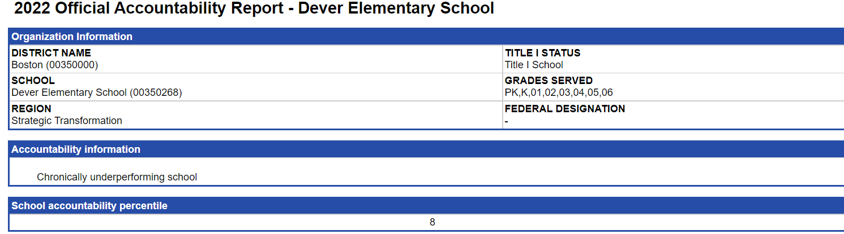
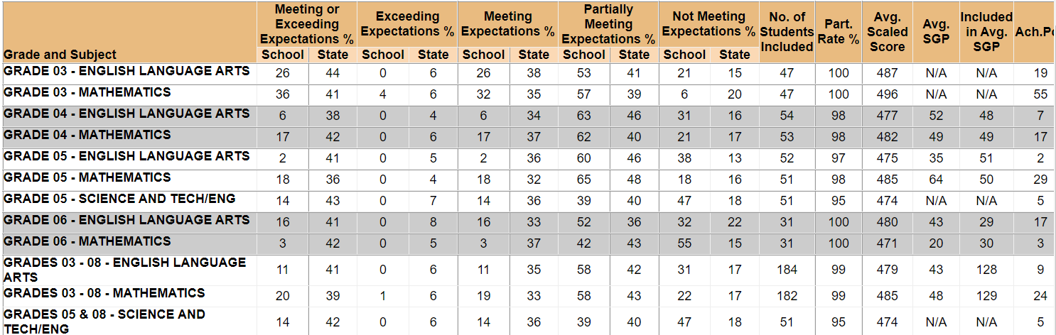

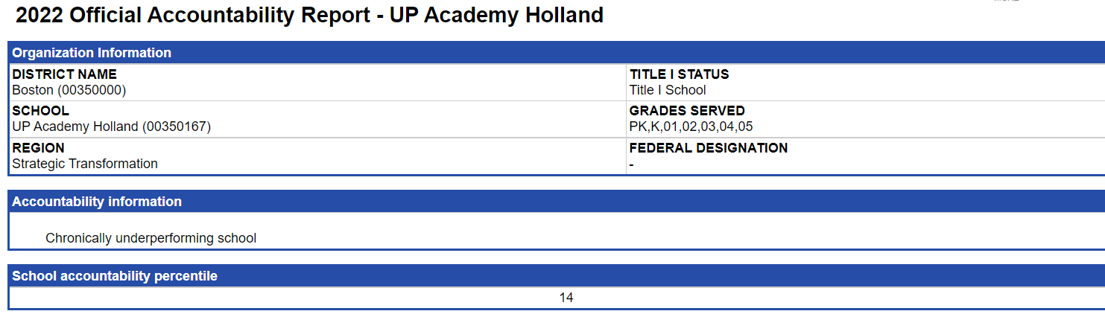
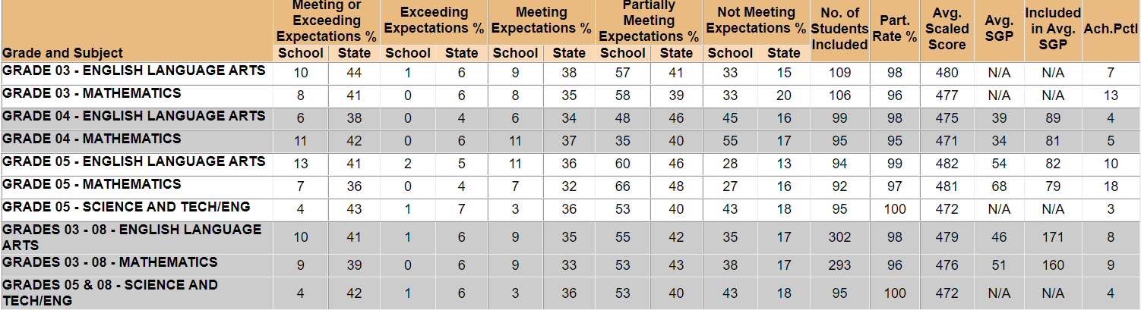

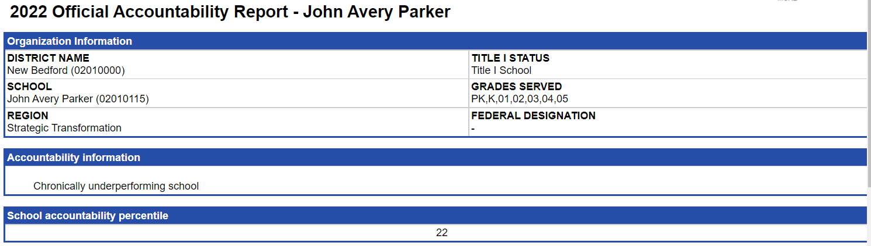
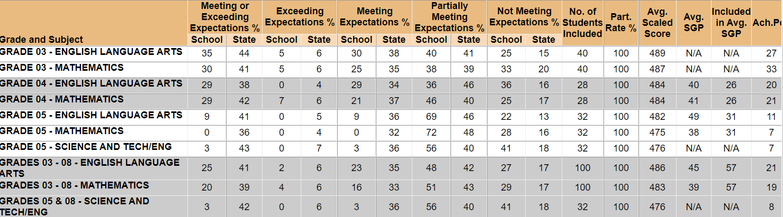

The September 26, 2022 letter announcing the change in designation for Morgan may be found here: https://www.doe.mass.edu/level5/schools/morgan.html.

