Worcester Cultural Academy Charter Public School
Executive Summary

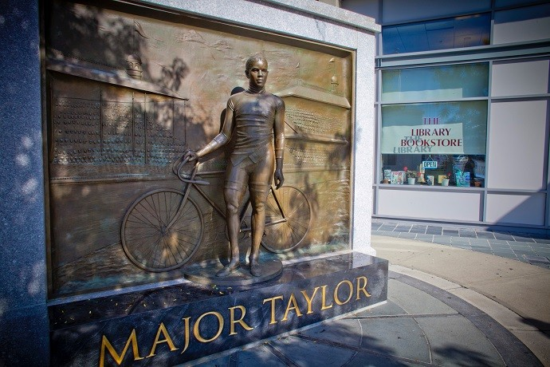
The executive summary was provided by the charter applicant group.
The image above shows a public piece of art in the city of Worcester. The statue of Major Taylor, by artist Antonio Tobias Mendez from 2008, is significant because it is the only such depiction of an African American in Worcester.² Located in front of the Worcester Public Library, this public work embodies the values of the founding group of this proposed charter public school which is described in this initial application. In short, it is a model of what we want our future students to see-themselves reflected in public works of art which, in turn, connect them to the cultural institutions of their city, Worcester, Massachusetts.

Mission and Key Design Elements
The Worcester Cultural Academy Charter Public School (hereinafter WCACPS) will be the result of an exciting partnership between the proposed charter school, EL Education (formerly known as Expeditionary Learning and hereinafter EL Education) – a national organization with a strong track record of success in educating hundreds of thousands of students with emphasis on student engagement and culturally responsive teaching and learning– and Central Massachusetts cultural intuitions (hereinafter Expedition Institutions). Students at WCACPS will learn through projects, specifically called Learning Expeditions in EL Education schools.
Furthermore, the proximity of WCACPS to world class Expedition Institutions in Central Massachusetts will provide a unique learning experience for our proposed student body to access the collections, experts, and resources to provide an engaging learning environment for all students that pushes the boundaries of the four walls of the classroom. WCACPS is based on the success of Old Sturbridge Academy Charter Public School (hereinafter OSACPS) where a successful school/museum/EL Education partnership has flourished over the past five years. OSACPS partnered with both EL Education and Old Sturbridge Village (hereinafter OSV), a 19th century living history museum in southern Worcester county, located in Sturbridge. OSACPS has seen this model work with all students, especially those who come from diverse backgrounds that are considered at-risk for successful learning – students with disabilities, English language learners, and low income. WCACPS will utilize the blueprint of this school/museum/EL Education model along with OSACPS’s best practices and lessons learned over the first charter term. WCACPS will be different as it is set in the culturally rich, urban environment of Worcester.

² http://www.majortaylorassociation.org/statue.shtml

Proposed Mission:
Our mission is to educate, inspire, and uncover the inner genius of all learners through real-world and
project-based experiences. In partnership with local cultural institutions, we provide Worcester students with learning opportunities that match their varied learning styles and needs and prepare them to be the cultural leaders of tomorrow.

An EL Education school, the Worcester Cultural Academy Charter Public School fosters a supportive and nurturing environment that represents all aspects of the diversity spectrum and enables our students to achieve above-average growth or meet/exceed grade-level expectations in English language arts, math, science, social studies, and the arts. WCACPS provides students with rigorous, real-world learning experiences to inspire intellectual curiosity. In collaboration with Central Massachusetts cultural organizations, called Expedition Institutions, WCACPS facilitates extended, interdisciplinary Learning Expeditions and field work at sites across Worcester County. These experiences inside and outside of the classroom encourage students to become articulate communicators, critical thinkers, and skilled problem solvers who care for themselves, those around them, and their community.

As cultural leaders of tomorrow, our students will have their authentic work displayed throughout the city, speak articulately about their projects, gain confidence by leading meetings and collaboratively working with their peers and community members to solve real-world problems, develop organizational skills as they see a project from start to finish, and practice self-management and agency as they monitor progress to meet their goals. Students will edit, revise, and polish their written and oral presentations in order to demonstrate excellent communication skills. A culture of quality will permeate the school. Our students will graduate with an understanding of how they learn best and how to advocate for the resources they need to succeed.

Early in his tenure as President and CEO of OSV, Jim Donahue began hearing from the community that there was a need for a high-quality alternative to the traditional public school – especially for historically underserved students and for children who learn differently. Families who could afford to send their children to private day schools were doing so. As the founding CEO of the Highlander Charter School in Providence, Rhode Island, Jim always believed that OSV would be the ideal setting for a school. In 2017, Old Sturbridge Academy Charter Public School opened under Jim Donahue, who is the school’s Executive Director. The model of OSACPS provides students, especially those from underperforming urban districts, such as Southbridge, with rigorous learning experiences rooted in the context of the real world.
Approximately half of OSACPS’s students come from Southbridge along with other underperforming towns including Webster, North Brookfield, and Palmer. After its first five years of operation, under the leadership of Jim Donahue, Executive Director, Lisa DeTora, Principal, and Melissa Hogan, Director of Special Education and Student Supports, the school received an unconditional renewal for the next charter term with proficient ratings in every category. Jim Donahue and Lisa DeTora are the primary authors of this application. We intend to replicate this model in Worcester where the founding group feels there are more opportunities to connect urban children historically underserved for learning due to poverty, language or learning differences, to thrive in a charter public school setting.

While in Providence, Jim had the opportunity to visit Ron Berger’s (who is now on the Senior Leadership Team at EL Education) classroom in Shutesbury, Massachusetts. EL Education’s model is based, in part, on Berger’s approach to teaching. Jim talked with Ron about his work in helping schools to create a “culture of quality” in their classrooms and in the building. In fact, they talked about thinking of student work as if it were going to be displayed in a museum. With that in mind, it was no surprise that EL Education was recommended to the

museum as a school-design partner for OSACPS. Our shared vision for rigorous teaching, authentic learning experiences, differentiated instruction, teacher efficacy, and robust assessment practices led us to a
ground-breaking partnership in the creation of OSACPS. In May 2022, for EL Education’s Better World Day, Ron Berger visited OSACPS to see Academy students in action creating a project, the creation of a book entitled Out of the Margins. The book, containing original research based on field work that students did from OSV’s collection, tells the untold or lesser known stories of the people in the 19th century, including Indigenous people, people of color, women, and children. In just five years, this school is creating authentic, high-quality work based on its partnerships with EL Education and a cultural institution that is featured at the national level. We expect to replicate this model at WCACPS through our past experiences with even more Expedition Institutions and an exclusively urban population of students.

To these children and their families, Worcester Cultural Academy will offer a learning environment that is both unique because of its partnership with EL Education and access to Central Massachusetts-based Expedition Institutions on a frequent basis. We want children to rise every morning with the same sense of excitement, passion, and wonder as they do on a day when they are preparing to go on a field trip – away from school. The work of Reach Advisors has shown the transformative power of early museum visits among children in their book Life Stages of the Museum Visitor: Building Engagement Over a Lifetime.
People who visit museums self-identify as lifelong learners, and children who visit museums are more likely to be museum visitors in the future.³ Our students will actually grow up at these Expedition Institutions – developing essential Habits of Character. This will be especially true for students for whom the traditional classroom setting can present learning challenges. In addition, WCACPS would be the only school in the identified region that is using EL Education as a school-design model.

The founding group, who represent expertise in culture, leadership, finance, public schools, museums, community organizations, DEIA, culturally responsive practices and more, has been actively assessing demand and support for the proposed school through Worcester-based businesses, community organizations, and families. As Worcester Public Schools remain the lowest performing 10% of school districts in the state, our research has shown the need for a high-quality, public school option for families that support the needs of all students. With a small school feel, WCACPS will provide that option.

We will open with grades K-4. Each grade will include two classrooms, with an enrollment of no more than twenty students per classroom. Total enrollment in the first year will be 200. The school will accept an incoming class of kindergarten students each year until it reaches its full capacity of 360 students in grades K-8 in year 5. Building on the lessons learned and experience at OSACPS, beginning with these five grades at onces provides solid support systems in literacy and math along with establishing the school’s culture, character, and climate. We have seen a successful elementary launch in Sturbridge and have the curriculum
and instructional practices in place that can be replicated in Worcester. The benefit to this gradual expansion is that we will also reach full enrollment within the first charter term.

When students graduate from WCACPS, they will do so as articulate communicators, critical thinkers, and skilled problem solvers who care for themselves, others around them, and their community. They will have clear Habits of Character that they show at the high school of their choosing, the Expedition Institutions that they will still visit after graduation, and the city of Worcester. Through project-based learning, they will have discovered other passions and crafts as well – whether in woodworking or gardening, music or painting. They will have produced academic work that is “museum quality” and will have engaged in real-world learning at every grade level. They will be able to describe how they learn best and will be able to advocate for the tools they need when they are struggling. As EL Education describes, our students will have the academic skills they need to produce beautiful work to make the world a better place.

³ Wilkening, Susie, and James Chung. Life Stages of the Museum Visitor: Building Engagement Over a Lifetime. Washington, D.C.: American Alliance of Museums Press, 2009.

