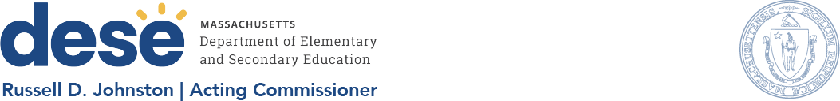

MEMORANDUM

To: | Members of the Board of Elementary and Secondary Education Russell D. Johnston, Acting Commissioner  March 22, 2024
From:
Date:
Subject: | DESE’s Educational Vision and Strategic Objectives: Progress and Next Steps

This memorandum provides an update on the Department of Elementary and Secondary Education’s (Department’s/DESE’s) Educational Vision and Strategic Objectives. We initially presented our Educational Vision and Strategic Objectives to the Board of Elementary and Secondary Education (BESE) on May 23, 2023.
DESE began the process of updating our Educational Vision in spring 2022, largely in response to the unique context we found ourselves in as we emerged from the COVID-19 pandemic. The data highlighted the need to provide effective support that advances equitable opportunities for each and every student.

Academic disparities across student groups in Massachusetts existed pre-pandemic and they persist today. For example, the table below shows the 2023 English Language Arts
(ELA) results for students in grade 3-8 by race/ethnicity. First, these data demonstrate that all racial/ethnic student groups are performing below pre-pandemic levels (2023 compared to 2019) and that the recovery process is slow to nonexistent (2023 compared to 2022). Of particular concern are the low rates of achievement and recovery for African
American/Black and Hispanic students. The percentage of African American/Black and Hispanic students meeting or exceeding expectations in ELA has not measurably improved from 2022 to 2023.

2023 ELA MCAS Results by Race/Ethnicity

Grades 3-8 | % Meeting or Exceeding Expectations (% M or E) | % M or E change compared to
 |  | 2022 | 2019
African American/Black | 26 | 0 | -7
Asian | 64 | +1 | -8
Hispanic/Latino | 22 | 0 | -11
White | 50 | -1 | -9

In response to these and other similar forms of data and information, DESE sought to develop and promote an Educational Vision and aligned supports so districts and schools would strategically select and leverage DESE resources in service of equitable student learning opportunities and improved outcomes.

The Educational Vision document describes DESE’s aspiration – our vision – for elementary and secondary public education and adult basic education in the Commonwealth of Massachusetts.
This vision is anchored in our commitment to high-quality teaching and learning in the Commonwealth. We will continue to work with districts, schools, and educators to promote teaching and learning that is antiracist, inclusive, multilingual, and multicultural; that values and affirms each and every student and their families; and that creates equitable opportunities and experiences for all students, particularly those who have been historically underserved.

The Department is deeply committed to providing aligned supports to districts, schools, and programs so that this vision may become a reality. As such, DESE identiﬁed three key strategic objectives that it has focused on strengthening over the past year and will continue to use to guide our work going forward. The Department believes that for schools and districts to provide the learning experiences to all students as described in the vision, it must

- focus on supporting the whole student, so they feel connected and ready to learn,
- support schools in engaging students in grade-level (or beyond) work that is relevant and meaningful, and
- continue to foster a diverse and well-prepared workforce that promotes a sense of belonging and provides access to deeper learning experiences every day.

The Department has made signiﬁcant progress in utilizing our Educational Vision and Strategic Objectives to present coherent and aligned supports to districts and schools, promote internal coherence and collaboration, and drive strategic decision-making around fund allocation, and project development.
At the March 26 meeting, I along with my colleagues Deputy Commissioner Regina Robinson and Chief of Schools Komal Bhasin will present an update on the Educational Vision and Strategic Objectives and core functions. We will report on progress to date on our ongoing efforts to align DESE’s supports to districts and schools in service of this vision and map out some next steps. We look forward to the discussion.
2

