MEMORANDUM

To: | Members of the Board of Elementary and Secondary Education and Members of the Board of Higher Education
From: | Russell D. Johnston, Acting Commissioner
Date: | June 10, 2024
Subject: | Update on Early Literacy Expectations in Teacher Preparation

This memorandum is an update on our work to establish evidence-based, culturally and linguistically sustaining early literacy practices in Massachusetts teacher preparation.

Background
In 2019, the Department of Elementary and Secondary Education (DESE) launched the Mass Literacy initiative, the goal of which is to support pre-service and in-service educators in grades PreK–3 to gain deep knowledge of literacy development and to skillfully implement evidence-based, inclusive, culturally responsive and linguistically sustaining practices using high-quality instructional materials and assessments.
In line with the mission of Mass Literacy, it is critical that pre-service teachers learn evidence-based early literacy practices and how they can be enacted in a culturally responsive and linguistically sustaining way. Currently in Massachusetts, the extent to which new teachers are learning evidence-based early literacy practices varies widely. Recent data from surveys and a review of syllabi from teacher preparation courses indicated the need to strengthen how Massachusetts teachers are being prepared. Specifically,
- Surveys of teacher candidates and recent completers in 2020 and 2021 found that only one-third agreed that "there are instructional routines for teaching each component of literacy supported by scientific evidence."
- According to a 2021 syllabi review of required courses in elementary and early childhood programs across nine teacher preparation providers, some candidates are currently taught little or nothing about key foundational literacy topics, such as decoding and phonemic awareness. Discredited practices like 3-cueing continue to be taught in lieu of or alongside evidence-based practices.
- Only half of the syllabi reviewed in 2021 included all components of effective writing instruction, findings that align with national research that suggests educator preparation providers may not be preparing teachers to teach essential writing skills.

Establishing Evidence-Based Early Literacy Practices in Teacher Preparation
In 2021, DESE set the following goal: By SY2024-2025, all Early Childhood, Elementary, and Moderate Disabilities teacher candidates in Massachusetts are prepared, through coursework and opportunities for practice and high-quality feedback, in evidence-based early literacy as outlined in the Mass Literacy Guide.
In order to accomplish this goal, DESE launched a multi-year initiative to integrate new standards and requirements for evidence-based early literacy instruction into teacher preparation programs and licensing systems.
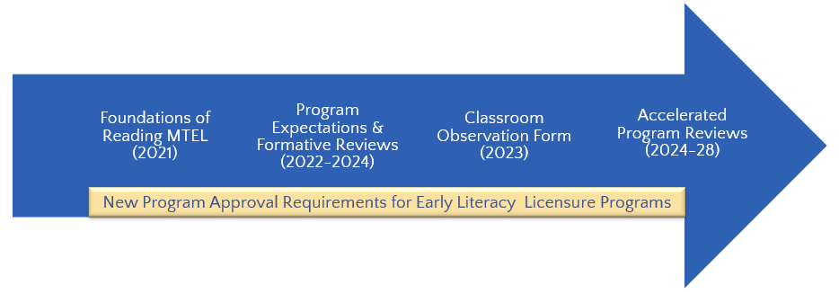
Updating Licensure Requirements. The first step was to revise licensure assessments (the Massachusetts Tests for Educator Licensure, or MTEL) in accordance with scientifically-based research in reading development. The relevant assessments included the Foundations of Reading MTEL (updated and released 2020), the Reading Specialist MTEL (updated and released 2022), and the identification of alternative assessments for Foundations of Reading through the MTEL-Alternative Assessment Pilot. Collectively, these licensure assessments now set the standards for candidates to have knowledge of scientifically-based practices in reading development, comprehension, and foundational skills.

New Program Expectations. In 2022, DESE partnered with faculty and K-12 literacy experts to develop new program expectations for early literacy preparation, aligned to Mass Literacy. Finalized and released in 2024, these program expectations articulate requirements for coursework, field-based experiences, and partnerships with K-12 districts, and cover all aspects of evidence-based literacy development, from language comprehension to foundational skills, reading comprehension, and writing. Simultaneously, DESE developed a new classroom observation tool aligned to core components of an instructional literacy block. This tool will be a required component of the Candidate Assessment of Performance (CAP), the state’s performance assessment for Initial teacher licensure. Providers authorized to endorse candidates for licensure in early childhood, elementary, and moderate disabilities must demonstrate alignment to these new program expectations and CAP observation requirements starting in SY2024-2025.
Accelerated Program Review and Approval, 2024-2028. In accordance with the Commissioner of Elementary and Secondary Education’s statutory authority to review and approve programs that prepare candidates for educator licensure in Massachusetts¹, DESE will be conducting program-level reviews of all early childhood, elementary, and moderate disabilities PK-2/PK-8 licensure programs with a focus on their literacy preparation practices to determine if they meet the new program approval requirements. With additional funding through Literacy Launch, DESE plans to accelerate the review cycle for these programs over the next four years. These reviews will result in program-level approval determinations for 170 early childhood, elementary, and moderate disabilities licensure programs across 46 educator preparation providers. If a program or set of programs receives conditional or probationary approval, they will be expected to address those conditional findings within a certain period of time or risk losing their approval².

Technical Assistance, Grants, and Additional Supports
During the development of these new program requirements, DESE encouraged educator preparation providers to start examining their own programs’ alignment to these new expectations, and to start making any necessary changes. We therefore invested $800,000 of ESSER funds in continuous improvement grants and a partnership with TPI-US to provide optional, confidential formative feedback reviews of preparation programs in accordance with these new literacy requirements. From 2022 to 2024, sixteen educator preparation providers took part in these formative feedback reviews. More information about these optional reviews is available here: https://www.doe.mass.edu/edprep/resources/feedback-reviews.html.
DESE has also provided the following supports and programs to educator preparation leadership and faculty:
- Priority access to Open Access Professional Learning courses on evidence-based early literacy for educators funded through DESE
- Equity Through Early Literacy Webinar Series (2023)
- Early Literacy Community of Practice for Program Supervisors (2023-24)
- Early Literacy in Educator Preparation: A Professional Learning Community for Faculty and Leadership (SY2023-24 and SY2024-25)
More information about each of these supports is available here: https://www.doe.mass.edu/edprep/resources/early-literacy.html.
This spring, DESE was pleased to award over $370,000 in grants to six partnerships between educator preparation providers and PK–12 districts to promote improved teacher preparation in evidence-based early literacy instruction and improved early literacy outcomes for PK–3 students. The goal of this grant program is for both districts and educator preparation providers to benefit through multi-year partnerships designed to improve early literacy teaching and learning through the preparation of candidates and ultimately hiring and employment of effective elementary, early childhood, and moderate disabilities teachers.

Stakeholder Engagement
Throughout this work, DESE is relying on the guidance and thought partnership of various stakeholders. At the outset of this initiative in 2022, DESE staff conducted a statewide listening tour focused on early literacy and heard from faculty members in educator preparation programs across the Commonwealth. In drafting the program approval criteria, DESE worked closely with literacy faculty from Salem State University and national experts to develop the outline and begin building out expectations; and in 2022, DESE convened a working group of Massachusetts PK-12 educators and higher education faculty in elementary, early childhood, and moderate disabilities licensure programs to inform the development of the criteria. DESE also solicited anonymous feedback from organizations who participated in an Early Literacy Formative Feedback Review, and benefited from expertise throughout our agency, including the Office of Language Acquisition and the Early Learning Team, so that these expectations would be responsive to the needs of all students. More information about stakeholder engagement related to this initiative is available in Appendix E of the Early Literacy Program Approval Criteria (download).

Looking Ahead
DESE will continue to support educator preparation providers in making the necessary programmatic shifts to align to these new expectations and requirements, so that Massachusetts educators are prepared with the tools they need for effective, evidence-based, culturally and linguistically sustaining literacy instruction.

