MEMORANDUM

**To:** Members of the Board of Elementary and Secondary Education

**From:** Russell D. Johnston, Acting Commissioner

**Date:** October 22, 2024

**Subject:** Update on Chronically Underperforming Schools: SY2024 –2025 Quarter 1 Reports

This month, I am presenting the first of four SY2024-2025 quarterly progress updates to the Board of Elementary and Secondary Education (Board) on the three chronically underperforming schools’ implementations of their school turnaround plans, focusing on activities from July to October 2024. Future quarterly updates for SY2024-2025 will be presented in January 2025 and March 2025, and a final annual review in June 2025.

SY2023-2024 accountability data has been included for your reference.

**Chronically Underperforming Schools**

In the fall of 2013, four schools were designated as chronically underperforming in response to their low performance and lack of improvement while in underperforming status: John P. Holland Elementary School (UP Academy Holland) and Paul A. Dever Elementary School (Dever) in Boston, Morgan Full Service Community School (Morgan) in Holyoke, and John Avery Parker Elementary School (Parker) in New Bedford.

In September 2022, former Commissioner Riley exercised his authority under 603 CMR 2.06 (10)(d) to remove the chronically underperforming status from the Morgan Full Service Community School in Holyoke on the basis of the district’s concurrent designation as chronically underperforming.[1] With this technical change, the ongoing strategic transformation efforts at Morgan are fully aligned with and supported by Holyoke’s district turnaround plan. As a result, this update and future quarterly updates include information on the three remaining chronically underperforming schools: UP Academy Holland, Dever, and Parker.

**Strategic Planning with School Empowerment Network**

During the summer of 2024, the Department of Elementary and Secondary Education’s Office of Strategic Transformation (OST) and the School Empowerment Network (SEN) engaged school leaders of the three chronically underperforming schools in a robust strategic planning process to create one-year implementation plans for their schools, aligned to their turnaround plans. For Dever and UP Academy Holland, this process included at least four meetings with the school leader and their leadership teams between May and September to discuss school goals, areas for growth, and specific actions intended to advance student achievement and racial equity this school year. SEN did not meet with Parker school leaders because of a transition of the entire leadership team during the summer of 2024. Parker’s receiver supported the revision of the strategic plan, and the OST team met with the new leadership team to discuss the plan in September.

Throughout the year, OST will meet regularly with school leaders of the chronically underperforming schools to discuss progress on school action plans and benchmarks and provide targeted support. Updates on the focus areas of each school’s action plan are summarized below.

**Updates on the Chronically Underperforming Schools**

*Paul A. Dever Elementary School, Boston.*

The Paul A. Dever Elementary (Dever) opened school with School & Main Institute (SMI) returning as receiver for the sixth year and Margaret Reardon beginning her sixth year as principal.

Dever school leaders engaged with OST and SEN in a series of strategic planning meetings between June 2024 and August 2024. The key priorities for the plan were informed by the leadership team’s analysis of end of year outcomes in the identified priority areas of the school’s SY2023-2024 action plan. The school’s theory of action states “if we create a sense of unconditional belonging for staff, students, and families, then we will become a learning organization with transformative experiences for all members of the community so that families and students are agents of their own academic and social development.”

During the strategic planning process, school leaders analyzed end of year metrics in attendance and chronic absenteeism; staff, student, and family survey data; and qualitative findings in the year-end school quality review report to develop goals and actions for the current school year around unconditional belonging. The school will implement a social emotional curriculum schoolwide to increase the sense of peer-to-peer belonging and decrease the number of incidents involving peer-to-peer conflict. In addition, an attendance team will work to uncover the root causes of chronic absenteeism for individual students and collaborate with students and families on solutions to the root causes with a goal of decreasing chronic absenteeism.

The second priority for this year identified through the data review is to ensure that all students have access to transformative classrooms reflective of their cultures and communities, featuring engaging debate, risk-taking, and student voice. The leadership team will hold teachers accountable for developing these expected practices in their classrooms through ongoing cycles of observation and feedback aligned to the instructional vision. The team will more effectively and frequently analyze schoolwide and classroom level academic achievement data using a schoolwide data hub. Continual analysis of data will enable instructional leaders to target the specific support needs of staff and students in a more systematic and proactive manner.

The Dever staff spent a week in August participating in professional development that sustained the school’s instructional focus on using systemic functional linguistics to ensure equitable access for multilingual learners. Throughout the year, Dever educators will build upon their summer professional learning experiences by collaboratively unpacking units of study from the core curriculum, analyzing student work to determine ongoing strengths and areas of need, and deepening their knowledge of strategies to address students' literacy needs. The school’s instructional leaders and coaches will support Dever teachers to incorporate their professional learnings through a new eight-week learning walk cycle. This cycle will utilize instructional walkthrough data to inform individual teacher feedback, professional development, coaching cycles, and planning for upcoming units of study.

*UP Academy Holland, Boston.*

Victoria Thompson will be in her fifth year as principal of UP Academy Holland (UAH), upon returning from a leave of absence at the outset of the school year. In preparation for this leave, Amelia Massoud-Tastor served as a Principal in Residence during the SY23-24 school year and is leading the school during Ms. Thompson’s absence. UP Education Network continues to serve as the school’s receiver.

OST and SEN met with Principal Thompson (May and June only), Ms. Massoud-Tastor, and Network Leader Hillary Casson from May 2024 through August 2024 to create the year’s strategic plan and prepare specific actions for professional development to launch the plan in classrooms at the beginning of the school year. School leaders worked in concert with the UP Network to adopt network priorities as the school's strategic plan framework. The network priorities were developed following review of data from school quality reviews, classroom observations, student assessments, teacher observation data, and network wide needs. The UAH team is centering priorities in three areas for the SY24-25 school year: instruction that meets the needs of all students, values-rooted adult culture, and coaching and development for impact and ownership.

To meet the instructional needs of all students, the UAH team will build upon the school’s focus over the last three years on planning appropriate scaffolds and accommodations to ensure that all learners have equitable access to rigorous learning expectations. Teachers will utilize a planning process that aligns to Universal Design for Learning principles. Building on processes already utilized during common planning time, educators will plan for the needs of students based upon ongoing data cycles to ensure that students are provided access without lowering the rigor of the tasks.

Based upon analysis of staff surveys, there will be an intentional focus upon adult culture and coaching and development within the school. Instructional leaders will aim to strengthen the quality of one-on-one coaching sessions aligned to the instructional priorities within each individual classroom.

The primary focus of UAH staff professional development over the summer and across the year is to build staff understanding of how the curriculum, scaffolds, and accommodations work together to ensure rigorous instruction for all students. Teachers will be trained to utilize a planning process that explicitly prompts educators to ensure rigor, create access, individualize support, and check for efficacy.

*John Avery Parker Elementary School, New Bedford.*

The John Avery Parker Elementary (Parker) opened the 2024-2025 school year with School & Main Institute (SMI) returning for its seventh year as receiver and Jacell Feliciano entering her first year as principal. While the leadership team is new this year, each member has a long history at the school, and collectively the team is poised to maintain the school’s positive trajectory.

The receiver led the school leadership team through a data review and reflection on their prior year’s strategic plan. The team made thoughtful updates to the plan to reflect a sustained focus on educator development, grade-level instruction with appropriate scaffolds, and curricular priorities of inquiry, collaboration, and relevance.

Educator development is targeted to meet the needs of individual teachers. The school will utilize regular observation and feedback coaching cycles as well as peer observations to build capacity of its staff. The school leaders will offer professional development on using formative assessments in the classroom as well as utilizing a method of discourse and questioning to support students’ inquiry and depth of understanding. Teachers and leaders will regularly analyze data to inform instruction and specific student supports. Finally, the instructional coach will support grade-level teams in understanding the standards embedded in each lesson and how to deliver content in ways that are aligned to the school’s instructional vision. The leadership team will monitor the alignment of lesson plans and classroom practice through weekly observations and provide feedback to teachers.

## **MCAS and Accountability Data 2024**

**Image indicating school progress toward improvement targets and accountability percentile.
Table with data that includes percentage of students meeting, exceeding, partially meeting, or not meeting expectations on MCAS in English Language Arts, Mathematics, and Science.**

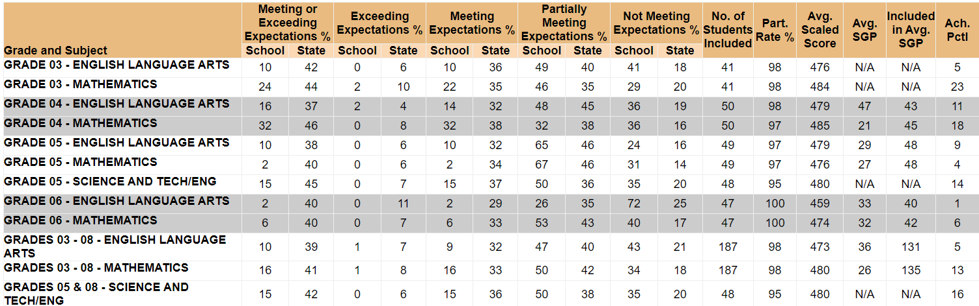

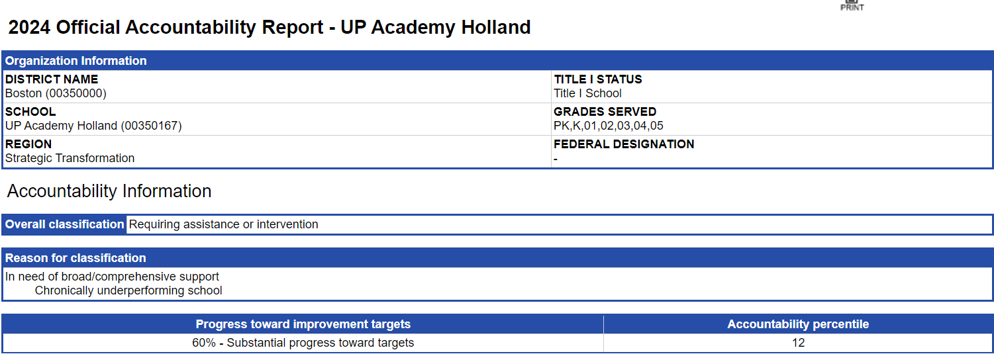

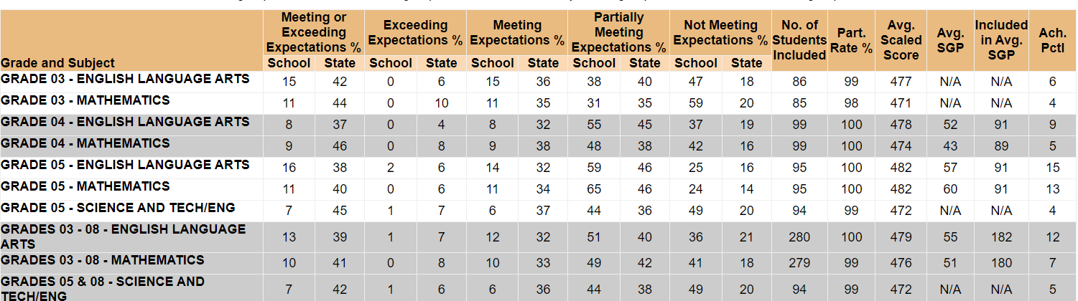

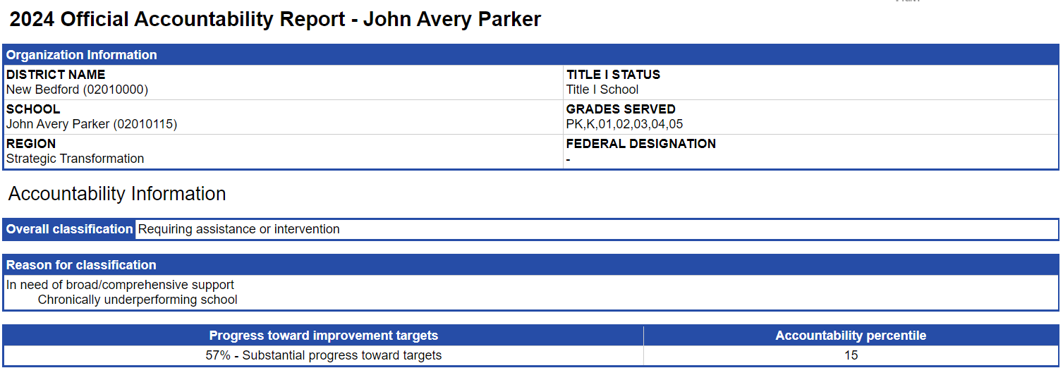

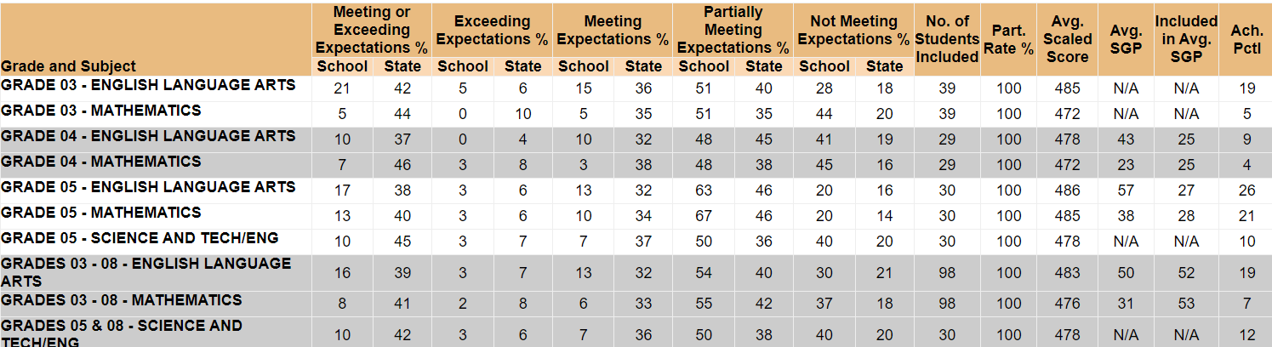

1. The September 26, 2022 letter announcing the change in designation for Morgan may be found here: <https://www.doe.mass.edu/level5/schools/morgan.html>.