# **MEMORANDUM**

|  |  |
| --- | --- |
| **To:** | Members of the Board of Elementary and Secondary Education |
| **From:** | Pedro Martinez, Commissioner |
| **Date:** | October 21, 2025 |
| **Subject:** | Update on Chronically Underperforming Schools: SY2025 –2026 Quarter 1 Reports |

This month, I am presenting the first of four SY2025-2026 quarterly progress updates to the Board of Elementary and Secondary Education (Board) on the two chronically underperforming schools’ implementation of their school turnaround plans, focusing on activities from July to October 2025. Future quarterly updates for SY2025-2026 will be presented in January 2026 and March 2026, and a final annual review in June 2026.

SY2024-2025 accountability data has been included for your reference.

**Chronically Underperforming Schools**

In the fall of 2013, four schools were designated as chronically underperforming in response to their low performance and lack of improvement while in underperforming status: John P. Holland Elementary School (UP Academy Holland) and Paul A. Dever Elementary School (Dever) in Boston, Morgan Full Service Community School (Morgan) in Holyoke, and John Avery Parker Elementary School (Parker) in New Bedford.

As of September 26, 2022, the Morgan Full Service Community School in Holyoke was no longer designated as a chronically underperforming school.[1] The John Avery Parker Elementary School in New Bedford exited chronically underperforming status on January 1, 2025[2] and has been converted by the district into an early childhood center serving pre-kindergarten students as of the 2025-2026 school year. As a result, this update and future quarterly updates include information on the two remaining chronically underperforming schools: UP Academy Holland and Dever.

**Updates on the Chronically Underperforming Schools**

Paul A. Dever Elementary School, Boston

The Paul A. Dever Elementary (Dever) opened school with School & Main Institute (SMI) returning as receiver for the sixth year and Margaret Reardon beginning her sixth year as principal. The 2025-2026 school year will be Dever’s final year of operations, following a school closure vote by the Boston School Committee on March 20, 2025. With involvement of SMI and staff from the Department of Elementary and Secondary Education, the district is implementing a comprehensive closure plan that includes personalized supports for families and staff transitioning to a new school next year.

For the school’s final year of operations, Dever school leaders developed a strategic plan that maintains the school’s focus on three primary improvement strategies: a schoolwide social-emotional learning curriculum, collaborative problem-solving with families around attendance needs, and intensive use of data on classroom instruction and student learning outcomes to inform decision-making at the school and classroom levels. The school’s 2025-2026 strategic plan also contains a focus on transition planning for Dever families during the school’s closure year.

For the fourth consecutive year, Dever faculty are engaged in professional development on incorporating systemic functional linguistics into their curricula to ensure equitable access for multilingual learners. With support from an external consultant, Dever faculty continue to revise units of the school’s English Language Arts and English Language Development curricula to embed instructional strategies based upon systemic functional linguistics. In the school’s mathematics instruction, Dever teachers are incorporating resources from high-quality mathematics curricula used by other district schools, to facilitate the transition of both teachers and students to other schools next year.

To support the intensive use of data outlined in the school’s strategic plan, Dever school leaders lead eight-week cycles of biweekly learning walks in which the instructional leaders meet regularly as a team to calibrate their feedback to teachers and to collaboratively plan the focus of the next learning walk. The school applies this system of classroom observations to monitor both academic instruction and implementation of the schoolwide social emotional learning curriculum.

UP Academy Holland, Boston

Amelia Massoud-Tastor is serving in her first year as principal of UP Academy Holland (UAH). Since joining the UAH faculty in 2014, Principal Massoud-Tastor has held numerous leadership positions at the school, including serving as a Principal in Residence during the 2023-2024 school year and leading the school during her predecessor’s leave of absence during the 2024-2025 school year. UP Education Network continues to serve as the school’s receiver.

UAH is entering the second year of implementing an instructional framework that is organized around four core actions: promoting rigor by setting the bar for student thinking; creating access through appropriately designed scaffolds; individualizing supports for unique student needs; and checking for efficacy of the instruction on a daily basis. For the 2025-2026 school year, the school has developed a strategic plan that aims to strengthen the implementation of this framework through more focused monitoring of schoolwide practices. Strategic adjustments include the articulation of non-negotiable culture and instructional moves to be implemented schoolwide at the beginning of the year, followed by a narrower focus on creating access for all learners in the middle of the year.

In UAH’s strategic plan, instructional coaching is powered by both rigorous monitoring of classroom practices and frequent analysis of student learning outcomes. In the latter area, teachers administer weekly assessments in English Language Arts, math and English Language Development (for students identified as English learners) and analyze the data using a schoolwide data protocol. Teachers of foundational reading skills analyze progress monitoring data on two-week cycles to adjust their small-group instruction.

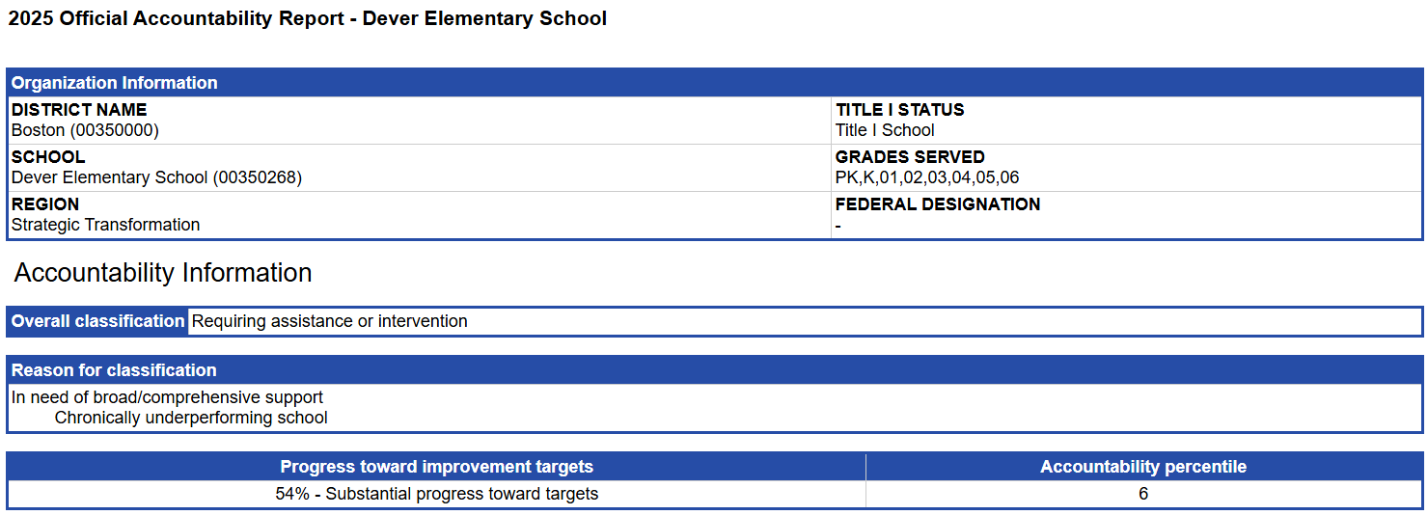**MCAS and Accountability Data 2025**

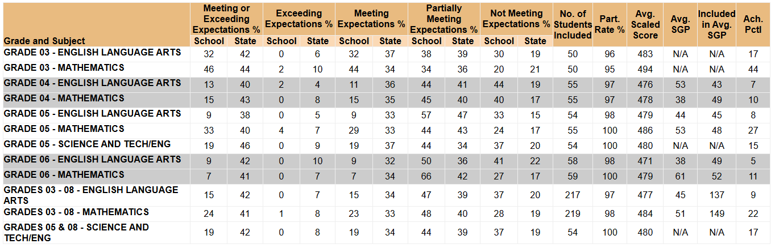

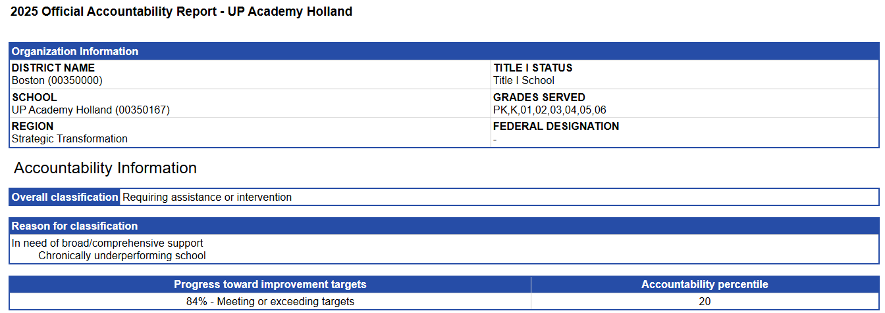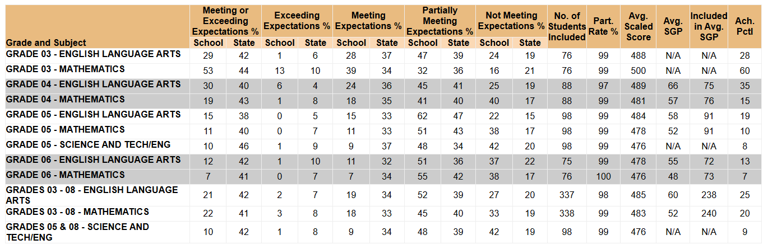

1. The September 26, 2022 letter announcing the change in designation for Morgan may be found here: <https://www.doe.mass.edu/level5/schools/morgan.html>.
2. The December 17, 2024 letter announcing the change in designation for Parker may be found here: <https://www.doe.mass.edu/level5/schools/john-avery-parker.html>.