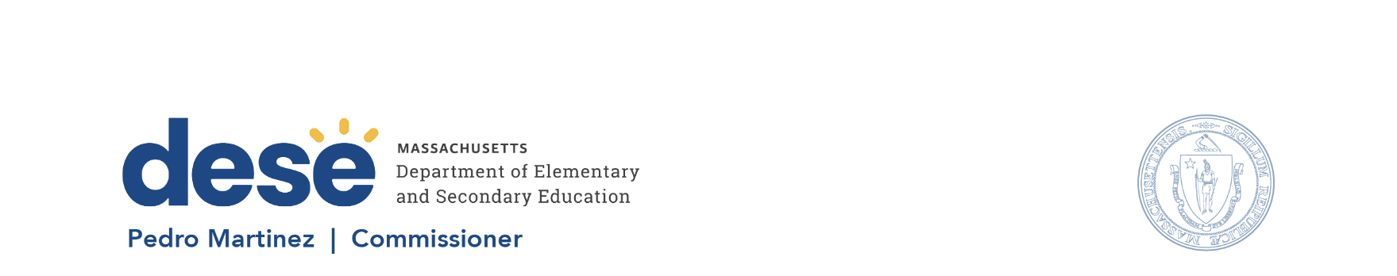

135 Santilli Hwy, Everett MA 02149 Voice: (781) 338-3000 TTY: 1-800-439-2370 www.doe.mass.edu

Memorandum
To: Members of the Board of Elementary and Secondary Education
From: Pedro Martinez, Commissioner
Date: September 15, 2026
Subject: 2026 Assessment and Accountability Results

At the September 22, 2026, meeting of the Board of Elementary and Secondary Education (Board), I will present the 2026 assessment and accountability results and release the results to the public.
2026 Assessment Results
At the meeting, I will share results from the spring 2026 administration of the MCAS tests in English language arts, mathematics, and science and technology/engineering, as well as results from the second administration of the MCAS grade 8 civics test.
2026 Accountability Results
The Department of Elementary and Secondary Education (DESE) issues accountability determinations for each district and school with sufficient data. Accountability determinations include information about the degree to which each district, school, and student group is making progress towards improvement targets, how each school is performing relative to other schools that administered similar assessments, and student group results. Results are reported in two categories: districts or schools that require assistance or intervention, and districts or schools that do not require assistance or intervention. With this data release, DESE has also identified schools of recognition, which are schools that demonstrate high achievement, high growth, and meet or exceed targets.
Rob Curtin, Deputy Commissioner, and Erica Gonzales, Senior Associate Commissioner, will join us for the discussion on September 22.

