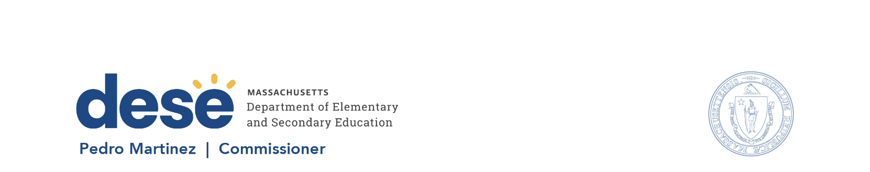

135 Santilli Hwy, Everett MA 02149 Voice: (781) 338-3000 TTY: 1-800-439-2370 www.doe.mass.edu

Memorandum
To: Members of the Board of Elementary and Secondary Education
From: Pedro Martinez, Commissioner
Date: October 15, 2026
Subject: State Student Advisory Council (SSAC) Brief Update and Focus for 2026-2027 Council Year
______________________________________________________________________
At the October 27, 2026, Board meeting Sara Khan, the student member of our Board of Elementary and Secondary Education (BESE) and chair of the State Student Advisory Council (SSAC), will provide a brief update on the SSAC and their agreed upon focus areas for the 2026-2027 council year.
The SSAC is a state-legislated advisory council to BESE, as set forth in Massachusetts General Laws Chapter 15, Section 1E. Students in every secondary school in the Commonwealth can elect two student representatives to participate in their Regional Student Advisory Council (RSAC). Currently, there are five RSACs serving Central, Greater Boston, Northeast, Southeast and Western geographic regions of the state.
Each RSAC elects their leadership team. Regional leadership is comprised of three positions each shared by two students: Chair, Communications Chair, and Stakeholder Engagement Coordinator. The elected regional leadership from each RSAC form the State Student Advisory Council. The SSAC serves as the communication link between the RSACs and BESE. The elected Chair of SSAC is a full voting member of the BESE.
In August, the SSAC met for two days at a summer leadership retreat at Fitchburg State University. During those two days, the students were presented with the council’s purpose and charge and the Department of Elementary and Secondary Education’s (DESE) educational priorities. They also built collaborative relationships with fellow students and DESE staff advisors, gained leadership skills, chose the council’s focus area and discussed the goals for the year.
Board member Khan will briefly review the structure of the council and the council’s focus area for the year. Her presentation will reference discussions from the summer leadership retreat, such as increasing the BESE’s engagement with the council, and the data the SSAC analyzed to inform their focus for the year.

