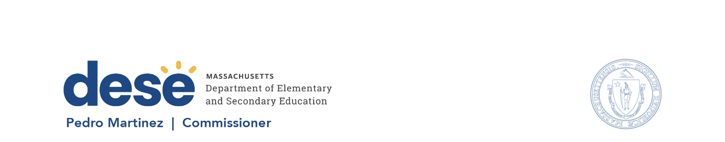

135 Santilli Hwy, Everett MA 02149 Voice: (781) 338-3000 TTY: 1-800-439-2370 www.doe.mass.edu

Memorandum
To: Members of the Board of Elementary and Secondary Education
From: Pedro Martinez, Commissioner
Date: October 15, 2026
Subject: Waiver of Reporting Date in Regulation Requiring Charter School Submission of Annual Audit by November 1

The charter school regulations, at 603 CMR 1.03(2),¹ allow the Board of Elementary and Secondary Education (Board) to waive provisions of the charter school regulations for good cause and under circumstances the Board deems exceptional. Due to a delay in the issuance of key guidance from the U.S. Office of Management and Budget (OMB) for a second year, audit firms are unable to complete the federal portion of a charter school financial audit. As a result, affected charter schools are unable to submit their annual financial audits by the regulatory deadline. Given these circumstances, I am asking the Board to waive the November 1 reporting date in 603 CMR 1.08(3) ² for any charter school unable to submit its annual financial audit by November 1.
Last year, at the October 28, 2025, Board meeting, due to the same delay in federal guidance, members unanimously approved a motion to waive the November 1 regulatory deadline for charter school annual financial audit submission. The affirmative vote, as well as the eventual release of federal guidance, supported all charter schools to submit their full annual financial audits by the January 1 statutory deadline. Similar to last year, I will report back to the Board on this procedural matter during the December 2026 meeting.
Background information follows; a motion is attached.
Background
The charter school regulations, 603 CMR 1.08(3), require charter schools to file an independent financial audit annually with the Department and the Office of the State Auditor by November 1. This regulation is consistent with the charter school statute, G.L c. 71, § 89, which requires the audit to be filed annually on or before January 1.³
Charter schools must submit independent financial audits in a form prescribed by the Office of the State Auditor. These audits typically consist of two components: the charter school’s audited financial statements for the prior fiscal year and, if applicable, a “Single Audit” of grants awarded by the U.S. Government as outlined by OMB’s Uniform Guidance. If a charter school spends $1,000,000 or more in federal grant funds in the prior fiscal year, a Single Audit must be performed in alignment with OMB’s guidance. Under 2 CFR § 200.512(c), the applicable federal regulation, the Single Audit must be submitted at the same time as the charter school’s independent financial audit to ensure comprehensive compliance and reporting.
As of early October, OMB has released draft guidance in an OMB 2026 Compliance Supplement (2026 Supplement) that contains significant revisions of the Single Audit requirements for fiscal year 2026 (FY26). OMB also stated that FY26 Single Audits may not be submitted until the final version of the 2026 Supplement is officially released. There is currently no definitive timeline for its issuance.

Proposed Waiver of Reporting Date in the Regulations
Due to the delay in the 2026 Supplement, affected charter schools will be unable to submit independent financial audits by November 1 as required by our state regulations. I recommend that the Board grant a waiver of the requirement in 603 CMR 1.08(3) for charter schools to submit an independent financial audit by November 1 for those charter schools that must also submit a Single Audit. The Department has contacted the Office of the State Auditor about this proposed action, and they raised no concerns about the proposed waiver of the reporting date in these circumstances.

With this waiver, all affected charter schools may submit their annual financial audit after November 1 but prior to January 1 (the statutory deadline). In the absence of a waiver, affected charter schools would be unable to meet the regulatory deadline. A motion for your consideration is attached.

If you have any questions regarding this matter or require additional information, please contact Lauren Woo, Deputy Commissioner, at Lauren.Woo@mass.gov, or me.

