Section 4. Appendices

Appendix A. Overview: Massachusetts EWIS (updated July 2022)

Introduction

The Massachusetts Early Warning Indicator System (EWIS) helps educators understand which of their students are at academic risk, and provides an entry point for the use of data in responding to student risk. EWIS is based on several years of research examining state data and identifying indicators that can most accurately predict the likelihood that a student will either achieve or miss important academic milestones. With early identification of students who are at risk, the EWIS allows educators to intervene and support struggling students to help them get back on track.

Background

The Massachusetts Department of Elementary and Secondary Education (ESE) created EWIS in response to district interest in the Early Warning Indicator Index which identified rising grade 9 students at risk of not graduating from high school. Districts were interested in understanding students who may be at risk in earlier grades and throughout high school. EWIS was created to identify students in grades 1–12 who are at risk of missing important and meaningful academic outcomes. In 2016, ESE added postsecondary milestones to EWIS to help educators understand whether high school students are on track to succeed in postsecondary education.

ESE collaborated with American Institutes for Research (AIR) to develop the initial EWIS statistical risk models for each grade level and age groups (e.g., early elementary school, late elementary school, middle school, and high school). Researchers used historical longitudinal data and rigorous statistical methods to create a valid EWIS model for each grade level from elementary through high school. Although there are some common indicators (e.g. attendance, suspension) across age groups and grade levels, the risk models vary by grade level. A team from ESE worked closely with AIR to determine the best models for each grade level, and an EWIS advisory group from ESE and other state agencies reviewed the research findings and discussed key decisions. ESE has continued to update the EWIS models annually.

Academic Milestones and Age Groups

For each grade level, academic milestones have been identified that are developmentally appropriate, available in state data, important to the success of Massachusetts students, and meaningful and actionable for adult educators working with students in each grade grouping. The intent is that milestones are scaffolded, with each outcome built on the success in the previous one.

Exhibit A-1 shows the age groups and the academic outcomes.

Exhibit A-1. Massachusetts EWIS Age Groups, Grade Levels, and Academic Milestones

The Massachusetts EWIS
 | Age Group | Grades | Academic Milestones: Expected student outcomes
K–12 | Early Elementary | 1, 2,3 | Reading by the end of third grade  Meeting or exceeding expectations on the 3rd grade ELA Massachusetts State Assessment
 | Late Elementary | 4, 5, 6 | Middle school ready  Meeting or exceeding expectations on 6th grade ELA and Mathematics State Assessments
 | Middle Grades | 7, 8, 9 | High school ready  Passing grades on all 9th grade courses
 | High School | 10, 11, 12 | High school graduation  Completing high school graduation requirements in four years
Postsecondary |  |  | College Enrollment  Enrolling in postsecondary education
College Persistence
Enrolling in a second year of postsecondary education

EWIS Risk Levels
Each student is assigned a risk level for each outcome: High, Moderate or Low risk. These risk levels reflect a student’s likelihood of missing an upcoming academic milestone, if no interventions are provided. For example, a student with low risk is likely to meet the milestone; a student with high risk is likely to miss the milestone. The risk level indicates whether a student is currently off track to reach the upcoming academic milestone.

The risk levels are calculated using data from the previous year and designed to inform supports for the next school year. A risk level is assigned to every student enrolled in a Massachusetts public school the prior year. Risk Levels are determined on an individual student basis, and take into account the cumulative impact of information about the student. There is not a set number of students for each risk level. For example, it is possible to have all students in the low-risk category.

Students enrolled in Massachusetts public schools the prior year, but without sufficient state data, and students new to Massachusetts public schools are given a risk level of Not Available (NA).

Exhibit A-2. Massachusetts EWIS Student Risk Levels

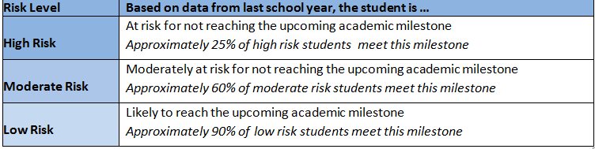Students in grades 10, 11 and 12 may have four risk levels, one for each academic milestone: high school graduation, college enrollment, and college persistence. For example, an 11th grade student may be at low risk of missing high school graduation; moderate risk of missing college enrollment; and high risk of missing academic readiness and college persistence. This means the student is likely to graduate from high school; and if additional support is not provided, is at some risk of not enrolling in college, and is unlikely to enroll in a second year of college.

Early warning systems cannot predict with 100 percent accuracy whether students will achieve academic outcomes. There will be false positives (students identified as at high risk who end up meeting the academic milestone, regardless of additional supports) and false negatives (students identified as low risk who fail to meet the upcoming milestones).

Data used to Create EWIS Risk Levels

ESE designed EWIS to rely solely on data available from existing statewide collections. The data come from several data sources: the Student Information Management System (SIMS), Student Course Schedule (SCS) and School Safety Discipline Report (SSDR) data collections, and assessment data from State Assessments and the Assessing Comprehension and Communication in English State-to-State for English Language Learners (ACCESS for ELLs). EWIS is validated and updated annually as more recent years of data becomes available and to account for changes in data sources.

Exhibits A-4 shows the indicators used for EWIS by grade levels.

Limitations and Uses for EWIS

EWIS was created to help educators understand which students in their schools are most in need of additional interventions to reach an upcoming academic milestone. With EWIS and a data inquiry cycle, educators can take action to improve students’ experiences. School impacts such as targeted student interventions can move a student from being off track, or high risk, to meeting an academic milestone. Research is clear that a variety of factors contribute to a student’s likelihood of achieving key academic outcomes.

EWIS is a starting point for identifying and supporting students at risk for not reaching an upcoming academic milestone. The EWIS risk level should never be the sole piece of data used for student planning; schools should use their local data and additional context – in conjunction with the EWIS Guide –to identify, diagnose, and support students. For more on the Early Warning Implementation Cycle, see the on-demand e-learning tutorial on the EWIS website.

For more detailed information on EWIS development, refer to ESE’s EWIS Risk Model Development
reports, also on the EWIS website.

Exhibit A-4. Overview of Indicators used in EWIS Modeling, by Grade Level and Milestones

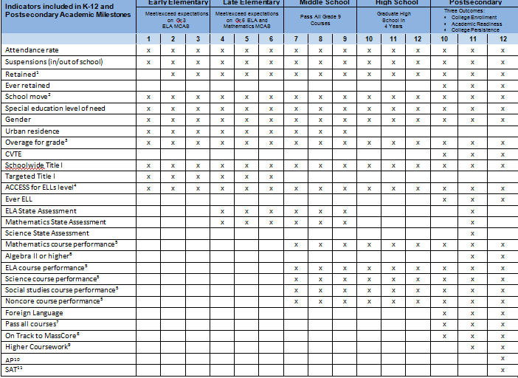

115

Section 4: Appendices

Exhibit A-4. Overview of Indicators used in EWIS Modeling, by Grade Level and Milestones Footnotes
- Retained students are automatically assigned as high risk in the High School model because they are unlikely to graduate on-time. Retained is a student identified as the same grade the prior fall as the fall before.
- School move captures if a student attended more than one school during the prior school year.
It does not capture mobility between school years.
- Overage for Early Elementary, Late Elementary and Middle School models is defined as one year older than the expected age for each grade level. For High School & Postsecondary models, overage is defined as students two or more years older than expected grade level.
- ACCESS for ELL Levels was introduced in 2012-13; prior to that year MEPA was used.
- In the high school models, ELA, Mathematics, Science, Social Studies and Non Core Course performance in the High School refer to whether a passed all courses in that subject area, failed any courses in the subject, did not complete a course in that subject area (or in some instances, No Performance Data Available).
In the Postsecondary model, in addition to the course performance noted above, the extent of course passing is captured with additional indicators, ELA Passing, Mathematics Passing, Social Studies Passing and Science Passing. These describe whether a student earned a B or higher for a year or more of a course; C or higher for a year or more of a course; Passed a year or more of a course; and Pass for less than a year of a course.
- Algebra II or higher is defined as taking Algebra II, the equivalent of Algebra II or a course more advanced than Algebra II.
- Pass all courses means that a student has passed all completed courses (core, non-core and others). 8.Higher Coursework is defined as students taking Advanced Placement, IB or Dual Enrollment.
- On Track to MassCore reflects students’ course-taking progress along the Massachusetts recommended program of study. We examine full-year equivalents (FYE) of courses that as student has passed, reflected in the Student Course Schedule data available. For more information on MassCore, see our MassCore website.
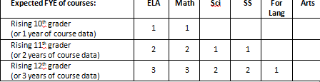
- AP refers to students taking the AP test.
- SAT refers to students taking the SAT by the end of 11th grade; this field is either Not Taken, Taken
– College Ready, or Taken – Not College Ready (using the college and career ready benchmark, 480 in ERW and 530 in math).

116

