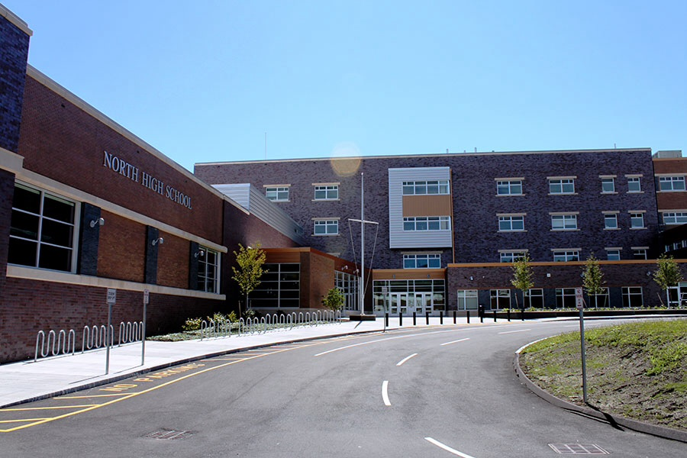

Worcester’s North High school MassGrad Coalition Case Study
A brief look at the coalition’s key activities, evolution and framework, lessons learned, impact, and future outlook of the Worcester Coalition at North High School and its strategies to improve graduation rates for English language Learners (ELLs).

Worcester’s North High school MassGrad Coalition Case Study
  - Coalition Partners
African Community Education (ACE)
Department of Public Health
Health Options for Prevention and Education (HOPE) Coalition
Latino Education Institute (LEI)
North High Young Alumni
Plumley Village
Worcester Community Connection Coalition (WCCC)
Worcester Public Schools
Youth Opportunities Upheld Inc. (Y.O.U. Inc.)

Through the MassGrad Initiative, funded through the federal High School Graduation Initiative, the Massachusetts Department of Elementary and Secondary Education (ESE) awarded four competitive awards in 2012 throughout the state to help ignite school-community coalitions. These four MassGrad Coalition Challenge Awards required recipients to focus on a specific topic area related to dropout reduction and improving graduation rates that warranted a school-community partnership response.

Worcester Public Schools received a MassGrad Coalition Challenge Award to focus on North High School and the needs of English language learners (ELLs) in order to support an increased ELL graduation rate.

This case study describes: the core coalition activities, the key steps and decisions, how the coalition works, the coalition’s impact, and lessons learned from the first three years of implementation (2012-13 school year through the 2014-15 school year). The case study ends with the future outlook of the coalition and some questions to consider based on the experiences of North High School.

Overview of Core Activities
- Implemented a collaborative case management model on individual cases of students at-risk of not graduating (without using student names), resulting in new insights about perspectives of various partners and how their expertise could further support the efforts at the school
- Conducted a needs assessment based on student data and on information gained in the collaborative case discussions
- Identified restorative justice as a mutual training need and implemented restorative justice professional development jointly for school administrators, school staff, students, and coalition members
- Participated in two shared book reads – Teaching with Poverty in Mind and Blindspot: Hidden Biases of Good People
- Collaboratively planned and facilitated within and beyond school day supports, including conflict resolution groups, theatre, mentoring, and trauma-sensitive yoga
- Facilitated a “World Café” model to gain the voices of parents and guardians around a key issue at the school
- Hosted Parent Leadership workshops
- Participated in statewide professional development opportunities jointly, e.g., ESE webinar on the discipline law and the Dropout Prevention and Reengagement Work Group

Key Steps & Decisions
Year 1
- In the first year, the ELL Coalition at North High School started with school members and only two community partners, the Latino Education Institute (LEI) and African Community Education (ACE)
- Coalition members started to gather and analyze data on ELLs; the coalition conversations and planning were based on a shared understanding of the data on ELL students at the school
- Hosted an assembly for ELL students with North High ELL graduates as presenters
- Started asset mapping based on the mission of each partner

Year 2
- In year 2 the Coalition facilitators focused on “getting partners on the right seats on the bus traveling toward the same destination”
- This was accomplished through 1) clarifying the purpose of the coalition and ensuring that the coalition was aligned with school and district goals and activities
- Based on this clarified purpose of the coalition, district leaders were then able to strategically extend personal invitations to additional community partners to ensure the most appropriate organizations were at the table and that the partners understood the shared purpose of the coalition
- Facilitated the Collaborative Case Consultancy Model to explore supportive and protective factors – gained insights about perspectives of various partners and how their expertise could further support the efforts at the school – helped all participants think differently about existing challenges and possible solutions
- Conducted needs assessment based on student data and on information gained in the Collaborative Case discussions
- Articulated shared goals for the coalition work
- Continued asset mapping of community resources
- Identified Restorative Justice training and building cultural competency as a need for school staff and coalition members
- Ended the year with coalition partners participating in Restorative Justice training with school staff and student leaders

Year 3
- Additional Restorative Justice training specifically focused on 9th grade teams
- Implemented restorative circles to mediate conflicts – resulting in reduced office referral and reduced suspensions at the 9th grade level
- Utilized the “restorative circle” approach to facilitate student discourse to promote social-emotional and academic growth – support students as active agents in their own development
- Participated in a shared book read – Teaching with Poverty in Mind
- Partners collaboratively planned and facilitated within and beyond school day supports – conflict resolution groups; theatre, mentoring, trauma-sensitive yoga
- Partners came together to facilitate a “World Café” model to gain the voices of parents and guardians around a key issue at the school
- Hosted Parent Leadership workshops
- By the third year of operation new community partners asked to join the coalition based on word of mouth on the benefits of the coalition

How the Coalition Works
- Worcester Public Schools’ central office administrators were instrumental in facilitating and growing the coalition – the school benefited from central office support throughout the first three years
- Ad hoc meetings occur based on conversations started at coalition meetings in order to strategize and implement particular aspects of the work
- The full coalition meets together monthly at North High School, and members reported appreciation for meeting at the school that is the focus of the coalition
- Agenda is set by the school and district, based on what was discussed at the previous coalition meeting, agendas included collaborative case discussions, planning for new activities, and sharing relevant news

Lessons Learned
- Joint professional development is possible and can be mutually beneficial to all partners
- Supporting high school level students more holistically through the coalition also has the potential to impact younger students and whole families
- Need to continually work on alignment to ensure coalition activities are aligned with school, district, and partner goals
- Collaborative case management can be a powerful tool to hear different perspectives and think more broadly about student needs and solutions
- Strategic outreach to potential partners based on the purpose of the coalition resulted in the “right” partners around the table

Impact
- North High’s ELL 4-year cohort graduation rate increased from 50% in 2011 to 73.2% in 2014
- Full implementation of Restorative Justice at grade 9 significantly reduced suspensions
- Coalition activities have resulted in staff and partners being increasingly open to learning together on topics of mutual interest
- New partners asked to join the coalition based on word of mouth on the benefits of the coalition
- Coalition meetings have resulted in increased ad hoc meetings between partners to plan additional partnership activities in support of North High students
- The collaborative case management activity to discuss the needs of at-risk ELL students helped all participants think differently about existing challenges and possible solutions
- Coalition member quotes:

“Through participation in the coalition I was able to become a part of the North High Community. During the Restorative Justice training I not only gained knowledge that I use in my own work, but I was also able to build relationships with North High staff and students. When coalition members came together to plan the family meeting we were all active participants in shaping the meeting. It provided me with an opportunity to see the unique perspectives of the various coalition members and the family meeting allowed me to learn from parents about their hopes and concerns.” Sarah Belisea, WCCC

“As a member of the ELL coalition, I have been highly impressed by the level of collaboration between community providers and the Worcester Public Schools. The coalition leadership has been able to successfully mobilize community members to address serious issues impacting the North High School’s culture and the student’s capacity to maximize their learning opportunities.” Judi Rock, Y.O.U., Inc.

“Participation in the MassGrad Coalition at North High School has been essential to my work and, most importantly, for our students and families. I am a trusted, familiar face to administration, counselors, and staff at North High. I am better able to support individual students by checking in with them about their academic and social progress, encouraging them to take MCAS Prep and be involved in other after school activities, arranging school meetings, connecting WPS with language interpreters, and transporting parents.

MassGrad Coalition has a multiplier effect for ACE. We were invited to participate in Restorative Justice and Trauma Sensitive Yoga trainings, which we then integrated into ACE. Through our Collaborative Casework, I have learned how different people of the school and district work together and how fellow community partners work with schools. I bring this back to ACE to inform and train my colleagues. With greater knowledge of DESE and WPS policies and requirements, I can better support students and families who attend over eleven other schools across the city. We can then plan programs that align because we share a mission to create culturally competent and supportive schools for ELLs where they graduate prepared for success after high school.” Frank Murphy, ACE

Future Outlook
The North High ELL Coalition plans to continue after the MassGrad funding ends and is focused on the following to continually sustain and enhance the coalition’s work:
- Deepen partnership with current members and expand the Coalition’s membership
- Transition facilitation of the meetings from Worcester central office staff to the North High School and community partners
- Increase co-construction of meeting agendas to reflect school and community partners’ ideas
- Increase communication with all partners (e.g., meeting notes)
- Align and combine funding and collaborate on grant writing
- Continue collaborative case management model
- Scale up the Restorative Justice model
- Access a train the trainer model for joint professional development on cultural competency
- Adjust the Coalition meeting schedule to better meet partners’ needs
- Expand tiered supports for students based on partners’ resources

  - Case Study Questions
- The Worcester North High ELL Coalition started with a small group of core community partners, and increased the Coalition members each year by strategically reaching out to new partners that are a good fit for the coalition based on the coalition’s purpose and the interests and missions of the community partners. As you begin or expand a coalition, what will outreach to potential partners look like? In your community is it better to start small and slowly grow, or to invite everyone to the table initially and then allow organizations to opt in or out? What key messages about your coalition’s purpose are important to share with potential partners at the onset?

- One of the key accomplishments of the Worcester coalition to date is the development of several joint (school and community) professional development activities (e.g., training on restorative justice and book reads). What opportunities are there for joint professional development in your community?

