

Labor Market Analysis of Skills Related to Advanced Manufacturing in Massachusetts

## Overview

This analysis uses labor market data from the Massachusetts Department of Economic Research to provide perspective on two theaters related to Advanced Manufacturing: the manufacturing industry and the occupations in the production career pathway.

The industry should be understood as the employers in the Commonwealth who are primarily engaged in the mechanical, physical, or chemical transformation of materials, substances, or components into new products. Those companies employ a spectrum of occupations, ranging from machinists and technicians to account managers and lawyers.

In public data systems, occupations are a set of tasks regularly performed by one individual on an employer’s payroll. In this analysis, occupations related to Advanced Manufacturingare profiled in a career pathway framework as we seek to provide strategic value in the development and administration of Advanced Manufacturing curriculum and the construction of compelling and instructive narrative that will introduce students to the world of 21st Century manufacturing.

## The Manufacturing Industry

### The Manufacturing Industry in Labor Market Data Systems

Definitions of the terms in public labor market systems and the impact of emerging technologies create a challenge in providing perspective on the “advanced manufacturing” sector. The federal government’s Advanced Manufacturing National Program Office defines advanced manufacturing as “use of innovative technologies to create existing products and the creation of new products.” In this excerpt from manufacturing.gov, it clarifies that “advanced manufacturing can include production activities that depend on information, automation, computation, software, sensing, and networking.” By this definition, advanced manufacturing principles can be applied to the manufacture of almost any type of good, meaning that advanced manufacturing is more appropriately considered as a technology or a process within the manufacturing industry rather than as a separate type of business.

Manufacturing (NAICS code 31-33) comprises all employers whose primary line of business is the mechanical, physical, or chemical transformation of materials, substances, or components into new products. The industry category is divided into twenty-one sub-industries:

* 311 Food Manufacturing
* 312 Beverage and Tobacco Product Manufacturing
* 313 Textile Mills
* 314 Textile Product Mills
* 315 Apparel Manufacturing
* 316 Leather and Allied Product Manufacturing
* 321 Wood Product Manufacturing
* 322 Paper Manufacturing
* 323 Printing and Related Support Activities
* 324 Petroleum and Coal Products Manufacturing
* 325 Chemical Manufacturing
* 326 Plastics and Rubber Products Manufacturing
* 327 Nonmetallic Mineral Product Manufacturing
* 331 Primary Metal Manufacturing
* 332 Fabricated Metal Product Manufacturing
* 333 Machinery Manufacturing
* 334 Computer and Electronic Product Manufacturing
* 335 Electrical Equipment, Appliance, and Component Manufacturing
* 336 Transportation Equipment Manufacturing
* 337 Furniture and Related Product Manufacturing
* 339 Miscellaneous Manufacturing

Each of these categories is further parsed into four-, five-, and ultimately six-digit level categories, and the Massachusetts Department of Economic Research produces employment and wage estimates for each.

## Construction Industry Categories

* 31
  + 311 Food Manufacturing
  + 312 Beverage and Tobacco Product Manufacturing
  + 313 Textile Mills
  + 314 Textile Product Mills
  + 315 Apparel Manufacturing
  + 316 Leather and Allied Product Manufacturing
* 32
  + 321 Wood Product Manufacturing
  + 322 Paper Manufacturing
  + 323 Printing and Related Support Activities
  + 324 Petroleum and Coal Products Manufacturing
  + 325 Chemical Manufacturing
  + 326 Plastics and Rubber Products Manufacturing
  + 327 Nonmetallic Mineral Product Manufacturing
* 33 Metal Manufacturing
  + 331 Primary Metal Manufacturing
  + 332 Fabricated Metal Product Manufacturing
  + 333 Machinery Manufacturing
  + 334 Computer and Electronic Product Manufacturing
  + 335 Electrical Equipment, Appliance, and Component Manufacturing
  + 336 Transportation Equipment Manufacturing
  + 337 Furniture and Related Product Manufacturing
  + 339 Miscellaneous Manufacturing

## Employment-Carpenters and Carpenter Helpers

More than 150,000 people in Massachusetts are employed in Production Occupations (51-0000) like Machinists (51-4041), Electromechanical Assemblers (SOC 51-2028), and Welders (51-4121). It is not surprising that more than two thirds of total employment in production occupations is found in the Manufacturing industry. At a more detailed level, we find that 11.6% of total employment in these occupations is found in the Fabricated Metal Product Manufacturing (332) sector. Another 10% work for Computer and Electronic Product Manufacturers (334). Food manufacturing (311), Administrative and Support Services (561), and Machinery Manufacturing (333) round out the top five.

Among non-manufacturing industries, Temporary Help Services (56132), Supermarkets (44511), and Local Government (90399) are the largest employers of Production Occupations, together accounting for more than one in nine jobs among Production Occupations.

### Table 1: Top Detailed Industries for Production Occupations

|  |  |
| --- | --- |
| Industry | Share of Occupation Jobs |
| Temporary Help Services | 7.0% |
| Navigational, Measuring, Electromedical, and Control Instruments Manufacturing | 4.5% |
| Semiconductor and Other Electronic Component Manufacturing | 3.9% |
| Machine Shops | 3.8% |
| Bread and Bakery Product Manufacturing | 3.3% |

## Employment Trends

The number of people employed in the Manufacturing industry in Massachusetts was remarkably steady from 2015 to 2019, but the COVID-19 pandemic appears to have had a significant impact on the size of the industry with a one-year decrease of approximately 6%. As of the second quarter of 2023, employment in the industry has yet to return to pre-pandemic levels. The net change has been a decrease of 3.8% in jobs over the last decade.

### Table 2: Average Annual Employment, Manufacturing Industry, Massachusetts, 2014-2023

|  |  |
| --- | --- |
| **Year** | **Jobs** |
| 2014 | 250,300 |
| 2015 | 249,084 |
| 2016 | 245,759 |
| 2017 | 244,647 |
| 2018 | 245,091 |
| 2019 | 244,258 |
| 2020 | 229,741 |
| 2021 | 232,786 |
| 2022 | 238,513 |
| 2023 | 240,781 |

Line chart, Total Employment, Manufacturing, Massachusetts, 2014-2023


When we break down the growth of the Manufacturing industry, we see that the largest growth of employment has been in the Breweries sector (NAICS 31212), which has added more than 2,800 jobs over that span. Growth as a percentage of total employment has also been fastest in the Breweries sector (436%).

### Table 3: Employment Change, Manufacturing Industries, Massachusetts, 2014-2023

|  |  |  |  |  |  |  |  |
| --- | --- | --- | --- | --- | --- | --- | --- |
| Industry | 2014 | 2018 | 2019 | 2020 | 2021 | 2022 | 2023 |
| Breweries | 647 | 985 | 1,339 | 1,651 | 2,199 | 2,705 | 2,226 |
| Navigational, Measuring, Electromedical, and Control Instruments Manufacturing | 24,754 | 24,735 | 24,871 | 24,364 | 25,200 | 25,538 | 25,623 |
| Industrial Machinery Manufacturing | 4,111 | 3,998 | 3,945 | 4,258 | 4,382 | 4,363 | 4,157 |
| Seafood Product Preparation and Packaging | 2,251 | 2,292 | 2,286 | 2,226 | 2,457 | 2,780 | 2,835 |

|  |  |  |
| --- | --- | --- |
| Industry | 2014-2023 Change | 2014-2023 % Change |
| Breweries | 2,821 | 436% |
| Navigational, Measuring, Electromedical, and Control Instruments Manufacturing | 2,372 | 10% |
| Industrial Machinery Manufacturing | 1,694 | 41% |
| Seafood Product Preparation and Packaging | 1,392 | 62% |

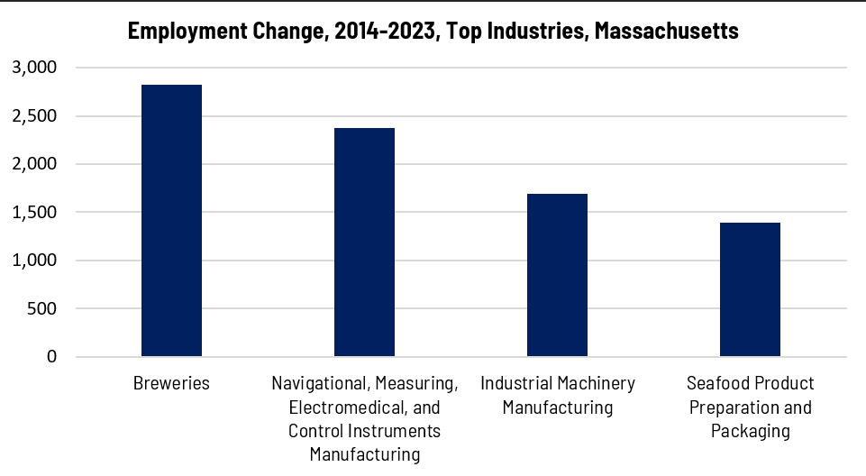

## Wages, Salaries and Proprietor Earnings

Among the detailed industry categories, the highest wages are found among the Computer and Peripheral Equipment employers. Audio and Video Equipment Manufacturing ranks third for average wages, although the total number of workers in that sector is relatively low. The lowest wages are in Bread and Bakery Products Manufacturing.

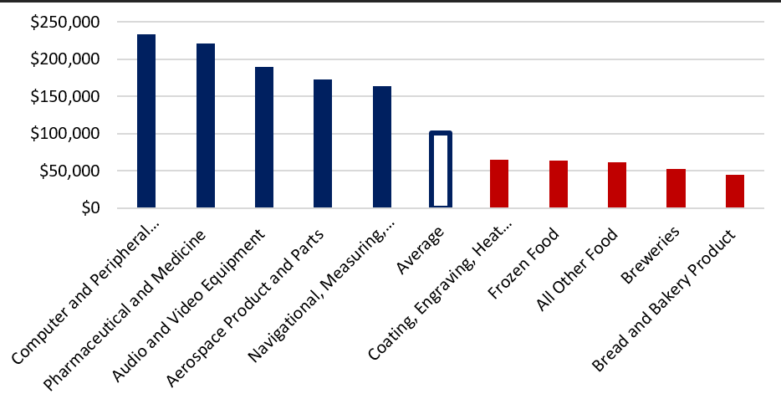

## The Pathways

### Advanced Manufacturing Technology Occupations and Pathways

This section looks at three target occupation categories: Computer Numerically Controlled Tool Operators, Machinists and Lathe and Turning Machine Tool Operators and Setters. It will also consider advancement opportunities in related careers that are not directly related to the program of study, but that illustrate opportunities that may be available to workers in these occupations with additional education and experience.

#### Table 4: Carpentry Occupations, Massachusetts

|  |  |  |  |  |  |
| --- | --- | --- | --- | --- | --- |
| Occupation | 2023 Jobs | Turnover Rate | 2014 - 2023 Change | 2014 - 2023 % Change | Median Annual Earnings |
| Lathe and Turning Machine Tool Setters, Operators, and Tenders, Metal and Plastic | 305 | 48.3% | (859) | (73.8%) | $50,294 |
| Machinists | 6,766 | 38.4% | (1,148) | (14.5%) | $55,994 |
| Computer Numerically Controlled Tool Operators | 3,349 | 37.7% | 711 | 27.0% | $50,669 |

While careers in these two occupations are certainly viable in their own rights, they also can serve as entry points to progressively more sophisticated and better-paying roles.

#### Tables 5 and 6: Pathway Related Careers

##### Job Zone Two Occupations

|  |  |  |  |
| --- | --- | --- | --- |
| Occupation | 2023 Jobs | Typical Education Requirement | Median Annual Earnings |
| Computer Numerically Controlled Tool Operators | 3,349 | High school | 50,669 |
| Lathe and Turning Machine Tool Setters, Operators, and Tenders, Metal and Plastic | 305 | High school | $50,294 |
| Welding, Soldering, and Brazing Machine Setters, Operators, and Tenders | 671 | High school | $48,755 |
| Milling and Planing Machine Setters, Operators, and Tenders, Metal and Plastic | 280 | High school | $45,906 |
| Grinding, Lapping, Polishing, and Buffing Machine Tool Setters, Operators, and Tenders, Metal and Plastic | 1,848 | High school | $43,493 |
| Drilling and Boring Machine Tool Setters, Operators, and Tenders, Metal and Plastic | 73 | High school | $66,498 |
| Cutting, Punching, and Press Machine Setters, Operators, and Tenders, Metal and Plastic | 2,159 | High school | $43,347 |
| Rolling Machine Setters, Operators, and Tenders, Metal and Plastic | 417 | High school | $45,469 |
| Forging Machine Setters, Operators, and Tenders, Metal and Plastic | 94 | High school | $46,114 |
| Extruding and Drawing Machine Setters, Operators, and Tenders, Metal and Plastic | 1,755 | High school | $37,523 |

##### Job Zone Three Occupations

|  |  |  |  |
| --- | --- | --- | --- |
| Occupation | 2023 Jobs | Typical Education Requirement | Median Annual Earnings |
| Tool and Die Makers | 1,214 | Nondegree Award | $66,269 |
| Machinists | 6,766 | High school | $55,994 |

### Occupation Profile

The United States Department of Labor, Employment and Training Administration created and regularly updates more than 800 occupational profiles with characteristics like skills, educational requirements, and daily tasks, based on the inputs of industry experts and people who are employed in the occupations.

#### Computer Numerically Controlled Tool Operators

##### Top Skills

* Watching gauges, dials, or other indicators to make sure a machine is working properly.
* Controlling operations of equipment or systems.
* Using logic and reasoning to identify the strengths and weaknesses of alternative solutions, conclusions, or approaches to problems.
* Monitoring/Assessing performance of yourself, other individuals, or organizations to make improvements or take corrective action.
* Conducting tests and inspections of products, services, or processes to evaluate quality or performance.
* Giving full attention to what other people are saying, taking time to understand the points being made, asking questions as appropriate, and not interrupting at inappropriate times.
* Identifying complex problems and reviewing related information to develop and evaluate options and implement solutions.
* Determining causes of operating errors and deciding what to do about it.
* Talking to others to convey information effectively.
* Performing routine maintenance on equipment and determining when and what kind of maintenance is needed.
* Repairing machines or systems using the needed tools.
* Considering the relative costs and benefits of potential actions to choose the most appropriate one.

##### Top Daily Tasks

* Program equipment to perform production tasks.
* Install mechanical components in production equipment.
* Mount attachments or tools onto production equipment.
* Mount materials or workpieces onto production equipment.
* Study blueprints or other instructions to determine equipment setup requirements.
* Enter commands, instructions, or specifications into equipment.
* Calculate specific material, equipment, or labor requirements for production.
* Remove products or workpieces from production equipment.
* Watch operating equipment to detect malfunctions.
* Replace worn equipment components.
* Remove accessories, tools, or other parts from equipment.
* Monitor lubrication of equipment or workpieces.
* Adjust equipment controls to regulate flow of production materials or products.
* Monitor equipment operation to ensure proper functioning.
* Set equipment controls to meet cutting specifications.

##### Additional Information

* Association for Manufacturing Technology
* Fabricators & Manufacturers Association International
* International Association of Sheet Metal, Air, Rail and Transportation Workers
* National Institute for Metalworking Skills
* National Tooling and Machining Association
* Occupational Outlook Handbook: Metal and plastic machine workers
* Precision Machined Products Association
* Precision Metalforming Association

#### Machinist

##### Top Skills

* Controlling operations of equipment or systems.
* Using logic and reasoning to identify the strengths and weaknesses of alternative solutions, conclusions, or approaches to problems.
* Monitoring/Assessing performance of yourself, other individuals, or organizations to make improvements or take corrective action.
* Watching gauges, dials, or other indicators to make sure a machine is working properly.
* Giving full attention to what other people are saying, taking time to understand the points being made, asking questions as appropriate, and not interrupting at inappropriate times.
* Talking to others to convey information effectively.
* Adjusting actions in relation to others' actions.
* Identifying complex problems and reviewing related information to develop and evaluate options and implement solutions.
* Determining causes of operating errors and deciding what to do about it.
* Conducting tests and inspections of products, services, or processes to evaluate quality or performance.
* Understanding written sentences and paragraphs in work-related documents.
* Using mathematics to solve problems.
* Being aware of others' reactions and understanding why they react as they do.
* Performing routine maintenance on equipment and determining when and what kind of maintenance is needed.
* Repairing machines or systems using the needed tools.

##### Top Daily Tasks

* Calculate dimensions of workpieces, products, or equipment.
* Operate cutting equipment.
* Operate grinding equipment.
* Operate metal or plastic forming equipment.
* Program equipment to perform production tasks.
* Monitor equipment operation to ensure proper functioning.
* Review blueprints or other instructions to determine operational methods or sequences.
* Maintain production or processing equipment.
* Assemble machine tools, parts, or fixtures.
* Determine metal or plastic production methods.
* Prepare fabrics or materials for processing or production.
* Mount attachments or tools onto production equipment.
* Conduct test runs of production equipment.
* Exchange information with colleagues.
* Advise others on ways to improve processes or products.

##### Additional Information

* American Mold Builders Association
* Association for Manufacturing Technology
* Fabricators & Manufacturers Association International
* International Association of Machinists and Aerospace Workers
* International Union, United Automobile, Aerospace and Agricultural Implement Workers of America
* Manufacturing Institute
* National Institute for Metalworking Skills
* National Tooling and Machining Association
* Occupational Outlook Handbook: Machinists and tool and die makers
* Precision Machined Products Association

#### Lathe and Turning Machine Tool Setters, Operators, and Tenders, Metal and Plastic

##### Top Skills

* Watching gauges, dials, or other indicators to make sure a machine is working properly.
* Controlling operations of equipment or systems.
* Monitoring/Assessing performance of yourself, other individuals, or organizations to make improvements or take corrective action.
* Conducting tests and inspections of products, services, or processes to evaluate quality or performance.
* Understanding written sentences and paragraphs in work-related documents.
* Giving full attention to what other people are saying, taking time to understand the points being made, asking questions as appropriate, and not interrupting at inappropriate times.
* Talking to others to convey information effectively.
* Using logic and reasoning to identify the strengths and weaknesses of alternative solutions, conclusions, or approaches to problems.
* Adjusting actions in relation to others' actions.
* Determining causes of operating errors and deciding what to do about it.
* Managing one's own time and the time of others.
* Identifying complex problems and reviewing related information to develop and evaluate options and implement solutions.
* Considering the relative costs and benefits of potential actions to choose the most appropriate one.
* Being aware of others' reactions and understanding why they react as they do.
* Determining the kind of tools and equipment needed to do a job.

##### Top Daily Tasks

* Operate metal or plastic forming equipment.
* Operate grinding equipment.
* Replace worn equipment components.
* Sharpen cutting or grinding tools.
* Measure dimensions of completed products or workpieces to verify conformance to specifications.
* Monitor equipment operation to ensure that products are not flawed.
* Operate cutting equipment.
* Mount attachments or tools onto production equipment.
* Conduct test runs of production equipment.
* Read work orders or other instructions to determine product specifications or materials requirements.
* Review blueprints or other instructions to determine operational methods or sequences.
* Select production equipment according to product specifications.
* Set equipment controls to meet cutting specifications.
* Install mechanical components in production equipment.
* Perform basic equipment maintenance.

##### Additional Information

* Association for Manufacturing Technology
* Fabricators & Manufacturers Association International
* National Institute for Metalworking Skills
* National Tooling and Machining Association
* Occupational Outlook Handbook: Metal and plastic machine workers
* Precision Machined Products Association
* Precision Metalforming Association

#### Job Postings-Computer Numerically Controlled Tool Operators

P2C uses a third-party system that aggregates data from job postings to provide perspective on the skills and qualifications employers are prioritizing in their advertisements for these occupations.

* After controlling for multiple postings that likely referenced the same single opening, over the last year, we identified 697 unique job postings for Numerically Controlled Tool Operators in Massachusetts.
* We identified 235 unique employers who posted openings online.

##### Top Employers Advertising:

* Randstad
* Aerotek
* Pace Industries
* Kelly Services
* CoorsTek
* Ipg Photonics
* Reliable Temps
* Coworx Staffing
* Morgan Advanced Materials
* Adecco

##### Top Job Titles:

* CNC Operators
* Machine Operators
* CNC Machine Operators
* CNC Set Up Operators
* CNC Lathe Operators
* CNC Mill Operators
* CNC Set Up Machinists
* CNC Milling Machinists
* CNC Swiss Machinists
* Equipment Engineers
* CNC Technicians
* CNC Operators/Machinists

1. Security Clearance

* CNC Machining Certification
* Valid Driver's License
* MA Class 3A Hoisting License
* Forklift Certification
* Certified Safety Professional
* OSHA Certification
* Secret Clearance

##### Top Skills:

* Computer Numeric Control
* Machining
* Machine Operation
* CNC Machining
* Machinery

#### Job Postings-Machinists

P2C uses a third-party system that aggregates data from job postings to provide perspective on the skills and qualifications employers are prioritizing in their advertisements for these occupations.

* After controlling for multiple postings that likely referenced the same single opening, over the last year, we identified 1,155 unique job postings for Numerically Controlled Tool Operators in Massachusetts.
* We identified 287 unique employers who posted openings online.

##### Top Employers Advertising:

* Waters
* Tecomet
* Aerotek
* Randstad
* Kelly Services
* Materion
* Rolls-Royce
* Smith & Nephew
* Saint-Gobain
* Harvard University
* Siemens
* Amtrak

##### Top Job Titles:

* CNC Machinists
* Machinists
* CNC Milling Machinists
* Production Machinists
* Lead CNC Machinists
* CNC Lathe Machinists
* Aerospace Machinists
* Experimental Machinists
* Manual Machinists
* CNC Mill Machinists

##### Top Qualifications:

* Security Clearance
* Valid Driver's License
* Secret Clearance
* Forklift Certification
* Solidworks Certification
* 10-Hour OSHA General Industry Card
* Commercial Driver's License (CDL)
* Registered Nurse (RN)
* Hoisting License
* Security Identification Display Area (SIDA) Badge
* Operator Certification
* National Apprenticeship Certificate
* Top Secret-Sensitive Compartmented Information (TS/SCI Clearance)

##### Top Skills:

* Machining
* Lathes
* Tools
* Computer Numeric Control
* Milling