Labor Market Analysis of Skills Related to Automotive Technician in Massachusetts

**October 2023**

## Table of Contents­­

Table of Contents 1

Overview 2

The Automotive Repair and Maintenance Industry 2

The Automotive Repair and Maintenance Industry in Labor Market Data Systems 2

Employment – Vehicle and Mobile Equipment Mechanics, Installers, and Repairers 3

Employment Trends 4

Wages, Salaries and Proprietor Earnings 8

The Pathways 9

Auto Collision Occupations and Pathways 9

Occupation Profile 11

Automotive Service Technicians and Mechanics 11

## Overview

This analysis uses labor market data from the Massachusetts Department of Economic Research to provide perspective on two theaters related to Auto Repair: the Automotive Repair and Maintenance (NAICS 8111) industry and key occupations in the Vehicle Mechanics, Installers, and Repairers career pathway.

The industry should be understood as the employers in the Commonwealth who are primarily engaged in providing repair and maintenance services for automotive vehicles, such as passenger cars, trucks, and vans, and all trailers. Establishments in this industry group employ mechanics with specialized technical skills to diagnose and repair the mechanical and electrical systems for automotive vehicles, repair automotive interiors, and paint or repair automotive exteriors.

In public data systems, occupations are a set of tasks regularly performed by one individual on an employer’s payroll. In this analysis, occupations related to Auto Repairare profiled in a career pathway framework as we seek to provide strategic value in the development and administration of Auto Repair curriculum and the construction of compelling and instructive narrative that will introduce students to the world of 21st Century Automotive Repair Technology.

## The Automotive Repair and Maintenance Industry

### The Automotive Repair and Maintenance Industry in Labor Market Data Systems

In public labor market data systems, the Automotive Repair and Maintenance Industry (NAICS 811) is a component of the Other (NAICS 81) sector. It comprises all the employers whose primary line of business is providing repair and maintenance services for automotive vehicles, such as passenger cars, trucks, and vans, and all trailers. This industry is the largest employer of the occupations targeted by this program of study. The category is then further parsed into four-, five-, and ultimately six-digit level categories, and the Massachusetts Department of Economic Research produces employment and wage estimates for each.

#### Other Industry Categories

* 81 Other Services
  + 811 Repair and Maintenance
    - 8111 Automotive Repair and Maintenance
      * 81111 Automotive, Mechanical, and Electrical Repair and Maintenance
        + 811111 General Automotive Repair
        + 811114 Specialized Auto Repair
      * 81112 Automotive Body, Paint, Interior and Glass Repair
        + 811121 Automotive Body, Paint and Interior Repair and Maintenance
        + 811122 Automotive Glass Replacement Shops
      * 81119 Other Automotive Repair and Maintenance
        + 811191 Automotive Oil Change and Lubrication Shops
        + 811192 Car Washes
        + 811198 All Other Automotive Repair and Maintenance
    - 8112 Electronic and Precision Equipment Repair and Maintenance
    - 8113 Commercial and Industrial Machinery and Equipment Repair and Maintenance
    - 8114 Personal and Household Goods Repair and Maintenance
  + 812 Personal and Laundry Services
  + 813 Religious, Grantmaking, Civic, Professional and Similar Organizations
  + 814 Private Households

### Employment – Vehicle and Mobile Equipment Mechanics, Installers, and Repairers

More than 29,000 people in Massachusetts are employed in Vehicle and Mobile Equipment Mechanics, Installers and Repairers Occupations (49-3000), including Automotive Body and Related Repairers (SOC 49-3021) and Automotive Service Technicians and Mechanics (SOC 49-3023). It is not surprising that more than 40% of total employment in these occupations is found in the Automotive Repair and Maintenance industry. Another third are employed by Automobile Dealers.

Automotive Parts Retailers and Wholesalers and state and local government organizations also employ notable numbers of workers within these occupation categories.

#### Table 1: Top Detailed Industries for Target Occupations

|  |  |
| --- | --- |
| Industry | Share of Occupation Jobs |
| Automotive Repair and Maintenance | 43.9% |
| Automobile Dealers | 33.5% |
| Automotive Parts, Accessories, and Tire Retailers | 5.6% |
| Local Government | 1.7% |
| State Government | 1.5% |
| Motor Vehicle and Motor Vehicle Parts and Supplies Merchant Wholesalers | 1.4% |

### Employment Trends

More than 19,000 people are employed at 3,931 payrolled locations in the Automotive Repair and Maintenance industry (NAICS 8111) in Massachusetts. Employment in this sector had been on a significant upward trend prior to the COVID-19 pandemic when it shed more than 2,000 jobs (13.3% of all jobs) between 2019 and 2020. As of the second quarter of 2023, employment is approaching pre-pandemic levels, but remains slightly lower.

#### Table 2: Average Annual Employment, Automotive Repair/Maintenance Industry, Massachusetts, 2014-2023

|  |  |
| --- | --- |
| Year | Jobs |
| 2014 | 18,319 |
| 2015 | 18,963 |
| 2016 | 19,406 |
| 2017 | 19,221 |
| 2018 | 19,471 |
| 2019 | 19,561 |
| 2020 | 17,269 |
| 2021 | 18,092 |
| 2022 | 19,067 |
| 2023 | 19,429 |

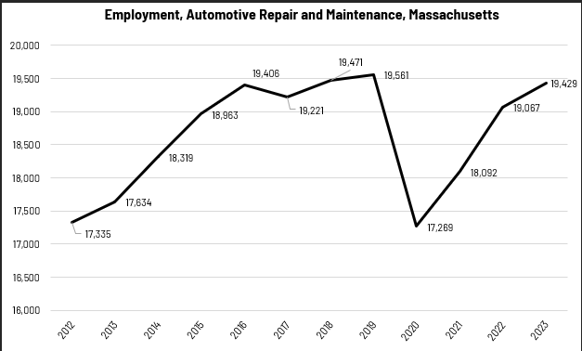When we break down the growth of the Automotive Repair and Maintenance industry, we see that the largest growth of employment has been in the Breweries sector (NAICS 31212), which has added more than 2,800 jobs over that span. Growth as a percentage of total employment has also been fastest in the Breweries sector (436%).

#### Tables 3 and 4: Employment Change, Automotive Repair and Maintenance Industries, Massachusetts, 2014-2023

|  |  |  |  |  |  |  |  |
| --- | --- | --- | --- | --- | --- | --- | --- |
| Industry | 2014 | 2018 | 2019 | 2020 | 2021 | 2022 | 2023 |
| General Automotive Repair | 6,954 | 7,393 | 7,539 | 6,876 | 7,251 | 7,436 | 7,594 |
| Automotive Body, Paint, and Interior Repair and Maintenance | 5,833 | 6,303 | 6,376 | 5,605 | 5,745 | 5,946 | 6,021 |
| Automotive Oil Change and Lubrication Shops | 992 | 1,103 | 1,123 | 1,005 | 1,076 | 1,200 | 1,239 |
| All Other Automotive Repair and Maintenance | 226 | 347 | 402 | 347 | 426 | 724 | 814 |

|  |  |  |
| --- | --- | --- |
| Industry | 2014-2023 Change | 2014-2023 % Change |
| General Automotive Repair | 640 | 9.2% |
| Automotive Body, Paint, and Interior Repair and Maintenance | 189 | 3.2% |
| Automotive Oil Change and Lubrication Shops | 247 | 24.9% |
| All Other Automotive Repair and Maintenance | 588 | 260.3% |

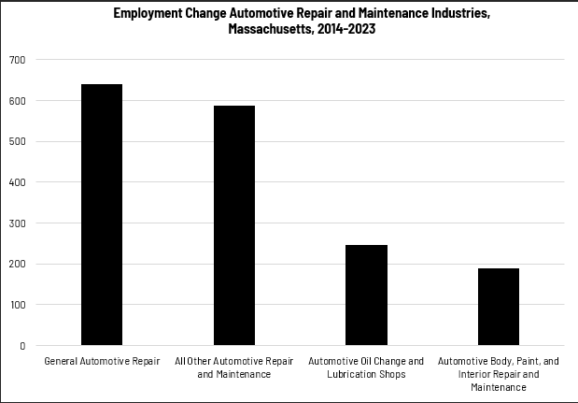

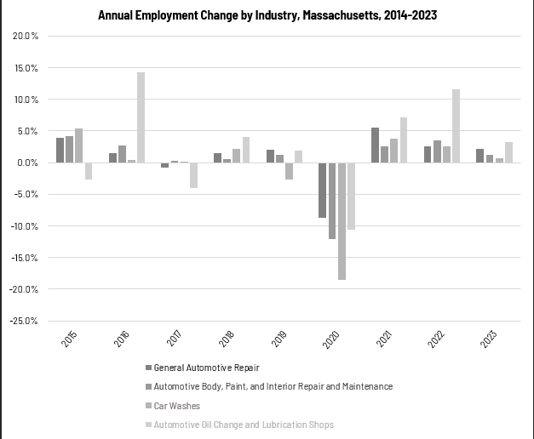

### Wages, Salaries and Proprietor Earnings

Among the detailed industry categories, the highest wages are found among the Automotive Glass Replacement Shops employers. Automotive Body, Paint, and Interior Repair and Maintenance is second. The lowest wages are in Car Washes.

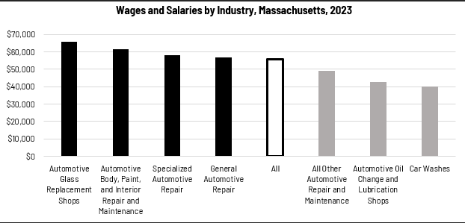

## The Pathways

### Auto Collision Occupations and Pathways

This section looks at two target occupation categories: Automotive Body and Related Repairers and Automotive Service Technicians and Mechanics. It will also consider advancement opportunities in related careers that are not directly related to the program of study, but that illustrate opportunities that may be available to workers in these occupations with additional education and experience.

#### Table 5: Auto Collision Occupations, Massachusetts

|  |  |  |  |  |  |
| --- | --- | --- | --- | --- | --- |
| Occupation | 2023 Jobs | Turnover Rate | 2014 - 2023 Change | 2014 - 2023 % Change | Median Annual Earnings |
| Automotive Body and Related Repairers | 2,805 | 45% | -536 | -16% | $60,382 |
| Automotive Service Technicians and Mechanics | 13,830 | 46% | -309 | -2% | $47,819 |

While careers in these two occupations are certainly viable in their own rights, they also can serve as entry points to progressively more sophisticated and better-paying roles.

#### Table 6: Related Career Pathways

##### Job Zone Two Occupations

|  |  |  |  |
| --- | --- | --- | --- |
| Occupation | 2023 Jobs | Typical Education Requirement | Median Annual Earnings |
| Automotive Body and Related Repairers | 2,764 | High school | $60,382 |
| Automotive Glass Installers and Repairers | 272 | High school | $49,150 |
| Recreational Vehicle Service Technicians | 125 | High school | $49,171 |
| Tire Repairers and Changers | 1,247 | High school | $35,131 |
| Rail Car Repairers | 220 | High school | $79,396 |

##### Job Zone Three Occupations

|  |  |  |  |
| --- | --- | --- | --- |
| Occupation | 2023 Jobs | Typical Education Requirement | Median Annual Earnings |
| Automotive Service Technicians and Mechanics | 13,631 | Nondegree award | $47,819 |
| Motorcycle Mechanics | 101 | Nondegree award | $46,238 |
| Motorboat Mechanics and Service Technicians | 743 | High school diploma | $62,878 |
| Farm Equipment Mechanics and Service Technicians | 214 | High school diploma | $51,172 |
| Aircraft Mechanics and Service Technicians | 1,472 | Postsecondary nondegree award | $78,707 |

## Occupation Profile

The United States Department of Labor, Employment and Training Administration created and regularly updates more than 800 occupational profiles with characteristics like skills, educational requirements, and daily tasks, based on the inputs of industry experts and people who are employed in the occupations.

### Automotive Service Technicians and Mechanics

#### Description

Diagnose, adjust, repair, or overhaul automotive vehicles.

#### Top Skills

* Repairing machines or systems using the needed tools.
* Determining causes of operating errors and deciding what to do about it.
* Using logic and reasoning to identify the strengths and weaknesses of alternative solutions, conclusions, or approaches to problems.
* Watching gauges, dials, or other indicators to make sure a machine is working properly.
* Performing routine maintenance on equipment and determining when and what kind of maintenance is needed.
* Giving full attention to what other people are saying, taking time to understand the points being made, asking questions as appropriate, and not interrupting at inappropriate times.
* Monitoring/Assessing performance of yourself, other individuals, or organizations to make improvements or take corrective action.
* Controlling operations of equipment or systems.
* Considering the relative costs and benefits of potential actions to choose the most appropriate one.
* Talking to others to convey information effectively.
* Identifying complex problems and reviewing related information to develop and evaluate options and implement solutions.
* Conducting tests and inspections of products, services, or processes to evaluate quality or performance.

#### Top Daily Tasks

* Inspect vehicles to determine overall condition.
* Record information about parts, materials or repair procedures.
* Operate transportation equipment to demonstrate function or malfunction.
* Adjust equipment to ensure optimal performance.
* Test mechanical systems to ensure proper functioning.
* Replace worn, damaged, or defective mechanical parts.
* Adjust vehicle components according to specifications.
* Repair non-engine automotive or vehicle components.
* Confer with coworkers to coordinate work activities.
* Read work orders or descriptions of problems to determine repairs or modifications needed.
* Inspect gas systems or components to identify leaks or other potential hazards.
* Estimate costs for labor or materials.
* Confer with customers or users to assess problems.
* Align equipment or machinery.
* Disassemble equipment for maintenance or repair.

#### Additional Information

* [Accrediting Commission of Career Schools and Colleges](http://www.accsc.org/)
* [Automotive Maintenance and Repair Association](http://www.amra.org/)
* [Automotive Youth Educational Systems](https://www.ayes.org/)
* [International Association of General Motors Automotive Service Educational Program](https://www.gmasep.org/)
* [Mobile Air Conditioning Society Worldwide](https://www.macsw.org/)
* [National Automobile Dealers Association](https://www.nada.org/)
* [National Automotive Technicians Education Foundation](https://www.asealliance.org/)
* [National Institute for Automotive Service Excellence](https://www.ase.com/)
* [Occupational Outlook Handbook: Automotive service technicians and mechanics](https://www.bls.gov/ooh/installation-maintenance-and-repair/automotive-service-technicians-and-mechanics.htm)
* [SAE International](https://www.sae.org/)

#### Job Postings - Automotive Service Technicians and Mechanics

P2C uses a third-party system that aggregates data from job postings to provide perspective on the skills and qualifications employers are prioritizing in their advertisements for these occupations.

* After controlling for multiple postings that likely referenced the same single opening, over the last year, we identified 10,293 unique job postings for Automotive Body and Related Repairers.
* We identified 1,101 unique employers who posted openings online.

##### Top Employers Advertising:

* Toyota Motors
* Valvoline
* Monro Auto Service and Tire Centers
* Group 1 Automotive
* Walmart
* Honda
* YourMechanic
* Mercedes-Benz Group
* Pep Boys
* Bridgestone Corporation
* Goodyear
* CarMax

##### Top Job Titles:

* Automotive Technicians
* Automotive Service Advisors
* Automotive Service Technicians
* Automotive Specialists
* Automotive Technicians/Mechanics
* Automotive Tire Technicians
* Automotive Express Technicians
* Automotive Lot Attendants
* Automotive Mechanics
* Master Automotive Technicians
* Automotive Tire and Lube Technicians
* Lube Technicians

##### Top Qualifications:

* Valid Driver's License
* Automotive Service Excellence (ASE) Certification
* Commercial Driver's License (CDL)
* CDL Class A License
* OSHA Certification
* CDL Class B License
* Security Clearance
* Hazmat Endorsement
* ASE Advanced Engine Performance Certification
* AAADM Certification
* American Society for Quality (ASQ) Certified

##### Top Skills:

* Automotive Services
* Vehicle Maintenance
* Mechanical Inspection
* Inventory Control
* Supply Management
* Tooling
* Mechanics