A person working on an aircraft engine



# Labor Market Analysis of Skills Related to Aviation

## Table of Contents­­

Labor Market Analysis of Skills Related to Aviation 0

Table of Contents 1

Overview 2

The Air Transportation Industry 2

The Construction Industry in Labor Market Data Systems 2

Employment-Aircraft Mechanics and Service Technicians 3

Employment Trends 4

Wages, Salaries and Proprietor Earnings 8

The Pathways 8

Aviation Maintenance Technology Occupations and Pathways 8

Occupation Profile 11

Aircraft Mechanics and Service Technicians 11

Aircraft Structure, Surface, Rigging and Systems Assemblers 14

## Overview

This analysis uses labor market data from the Massachusetts Department of Economic Research provide perspective on two theaters related to Aviation Maintenance Technology: the air transportation industry and the occupations in the career pathway.

The industry should be understood as the employers in the Commonwealth whose primary line of business is air transportation. Those companies employ a spectrum of occupations, ranging from mechanics and technicians to customer service agents and lawyers. While trends in the air transportation industry are not necessarily directly related to Aviation Maintenance Technology, the large majority of aircraft mechanics work for air transportation companies, making its realities and trends a valuable backdrop against which to evaluate Aviation Maintenance Technology careers in Massachusetts.

In public data systems, occupations are a set of tasks regularly performed by one individual on an employer’s payroll. In this analysis, occupations related to Aviation Maintenance Technologyare profiled in a career pathway framework, as we seek to provide strategic value in the development and administration of Aviation Maintenance Technology curriculum and the construction of compelling and instructive narrative that will introduce students to the world of aviation maintenance.

## The Air Transportation Industry

### The Construction Industry in Labor Market Data Systems

Air Transportation (NAICS code 481) comprises all employers whose primary line of business is air transportation. The industry category is divided into two sub-industries:

* 4811 Scheduled Air Transportation
* 4812 Nonscheduled Air Transportation

Each of these categories is further parsed into four-, five-, and ultimately six-digit level categories, and the Massachusetts Department of Economic Research produces employment and wage estimates for each.

#### Construction Industry Categories

* 4811 Scheduled Air Transportation
  + 481111 Scheduled Passenger Air Transportation
  + 481112 Scheduled Freight Air Transportation
* 4812 Nonscheduled Air Transportation
  + 481211 Nonscheduled Chartered Passenger Air Transportation
  + 481212 Nonscheduled Chartered Freight Air Transportation
  + 481219 Other Nonscheduled Air Transportation

### Employment-Aircraft Mechanics and Service Technicians

It is not surprising that the type of business that most often employs Aircraft Mechanics and Service Technicians is Scheduled Air Transportation (NAICS 48). More than a third work in that industry, while another 19% are employed by organizations that provide support activities for transportation (NAICS 488). It is interesting to note that the third most common type of employer for these occupations is Transportation Equipment Manufacturing (NAICS 336). The federal government (901) and Professional, Scientific and Technical Services (541) round out the top five.

#### Table 1: Top Industries for Aircraft Mechanics and Service Technicians

|  |  |
| --- | --- |
| Industry | Share of Occupation Jobs |
| Air Transportation | 38.1% |
| Support Activities for Transportation | 19.2% |
| Transportation Equipment Manufacturing | 15.2% |
| Federal Government | 6.0% |
| Professional, Scientific and Technical Services | 5.2% |

### Employment Trends

The number of people employed in the Air Transportation industry in Massachusetts has been increasing significantly and steadily over the last decade, except for a COVID-19-related decline of 15% in 2020. The net change has been an increase of 35.5% in jobs over the last decade.

#### Table 2: Average Annual Employment, Air Transportation Industry, Massachusetts, 2014-2023

|  |  |
| --- | --- |
| Year | Jobs |
| 2014 | 7,450 |
| 2015 | 7,814 |
| 2016 | 8,087 |
| 2017 | 8,220 |
| 2018 | 8,770 |
| 2019 | 9,689 |
| 2020 | 8,243 |
| 2021 | 8,702 |
| 2022 | 10,849 |
| 2023 | 11,546 |

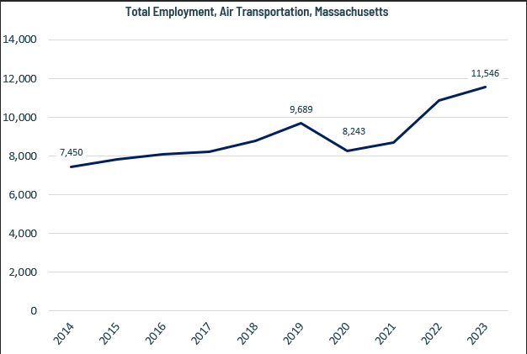

When we break down the growth of the Air Transportation industry, we see that the large majority of employment and of growth has been seen in the Scheduled Air Transportation sector. Growth as a percentage of total employment, however, has been fastest in the freight transportation sectors.

#### Tables 3 and 4: Employment Change, Air Transportation Industries, Massachusetts, 2014-2023

|  |  |  |  |  |  |  |  |
| --- | --- | --- | --- | --- | --- | --- | --- |
| Industry | 2014 | 2018 | 2019 | 2020 | 2021 | 2022 | 2023 |
| Scheduled Passenger Air Transportation | 7,075 | 8,204 | 9,069 | 7,767 | 8,162 | 10,081 | 10,705 |
| Nonscheduled Chartered Passenger Air Transportation | 279 | 360 | 392 | 280 | 302 | 374 | 399 |
| Nonscheduled Chartered Freight Air Transportation | 35 | 124 | 137 | 141 | 196 | 202 | 221 |
| Scheduled Freight Air Transportation | 40 | 56 | 58 | 26 | 10 | 161 | 187 |

|  |  |  |
| --- | --- | --- |
| Industry | 2014-2023 Change | 2014-2023 % Change |
| Scheduled Passenger Air Transportation | 3,631 | 51% |
| Nonscheduled Chartered Passenger Air Transportation | 120 | 43% |
| Nonscheduled Chartered Freight Air Transportation | 186 | 529% |
| Scheduled Freight Air Transportation | 147 | 364% |

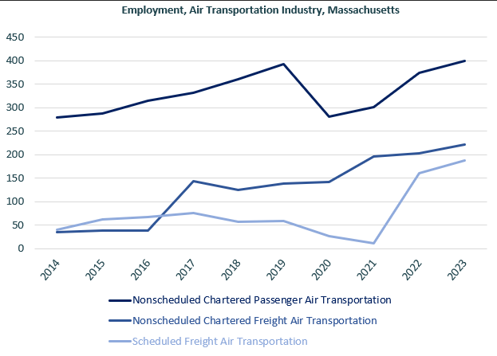

### Wages, Salaries and Proprietor Earnings

Among the detailed industry categories, the highest wages are found among the Chartered Passenger Air Transportation employers, although the total number of workers is relatively low. The lowest wages are in Scheduled Freight Air Transportation.

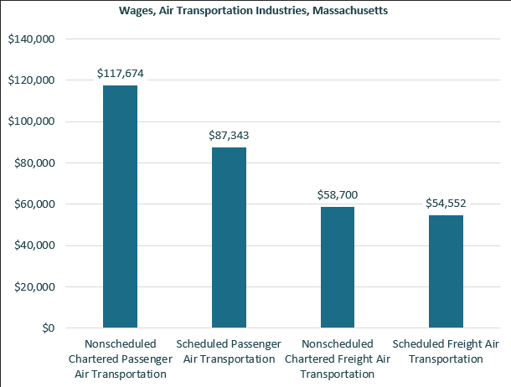

## The Pathways

### Aviation Maintenance Technology Occupations and Pathways

This section looks at two target occupations: Aircraft Structure, Surfaces, Rigging and Systems Assemblers and Aircraft Mechanics and Service Technicians. It will also consider advancement opportunities in related careers that are not directly related to the program of study, but that illustrate opportunities that may be available to Aircraft Mechanics and Service Technicians with additional experience and education.

#### Table 5: Aviation Maintenance Technology Occupations, Massachusetts

|  |  |  |  |  |  |
| --- | --- | --- | --- | --- | --- |
| Occupation | 2023 Jobs | Turnover Rate | 2014 - 2023 Change | 2014 - 2023 % Change | Median Annual Earnings |
| Aircraft Structure, Surfaces, Rigging and Systems  Assemblers | 216 | 50.8% | (294) | (57.6%) | $55,265 |
| Aircraft Mechanics and Service Technicians | 1,540 | 36.8% | 288 | 23.0% | $78,707 |

While careers in these two occupations are certainly viable in their own rights, they also can serve as entry points to progressively more sophisticated and better-paying roles.

#### Table 6: Related Career Pathways

##### Job Zone Two Occupations

|  |  |  |  |
| --- | --- | --- | --- |
| Occupation | 2023 Jobs | Typical Education Requirement | Median Annual Earnings |
| Aircraft Structure, Surfaces, Rigging and Systems Assemblers | 216 | High school | $55,265 |

##### Job Zone Three Occupations

|  |  |  |  |
| --- | --- | --- | --- |
| Occupation | 2023 Jobs | Typical Education Requirement | Median Annual Earnings |
| Aircraft Mechanics and Service Technicians | 1,540 | Nondegree award | $78,707 |
| Aerospace Engineering and Operations Technologists and Technicians | 82 | Associate's degree | $98,736 |
| Avionics Technicians | 276 | Associate's degree | $81,195 |

##### Job Zone Four Occupations

|  |  |  |  |
| --- | --- | --- | --- |
| Occupation | 2023 Jobs | Typical Education Requirement | Median Annual Earnings |
| Aerospace Engineers | 723 | Bachelor's degree | $132,350 |
| Transportation Inspectors (including Aviation Inspectors) | 651 | Associate’s degree | $61,736 |

## Occupation Profile

The United States Department of Labor, Employment and Training Administration created and regularly updates more than 800 occupational profiles with characteristics like skills, educational requirements and daily tasks, based on the inputs of industry experts and people who are employed in the occupations.

### Aircraft Mechanics and Service Technicians

#### Top Skills

* Using logic and reasoning to identify the strengths and weaknesses of alternative solutions, conclusions, or approaches to problems
* Understanding written sentences and paragraphs in work-related documents
* Giving full attention to what other people are saying, taking time to understand the points being made, asking questions as appropriate, and not interrupting at inappropriate times
* Talking to others to convey information effectively
* Watching gauges, dials, or other indicators to make sure a machine is working properly
* Conducting tests and inspections of products, services, or processes to evaluate quality or performance
* Communicating effectively in writing as appropriate for the needs of the audience
* Monitoring/Assessing performance of yourself, other individuals, or organizations to make improvements or take corrective action
* Identifying complex problems and reviewing related information to develop and evaluate options and implement solutions
* Determining causes of operating errors and deciding what to do about it
* Considering the relative costs and benefits of potential actions to choose the most appropriate one
* Managing one's own time and the time of others

#### Top Daily Tasks

* Inspect work of aircraft mechanics performing maintenance, modification, or repair and overhaul of aircraft and aircraft mechanical systems to ensure adherence to standards and procedures
* Examine maintenance records and flight logs to determine if service and maintenance checks and overhauls were performed at prescribed intervals
* Inspect new, repaired, or modified aircraft to identify damage or defects and to assess airworthiness and conformance to standards, using checklists, hand tools, and test instruments
* Approve or deny issuance of certificates of airworthiness
* Prepare and maintain detailed repair, inspection, investigation, and certification records and reports
* Examine landing gear, tires, and exteriors of fuselage, wings, and engines for evidence of damage or corrosion and the need for repairs
* Recommend replacement, repair, or modification of aircraft equipment
* Start aircraft and observe gauges, meters, and other instruments to detect evidence of malfunctions
* Examine aircraft access plates and doors for security
* Recommend changes in rules, policies, standards, and regulations, based on knowledge of operating conditions, aircraft improvements, and other factors

#### Additional Information

* Aircraft Owners and Pilots Association
* Aviation Institute of Maintenance
* Experimental Aircraft Association
* International Brotherhood of Teamsters
* National Business Aviation Association
* Professional Aviation Maintenance Association

#### Job Postings

P2C uses a third-party system that aggregates data from job postings to provide perspective on the skills and qualifications employers are prioritizing in their advertisements for these occupations.

* After controlling for multiple postings that likely referenced the same single opening, over the last year, we identified 321 unique job postings for Aircraft Mechanics and Service Technicians in Massachusetts.
* We identified 94 unique employers who posted openings online.

##### Top Employers Advertising:

* Gulfstream Aerospace
* Liberty Mutual
* Aerotek
* Expleo
* Delta Air Lines
* Signature Flight Support
* STS Technical Services
* Thales
* RPh on the Go
* Cape Air
* Total Aviation Staffing

##### Top Job Titles:

* Aircraft Technicians
* Aircraft Maintenance Technicians
* GSE Technicians
* Airframe and Powerplant Mechanics
* Aircraft Mechanics
* Aircraft Support Mechanics
* Airframe and Powerplant Technicians
* Engine Field Service Technicians
* Aircraft Structures Mechanics
* Mobile Service Technicians
* Engine Mechanics

##### Top Qualifications:

* Airframe & Powerplant (A&P) Certificate
* Valid Driver's License
* Airport Security Clearance
* Security Identification Display Area (SIDA) Badge
* FAA Certified Aviation Maintenance Technician
* ASE Advanced Engine Performance Certification

##### Top Skills:

* Troubleshooting
* Communications
* English Language
* Lifting Ability
* Quality Control

### Aircraft Structure, Surface, Rigging and Systems Assemblers

#### Top Skills

* Conducting tests and inspections of products, services, or processes to evaluate quality or performance.
* Giving full attention to what other people are saying, taking time to understand the points being made, asking questions as appropriate, and not interrupting at inappropriate times.
* Using logic and reasoning to identify the strengths and weaknesses of alternative solutions, conclusions, or approaches to problems.
* Monitoring/Assessing performance of yourself, other individuals, or organizations to make improvements or take corrective action.
* Understanding written sentences and paragraphs in work-related documents.
* Talking to others to convey information effectively.
* Identifying complex problems and reviewing related information to develop and evaluate options and implement solutions.
* Performing routine maintenance on equipment and determining when and what kind of maintenance is needed.
* Considering the relative costs and benefits of potential actions to choose the most appropriate one.
* Managing one's own time and the time of others.
* Understanding the implications of new information for both current and future problem-solving and decision-making.

#### Top Daily Tasks

* Assemble parts, fittings, or subassemblies on aircraft, using layout tools, hand tools, power tools, or fasteners, such as bolts, screws, rivets, or clamps.
* Read blueprints, illustrations, or specifications to determine layouts, sequences of operations, or identities or relationships of parts.
* Attach brackets, hinges, or clips to secure or support components or subassemblies, using bolts, screws, rivets, chemical bonding, or welding.
* Inspect or test installed units, parts, systems, or assemblies for fit, alignment, performance, defects, or compliance with standards, using measuring instruments or test equipment.
* Adjust, repair, rework, or replace parts or assemblies to ensure proper operation.
* Cut, trim, file, bend, or smooth parts to ensure proper fit and clearance.
* Fabricate parts needed for assembly or installation, using shop machinery or equipment.
* Layout and mark reference points and locations for installation of parts or components, using jigs, templates, or measuring and marking instruments.
* Clean, oil, or coat system components, as necessary, before assembly or attachment.
* Assemble prefabricated parts to form subassemblies.

#### Additional Information

* Aircraft Owners and Pilots Association
* Experimental Aircraft Association
* Fabricators & Manufacturers Association International
* International Association of Machinists and Aerospace Workers
* IPC (Association Connecting Electronics Industries)