# Labor Market Analysis Biotechnology Careers in Massachusetts

## Overview

This analysis uses labor market data from the Massachusetts Department of Economic Research to provide perspective on multiple theaters related to the field of Manufacturing in the Commonwealth:

### The Production Occupation Family

There are 105 occupation categories in this family, ranging from Inspectors, Testers, Sorters, Samplers and Weighers (10,500 jobs in Massachusetts) to Semiconductor Processing Technicians (1,600 jobs) and Dental Laboratory Technicians (230 jobs).

### Seven primary industries

* Navigational, Measuring, Electromedical, and Control Instruments Manufacturing
* Semiconductor and Other Electronic Component Manufacturing
* Plastics Product Manufacturing
* Bakeries and Tortilla Manufacturing
* Medical Equipment and Supplies Manufacturing
* Pharmaceutical and Medicine Manufacturing
* Machine Shops; Turned Product; and Screw, Nut, and Bolt Manufacturing

**The Occupations** are the specific jobs into which graduates of the Manufacturing programs will hopefully enter after graduation. In public data systems, occupations are a set of tasks regularly performed by one individual on an employer’s payroll. In this analysis, the target occupations are profiled in addition to the broad spectrum of industries that employ them as we seek to provide strategic value in the development and administration of related curriculum and the construction of compelling and instructive narratives that will introduce students to the world of Manufacturing in the 21st Century.

**The Industries** which employ the target occupations are defined by their primary lines of business. The manufacturing industry in Massachusetts is defined as “establishments engaged in the mechanical, physical, or chemical transformation of materials, substances, or components into new products.” The industry employes more than 237,000 people in the Commonwealth, and those jobs are spread across abroad spectrum of manufacturing types. In terms of total employment, there are seven manufacturing industries which employ 10,000 or more people in Massachusetts:

* Navigational, Measuring, Electromedical, and Control Instruments Manufacturing
* Semiconductor and Other Electronic Component Manufacturing
* Plastics Product Manufacturing
* Bakeries and Tortilla Manufacturing
* Medical Equipment and Supplies Manufacturing
* Pharmaceutical and Medicine Manufacturing
* Machine Shops; Turned Product; and Screw, Nut, and Bolt Manufacturing

Navigational, Measuring, Electromedical, and Control Instruments Manufacturing

Establishments primarily engaged in manufacturing navigational, measuring, electromedical, and control instruments. Examples of products made by these establishments are aeronautical instruments, appliance regulators and controls (except switches), laboratory analytical instruments, navigation and guidance systems, and physical properties testing equipment.

Semiconductor and Other Electronic Component Manufacturing

Establishments primarily engaged in manufacturing semiconductors and other components for electronic applications. Examples of products made by these establishments are capacitors, resistors, microprocessors, bare and loaded printed circuit boards, electron tubes, electronic connectors, and computer modems.

Plastics Product Manufacturing

Establishments Primarily Engaged in Processing New or Spent (I.E., Recycled) Plastics Resins into intermediate or final products, using such processes as compression molding; extrusion molding; injection molding; blow molding; and casting. Within most of these industries, the production process is such that a wide variety of products can be made.

Bakeries and Tortilla Manufacturing

Establishments primarily engaged in one of the following: (1) manufacturing fresh and frozen bread and other bakery products; (2) retailing bread and other bakery products not for immediate consumption made on the premises from flour, not from prepared dough; (3) manufacturing cookies, crackers, and dry pasta; (4) manufacturing prepared flour mixes or dough from flour ground elsewhere; or (5) manufacturing tortillas.

Medical Equipment and Supplies Manufacturing

Establishments primarily engaged in manufacturing medical equipment and supplies. Examples of products made by these establishments are surgical and medical instruments, surgical appliances and supplies, dental equipment and supplies, orthodontic goods, ophthalmic goods, dentures, and orthodontic appliances.

Pharmaceutical and Medicine Manufacturing

Establishments primarily engaged in one or more of the following: (1) manufacturing biological and medicinal products; (2) processing (i.e., grading, grinding, and milling) botanical drugs and herbs; (3) isolating active medicinal principals from botanical drugs and herbs; and (4) manufacturing pharmaceutical products intended for internal and external consumption in such forms as ampoules, tablets, capsules, vials, ointments, powders, solutions, and suspensions.

Machine Shops; Turned Product; and Screw, Nut, and Bolt Manufacturing

Establishments known as machine shops primarily engaged in machining metal and plastic parts and parts of other composite materials on a job or order basis. Generally, machine shop jobs are low volume using machine tools, such as lathes (including computer numerically controlled); automatic screw machines; and machines for boring, grinding, milling, and additive manufacturing.

## The Industries

The Federal system of labor market data defines 86 specific manufacturing industries at the four-digit NAICS (North American Industry Classification System level), allowing for a detailed analysis of the various types of manufacturing operations that make up this critical sector of the Massachusetts economy.

### Table 1: Largest Manufacturing Industries, Massachusetts, 2023

|  |  |  |
| --- | --- | --- |
| **Industry** | **2023 Jobs** | **Median Annual Earnings** |
| Navigational, Measuring, Electromedical, and Control Instruments Manufacturing | 26,515 | $134,520 |
| Semiconductor and Other Electronic Component Manufacturing | 14,797 | $134,340 |
| Plastics Product Manufacturing | 11,941 | $75,103 |
| Bakeries and Tortilla Manufacturing | 11,313 | $47,710 |
| Medical Equipment and Supplies Manufacturing | 10,893 | $109,089 |
| Pharmaceutical and Medicine Manufacturing | 10,495 | $162,738 |
| Machine Shops; Turned Product; and Screw, Nut, and Bolt Manufacturing | 10,463 | $79,549 |
| Aerospace Product and Parts Manufacturing | 9,575 | $139,713 |
| Other Miscellaneous Manufacturing | 7,976 | $85,671 |
| Printing and Related Support Activities | 7,868 | $78,017 |
| Beverage Manufacturing | 6,635 | $65,228 |
| Computer and Peripheral Equipment Manufacturing | 6,194 | $197,582 |
| Industrial Machinery Manufacturing | 5,920 | $134,020 |
| Converted Paper Product Manufacturing | 5,315 | $77,660 |
| Architectural and Structural Metals Manufacturing | 4,964 | $84,812 |
| Other Food Manufacturing | 4,367 | $73,219 |

Total = 155,231

### Employment Trends

The total number of jobs in the Massachusetts manufacturing sector has declined in recent years, but with more than 237,000 jobs, remains a critical component of the Massachusetts economy. These businesses shed six percent of their total employment during the COVID-19 pandemic and have yet to return to pre-COVID levels.

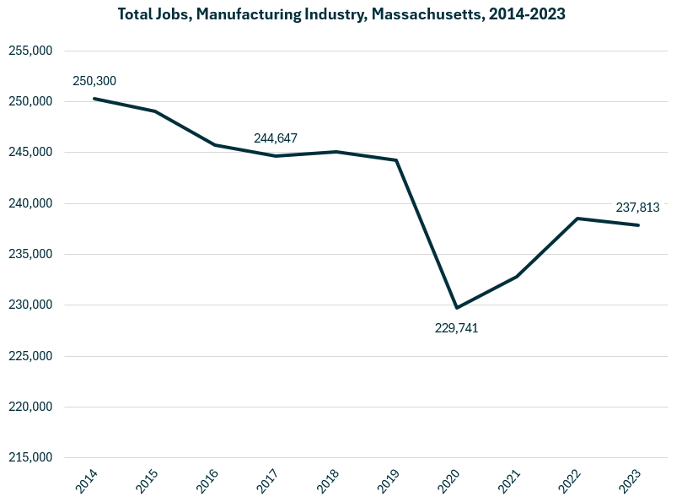

Growth in employment has been led by the Breweries (NAICS 312120) industry, which has added more than 2,600 jobs over the last decade. Analytical Laboratory Instrument Manufacturing (334516), Retail Bakeries (311811), Semiconductors (333242) and Seafood Products (311710) round out the top five.

#### Table 2: Detailed (6DL) Industries, by Largest Ten-Year Increase in Employment, Massachusetts, 2014-2023

|  |  |  |
| --- | --- | --- |
| **Industry** | **Ten-Year Change** | **Ten-Year % Change** |
| Breweries | 2,685 | 415% |
| Analytical Laboratory Instrument Manufacturing | 2,447 | 37% |
| Retail Bakeries | 1,474 | 39% |
| Semiconductor Machinery Manufacturing | 1,361 | 58% |
| Seafood Product Preparation and Packaging | 1,330 | 59% |
| Electromedical and Electrotherapeutic Apparatus Manufacturing | 1,250 | 33% |
| Biological Product (except Diagnostic) Manufacturing | 909 | 135% |
| Frozen Specialty Food Manufacturing | 808 | 137% |
| Other Electronic Component Manufacturing | 760 | 31% |
| Meat Processed from Carcasses | 552 | 32% |
| All Other Miscellaneous Electrical Equipment and Component Manufacturing | 535 | 36% |
| All Other Industrial Machinery Manufacturing | 529 | 41% |
| Soft Drink Manufacturing | 511 | 32% |
| Mayonnaise, Dressing, and Other Prepared Sauce Manufacturing | 477 | 52% |
| Custom Architectural Woodwork and Millwork Manufacturing | 452 | 82% |
| All Other Plastics Product Manufacturing | 411 | 6% |
| Cut and Sew Apparel Contractors | 404 | 137% |
| Rubber Product Manufacturing for Mechanical Use | 375 | 114% |
| All Other Miscellaneous Food Manufacturing | 360 | 93% |
| Commercial and Service Industry Machinery Manufacturing | 345 | 12% |

The industries experiencing the largest decrease in total employment include Computer Storage Device Manufacturing and Commercial Printing.

#### Table 3: Detailed (6DL) Industries, by Largest Ten-Year Decrease in Employment, Massachusetts, 2014-2023

|  |  |  |
| --- | --- | --- |
| **Industry** | **Ten-Year Change** | **Ten-Year % Change** |
| Computer Storage Device Manufacturing | (3,596) | (44.8%) |
| Commercial Printing (except Screen and Books) | (2,864) | (36.4%) |
| Commercial Bakeries | (1,661) | (26.9%) |
| Electronic Computer Manufacturing | (1,637) | (53.7%) |
| Search, Detection, Navigation, Guidance, Aeronautical, and Nautical System and Instrument Manufacturing | (1,211) | (23.8%) |
| Cut and Sew Apparel Manufacturing (except Contractors) | (1,063) | (53.6%) |
| Computer Terminal and Other Computer Peripheral Equipment Manufacturing | (974) | (73.5%) |
| Fruit and Vegetable Canning | (971) | (74.3%) |
| Audio and Video Equipment Manufacturing | (901) | (36.3%) |
| Pharmaceutical Preparation Manufacturing | (867) | (11.3%) |
| Aircraft Engine and Engine Parts Manufacturing | (840) | (20.3%) |
| Instruments and Related Products Manufacturing for Measuring, Displaying, and Controlling Industrial Process Variables | (679) | (15.3%) |
| Plastics Material and Resin Manufacturing | (676) | (31.9%) |
| Relay and Industrial Control Manufacturing | (663) | (44.6%) |
| Fluid Milk Manufacturing | (659) | (45.2%) |
| Jewelry and Silverware Manufacturing | (587) | (39.2%) |
| Paper Mills | (565) | (33.9%) |
| Perishable Prepared Food Manufacturing | (550) | (36.5%) |
| Knit Fabric Mills | (509) | (89.0%) |
| Paper Bag and Coated and Treated Paper Manufacturing | (495) | (19.6%) |

### Comparative Advantage

An employment Location Quotient (LQ) is a value in which the concentration of a region’s employment in a particular industry is indexed against the national norm. For example, if the percentage of a region’s workforce that is employed in the Aerospace Manufacturing sector were identical to the national average, that industry would return an LQ of 1.0. If the region’s workforce were employed in that industry at a rate double the national average, that would return an LQ of 2.0.

We estimated Location Quotients for detailed manufacturing industries in Massachusetts, using that value to highlight industries that are part of the unique fabric of regional economies, regardless of total employment. This critical exercise affords a valuable perspective by looking at the manufacturing industries uniquely important to the economic prospects of the Commonwealth.

#### Table 4: Detailed (6DL) Manufacturing Industry

|  |  |  |
| --- | --- | --- |
| **Detailed (6DL) Manufacturing Industry** | **LQ** | **Jobs** |
| Computer Storage Device Manufacturing | 13.11 | 4,427 |
| Analytical Laboratory Instrument Manufacturing | 8.05 | 9,033 |
| Fabric Coating Mills | 6.75 | 1,091 |
| Metal Kitchen Cookware, Utensil, Cutlery, and Flatware Manufacturing | 6.23 | 1,439 |
| Semiconductor Machinery Manufacturing | 5.20 | 3,712 |
| Footwear Manufacturing | 4.63 | 1,293 |
| Seafood Product Preparation and Packaging | 4.51 | 3,581 |
| Audio and Video Equipment Manufacturing | 3.49 | 1,579 |
| Abrasive Product Manufacturing | 3.38 | 798 |
| Irradiation Apparatus Manufacturing | 3.19 | 1,066 |
| Saw Blade and Handtool Manufacturing | 3.19 | 2,004 |
| Guided Missile and Space Vehicle Manufacturing | 3.16 | 5,916 |
| Electromedical and Electrotherapeutic Apparatus Manufacturing | 2.78 | 4,981 |
| Instruments for Measuring, Displaying, Controlling Industrial Process Variables | 2.76 | 3,760 |
| Other Communication and Energy Wire Manufacturing | 2.74 | 854 |

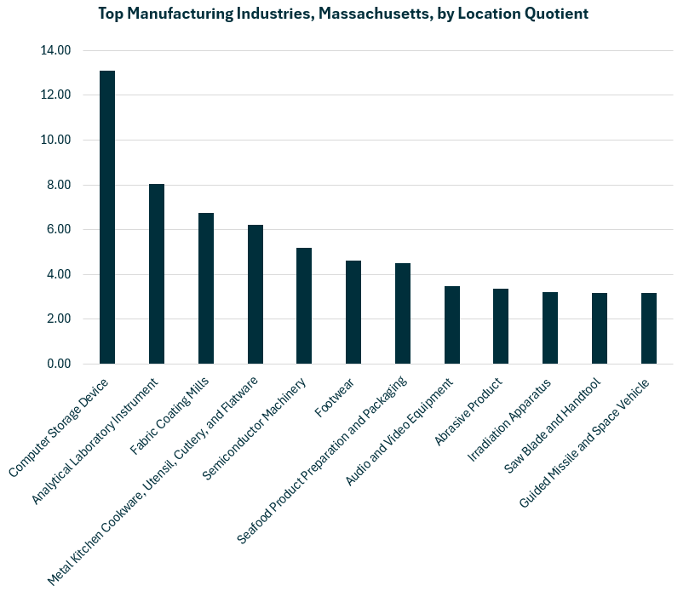

### Economic Activity

Manufacturing is one of the Commonwealth’s five largest private-sector contributors to the regional economy, accounting for approximately one of every thirteen dollars generated. In 2023 the sector contributed $56 billion to the state’s Gross Domestic Product.

**Pie chart, Gross Domestic Product by Industry, Massachusetts, 2023, see tables for data points

**

### Earnings

Earnings per manufacturing job in Massachusetts are well above the national average. The national average salary for Manufacturing in an area this size is $99,673, while in Massachusetts it is $123,029. The average has increased steadily over the last decade and now reflects an average 20.7% higher than in 2014.

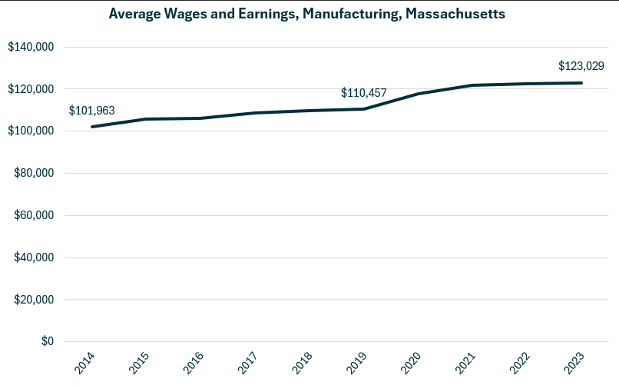

**Bar Chart, Average Wages and Earnings, Manufacturing Industries, Massachusetts, see tables for data points
**

### Staffing Patterns

The occupations most commonly employed by manufacturers in Massachusetts are from the Production (SOC 51-0000). Occupations from the Management (11-0000), Engineering (17-0000) and Computer and Mathematical (15-0000) families are also found in the top ten.

#### Table 5: Top Occupations, Manufacturing Industry, Massachusetts

|  |  |  |
| --- | --- | --- |
| **SOC Code** | **Occupation** | **% of Jobs in Industry** |
| 51-2098 | Miscellaneous Assemblers and Fabricators | 4.0% |
| 51-1011 | First-Line Supervisors of Production and Operating Workers | 3.9% |
| 51-2028 | Electrical, Electronic, and Electromechanical Assemblers | 3.9% |
| 11-1021 | General and Operations Managers | 3.1% |
| 51-4041 | Machinists | 2.8% |
| 51-9061 | Inspectors, Testers, Sorters, Samplers, and Weighers | 2.8% |
| 17-2112 | Industrial Engineers | 2.8% |
| 15-1252 | Software Developers | 2.2% |
| 41-4012 | Sales Representatives, Wholesale and Manufacturing | 2.0% |
| 51-9111 | Packaging and Filling Machine Operators and Tenders | 1.9% |
| 43-5071 | Shipping, Receiving, and Inventory Clerks | 1.9% |
| 51-3092 | Food Batchmakers | 1.8% |
| 11-3051 | Industrial Production Managers | 1.7% |
| 53-7062 | Laborers and Freight, Stock, and Material Movers, Hand | 1.7% |
| 51-4072 | Molding, Coremaking, Casting Machine Setters, Operators, Metal & Plastic | 1.7% |
| 53-7064 | Packers and Packagers, Hand | 1.6% |
| 51-9161 | Computer Numerically Controlled Tool Operators | 1.5% |

## Program Profiles-Biotechnology

### Priority Industries in Labor Market Data Systems

Analysis of the Biotechnology industry in Massachusetts presents some challenges in terms of defining the industry. For the purposes of this report, two industry categories are being considered in order to provide a more comprehensive perspective on the world of Biotechnology in Massachusetts:

* Biological Products Manufacturing
* Research and Development in Biotechnology.

The taxonomic structure of the North American Industry Classification System is illustrated in the following tables to provide perspective on the realities being referenced by the statistics in the balance of this analysis.

#### The Biological Products Manufacturing Industry Taxonomy

* **32 Manufacturing**
  + **321 Wood Product Manufacturing**
  + **322 Paper Manufacturing**
  + **323 Printing and Related Support Services Manufacturing**
  + **324 Petroleum and Coal Products Manufacturing**
  + **325 Chemical Manufacturing**
    - **3251 Basic Chemical Manufacturing**
    - **3252 Resin, Synthetic Rubber, and Artificial and Synthetic Fibers and Filaments Manufacturing**
    - **3253 Pesticide, Fertilizer, and Other Agricultural Chemical Manufacturing**
    - **3254 Pharmaceutical and Medicine Manufacturing**
      * **325411 Medicinal and Botanical Manufacturing**
      * **325412 Pharmaceutical Preparation Manufacturing**
      * **325413 In-Vitro Diagnostic Substance Manufacturing**
      * **325414 Biological Product (except Diagnostic) Manufacturing**
    - **3255 Paint, Coating, and Adhesive Manufacturing**
    - **3256 Soap, Cleaning Compound, and Toilet Preparation Manufacturing**
  + **326 Plastics and Rubber Manufacturing**
  + **327 Nonmetalic Mineral Manufacturing**

#### Research and Development in Biotechnology

* **541 Professional, Scientific and Technical Services**
  + **5411 Legal Services**
  + **5412 Accounting, Tax Preparation, Bookkeeping, and Payroll Services**
  + **5413 Architectural, Engineering, and Related Services**
  + **5414 Specialized Design Services**
  + **5415 Computer Systems Design and Related Services**
  + **5416 Management, Scientific, and Technical Consulting Services**
  + **5417 Scientific Research and Development Services**
    - **541713 Research and Development in Nanotechnology**
    - **541714 Research and Development in Biotechnology (except Nanobiotechnology)**
    - **541715 Research and Development in the Physical, Engineering, and Life Sciences (except Nanotechnology and Biotechnology)**
    - **541720 Research and Development in the Social Sciences and Humanities**

### Employment Trends

The number of people employed in the Biological Products Manufacturing industry has increased dramatically over the last decade, recording a total increase of 135% over those ten years. The Research and Development in Biotechnology industry has similarly grown, with a net change of 122%.

#### Table 5: Average Annual Employment, Biological Product Manufacturing Industry, Massachusetts, 2014-2023

|  |  |
| --- | --- |
| **Year** | **Jobs** |
| 2014 | 673 |
| 2015 | 824 |
| 2016 | 907 |
| 2017 | 979 |
| 2018 | 1,033 |
| 2019 | 1,166 |
| 2020 | 1,218 |
| 2021 | 1,433 |
| 2022 | 1,711 |
| 2023 | 1,583 |

#### Table 6: Average Annual Employment, Research and Development in Biotechnology Industry, Massachusetts, 2014-2023

|  |  |
| --- | --- |
| **Year** | **Jobs** |
| 2014 | 29,793 |
| 2015 | 31,454 |
| 2016 | 34,827 |
| 2017 | 35,758 |
| 2018 | 39,363 |
| 2019 | 46,520 |
| 2020 | 50,403 |
| 2021 | 55,991 |
| 2022 | 62,413 |
| 2023 | 66,060 |

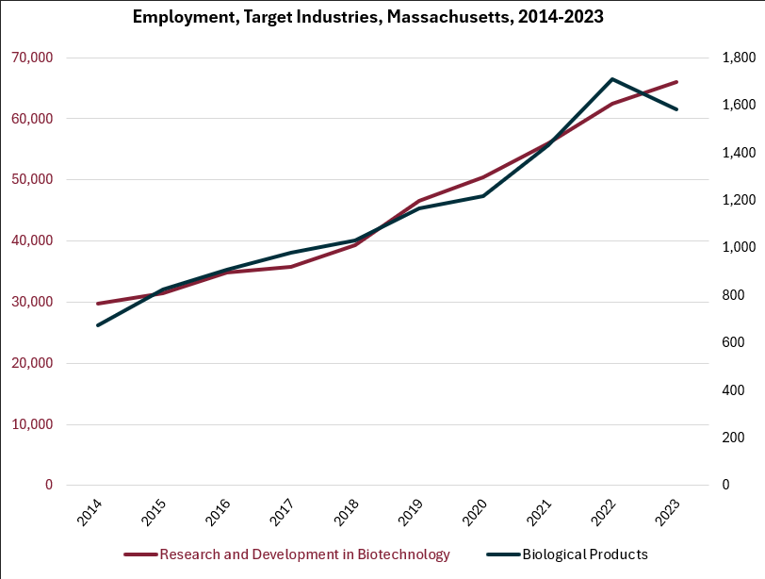

### Target Occupation – Biological Technicians

#### Jobs

One occupation is profiled in this analysis to provide perspective on the Biotechnology program: Biological Technicians (SOC 29-2018). Approximately 7,000 people are employed in this occupation category in Massachusetts. It is understood that much of the opportunity in this field is found in other production/manufacturing occupation categories, and the analysis will look at some of those occupations; however, for the purposes of understanding the unique demands of this field of work, the Biological Technician occupation will be profiled in detail.

While the total number of people employed in this job is a relatively small component of the Commonwealth’s labor force, it is a uniquely important occupation in the local economy. One measure of the comparative importance of an occupation in a regional economy is a Location Quotient (LQ). This scale value uses 1.0 as the national average of the target occupation as a share of the total workforce. For example, if an occupation has an LQ of 2.0, that indicates that there are double the number of people in that occupation than would be expected for a population of that size based on national averages. In Massachusetts, the Biological Technicians occupation category has an LQ of 3.7, indicating that the Commonwealth is a hotbed for career opportunities in this field.

##### Table 7: Biological Technicians

|  |  |  |  |
| --- | --- | --- | --- |
| **Occupation** | **2023 Jobs** | **Median Earnings** | **Typical Entry Level Education** |
| Biological Technicians | 6.909 | $61,693 | Bachelor's degree |

#### Employment Trends

##### Table 8: Employment, Biological Technicians, Massachusetts, 2014-2023

|  |  |
| --- | --- |
| **Year** | **Jobs** |
| 2014 | 5,518 |
| 2015 | 5,635 |
| 2016 | 5,625 |
| 2017 | 5,672 |
| 2018 | 5,721 |
| 2019 | 5,880 |
| 2020 | 5,823 |
| 2021 | 5,880 |
| 2022 | 5,870 |
| 2023 | 6,909 |

##### Employment, by Year, Massachusetts, 2014-2023

The number of Biological Technicians in Massachusetts had been notably steady over the last decade, including a remarkably stable level through the COVID-19 pandemic. However, a sharp increase in total jobs (17.8%) was recorded in 2023.

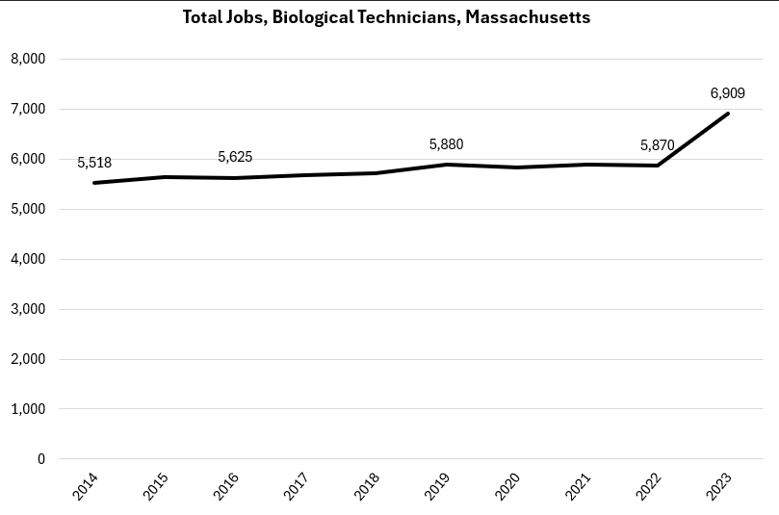

#### Wages

The wages most often earned by Biological Technicians in Massachusetts have increased significantly over the last decade, currently measuring $61,693. That represents an increase of 38.3% since 2014.

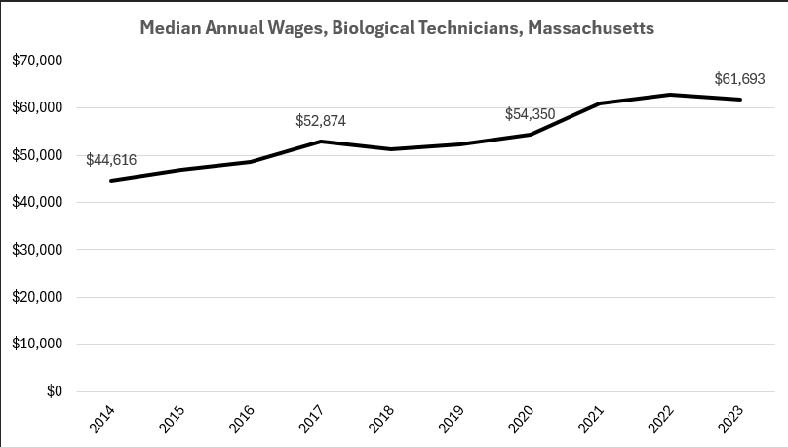

#### Inverse Staffing Patterns

The industry that most often employs Biological Technicians is Scientific Research and Development Services. Significant numbers of people in this job are also employed in Government, Education, Health Care and Manufacturing.

##### Table 9: Employment of Biological Technicians by Industry, Massachusetts

|  |  |  |
| --- | --- | --- |
| **NAICS Code** | **Industry** | **Share of Jobs in Industry** |
| 54 | Professional, Scientific and Technical Services | 61.7% |
| 5417 | Scientific Research and Development Services | 58.4% |
| 90 | Government | 11.9% |
| 9026 | Education and Hospitals, State Government | 5.3% |
| 61 | Education | 10.6% |
| 6113 | Colleges, Universities and Professional Schools | 10.5% |
| 62 | Health Care | 8.3% |
| 6221 | General Medical and Surgical Hospitals | 4.5% |
| 31-33 | Manufacturing | 5.9% |
| 3245 | Pharmaceutical and Medicine Manufacturing | 5.5% |

#### Employment Trends

##### Scientific Research and Development Services in Massachusetts

Employment in businesses within the Scientific Research and Development Services industry has been increasing dramatically and steadily over the last decade. Employment currently measures 103,529. Employment was remarkably unaffected by the COVID-19 pandemic.

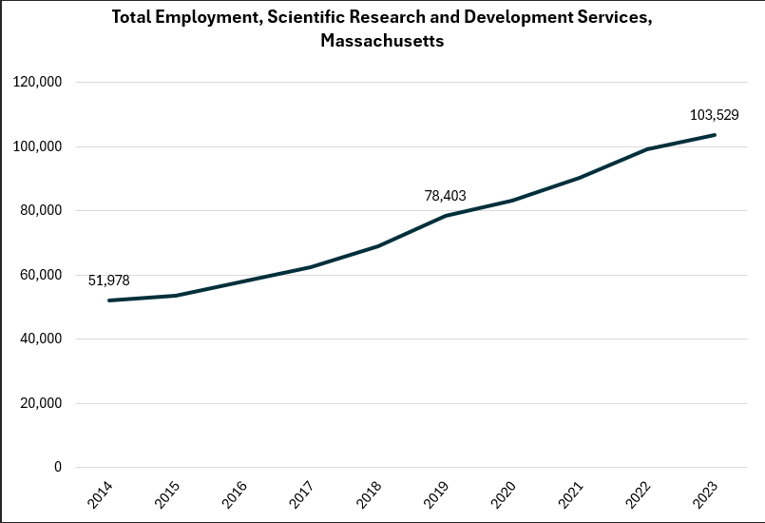

## Pathways

Occupations that are not unique to biotechnology are key to the career pathways that exist within the industry. In particular, general manufacturing/production occupations are often filled by graduates of the Massachusetts Chapter 74 Biotechnology program.

### Table 10: Occupations

#### Job Zone Two Occupations

|  |  |  |  |
| --- | --- | --- | --- |
| Occupation | 2023 Jobs | Typical Education Requirement | Median Annual Earnings |
| Packaging and Filling Machine Operators and Tenders | 6,097 | High school | $36,795 |
| Separating, Filtering, Clarifying, Precipitating and Still Machine Tenders | 721 | High school | $44,304 |
| Inspectors, Testers, Sorters, Samplers and Weighers | 10,505 | High school | $50,648 |
| Crushing, Grinding, and Polishing Machine Setters, Operators and Tenders | 426 | High school | $54,246 |

#### Job Zone Three Occupations

|  |  |  |  |
| --- | --- | --- | --- |
| Occupation | 2023 Jobs | Typical Education Requirement | Median Annual Earnings |
| Medical and Clinical Laboratory Technicians | 12,977 | Bachelor's | $65,811 |

#### Job Zone Four Occupations

|  |  |  |  |
| --- | --- | --- | --- |
| Occupation | 2023 Jobs | Typical Education Requirement | Median Annual Earnings |
| Biological Technicians | 6,909 | Bachelor's | $61,693 |

#### Occupational Profile – Biological Technicians

##### Description:

Assist biological and medical scientists. Set up, operate, and maintain laboratory instruments and equipment, monitor experiments, collect data and samples, make observations, and calculate and record results. May analyze organic substances, such as blood, food, and drugs.

##### Skills:

* Understanding written sentences and paragraphs in work-related documents.
* Using logic and reasoning to identify the strengths and weaknesses of alternative solutions, conclusions, or approaches to problems.
* Giving full attention to what other people are saying, taking time to understand the points being made, asking questions as appropriate, and not interrupting at inappropriate times.
* Using scientific rules and methods to solve problems.
* Understanding the implications of new information for both current and future problem-solving and decision-making.
* Communicating effectively in writing as appropriate for the needs of the audience.
* Talking to others to convey information effectively.
* Monitoring/assessing performance of yourself, other individuals, or organizations to make improvements or take corrective action.
* Identifying complex problems and reviewing related information to develop and evaluate options and implement solutions.
* Considering the relative costs and benefits of potential actions to choose the most appropriate one.
* Using mathematics to solve problems.
* Watching gauges, dials, or other indicators to make sure a machine is working properly.
* Determining how a system should work and how changes in conditions, operations, and the environment will affect outcomes.

##### Tasks:

* Collect biological specimens.
* Monitor operational procedures in technical environments to ensure conformance to standards.
* Interpret research or operational data.
* Research microbiological or chemical processes or structures.
* Record research or operational data.
* Prepare biological samples for testing or analysis.
* Set up laboratory or field equipment.
* Clean objects.
* Analyze chemical compounds or substances.
* Examine characteristics or behavior of living organisms.
* Order materials, supplies, or equipment.

##### Job Postings – Biological Technicians

###### Frequency:

* We found 849 unique job postings from the last year in Massachusetts.
* We identified 293 employers actively posting openings for this occupation.

###### Employers:

* Bristol-Myers Squibb
* Actalent
* Vertex Pharmaceuticals
* Moderna Therapeutics
* Mass General Brigham
* AbbVie
* Disability Solutions
* Takeda Pharmaceutical Company
* Eurofins
* Eclaro
* Merck KGaA Darmstadt Germany
* Thermo Fisher Scientific
* Labcorp
* Eli Lilly
* Myokardia

###### Skills:

* Good manufacturing practices
* Biology
* Biotechnology
* Standard Operating Procedure
* Cell cultures
* Chemistry

###### Job Titles:

* Bioprocess Associates
* Laboratory Technicians
* Manufacturing Technicians
* Molecular Technologists
* Extraction Technicians
* Microbiology Technicians
* Process Associates
* Cell Culture Technicians
* Scientific Associates
* General Service Technicians
* Neuroscience Specialists
* Biological Science Technicians
* Bioprocess Specialists