

# Labor Market Analysis of Skills Related to Business Technology Careers in Massachusetts

**November 2024**



In partnership with Pathway2Careers™, Massachusetts Department of Secondary Education is modernizing its CTE Frameworks to close the gap that exists between education and industry.

## Table of Contents

Labor Market Analysis of Skills Related to Business Technology Careers in Massachusetts 1

Table of Contents 2

Overview and Key Findings 3

Programs 3

Office and Administrative Support Occupations 4

Market Research Analysts and Marketing Specialists 4

Sales and Related Occupations 8

Employment Trends-Office and Administrative Support, Sales and Related, and Business and Financial Operations Occupations 10

Key Findings 12

Occupation Profiles and Job Postings 12

O*Net Occupation Profile-Hairdressers, Hairstylists and Cosmetologists 12

O*Net Occupation Profile-Customer Service Representative 14

O*Net Occupation Profile-Bookkeeping, Accounting and Auditing Clerks 18

O*Net Occupation Profile-Project Management Specialists 23

## Overview and Key Findings

### Programs

Three Chapter 74 programs of study are currently offered within the Agriculture and Natural Resources Cluster:

* Cosmetology
* Business Technology
* Marketing

The Cosmetology program prepares students for the Massachusetts Cosmetology Examination and covers all the standards of the state examination.

The Business Technology program is extremely broad, covering customer service, marketing, accounting, finance, social media, web design, database administration, spreadsheets, and presentations, among other concepts. It maps to industry-recognized credentials that include Microsoft Office and Adobe certifications and the National Professional Certification for Customer Service.

The Marketing program covers the fundamentals of marketing, as well as customer relations, financial analysis, business operations, channel management, marketing information management, pricing, product/service management, strategic management, and accounting. In addition to OSHA, the National Retail Federation’s Customer Service Certification is identified.

Each of these programs maps to at least one target occupation, and each occupation is employed by multiple industries. This analysis uses labor market data from the Massachusetts Department of Economic Research to provide perspective on both the industries (the employers) and the career paths that are available to our graduates.

Three distinct approaches to occupational information are taken in this analysis:

* Cosmetologists
* Office and Administrative Support Occupations
* Sales and Related Occupations
* Market Research Analysts and Marketing Specialists

### Office and Administrative Support Occupations

The Office and Administrative Support Occupation Family as a whole accounts for almost 400,000 jobs in Massachusetts. The average earnings for this family of occupations ($55,740) are more than 25% lower than the state average.

#### Table 1: Employment and Wages, Business and Financial Operations Occupations, Massachusetts

|  |  |  |  |
| --- | --- | --- | --- |
| Occupation | 2023 Jobs | 2023 Mean Wages | Experienced Annual Wages |
| Office and Administrative Support Occupations | 398,150 | $55,740 | $64,180 |
| All Occupations | N/A | $80,330 | $101,420 |

### Market Research Analysts and Marketing Specialists

Market Research Analysts and Marketing Specialists account for more than 27,000 jobs in Massachusetts with average wages of $92,260, which is more than 6.6% higher than the state average.

#### Table 2: Employment and Wages, Business and Financial Operations Occupations, Massachusetts

|  |  |  |  |
| --- | --- | --- | --- |
| Occupation | 2023 Jobs | 2023 Mean Wages | Experienced Wages |
| Market Research Analysts and Marketing Specialists | 398,150 | $55,740 | $64,180 |

#### Tables 3 and 4: Employment and Wages, Office and Administrative Support Detailed Occupations, Massachusetts

|  |  |  |  |  |
| --- | --- | --- | --- | --- |
| Occupation | 2023 Jobs | 2023 Mean Wages | Experienced Annual Wages | Typical Education Requirement |
| First-Line Supervisors of Office and Administrative Support Workers | 42,300 | $77,120 | $89,590 | High school |
| Switchboard Operators, Including Answering Service | 970 | $42,500 | $45,830 | High school |
| Communications Equipment Operators, All Other | *** | $58,940 | $64,510 | High school |
| Bill and Account Collectors | 2,690 | $55,180 | $61,620 | High school |
| Billing and Posting Clerks | 8,150 | $54,210 | $59,430 | High school |
| Bookkeeping, Accounting, and Auditing Clerks | 34,930 | $56,880 | $64,460 | Some college |
| Payroll and Timekeeping Clerks | 3,190 | $61,730 | $70,240 | High school |
| Procurement Clerks | 610 | $64,080 | $74,260 | High school |
| Tellers | 7,840 | $41,790 | $44,550 | High school |
| Financial Clerks, All Other | 440 | $69,340 | $77,760 | High school |
| Brokerage Clerks | 590 | $65,880 | $72,170 | High school |
| Correspondence Clerks | 20 | $47,620 | $51,600 | High school |
| Court, Municipal, and License Clerks | 1,460 | $63,820 | $73,380 | High school |
| Credit Authorizers, Checkers, and Clerks | 160 | $54,440 | $57,670 | High school |
| Customer Service Representatives | 62,100 | $50,450 | $57,350 | High school |
| Eligibility Interviewers, Government Programs | 1,800 | $55,820 | $62,220 | High school |

|  |  |  |  |  |
| --- | --- | --- | --- | --- |
| Occupation | 2023 Jobs | 2023 Mean Wages | Experienced Annual Wages | Typical Education Requirement |
| File Clerks | 790 | $50,480 | $57,030 | High school |
| Hotel, Motel, and Resort Desk Clerks | 3,780 | $40,630 | $43,230 | High school |
| Interviewers, Except Eligibility and Loan | 2,950 | $49,570 | $54,400 | High school |
| Library Assistants, Clerical | 2,350 | $45,440 | $51,780 | High school |
| Loan Interviewers and Clerks | 3,380 | $52,710 | $58,400 | High school |
| New Accounts Clerks | 120 | $50,610 | $52,710 | High school |
| Order Clerks | 1,400 | $51,620 | $57,930 | Some college |
| Human Resources Assistants, Except Payroll and Timekeeping | 1,160 | $55,530 | $61,440 | Associate's |
| Receptionists and Information Clerks | 23,420 | $41,570 | $45,420 | High school |
| Reservation and Transportation Ticket Agents and Travel Clerks | 1,530 | $42,770 | $46,780 | High school |
| Information and Record Clerks, All Other | 1,220 | $51,670 | $59,040 | High school |
| Cargo and Freight Agents | 760 | $53,380 | $59,400 | High school |

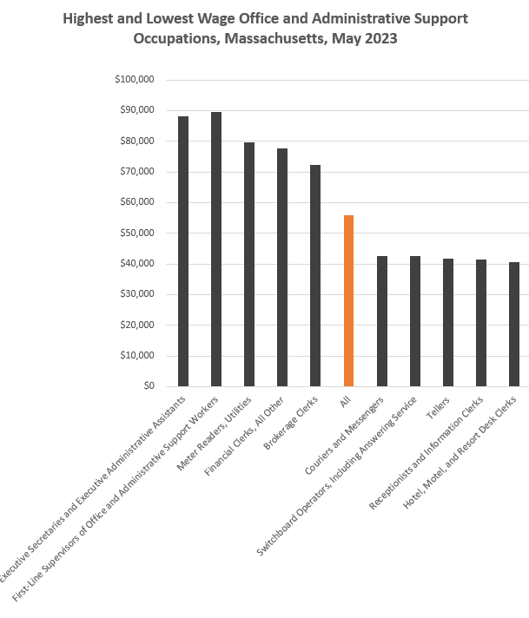

### Sales and Related Occupations

The Sales and Related Occupations Family as a whole accounts for more than a quarter million jobs in Massachusetts. The average earnings for this family of occupations ($61,060) are almost 20% lower than the state average.

#### Tables 5 and 6: Employment and Wages, Sales and Related Detailed Occupations, Massachusetts

|  |  |  |  |  |
| --- | --- | --- | --- | --- |
| Occupation | 2023 Jobs | 2023 Mean Wages | Experienced Annual Wages | Typical Education Requirement |
| Total Sales and Related Occupations | 287,260 | $61,060 | $74,710 | None |
| Retail Salespersons | 83,780 | $40,490 | $44,240 | None |
| Cashiers | 66,760 | $34,950 | $36,420 | None |
| Sales Representatives, Wholesale and Manufacturing, Except Technical and Scientific | 27,460 | $85,190 | $103,850 | High school |
| Sales Representatives of Services, Except Advertising, Insurance, Financial and Travel | 25,530 | $89,110 | $108,930 | High school |
| First-Line Supervisors of Retail Sales Workers | 23,290 | $57,210 | $65,790 | High school |
| Securities, Commodities, and Financial Services Sales Agents | 13,610 | $110,510 | $137,290 | Bachelor's |

|  |  |  |  |  |
| --- | --- | --- | --- | --- |
| Occupation | 2023 Jobs | 2023 Mean Wages | Experienced Annual Wages | Typical Education Requirement |
| Sales Representatives, Wholesale and Manufacturing, Technical and Scientific Products | 10,430 | $114,720 | $141,660 | Bachelor's |
| Insurance Sales Agents | 10,000 | $100,590 | $128,070 | High school |
| First-Line Supervisors of Non-Retail Sales Workers | 4,830 | $120,710 | $146,580 | High school |
| Counter and Rental Clerks | 4,350 | $44,650 | $49,470 | None |
| Parts Salespersons | 3,570 | $45,100 | $50,190 | None |
| Sales Engineers | 2,820 | $126,490 | $148,510 | Bachelor's |
| Travel Agents | 2,110 | $57,920 | $65,740 | High school |
| Advertising Sales Agents | 1,320 | $78,140 | $92,290 | High school |
| Real Estate Brokers | 1,310 | $127,810 | $163,800 | High school |
| Market Research Analysts and Marketing Specialists | 27,020 | $92,260 | $111,180 | Bachelor’s |

While Market Research Analysts and Marketing Specialists are employed by dozens of industries, one industry is specifically defined by its output of marketing services: Marketing Consulting Services (NAICS 541613). This industry is defined by the United States Census Bureau this way:

*This U.S. industry comprises establishments primarily engaged in providing operating advice and assistance to businesses and other organizations on marketing issues, such as developing marketing objectives and policies, sales forecasting, new product developing and pricing, licensing and franchise planning, and marketing planning and strategy.*

Employment in this industry peaked at 8,301 Massachusetts jobs in 2019 and has yet to recover to pre-pandemic levels.

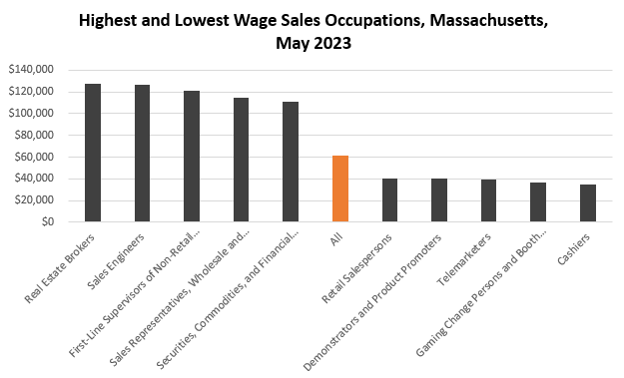

### Employment Trends-Office and Administrative Support, Sales and Related, and Business and Financial Operations Occupations

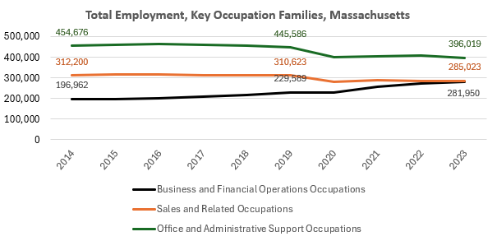

#### Table 7: Marketing Industry Trends

|  |  |  |  |  |  |  |  |  |  |
| --- | --- | --- | --- | --- | --- | --- | --- | --- | --- |
| **NAICS** | **Description** | **2014** | **2016** | **2019** | **2020** | **2023** | **Change** | **% Change** | **2023 Locations** |
| 541613 | Marketing Consulting Services | 7,398 | 8,252 | 8,301 | 7,989 | 7,676 | 278 | 3.8% | 1,634 |

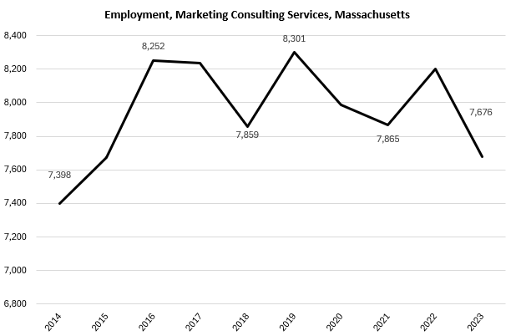

### Key Findings

A detailed analysis of the Programs of study, related industries, and related occupations led to several key conclusions:

1. **Low Wage and High Demand**

The occupations associated with these programs tend to pay lower-than-average wages, but account for a significant portion of the Commonwealth’s workforce

1. **Career outlooks for the target occupations**

While these occupations tend to be low-wage in and of themselves, they do provide entrée into higher-value career pathways and more sophisticated careers with the addition of experience and/or additional education.

1. **The importance of a driver’s license**

A valid driver's license is by far the most mentioned qualification for careers in these fields, making it not only a value to the individual on a personal level, but also as a career-related asset.

## Occupation Profiles and Job Postings

### O*Net Occupation Profile-Hairdressers, Hairstylists and Cosmetologists

The United States Department of Labor, Employment and Training Administration created and regularly updates more than 800 occupational profiles with characteristics like skills, educational requirements, and daily tasks, based on the inputs of industry experts and people who are employed in the occupations.

#### Description

Hairdressers, Hairstylists and Cosmetologists provide beauty services, such as cutting, coloring, and styling hair, and massaging and treating scalp. They may shampoo hair, apply makeup, dress wigs, remove hair, and provide nail and skincare services.

#### Top Skills

* Giving full attention to what other people are saying, taking time to understand the points being made, asking questions as appropriate, and not interrupting at inappropriate times.
* Talking to others to convey information effectively.
* Actively looking for ways to help people.
* Using logic and reasoning to identify the strengths and weaknesses of alternative solutions, conclusions, or approaches to problems.
* Understanding the implications of new information for both current and future problem-solving and decision-making.
* Considering the relative costs and benefits of potential actions to choose the most appropriate one.
* Being aware of others' reactions and understanding why they react as they do.
* Identifying complex problems and reviewing related information to develop and evaluate options and implement solutions.
* Monitoring/assessing performance of yourself, other individuals, or organizations to make improvements or take corrective action.
* Understanding written sentences and paragraphs in work-related documents.
* Managing one's own time and the time of others.
* Adjusting actions in relation to others' actions.
* Teaching others how to do something.
* Selecting and using training/instructional methods and procedures appropriate for the situation when learning or teaching new things.
* Persuading others to change their minds or behavior.
* Communicating effectively in writing as appropriate for the needs of the audience.
* Bringing others together and trying to reconcile differences.
* Motivating, developing, and directing people as they work, identifying the best people for the job.
* Analyzing needs and product requirements to create a design.

#### Top Daily Tasks

* Clean facilities or work areas.
* Clean tools or equipment.
* Apply solutions to hair for therapeutic or cosmetic purposes.
* Groom wigs or hairpieces.
* Trim client hair.
* Schedule appointments.
* Demonstrate activity techniques or equipment use.
* Maintain client information or service records.
* Promote products, services, or programs.
* Sell products or services.
* Assess skin or hair conditions.
* Supervise service workers.
* Train service staff.
* Apply cleansing or conditioning agents to client hair, scalp, or skin.
* Administer therapeutic massages.
* Operate cash registers.
* Provide medical or cosmetic advice for clients.
* Order materials, supplies, or equipment.
* Set up merchandise displays.
* Administer basic health care or medical treatments.
* Design costumes or cosmetic effects for characters.
* Treat nails by shaping, decorating, or augmenting.

#### Additional Information

* American Association of Cosmetology Schools
* Professional Beauty Association

### O*Net Occupation Profile-Customer Service Representative

The United States Department of Labor, Employment and Training Administration created and regularly updates more than 800 occupational profiles with characteristics like skills, educational requirements, and daily tasks, based on the inputs of industry experts and people who are employed in the occupations.

#### Description

Interact with customers to provide basic or scripted information in response to routine inquiries about products and services. May handle and resolve general complaints. Excludes individuals whose duties are primarily installation, sales, repair, and technical support.

#### Top Skills:

* Giving full attention to what other people are saying, taking time to understand the points being made, asking questions as appropriate, and not interrupting at inappropriate times.
* Actively looking for ways to help people.
* Talking to others to convey information effectively.
* Understanding written sentences and paragraphs in work-related documents.
* Using logic and reasoning to identify the strengths and weaknesses of alternative solutions, conclusions, or approaches to problems.
* Identifying complex problems and reviewing related information to develop and evaluate options and implement solutions.
* Managing one's own time and the time of others.
* Monitoring/assessing performance of yourself, other individuals, or organizations to make improvements or take corrective action.
* Bringing others together and trying to reconcile differences.
* Persuading others to change their minds or behavior.
* Being aware of others' reactions and understanding why they react as they do.
* Communicating effectively in writing as appropriate for the needs of the audience.
* Understanding the implications of new information for both current and future problem-solving and decision-making.
* Adjusting actions in relation to others' actions.
* Considering the relative costs and benefits of potential actions to choose the most appropriate one.

#### Top Daily Tasks:

* Discuss goods or services information with customers or patrons.
* Maintain financial or account records.
* Respond to customer problems or complaints.
* Provide notifications to customers or patrons.
* Calculate costs of goods or services.
* Collect deposits, payments or fees.
* Execute sales or other financial transactions.
* Prepare documentation for contracts, transactions, or regulatory compliance.
* Refer customers to appropriate personnel.
* Review customer insurance information.
* Promote products, services, or programs.
* Process customer bills or payments.
* Verify accuracy of financial or transactional data.
* Recommend packing or shipping methods.

#### Professional Associations:

* U.S. Chamber of Commerce

#### Job Postings – Customer Service Representatives

P2C uses a third-party system that aggregates data from job postings to provide perspective on the skills and qualifications employers are prioritizing in their advertisements for these occupations.

* After controlling for multiple postings that likely referenced the same single opening, over the last year, we identified 14,295 unique job postings for Customer Service Representatives.
* We identified 3,109 unique employers who posted openings online.

##### Top Employers Advertising:

* Walgreens Boots Alliance
* Fidelity Investments
* Domino's Pizza
* Hire Standard Staffing
* U-Haul
* Robert Half
* Eastern Bank
* Amazon
* Panera Bread
* Chico's FAS
* Sherwin-Williams
* Express Employment Professionals
* The Hospitals of Providence
* Planet Fitness
* Randstad
* TEKsystems
* The Home Depot
* Penske Automotive Group
* Adecco
* Family Dollar

##### Top Job Titles:

* Customer Service Representatives
* Customer Service Associates
* Pharmacy Service Associates
* Call Center Representatives
* Client Service Representatives
* Service Advisors
* Customer Service Cashiers
* Customer Service Specialists
* Member Service Representatives
* Client Service Associates
* Customer Care Representatives
* Service Writers
* Hiring Managers
* Customer Support Specialists
* Food Service Associates
* Support Associates
* Customer Service Leads
* Service Associates
* Customer Relationship Advocates
* Benefits Customer Service Representatives

##### Top Qualifications:

* Valid Driver's License

### O*Net Occupation Profile-Bookkeeping, Accounting and Auditing Clerks

The United States Department of Labor, Employment and Training Administration created and regularly updates more than 800 occupational profiles with characteristics like skills, educational requirements, and daily tasks, based on the inputs of industry experts and people who are employed in the occupations.

#### Description

Compute, classify, and record numerical data to keep financial records complete. Perform any combination of routine calculating, posting, and verifying duties to obtain primary financial data for use in maintaining accounting records. May also check the accuracy of figures, calculations, and postings pertaining to business transactions recorded by other workers.

#### Top Skills:

* Using mathematics to solve problems.
* Giving full attention to what other people are saying, taking time to understand the points being made, asking questions as appropriate, and not interrupting at inappropriate times.
* Using logic and reasoning to identify the strengths and weaknesses of alternative solutions, conclusions, or approaches to problems.
* Understanding written sentences and paragraphs in work-related documents.
* Talking to others to convey information effectively.
* Communicating effectively in writing as appropriate for the needs of the audience.
* Monitoring/assessing performance of yourself, other individuals, or organizations to make improvements or take corrective action.
* Managing one's own time and the time of others.
* Identifying complex problems and reviewing related information to develop and evaluate options and implement solutions.
* Adjusting actions in relation to others' actions.
* Actively looking for ways to help people.
* Understanding the implications of new information for both current and future problem-solving and decision-making.
* Considering the relative costs and benefits of potential actions to choose the most appropriate one.
* Being aware of others' reactions and understanding why they react as they do.
* Bringing others together and trying to reconcile differences.

#### Top Daily Tasks:

* Operate computers or computerized equipment.
* Execute sales or other financial transactions.
* Verify accuracy of financial or transactional data.
* Compile data or documentation.
* Prepare cash for deposit or disbursement.
* Monitor organizational compliance with regulations.
* Collect deposits, payments or fees.
* Operate office equipment.
* Calculate financial data.
* Reconcile records of sales or other financial transactions.
* Monitor financial information.
* Code data or other information.
* Answer telephones to direct calls or provide information.
* File documents or records.
* Search files, databases or reference materials to obtain needed information.
* Convert data among multiple digital or analog formats.
* Maintain financial or account records.
* Prepare documentation for contracts, transactions, or regulatory compliance.
* Calculate costs of goods or services.
* Maintain inventory records.

#### Professional Associations:

* American Institute of Professional Bookkeepers

#### Job Postings – Bookkeeping, Accounting and Auditing Clerks

P2C uses a third-party system that aggregates data from job postings to provide perspective on the skills and qualifications employers are prioritizing in their advertisements for these occupations.

* After controlling for multiple postings that likely referenced the same single opening, over the last year, we identified 5,452 unique job postings for Bookkeeping, Accounting and Auditing Clerks.
* We identified 2,017 unique employers who posted openings online.

##### Top Employers Advertising:

* Robert Half
* Roessel Joy
* Creative Financial Staffing
* Randstad
* KBW Financial Staffing & Recruiting
* Vaco
* Beacon Hill Staffing Group
* Amazon
* Nr Consulting
* Kelly Services
* Express Employment Professionals
* Ledgent
* Beth Israel Lahey Health
* FIS
* SNI Companies
* Kforce
* UMass Memorial Health
* Aston Carter
* Ascendo Resources
* The College Board

##### Top Job Titles:

* Accounts Payable Specialists
* Bookkeepers
* Accounts Receivable Specialists
* Accounting Clerks
* Accounts Payable Clerks
* Accounting Assistants
* Accounts Payable Coordinators
* Accounting Specialists
* Accounts Receivable Clerks
* Full Charge Bookkeepers
* Accounts Payable Administrators
* Accounts Payable/Accounts Receivable Specialists
* Accounts Payable Associates
* Accounts Payable/Accounts Receivable Clerks
* Accounts Receivable Coordinators
* Financial Assistants
* Accounts Payable Representatives
* Cash Applications Specialists
* Accounts Payable Assistants
* Accounts Payable Processors

##### Top Skills:

###### Common Skills:

* Detail Orientation
* Communication
* Management
* Customer Service
* Organizational Skills

###### Specialized Skills:

* Accounting
* Accounts Payable
* Invoicing
* Accounts Receivable
* Financial Statements
* Data Entry

###### Software Skills:

* Microsoft Excel
* Accounting Software
* Microsoft Office
* QuickBooks
* SAP Applications
* PeopleSoft Applications

##### Top Qualifications:

* Valid Driver's License
* Certified Public Accountant
* Certified Internet Webmaster
* Board Certified/Board Eligible
* Certified Bookkeeper
* Medical Coding Certification
* Certified Accounting Technician
* QuickBooks Certification
* Accredited ACH Professional
* Chartered Financial Analyst
* Financial Accounting Standards Board (FASB) Certified

### O*Net Occupation Profile-Project Management Specialists

The United States Department of Labor, Employment and Training Administration created and regularly updates more than 800 occupational profiles with characteristics like skills, educational requirements, and daily tasks, based on the inputs of industry experts and people who are employed in the occupations.

#### Description

Analyze and coordinate the schedule, timeline, procurement, staffing, and budget of a product or service on a per-project basis. Lead and guide the work of technical staff. May serve as a point of contact for the client or customer.

#### Top Tasks:

* Assign duties or responsibilities to project personnel.
* Communicate with key stakeholders to determine project requirements and objectives.
* Confer with project personnel to identify and resolve problems.
* Create project status presentations for delivery to customers or project personnel.
* Develop or update project plans including information, such as objectives, technologies, schedules, funding, and staffing.
* Identify project needs such as resources, staff, or finances by reviewing project objectives and schedules.
* Identify, review, or select vendors or consultants to meet project needs.
* Monitor costs incurred by project staff to identify budget issues.
* Monitor project milestones and deliverables.
* Monitor the performance of project team members to provide performance feedback.
* Negotiate with project stakeholders or suppliers to obtain resources or materials.
* Plan, schedule, or coordinate project activities to meet deadlines.
* Prepare and submit budget estimates, progress reports, or cost tracking reports.
* Produce and distribute project documents.
* Propose, review, or approve modifications to project plans.
* Recruit or hire project personnel.
* Report project status, such as budget, resources, technical issues, or customer satisfaction, to managers.
* Request and review project updates to ensure deadlines are met.
* Schedule or facilitate project meetings.
* Submit project deliverables to clients, ensuring adherence to quality standards.

#### Top Detailed Work Activities:

* Develop detailed project plans.
* Manage information technology projects or system activities.
* Participate in staffing decisions.
* Assign duties or work schedules to employees.
* Collaborate with others to resolve information technology issues.
* Coordinate resource procurement activities.
* Develop operating strategies, plans, or procedures.
* Discuss business strategies, practices, or policies with managers.
* Gather organizational performance information.
* Manage construction activities.
* Manage operations, research, or logistics projects.
* Monitor flow of cash or other resources.
* Prepare financial documents, reports, or budgets.
* Prepare operational reports or records.
* Prepare scientific or technical reports or presentations.
* Present work to clients for approval.
* Report information to managers or other personnel.
* Select resources needed to accomplish tasks.
* Supervise information technology personnel.

#### Professional Associations:

* American Society for Engineering Management
* Association for Project Management
* Association for Supply Chain Management
* Association of Business Process Management Professionals
* Financial Management Association International
* Institute for Supply Management
* Institute of Management Consultants USA
* International Association of Emergency Managers
* National Association of Women in Construction
* National Contract Management Association
* National Management Association
* National Society of Black Engineers
* Society for Human Resource Management
* Society for Information Management
* Accreditation, Certification, & Unions
* CompTIA
* Project Management Institute
* AACE International
* American Management Association
* Institute of Certified Professional Managers
* World Commerce and Contracting

#### Job Postings – Project Management Specialists

P2C uses a third-party system that aggregates data from job postings to provide perspective on the skills and qualifications employers are prioritizing in their advertisements for these occupations.

* After controlling for multiple postings that likely referenced the same single opening, over the last year, we identified 9,289 unique job postings for Project Management Specialists.
* We identified 2,680 unique employers who posted openings online.

##### Top Employers Advertising:

* GPAC
* CyberCoders
* Actalent
* PageGroup
* Harvard University
* Mass General Brigham
* Brigham and Womens Hospital
* Randstad
* University of Massachusetts
* Dana-Farber Cancer Institute
* Massachusetts General Hospital
* National Grid
* The Judge Group
* Insight Global
* CBRE
* Kforce
* Stantec
* Eversource Energy
* AECOM
* Consigli Construction Co.

##### Top Job Titles:

* Project Managers
* Project Coordinators
* Assistant Project Managers
* Technical Project Managers
* Environmental Project Managers
* Commercial Drywall Project Managers
* Research Project Managers
* Associate Project Managers
* Capital Project Managers
* Project Management Managers
* Directors of Projects
* Infrastructure Project Managers
* Directors of Project Management
* Life Sciences Account Managers
* Operations Project Managers
* Commercial Project Managers
* Marketing Project Managers
* Architectural Project Managers
* Real Estate Project Managers
* Survey Project Managers

##### Top Qualifications:

* Project Management Professional Certification
* Valid Driver's License
* Project Management Certification
* 10-Hour OSHA General Industry Card
* Certified Scrum Master
* Certified Associate In Project Management