# Labor Market Analysis of Skills Related to Carpentry in Massachusetts

## Table of Contents­­

Labor Market Analysis of Skills Related to Carpentry in Massachusetts 0

Table of Contents 1

Overview 2

The Construction Industry 2

The Construction Industry in Labor Market Data Systems 2

Employment-Carpenters and Carpenter Helpers 3

Employment Trends 4

Wages, Salaries and Proprietor Earnings 7

The Pathways 7

Carpentry Occupations and Pathways 7

Occupation Profile 8

## Overview

This analysis uses labor market data from the Massachusetts Department of Economic Research provide perspective on two theaters related to carpentry: the construction industry and the occupations in the career pathway.

The industry should be understood as the employers in the Commonwealth whose primary line of business is construction. Those companies employ a spectrum of occupations, ranging from skilled tradesmen to real estate agents. While trends in the construction industry are not necessarily directly related to carpentry, the large majority of carpenters work for construction companies, making its realities and trends a valuable backdrop against which to evaluate carpentry careers in Massachusetts.

In public data systems, occupations are a set of tasks regularly performed by one individual on an employer’s payroll. In this analysis, occupations related to carpentry are profiled in a career pathway framework as we seek to provide strategic value in the development and administration of carpentry curriculum and the construction of compelling and instructive narrative that will introduce students to the world of carpentry.

## The Construction Industry

### The Construction Industry in Labor Market Data Systems

Construction (NAICS code 23) comprises all employers whose primary line of business is construction. The industry category is divided into three sub-industries:

* 236-Construction of Buildings
* 237-Heavy and Civil Engineering Construction
* 238-Specialty Trades Contractors

Each of these categories is further parsed into four-, five-, and ultimately six-digit level categories, and the Massachusetts Department of Economic Research produces employment and wage estimates for each.

Among the detailed industry categories, the highest wages are found in employers from the Offices of Physicians (NAICS 62111) category. The lowest are in Continuing Care Retirement Communities and Elderly Assisted Living Facilities (62331).

#### Construction Industry Categories

* 236 Construction of Buildings
  + 236115 New Single-Family Housing Construction (except For-Sale Builders)
  + 236116 New Multifamily Housing Construction (except For-Sale Builders)
  + 236117 New Housing For-Sale Builders
  + 236118 Residential Remodelers
  + 236210 Industrial Building Construction
  + 236220 Commercial and Institutional Building Construction
* 237 Heavy and Civil Engineering Construction
  + 237110 Water and Sewer Line and Related Structures Construction
  + 237120 Oil and Gas Pipeline and Related Structures Construction
  + 237130 Power and Communication Line and Related Structures Construction
  + 237210 Land Subdivision
  + 237310 Highway, Street, and Bridge Construction
  + 237990 Other Heavy and Civil Engineering Construction
* 238 Specialty Trades Contractors
  + 238110 Poured Concrete Foundation and Structure Contractors
  + 238120 Structural Steel and Precast Concrete Contractors
  + 238130 Framing Contractors
  + 238140 Masonry Contractors
  + 238150 Glass and Glazing Contractors
  + 238160 Roofing Contractors
  + 238170 Siding Contractors
  + 238190 Other Foundation, Structure, and Building Exterior Contractors
  + 238210 Electrical Contractors and Other Wiring Installation Contractors
  + 238220 Plumbing, Heating, and Air-Conditioning Contractors
  + 238290 Other Building Equipment Contractors
  + 238310 Drywall and Insulation Contractors
  + 238320 Painting and Wall Covering Contractors
  + 238330 Flooring Contractors
  + 238340 Tile and Terrazzo Contractors
  + 238350 Finish Carpentry Contractors
  + 238390 Other Building Finishing Contractors

### Employment-Carpenters and Carpenter Helpers

It is not surprising that the type of business that most often employs carpenters and carpenter helpers is Construction of Buildings (NAICS 236). More than 40% work in that industry, while another 40% are employed at Specialty Trade Contractors (NAICS 238). It is interesting to note that the third most common type of employer for these occupations is Administrative and Support Services (NAICS 561), which employs more carpenters and carpenter helpers than the Heavy and Civil Engineering Construction industry (NAICS 237).

#### Table 1: Top Industries for Carpenters and Carpenter Helpers

|  |  |
| --- | --- |
| Industry | Share of Occupation Jobs |
| Construction of Buildings | 44.2% |
| Specialty Trade Contractors | 40.3% |
| Administrative and Support Services | 2.8% |
| Heavy and Civil Engineering Construction | 2.2% |
| Local Government | 1.0% |

### Employment Trends

The number of people employed in the Construction industry in Massachusetts has been steadily increasing over the last decade, except for a significant COVID-19-related decline in 2020. The net change has been an increase of 35.9% in jobs over the last decade.

#### Table 2: Average Annual Employment, Construction Industry, Massachusetts, 2014-2023

|  |  |
| --- | --- |
| Year | Jobs |
| 2014 | 128,919 |
| 2015 | 138,991 |
| 2016 | 146,503 |
| 2017 | 152,131 |
| 2018 | 158,656 |
| 2019 | 163,062 |
| 2020 | 152,366 |
| 2021 | 164,435 |
| 2022 | 169,132 |
| 2023 | 175,182 |

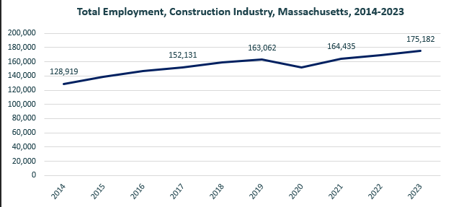

When we break down the growth of the Construction industry, we see that while growth has been seen in all three construction sectors, growth in both the total number of jobs and the percentage of jobs added has been led by the Specialty Trades Contractors sector.

#### Tables 3 and 4: Employment Change, Construction Industries, Massachusetts, 2014-2023

|  |  |  |  |  |  |  |  |
| --- | --- | --- | --- | --- | --- | --- | --- |
| Industry | 2014 | 2018 | 2019 | 2020 | 2021 | 2022 | 2023 |
| Construction of Buildings | 27,137 | 33,381 | 34,166 | 32,452 | 34,825 | 35,900 | 37,092 |
| Heavy/Civil Engineering Construction | 12,671 | 14,105 | 13,893 | 13,820 | 13,843 | 14,128 | 14,325 |
| Specialty Trade Contractors | 89,112 | 111,169 | 115,003 | 106,094 | 115,768 | 119,104 | 123,765 |

|  |  |  |
| --- | --- | --- |
| Industry | Change | % Change |
| Construction of Buildings | 9,955 | 36.7% |
| Heavy/Civil Engineering Construction | 1,654 | 13.1% |
| Specialty Trade Contractors | 34,654 | 38.9% |

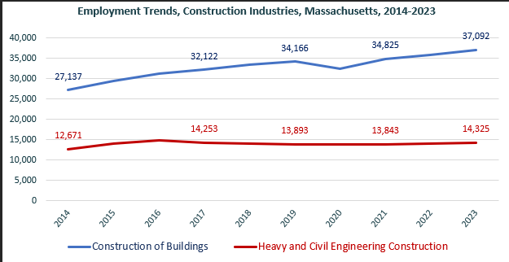

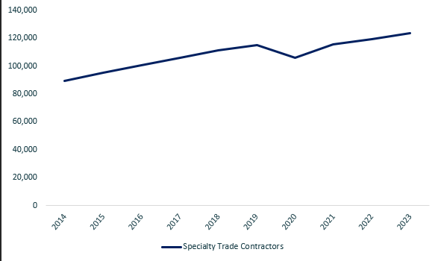

At the most detailed level available, we see that growth was led over the decade by Poured Concrete Contractors (NAICS 238110) and Residential Remodelers (NAICS 236118).

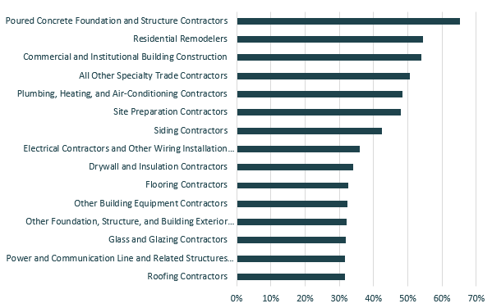

### Wages, Salaries and Proprietor Earnings

Among the detailed industry categories, the highest wages are found in the Industrial Building and Power Line Construction employers. The lowest are in Residential Remodelers and Painting Contractors.

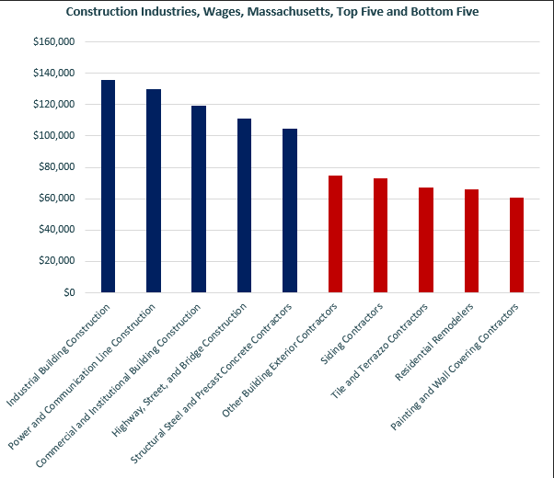

## The Pathways

### Carpentry Occupations and Pathways

This section looks at two entry-level occupations, Carpenters Helpers and Carpenters. It will also consider advancement opportunities in related careers that are not purely carpentry-related, but that illustrate opportunities that may be available to carpenters with additional experience and education.

#### Table 5: Carpentry Occupations, Massachusetts

|  |  |  |  |  |  |
| --- | --- | --- | --- | --- | --- |
| Occupation | 2023 Jobs | Turnover Rate | 2014 - 2023 Change | 2014 - 2023 % Change | Median Annual Earnings |
| Carpenters | 20,095 | 62% | 4,128 | 26% | $61,027 |
| Helpers--Carpenters | 620 | 84% | (394) | (39%) | $37,856 |

While carpentry-related occupations are certainly viable careers in their own rights, they also can serve as entry points to progressively more sophisticated and better-paying roles.

#### Table 6: Related Career Pathways

|  |  |  |  |
| --- | --- | --- | --- |
| Occupation | Job Zone | Typical Education Requirement | Median Annual Earnings |
| Helpers--Carpenters | One | None | $37,856 |
| Construction Laborers | One | None | $56,722 |
| Carpenters | Two | High School | $61,027 |
| First-Line Supervisors of Construction Workers | Three | Postsecondary Certificate | $98,114 |
| Construction Managers | Four | Bachelor’s Degree | $119,413 |
| Cost Estimators | Four | Bachelor’s Degree | $98,842 |

### Occupation Profile

The United States Department of Labor, Employment and Training Administration created and regularly updates more than 800 occupational profiles with characteristics like skills, educational requirements and daily tasks, based on the inputs of industry experts and people who are employed in the occupations.

#### Carpenters

##### Top Skills

* Identifying information by categorizing, estimating, recognizing differences or similarities, and detecting changes in circumstances or events.
* Observing, receiving, and otherwise obtaining information from all relevant sources.
* Monitoring and reviewing information from materials, events, or the environment, to detect or assess problems.
* Inspecting equipment, structures, or materials to identify the cause of errors or other problems or defects.
* Using hands and arms in handling, installing, positioning, and moving materials, and manipulating things.
* Performing physical activities that require considerable use of your arms and legs and moving your whole body, such as climbing, lifting, balancing, walking, stooping, and handling materials.
* Providing information to supervisors, co-workers, and subordinates by telephone, in written form, e-mail, or in person.
* Analyzing information and evaluating results to choose the best solution and solve problems.
* Developing specific goals and plans to prioritize, organize, and accomplish your work.
* Compiling, coding, categorizing, calculating, tabulating, auditing, or verifying information or data.

##### Top Daily Activities

* Follow established safety rules and regulations and maintain a safe and clean environment.
* Measure and mark cutting lines on materials, using a ruler, pencil, chalk, and marking gauge.
* Assemble and fasten materials to make frameworks or props, using hand tools and wood screws, nails, dowel pins, or glue.
* Study specifications in blueprints, sketches, or building plans to prepare project layout and determine dimensions and materials required.
* Shape or cut materials to specified measurements, using hand tools, machines, or power saws.
* Verify trueness of structure, using plumb bob and level.
* Inspect ceiling or floor tile, wall coverings, siding, glass, or woodwork to detect broken or damaged structures.
* Erect scaffolding or ladders for assembling structures above ground level.
* Install structures or fixtures, such as windows, frames, floorings, trim, or hardware, using carpenters' hand or power tools.
* Maintain records, document actions, and present written progress reports.

##### Additional Information

* [Associated Builders and Contractors](https://www.abc.org/) [external site](https://www.onetonline.org/help/exit?u=https%3A%2F%2Fwww.abc.org%2F&t=Associated%20Builders%20and%20Contractors)
* [Home Builders Institute](https://www.hbi.org/) [external site](https://www.onetonline.org/help/exit?u=https%3A%2F%2Fwww.hbi.org%2F&t=Home%20Builders%20Institute)
* [International Union of Operating Engineers](https://www.iuoe.org/) [external site](https://www.onetonline.org/help/exit?u=https%3A%2F%2Fwww.iuoe.org%2F&t=International%20Union%20of%20Operating%20Engineers)
* [National Association of Home Builders](https://www.nahb.org/) [external site](https://www.onetonline.org/help/exit?u=https%3A%2F%2Fwww.nahb.org%2F&t=National%20Association%20of%20Home%20Builders)
* [National Association of the Remodeling Industry](https://www.nari.org/) [external site](https://www.onetonline.org/help/exit?u=https%3A%2F%2Fwww.nari.org%2F&t=National%20Association%20of%20the%20Remodeling%20Industry)
* [National Center for Construction Education and Research](https://www.nccer.org/) [external site](https://www.onetonline.org/help/exit?u=https%3A%2F%2Fwww.nccer.org%2F&t=National%20Center%20for%20Construction%20Education%20and%20Research)
* [National Wood Flooring Association](https://www.nwfa.org/) [external site](https://www.onetonline.org/help/exit?u=https%3A%2F%2Fwww.nwfa.org%2F&t=National%20Wood%20Flooring%20Association)
* [Occupational Outlook Handbook: Carpenters](https://www.bls.gov/ooh/construction-and-extraction/carpenters.htm) [external site](https://www.onetonline.org/help/exit?u=https%3A%2F%2Fwww.bls.gov%2Fooh%2Fconstruction-and-extraction%2Fcarpenters.htm&t=Occupational%20Outlook%20Handbook%3A%20Carpenters)
* [The Associated General Contractors of America](https://www.agc.org/) [external site](https://www.onetonline.org/help/exit?u=https%3A%2F%2Fwww.agc.org%2F&t=The%20Associated%20General%20Contractors%20of%20America)
* [United Brotherhood of Carpenters and Joiners of America](https://www.carpenters.org/)

##### Job Postings

P2C uses a third-party system that aggregates data from job postings to provide perspective on the skills and qualifications employers are prioritizing in their advertisements for these occupations.

* After controlling for multiple postings that likely referenced the same single opening, over the last year, we identified 1,978 unique job postings for carpenters in Massachusetts.
* We identified 317 unique employers who posted openings online.

###### Top Employers Advertising:

* Aerotek
* Michaels
* PeopleReady
* Resource Options
* Tradesmen International
* University of Massachusetts
* The Hire Culture
* Harvard University
* Tradesource
* UFP Industries

###### Top Job Titles:

* Carpenters
* Lead Carpenters
* Carpenters/Laborers
* Framers
* Finish Carpenters
* Carpenters/Framers
* Construction Carpenters
* Carpenters/Handymen
* Journeyman Carpenters
* Residential Carpenters

###### Top Qualifications:

* Valid Driver's License
* 10-Hour OSHA General Industry Card
* 30-Hour OSHA General Industry Card
* Contractor License
* Security Clearance
* Boom Lift Certification

###### Top Skills:

* Communications
* Customer Service
* Detail Oriented
* Tape Measure
* Problem Solving