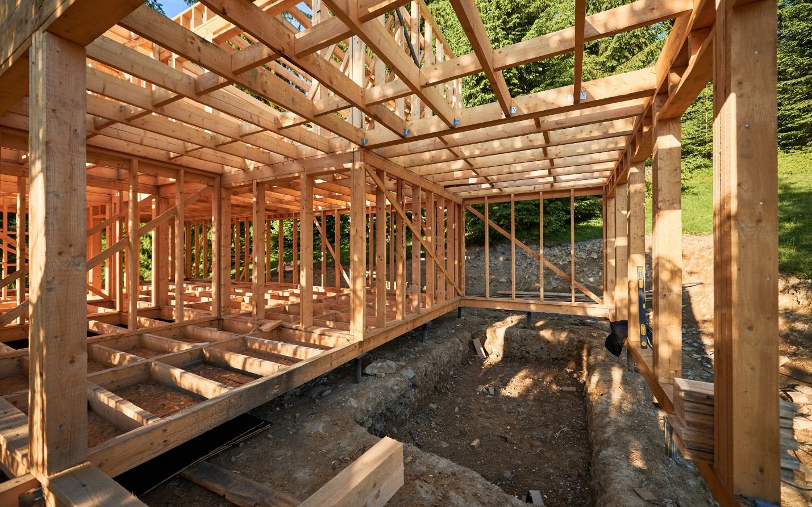

CTE Frameworks - Construction Craft Laborer Equipment List

## Equipment List

### Safety Equipment

* Gloves
* Ear protection
* Safety glasses
* Hard hats
* Steel-toed boots
* Safety vest

### Technical Blueprint Reading

* Architect’s scale
* Protractor
* Calipers
* Compass
* Various measurement tools
* Magnifying glass

### Hand Tools

* Hammer
* Screwdrivers
* Pliers
* Wrenches
* Utility knife
* Tape measure
* Chisels
* Pry bars
* Planing, shaping, and smoothing tools
* Levels
* Hand saws
* Shovels, rakes, picks

### Power and Pneumatic Tools

* Circular saw
* Reciprocating saw
* Wet saw and diamond blades
* Drill/driver
* Impact driver
* Rotary hammer drill
* Power drill
* Angle grinder
* Power sander
* Screw drill
* Table Saw
* Compound Miter Saw
* Jigsaw
* Belt Sander
* Planer
* Router

### Hoisting and Rigging Tools and Equipment

* Manual chain hoists
* Wire rope hoists
* Winch
* Lifting slings and chains
* Lifting magnets
* Pallet jacks
* Hand trucks and carts
* Dollies and rollers

### Trenching and Excavation Tools and Equipment

* Shovels
* Spades
* Trenching picks
* Trenching shovels
* Trenching hoe
* Trenching spades
* Trench boxes/shields
* Tape measures
* Levels
* String lines and stakes
* Trench compaction equipment
* Trenching safety signs and barriers
* Bolt cutters
* Wire brushes

### Pipelaying Tools and Equipment

* Pipe wrenches
* Adjustable wrenches
* Socket wrenches
* Pipe cutters
* Pipe reamers
* Pipe threaders and dies
* Flaring tools
* Pipe deburring tools
* Pipe benders
* Pipe vises and clamps
* Wheelbarrow
* Pipe sealants and lubricants
* Pipe lasers
* Pick axes and Mattocks

### Power and Pneumatic Tools Continued

* Nail Gun
* Air Compressor
* Pressure Washer
* Gas or electric mixers
* Pneumatic Nail Gun
* Pneumatic Stapler
* Pneumatic Drill
* Pneumatic Jackhammer
* Pneumatic Chisel
* Pneumatic Impact Wrench
* Pneumatic Grinder

### Line and Grading Equipment

* Surveying equipment
* Precision optical instrument
* Automatic level
* Laser auto level
* Theodolite
* Grade rods
* GPS receivers
* Plumb bobs
* Engineer’s rules
* Wood Stakes
* Marking paint and flagging
* Compacting/tamping tools

### Masonry Tools and Equipment

* Brick Trowel
* Margin Trowel
* Pointing Trowel
* Mason's Hammer
* Chisels
* Jointers
* Masonry Brushes
* Mason's Levels
* Line Blocks and Mason's Line
* Mixing Equipment
* Masonry Drill and Bits
* Safety Equipment
* Masonry Saw
* Grout Bag

### Demolition Tools

* Sledgehammer
* Demolition hammer
* Crowbar or pry bar
* Air compressor and hoses
* Reciprocating saw
* Circular saw
* Chainsaw
* Wrecking bar
* Bolt cutters
* Angle grinder
* Dust masks or respirators
* Hand tools
* Ladders and scaffolding
* Dumpsters or waste bins
* Fire extinguishers

### Concrete Tools and Equipment

* Concrete mixer
* Concrete vibrator
* Concrete screed
* Concrete float
* Bull float
* Edger
* Groover
* Hand trowels
* Concrete broom
* Concrete saw
* Diamond blades
* Leveling tools, laser, transit
* Concrete formwork
* Concrete finishing brooms
* Concrete sprayer
* Concrete testing equipment
* Fall protection equipment

### Metal Arc Welding Equipment and Tools

* Arc Welder
* Oxy-acetylene cutting torch
* Welding Electrodes (Rods)
* Welding Helmet
* Welding Gloves
* Welding Jacket or Apron
* Welding Electrode Holder (Stinger
* Ground Clamp
* Chipping Hammer and Wire Brush
* Welding Pliers
* Protective Clothing
* Welding Table or Workbench
* Safety Glasses
* Fire Extinguisher

### Ladders and Scaffolds

* Extension ladder
* Step ladder
* Platform ladder
* Aluminum scaffolding
* Rolling scaffolding
* Baker’s scaffolding

### Weatherization Tools and Equipment

* Caulking Gun
* Caulk and Sealant
* Weatherstripping
* Insulation Materials
* Insulation Knife or Utility Knife
* Insulation Blowing Machine
* Staple gun
* Tape measure
* Utility knife
* Vapor barrier materials
* Foam sealant
* Putty knife or spreader
* Mastic or foil tape
* Dust masks and respirators
* Ladder or scaffolding
* Flashlight or work light
* Moisture meter