Labor Market Analysis of the Construction-Related Industry in Massachusetts

## Overview

This analysis uses labor market data from the Massachusetts Department of Economic Research to provide perspective on two theaters related to the skilled trades in the construction field: the construction industry and thirteen occupations in the career pathway commonly referred to as the Skilled Trades:

1. Brickmasons and Blockmasons
2. Stonemasons
3. Carpenters
4. Tile and Stone Setters
5. Cement Masons and Concrete Finishers
6. Operating Engineers and Other Equipment Operators
7. Electricians
8. Painters, Construction, and Maintenance
9. Pipelayers
10. Plumbers, Pipefitters, and Steamfitters
11. Reinforcing Iron and Rebar Workers
12. Sheet Metal Workers
13. Structural Iron and Steel Workers

The industry should be understood as the employers in the Commonwealth whose primary line of business is construction. Those companies employ a spectrum of occupations, ranging from skilled tradesmen to real estate agents. While trends in the construction industry are not necessarily directly related to the skilled trades, the large majority of tradesmen work for construction companies, making its realities and trends a valuable backdrop against which to evaluate these careers in Massachusetts.

In public data systems, occupations are a set of tasks regularly performed by one individual on an employer’s payroll. In this analysis, the target occupations are profiled both as a set and individually as we seek to provide strategic value in the development and administration of related curriculum and the construction of compelling and instructive narratives that will introduce students to the world of the skilled trades in the 21st Century.

## The Construction Industry

### The Construction Industry in Labor Market Data Systems

Construction (NAICS code 23) comprises all employers whose primary line of business is construction. The industry category is divided into three sub-industries:

* 236-Construction of Buildings
* 237-Heavy and Civil Engineering Construction
* 238-Specialty Trades Contractors

Each of these categories is further parsed into four-, five-, and ultimately six-digit level categories, and the Massachusetts Department of Economic Research produces employment and wage estimates for each.

#### Construction Industry Categories

* 236 Construction of Buildings
  + 236115 New Single-Family Housing Construction (except For-Sale Builders)
  + 236116 New Multifamily Housing Construction (except For-Sale Builders)
  + 236117 New Housing For-Sale Builders
  + 236118 Residential Remodelers
  + 236210 Industrial Building Construction
  + 236220 Commercial and Institutional Building Construction
* 237 Heavy and Civil Engineering Construction
  + 237110 Water and Sewer Line and Related Structures Construction
  + 237120 Oil and Gas Pipeline and Related Structures Construction
  + 237130 Power and Communication Line and Related Structures Construction
  + 237210 Land Subdivision
  + 237310 Highway, Street, and Bridge Construction
  + 237990 Other Heavy and Civil Engineering Construction
* 238 Specialty Trades Contractors
  + 238110 Poured Concrete Foundation and Structure Contractors
  + 238120 Structural Steel and Precast Concrete Contractors
  + 238130 Framing Contractors
  + 238140 Masonry Contractors
  + 238150 Glass and Glazing Contractors
  + 238160 Roofing Contractors
  + 238170 Siding Contractors
  + 238190 Other Foundation, Structure, and Building Exterior Contractors
  + 238210 Electrical Contractors and Other Wiring Installation Contractors
  + 238220 Plumbing, Heating, and Air-Conditioning Contractors
  + 238290 Other Building Equipment Contractors
  + 238310 Drywall and Insulation Contractors
  + 238320 Painting and Wall Covering Contractors
  + 238330 Flooring Contractors
  + 238340 Tile and Terrazzo Contractors
  + 238350 Finish Carpentry Contractors
  + 238390 Other Building Finishing Contractors

### Employment-Skilled Trades

It is not surprising that at the most general level available, the industry that most often employ skilled tradespeople in Massachusetts is Construction (NAICS 23); however, only 35% of skilled tradesmen work for employers whose primary line of business is construction. Just less than 10% work in the Mining, Quarrying and Oil and Gas industry (NAICS21) and another 6% work in Utilities (NAICS 22). The table below details the top five detailed industry sectors by the share of skilled tradespeople who are employed in them.

#### Tables 1 and 2: Top Detailed Industries for Skilled Trades

|  |  |
| --- | --- |
| **Industry** | **Share of Occupation Jobs** |
| Electrical Contractors and Other Wiring Installation Contractors | 19.1% |
| Plumbing, Heating and Air Conditioning Contractors | 18.3% |
| Commercial and Institutional Building Construction | 5.5% |
| Residential Remodelers | 5.2% |
| Painting and Wall Covering Contractors | 4.1% |

|  |  |  |
| --- | --- | --- |
| **Occupation** | **Top Industry** | **Share of Occupation Jobs** |
| Brickmasons and Blockmasons | Masonry Contractors | 77.9% |
| Stonemasons | Masonry Contractors | 62.4% |
| Carpenters | Residential Remodelers | 17.4% |
| Tile and Stone Setters | Finish Carpentry Contractors | 27.2% |
| Cement Masons and Concrete Finishers | Poured Concrete Foundation and Structure Contractors | 33.8% |
| Operating Engineers and Other Equipment Operators | Site Preparation Contractors | 20.1% |
| Electricians | Electrical Contractors | 74.9% |
| Painters, Construction, and Maintenance | Painting and Wall Covering Contractors | 66.9% |
| Pipelayers | Water and Sewer Line Construction | 17.1% |
| Plumbers, Pipefitters, and Steamfitters | Plumbing, Heating and Air Conditioning Contractors | 77.3% |
| Reinforcing Iron and Rebar Workers | Glass and Glazing Contractors | 14.5% |
| Sheet Metal Workers | Plumbing, Heating and Air Conditioning Contractors | 58.3% |
| Structural Iron and Steel Workers | Commercial and Institutional Building Construction | 18.4% |

### Employment Trends

The number of people employed in the Construction industry in Massachusetts has been steadily increasing over the last decade, except for a significant COVID-19-related decline in 2020. The net change has been an increase of 35.9% in jobs over the last decade.

#### Table 3: Average Annual Employment, Construction Industry, Massachusetts, 2014-2023

|  |  |
| --- | --- |
| **Year** | **Jobs** |
| 2014 | 128,919 |
| 2015 | 138,991 |
| 2016 | 146,503 |
| 2017 | 152,131 |
| 2018 | 158,656 |
| 2019 | 163,062 |
| 2020 | 152,366 |
| 2021 | 164,435 |
| 2022 | 170,026 |
| 2023 | 176,199 |

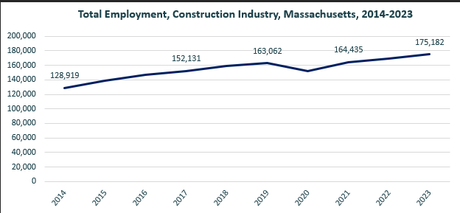

When we break down the growth of the Construction industry, we see that while growth has been seen in all three construction sectors, growth in both the total number of jobs and the percentage of jobs added has been led by the Specialty Trades Contractors sector.

#### Table 4: Employment Change, Construction Industries, Massachusetts, 2014-2023

|  |  |  |  |  |  |  |  |
| --- | --- | --- | --- | --- | --- | --- | --- |
| Industry | 2014 | 2018 | 2019 | 2020 | 2021 | 2022 | 2023 |
| Construction of Buildings | 27,137 | 33,381 | 34,166 | 32,452 | 34,825 | 35,900 | 37,092 |
| Heavy/Civil Engineering Construction | 12,671 | 14,105 | 13,893 | 13,820 | 13,843 | 14,128 | 14,325 |
| Specialty Trade Contractors | 89,112 | 111,169 | 115,003 | 106,094 | 115,768 | 119,104 | 123,765 |

|  |  |  |
| --- | --- | --- |
| Industry | Change | % Change |
| Construction of Buildings | 9,955 | 36.7% |
| Heavy/Civil Engineering Construction | 1,654 | 13.1% |
| Specialty Trade Contractors | 34,654 | 38.9% |

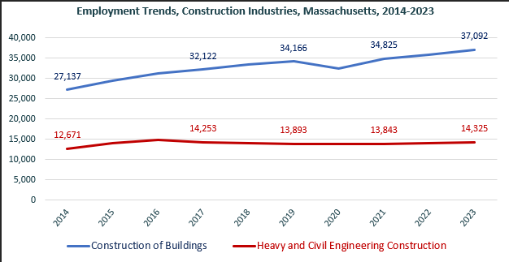

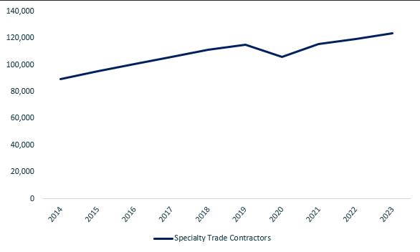

At the most detailed level available, we see that growth was led over the decade by Poured Concrete Contractors (NAICS 238110) and Residential Remodelers (NAICS 236118).

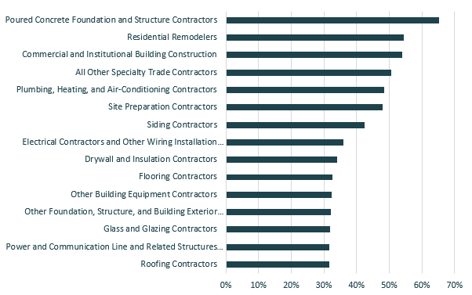

### Wages, Salaries and Proprietor Earnings

Among the detailed industry categories, the highest wages are found in the Industrial Building and Power Line Construction employers. The lowest are in Residential Remodelers and Painting Contractors.

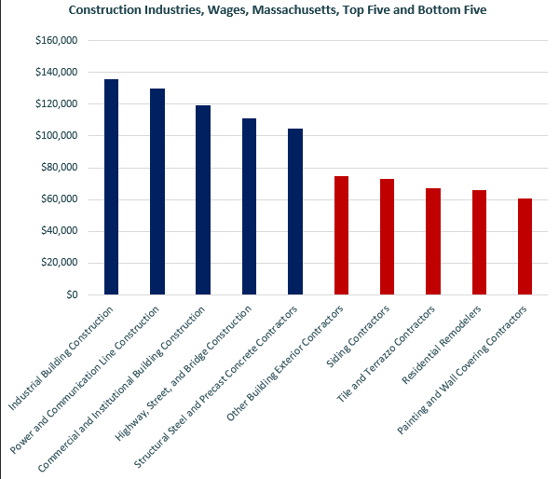

## The Pathways

### Skilled Trades Occupations and Pathways

This section looks at the target occupations and pathways and also considers advancement opportunities in related careers that are not directly related to the program of study, but that illustrate opportunities that may be available to workers in these fields with additional education and experience.

#### Table 5: Occupational Outlook, Massachusetts

|  |  |  |  |  |  |
| --- | --- | --- | --- | --- | --- |
| Occupation | 2023 Jobs | Turnover Rate | 2014 - 2023 Change | 2014 - 2023 % Change | Median Annual Earnings |
| Brickmasons and Blockmasons | 1,586 | 68% | 77 | 5% | $77,355 |
| Stonemasons | 409 | 76.8% | (71) | (15%) | $49,421 |
| Carpenters | 19,001 | 62.5% | 2,407 | 15% | $62,546 |
| Tile and Stone Setters | 208 | 56.8% | (402) | (66%) | $63,939 |
| Cement Masons and Concrete Finishers | 2,756 | 64.2% | 1,355 | 97% | $76,398 |
| Operating Engineers and Other Equipment Operators | 8,094 | 63.0% | 2,163 | 36% | $69,098 |
| Electricians | 18,535 | 49.6% | 3,867 | 26% | $79,747 |
| Painters, Construction, and Maintenance | 4,361 | 62.3% | (144) | (3%) | $55,786 |
| Pipelayers | 201 | 52.9% | (332) | (62%) | $56,264 |
| Plumbers, Pipefitters, and Steamfitters | 15,097 | 48.5% | 4,019 | 36% | $79,830 |
| Reinforcing Iron and Rebar Workers | 188 | 70.7% | (41) | (18%) | $88,392 |
| Sheet Metal Workers | 2,232 | 51.4% | (1,188) | (35%) | $72,259 |
| Structural Iron and Steel Workers | 1,680 | 67.0% | 464 | 38% | $104,125 |

While careers in these occupations are certainly viable in their own rights, they also can serve as entry points to progressively more sophisticated and better-paying roles.

#### Table 6: Related Career Pathways

##### Job Zone Two Occupations

|  |  |  |  |
| --- | --- | --- | --- |
| Occupation | 2023 Jobs | Typical Education Requirement | Median Annual Earnings |
| Brickmasons and Blockmasons | 1,621 | High School | $77,365 |
| Carpenters | 19,001 | High School | $62,546 |
| Tile and Stone Setters | 208 | High School | $63,939 |
| Cement Masons and Concrete Finishers | 2,756 | High School | $76,398 |
| Operating Engineers and Other Equipment Operators | 8,094 | High School | $69,098 |
| Painters, Construction, and Maintenance | 4,361 | High School | $55,786 |
| Pipelayers | 201 | High School | $56,264 |
| Reinforcing Iron and Rebar Workers | 188 | High School | $88,392 |
| Sheet Metal Workers | 2,232 | High School | $72,259 |
| Structural Iron and Steel Workers | 1,680 | High School | $104,125 |
| Stonemasons | 409 | High School | $49,421 |
| Electricians | 18,535 | High School | $79,747 |
| Plumbers, Pipefitters, and Steamfitters | 15,097 | High School | $79,830 |
| Solar Thermal Installers and Technicians | N/A | High School | $79,830 |
| Occupation | 2023 Jobs | Typical Education Requirement | Median Annual Earnings |
| First-Line Supervisors of Construction Trades Workers | 15,683 | High School | $98,592 |
| Energy Auditors | N/A | No Formal Educational Credential | $77,917 (Construction and Building Inspectors) |

##### Job Zone Three Occupations

|  |  |  |  |
| --- | --- | --- | --- |
| Occupation | 2023 Jobs | Typical Education Requirement | Median Annual Earnings |
| Construction and Building Inspectors | 3,848 | Postsecondary Nondegree Award | $77,917 |
| Solar Energy Installation Managers | N/A | Postsecondary Nondegree Award | $98,592  (First-Line Supervisors of Construction Trades Workers |

##### Job Zone Four Occupations

|  |  |  |  |
| --- | --- | --- | --- |
| Occupation | 2023 Jobs | Typical Education Requirement | Median Annual Earnings |
| Energy Engineers (data for Engineers, All Other) | 3,229 | Bachelor’s | $112,690 |
| Construction Managers | 7,087 | Bachelor’s | $131,727 |