# Labor Market Analysis of Skills Related to Cosmetology in Massachusetts

## Table of Contents

Labor Market Analysis of Skills Related to Cosmetology in Massachusetts 0

Table of Contents 1

Overview 2

The Personal Care Services Industry 2

The Personal Care Services Industry in Labor Market Data Systems 2

Employment-Barbers, Hairdressers, Hairstylists and Cosmetologists 3

Employment Trends 3

Wages, Salaries and Proprietor Earnings 7

The Pathways 7

Personal Care and Service Occupations and Pathways 7

Occupation Profile 9

Hairdressers, Hairstylists and Cosmetologists 9

## Overview

This analysis uses labor market data from the Massachusetts Department of Economic Research to provide perspective on two theaters related to Cosmetology: the personal care services industry and key occupations in the personal care and service career pathway.

The industry should be understood as the employers in the Commonwealth such as barber and beauty shops, that provide appearance care services to individual consumers. Those companies employ a spectrum of occupations, ranging from hair stylists and nail technicians to business managers and marketing managers.

In public data systems, occupations are a set of tasks regularly performed by one individual on an employer’s payroll. In this analysis, occupations related to Cosmetologyare profiled in a career pathway framework as we seek to provide strategic value in the development and administration of Cosmetology curriculum and the construction of compelling and instructive narrative that will introduce students to the world of 21st Century cosmetology.

## The Personal Care Services Industry

### The Personal Care Services Industry in Labor Market Data Systems

In public labor market data systems, the Personal Care Services Industry (NAICS 8121) is a component of the Other Services (NAICS 81) sector. This industry group comprises establishments, such as barber and beauty shops, that provide appearance care services to individual consumers. This industry is the largest employer of the occupations targeted by this program of study. The category is then further parsed into four-, five-, and ultimately six-digit level categories, and the Massachusetts Department of Economic Research produces employment and wage estimates for each.

#### Other Industry Categories

81 Other Services

* 811 Repair and Maintenance
* 812 Personal and Laundry Services
  + 8121 Personal Care Service
    - 81211 Hair, Nail and Skin Care Services
      * 812111 Barber Shops
      * 812112 Beauty Salons
      * 812113 Nail Salons
    - 81219 Other Personal Care Services
      * 812191 Diet and Weight Reducing Centers
      * 812199 Other Personal Care Services
  + 8122 Death Care Services
  + 8123 Drycleaning and Laundry Services
  + 8124 Other Personal Services
* 813 Religious, Grantmaking, Civic, Professional, and Similar Organizations
* 814 Private Households

### Employment-Barbers, Hairdressers, Hairstylists and Cosmetologists

More than 10,000 people in Massachusetts are employed in in the Barbers, Hairdressers, Hairstylists, and Cosmetologists occupation category (39-5010). It is not surprising that more than 90% of total employment in these occupations is found in the Personal Care Services industry (NAICS 8121). At a more detailed level, we find that 54.6% of total employment in these occupations is found in the Beauty Salons (812112) sector. Another 21.1% work for Nail Salons (812113). Department Stores, Weight Loss Centers and Barber Shops round out the top five.

#### Table 1: Top Detailed Industries for Target Occupations

|  |  |
| --- | --- |
| Industry | Share of Occupation Jobs |
| Beauty Salons | 54.6% |
| Nail Salons | 21.1% |
| Other Personal Care Services | 12.8% |
| Department Stores | 2.2% |
| Diet and Weight Reducing Centers | 1.8% |

### Employment Trends

The number of people employed in the Personal Care Services industry in Massachusetts was remarkably steady from 2014 to 2019, but the COVID-19 pandemic appears to have had a significant impact with a one-year decrease of 27.7% As of the second quarter of 2023, employment in the industry has yet to return to pre-pandemic levels. The net change has been an increase of 5.4% in jobs over the last decade.

#### Table 2: Average Annual Employment, Personal Care Services Industry, Massachusetts, 2014-2023

|  |  |
| --- | --- |
| Year | Jobs |
| 2014 | 21,671 |
| 2015 | 22,123 |
| 2016 | 22,853 |
| 2017 | 23,613 |
| 2018 | 23,970 |
| 2019 | 24,195 |
| 2020 | 17,486 |
| 2021 | 20,906 |
| 2022 | 21,926 |
| 2023 | 22,852 |

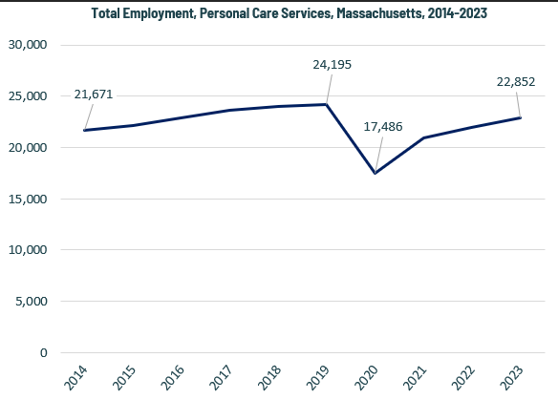

When we break down the growth of the Personal Care Services industry, we see that the largest growth of employment has been in the Nail Salons sector (NAICS 812113), which has added more than 3,000 jobs over that span. Growth as a percentage of total employment has also been fastest in the Nail Salons sector (176%).

#### Tables 3 and 4: Employment Change, Personal Care Services Industries, Massachusetts, 2014-2023

|  |  |  |  |  |  |  |  |
| --- | --- | --- | --- | --- | --- | --- | --- |
| Industry | 2014 | 2018 | 2019 | 2020 | 2021 | 2022 | 2023 |
| Beauty Salons | 16,253 | 16,023 | 15,716 | 11,142 | 12,705 | 13,010 | 13,103 |
| Nail Salons | 2,536 | 4,001 | 4,449 | 3,352 | 4,627 | 5,022 | 5,575 |
| Other Personal Care Services | 1,885 | 2,765 | 2,854 | 2,080 | 2,705 | 3,044 | 3,326 |
| Barber Shops | 302 | 458 | 459 | 359 | 395 | 416 | 441 |
| Diet and Weight Reducing Centers | 696 | 724 | 718 | 553 | 474 | 435 | 407 |

|  |  |  |
| --- | --- | --- |
| Industry | 2014-2023 Change | 2014-2023 % Change |
| Beauty Salons | (3,150) | -19.4% |
| Nail Salons | 3,039 | 119.8% |
| Other Personal Care Services | 1,442 | 76.5% |
| Barber Shops | 139 | 46.1% |
| Diet and Weight Reducing Centers | (289) | -41.5% |

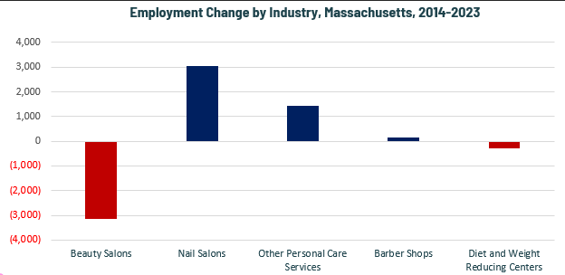

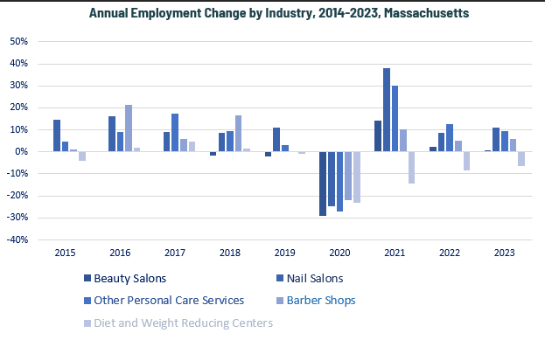

### Wages, Salaries and Proprietor Earnings

Among the detailed industry categories, the highest wages are found among Barber Shops. Beauty Salons rank second for average wages. The lowest wages are in Nail Salons.

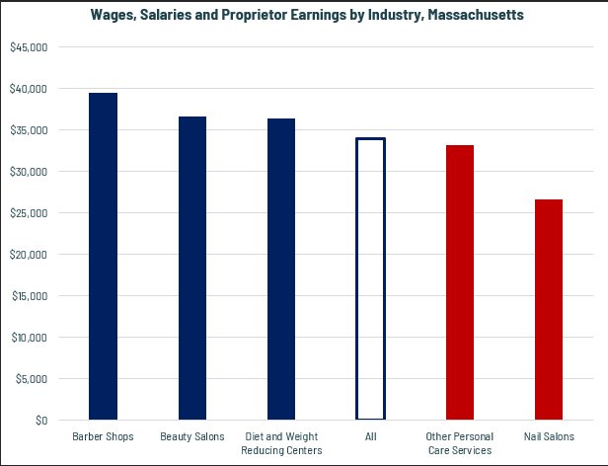

## The Pathways

### Personal Care and Service Occupations and Pathways

This section looks at the primary target occupation category: Barbers, Hairdressers, Hairstylists and Cosmetologists. It will also consider advancement opportunities in related careers that are not directly related to the program of study, but that illustrate opportunities that may be available to workers in these occupations with additional education and experience.

#### Table 5: Personal Care and Service Occupations, Massachusetts

|  |  |  |  |  |  |
| --- | --- | --- | --- | --- | --- |
| Occupation | 2023 Jobs | Turnover Rate | 2014 - 2023 Change | 2014 - 2023 % Change | Median Annual Earnings |
| Barbers | 192 | 48.0% | (71) | (27.1%) | $31,824 |
| Hairdressers, Hairstylists, and Cosmetologists | 10,161 | 60.1% | 41 | 0.4% | $48,714 |

While careers in these two occupations are certainly viable in their own rights, they also can serve as entry points to progressively more sophisticated and better-paying roles.

#### Table 6: Related Career Pathways

##### Job Zone Two Occupations

|  |  |  |  |
| --- | --- | --- | --- |
| Occupation | 2023 Jobs | Typical Education Requirement | Median Annual Earnings |
| Childcare Workers | 17,784 | High school | $37,508 |
| Travel Guides | 612 | High school | $39,291 |
| Baggage Porters and Bellhops | 1,125 | High school | $38,085 |
| Shampooers | 234 | None | $30,870 |

##### Job Zone Three Occupations

|  |  |  |  |
| --- | --- | --- | --- |
| Occupation | 2023 Jobs | Typical Education Requirement | Median Annual Earnings |
| Skincare Specialists | 1,110 | Nondegree award | $51,646 |
| Makeup Artists, Theatrical and Performance | 47 | Nondegree award | $90,922 |
| Hairdressers, Hairstylists, and Cosmetologists | 10,161 | Nondegree award | $48,714 |
| Barbers | 192 | Nondegree award | $31,824 |
| Morticians, Undertakers, and Funeral Arrangers | 440 | Associate's degree | $78,000 |
| Embalmers | 69 | Associate's degree | $54,371 |
| First-line Supervisors of Personal Care Workers | 1,809 | High school | $60,944 |

## Occupation Profile

The United States Department of Labor, Employment and Training Administration created and regularly updates more than 800 occupational profiles with characteristics like skills, educational requirements, and daily tasks, based on the inputs of industry experts and people who are employed in the occupations.

### Hairdressers, Hairstylists and Cosmetologists

#### Top Skills

* Giving full attention to what other people are saying, taking time to understand the points being made, asking questions as appropriate, and not interrupting at inappropriate times.
* Talking to others to convey information effectively.
* Actively looking for ways to help people.
* Using logic and reasoning to identify the strengths and weaknesses of alternative solutions, conclusions, or approaches to problems.
* Understanding the implications of new information for both current and future problem-solving and decision-making.
* Considering the relative costs and benefits of potential actions to choose the most appropriate one.
* Being aware of others' reactions and understanding why they react as they do.
* Understanding written sentences and paragraphs in work-related documents.
* Monitoring/Assessing performance of yourself, other individuals, or organizations to make improvements or take corrective action.
* Identifying complex problems and reviewing related information to develop and evaluate options and implement solutions.
* Managing one's own time and the time of others.
* Communicating effectively in writing as appropriate for the needs of the audience.
* Selecting and using training/instructional methods and procedures appropriate for the situation when learning or teaching new things.
* Adjusting actions in relation to others' actions.
* Persuading others to change their minds or behavior.
* Bringing others together and trying to reconcile differences.
* Analyzing needs and product requirements to create a design.

#### Top Daily Tasks

* Clean facilities or work areas.
* Clean tools or equipment.
* Apply solutions to hair for therapeutic or cosmetic purposes.
* Groom wigs or hairpieces.
* Trim client hair.
* Schedule appointments.
* Demonstrate activity techniques or equipment use.
* Maintain client information or service records.
* Promote products, services, or programs.
* Sell products or services.
* Assess skin or hair conditions.
* Supervise service workers.
* Train service staff.
* Apply cleansing or conditioning agents to client hair, scalp, or skin.
* Administer therapeutic massages.
* Operate cash registers.
* Provide medical or cosmetic advice for clients.
* Order materials, supplies, or equipment.
* Set up merchandise displays.
* Administer basic health care or medical treatments.
* Design costumes or cosmetic effects for characters.
* Treat nails by shaping, decorating, or augmenting.

#### Additional Information

* [American Association of Cosmetology Schools](http://www.beautyschools.org/)
* [Occupational Outlook Handbook: Barbers, hairstylists, and cosmetologists](https://www.bls.gov/ooh/personal-care-and-service/barbers-hairstylists-and-cosmetologists.htm)
* [Professional Beauty Association](https://www.probeauty.org/)

#### Job Postings – Hairdressers, Hair Stylists, and Cosmetologists

* P2C uses a third-party system that aggregates data from job postings to provide perspective on the skills and qualifications employers are prioritizing in their advertisements for these occupations.
* After controlling for multiple postings that likely referenced the same single opening, over the last year, we identified 2,112 unique job postings for Hairdressers, Hairstylists and Cosmetologists.
* We identified 191 unique employers who posted openings online.

##### Top Employers Advertising:

* Great Clips
* Supercuts
* Sport Clips
* Ulta Beauty
* PS Lifestyle
* Macy's
* Saks Fifth Avenue
* Madison Reed
* Urban Outfitters
* Express Employment Professionals
* Hudson Group
* Windsor
* Nordstrom
* Vaiani & Clarke Salon

##### Top Qualifications:

* Barber License
* Cosmetology License
* Valid Driver's License
* Esthetician License

##### Top Skills:

* Cosmetology
* Product Knowledge
* Professional Hair Care
* Selling Techniques
* Cosmetics

##### Top Job Titles:

* Hair Stylists
* Stylists/Cosmetologists
* Licensed Hair Stylists
* Stylists
* Hairdressers
* Cosmetologists
* Hair Stylists/Cosmetologists
* Leadership Trainees
* Licensed Cosmetologists
* Cosmetologists/Hairstylists
* Beauty Specialists
* Hair Salon Managers
* Salon Receptionists
* Personal Stylists