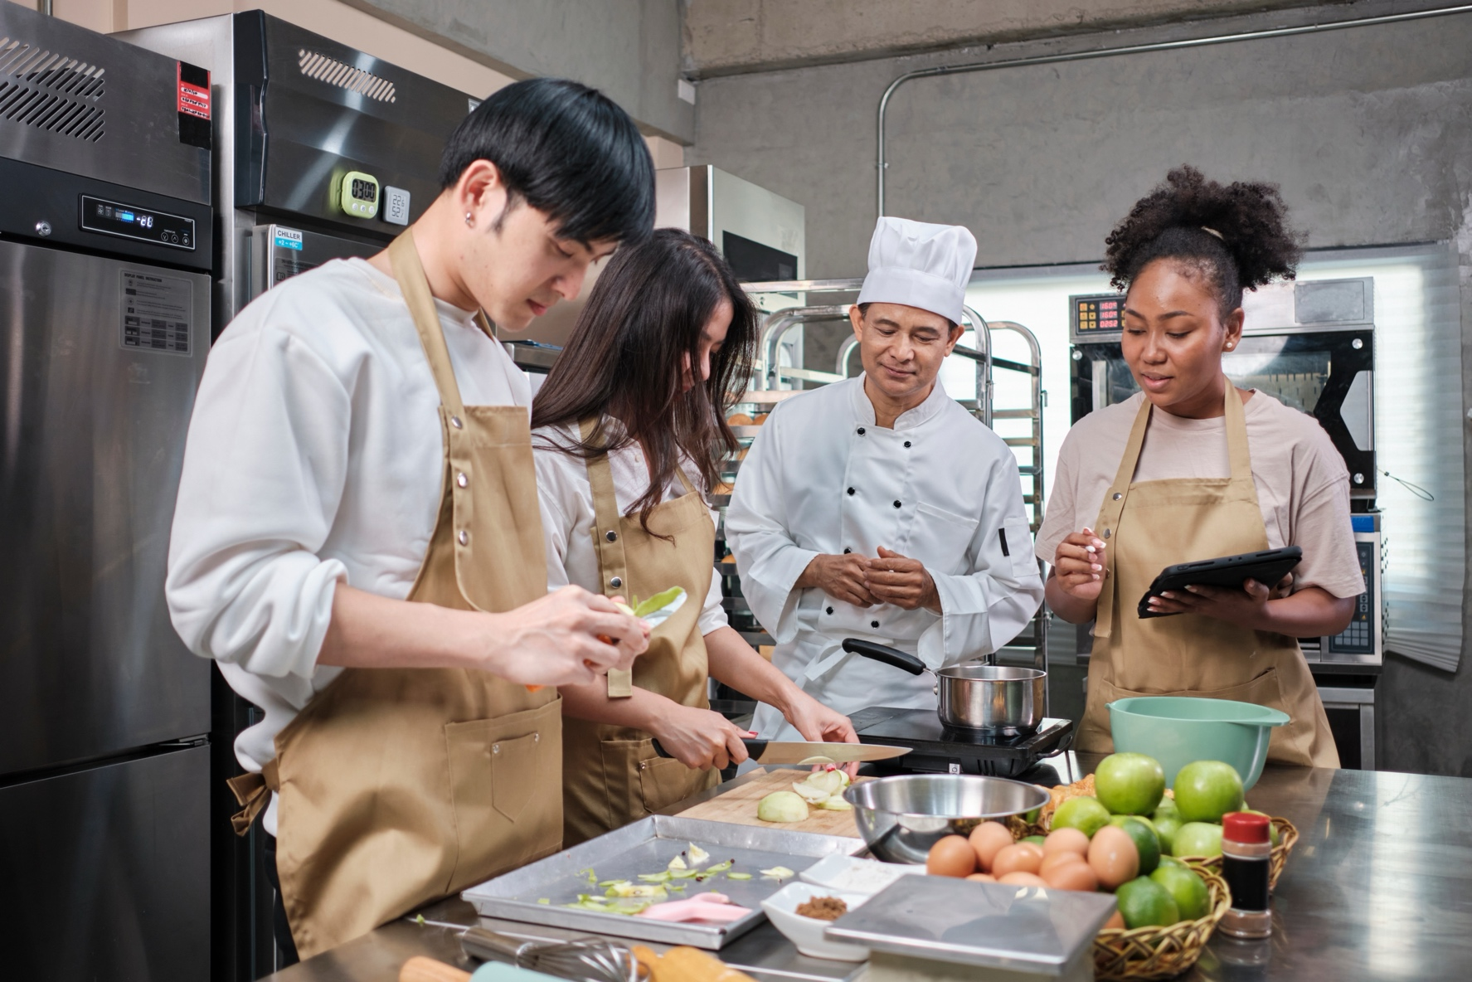

Culinary Arts Equipment List

## Suggested Equipment List

### Safety

* Non-Slip Shoes
* Cut Proof Gloves
* Heat Resistant Gloves
* Apron
* Face Shield
* Oil filtering unit
* First Aid Kit
* Burn Kit
* Slip Resistant Mats
* Fire Suppression & Extinguishers
* MSDS Golder
* Safety Box Knife

### Classroom Technology

* Instructor/Student Computers or Laptops (8GB+ RAM, i5+, SSD)
* Smartboard or projector
* Food Photography Equipment
* Document Camera
* Printer/Scanner/Copier
* Presentation Clicker, Pointer

### Software

* Microsoft Office Suite, (Word, Excel, Powerpoint)
* ServSafe Online Learning (via ServSafe website)
* ProStart Online Curriculum
* Recipe Management Software (MasterCook) (Optional)
* Kitchen Management Software (Industry standard, Restaurant365, Square) (Optional)
* Virtual Cooking Simulators/VR (for advanced programs) (Optional)

### Serving Equipment

* Serving Bowls
* Trays
* Serving utensils
* Glasses/Cups
* Dinnerware
* Flatware (spoon, fork, knife)

### Miscellaneous Equipment and Tools

* Aprons/Chef Coats
* Caps
* Sanitizer
* Litmus Paper (Sanitizer test kit)
* Disposable Gloves
* Washer and Dryers

### Lab Equipment

**(Recommended Per Lab Station)**

* 3 Compartment Sink
* Vegetable Prep Sink
* Handwashing Sink
* Dishwasher
* Range
* Oven
* Grill (also called flat top or griddle)
* Fryer
* Microwave
* Refrigerator (outside thermometers best)
* Freezer (outside thermometers best)
* Food Processor
* Blender
* Tabletop Mixer
* Garbage Disposal
* Stainless Steel Worktables
* Spring and/or Digital Scales
* Wire Shelving (3’ by 6’ Equipment rack)
* Sanitizer and Wash Buckets
* Ingredients Bin (flour and sugar bin)

### Smallware (Utensils and Small Equipment)

* Can Opener
* Measuring Cups (sets)
* Large Measuring Cups (2 or 4 cups)
* Liquid/Volume Measuring Cups
* Measuring Spoons (sets)
* Thermometers
* Cutting Board
* 8” Chef Knife
* 6” Boning Knife
* 3” Paring Knife
* 7” Utility Knife
* 7” Santoku
* 8” Break Knife
* 8” Carving knife
* Butcher Steel/Knife Sharpener
* Knife Storage
* Vegetable Peeler
* Graders, handheld or box
* Sieves/Sifters
* Colanders
* 8” Strainer
* Stainless Bowls (set)
* Wire Whisk (6” to 8”)
* Scoops (Flour, sugar, ice)
* Ladles
* Serving Spoons/Solid
* Serving Spoons/Slotted
* Serving Spoons/Perforated
* Meat Forks
* Heat Resistant Rubber Scrapers
* Off Set Spatulas/Turner
* Tongs (6” or 9”)
* Pots – 1-quart saucepan (some with lid)
* Pots – 3.5-quart saucepan (some with lid)
* Pots – 4-quart saucepan
* Pots – 5 quarts (some with lid)
* Stock Pot – 10 quarts (some with lid)
* 12” Sautoir
* 12 Quart Rondeau/Brazier
* Sauté pans - 6”, 7” or 9”
* Sauté Pan – 10”, 12” straight sided
* Sheet pans, full, half and quarter
* Hotel pans (assorted sizes: Full, Half, Third)
* Roasting Pans (can use hotel pans)
* Food Storage Containers and Lids
* Grill Scraper
* Potholders/Oven Mitt
* Dish Cloths
* Dish Towels
* Trash Containers

### Optional Equipment

* Bakers scale
* Salamander Broiler
* Salad Spinner
* Point of Sales System
* Mandoline
* Broiler
* Steamer
* Floor Mixer
* Hot holding equipment or table
* Cold holding equipment or table
* Speed rack (called bun rack or speed pan rack)
* Ice Machine
* Serrated Knife
* Carving/Slicing Knife
* Hotel Pans – Full Perforated
* Ramekins
* Pizza Peels
* Dough Docker
* Parisienne Scoops (melon ballers)
* Zesters
* Garnishing tools
* China caps (6” to 8”)
* Food mill
* Kitchen Shears
* Bus Tubs
* Equipment Thermometers

### Baking and Pastry Equipment

* Bench and bowl scrapers
* Rolling pins
* Pastry Bags
* Pastry brushes
* Pastry tips
* Portion scoops
* Pizza Cutters
* Dough Cutter
* Bread kneading and shaping bread board or baker’s table
* Bakers Spatula (straight edge)
* Pastry blenders
* Warmer/Proofer
* Cooling racks
* 8” Cake pans
* Pie pans
* Loaf pans
* Tube pans
* Muffin pans
* Spring Form pans
* Candy Thermometer
* Pastry Off Set Spatula
* Cake Decorating Sets