Labor Market Analysis of Drafting Careers in Massachusetts

## Overview

This analysis uses labor market data from the Massachusetts Department of Economic Research to provide perspective on multiple theaters related to the field of Manufacturing in the Commonwealth:

### The Production Occupation Family

There are 105 occupation categories in this family, ranging from Inspectors, Testers, Sorters, Samplers and Weighers (10,500 jobs in Massachusetts) to Semiconductor Processing Technicians (1,600 jobs) and Dental Laboratory Technicians (230 jobs).

### Seven primary industries

* Navigational, Measuring, Electromedical, and Control Instruments Manufacturing
* Semiconductor and Other Electronic Component Manufacturing
* Plastics Product Manufacturing
* Bakeries and Tortilla Manufacturing
* Medical Equipment and Supplies Manufacturing
* Pharmaceutical and Medicine Manufacturing
* Machine Shops; Turned Product; and Screw, Nut, and Bolt Manufacturing

**The Occupations** are the specific jobs into which graduates of the Manufacturing programs will hopefully enter after graduation. In public data systems, occupations are a set of tasks regularly performed by one individual on an employer’s payroll. In this analysis, the target occupations are profiled in addition to the broad spectrum of industries that employ them as we seek to provide strategic value in the development and administration of related curriculum and the construction of compelling and instructive narratives that will introduce students to the world of Manufacturing in the 21st Century.

**The Industries** which employ the target occupations are defined by their primary lines of business. The manufacturing industry in Massachusetts is defined as “establishments engaged in the mechanical, physical, or chemical transformation of materials, substances, or components into new products.” The industry employes more than 237,000 people in the Commonwealth, and those jobs are spread across abroad spectrum of manufacturing types. In terms of total employment, there are seven manufacturing industries which employ 10,000 or more people in Massachusetts:

* Navigational, Measuring, Electromedical, and Control Instruments Manufacturing
* Semiconductor and Other Electronic Component Manufacturing
* Plastics Product Manufacturing
* Bakeries and Tortilla Manufacturing
* Medical Equipment and Supplies Manufacturing
* Pharmaceutical and Medicine Manufacturing
* Machine Shops; Turned Product; and Screw, Nut, and Bolt Manufacturing

**Navigational, Measuring, Electromedical, and Control Instruments Manufacturing**

Establishments primarily engaged in manufacturing navigational, measuring, electromedical, and control instruments. Examples of products made by these establishments are aeronautical instruments, appliance regulators and controls (except switches), laboratory analytical instruments, navigation and guidance systems, and physical properties testing equipment.

**Semiconductor and Other Electronic Component Manufacturing**

Establishments primarily engaged in manufacturing semiconductors and other components for electronic applications. Examples of products made by these establishments are capacitors, resistors, microprocessors, bare and loaded printed circuit boards, electron tubes, electronic connectors, and computer modems.

**Plastics Product Manufacturing**

Establishments Primarily Engaged in Processing New or Spent (I.E., Recycled) Plastics Resins into intermediate or final products, using such processes as compression molding; extrusion molding; injection molding; blow molding; and casting. Within most of these industries, the production process is such that a wide variety of products can be made.

**Bakeries and Tortilla Manufacturing**

Establishments primarily engaged in one of the following: (1) manufacturing fresh and frozen bread and other bakery products; (2) retailing bread and other bakery products not for immediate consumption made on the premises from flour, not from prepared dough; (3) manufacturing cookies, crackers, and dry pasta; (4) manufacturing prepared flour mixes or dough from flour ground elsewhere; or (5) manufacturing tortillas.

**Medical Equipment and Supplies Manufacturing**

Establishments primarily engaged in manufacturing medical equipment and supplies. Examples of products made by these establishments are surgical and medical instruments, surgical appliances and supplies, dental equipment and supplies, orthodontic goods, ophthalmic goods, dentures, and orthodontic appliances.

**Pharmaceutical and Medicine Manufacturing**

Establishments primarily engaged in one or more of the following: (1) manufacturing biological and medicinal products; (2) processing (i.e., grading, grinding, and milling) botanical drugs and herbs; (3) isolating active medicinal principals from botanical drugs and herbs; and (4) manufacturing pharmaceutical products intended for internal and external consumption in such forms as ampoules, tablets, capsules, vials, ointments, powders, solutions, and suspensions.

**Machine Shops; Turned Product; and Screw, Nut, and Bolt Manufacturing**

Establishments known as machine shops primarily engaged in machining metal and plastic parts and parts of other composite materials on a job or order basis. Generally, machine shop jobs are low volume using machine tools, such as lathes (including computer numerically controlled); automatic screw machines; and machines for boring, grinding, milling, and additive manufacturing.

## The Industries

The Federal system of labor market data defines 86 specific manufacturing industries at the four-digit NAICS (North American Industry Classification System level), allowing for a detailed analysis of the various types of manufacturing operations that make up this critical sector of the Massachusetts economy.

### Table 1: Largest Manufacturing Industries, Massachusetts, 2023

|  |  |  |
| --- | --- | --- |
| **Industry** | **2023 Jobs** | **Median Annual Earnings** |
| Navigational, Measuring, Electromedical, and Control Instruments Manufacturing | 26,515 | $134,520 |
| Semiconductor and Other Electronic Component Manufacturing | 14,797 | $134,340 |
| Plastics Product Manufacturing | 11,941 | $75,103 |
| Bakeries and Tortilla Manufacturing | 11,313 | $47,710 |
| Medical Equipment and Supplies Manufacturing | 10,893 | $109,089 |
| Pharmaceutical and Medicine Manufacturing | 10,495 | $162,738 |
| Machine Shops; Turned Product; and Screw, Nut, and Bolt Manufacturing | 10,463 | $79,549 |
| Aerospace Product and Parts Manufacturing | 9,575 | $139,713 |
| Other Miscellaneous Manufacturing | 7,976 | $85,671 |
| Printing and Related Support Activities | 7,868 | $78,017 |
| Beverage Manufacturing | 6,635 | $65,228 |
| Computer and Peripheral Equipment Manufacturing | 6,194 | $197,582 |
| Industrial Machinery Manufacturing | 5,920 | $134,020 |
| Converted Paper Product Manufacturing | 5,315 | $77,660 |
| Architectural and Structural Metals Manufacturing | 4,964 | $84,812 |
| Other Food Manufacturing | 4,367 | $73,219 |

Total = 155,231

### Employment Trends

The total number of jobs in the Massachusetts manufacturing sector has declined in recent years, but with more than 237,000 jobs, remains a critical component of the Massachusetts economy. These businesses shed six percent of their total employment during the COVID-19 pandemic and have yet to return to pre-COVID levels.

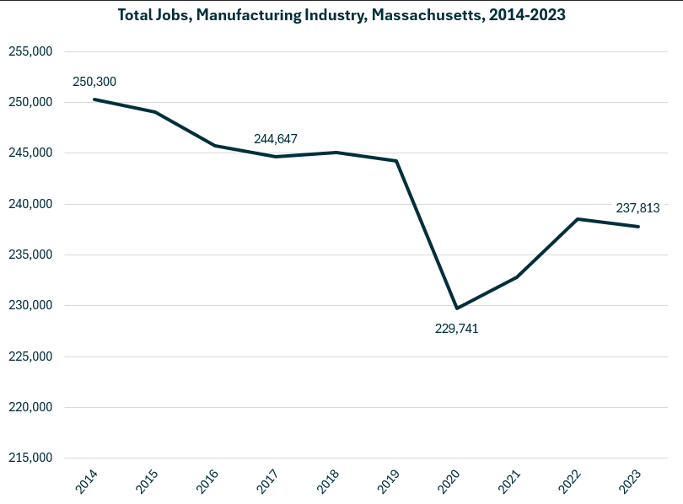

Growth in employment has been led by the Breweries (NAICS 312120) industry, which has added more than 2,600 jobs over the last decade. Analytical Laboratory Instrument Manufacturing (334516), Retail Bakeries (311811), Semiconductors (333242) and Seafood Products (311710) round out the top five.

### Table 2: Detailed (6DL) Industries, by Largest Ten-Year Increase in Employment, Massachusetts, 2014-2023

|  |  |  |
| --- | --- | --- |
| **Industry** | **Ten-Year Change** | **Ten-Year % Change** |
| Breweries | 2,685 | 415% |
| Analytical Laboratory Instrument Manufacturing | 2,447 | 37% |
| Retail Bakeries | 1,474 | 39% |
| Semiconductor Machinery Manufacturing | 1,361 | 58% |
| Seafood Product Preparation and Packaging | 1,330 | 59% |
| Electromedical and Electrotherapeutic Apparatus Manufacturing | 1,250 | 33% |
| Biological Product (except Diagnostic) Manufacturing | 909 | 135% |
| Frozen Specialty Food Manufacturing | 808 | 137% |
| Other Electronic Component Manufacturing | 760 | 31% |
| Meat Processed from Carcasses | 552 | 32% |
| All Other Miscellaneous Electrical Equipment and Component Manufacturing | 535 | 36% |
| All Other Industrial Machinery Manufacturing | 529 | 41% |
| Soft Drink Manufacturing | 511 | 32% |
| Mayonnaise, Dressing, and Other Prepared Sauce Manufacturing | 477 | 52% |
| Custom Architectural Woodwork and Millwork Manufacturing | 452 | 82% |
| All Other Plastics Product Manufacturing | 411 | 6% |
| Cut and Sew Apparel Contractors | 404 | 137% |
| Rubber Product Manufacturing for Mechanical Use | 375 | 114% |
| All Other Miscellaneous Food Manufacturing | 360 | 93% |
| Commercial and Service Industry Machinery Manufacturing | 345 | 12% |

The industries experiencing the largest decrease in total employment include Computer Storage Device Manufacturing and Commercial Printing.

### Table 3: Detailed (6DL) Industries, by Largest Ten-Year Decrease in Employment, Massachusetts, 2014-2023

|  |  |  |
| --- | --- | --- |
| **Industry** | **Ten-Year Change** | **Ten-Year % Change** |
| Computer Storage Device Manufacturing | (3,596) | (44.8%) |
| Commercial Printing (except Screen and Books) | (2,864) | (36.4%) |
| Commercial Bakeries | (1,661) | (26.9%) |
| Electronic Computer Manufacturing | (1,637) | (53.7%) |
| Search, Detection, Navigation, Guidance, Aeronautical, and Nautical System and Instrument Manufacturing | (1,211) | (23.8%) |
| Cut and Sew Apparel Manufacturing (except Contractors) | (1,063) | (53.6%) |
| Computer Terminal and Other Computer Peripheral Equipment Manufacturing | (974) | (73.5%) |
| Fruit and Vegetable Canning | (971) | (74.3%) |
| Audio and Video Equipment Manufacturing | (901) | (36.3%) |
| Pharmaceutical Preparation Manufacturing | (867) | (11.3%) |
| Aircraft Engine and Engine Parts Manufacturing | (840) | (20.3%) |
| Instruments and Related Products Manufacturing for Measuring, Displaying, and Controlling Industrial Process Variables | (679) | (15.3%) |
| Plastics Material and Resin Manufacturing | (676) | (31.9%) |
| Relay and Industrial Control Manufacturing | (663) | (44.6%) |
| Fluid Milk Manufacturing | (659) | (45.2%) |
| Jewelry and Silverware Manufacturing | (587) | (39.2%) |
| Paper Mills | (565) | (33.9%) |
| Perishable Prepared Food Manufacturing | (550) | (36.5%) |
| Knit Fabric Mills | (509) | (89.0%) |
| Paper Bag and Coated and Treated Paper Manufacturing | (495) | (19.6%) |

### Comparative Advantage

An employment Location Quotient (LQ) is a value in which the concentration of a region’s employment in a particular industry is indexed against the national norm. For example, if the percentage of a region’s workforce that is employed in the Aerospace Manufacturing sector were identical to the national average, that industry would return an LQ of 1.0. If the region’s workforce were employed in that industry at a rate double the national average, that would return an LQ of 2.0.

We estimated Location Quotients for detailed manufacturing industries in Massachusetts, using that value to highlight industries that are part of the unique fabric of regional economies, regardless of total employment. This critical exercise affords a valuable perspective by looking at the manufacturing industries uniquely important to the economic prospects of the Commonwealth.

#### Table 4: Detailed (6DL) Manufacturing Industry by Location Quotient (LQ) and Jobs

|  |  |  |
| --- | --- | --- |
| **Detailed (6DL) Manufacturing Industry** | **LQ** | **Jobs** |
| Computer Storage Device Manufacturing | 13.11 | 4,427 |
| Analytical Laboratory Instrument Manufacturing | 8.05 | 9,033 |
| Fabric Coating Mills | 6.75 | 1,091 |
| Metal Kitchen Cookware, Utensil, Cutlery, and Flatware Manufacturing | 6.23 | 1,439 |
| Semiconductor Machinery Manufacturing | 5.20 | 3,712 |
| Footwear Manufacturing | 4.63 | 1,293 |
| Seafood Product Preparation and Packaging | 4.51 | 3,581 |
| Audio and Video Equipment Manufacturing | 3.49 | 1,579 |
| Abrasive Product Manufacturing | 3.38 | 798 |
| Irradiation Apparatus Manufacturing | 3.19 | 1,066 |
| Saw Blade and Handtool Manufacturing | 3.19 | 2,004 |
| Guided Missile and Space Vehicle Manufacturing | 3.16 | 5,916 |
| Electromedical and Electrotherapeutic Apparatus Manufacturing | 2.78 | 4,981 |
| Instruments for Measuring, Displaying, Controlling Industrial Process Variables | 2.76 | 3,760 |
| Other Communication and Energy Wire Manufacturing | 2.74 | 854 |

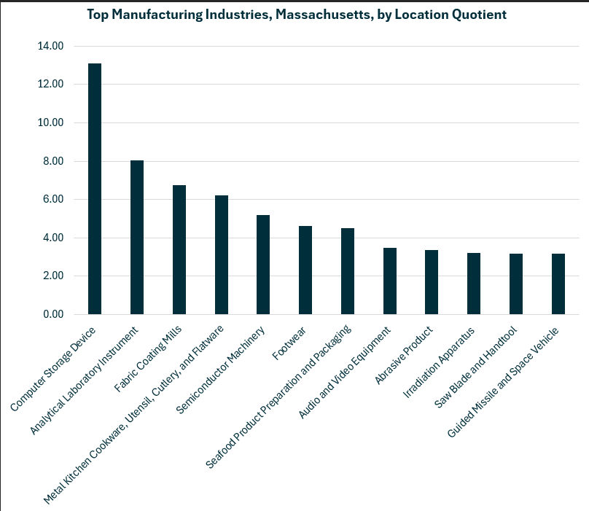

### Economic Activity

Manufacturing is one of the Commonwealth’s five largest private-sector contributors to the regional economy, accounting for approximately one of every thirteen dollars generated. In 2023 the sector contributed $56 billion to the state’s Gross Domestic Product.

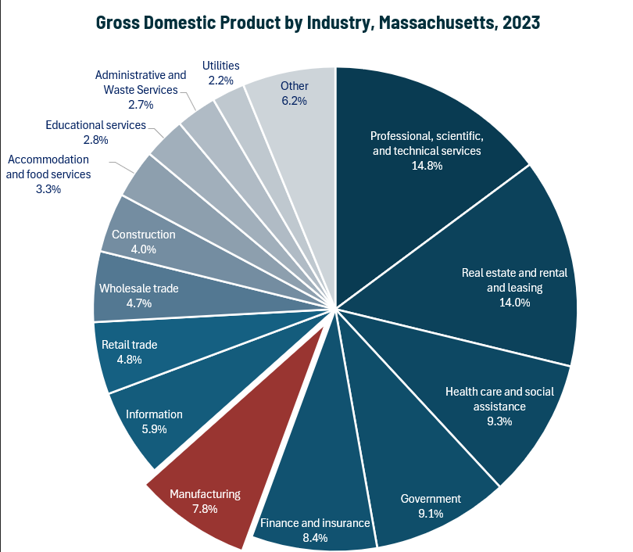

### Earnings

Earnings per manufacturing job in Massachusetts are well above the national average. The national average salary for Manufacturing in an area this size is $99,673, while in Massachusetts it is $123,029. The average has increased steadily over the last decade and now reflects an average 20.7% higher than in 2014.

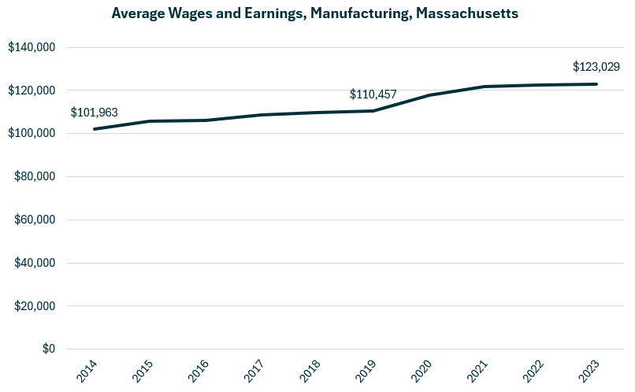

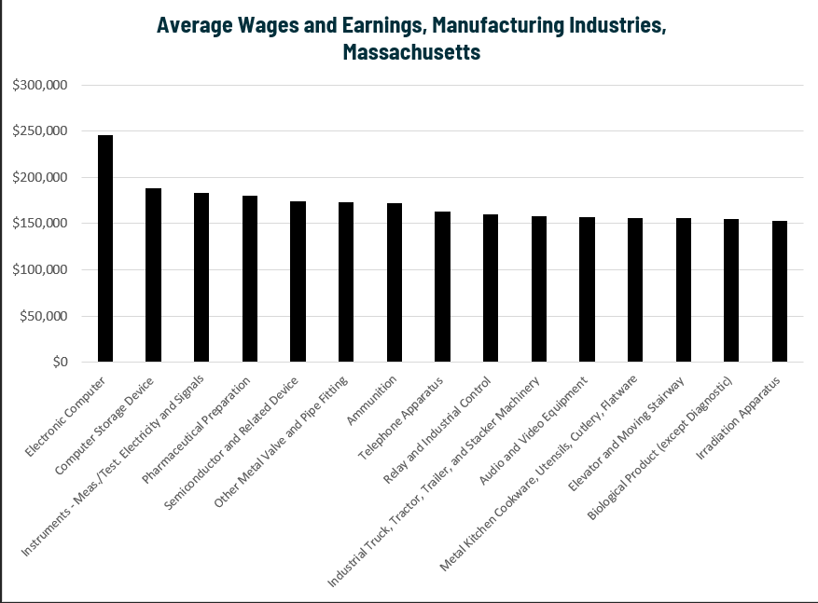

### Staffing Patterns

The occupations most commonly employed by manufacturers in Massachusetts are from the Production (SOC 51-0000). Occupations from the Management (11-0000), Engineering (17-0000) and Computer and Mathematical (15-0000) families are also found in the top ten.

#### Table 5: Top Occupations, Manufacturing Industry, Massachusetts

|  |  |  |
| --- | --- | --- |
| **SOC Code** | **Occupation** | **% of Jobs in Industry** |
| 51-2098 | Miscellaneous Assemblers and Fabricators | 4.0% |
| 51-1011 | First-Line Supervisors of Production and Operating Workers | 3.9% |
| 51-2028 | Electrical, Electronic, and Electromechanical Assemblers | 3.9% |
| 11-1021 | General and Operations Managers | 3.1% |
| 51-4041 | Machinists | 2.8% |
| 51-9061 | Inspectors, Testers, Sorters, Samplers, and Weighers | 2.8% |
| 17-2112 | Industrial Engineers | 2.8% |
| 15-1252 | Software Developers | 2.2% |
| 41-4012 | Sales Representatives, Wholesale and Manufacturing | 2.0% |
| 51-9111 | Packaging and Filling Machine Operators and Tenders | 1.9% |
| 43-5071 | Shipping, Receiving, and Inventory Clerks | 1.9% |
| 51-3092 | Food Batchmakers | 1.8% |
| 11-3051 | Industrial Production Managers | 1.7% |
| 53-7062 | Laborers and Freight, Stock, and Material Movers, Hand | 1.7% |
| 51-4072 | Molding, Coremaking, Casting Machine Setters, Operators, Metal & Plastic | 1.7% |
| 53-7064 | Packers and Packagers, Hand | 1.6% |
| 51-9161 | Computer Numerically Controlled Tool Operators | 1.5% |

## Program Profiles - Drafting

### Introduction

Drafting is at once an industry, an occupation, and a skill, making any one analytical approach insufficient to provide a comprehensive view of career opportunities.

There are three occupation categories that are relevant to this program of study, with the Architectural and Civil Drafters category being the largest.

#### Table 6: Occupations

|  |  |  |  |
| --- | --- | --- | --- |
| **Occupation** | **2023 Jobs** | **Typical Entry Level Education** | **Median Annual Earnings** |
| Architectural and Civil Drafters | 2,937 | Associate's degree | $67,891 |
| Electrical and Electronics Drafters | 197 | Associate's degree | $70,325 |
| Mechanical Drafters | 970 | Associate's degree | $65,811 |

While the numbers of electrical and mechanical drafters in Massachusetts have decreased in recent years, the number of architectural and civil drafters has increased significantly.

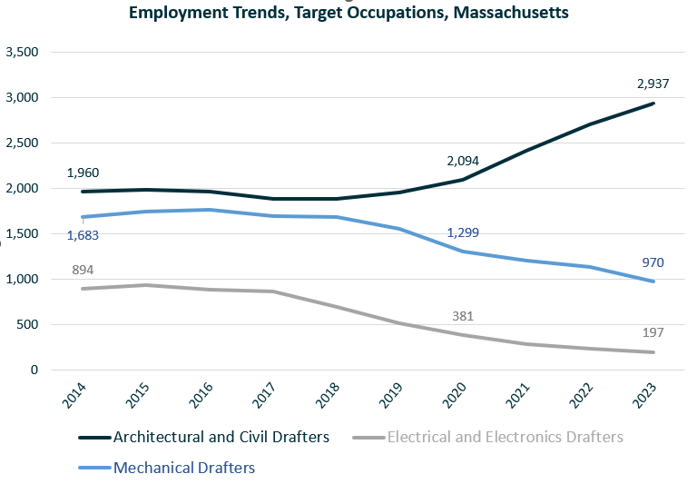

### Occupational Profile – Architectural and Civil Drafters

#### Description:

*Prepare detailed drawings of architectural and structural features of buildings or drawings and topographical relief maps used in civil engineering projects, such as highways, bridges, and public works. Use knowledge of building materials, engineering practices, and mathematics to complete drawings.*

#### Skills:

* Giving full attention to what other people are saying, taking time to understand the points being made, asking questions as appropriate, and not interrupting at inappropriate times.
* Using logic and reasoning to identify the strengths and weaknesses of alternative solutions, conclusions, or approaches to problems.
* Understanding written sentences and paragraphs in work-related documents.
* Talking to others to convey information effectively.
* Communicating effectively in writing as appropriate for the needs of the audience.
* Identifying complex problems and reviewing related information to develop and evaluate options and implement solutions.
* Considering the relative costs and benefits of potential actions to choose the most appropriate one.
* Determining how a system should work and how changes in conditions, operations, and the environment will affect outcomes.
* Using mathematics to solve problems.
* Understanding the implications of new information for both current and future problem-solving and decision-making.
* Monitoring/assessing performance of yourself, other individuals, or organizations to make improvements or take corrective action.
* Managing one's own time and the time of others.
* Being aware of others' reactions and understanding why they react as they do.
* Adjusting actions in relation to others' actions.
* Analyzing needs and product requirements to create a design.
* Identifying measures or indicators of system performance and the actions needed to improve or correct performance, relative to the goals of the system.
* Persuading others to change their minds or behavior.
* Selecting and using training/instructional methods and procedures appropriate for the situation when learning or teaching new things.
* Teaching others how to do something.
* Actively looking for ways to help people.
* Conducting tests and inspections of products, services, or processes to evaluate quality or performance.
* Motivating, developing, and directing people as they work, identifying the best people for the job.
* Bringing others together and trying to reconcile differences.
* Using scientific rules and methods to solve problems.
* Writing computer programs for various purposes.
* Watching gauges, dials, or other indicators to make sure a machine is working properly.

#### Tasks:

* Create graphical representations of civil structures.
* Create graphical representations of structures or landscapes.
* Evaluate technical data to determine effect on designs or plans.
* Create maps.
* Supervise engineering or other technical personnel.
* Prepare detailed work plans.
* Analyze operational data to evaluate operations, processes or products.
* Verify mathematical calculations.
* Determine operational methods.
* Survey land or bodies of water to measure or determine features.
* Collect data about project sites.
* Explain engineering drawings, specifications, or other technical information.
* Estimate operational costs.
* Estimate technical or resource requirements for development or production projects.
* Prepare procedural documents.
* Review technical documents to plan work.
* Analyze costs and benefits of proposed designs or projects.
* Create graphical representations of energy production systems.
* Evaluate designs or specifications to ensure quality.
* Monitor processes for compliance with standards.
* Prepare contracts, disclosures, or applications.
* Prepare technical reports for internal use.
* Provide technical guidance to other personnel.
* Recommend technical design or process changes to improve efficiency, quality, or performance.
* Review details of technical drawings or specifications.

#### Job Postings- Architectural and Civil Drafters

##### Frequency:

* We found 614 unique job postings from the last year in Massachusetts.
* We identified 226 employers actively posting openings for this occupation.

##### Employers:

* Actalent
* AECOM
* GPAC
* CDM Smith
* Stantec
* Michael Baker International
* State of Massachusetts
* Consigli Construction Co.
* Sleeping Dog Properties
* Harvard University
* Vanasse Hangen Brustlin
* ManpowerGroup
* Mott MacDonald
* Boston Society of Architects
* AMD
* Arup
* Bond Brothers
* Jacobs Engineering Group
* System One
* GHD
* Nitsch Engineering
* Page Southerland & Page
* New England Design & Construction
* WSP Global

##### Skills:

###### Common:

* Communication
* Coordinating
* Planning
* Microsoft Office
* Problem solving

###### Specialized:

* AutoDesk Revit
* AutoCAD
* Construction
* Civil Engineering
* Building Information Modeling

##### Job Titles:

* Architectural Designers
* Civil Designers
* Civil Design Engineers
* Roadway Design Engineers
* Architecture Designers
* BIM Modelers
* Architectural Design Managers
* Interior Architectural Designers
* Architectural Drafters
* BIM Specialists
* Drafters
* Civil Site Design Engineers

##### Top Qualifications:

* Architecture License
* Professional Engineer (PE) License
* LEED Accredited Professional (AP)
* Engineer in Training
* Valid Driver's License
* Architect Registration Examination
* Autodesk Certified Professional
* Solidworks Certification
* LEED Green Associate
* National Council for Interior Design Qualification (NCIDQ)

##### Additional Information:

###### National Associations:

* American Design Drafting Association external site
* American Institute of Architects external site
* American Public Works Association external site
* American Society of Landscape Architects external site
* Association for Career and Technical Education external site

###### Accreditation, Certification, & Unions:

* Accrediting Commission of Career Schools and Colleges