Labor Market Analysis of the Early Education and Care Field in Massachusetts

## Overview

This analysis uses labor market data from the Massachusetts Department of Economic Research to provide perspective on four theaters related to the field of Early Education and Care in the Commonwealth: the Education Sectors within State and Local Government (NAICS 90261 and 90361), the Child Day Care Servies industry (NAICS 6244) and the Childcare Worker occupation (SOC 39-9011) within the Personal Services and Education and Training pathways.

**The Public Education Sector** is a customized grouping of industry classifications that reflect employment within state and local government in organizations that primarily focus on delivering public education services. This customized grouping will not be found by name in the public labor market information system, and its use is limited to this analysis. It relies heavily on the Lightcast industry classification system of Economic Modeling Specialists International The sector is divided into two industry classifications:

* Elementary and Secondary Schools, Local Government
* Elementary and Secondary Schools, State Government

As will be shown in the following industry profile, the Public Education Sector is a major employer within the Commonwealth’s economy. The number of jobs in the sector decreased during the COVID-19 pandemic and only recovered to its 2019 levels in 2022.

The occupations employed in the Public Education Sector are predictably heavy in Educational Instruction and Library Occupations (65.9%), but a spectrum of occupations are employed in the sector, including Office and Administrative, Management, and Building and Grounds Cleaning and Maintenance Occupations.

**The Child Day Care industry** should be understood as the employers in the Commonwealth whose primary line of business is providing care and early learning opportunities for infants and children. These establishments generally care for children from birth through school age and may also offer pre-kindergarten, kindergarten, and/or before- or after-school educational programs. The care and early learning provided by these establishments may include opportunities for development in health, social and emotional learning, and family engagement.

Illustrative Examples:

* Before-school and after-school educational programs, separate from schools
* Childcare babysitting services
* Child or infant care centers
* Head Start and Early Head Start programs, separate from schools
* Nursery schools
* Preschool centers

Those companies employ a spectrum of occupations, ranging from childcare workers to office managers to cafeteria cooks. While trends in the Day Care Center industry are not necessarily directly related to early education and care careers, it does provide a backdrop against which to evaluate these careers in Massachusetts.

In public data systems, occupations are a set of tasks regularly performed by one individual on an employer’s payroll. In this analysis, the target occupation is profiled in addition to the industry as we seek to provide strategic value in the development and administration of related curriculum and the construction of compelling and instructive narratives that will introduce students to the world of Early Education and Care in the 21st Century.

## The Public Education Sector

### The Public Education Sector in Labor Market Data Systems

Public Education Services (Industry codes 90261 and 90361) comprises all employers whose primary line of business is providing public education services. The industry category is a component of the larger Local Government (902) and State Government (903) industries.

Each of these categories is further parsed into four-, five-, and ultimately six-digit level categories, and the Lightcast system produces employment and wage estimates for each based on data from the Massachusetts Department of Economic Research.

#### Public Education Services Related Industries Categories

* 902 State Government
  + 902611 Elementary and Secondary Schools
  + 902612 Colleges, Universities, and Professional Schools
  + 902619 All Other Schools and Educational Support Services
* 903 Local Government
  + 903611 Elementary and Secondary Schools
  + 903612 Colleges, Universities, and Professional Schools
  + 903619 All Other Schools and Educational Support Services

#### Employment Trends

The number of people employed in the Public Education Sector in Massachusetts had been steadily increasing over the last decade, until a significant and dramatic COVID-19-related decline. Between 2019 and 2020, the industry shed more than 10,000 jobs, approximately 6% of its total employment. The number of jobs in the industry returned to pre-COVID levels in 2022 and resumed an upward trajectory in 2023.

#### Table 1: Average Annual Employment, Public Education Sector, Massachusetts, 2014-2023

|  |  |
| --- | --- |
| **Year** | **Jobs** |
| 2014 | 168,661 |
| 2015 | 170,359 |
| 2016 | 171,618 |
| 2017 | 172,521 |
| 2018 | 173,830 |
| 2019 | 174,859 |
| 2020 | 164,355 |
| 2021 | 167,848 |
| 2022 | 175,425 |
| 2023 | 177,922 |

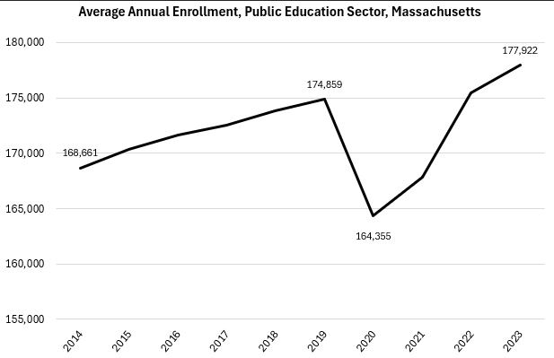

In addition to the Public Education Sector used in this analysis, the Educational Services (NAICS 61) comprises organizations whose primary line of business is providing instruction in a wide variety of subjects. This instruction and training are provided by specialized establishments, such as schools, colleges, universities, and training centers in the private sector.

#### Table 2: Average Annual Employment, Select Education Sectors, Massachusetts, 2023

|  |  |  |  |  |
| --- | --- | --- | --- | --- |
| **NAICS** | **Industry** | **2023 Jobs** | **2014 - 2023 Change** | **2014 - 2023 % Change** |
| 611110 | Elementary and Secondary Schools | 23,195 | 908 | 4.1% |
| 611710 | Educational Support Services | 7,188 | 2,916 | 68.3% |
| 611620 | Sports and Recreation Instruction | 5,477 | 1,868 | 51.7% |
| 611691 | Exam Preparation and Tutoring | 2,632 | 140 | 5.6% |

#### Wages, Salaries and Proprietor Earnings

In terms of inflation-adjusted dollars, earnings in the Public Education Sector had risen steadily over the last decade until 2020. It appears that the unemployment resulting from the COVID-19 pandemic disproportionately affected the lower-earning occupations in the industry, causing the average earnings to rise. The value has been declining since that 2019-2020 increase.

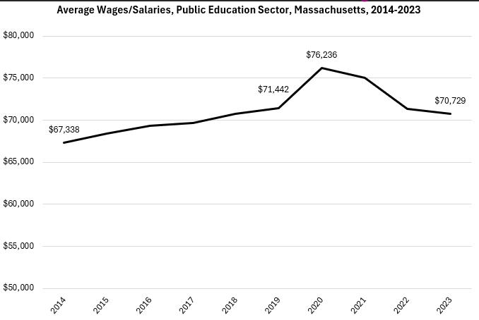

## The Child Day Care Services Industry

### The Child Day Care Services Industry in Labor Market Data Systems

Child Day Care Services (NAICS code 6244) comprises all employers whose primary line of business is providing care and early learning opportunities for infants and children. The industry category is a component of the larger Social Assistance industry.

Each of these categories is further parsed into four-, five-, and ultimately six-digit level categories, and the Massachusetts Department of Economic Research produces employment and wage estimates for each.

#### Childcare Services Related Industries Categories

* 624 Social Assistance
  + 6241 Individual and Family Services
  + 6242 Community Food and Housing, and Emergency and Other Relief Services
  + 6243 Vocational Rehabilitation Services
  + 6244 Child Day Care Servies

#### Employment-Childcare Workers

It is not surprising that at the most general level available, the industry that most often employ Childcare Workers (39-9011) in Massachusetts is Child Day Care Services (NAICS 6244); however, significant numbers of Childcare Workers are also employed by Private Households (NAICS 8141), Local Government Education and Hospitals (NAICS 9036), and Civic and Social Organizations (8141). The table below details the top five detailed industry sectors by the share of Childcare Workers who are employed in them.

#### Table 3: Top Detailed Industries for Skilled Trades

|  |  |
| --- | --- |
| **Industry** | **Share of Occupation Jobs** |
| Child Day Care Services | 48.7% |
| Private Households | 11.9% |
| Education and Hospitals (Local Government) | 11.9% |
| Civic and Social Organizations | 6.4% |
| Other Amusement and Recreation Industries | 4.9% |

#### Employment Trends

The number of people employed in the Child Day Care Services industry in Massachusetts had been steadily increasing over the last decade, until a significant and dramatic COVID-19-related decline. Between 2019 and 2020, the industry shed almost a quarter of its total employment. The number of jobs in the industry has yet to return to pre-COVID levels.

#### Table 4: Average Annual Employment, Child Day Care Services Industry, Massachusetts, 2014-2023

|  |  |
| --- | --- |
| **Year** | **Jobs** |
| 2014 | 24,270 |
| 2015 | 25,761 |
| 2016 | 26,272 |
| 2017 | 27,106 |
| 2018 | 27,868 |
| 2019 | 28,799 |
| 2020 | 21,385 |
| 2021 | 23,981 |
| 2022 | 26,889 |
| 2023 | 28,078 |

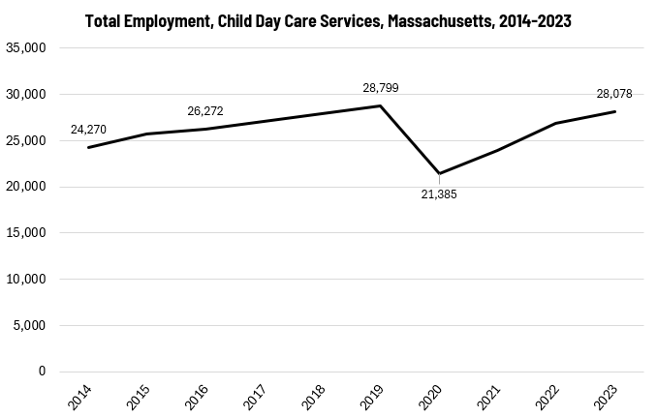

The larger Social Assistance industry (NAICS 624) has experienced significant growth over the last decade, led by Individual and Family Services, which has added more than 27,000 jobs (a 35.3% change) over the last ten years. The Child Day Care Services industry also experienced growth with an additional 3,800 jobs, a 15.7% rate of change.

#### Table 5: Average Annual Employment, Social Assistance Industries, Massachusetts, 2014-2023

|  |  |  |  |
| --- | --- | --- | --- |
| **NAICS** | **Industry** | **2014 - 2023 Change** | **2014 - 2023 % Change** |
| 6241 | Individual and Family Services | 27,669 | 35.3% |
| 6244 | Child Day Care Services | 3,808 | 15.7% |
| 6242 | Community Food and Housing, and Emergency and Other Relief Services | 1,367 | 22.9% |
| 6243 | Vocational Rehabilitation Services | (1,782) | (17.3%) |
| 624 | Total Social Assistance | 31,061 | 26.1% |

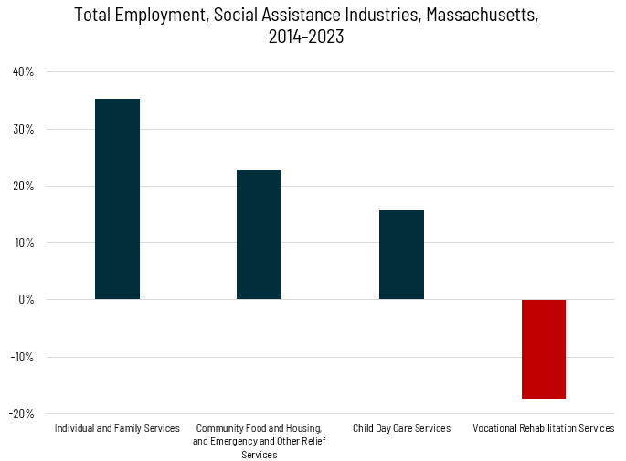

#### Wages, Salaries and Proprietor Earnings

Among the detailed industry categories within Social Assistance (NAICS 624), the highest wages are found in the Emergency and Disaster Relief employers. The lowest are in Services for the Elderly and Disabled. Child Day Care is second lowest at an average of $38,689.

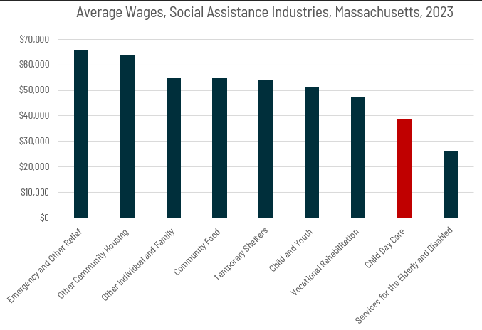

## The Pathway

### Early Education and Care Occupations and Pathways

This section looks at the target occupations and pathways and also considers advancement opportunities in related careers that are not directly related to the program of study, but that illustrate opportunities that may be available to workers in these fields with additional education and experience.

While careers in these occupations are certainly viable in their own rights, they also can serve as entry points to progressively more sophisticated and better-paying roles.

#### Table 6: Related Career Pathways-Personal Care and Services

##### Job Zone Two Occupations

|  |  |  |  |
| --- | --- | --- | --- |
| Occupation | 2023 Jobs | Typical Education Requirement | Median Annual Earnings |
| Childcare Worker | 17,890 | High School | $37,379 |
| Recreation Workers | 8,603 | High School | $34,944 |

##### Job Zone Three Occupations

|  |  |  |  |
| --- | --- | --- | --- |
| Occupation | 2023 Jobs | Typical Education Requirement | Median Annual Earnings |
| Childcare Worker | 17,890 | High School | $37,379 |
| Recreation Workers | 8,603 | High School | $34,944 |

##### Job Zone Four Occupations

|  |  |  |  |
| --- | --- | --- | --- |
| **Occupation** | **2023 Jobs** | **Typical Education Requirement** | **Median Annual Earnings** |
| Residential Advisors | 6,263 | High School | $39,790 |

#### Table 7: Related Career Pathways-Education Services

##### Job Zone Three Occupations

|  |  |  |  |
| --- | --- | --- | --- |
| Occupation | 2023 Jobs | Typical Education Requirement | Median Annual Earnings |
| Preschool Teachers | 12,721 | Associate’s | $38,022 |
| Tutors | 5,167 | Bachelor’s | $60,861 |

##### Job Zone Four Occupations

|  |  |  |  |
| --- | --- | --- | --- |
| **Occupation** | **2023 Jobs** | **Typical Education Requirement** | **Median Annual Earnings** |
| Substitute Teachers, Short-Term | 5,464 | Bachelor’s | $37,336 |
| Kindergarten Teachers | 2,474 | Bachelor’s | $80,850 |
| Special Education Teachers, Kindergarten and Elementary School | 5,427 | Bachelor’s | $79,170 |
| Elementary School Teachers | 31,051 | Bachelor’s | $80,070 |

##### Job Zone Five Occupations

|  |  |  |  |
| --- | --- | --- | --- |
| **Occupation** | **2023 Jobs** | **Typical Education Requirement** | **Median Annual Earnings** |
| Special Education Teachers, Preschool | 798 | Master’s | $78,740 |

## Occupation Profiles

The United States Department of Labor, Employment, and Training Administration created and regularly updates more than 800 occupational profiles with characteristics like skills, educational requirements, and daily tasks, based on the inputs of industry experts and people who are employed in the occupations.

### Elementary School Teachers

#### Description

Teach academic and social skills to students at the elementary school level.

#### Top Skills

* Talking to others to convey information effectively.
* Teaching others how to do something.
* Selecting and using training/instructional methods and procedures appropriate for the situation when learning or teaching new things.
* Understanding written sentences and paragraphs in work-related documents.
* Giving full attention to what other people are saying, taking time to understand the points being made, asking questions as appropriate, and not interrupting at inappropriate times.
* Using logic and reasoning to identify the strengths and weaknesses of alternative solutions, conclusions, or approaches to problems.
* Communicating effectively in writing as appropriate for the needs of the audience.
* Monitoring/assessing performance of yourself, other individuals, or organizations to make improvements or take corrective action.
* Being aware of others' reactions and understanding why they react as they do.
* Adjusting actions in relation to others' actions.
* Understanding the implications of new information for both current and future problem-solving and decision-making.
* Considering the relative costs and benefits of potential actions to choose the most appropriate one.
* Actively looking for ways to help people.

#### Top Daily Tasks

* Establish rules or policies governing student behavior.
* Apply multiple teaching methods.
* Modify teaching methods or materials to accommodate student needs.
* Discuss problems or issues with supervisors.
* Discuss student progress with parents or guardians.
* Set up classroom materials or equipment.
* Encourage students.
* Evaluate student work.
* Develop instructional objectives.
* Monitor student performance.
* Advise students on academic or career matters.
* Monitor student behavior, social development, or health.
* Enforce rules or policies governing student behavior.
* Read to students.
* Plan educational activities.
* Assist students with special educational needs.
* Collaborate with other teaching professionals to develop educational programs.
* Develop strategies or programs for students with special needs.
* Administer tests to assess educational needs or progress.
* Prepare tests.
* Create technology-based learning materials.
* Maintain student records.
* Assign class work to students.
* Teach others to use technology or equipment.
* Attend training sessions or professional meetings to develop or maintain professional knowledge.
* Document lesson plans.
* Prepare reports detailing student activities or performance.
* Display student work.
* Evaluate performance of educational staff.
* Supervise student research or internship work.
* Plan experiential learning activities.
* Serve on institutional or departmental committees.
* Supervise school or student activities.
* Distribute instructional or library materials.
* Maintain inventories of materials, equipment, or products.
* Order instructional or library materials or equipment.
* Coordinate student extracurricular activities.

#### Additional Information

* Alpha Delta Kappa International Honorary Organization for Women Educators
* American Federation of Teachers, AFL-CIO
* Association for Childhood Education International
* Council for the Accreditation of Educator Preparation
* International Literacy Association
* Lutheran Education Association
* National Council of Teachers of English
* National Council of Teachers of Mathematics
* National Education Association
* National PTA

#### Job Postings – Elementary School Teachers

P2C uses a third-party system that aggregates data from job postings to provide perspective on the skills and qualifications employers are prioritizing in their advertisements for these occupations.

* After controlling for multiple postings that likely referenced the same single opening, over the last year, we identified 5,018 unique job postings for Elementary School Teachers in the Commonwealth.
* We identified 833 unique employers who posted openings online.

##### Top Employers Advertising:

* Boston Public Schools
* Cambridge Public Schools
* Sargent Rehabilitation Center
* Brookline Public Schools
* Fall River Public Schools
* Collegiate Charter School of Lowell
* Mystic Valley Regional Charter School
* Match Education
* Boston University
* Foxborough Regional Charter School
* Somerville Public Schools
* Lawrence Family Development
* Lowell Public Schools
* Framingham Public Schools
* Methuen Public Schools
* Brockton Public Schools
* Worcester Public Schools

##### Top Job Titles:

* Elementary Teachers
* Long Term Substitute Teachers
* Upper Elementary Teachers
* Long Term Substitute Elementary Teachers
* Elementary School Teachers
* Classroom Teachers
* 5th Grade Teachers
* Elementary Classroom Teachers
* Inclusion Teachers
* Title 1 Teachers
* Elementary Music Teachers

##### Top Overall Skills:

* Pedagogy
* Lesson Planning
* Differentiated Instruction
* Special Education
* Student Engagement
* Curriculum Development
* Individualized Education Programs
* Classroom Management

### Teaching Assistants

#### Description

Assist a preschool, elementary, middle, or secondary school teacher with instructional duties. Serve in a position for which a teacher has primary responsibility for the design and implementation of educational programs and services.

#### Top Daily Tasks

* Maintain student records.
* Develop instructional materials.
* Distribute instructional or library materials.
* Maintain inventories of materials, equipment, or products.
* Monitor student performance.
* Supervise school or student activities.
* Assist other educational professionals with projects or research.
* Clean facilities or work areas.
* Collaborate with other teaching professionals to develop educational programs.
* Collect deposits, payments, or fees.
* Create technology-based learning materials.
* Discuss student progress with parents or guardians.
* Display student work.
* Document lesson plans.
* Enforce rules or policies governing student behavior.
* Evaluate student work.
* Lead classes or community events.
* Maintain clean work areas.
* Maintain computer equipment or software.
* Operate audiovisual equipment.
* Plan educational activities.
* Serve on institutional or departmental committees.
* Set up classroom materials or equipment.
* Teach daily living skills or behaviors.
* Teach life skills.
* Teach others to use technology or equipment.
* Teach physical education.
* Tutor students who need extra assistance.

#### Additional Information

* [American Federation of State, County and Municipal Employees, AFL-CIO](https://www.afscme.org/)
* [American Federation of Teachers, AFL-CIO](https://www.aft.org/)
* [National Association for the Education of Young Children](https://www.naeyc.org/)
* [National Education Association](https://www.nea.org/)
* [National PTA](https://www.pta.org/)
* [National Resource Center for Paraeducators, Related Service Providers, and Interveners](https://www.nrcpara.org/)

#### Job Postings – Teaching Assistants

P2C uses a third-party system that aggregates data from job postings to provide perspective on the skills and qualifications employers are prioritizing in their advertisements for these occupations.

* After controlling for multiple postings that likely referenced the same single opening, over the last year, we identified 7,882 unique job postings for Teaching Assistants in the Commonwealth.
* We identified 1,022 unique employers who posted openings online.

##### Top Employers Advertising:

* Boston Public Schools
* KinderCare Education
* Springfield Public Schools, MO
* Cambridge Public Schools
* ATX Learning
* Sargent Rehabilitation Center
* Marlborough Public Schools
* Fall River Public Schools
* Brockton Public Schools
* Worcester Public Schools

##### Top Job Titles:

* Paraprofessionals
* Special Education Paraprofessionals
* Paraprofessional Aides
* Paraeducators
* Assistant Teachers
* Teacher Assistants
* School Paraprofessionals
* Teaching Assistants
* Elementary Paraprofessionals
* Instructional Assistants
* One-to-One Aides
* Classroom Paraprofessionals

##### Top Overall Skills:

* Special Education
* Individualized Education Programs
* Lesson Planning
* Behavior Management
* Cardiopulmonary Resuscitation
* First Aid
* Toileting
* Direct Instruction
* De-escalation Techniques
* Working with Children

### Childcare Workers

#### Description

Attend to children at schools, businesses, private households, and childcare institutions. Perform a variety of tasks, such as dressing, feeding, bathing, and overseeing play.

#### Top Skills

* Monitoring/assessing performance of yourself, other individuals, or organizations to make improvements or take corrective action.
* Actively looking for ways to help people.
* Being aware of others' reactions and understanding why they react as they do.
* Giving full attention to what other people are saying, taking time to understand the points being made, asking questions as appropriate, and not interrupting at inappropriate times.
* Talking to others to convey information effectively.
* Using logic and reasoning to identify the strengths and weaknesses of alternative solutions, conclusions, or approaches to problems.
* Adjusting actions in relation to others' actions.
* Understanding written sentences and paragraphs in work-related documents.
* Communicating effectively in writing as appropriate for the needs of the audience.
* Understanding the implications of new information for both current and future problem-solving and decision-making.
* Selecting and using training/instructional methods and procedures appropriate for the situation when learning or teaching new things.

#### Top Daily Tasks

* Arrange childcare or educational settings to ensure the physical safety of children.
* Monitor activities of individuals to ensure safety or compliance with rules.
* Discuss child development and behavior with parents or guardians.
* Assist individuals with special needs.
* Provide counsel, comfort, or encouragement to individuals or families.
* Clean tools or equipment.
* Provide for basic needs of children.
* Maintain client information or service records.
* Monitor the health or behavior of people or animals.
* Arrange items for use or display.
* Teach health or hygiene practices.
* Teach daily living skills or behaviors.
* Perform administrative or clerical tasks.
* Care for patients with mental illnesses.
* Develop educational or training programs.
* Perform housekeeping duties.
* Prepare food or meals.
* Develop daily schedules for children or families.
* Assign duties or work schedules to employees.
* Perform human resources activities.
* Train service staff.
* Organize recreational activities or events.
* Accompany individuals or groups to activities.

#### Additional Information

* American Federation of Teachers, AFL-CIO
* Association for Early Learning Leaders
* Childcare Aware of America
* International Nanny Association
* National Association for the Education of Young Children
* National Catholic Educational Association
* Occupational Outlook Handbook: Childcare workers

#### Job Postings – Childcare Workers

P2C uses a third-party system that aggregates data from job postings to provide perspective on the skills and qualifications employers are prioritizing in their advertisements for these occupations.

* After controlling for multiple postings that likely referenced the same single opening, over the last year, we identified 3,882 unique job postings for Childcare Workers in the Commonwealth.
* We identified 671 unique employers who posted openings online.

##### Top Employers Advertising:

* Care Group
* Boston Baby Nurse and Nanny
* Nanny Poppins
* YMCA
* Association of Premier Nanny Agencies
* Boston Public Schools
* Cambridge Public Schools
* KinderCare Education
* The Washburn Agency

##### Top Job Titles:

* Nannies
* Babysitters
* Household Managers
* Childcare Professionals
* Lunch Monitors
* After School Site Coordinators
* Program Monitors
* Lunch/Recess Monitors
* Sitters
* Baby Nurses
* Lunch Aides
* After School Program Staff

##### Top Qualifications:

* Cardiopulmonary Resuscitation Certification
* Valid Driver's License
* First Aid Certification
* Early Educator Certification

##### Top Overall Skills:

* Meal Planning and Preparation
* Housekeeping
* Working with Children
* Cardiopulmonary Resuscitation
* Child Development
* Caregiving