# Labor Market Analysis of Skills Related to Electricity in Massachusetts

## Table of Contents

Labor Market Analysis of Skills Related to Electricity in Massachusetts 0

Table of Contents 1

Overview 2

The Construction Industry 2

The Construction Industry in Labor Market Data Systems 2

Employment - Electricians 3

Employment Trends 4

Wages, Salaries and Proprietor Earnings 8

The Pathways 9

Electricity Occupations and Pathways 9

Occupation Profile 10

Electricians 10

## Overview

This analysis uses labor market data from the Massachusetts Department of Economic Research to provide perspective on two theaters related to electricians: the construction industry and the occupations in the career pathway.

The industry should be understood as the employers in the Commonwealth whose primary line of business is construction. Those companies employ a spectrum of occupations, ranging from skilled tradesmen to real estate agents. While trends in the construction industry are not necessarily directly related to electricity, the large majority of electricians work for construction companies, making its realities and trends a valuable backdrop against which to evaluate electricity careers in Massachusetts.

In public data systems, occupations are a set of tasks regularly performed by one individual on an employer’s payroll. In this analysis, occupations related to electricity are profiled in a career pathway framework as we seek to provide strategic value in the development and administration of electricity curriculum and the construction of compelling and instructive narrative that will introduce students to the world of electricity in the 21st Century.

## The Construction Industry

### The Construction Industry in Labor Market Data Systems

Construction (NAICS code 23) comprises all employers whose primary line of business is construction. The industry category is divided into three sub-industries:

* 236-Construction of Buildings
* 237-Heavy and Civil Engineering Construction
* 238-Specialty Trades Contractors

Each of these categories is further parsed into four-, five-, and ultimately six-digit level categories, and the Massachusetts Department of Economic Research produces employment and wage estimates for each.

#### Construction Industry Categories

* 236 Construction of Buildings
  + 236115 New Single-Family Housing Construction (except For-Sale Builders)
  + 236116 New Multifamily Housing Construction (except For-Sale Builders)
  + 236117 New Housing For-Sale Builders
  + 236118 Residential Remodelers
  + 236210 Industrial Building Construction
  + 236220 Commercial and Institutional Building Construction
* 237 Heavy and Civil Engineering Construction
  + 237110 Water and Sewer Line and Related Structures Construction
  + 237120 Oil and Gas Pipeline and Related Structures Construction
  + 237130 Power and Communication Line and Related Structures Construction
  + 237210 Land Subdivision
  + 237310 Highway, Street, and Bridge Construction
  + 237990 Other Heavy and Civil Engineering Construction
* 238 Specialty Trades Contractors
  + 238110 Poured Concrete Foundation and Structure Contractors
  + 238120 Structural Steel and Precast Concrete Contractors
  + 238130 Framing Contractors
  + 238140 Masonry Contractors
  + 238150 Glass and Glazing Contractors
  + 238160 Roofing Contractors
  + 238170 Siding Contractors
  + 238190 Other Foundation, Structure, and Building Exterior Contractors
  + 238210 Electrical Contractors and Other Wiring Installation Contractors
  + 238220 Plumbing, Heating, and Air-Conditioning Contractors
  + 238290 Other Building Equipment Contractors
  + 238310 Drywall and Insulation Contractors
  + 238320 Painting and Wall Covering Contractors
  + 238330 Flooring Contractors
  + 238340 Tile and Terrazzo Contractors
  + 238350 Finish Carpentry Contractors
  + 238390 Other Building Finishing Contractors

### Employment - Electricians

It is not surprising that at the most granular level available, the industry that most often employs electricians in Massachusetts is Electrical Contractors (NAICS 23821). Approximately three quarters of the Commonwealth’s electricians work in that industry. It is interesting to note, however, that the Temporary Help Services (56132) and Local Government (90399) sectors also rank in the top five for employment of electricians. The table below details the top five detailed industry sectors by the share of electricians who are employed in them.

#### Table 1: Top Detailed Industries for Electricians

|  |  |
| --- | --- |
| Industry | Share of Occupation Jobs |
| Electrical and Other Wiring Installation Contractors | 74.9% |
| Temporary Help Services | 3.4% |
| Plumbing, Heating, and Air-Conditioning Contractors | 2.3% |
| Commercial and Institutional Building Construction | 1.6% |
| Local Government | 1.4% |

### Employment Trends

The number of people employed in the Construction industry in Massachusetts has been steadily increasing over the last decade, except for a significant COVID-19-related decline in 2020. The net change has been an increase of 35.9% in jobs over the last decade.

#### Table 2: Average Annual Employment, Construction Industry, Massachusetts, 2014-2023

|  |  |
| --- | --- |
| Year | Jobs |
| 2014 | 128,919 |
| 2015 | 138,991 |
| 2016 | 146,503 |
| 2017 | 152,131 |
| 2018 | 158,656 |
| 2019 | 163,062 |
| 2020 | 152,366 |
| 2021 | 164,435 |
| 2022 | 170,026 |
| 2023 | 176,199 |

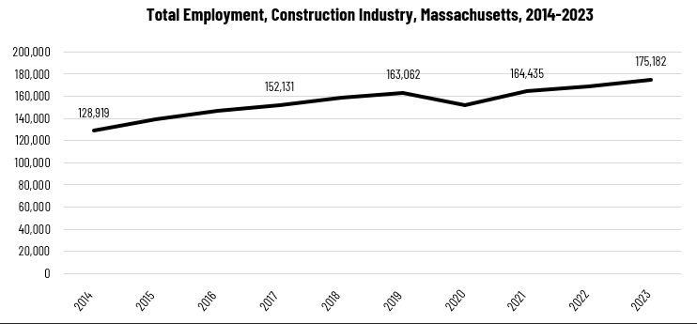

When we break down the growth of the Construction industry, we see that while increases have been seen in all three construction sectors, growth in both the total number of jobs and the percentage of jobs added has been led by the Specialty Trades Contractors sector.

#### Tables 3 and 4: Employment Change, Construction Industries, Massachusetts, 2014-2023

|  |  |  |  |  |  |  |  |
| --- | --- | --- | --- | --- | --- | --- | --- |
| Industry | 2014 | 2018 | 2019 | 2020 | 2021 | 2022 | 2023 |
| Construction of Buildings | 27,137 | 33,381 | 34,166 | 32,452 | 34,825 | 35,900 | 37,092 |
| Heavy/Civil Engineering Construction | 12,671 | 14,105 | 13,893 | 13,820 | 13,843 | 14,128 | 14,325 |
| Specialty Trade Contractors | 89,112 | 111,169 | 115,003 | 106,094 | 115,768 | 119,104 | 123,765 |

|  |  |  |
| --- | --- | --- |
| Industry | Change | % Change |
| Construction of Buildings | 9,955 | 36.7% |
| Heavy/Civil Engineering Construction | 1,654 | 13.1% |
| Specialty Trade Contractors | 34,654 | 38.9% |

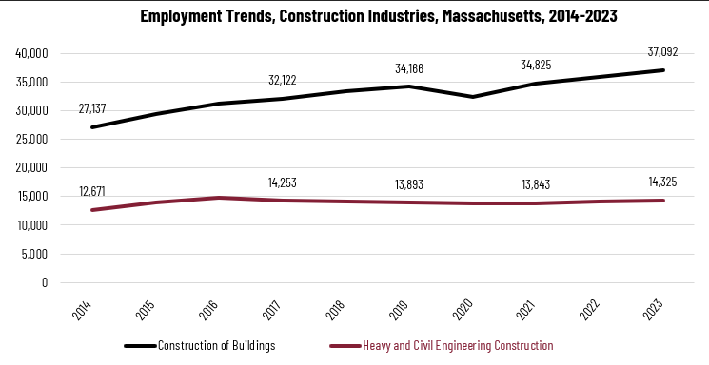

Chart, line chart


At the most detailed level available, we see that growth was led over the decade by Poured Concrete Contractors (NAICS 238110) and Residential Remodelers (NAICS 236118). Plumbing, Heating and Air-conditioning Contractors ranked fifth with more than 48% growth.

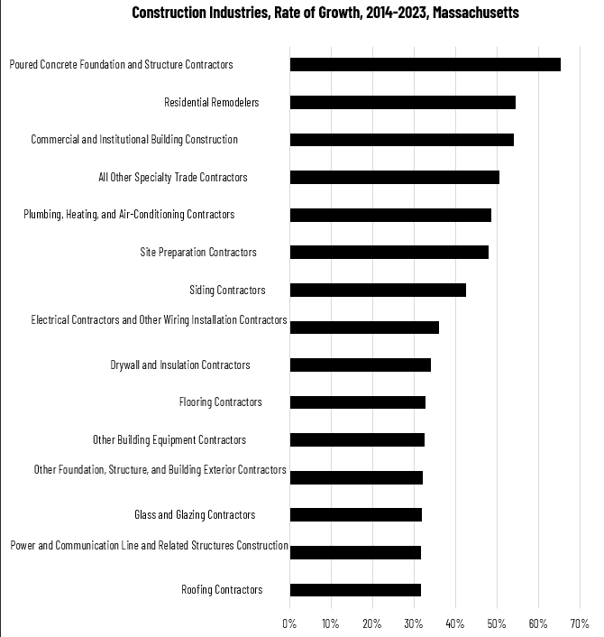

### Wages, Salaries and Proprietor Earnings

Among the detailed industry categories, the highest wages are found in the Industrial Building and Power Line Construction employers. The lowest are in Residential Remodelers and Painting Contractors.

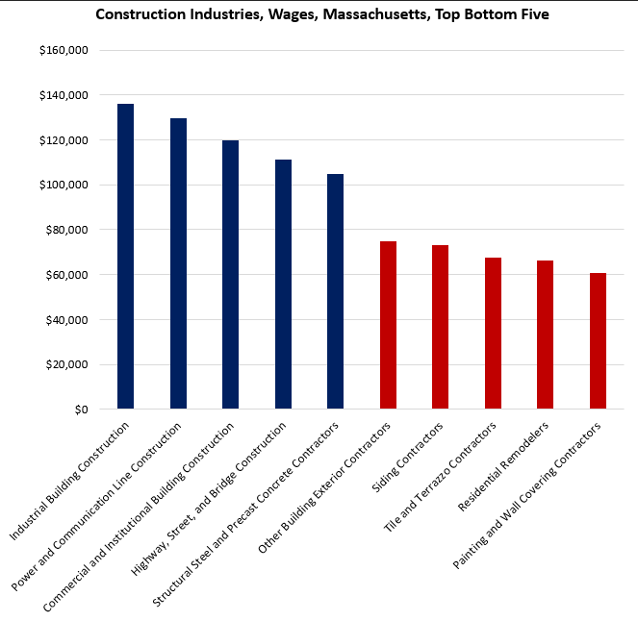

## The Pathways

### Electricity Occupations and Pathways

This section looks at the target occupation category: Electricians. It will also consider advancement opportunities in related careers that are not directly related to the program of study, but that illustrate opportunities that may be available to workers in this field with additional education and experience.

#### Table 5: Electricians, Massachusetts

|  |  |  |  |  |  |
| --- | --- | --- | --- | --- | --- |
| Occupation | 2023 Jobs | Turnover Rate | 2014 - 2023 Change | 2014 - 2023 % Change | Median Annual Earnings |
| Electricians | 18,498 | 51.0% | 3,832 | 26% | $82,222 |

While careers in these two occupations are certainly viable in their own rights, they also can serve as entry points to progressively more sophisticated and better-paying roles.

#### Table 6: Related Career Pathways

##### Job Zone Two Occupations

|  |  |  |  |
| --- | --- | --- | --- |
| Occupation | 2023 Jobs | Typical Education Requirement | Median Annual Earnings |
| Helpers-Electricians | 1,428 | High school | $45,906 |
| Solar Photovoltaic Installers | 982 | High school | $48,620 |
| Electricians | 18,498 | High school | $82,222 |
| Energy Auditors (data for building inspectors) | 3,835 | High school | $77,522 |
| Construction and Building Inspectors | 3,835 | High school | $77,522 |
| Solar Energy Installation Managers (data for construction supervisors) | 15,659 | High school | $98,592 |

##### Job Zone Three Occupations

|  |  |  |  |
| --- | --- | --- | --- |
| Occupation | 2023 Jobs | Typical Education Requirement | Median Annual Earnings |
| First-Line Supervisors of Construction Trades and Extraction Workers | 15,659 | High school | $98,592 |
| Energy Engineers (data for Engineers, All Other) | 3,229 | Bachelor’s | $112,690 |

##### Job Zone Four Occupations

|  |  |  |  |
| --- | --- | --- | --- |
| Occupation | 2023 Jobs | Typical Education Requirement | Median Annual Earnings |
| Construction Managers | 7,087 | Bachelor’s | $131,727 |

## Occupation Profile

The United States Department of Labor, Employment and Training Administration created and regularly updates more than 800 occupational profiles with characteristics like skills, educational requirements, and daily tasks, based on the inputs of industry experts and people who are employed in the occupations.

### Electricians

#### Description

Install, maintain, and repair electrical wiring, equipment, and fixtures. Ensure that work is in accordance with relevant codes. May install or service streetlights, intercom systems, or electrical control systems.

#### Top Skills

* Determining causes of operating errors and deciding what to do about it.
* Repairing machines or systems using the needed tools.
* Giving full attention to what other people are saying, taking time to understand the points being made, asking questions as appropriate, and not interrupting at inappropriate times.
* Talking to others to convey information effectively.
* Using logic and reasoning to identify the strengths and weaknesses of alternative solutions, conclusions, or approaches to problems.
* Understanding the implications of new information for both current and future problem-solving and decision-making.
* Installing equipment, machines, wiring, or programs to meet specifications.
* Conducting tests and inspections of products, services, or processes to evaluate quality or performance.
* Considering the relative costs and benefits of potential actions to choose the most appropriate one.
* Understanding written sentences and paragraphs in work-related documents.
* Monitoring/Assessing performance of yourself, other individuals, or organizations to make improvements or take corrective action.
* Adjusting actions in relation to others' actions.
* Identifying complex problems and reviewing related information to develop and evaluate options and implement solutions.
* Watching gauges, dials, or other indicators to make sure a machine is working properly.
* Communicating effectively in writing as appropriate for the needs of the audience.
* Using mathematics to solve problems.

#### Top Daily Tasks

* Create construction or installation diagrams.
* Thread wire or cable through ducts or conduits.
* Repair electrical equipment.
* Test electrical equipment or systems to ensure proper functioning.
* Install electrical components, equipment, or systems.
* Update job related knowledge or skills.
* Plan layout of construction, installation, or repairs.
* Direct construction or extraction personnel.
* Train construction or extraction personnel.
* Inspect electrical or electronic systems for defects.
* Communicate with other construction or extraction personnel to discuss project details.
* Fabricate parts or components.
* Assist skilled construction or extraction personnel.

#### Additional Information

* [Associated Builders and Contractors](https://www.abc.org/)
* [Association of Western Pulp and Paper Workers Union](http://www.awppw.org/)
* [Electrical Training Alliance](https://www.electricaltrainingalliance.org/)
* [Explore the Trades](https://www.explorethetrades.org/)
* [Home Builders Institute](https://www.hbi.org/)
* [Independent Electrical Contractors](https://www.ieci.org/)
* [Industrial Division of the Communication Workers of America](https://www.iue-cwa.org/)
* [International Association of Electrical Inspectors](https://www.iaei.org/)
* [International Brotherhood of Electrical Workers](https://www.ibew.org/)
* [International Municipal Signal Association](https://www.imsasafety.org/)

#### Job Postings- Electricians

P2C uses a third-party system that aggregates data from job postings to provide perspective on the skills and qualifications employers are prioritizing in their advertisements for these occupations.

* After controlling for multiple postings that likely referenced the same single opening, over the last year, we identified 2,478 unique job postings for Electricians.
* We identified 481 unique employers who posted openings online.

##### Top Employers Advertising:

* Trinity Solar
* PeopleReady
* JLL
* Tradesmen International
* State of Massachusetts
* Harvard University
* Sunrun
* GPAC
* Amtrak
* Cushman & Wakefield
* Vision Solar
* Takeda Pharmaceutical Company

##### Top Job Titles:

* Electricians
* Licensed Electricians
* Journeyman Electricians
* Maintenance Electricians
* Residential Service Electricians
* Service Electricians
* Solar Electricians
* Master Electricians
* Industrial Electricians
* Residential Electricians
* Electrical Trainees
* Certified Electricians

##### Top Qualifications:

* Valid Driver's License
* Journeyman Electrician
* 10-Hour OSHA General Industry Card
* 30-Hour OSHA General Industry Card
* NABCEP Certified Energy Practitioner
* Commercial Driver's License (CDL)
* Security Clearance
* Journeyman Lineman
* Hoisting License
* Certified Network Cable Installer (CNCI)

##### Top Overall Skills:

* Machinery
* Electronic Components
* Wiring Diagram
* Preventative Maintenance
* Network Switches
* Power Tool Operation
* Low Voltage

###### Defining Skills

* Electrical Wiring
* Electrical Systems
* Electrical Equipment
* Hand Tools
* Blueprinting
* Transformers (Electrical)
* Electrical Codes
* Circuit Breakers

###### Differentiating Skills

* Voltmeter
* Lighting Systems
* Switchgear
* Relays
* Motor Controllers
* Variable Frequency Drives
* Junction Boxes
* Electrical Conduit
* Electrical Theory