Labor Market Analysis of Facilities Maintenance Management in Massachusetts

April 2024

## Overview

This analysis uses labor market data from the Massachusetts Department of Economic Research to provide perspective on three theaters related to Building and Grounds Cleaning and Maintenance Workers: the administrative and support services industry, the construction industry, and opportunities within the related career pathways.

The administrative and support services industry should be understood as employers engaged in activities that support the day-to-day operations of other organizations. The processes employed in this sector (e.g., general management, personnel administration, clerical activities, cleaning activities) are often integral parts of the activities of establishments found in all sectors of the economy. The establishments classified in this subsector have specialization in one or more of these activities and can, therefore, provide services to clients in a variety of industries and, in some cases, to households. The individual industries of this subsector are defined on the basis of the particular process that they are engaged in and the particular services they provide. Many of the activities in this subsector are ongoing routine support functions that businesses and organizations perform in-house. However, it is common to contract or purchase services from businesses that specialize in such activities and can, therefore, provide the services more efficiently.

The construction industry should be understood as the employers in the Commonwealth whose primary line of business is construction. Those companies employ a spectrum of occupations, ranging from skilled tradesmen to real estate agents. While trends in the construction industry are not necessarily directly related to Building and Grounds Cleaning and Maintenance Workers, a significant share of people in this occupation work for construction companies, making its realities and trends a valuable backdrop against which to evaluate these careers in Massachusetts.

In public data systems, occupations are a set of tasks regularly performed by one individual on an employer’s payroll. In this analysis, the target occupations are profiled both as a set and individually, as we seek to provide strategic value in the development and administration of related curriculum and the construction of compelling and instructive narratives that will introduce students to the world of the skilled trades in the 21st Century.

## The Construction Industry

### The Construction Industry in Labor Market Data Systems

Construction (NAICS code 23) comprises all employers whose primary line of business is construction. The industry category is divided into three sub-industries:

* 236-Construction of Buildings
* 237-Heavy and Civil Engineering Construction
* 238-Specialty Trades Contractors

Each of these categories is further parsed into four-, five-, and ultimately six-digit level categories, and the Massachusetts Department of Economic Research produces employment and wage estimates for each.

#### Construction Industry Categories

* 236 Construction of Buildings
  + 236115 New Single-Family Housing Construction (except For-Sale Builders)
  + 236116 New Multifamily Housing Construction (except For-Sale Builders)
  + 236117 New Housing For-Sale Builders
  + 236118 Residential Remodelers
  + 236210 Industrial Building Construction
  + 236220 Commercial and Institutional Building Construction
* 237 Heavy and Civil Engineering Construction
  + 237110 Water and Sewer Line and Related Structures Construction
  + 237120 Oil and Gas Pipeline and Related Structures Construction
  + 237130 Power and Communication Line and Related Structures Construction
  + 237210 Land Subdivision
  + 237310 Highway, Street, and Bridge Construction
  + 237990 Other Heavy and Civil Engineering Construction
* 238 Specialty Trades Contractors
  + 238110 Poured Concrete Foundation and Structure Contractors
  + 238120 Structural Steel and Precast Concrete Contractors
  + 238130 Framing Contractors
  + 238140 Masonry Contractors
  + 238150 Glass and Glazing Contractors
  + 238160 Roofing Contractors
  + 238170 Siding Contractors
  + 238190 Other Foundation, Structure, and Building Exterior Contractors
  + 238210 Electrical Contractors and Other Wiring Installation Contractors
  + 238220 Plumbing, Heating, and Air-Conditioning Contractors
  + 238290 Other Building Equipment Contractors
  + 238310 Drywall and Insulation Contractors
  + 238320 Painting and Wall Covering Contractors
  + 238330 Flooring Contractors
  + 238340 Tile and Terrazzo Contractors
  + 238350 Finish Carpentry Contractors
  + 238390 Other Building Finishing Contractors

### Employment-Skilled Trades

It is not surprising that at the most general level available, the industry that most often employ skilled tradespeople in Massachusetts is Construction (NAICS 23); however, only 35% of skilled tradesmen work for employers whose primary line of business is construction. Just less than 10% work in the Mining, Quarrying and Oil and Gas industry (NAICS21) and another 6% work in Utilities (NAICS 22). The table below details the top five detailed industry sectors by the share of skilled tradespeople who are employed in them.

#### Tables 1 and 2: Top Detailed Industries for Skilled Trades

|  |  |
| --- | --- |
| **Industry** | **Share of Occupation Jobs** |
| Electrical Contractors and Other Wiring Installation Contractors | 19.1% |
| Plumbing, Heating and Air Conditioning Contractors | 18.3% |
| Commercial and Institutional Building Construction | 5.5% |
| Residential Remodelers | 5.2% |
| Painting and Wall Covering Contractors | 4.1% |

|  |  |  |
| --- | --- | --- |
| **Occupation** | **Top Industry** | **Share of Occupation Jobs** |
| Brickmasons and Blockmasons | Masonry Contractors | 77.9% |
| Stonemasons | Masonry Contractors | 62.4% |
| Carpenters | Residential Remodelers | 17.4% |
| Tile and Stone Setters | Finish Carpentry Contractors | 27.2% |
| Cement Masons and Concrete Finishers | Poured Concrete Foundation and Structure Contractors | 33.8% |
| Operating Engineers and Other Equipment Operators | Site Preparation Contractors | 20.1% |
| Electricians | Electrical Contractors | 74.9% |
| Painters, Construction, and Maintenance | Painting and Wall Covering Contractors | 66.9% |
| Pipelayers | Water and Sewer Line Construction | 17.1% |
| Plumbers, Pipefitters, and Steamfitters | Plumbing, Heating and Air Conditioning Contractors | 77.3% |
| Reinforcing Iron and Rebar Workers | Glass and Glazing Contractors | 14.5% |
| Sheet Metal Workers | Plumbing, Heating and Air Conditioning Contractors | 58.3% |
| Structural Iron and Steel Workers | Commercial and Institutional Building Construction | 18.4% |

### Employment Trends

The number of people employed in the Construction industry in Massachusetts has been steadily increasing over the last decade, except for a significant COVID-19-related decline in 2020. The net change has been an increase of 35.9% in jobs over the last decade.

#### Table 3: Average Annual Employment, Construction Industry, Massachusetts, 2014-2023

|  |  |
| --- | --- |
| **Year** | **Jobs** |
| 2014 | 128,919 |
| 2015 | 138,991 |
| 2016 | 146,503 |
| 2017 | 152,131 |
| 2018 | 158,656 |
| 2019 | 163,062 |
| 2020 | 152,366 |
| 2021 | 164,435 |
| 2022 | 170,026 |
| 2023 | 176,199 |

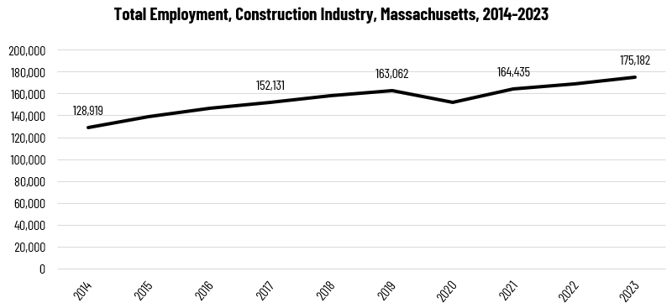

When we break down the growth of the Construction industry, we see that while increases have been seen in all three Construction sectors, growth in both the total number of jobs, and the percentage of jobs added, has been led by the Specialty Trades Contractors sector.

#### Tables 4 and 5: Employment Change, Construction Industries, Massachusetts, 2014-2023

|  |  |  |  |  |  |  |  |
| --- | --- | --- | --- | --- | --- | --- | --- |
| **Industry** | **2014** | **2018** | **2019** | **2020** | **2021** | **2022** | **2023** |
| Construction of Buildings | 27,137 | 33,381 | 34,166 | 32,452 | 34,825 | 35,900 | 37,092 |
| Heavy/Civil Engineering Construction | 12,671 | 14,105 | 13,893 | 13,820 | 13,843 | 14,128 | 14,325 |
| Specialty Trade Contractors | 89,112 | 111,169 | 115,003 | 106,094 | 115,768 | 119,104 | 123,765 |

|  |  |  |
| --- | --- | --- |
| **Industry** | **Change** | **% Change** |
| Construction of Buildings | 9,955 | 36.7% |
| Heavy/Civil Engineering Construction | 1,654 | 13.1% |
| Specialty Trade Contractors | 34,654 | 38.9% |

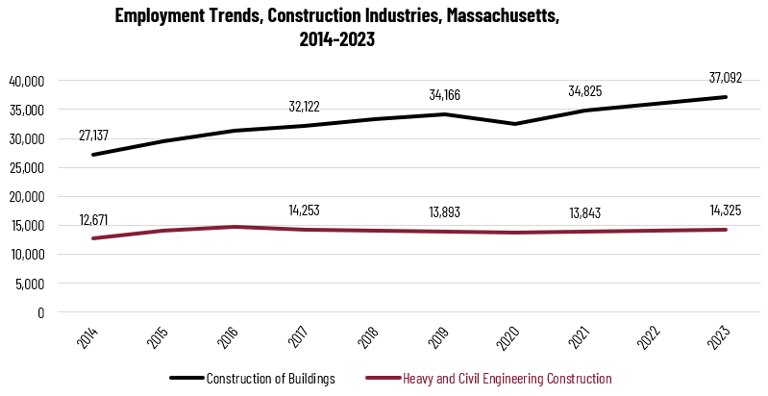

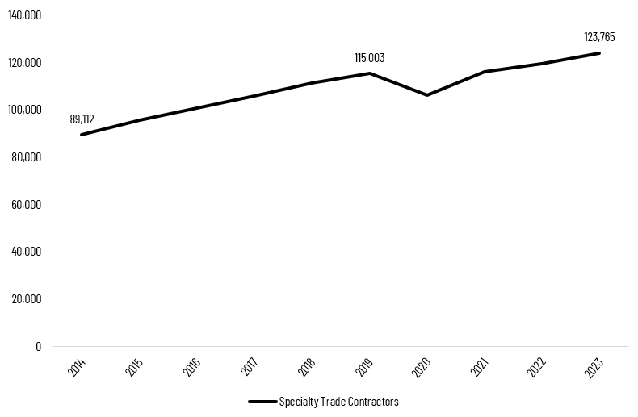

At the most detailed level available, we see that growth was led over the decade by Poured Concrete Contractors (NAICS 238110) and Residential Remodelers (NAICS 236118). Plumbing, Heating, and Air-Conditioning Contractors ranked fifth with more than 48% growth.

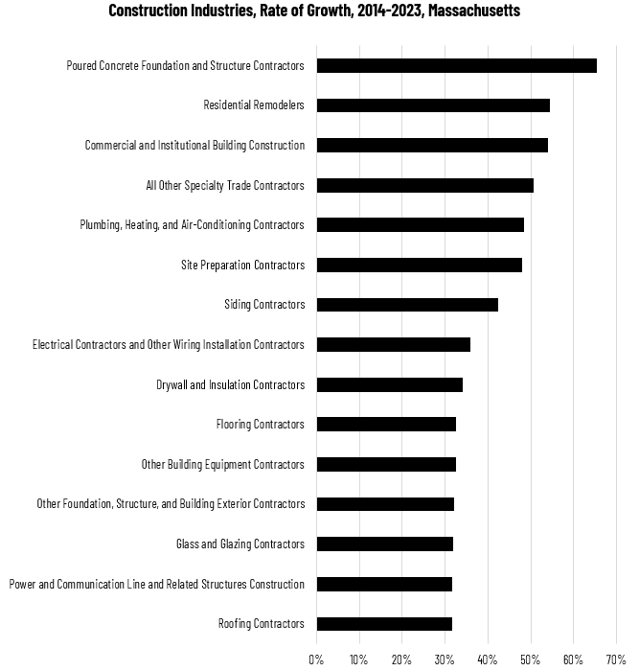

### Wages, Salaries and Proprietor Earnings

Among the detailed industry categories, the highest wages are found in the Industrial Building and Power Line Construction employers. The lowest are in Residential Remodelers and Painting Contractors.

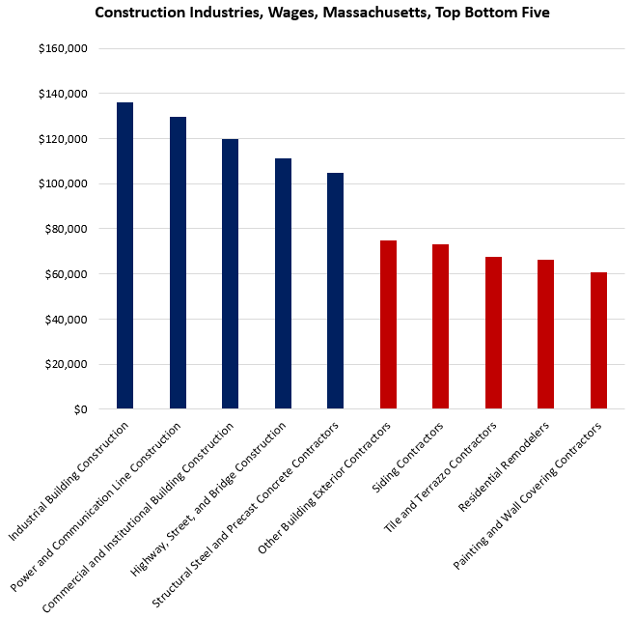

## The Administrative and Support Services Industry

### The Administrative and Support Services Industry in Labor Market Data Systems

Administrative and Support Services (NAICS code 561) comprises all employers whose primary line of business is supporting the day-to-day operations of other organizations. The processes employed in this sector (e.g., general management, personnel administration, clerical activities, cleaning activities) are often integral parts of the activities of establishments found in all sectors of the economy. The establishments classified in this subsector have specialization in one or more of these activities and can, therefore, provide services to clients in a variety of industries and, in some cases, to households. The individual industries of this subsector are defined on the basis of the particular process that they are engaged in and the particular services they provide.

Many of the activities in this subsector are ongoing routine support functions that businesses and organizations perform in-house. However, it is common to contract or purchase services from businesses that specialize in such activities and can, therefore, provide the services more efficiently.

The industry category is a component of the larger Administrative and Support and Waste Management and Remediation category. Each subindustry is further parsed into four-, five-, and ultimately six-digit level categories, and the Massachusetts Department of Economic Research produces employment and wage estimates for each.

#### Administrative and Support Services Industry, Select Categories

* 561 Administrative and Support Services
  + 5611 Office Administrative Services
  + 5612 Facilities Support Services
  + 5613 Employment Services
    - 561312 Executive Search Services
    - 561320 Temporary Help Services
    - 561330 Professional Employer Organizations
  + 5614 Business Support Services
  + 5615 Travel Arrangement and Reservation Services
  + 5616 Investigation and Security Services
  + 5617 Services to Buildings and Dwellings
    - 561710 Exterminating and Pest Control Services
    - 561720 Janitorial Services
    - 561730 Landscaping Services
    - 561740 Carpet and Upholstery Cleaning Services
    - 561790 Other Services to Buildings and Dwellings
  + 5619 Other Support Services

### Employment-Building and Grounds Maintenance Occupations

It is not surprising that at the most general level available, the industry that most often employs Building and Grounds Cleaning and Maintenance in Massachusetts is Administrative and Support and Waste Management and Remediation (NAICS 56); however, fewer than half of people in these occupations are employed by organizations whose primary line of business is administrative and waste services. More than 11% work in the Government industry (NAICS 90) and another 10% work in Accommodation and Food Services (NAICS 72). The table below details the top five detailed industry sectors by the share of Building and Grounds Cleaning and Maintenance workers who are employed in them.

#### Tables 6 and 7: Top Detailed Industries for Building and Grounds Cleaning and Maintenance Occupations

|  |  |
| --- | --- |
| **Industry** | **Share of Occupation Jobs** |
| Services to Buildings and Dwellings | 45.9% |
| Traveler Accommodation | 8.3% |
| Education and Hospitals (Local Government) | 7.0% |
| Other Amusement and Recreation Industries | 4.5% |
| General Medical and Surgical Hospitals | 3.7% |

|  |  |  |
| --- | --- | --- |
| **Occupation** | **Top Industry** | **Share of Occupation Jobs** |
| Janitors and Cleaners | Janitorial Services | 42.9% |
| Pest Control Workers | Exterminating and Pest Control Services | 93.6% |
| Landscaping and Groundskeeping Workers | Landscaping Services | 58.6% |
| Pesticide Handlers, Sprayers, and Applicators, Vegetation | Landscaping Services | 42.9% |
| First-Line Supervisors of Landscaping, Lawn Service, and Groundskeeping Workers | Landscaping Services | 66.1% |
| Facilities Managers | Colleges, Universities, and Professional Schools | 7.5% |

### Employment Trends

The number of people employed in the Administrative and Support Services industry in Massachusetts had been steadily increasing over the last decade, until a dramatic COVID-19-related decline in 2020. The net change has been an increase of 9.5% in jobs over the last decade.

#### Table 8: Average Annual Employment, Administrative and Support Services Industry, Massachusetts

|  |  |
| --- | --- |
| **Year** | **Jobs** |
| 2014 | 161,144 |
| 2015 | 165,468 |
| 2016 | 169,097 |
| 2017 | 171,583 |
| 2018 | 173,344 |
| 2019 | 173,854 |
| 2020 | 154,830 |
| 2021 | 166,798 |
| 2022 | 176,710 |
| 2023 | 176,521 |

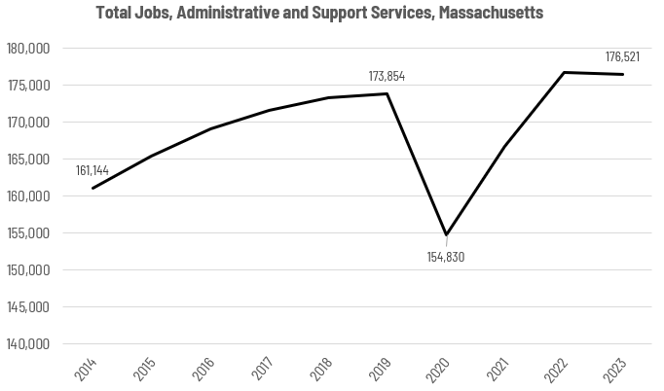

When we break down the growth of the industry, we see that increases have been led by two subindustries, Temporary Help Services and Landscaping Services. Temporary Help Services leads growth in the total number of jobs, while the percentage of jobs added has been led by the Facilities Support Services.

#### Tables 9 and 10: Employment Change, Administrative and Support Industries, Massachusetts, 2014-2023

|  |  |  |  |  |  |  |  |
| --- | --- | --- | --- | --- | --- | --- | --- |
| **Industry** | **2014** | **2018** | **2019** | **2020** | **2021** | **2022** | **2023** |
| Temporary Help Services | 54,915 | 55,668 | 55,112 | 47,531 | 57,304 | 61,839 | 61,299 |
| Landscaping Services | 18,071 | 22,048 | 22,288 | 21,678 | 23,283 | 23,988 | 23,828 |
| Facilities Support Services | 899 | 1,515 | 1,582 | 1,559 | 1,658 | 1,729 | 1,775 |

|  |  |  |
| --- | --- | --- |
| **Industry** | **Change** | **% Change** |
| Temporary Help Services | 6,383 | 11.6% |
| Landscaping Services | 5,757 | 31.9% |
| Facilities Support Services | 876 | 97.4% |

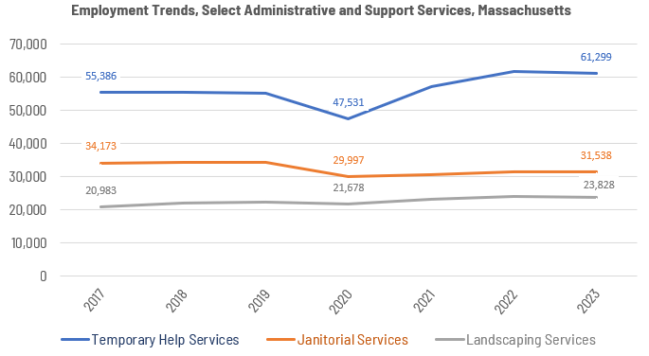

At the most detailed level available, we see that growth was led over the decade by Facilities Support Services (NAICS 561210) and Exterminating and Pest Control Services (NAICS 561710). Office Administrative Services ranked seventh.

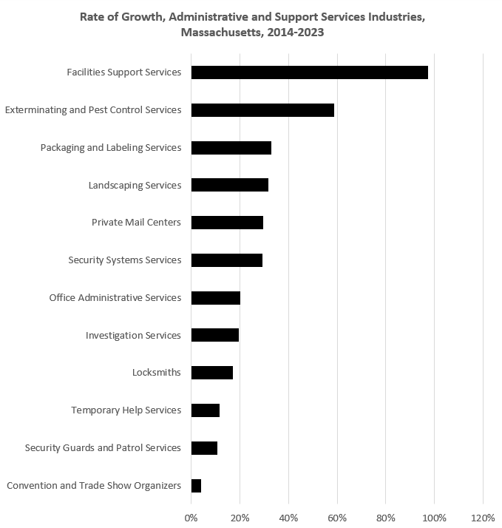

### Wages, Salaries and Proprietor Earnings

Among the detailed industry categories and excluding the “other” category, the highest wages are found in the exterminating and pest control employers. The lowest are in janitorial services.

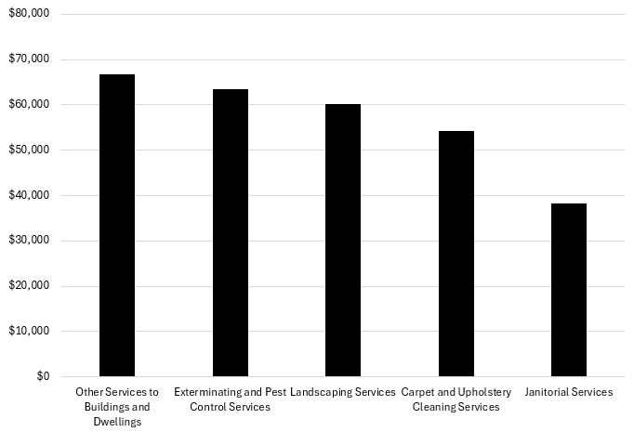

## The Pathways

### Facilities Management Occupations and Pathways

This section looks at the target occupations and pathways and also considers advancement opportunities in related careers that are not directly related to the program of study, but that illustrate opportunities that may be available to workers in these fields with additional education and experience.

#### Table 11: Occupational Outlook, Massachusetts

|  |  |  |  |  |  |
| --- | --- | --- | --- | --- | --- |
| Occupation | 2023 Jobs | Turnover Rate | 2014 - 2023 Change | 2014 - 2023 % Change | Median Annual Earnings |
| First-Line Supervisors of Housekeeping and Janitorial Workers | 3,574 | 68.2% | (1,122) | (23.9%) | $57,949 |
| First-Line Supervisors of Landscaping, Lawn Service and Groundskeeping Workers | 4,109 | 78.0% | 1,077 | 35.5% | $65,104 |
| Janitors and Cleaners | 51,890 | 84.5% | (1,115) | (2.1%) | $36,733 |
| Landscaping and Groundskeeping Workers | 24,679 | 98.7% | 3,080 | 14.3% | $44,574 |
| Maids and Housekeeping Cleaners | 17,015 | 86.1% | (3,397) | (16.6%) | $35,936 |
| Pest Control Workers | 1,591 | 98.5% | 505 | 46.5% | $48,589 |
| Pesticide Handlers, Sprayers and Applicators, Vegetation | 489 | 88.4% | 63 | 14.8% | $53,569 |
| Tree Trimmers and Pruners | 1,400 | 99.0% | 396 | 39.5% | $49,858 |
| Administrative Services Managers | 9,009 | 40.8% | 776 | 9.4% | $128,274 |
| Facilities Managers | 4,869 | 42.0% | 1,020 | 26.5% | $103,563 |
| Lodging Managers | 750 | 63.6% | (9) | (1.2%) | $69,805 |
| First-Line Supervisors of Office and Administrative Workers | 39,227 | 54.0% | 2,076 | 5.6% | $68,286 |

While careers in these occupations are certainly viable in their own rights, they also can serve as entry points to progressively more sophisticated and better-paying roles.

#### Table 12: Related Career Pathways

##### Job Zone Two Occupations

|  |  |  |  |
| --- | --- | --- | --- |
| Occupation | 2023 Jobs | Annual Median Earnings | Typical Education Requirement |
| First-Line Supervisors of Housekeeping and Janitorial Workers | 3,574 | $57,949 | High School |
| Pest Control Workers | 1,591 | $48,589 | High School |
| Pesticide Handlers, Sprayers and Applicators, Vegetation | 489 | $53,569 | High School |
| Tree Trimmers and Pruners | 1,400 | $49,858 | High School |

##### Job Zone Three Occupations

|  |  |  |  |
| --- | --- | --- | --- |
| Occupation | 2023 Jobs | Annual Median Earnings | Typical Education Requirement |
| Facilities Managers | 4,869 | $103,563 | Bachelor's |
| Administrative Services Managers | 9,009 | $128,274 | Bachelor's |
| First-Line Supervisors of Landscaping, Lawn Service and Groundskeeping Workers | 4,109 | $65,104 | High School |
| Janitors and Cleaners | 51,890 | $36,733 | None |
| First-Line Supervisors of Office and Administrative Workers | 39,227 | $68,286 | High School |
| Construction and Building Inspectors | 3,781 | $77,917 | High School |

##### Job Zone Four Occupations

|  |  |  |  |
| --- | --- | --- | --- |
| Occupation | 2023 Jobs | Annual Median Earnings | Typical Education Requirement |
| Lodging Managers | 750 | $69,805 | High School |
| Property, Real Estate and Community Association Managers | 5,059 | $78,874 | High School |

### Skilled Trades Occupations and Pathways

This section looks at the target occupations and pathways and also considers advancement opportunities in related careers that are not directly related to the program of study, but that illustrate opportunities that may be available to workers in these fields with additional education and experience.

#### Table 13: Occupational Outlook, Massachusetts

|  |  |  |  |  |  |
| --- | --- | --- | --- | --- | --- |
| Occupation | 2023 Jobs | Turnover Rate | 2014 - 2023 Change | 2014 - 2023 % Change | Median Annual Earnings |
| Brickmasons and Blockmasons | 1,586 | 68.0% | 77 | 5% | $77,355 |
| Stonemasons | 409 | 76.8% | (71) | (15%) | $49,421 |
| Carpenters | 19,001 | 62.5% | 2,407 | 15% | $62,546 |
| Tile and Stone Setters | 208 | 56.8% | (402) | (66%) | $63,939 |
| Cement Masons and Concrete Finishers | 2,756 | 64.2% | 1,355 | 97% | $76,398 |
| Operating Engineers and Other Equipment Operators | 8,094 | 63.0% | 2,163 | 36% | $69,098 |
| Electricians | 18,535 | 49.6% | 3,867 | 26% | $79,747 |
| Painters, Construction, and Maintenance | 4,361 | 62.3% | (144) | (3%) | $55,786 |
| Pipelayers | 201 | 52.9% | (332) | (62%) | $56,264 |
| Plumbers, Pipefitters, and Steamfitters | 15,097 | 48.5% | 4,019 | 36% | $79,830 |
| Reinforcing Iron and Rebar Workers | 188 | 70.7% | (41) | (18%) | $88,392 |
| Sheet Metal Workers | 2,232 | 51.4% | (1,188) | (35%) | $72,259 |
| Structural Iron and Steel Workers | 1,680 | 67.0% | 464 | 38% | $104,125 |

While careers in these occupations are certainly viable in their own rights, they also can serve as entry points to progressively more sophisticated and better-paying roles.

#### Table 14: Related Career Pathways

##### Job Zone Two Occupations

|  |  |  |  |
| --- | --- | --- | --- |
| Occupation | 2023 Jobs | Typical Education Requirement | Median Annual Earnings |
| Brickmasons and Blockmasons | 1,621 | High School | $77,365 |
| Carpenters | 19,001 | High School | $62,546 |
| Tile and Stone Setters | 208 | High School | $63,939 |
| Cement Masons and Concrete Finishers | 2,756 | High School | $76,398 |
| Operating Engineers and Other Equipment Operators | 8,094 | High School | $69,098 |
| Painters, Construction and Maintenance | 4,361 | High School | $55,786 |
| Pipelayers | 201 | High School | $56,264 |
| Reinforcing Iron and Rebar Workers | 188 | High School | $88,392 |
| Sheet Metal Workers | 2,232 | High School | $72,259 |
| Structural Iron and Steel Workers | 1,680 | High School | $104,125 |
| Stonemasons | 409 | High School | $49,421 |
| Electricians | 18,535 | High School | $79,747 |
| Plumbers, Pipefitters and Steamfitters | 15,097 | High School | $79,830 |
| Solar Thermal Installers and Technicians | N/A | High School | $79,830 |
| First-Line Supervisors of Construction Trades Workers | 15,683 | High School | $98,592 |
| Energy Auditors | N/A | None | $77,917 |

##### Job Zone Three Occupations

|  |  |  |  |
| --- | --- | --- | --- |
| Occupation | 2023 Jobs | Typical Education Requirement | Median Annual Earnings |
| Construction and Building Inspectors | 3,848 | Postsecondary Nondegree Award | $77,917 |
| Solar Energy Installation Managers | N/A | Postsecondary Nondegree Award | $98,592* |

##### Job Zone Four Occupations

|  |  |  |  |
| --- | --- | --- | --- |
| Occupation | 2023 Jobs | Typical Education Requirement | Median Annual Earnings |
| Energy Engineers (data for Engineers, All Other) | 3,229 | Bachelor’s | $112,690 |
| Construction Managers | 7,087 | Bachelor’s | $131,727 |

*\** *Data for Construction and Building Inspectors*

*\*\*Data for First-Line Supervisors of Construction Trades Workers*

## Occupation Profiles

The United States Department of Labor, Employment and Training Administration created and regularly updates more than 800 occupational profiles with characteristics like skills, educational requirements, and daily tasks, based on the inputs of industry experts and people who are employed in the occupations.

### First-Line Supervisors of Housekeeping and Janitorial Workers

#### Description

Directly supervise and coordinate work activities of cleaning personnel in hotels, hospitals, offices, and other establishments.

#### Top Skills

* Motivating, developing, and directing people as they work, identifying the best people for the job.
* Talking to others to convey information effectively.
* Monitoring/assessing performance of yourself, other individuals, or organizations to make improvements or take corrective action.
* Adjusting actions in relation to others' actions.
* Managing one's own time and the time of others.
* Giving full attention to what other people are saying, taking time to understand the points being made, asking questions as appropriate, and not interrupting at inappropriate times.
* Using logic and reasoning to identify the strengths and weaknesses of alternative solutions, conclusions, or approaches to problems.
* Selecting and using training/instructional methods and procedures appropriate for the situation when learning or teaching new things.
* Being aware of others' reactions and understanding why they react as they do.
* Teaching others how to do something.
* Actively looking for ways to help people.
* Identifying complex problems and reviewing related information to develop and evaluate options and implement solutions.

#### Top Daily Tasks

* Supervise maintenance workers.
* Select equipment, materials, or supplies for cleaning or maintenance activities.
* Confer with coworkers to coordinate maintenance or cleaning activities.
* Clean facilities or sites.
* Inspect work to ensure standards are met.
* Plan employee work schedules.
* Establish work standards.
* Inspect buildings or grounds to determine condition.
* Inventory materials or equipment.
* Determine resource needs.
* Distribute supplies to workers.
* Maintain equipment or systems to ensure proper functioning.
* Document work hours or activities.
* Arrange maintenance activities.
* Recommend changes or corrective procedures.
* Investigate work related complaints to determine corrective actions.
* Instruct staff in work policies or procedures.
* Estimate maintenance service requirements or costs.
* Evaluate current or prospective maintenance employees.
* Recommend organizational process or policy changes.
* Remove snow.

#### Additional Information

* International Healthcare and Hospitality Association
* International Facility Management Association

#### Job Postings - First-Line Supervisors of Housekeeping and Janitorial Workers

P2C uses a third-party system that aggregates data from job postings to provide perspective on the skills and qualifications employers are prioritizing in their advertisements for these occupations.

* After controlling for multiple postings that likely referenced the same single opening, over the last year, we identified 1,379 unique job postings for First-Line Supervisors of Housekeeping and Janitorial Workers.
* We identified 337 unique employers who posted openings online.

##### Top Employers Advertising:

* Marriott International
* Hilton
* Mass General Brigham
* Cushman & Wakefield
* Sodexo
* Southcoast Health
* Colwen Hotels
* Aramark
* The Judge Group
* Holiday Inn
* Aimbridge Hospitality
* Beth Israel Lahey Health
* Sonesta Hotels
* Notre Dame Health Care Center
* Highgate Hotels
* Harvard University
* Homewood Suites
* HEI Hotels & Resorts
* Compass Group
* Healthcare Services Group

##### Top Job Titles:

* Housekeeping Supervisors
* Housekeeping Managers
* Custodial Supervisors
* Environmental Services Managers
* Sanitation Supervisors
* Executive Housekeepers
* Environmental Services Supervisors
* Environmental Services Leads
* Janitorial Supervisors
* Directors of Environmental Services
* Housekeeping Team Leaders
* Directors of Housekeeping and Laundry
* Environmental Aides
* Environmental Services Operations Managers
* Housekeeping Leads
* Maintenance Managers
* Laundry Supervisors
* Directors of Buildings and Grounds
* Janitorial Managers
* Hotel Housekeeping Supervisors

##### Top Qualifications:

* Valid Driver's License
* OSHA 10-Hour General Industry

##### Top Overall Skills:

* Housekeeping
* Auditing
* Front Office
* Workflow Management
* Performance Appraisal

### Facilities Manager

#### Description

Plan, direct, or coordinate operations and functionalities of facilities and buildings. May include surrounding grounds or multiple facilities of an organization's campus.

#### Top Daily Tasks

* Acquire, distribute, and store supplies.
* Conduct classes to teach procedures to staff.
* Dispose of, or oversee the disposal of, surplus or unclaimed property.
* Manage leasing of facility space.
* Monitor the facility to ensure that it remains safe, secure, and well-maintained.
* Oversee construction and renovation projects to improve efficiency and to ensure that facilities meet environmental, health, and security standards, and comply with government regulations.
* Oversee the maintenance and repair of machinery, equipment, and electrical and mechanical systems.
* Participate in architectural and engineering planning and design, including space and installation management.
* Plan, administer, and control budgets for contracts, equipment, and supplies.
* Prepare and review operational reports and schedules to ensure accuracy and efficiency.
* Set goals and deadlines for the department.

#### Additional Information

* ARMA International external site
* Institute of Certified Records Managers external site
* International Facility Management Association

#### Job Postings – Facilities Manager

P2C uses a third-party system that aggregates data from job postings to provide perspective on the skills and qualifications employers are prioritizing in their advertisements for these occupations.

* After controlling for multiple postings that likely referenced the same single opening, over the last year, we identified 2,287 unique job postings for Facilities Managers.
* We identified 819 unique employers who posted openings online.

##### Top Employers Advertising:

* Allied Universal
* University of Massachusetts
* CBRE
* Securitas
* United Security Group
* JLL
* State of Massachusetts
* Mass General Brigham
* Sodexo
* Walgreens Boots Alliance
* Randstad
* YMCA
* Harvard University
* Northeastern University
* Symbotic
* Cushman & Wakefield
* Boston University
* Tufts University
* Capital One
* PricewaterhouseCoopers

##### Top Job Titles:

* Facilities Managers
* Facilities Coordinators
* Directors of Facilities
* Security Supervisors
* Security Site Supervisors
* Security Managers
* Facilities Specialists
* Facilities Engineers
* Facilities Maintenance Managers
* Facilities Project Managers

##### Top Qualifications:

* Valid Driver's License
* OSHA 10-Hour General Industry

##### Top Overall Skills:

* Project Management
* Construction
* HVAC
* Facility Repair and Maintenance
* Plumbing
* Renovation

###### Defining Skills

* Facility Management
* Security Management

###### Differentiating Skills

* Facilities Engineering