Labor Market Analysis of the Graphic Design and Visual Communications Fields in Massachusetts

## Overview

This analysis uses labor market data from the Massachusetts Department of Economic Research to provide perspective on multiple theaters related to the field of Design and Visual Communication in the Commonwealth:

Two Occupations

* The Graphic Designers Occupation
* The Special Effects Artists and Animators Occupation

Five Industries

* The Specialized Design Services Industry
* The Software Publishers Industry
* The Printing and Related Support Activities Industry
* Newspaper, Periodical, Book, and Directory Publishers Industry
* The Computer Systems Design and Related Services Industry

**The Occupations** are the specific jobs into which graduates of the Graphic Design and Visual Communications program will hopefully enter after graduation. In public data systems, occupations are a set of tasks regularly performed by one individual on an employer’s payroll. In this analysis, the target occupations are profiled in addition to the broad spectrum of industries that employ them, as we seek to provide strategic value in the development and administration of related curriculum and the construction of compelling and instructive narratives that will introduce students to the world of Graphic Design and Visual Communication in the 21st Century.

**The Industries** which employ the target occupations are defined by their primary lines of business. The most common industry in which to find these occupations is Specialized Design Services (NAICS 5414), which is home to more than 8% of these jobs in Massachusetts. Of these top industries for Graphic Designers and Special Effects Artists and Animators, two are components of the larger Professional, Scientific and Technical Services (NAICS 54), and another two are components of the Information industry (NAICS 51).

### Specialized Design Services

*This industry group comprises establishments providing specialized design services (except architectural, engineering, and computer systems design).*

### Software Publishers

*This industry comprises establishments primarily engaged in software publishing. Establishments in this industry carry out operations necessary for producing and distributing computer software, such as designing, providing documentation, assisting in installation, and providing support services to software purchasers. These establishments may design, develop, and publish, or publish only. These establishments may publish and distribute software through subscriptions and/or downloads.*

### Printing and Related Support Activities

*This industry comprises establishments primarily engaged in printing on apparel and textile products, paper, metal, glass, plastics, and other materials, except fabric (grey goods). The printing processes employed include, but are not limited to, lithographic, gravure, screen, flexographic, digital, and letterpress. Establishments in this industry do not manufacture the stock that they print, but may perform postprinting activities, such as folding, cutting, or laminating the materials they print, and mailing.*

### Newspaper, Periodical, Book and Directory Publishers

*This industry group comprises establishments primarily engaged in publishing newspapers, magazines, other periodicals, books, directories and mailing lists, and other works, such as calendars, greeting cards, and maps. These works are characterized by the intellectual creativity required in their development and are usually protected by copyright. Publishers distribute or arrange for the distribution of these works.*

*Publishing establishments may create the works in-house, or contract for, purchase, or compile works that were originally created by others. These works may be published in one or more formats, such as print and/or electronic form, including proprietary electronic networks or exclusively on the Internet. Establishments in this industry may print, reproduce, or offer direct access to the works themselves or may arrange with others to carry out such functions.*

*Establishments that both print and publish may fill excess capacity with commercial or job printing. However, the publishing activity is still considered to be the primary activity of these establishments.*

### Computer Systems Design and Related Services

*This industry comprises establishments primarily engaged in providing expertise in the field of information technologies through one or more of the following activities: (1) writing, modifying, testing, and supporting software to meet the needs of a particular customer; (2) planning and designing computer systems that integrate computer hardware, software, and communication technologies; (3) on-site management and operation of clients' computer systems and/or data processing facilities; and (4) other professional and technical computer related advice and services.*

## The Specialized Design Services Industry

### The Specialized Design Services Industry in Labor Market Data Systems

The Professional, Scientific and Technical Services Industry comprises a broad range of business services. This general industry category is parsed into three-, four-, five-, and ultimately six-digit categories, and the Lightcast system produces employment and wage estimates for each based on data from the Massachusetts Department of Economic Research.

#### Specialized Design Services Industry Taxonomy

* **541 Professional, Scientific and Technical Services**
  + **5411 Legal Services**
  + **5412 Accounting, Tax Preparation, Bookkeeping and Payroll Services**
  + **5413 Architectural, Engineering and Related Services**
  + **5414 Specialized Design Services**
  + **5415 Computer Systems Design and Related Services**
  + **5416 Management, Scientific and Technical Consulting Services**
  + **5417 Scientific Research and Development Services**
  + **5418 Advertising, Public Relations and Related Services**
  + **5419 Othe Professional, Scientific and Technical Services**

### Employment Trends

The number of people employed in the Specialized Design Services Sector in Massachusetts had been steadily increasing over the last decade, until a moderate COVID-19-related decline. Between 2019 and 2020, the industry shed approximately 4.6% of its total employment. The number of jobs in the industry returned to pre-COVID levels in 2021.

#### Table 1: Average Annual Employment, Specialized Design Services Sector, Massachusetts, 2014-2023

|  |  |
| --- | --- |
| **Year** | **Jobs** |
| 2014 | 2,801 |
| 2015 | 2,928 |
| 2016 | 3,067 |
| 2017 | 3,081 |
| 2018 | 3,112 |
| 2019 | 3,222 |
| 2020 | 3,075 |
| 2021 | 3,384 |
| 2022 | 3,625 |
| 2023 | 3,609 |

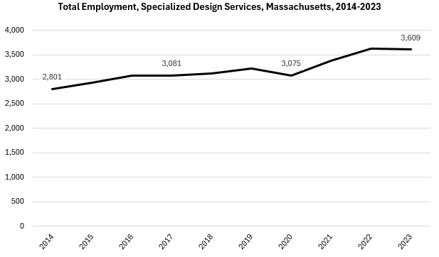

### Wages, Salaries and Proprietor Earnings

Across all occupations in the target industries, the highest earnings are found in the Software Publishers industry. The lowest are found in Printing and Related Support Services.

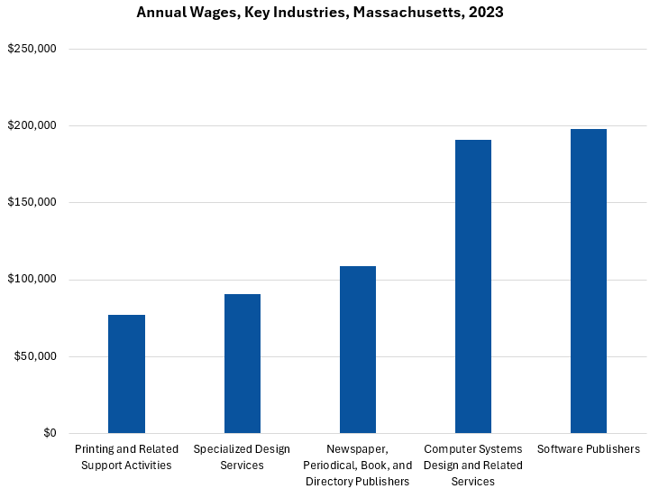

Wages, Salaries, and Proprietor Earnings in the Specialized Design Services industry have trended upward over the last decade, but the rate of growth accelerated significantly in 2019, and the average is now at an all-time high and is 30.9% higher than the 2014 value.

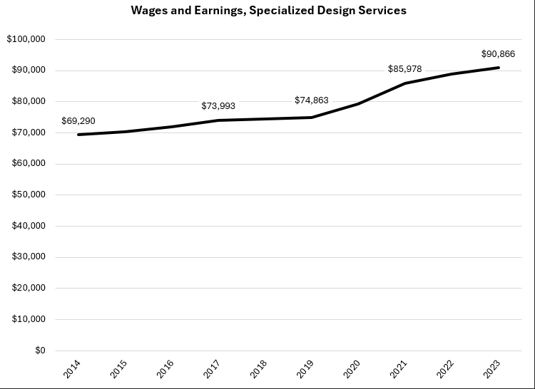

## The Software Publishers Industry

### The Software Publishers Industry in Labor Market Data Systems

The industry category is a component of the larger Information industry. The industry category is parsed into three-, four-, five-, and ultimately six-digit level categories, and the Massachusetts Department of Economic Research produces employment and wage estimates for each.

#### Information Industry Categories

* 51 Information
* 513 Motion Picture and Sound Recording
* 513 Publishing Industries
  + 5131 Newspaper, Periodical, Book and Directory Publishers
  + 5132 Software Publishers
* 516 Broadcasting and Content Providers
* 517 Telecommunications
* 518 Data Processing, Hosting and Related Services
* 519 Web Search Portals, Libraries, Archives and Other Information Services

### Employment Trends

The number of people employed in the Software Publishers industry in Massachusetts has been steadily increasing over the last decade. While most industries in the Commonwealth experienced a downturn in employment during the COVID-19 pandemic, the Software Publishers sector continued its upward trend unabated.

#### Table 2: Average Annual Employment, Software Publishers Industry, Massachusetts, 2014-2023

|  |  |
| --- | --- |
| **Year** | **Jobs** |
| 2014 | 27,041 |
| 2015 | 28,671 |
| 2016 | 29,174 |
| 2017 | 30,866 |
| 2018 | 31,956 |
| 2019 | 34,416 |
| 2020 | 35,166 |
| 2021 | 37,665 |
| 2022 | 40,626 |
| 2023 | 41,549 |

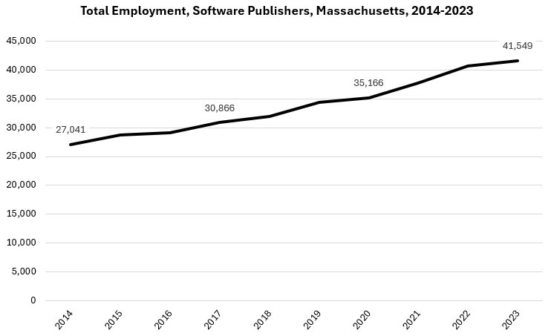

### Wages, Salaries, and Proprietor Earnings

Across all occupations in the target industries, the highest earnings are found in the Software Publishers industry. The lowest are found in Printing and Related Support Services.

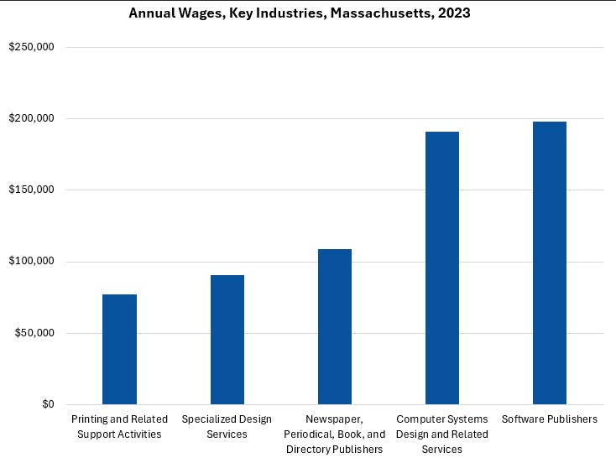

Wages, Salaries, and Proprietor Earnings in the Specialized Design Services industry have trended upward over the last decade, but the rate of growth accelerated significantly in 2019, and the average is now at an all-time high and is 47.7% higher than the 2014 value.

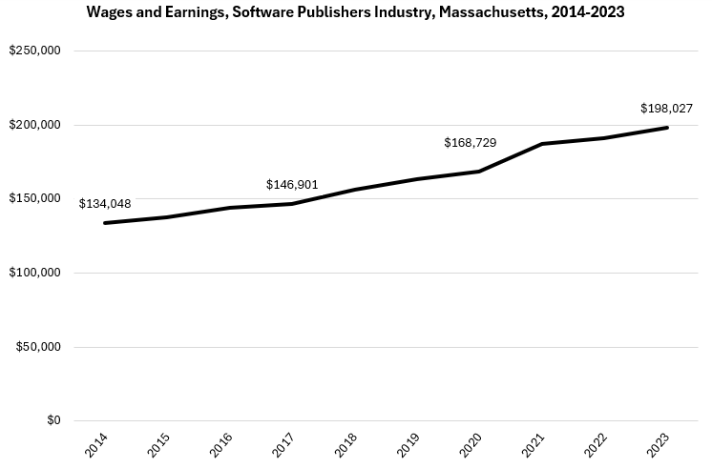

## The Pathway

### Occupations and Pathways

This section looks at the target occupations and pathways and also considers advancement opportunities in related careers that are not directly related to the program of study, but that illustrate opportunities that may be available to workers in these fields with additional education and experience.

While careers in these occupations are certainly viable in their own rights, they also can serve as entry points to progressively more sophisticated and better-paying roles.

The United States Department of Labor Employment and Training Administration organizes occupations into an index of “job zones,” which reflect the levels of preparation typically required to enter employment in the occupation.

#### Table 3: Occupations

##### Job Zone Two Occupations

|  |  |  |  |
| --- | --- | --- | --- |
| Occupation | 2023 Jobs | Typical Education Requirement | Median Annual Earnings |
| Prepress Technicians and Workers | 408 | Postsecondary nondegree award | $52,582 |
| Printing Press Operators | 2,391 | HS diploma or equivalent | $48,402 |

##### Job Zone Three Occupations

|  |  |  |  |
| --- | --- | --- | --- |
| Occupation | 2023 Jobs | Typical Education Requirement | Median Annual Earnings |
| Fine Artists, Including Painters, Sculptors, and Illustrators | 187 | Bachelor’s | $75,816 |
| Audio and Video Technicians | 1,503 | Nondegree Award | $60,091 |
| Print Binding and Finishing Workers | 632 | HS diploma or equivalent | $42,120 |

##### Job Zone Four Occupations

|  |  |  |  |
| --- | --- | --- | --- |
| Occupation | 2023 Jobs | Typical Education Requirement | Median Annual Earnings |
| Graphic Designers | 4,962 | Bachelor’s | $67,995 |
| Special Effects Artists and Animators | 790 | Bachelor’s | $77,563 |
| Film and Video Editors | 415 | Bachelor’s | $79,206 |

### Occupation Profile

The United States Department of Labor, Employment, and Training Administration created and regularly updates more than 800 occupational profiles with characteristics like skills, educational requirements, and daily tasks, based on the inputs of industry experts and people who are employed in the occupations.

#### Graphic Designers

##### Description

Design or create graphics to meet specific commercial or promotional needs, such as packaging, displays, or logos. May use a variety of mediums to achieve artistic or decorative effects.

##### Skills

* Giving full attention to what other people are saying, taking time to understand the points being made, asking questions as appropriate, and not interrupting at inappropriate times.
* Talking to others to convey information effectively.
* Communicating effectively in writing as appropriate for the needs of the audience.
* Using logic and reasoning to identify the strengths and weaknesses of alternative solutions, conclusions, or approaches to problems.
* Understanding the implications of new information for both current and future problem-solving and decision-making.
* Understanding written sentences and paragraphs in work-related documents.
* Being aware of others' reactions and understanding why they react as they do.
* Adjusting actions in relation to others' actions.
* Identifying complex problems and reviewing related information to develop and evaluate options and implement solutions.
* Considering the relative costs and benefits of potential actions to choose the most appropriate one.
* Managing one's own time and the time of others.
* Monitoring/assessing performance of yourself, other individuals, or organizations to make improvements or take corrective action.

##### Top Daily Tasks

* Design layout of art or product exhibits, displays, or promotional materials.
* Collaborate with others to develop or refine designs.
* Review art or design materials.
* Design layouts for print publications.
* Create computer-generated graphics or animation.
* Operate photographic developing or print production equipment.
* Perform administrative or clerical tasks.
* Confer with clients to determine needs.
* Collect data about customer needs.
* Conduct market research.
* Conduct research to inform art, designs, or other work.
* Draw detailed or technical illustrations.
* Maintain records, documents, or other files.
* Research new technologies.
* Edit written materials.
* Operate still or video cameras or related equipment.
* Write advertising or promotional material.

##### Additional Information

* [Council for Advancement and Support of Education](https://www.case.org/)
* [Graphic Artists Guild](https://www.graphicartistsguild.org/)
* [National Association of Schools of Art and Design](https://nasad.arts-accredit.org/)
* [Professional Association for Design](https://www.aiga.org/)
* [Society for Experiential Graphic D](https://www.segd.org/)esign

##### Job Postings – Graphic Designers

P2C uses a third-party system that aggregates data from job postings to provide perspective on the skills and qualifications employers are prioritizing in their advertisements for these occupations.

* After controlling for multiple postings that likely referenced the same single opening, over the last year, we identified 1,023 unique job postings for Graphic Designers in the Commonwealth.
* We identified 569 unique employers who posted openings online.

###### Top Employers:

* Robert Half
* Aquent
* PUMA
* Analog Devices
* Northeastern University
* TJX
* Adecco
* Harvard University
* University of Massachusetts
* Williams-Sonoma
* Vineyard Vines
* EBSCO Industries
* Emerson College
* Lightmatter
* Gcr Professional Services
* Amazon
* Cella
* Helen Of Troy
* Wayfair
* Mass General Brigham

###### Top Skills

* Graphic Design
* Adobe Illustrator
* Marketing
* Adobe Photoshop
* Adobe InDesign
* Typography
* Project Management
* Visual Design

###### Top Job Titles

* Graphic Designers
* Visual Designers
* Production Artists
* Visual Graphic Designers
* Digital Design Engineers
* Design Verification Engineers
* Graphic Artists
* Production Graphic Designers
* Production Designers
* Lead Graphic Designers
* Creative Designers
* Marketing Graphic Designers
* UI/Visual Designers
* Corporate Graphic Designers

### Occupation Profile

The United States Department of Labor, Employment, and Training Administration created and regularly updates more than 800 occupational profiles with characteristics like skills, educational requirements, and daily tasks, based on the inputs of industry experts and people who are employed in the occupations.

#### Special Effects Artists and Animators

##### Description

Create special effects or animations using film, video, computers, or other electronic tools and media for use in products, such as computer games, movies, music videos, and commercials.

##### Top Skills

* Giving full attention to what other people are saying, taking time to understand the points being made, asking questions as appropriate, and not interrupting at inappropriate times.
* Understanding written sentences and paragraphs in work-related documents.
* Using logic and reasoning to identify the strengths and weaknesses of alternative solutions, conclusions, or approaches to problems.
* Talking to others to convey information effectively.
* Communicating effectively in writing as appropriate for the needs of the audience.
* Understanding the implications of new information for both current and future problem-solving and decision-making.
* Considering the relative costs and benefits of potential actions to choose the most appropriate one.
* Monitoring/assessing performance of yourself, other individuals, or organizations to make improvements or take corrective action.
* Identifying complex problems and reviewing related information to develop and evaluate options and implement solutions.
* Managing one's own time and the time of others.
* Selecting and using training/instructional methods and procedures appropriate for the situation when learning or teaching new things.
* Being aware of others' reactions and understanding why they react as they do.
* Adjusting actions in relation to others' actions.

##### Top Daily Tasks

* Create computer-generated graphics or animation.
* Develop artistic or design concepts for decoration, exhibition, or commercial purposes.
* Coordinate logistics for productions or events.
* Draw detailed or technical illustrations.
* Construct distinctive physical objects for artistic, functional, or commercial purposes.
* Prepare production storyboards.
* Convert data among multiple digital or analog formats.

##### Additional Information

* ACM SIGGRAPH
* American Film Institute
* Association for Computing Machinery
* Comic Art Professional Society
* National Association of Schools of Art and Design
* Accreditation, Certification, & Unions
* International Cinematographers Guild
* The Animation Guild

##### Job Postings – Special Effects Artists and Animators

P2C uses a third-party system that aggregates data from job postings to provide perspective on the skills and qualifications employers are prioritizing in their advertisements for these occupations.

* After controlling for multiple postings that likely referenced the same single opening, over the last year, we identified 113 unique job postings for Special Effects Artists and Animators in the Commonwealth.
* We identified 65 unique employers who posted openings online.

###### Top Employers Advertising:

* Harvard University
* Meta
* Recruiting From Scratch
* Aquent
* Compass Group
* Pmi 2.0
* Canteen Vending
* Harvard Medical School
* Cd Projekt Red
* IBM
* Ask-Consulting
* The Judge Group
* Helen Of Troy
* Talbot And Company
* Bard College At Simon's Rock

###### Top Skills:

* Animations
* Adobe Photoshop
* Graphic Design
* Adobe After Effects
* Project Management
* Adobe Illustrator
* Typography
* Video Editing

###### Top Job Titles:

* Digital Content Producers
* Motion Graphics Designers
* Multimedia Technicians
* Interaction Designers
* VFX Artists
* Interactive Designers
* 3D Designers
* Animators
* Illustrators/Animators
* Technical Animators
* Motion Graphics Designers/Video Editors
* Lead Animators
* Material Handling Specialists
* Animation Directors
* Visual Effects Artists
* Digital Copywriters
* Cinematic Animators
* UX Interaction Designers
* Twister Operators
* Motion Graphics Designers/Animators