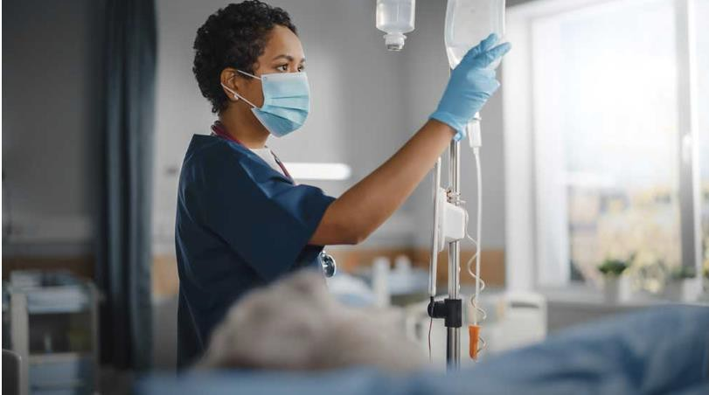

# Health Assisting Equipment List

January, 2025

In partnership with Pathway2Careers™, Massachusetts Department of Secondary Education is modernizing its CTE Frameworks to close the

gap that exists between education and industry.



## MADPH Required Equipment and Resources



Note that this list incorporates [**training equipment**](https://www.mass.gov/info-details/information-for-nurse-aide-training-programs#training-equipment-)identified by the Department of Public Health for Nurse Aide Training Programs.

### Equipment:

* Standing scale for height and weight, i.e. eye level (physician mechanical beam scale)
* 5 Standard bedpans
* 5 Fracture bedpans
* 5 Blood pressure cuffs
* 5 Stethoscopes
* 2 Teaching stethoscope (binaural)
* Bedside commode
* 5 Thermometers (non-mercury)
* 50 Alcohol wipes
* Clock with second hand for wall
* Trash can with cover
* Laundry hamper with cover
* Hospital bed with non-restraint (partial) side rails, call bell, and privacy curtains (1 for every 5 students)
* Bedside stand and over-bed table
* Chair with arms
* Sink with running hot & cold water in room or nearby, with a closed paper towel dispenser mounted on the wall and wall mounted soap dispenser
* Walker
* Wheelchair
* Gait belts (1 per every 2 students; minimum of 5)
* Manikin
* Disposable gloves (various sizes; 4 boxes)





* Isolation gowns and masks (6 of each)



* 5 Bath basins
* 5 Mouthwash, toothpaste and toothbrushes
* 5 Denture cups
* 50 Drinking cups for mouth care
* 1 set of Dentures
* Hearing Aide
* 24 Glycerin/lemon swabs for mouth care
* 5 Emesis basins
* Disposable bowls, cups, plastic spoons, food (applesauce and cereal) and thickener for feeding
* Disinfectant wipes or spray for equipment/classroom/lab cleaning

### Linens

* Pillows (4 per bed)
* Pillow cases (4 per bed)
* Sheets (4 per bed)
* Bedspreads (1 per bed)
* Bed protector (2 per bed)
* 6 Hand towels
* 6 Bath towels
* 6 Wash cloths
* 6 Hospital gowns
* Female street clothing (2 sets)
* Male street clothing (2 sets)





### Nurse Aide Training Program Resources



* Current editions of instructors’ manual and student textbooks and workbooks (not older than 5 years)
* Desks or tables and chairs for classroom
* Whiteboard and markers
* DVD player and DVDs demonstrating ADL skills
* Reference books such as medical dictionary, medical abbreviation book or listing, medical reference books
* Charts on relevant topics (example: poster about hand washing/infection control) and/or models of the human body
* Locking file cabinets to secure confidential student information