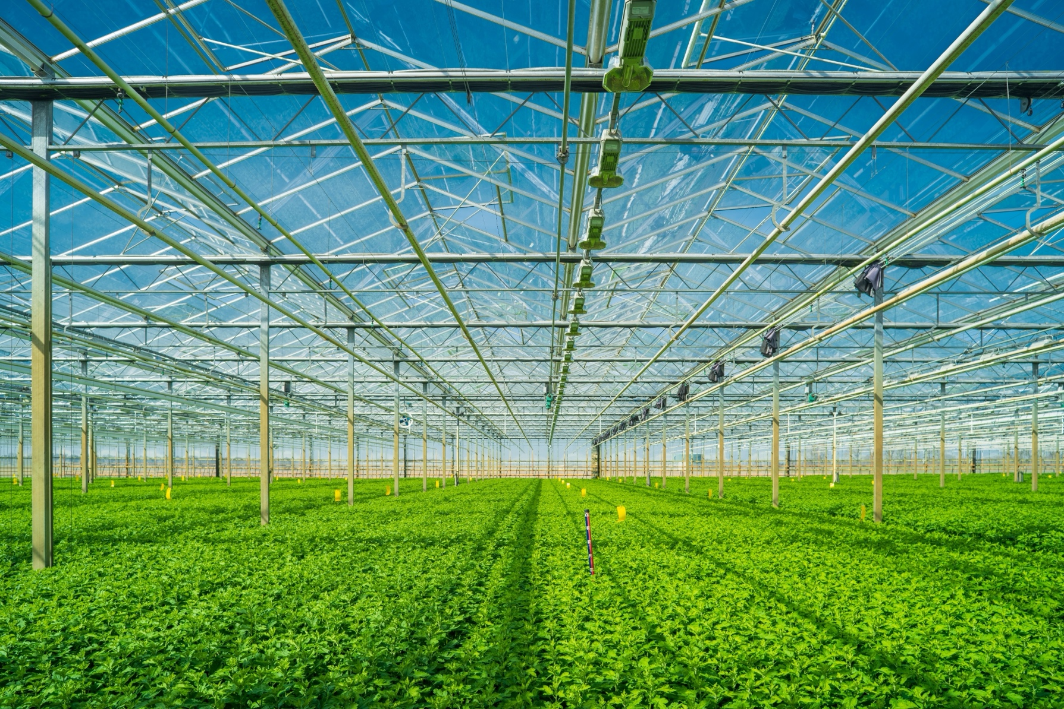
Agriculture Horticulture Equipment List

Suggested Equipment List

Health and Safety
- First Aid Kits
- Fire Extinguisher
- Hard Hats
- Work Gloves
- Safety Boots
- Safety Goggles/Face Shields
- Hearing Protection
- Respirators or Face Masks
- Knee Pads
- Protective clothing, e.g., Long-sleeved shirts, long pants, high visibility clothing, and chemical-resistant aprons or suits to prevent skin exposure
- Safety harnesses for tree climbing
- Chemical Spill Kits
- Safety Signs & Labels
- Eye Wash Station
- Sun Protection

Classroom Technology and Instructional Tools
- Projector or Interactive Whiteboard
- Computers or Tablets
- Document Camera
- Diagrams and Posters

General Hand Tools
- Measuring tape, ruler
- Pliers, wire cutters
- Trowels
- Hand Forks or Weeders
- Hand Pruners/Shears
- Pole Pruners
- Hand Hedge Trimmers
- Garden Scissors
- Loppers
- Garden Rakes
- Spades and Shovels
- Axe, or Hand Axe
- Mattocks
- Hoe
- Digging Forks
- Wheelbarrow
- Seed Spreaders
- Plant Markers
- Garden Kneeler
- Harvesting Baskets/Containers
- Pruning Saw, Hand Saw
- Plant Stakes and Ties
- Plant Sprayers
- Fertilizer Spreaders
- Plastic Mulch and Row Covers
- Spike Aerator
- Lawn Roller

Floral Design Tools
- Floral Shears (Floral Scissors)
- Pruning Shears
- Floral Knives
- Wire Cutters
- Stem Cutters
- Floral Foam (Oasis
- Floral Tape
- Greening Pins
- Flower Frogs
- Floral Wire
- Wiring Needles
- U-pins (Floral U-pins)
- Vases and Containers
- Floral Picks
- Water Tubes
- Curling Iron
- Flower Presses
- Petal Shapers
- Ribbon Scissors
- Decorative Picks
- Floral Adhesive (Floral Glue
- Spray Bottles or Misters
- Cage or Netting
- Corsage Pins
- Coolers or Refrigerators
- Hydration Chambers
- Floral Cleaner
- Paper Towels and Rags
- Tool Sharpening Kit

Power Tools
- Lawn Mowers, Powered, Push Lawn Mowers (Reel or Rotary), Riding Lawn Mowers, Zero-Turn Mowers
- Mulching Mowers
- Lawn Dethatches (powered or manual)
- String Trimmer/Weed Eater
- Hedge Trimmers
- Chainsaws with proper PPE
- Blowers
- Chipper
- Brush Cutter
- Stump grinder

Hoisting and Rigging Tools
- Hoists: Mechanical or Electric (e.g., chain hoists, electric hoists, and manual hoists)
- Jacks
- Trolley Jack or Hand Truck
- Chains
- Rope and Wire Rope
- Slings (Synthetic and Steel)
- Shackles
- Hooks
- Pulleys and Blocks
- Load Binders and Turnbuckles, Swivels
- Load measurement tools

Greenhouse Tools and Equipment
- Seed Trays and Flats
- Plant Labels
- Soil Scoops and Seeders
- Potting Benches
- Plant Ties and Twine
- Plant Clips
- Plant Cages
- Propagation Domes
- Trellis Systems
- Bamboo Stakes
- Soil Mixers
- Soil Test Kits
- Compost Bins
- Watering Cans
- Misting Systems
- Greenhouse Irrigation System
- Walter Filtration System
- Sprayers (Handheld or Backpack)
- Neem Oil Sprayers
- Pipette or Syringe
- Fungicide and Drenching Tools
- Thermometers/Hygrometers
- Fans and Exhaust Fans
- Shade Nets/Cloth
- Heaters
- CO₂ Injectors
- Fertilizer Spreaders
- Liquid Fertilizer Applicators
- Vacuum or Dust Blower

Greenhouse Tools and Equipment (cont.)
- Brooms and Dust Pans
- Power Washer
- Cleaning Brushes
- Storage Bins and Racks
- Plant Lifting tools
- Grow Lights
- Hydroponic System

Arboriculture Tools, Climbing Tools
- Crown Reduction Tools (Specialized tools used to reduce the canopy of a tree safely)
- Tree Bracing and Cabling Tools
- Tool belts, or gear bags
- Saddles (Climbing Harness)
- Climbing Ropes, Rope Bags for organization of ropes
- Rope Wrench
- Carabiners
- Ascenders
- Foot Ascender
- Lanyard
- Friction Hitch or Mechanical Descender
- Rigging Rope
- Rigging Blocks
- Slings
- Throwline
- Tree climbing spikes (optional)

Irrigation System Tools, Design, Installation, and Maintenance
- Measuring Tape
- Landscape Design Software (e.g., AutoCAD, Irricad, or similar)
- Soil Testing Kit
- Pressure Gauge
- Flow Meter
- Shovel, Post Hole Digger
- Pipe Cutter/Tube Cutter
- PVC Pipe Bender (if needed)
- Pipe Glue/Cement
- Drill with Bits
- Sprinkler Head Adjuster/Tool
- Pipe Wrench Set
- Valve Locator
- Water Flow Tester
- Wire Strippers/Crimping tools
- Clog Remover (e.g., Needle or Pin for Drip Emitters)
- Pressure Regulator Testing Tool
- Backflow Prevention Tester
- Socket Set/Adjustable Wrenches
- Bucket/Toolbox
- Teflon Tape
- Lubricant (e.g., Silicone Spray)
- Flagging Tape
- Optional: Trenching Machine (optional for larger installations)

Landscape Design and Hardscape Tools (Tools not mentioned in previous sections)
- Drafting tools: Landscape Design Paper, Scale Ruler, Pencils, Colored Pencils, Erasers, and Fine-tip Markers, Protractor and Compass, Triangle or Set Square
- Computer Software: Landscape Design Software: Programs like SketchUp, AutoCAD, or PRO Landscape Plant Identification Apps
- Laser Level, Level
- String Line and Stakes
- Tamper (Manual or Powered)
- Masonry Tools (e.g., Trowels, Mortar Mixers, Finishing Tools)
- Sledge Hammer, Masonry Hammer
- Rubber Mallet
- Brick or Stone Splitter
- Tile Cutter
- Edge Trimmers
- Post hole diggers (manual or powered)
- Measuring Wheel
- Cement Mixer
- Power Saw
- Lawn Graders
- Hydroseeder
- Turf Aerators

Pesticide Application Equipment
- Sprayers (Handheld, Backpack, or Tank Sprayers, Powered or Tractor-Mounted Sprayers)
- Granular Spreaders
- Pesticide Injection Systems (pesticides are injected directly into irrigation systems)
- Dust Applicators (For applying powdered pesticides to plants or soil)
- Pesticide Storage Containers: Secure, locked storage areas. (Ensure storage meets Massachusetts Department of Agricultural Resources (MDAR) guidelines.)
- Labeling Systems: Properly labeling pesticide containers, storage areas, and equipment for safety and compliance with state and federal regulations.
- Spill Containment Kits: Kits should include absorbent materials, containment barriers, and proper disposal bags.
- Pesticide Application Record Book: Massachusetts regulations require detailed records of pesticide usage to ensure compliance with safety and reporting guidelines, MDAR's regulations.
- Weather Monitoring Equipment: Recording temperature, humidity, and wind speed before and during pesticide application, as conditions impact the effectiveness and safety of pesticide use.

Soil Preparation Tools
- Soil Test Kit
- Tensiometer
- Penetrometer
- Soil Thermometer
- Tiller/Cultivator, Motorized or manual tool
- Soil Aerator
- Garden Leveling Rake
- Compost Bins
- Soil Mixers or Blenders
- Compost Spreader
- Fertilizer Spreader (Broadcast or Drop Spreader
- Mulch Spreader
- Lime Spreader
- Land Leveler
- Drag Mat/Soil Drag
- Hand Tampers

Turfgrass Management Tools (Tools not mentioned previously)
- Moisture Meter
- Turfgrass Quality Assessors
- Turfgrass Compaction Testers
- Grooming Rakes
- Mulch Mowers
- Mulch Blowers
- Core Aerators
- Field Marking Equipment

Watering Equipment
- Watering Cans
- Watering Wands or Extension Wands
- Garden Hoses
- Soaker Hoses
- Sprinklers
- Drip Irrigation System
- Irrigation Valves and Timers

Outdoor Storage
- Tool Shed
- Storage Containers

