Labor Market Analysis of Skills Related to Heating, Ventilation, Air Conditioning, and Refrigeration in Massachusetts

## Table of Contents

Labor Market Analysis of Skills Related to Heating, Ventilation, Air Conditioning, and Refrigeration in Massachusetts 0

Table of Contents 1

Overview 2

The Construction Industry 2

The Pathways 9

Electricity Occupations and Pathways 9

Occupation Profile 10

Heating, Ventilation and Air Conditioning Mechanics and Installers 10

## Overview

This analysis uses labor market data from the Massachusetts Department of Economic Research to provide perspective on two theaters related to the Heating, Ventilation and Air Conditioning (HVAC) program: the construction industry and occupations in the target career pathway.

The industry should be understood as the employers in the Commonwealth whose primary line of business is construction. Those companies employ a spectrum of occupations, ranging from skilled tradesmen to real estate agents. While trends in the construction industry are not necessarily directly related to HVAC, the large majority of HVAC Technicians work for construction companies, making its realities and trends a valuable backdrop against which to evaluate HVAC careers in Massachusetts.

In public data systems, occupations are a set of tasks regularly performed by one individual on an employer’s payroll. In this analysis, occupations related to plumbing are profiled in a career pathway framework as we seek to provide strategic value in the development and administration of HVAC curriculum and the construction of compelling and instructive narrative that will introduce students to the world of HVAC in the 21st Century.

### The Construction Industry

#### The Construction Industry in Labor Market Data Systems

Construction (NAICS code 23) comprises all employers whose primary line of business is construction. The industry category is divided into three sub-industries:

* 236-Construction of Buildings
* 237-Heavy and Civil Engineering Construction
* 238-Specialty Trades Contractors

Each of these categories is further parsed into four-, five-, and ultimately six-digit level categories, and the Massachusetts Department of Economic Research produces employment and wage estimates for each.

##### Construction Industry Categories

* **236 Construction of Buildings**
  + **236115 New Single-Family Housing Construction (except For-Sale Builders)**
  + **236116 New Multifamily Housing Construction (except For-Sale Builders)**
  + **236117 New Housing For-Sale Builders**
  + **236118 Residential Remodelers**
  + **236210 Industrial Building Construction**
  + **236220 Commercial and Institutional Building Construction**
* **237 Heavy and Civil Engineering Construction**
  + **237110 Water and Sewer Line and Related Structures Construction**
  + **237120 Oil and Gas Pipeline and Related Structures Construction**
  + **237130 Power and Communication Line and Related Structures Construction**
  + **237210 Land Subdivision**
  + **237310 Highway, Street, and Bridge Construction**
  + **237990 Other Heavy and Civil Engineering Construction**
* **238 Specialty Trades Contractors**
  + **238110 Poured Concrete Foundation and Structure Contractors**
  + **238120 Structural Steel and Precast Concrete Contractors**
  + **238130 Framing Contractors**
  + **238140 Masonry Contractors**
  + **238150 Glass and Glazing Contractors**
  + **238160 Roofing Contractors**
  + **238170 Siding Contractors**
  + **238190 Other Foundation, Structure, and Building Exterior Contractors**
  + **238210 Electrical Contractors and Other Wiring Installation Contractors**
  + **238220 Plumbing, Heating, and Air-Conditioning Contractors**
  + **238290 Other Building Equipment Contractors**
  + **238310 Drywall and Insulation Contractors**
  + **238320 Painting and Wall Covering Contractors**
  + **238330 Flooring Contractors**
  + **238340 Tile and Terrazzo Contractors**
  + **238350 Finish Carpentry Contractors**
  + **238390 Other Building Finishing Contractors**

#### Employment - Electricians

It is not surprising that at the most granular level available, the industry that most often employs electricians in Massachusetts is Electrical Contractors (NAICS 23821). Approximately three quarters of the Commonwealth’s electricians work in that industry. It is interesting to note, however, that the Temporary Help Services (56132) and Local Government (90399) sectors also rank in the top five for employment of electricians. The table below details the top five detailed industry sectors by the share of electricians who are employed in them.

##### Table 1: Top Detailed Industries for Electricians

|  |  |
| --- | --- |
| Industry | Share of Occupation Jobs |
| Electrical and Other Wiring Installation Contractors | 74.9% |
| Temporary Help Services | 3.4% |
| Plumbing, Heating, and Air-Conditioning Contractors | 2.3% |
| Commercial and Institutional Building Construction | 1.6% |
| Local Government | 1.4% |

#### Employment Trends

The number of people employed in the Construction industry in Massachusetts has been steadily increasing over the last decade, except for a significant COVID-19-related decline in 2020. The net change has been an increase of 35.9% in jobs over the last decade.

##### Table 2: Average Annual Employment, Construction Industry, Massachusetts, 2014-2023

|  |  |
| --- | --- |
| Year | Jobs |
| 2014 | 128,919 |
| 2015 | 138,991 |
| 2016 | 146,503 |
| 2017 | 152,131 |
| 2018 | 158,656 |
| 2019 | 163,062 |
| 2020 | 152,366 |
| 2021 | 164,435 |
| 2022 | 170,026 |
| 2023 | 176,199 |

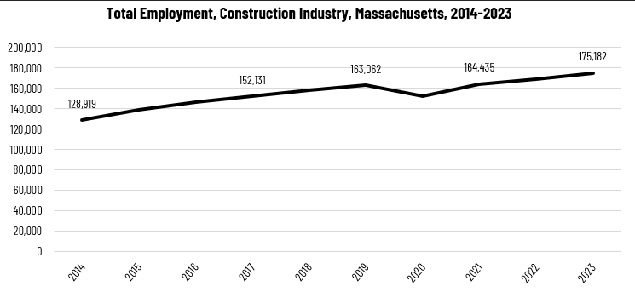

When we break down the growth of the Construction industry, we see that while increases have been seen in all three construction sectors, growth in both the total number of jobs and the percentage of jobs added has been led by the Specialty Trades Contractors sector.

##### Tables 3 and 4: Employment Change, Construction Industries, Massachusetts, 2014-2023

|  |  |  |  |  |  |  |  |
| --- | --- | --- | --- | --- | --- | --- | --- |
| Industry | 2014 | 2018 | 2019 | 2020 | 2021 | 2022 | 2023 |
| Construction of Buildings | 27,137 | 33,381 | 34,166 | 32,452 | 34,825 | 35,900 | 37,092 |
| Heavy/Civil Engineering Construction | 12,671 | 14,105 | 13,893 | 13,820 | 13,843 | 14,128 | 14,325 |
| Specialty Trade Contractors | 89,112 | 111,169 | 115,003 | 106,094 | 115,768 | 119,104 | 123,765 |

|  |  |  |
| --- | --- | --- |
| Industry | Change | % Change |
| Construction of Buildings | 9,955 | 36.7% |
| Heavy/Civil Engineering Construction | 1,654 | 13.1% |
| Specialty Trade Contractors | 34,654 | 38.9% |

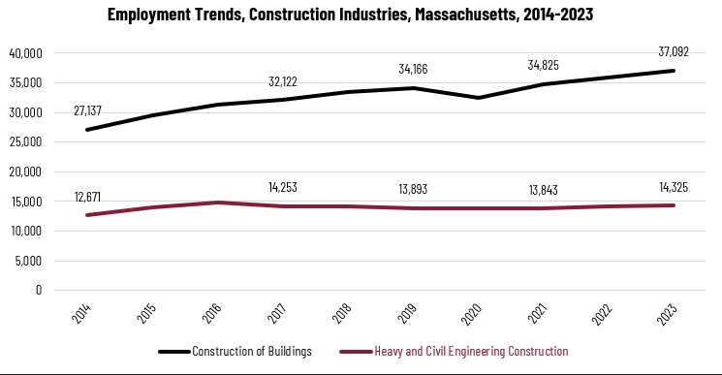

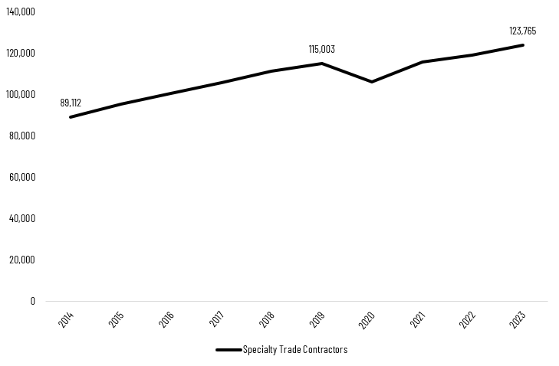

At the most detailed level available, we see that growth was led over the decade by Poured Concrete Contractors (NAICS 238110) and Residential Remodelers (NAICS 236118). Plumbing, Heating and Air-conditioning Contractors ranked fifth with more than 48% growth.

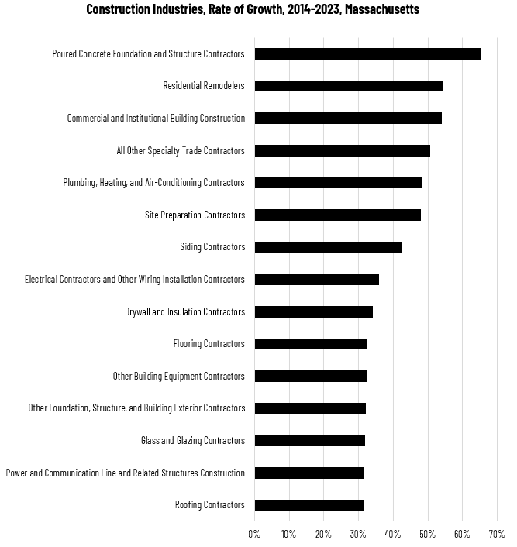

#### Wages, Salaries and Proprietor Earnings

Among the detailed industry categories, the highest wages are found in the Industrial Building and Power Line Construction employers. The lowest are in Residential Remodelers and Painting Contractors.

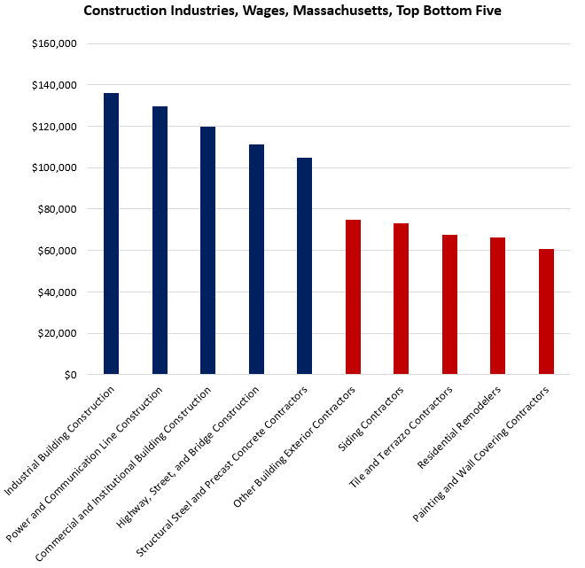

## The Pathways

### Electricity Occupations and Pathways

This section looks at the target occupation category: Electricians. It will also consider advancement opportunities in related careers that are not directly related to the program of study, but that illustrate opportunities that may be available to workers in this field with additional education and experience.

#### Table 5: Electricians, Massachusetts

|  |  |  |  |  |  |
| --- | --- | --- | --- | --- | --- |
| Occupation | 2023 Jobs | Turnover Rate | 2014 - 2023 Change | 2014 - 2023 % Change | Median Annual Earnings |
| Electricians | 18,498 | 51.0% | 3,832 | 26% | $82,222 |

While careers in these two occupations are certainly viable in their own rights, they also can serve as entry points to progressively more sophisticated and better-paying roles.

#### Table 6: Related Career Pathways

##### Job Zone Two Occupations

|  |  |  |  |
| --- | --- | --- | --- |
| Occupation | 2023 Jobs | Typical Education Requirement | Median Annual Earnings |
| Helpers-Electricians | 1,428 | High school | $45,906 |
| Solar Photovoltaic Installers | 982 | High school | $48,620 |

##### Job Zone Three Occupations

|  |  |  |  |
| --- | --- | --- | --- |
| Occupation | 2023 Jobs | Typical Education Requirement | Median Annual Earnings |
| Electricians | 18,498 | High school | $82,222 |
| Energy Auditors (data for building inspectors) | 3,835 | High school | $77,522 |
| Construction and Building Inspectors | 3,835 | High school | $77,522 |
| Solar Energy Installation Managers (data for construction supervisors) | 15,659 | High school | $98,592 |
| First-Line Supervisors of Construction Trades and Extraction Workers | 15,659 | High school | $98,592 |

##### Job Zone Four Occupations

|  |  |  |  |
| --- | --- | --- | --- |
| Occupation | 2023 Jobs | Typical Education Requirement | Median Annual Earnings |
| Energy Engineers (data for Engineers, All Other) | 3,229 | Bachelor’s | $112,690 |
| Construction Managers | 7,087 | Bachelor’s | $131,727 |

## Occupation Profile

The United States Department of Labor, Employment and Training Administration created and regularly updates more than 800 occupational profiles with characteristics like skills, educational requirements, and daily tasks, based on the inputs of industry experts and people who are employed in the occupations.

### Heating, Ventilation and Air Conditioning Mechanics and Installers

#### Description

Install or repair heating, central air conditioning, HVAC, or refrigeration systems, including oil burners, hot-air furnaces, and heating stoves.

#### Top Skills

* Watching gauges, dials, or other indicators to make sure a machine is working properly.
* Using logic and reasoning to identify the strengths and weaknesses of alternative solutions, conclusions, or approaches to problems.
* Determining causes of operating errors and deciding what to do about it.
* Understanding written sentences and paragraphs in work-related documents.
* Installing equipment, machines, wiring, or programs to meet specifications.
* Repairing machines or systems using the needed tools.
* Giving full attention to what other people are saying, taking time to understand the points being made, asking questions as appropriate, and not interrupting at inappropriate times.
* Identifying complex problems and reviewing related information to develop and evaluate options and implement solutions.
* Conducting tests and inspections of products, services, or processes to evaluate quality or performance.
* Talking to others to convey information effectively.
* Understanding the implications of new information for both current and future problem-solving and decision-making.

#### Top Daily Tasks

* Test electrical circuits or components for proper functioning.
* Determine operational compliance with regulations or standards.
* Interpret blueprints, specifications, or diagrams to inform installation, development or operation activities.
* Confer with customers or users to assess problems.
* Install heating, ventilation, or air conditioning (HVAC) equipment.
* Adjust equipment to ensure optimal performance.
* Service heating, ventilation or air-conditioning (HVAC) systems or components.
* Repair worn, damaged, or defective mechanical parts.
* Advise others on issues related to repairs, installation, or equipment design.
* Inspect systems to determine if they are operating properly.
* Replace worn, damaged, or defective mechanical parts.
* Install energy-efficient heating, ventilation, or air conditioning (HVAC) equipment.
* Braze metal parts or components.
* Connect electrical components or equipment.
* Install machine or equipment replacement parts.
* Cut materials according to specifications or needs.
* Measure distances or dimensions.
* Document operational activities.
* Maintain repair or maintenance records.
* Drill holes in parts, equipment, or materials.
* Install home appliances.
* Order materials, supplies, or equipment.
* Travel to work sites to perform installation, repair or maintenance work.
* Schedule repair, installation or maintenance activities.
* Supervise employees.
* Train others in operational procedures.
* Lay out work according to specifications.
* Operate cranes, hoists, or other moving or lifting equipment.
* Test mechanical systems to ensure proper functioning.

#### Additional Information

* [ASHRAE](https://www.ashrae.org/)
* [Associated Builders and Contractors](https://www.abc.org/)
* [International Institute of Ammonia Refrigeration](https://www.iiar.org/)
* [International Union of Operating Engineers](https://www.iuoe.org/)
* [North American Technician Excellence](https://www.natex.org/)
* [Occupational Outlook Handbook: Heating, air conditioning, and refrigeration mechanics and installers](https://www.bls.gov/ooh/installation-maintenance-and-repair/heating-air-conditioning-and-refrigeration-mechanics-and-installers.htm)
* [Plumbing-Heating-Cooling Contractors Association](https://www.phccweb.org/)
* [Refrigerating Engineers and Technicians Association](https://www.reta.com/)
* [Refrigeration Service Engineers Society](https://www.rses.org/)
* [United Association of Journeymen and Apprentices of the Plumbing and Pipe Fitting Industry](http://www.ua.org/)

#### Job Postings- Heating, Ventilation and Air Conditioning Mechanics and Installers

P2C uses a third-party system that aggregates data from job postings to provide perspective on the skills and qualifications employers are prioritizing in their advertisements for these occupations.

* After controlling for multiple postings that likely referenced the same single opening, over the last year, we identified 4,038 unique job postings for Heating, Ventilation and Air Conditioning Mechanics and Installers.
* We identified 633 unique employers who posted openings online.

##### Top Employers Advertising:

* Work With Your Handz
* Coolsys
* JLL
* GPAC
* Sysco
* Harvard University
* Ace Service
* Siemens
* Aerotek
* State of Massachusetts
* Sears
* Cushman & Wakefield

##### Top Job Titles:

* HVAC Technicians
* HVAC Service Technicians
* HVAC Installers
* Service Technicians
* HVAC Mechanics
* HVAC Installer Helpers
* Lead HVAC Service Technicians
* Refrigeration Technicians
* Lead HVAC Technicians
* Commercial Refrigeration Service Technicians
* HVAC Refrigeration Mechanics
* Residential HVAC Service Technicians

##### Top Qualifications:

* Valid Driver's License
* EPA 608 Technician Certification
* EPA Universal Certification
* HVAC Certification
* CFC Refrigeration Certification
* NATE Certification (North American Technician Excellence)
* Automotive Service Excellence (ASE) Certification
* Commercial Driver's License (CDL)
* 10-Hour OSHA General Industry Card
* Contractor License

##### Top Skills:

* Preventative Maintenance
* Hand Tools
* Plumbing
* Ventilation
* Refrigerant
* Electrical Wiring

###### Top Defining Skills

* Ventilation
* Boilers
* Refrigerant
* EPA 608 Technician Certification
* Refrigeration

###### Top Differentiating Skills

* EPA Universal Certification
* Thermostat
* Cooling Towers
* Brazing
* Wiring Diagram
* Furnaces
* Cooling Systems
* Ice Machines
* HVAC Repair and Maintenance