Labor Market Analysis of Skills Related to Information Support Services and Networking in Massachusetts

## Overview

This analysis uses labor market data from the Massachusetts Department of Economic Research to provide perspective on two theaters related to the Information Support Services and Networking program: the IT Sector as an industry and the Computer Occupations career pathway.

There is a fundamental challenge in any analysis of what is often called “the IT sector,” in that Information Technology is not a defined industry in public labor market data systems. It is also challenging from an educator’s perspective to consider IT as occupations, because IT skills have become ubiquitous across professional and administrative positions. Rather, information services is most appropriately considered as a skill set, a set of competencies necessary to performing the requirements of a spectrum of occupations employed in almost every industry.

It is, however, also immensely valuable to gain perspective at an industry level, so for the purposes of this analysis, a custom definition of the IT sector was created. This custom sector comprises seven categories across the most granular level of industry classification:

* NAICS 513210 Software Publishers

Establishments primarily engaged in software publishing. Establishments in this industry carry out operations necessary for producing and distributing computer software, such as designing, providing documentation, assisting in installation, and providing support services to software purchasers. These establishments may design, develop, and publish, or publish only. These establishments may publish and distribute software through subscriptions and/or downloads.

* NAICS 518210 Data Processing, Hosting and Related Services

Establishments primarily engaged in providing computing infrastructure, data processing services, Web hosting services (except software publishing), and related services, including streaming support services (except streaming distribution services). Data processing establishments provide complete processing and specialized reports from data supplied by clients or provide automated data processing and data entry services.

* NAICS 519290 Web Search Portals and All Other Information Services

Establishments primarily engaged in operating Web sites that use a search engine to generate and maintain extensive databases of Internet addresses and content in an easily searchable format (and known as Web search portals)

* NAICS 541511 Custom Computer Programming Services

Establishments primarily engaged in writing, modifying, testing, and supporting software to meet the needs of a particular customer.

* NAICS 541512 Computer Systems Design Services

Establishments primarily engaged in planning and designing computer systems that integrate computer hardware, software, and communication technologies. The hardware and software components of the system may be provided by this establishment or company as part of integrated services or may be provided by third parties or vendors. These establishments often install the system and train and support users of the system.

* NAICS 541513 Computer Facilities Management Services

Establishments primarily engaged in providing on-site management and operation of clients' computer systems and/or data processing facilities. Establishments providing computer systems or data processing facilities support services are included in this industry.

* NAICS 541519 Other Computer Related Services

Establishments primarily engaged in providing computer related services (except custom programming, systems integration design, and facilities management services). Establishments providing computer disaster recovery services or software installation services are included in this industry.

While trends in the industry are not necessarily directly related to demand for IT professionals because of the large numbers of IT professionals who work for organizations in other industries, it nevertheless provides perspective on some of the largest employers of computer occupations, making its realities and trends a valuable backdrop against which to evaluate these careers in Massachusetts.

In public data systems, occupations are a set of tasks regularly performed by one individual on an employer’s payroll. In this analysis, occupations related to information support services and networking are profiled in a career pathway framework as we seek to provide strategic value in the development and administration of appropriate curriculum and the construction of a compelling and instructive narrative that will introduce students to the world of information technology in the 21st Century.

## The IT Sector in Massachusetts

### The IT Sector in Labor Market Data Systems

This custom sector comprises employers whose primary line of business is related to digital information. Six categories are included in the custom definition:

* 513210 Software Publishers
* 518210 Data Processing, Hosting and Related Services
* 519290 Web Search Portals and All Other Information Services
* 541511 Custom Computer Programming Services
* 541512 Computer Systems Design Services
* 541513 Computer Facilities Management Services
* 541519 Other Computer Related Services

Each of these categories is a component of higher-level industries, and the Massachusetts Department of Economic Research produces employment and wage estimates for each.

#### IT Sector Categories

* 513 Publishing Industries
  + 513110 Newspaper Publishers
  + 513120 Periodical Publishers
  + 513130 Book Publishers
  + 513140 Directory and Mailing List Publishers
  + 513191 Greeting Card Publishers
  + 513199 All Other Publishers
  + 513210 Software Publishers
* 518 Data Processing, Hosting and Related Services
  + 518210 Data Processing, Hosting and Related Services
* 519 Web Search Portals, Libraries, Archives and Other Information Services
  + 519210 Libraries and Archives
  + 519290 Web Search Portals and All Other Information Services
* 541 Professional, Scientific and Technical Services
  + 541511 Custom Computer Programming Services
  + 541512 Computer Systems Design Services
  + 541513 Computer Facilities Management Services
  + 541519 Other Computer Related Services

### Employment - Computer Occupations

It is not surprising that at the most granular level available, the industry employs the largest percentage of all computer occupations in Massachusetts is Custom Computer Programming Services (NAICS 541511). Approximately 15% of people employed in the Commonwealth’s computer occupations work in that industry. It is interesting to note that four of the top ten industries for computer occupations are not directly related to computer services: Corporate, Subsidiary and Regional Managing Offices (NAICS 551114, 4.5% of jobs), Research and Development in Biotechnology (NAICS 541714, 4.4% of jobs), Temporary Help Services (NAICS 561320, 2.1% of jobs), and Colleges (NAICS 611310, 2.1% of jobs). The table below returns the top five detailed industry sectors by the share of those who are employed in them.

#### Table 1: Top Detailed Industries for Computer Occupations

|  |  |
| --- | --- |
| **Industry** | **Share of Occupation Jobs** |
| Custom Computer Programming Services | 15.4% |
| Software Publishers | 12.0% |
| Computer Systems Design Services | 11.8% |
| Corporate, Subsidiary, and Regional Managing Offices | 4.5% |
| Research and Development in Biotechnology | 4.4% |
| Temporary Help Services | 2.1% |
| Colleges | 2.1% |

### Employment Trends

The number of people employed in the IT Sector in Massachusetts has been steadily increasing over the last decade, except for a mild COVID-19-related flattening of the rate in 2020. The net change has been an increase of 35.7% in jobs over the last decade.

#### Table 2: Average Annual Employment, IT Sector, Massachusetts, 2014-2023

|  |  |
| --- | --- |
| **Year** | **Jobs** |
| 2014 | 110,535 |
| 2015 | 117,505 |
| 2016 | 122,728 |
| 2017 | 126,563 |
| 2018 | 129,947 |
| 2019 | 134,153 |
| 2020 | 136,014 |
| 2021 | 139,414 |
| 2022 | 144,628 |
| 2023 | 149,986 |

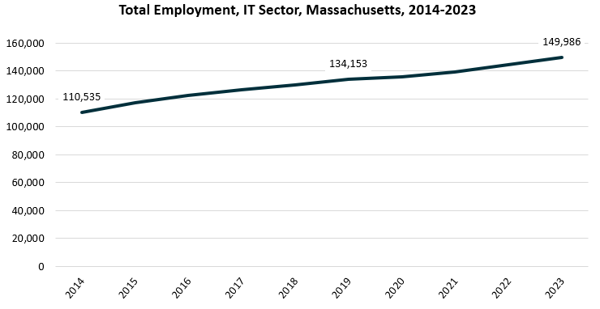

When we break down the growth of the IT Sector, we see that while increases have been seen across all its sectors, growth in both the total number of jobs and the percentage of jobs added has been led by the Software Publishers industry.

|  |  |  |  |  |  |  |  |
| --- | --- | --- | --- | --- | --- | --- | --- |
| **Industry** | **2014** | **2018** | **2019** | **2020** | **2021** | **2022** | **2023** |
| Custom Computer Programming Services | 34,493 | 41,779 | 44,501 | 45,097 | 45,287 | 45,517 | 47,324 |
| Software Publishers | 27,041 | 31,956 | 34,416 | 35,166 | 37,665 | 40,619 | 42,218 |
| Computer Systems Design Services | 32,721 | 35,706 | 34,790 | 34,403 | 33,932 | 34,932 | 35,670 |
| Data Processing, Hosting, and Related Services | 6,892 | 8,895 | 8,122 | 8,725 | 8,968 | 10,159 | 10,505 |

#### Tables 3 and 4: Employment Change, IT Sector Industries, Massachusetts, 2014-2023

|  |  |  |
| --- | --- | --- |
| **Industry** | **Change** | **% Change** |
| Custom Computer Programming Services | 12,831 | 37.2% |
| Software Publishers | 15,176 | 56.1% |
| Computer Systems Design Services | 2,949 | 9.0% |
| Data Processing, Hosting, and Related Services | 3,613 | 52.4% |

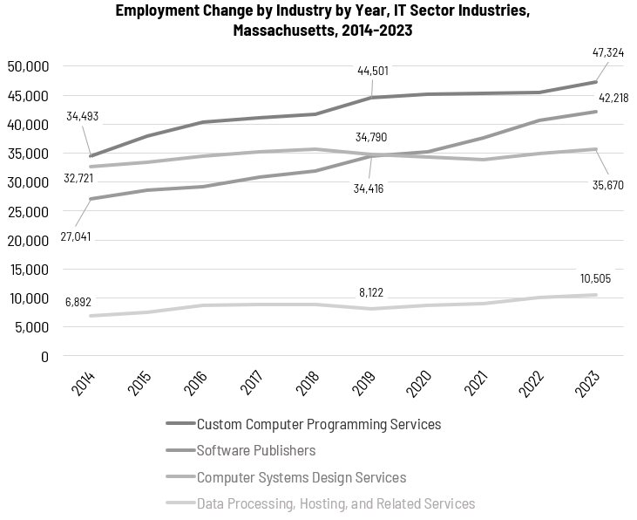

At the most detailed level available, we see that growth was led over the decade by Web Search Portals (NAICS 519290) and Software Publishers (NAICS 513210). Data Processing, Hosting and Related Services (NAICS 518210) ranked third with more than 52% growth.

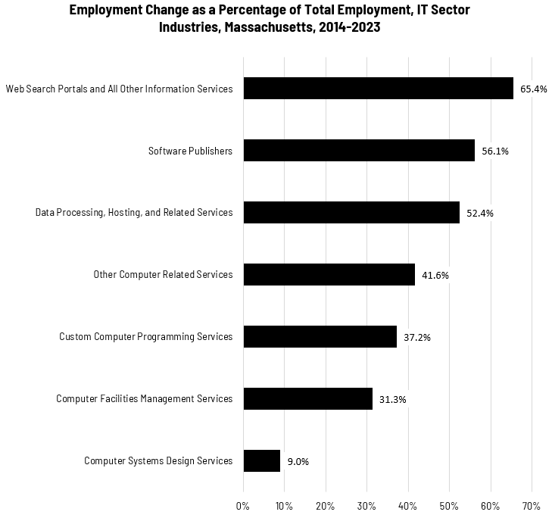

### Wages, Salaries and Proprietor Earnings

Among the detailed industry categories, the highest wages are found in the Web Search Portal employers. The lowest are in Computer Facilities Management Services, although its average wages still far outpace the state average.

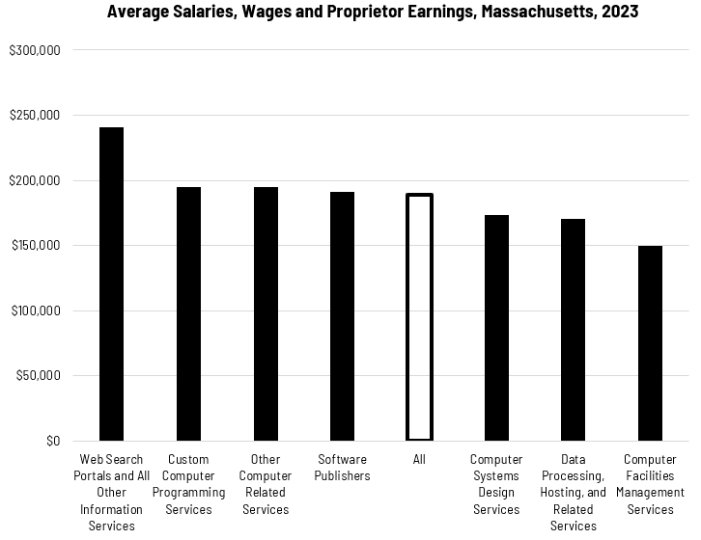

## The Pathways

### Computer Occupations and Pathways

This section looks at the target occupation category: Computer Occupations. It will also consider advancement opportunities in related careers that are not directly related to the program of study, but that illustrate opportunities that may be available to workers in this field with additional education and experience.

#### Table 5: Select Occupations, Massachusetts

|  |  |  |  |  |  |
| --- | --- | --- | --- | --- | --- |
| Occupation | 2023 Jobs | Turnover Rate | 2014 - 2023 Change | 2014 - 2023 % Change | Median Annual Earnings |
| Computer User Support Specialists | 18,741 | 40.6% | 2,024 | 11.8% | $66,186 |
| Network and Computer Systems Administrators | 7,462 | 32.4% | (1,810) | (19.1%) | $103,709 |
| Computer Network Support Specialists | 2,621 | 35.5% | (1,135) | (29.5%) | $81,786 |
| Database Architects | 1,521 | 34.4% | 531 | 51.3% | $141,357 |

While careers in these occupations are certainly viable in their own rights, they also can serve as entry points to progressively more sophisticated and better-paying roles.

#### Table 6: Related Career Pathways

##### Job Zone Three Occupations

|  |  |  |  |
| --- | --- | --- | --- |
| Occupation | 2023 Jobs | Typical Education Requirement | Median Annual Earnings |
| Computer User Support Specialists | 18,741 | Some college | $66,186 |
| Computer Systems Analysts | 11,422 | Bachelor's | $105,227 |

##### Job Zone Four Occupations

|  |  |  |  |
| --- | --- | --- | --- |
| Occupation | 2023 Jobs | Typical Education Requirement | Median Annual Earnings |
| Computer Network Support Specialists | 2,621 | Associate's | $81,786 |
| Computer Network Architects | 5,880 | Bachelor's | $163,862 |
| Database Administrators | 2,310 | Bachelor's | $107,910 |
| Network and Computer Systems Administrators | 7,462 | Bachelor's | $103,709 |
| Computer Programmers | 6,034 | Bachelor's | $107,723 |

## Occupation Profile

The United States Department of Labor, Employment and Training Administration created and regularly updates more than 800 occupational profiles with characteristics like skills, educational requirements, and daily tasks, based on the inputs of industry experts and people who are employed in the occupations.

### Computer User Support Specialists

#### Description

Provide technical assistance to computer users. Answer questions or resolve computer problems for clients in person, via telephone, or electronically. May provide assistance concerning the use of computer hardware and software, including printing, installation, word processing, electronic mail, and operating systems.

#### Top Skills

* Understanding written sentences and paragraphs in work-related documents.
* Giving full attention to what other people are saying, taking time to understand the points being made, asking questions as appropriate, and not interrupting at inappropriate times.
* Talking to others to convey information effectively.
* Using logic and reasoning to identify the strengths and weaknesses of alternative solutions, conclusions, or approaches to problems.
* Identifying complex problems and reviewing related information to develop and evaluate options and implement solutions.
* Communicating effectively in writing as appropriate for the needs of the audience.
* Considering the relative costs and benefits of potential actions to choose the most appropriate one.
* Understanding the implications of new information for both current and future problem-solving and decision-making.
* Selecting and using training/instructional methods and procedures appropriate for the situation when learning or teaching new things.
* Monitoring/Assessing performance of yourself, other individuals, or organizations to make improvements or take corrective action.
* Being aware of others' reactions and understanding why they react as they do.
* Actively looking for ways to help people.

#### Top Daily Tasks

* Monitor computer system performance to ensure proper operation.
* Collaborate with others to resolve information technology issues.
* Install computer hardware.
* Read documents to gather technical information.
* Resolve computer software problems.
* Provide technical support for software maintenance or use.
* Install computer software.
* Maintain computer hardware.
* Collaborate with others to determine design specifications or details.
* Test software performance.
* Document operational activities.
* Evaluate utility of software or hardware technologies.
* Provide recommendations to others about computer hardware.
* Recommend changes to improve computer or information systems.
* Teach others to use computer equipment or hardware.
* Train others in computer interface or software use.
* Test computer hardware performance.
* Conduct research to gain information about products or processes.
* Update knowledge about emerging industry or technology trends.
* Participate in staffing decisions.
* Supervise information technology personnel.
* Modify software programs to improve performance.

#### Additional Information

* Association for Computing Machinery
* Association of Support Professionals
* CompTIA
* Computing Research Association
* IEEE Computer Society
* ISACA
* National Center for Women and Information Technology
* Occupational Outlook Handbook: Computer support specialists
* The Institute of Electrical and Electronics Engineers

#### Job Postings- Computer User Support Specialists

P2C uses a third-party system that aggregates data from job postings to provide perspective on the skills and qualifications employers are prioritizing in their advertisements for these occupations.

* After controlling for multiple postings that likely referenced the same single opening, over the last year, we identified 13,019 unique job postings for Electricians.
* We identified 2,907 unique employers who posted openings online.

##### Top Employers Advertising:

* Robert Half
* Randstad
* TEKsystems
* Best Buy
* Alexander Technology Group
* Harvard University
* Insight Global
* State of Massachusetts
* Cognizant Technology Solutions
* Cynet Systems
* Motion Recruitment
* firstPRO

##### Top Job Titles:

* Desktop Support Technicians
* IT Support Specialists
* Help Desk Analysts
* Desktop Support Managers
* Help Desk Technicians
* Technical Support Specialists
* Technical Support Engineers
* Help Desk Specialists
* Desktop Support Analysts
* IT Specialists
* Desktop Support Specialists
* IT Support Technicians
* Field Service Technicians
* IT Technicians
* Computer Technicians
* Help Desk Support Technicians
* Desktop Support Engineers
* Desktop Technicians
* Technical Support Analysts
* IT Help Desk Technicians

##### Top Qualifications:

* CompTIA A+
* Valid Driver's License
* Microsoft Certified Professional
* CompTIA Network+
* ITIL Certifications
* Microsoft Certified Systems Engineer
* CompTIA Certification
* CompTIA Security+
* ITIL Foundation Certification
* Cisco Certified Network Associate
* Security Clearance
* Microsoft Certified Desktop Support Technician
* Microsoft Certified IT Professional

##### Top Overall Skills:

* Technical Support
* Help Desk Support
* Operating Systems
* Active Directory
* Desktop Support
* Peripheral Devices
* Computer Science
* Hardware
* Windows 10
* Issue Tracking

##### Differentiating Skills

* Windows 7
* Virtual Private Networks
* TCP/IP
* Windows Servers
* End-User Training and Support
* Software Installation
* Apple IOS
* Network Troubleshooting
* Mac OS
* Wide Area Networks

### Computer Systems Analysts

#### Description

Analyze science, engineering, business, and other data processing problems to develop and implement solutions to complex applications problems, system administration issues, or network concerns. Perform systems management and integration functions, improve existing computer systems, and review computer system capabilities, workflow, and schedule limitations. May analyze or recommend commercially available software.

#### Top Skills

* Talking to others to convey information effectively.
* Understanding written sentences and paragraphs in work-related documents.
* Giving full attention to what other people are saying, taking time to understand the points being made, asking questions as appropriate, and not interrupting at inappropriate times.
* Using logic and reasoning to identify the strengths and weaknesses of alternative solutions, conclusions, or approaches to problems.
* Determining how a system should work and how changes in conditions, operations, and the environment will affect outcomes.
* Identifying measures or indicators of system performance and the actions needed to improve or correct performance, relative to the goals of the system.
* Understanding the implications of new information for both current and future problem-solving and decision-making.
* Considering the relative costs and benefits of potential actions to choose the most appropriate one.
* Communicating effectively in writing as appropriate for the needs of the audience.
* Monitoring/Assessing performance of yourself, other individuals, or organizations to make improvements or take corrective action.
* Identifying complex problems and reviewing related information to develop and evaluate options and implement solutions.
* Writing computer programs for various purposes.

#### Top Daily Tasks

* Troubleshoot issues with computer applications or systems.
* Provide technical support for software maintenance or use.
* Coordinate software or hardware installation.
* Monitor computer system performance to ensure proper operation.
* Test software performance.
* Apply information technology to solve business or other applied problems.
* Configure computer networks.
* Write computer programming code.
* Analyze project data to determine specifications or requirements.
* Design integrated computer systems.
* Analyze data to identify or resolve operational problems.
* Collaborate with others to determine design specifications or details.
* Modify software programs to improve performance.
* Train others in computer interface or software use.
* Collect data about customer needs.
* Manage information technology projects or system activities.
* Supervise information technology personnel.
* Evaluate utility of software or hardware technologies.
* Identify information technology project resource requirements.
* Develop testing routines or procedures.
* Document design or development procedures.
* Read documents to gather technical information.
* Provide recommendations to others about computer hardware.
* Develop diagrams or flow charts of system operation.
* Estimate time or monetary resources needed to complete projects.

#### Additional Information

* AFCEA International
* Association for Computing Machinery
* Center of Excellence for Information and Computing Technology
* CompTIA
* Computing Research Association
* Cyber Degrees EDU
* IEEE Computer Society
* Institute for Certification of Computing Professionals
* International Institute of Business Analysis
* National Center for Women and Information Technology

#### Job Postings- Computer Systems Analysts

P2C uses a third-party system that aggregates data from job postings to provide perspective on the skills and qualifications employers are prioritizing in their advertisements for these occupations.

* After controlling for multiple postings that likely referenced the same single opening, over the last year, we identified 9,050 unique IT job postings.
* We identified 1,946 unique employers who posted openings online.

##### Top Employers Advertising:

* Randstad
* National Grid
* FIS
* Deloitte
* State Street Corporation
* Harvard University
* Elevance Health
* Kforce
* CTG
* The Judge Group
* Accenture
* MathWorks
* Fidelity Investments
* Motion Recruitment
* The Boston Consulting Group (BCG)

##### Top Job Titles:

* Business Systems Analysts
* Systems Analysts
* IT Business Analysts
* Technical Business Analysts
* Implementation Consultants
* Infrastructure Analysts
* Technical Consultants
* Financial Systems Analysts
* IT Business Systems Analysts
* Configuration Analysts
* Technology Analysts
* IT Systems Analysts
* Technical Analysts
* IT Analysts
* Systems Specialists
* Angular Developers
* Developers
* Principal Business Analysts
* SAP Functional Analysts
* Service Team Leaders

##### Top Qualifications:

* Valid Driver's License
* Master Of Business Administration (MBA)
* Security Clearance
* Project Management Professional Certification
* CompTIA A+
* Certified Power Quality Professional
* Microsoft Certified Professional
* Certified Information Systems Security Professional
* Certified Information System Auditor (CISA)
* Salesforce Certified Administrator
* ITIL Foundation Certification

##### Top Overall Skills:

* Project Management
* Computer Science
* Business Requirements
* Agile Methodology
* Business Process
* SQL
* Business Systems Analysis
* Systems Analysis
* Workflow Management

###### Differentiating Skills

* Functional Requirement
* Business Systems
* Requirements Elicitation
* Functional Specifications
* User Acceptance Testing (UAT)
* Technical Analysis