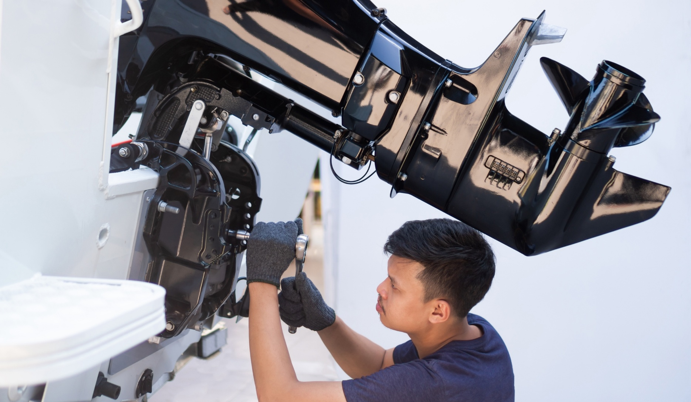

Marine Service Technology Equipment List
February 2026

Suggested Equipment List

Safety
- Safety Googles/Glasses
- Ear Protection
- Respiratory Gear (for working with Fiberglass, Hazardous Chemicals)
- Appropriate Footwear
- Hair Clips/Ties
- First Aid Kit
- Eye Wash Station/Safety Shower
- Fire Extinguisher, Fire blanket
- Chemical Spill Kit
- MSDS (Material Safety Data Sheets)
- Posted Emergency Contact Numbers
- CO2 Detector

Classroom Technology
- Computers/laptops with diagnostic software, customer and service management software, e.g., DockMaster, MyTaskit, and Lightspeed EVO, etc.
- Simulation and Virtual Training Tools
- Interactive Whiteboard or Projector
- Printer

Measuring Tools
- Tape measure (25 feet)
- Digital caliper (metric and SAE)
- Micrometers (inside and outside)
- Feeler gauges (metric and SAE)
- Dial indicator and magnetic base
- Straight edge
- Angle gauge/inclinometer

Hand Tools
- Wrenches: Combination wrenches (metric and SAE), Adjustable wrenches (6", 8", 12"), Torque wrenches (foot-pounds and inch-pounds)
- Torque Wrenches
- Screwdrivers: Phillips and flathead (various sizes), Precision screwdriver set
- Pliers: Slip-joint pliers, Needle-nose pliers, Locking pliers (Vise-Grip)
- Hammers: Ball-peen hammer, Dead-blow hammer, Rubber mallet
- Socket Sets
- Rachet Handles
- Files, Rasps
- Cutting Tools, Utility Knife, Wire Cutters
- Flashlight
- Mirrors used for inspection
- Pruning Shears and Snips
- Cleaning Tools, Brushes, Rags
- Toolbox or Tool Bags

Electrical Tools
- Digital multimeter (marine-grade)
- Test light
- Battery load tester
- Wire crimpers and strippers
- Soldering iron and heat shrink tubing
- Circuit tester
- Terminal and connector assortment kit
- Marine-grade electrical tape

Specialty Marine Tools
- Digital Diagnostic Tool, e.g., Mercury Marine CDS G3 diagnostic system
- Timing light (for outboards)
- Compression tester (for outboards and inboards)
- Vacuum/pressure gauge
- Water pressure tester
- Fuel pressure tester
- Propeller puller
- Gearcase pressure tester
- Impeller puller tool
- Trim and tilt gauge
- Shaft alignment tools

Engine Service Tools
- Valve spring compressor
- Piston ring compressor
- Flywheel puller
- Engine alignment tool
- Bearing puller kit
- Oil pressure tester
- Engine hoist or crane (for engine removal)
- Oil filter wrench
- Fuel injector tester
- Marine engine flusher (ear muffs for outboards)

Cooling System Tools
- Cooling system pressure tester
- Thermostat removal and testing kit
- Heat gun (for testing thermostats and shrink tubing)

Fuel System Tools
- Carburetor synchronizer
- Fuel line disconnect tool
- Fuel system pressure gauge
- Fuel filter wrench
- Ethanol fuel tester
- Multi-gas analyzer

Propulsion Tools
- Propeller shaft alignment tool
- Gearcase pressure and vacuum tester
- Propeller reconditioning tools (propeller file, blade gauge)

Workshop Equipment
- Marine engine stand
- Hydraulic press
- Parts washer
- Ultrasonic cleaner (for small parts)
- Battery charger and maintenance tool
- Workbench with marine-grade vise
- Air compressor with assorted air tools
- Storage cabinets and tool chests
- Waste Disposal Containers: For oil and chemical disposal, ensuring compliance with environmental regulations.
- Recycling Stations

Miscellaneous Tools
- Gasket scrapers
- Thread locker and sealant kits
- Hose clamp pliers
- Grease gun
- Anti-seize compound
- Deburring tool

New Technologies for Consideration
- Smart Marine Equipment: Embrace IoT-enabled devices that monitor boat systems, e.g., fuel levels, battery status, engine health, and communicate issues to technicians automatically.
- Virtual Reality (VR) and Augmented Reality (AR): Utilize VR/AR training programs to simulate real-world scenarios and provide hands-on experiences without the need for physical equipment.

