

# Labor Market Analysis of Skills Related to Marketing Careers in Massachusetts

**November 2024**



In partnership with Pathway2Careers™, Massachusetts Department of Secondary Education is modernizing its CTE Frameworks to close the gap that exists between education and industry.

## Table of Contents

Labor Market Analysis of Skills Related to the Marketing Careers in Massachusetts 1

Table of Contents 2

Overview and Key Findings 4

Programs 4

Employment Trends-Office and Administrative Support, Sales and Related, and Business and Financial Operations Occupations 12

Table 6: Marketing Industry Trends 13

Key Findings 12

Occupation Profiles and Job Postings 12

O*Net Occupation Profile-Market Research Analysts and Marketing Specialists 12

## Overview and Key Findings

### Programs

Three Chapter 74 programs of study are currently offered within the Agriculture and Natural Resources Cluster:

* Cosmetology
* Business Technology
* Marketing

The Cosmetology program prepares students for the Massachusetts Cosmetology Examination and covers all the standards of the state examination.

The Business Technology program is extremely broad, covering customer service, marketing, accounting, finance, social media, web design, database administration, spreadsheets, and presentations, among other concepts. It maps to industry-recognized credentials that include Microsoft Office and Adobe certifications and the National Professional Certification for Customer Service.

The Marketing program covers the fundamentals of marketing, as well as customer relations, financial analysis, business operations, channel management, marketing information management, pricing, product/service management, strategic management, and accounting. In addition to OSHA, the National Retail Federation’s Customer Service Certification is identified.

Each of these programs maps to at least one target occupation, and each occupation is employed by multiple industries. This analysis uses labor market data from the Massachusetts Department of Economic Research to provide perspective on both the industries (the employers) and the career paths that are available to our graduates.

Three distinct approaches to occupational information are taken in this analysis:

* Cosmetologists
* Office and Administrative Support Occupations
* Sales and Related Occupations
* Market Research Analysts and Marketing Specialists

#### Cosmetologists

Hairdressers, Hairstylists and Cosmetologists provide beauty services, such as cutting, coloring, and styling hair, and massaging and treating scalp. They may shampoo hair, apply makeup, dress wigs, remove hair, and provide nail and skincare services.

##### Table 1: Employment and Wages, Hairdressers, Hairstylists and Cosmetologists, Massachusetts

|  |  |  |  |
| --- | --- | --- | --- |
| Occupation | 2023 Jobs | 2023 Mean Wages | Experienced Annual Wages |
| Hairdressers, Hairstylists and Cosmetologists | 9,880 | $52,360 | $61,149 |
| All Occupations | N/A | $80,330 | $101,420 |

#### Office and Administrative Support Occupations

The Office and Administrative Support Occupation Family as a whole accounts for almost 400,000 jobs in Massachusetts. The average earnings for this family of occupations ($55,740) are more than 25% lower than the state average.

##### Table 2: Employment and Wages, Business and Financial Operations Occupations, Massachusetts

|  |  |  |  |
| --- | --- | --- | --- |
| Occupation | 2023 Jobs | 2023 Mean Wages | Experienced Annual Wages |
| Office and Administrative Support Occupations | 398,150 | $55,740 | $64,180 |
| All Occupations | N/A | $80,330 | $101,420 |

#### Market Research Analysts and Marketing Specialists

Market Research Analysts and Marketing Specialists account for more than 27,000 jobs in Massachusetts with average wages of $92,260, which is more than 6.6% higher than the state average.

##### Table 3: Employment and Wages, Business and Financial Operations Occupations, Massachusetts

|  |  |  |  |
| --- | --- | --- | --- |
| Occupation | 2023 Jobs | 2023 Mean Wages | Experienced Wages |
| Market Research Analysts and Marketing Specialists | 398,150 | $55,740 | $64,180 |

##### Table 4: Employment and Wages, Office and Administrative Support Detailed Occupations, Massachusetts

|  |  |  |  |  |
| --- | --- | --- | --- | --- |
| Occupation | 2023 Jobs | 2023 Mean Wages | Experienced Annual Wages | Typical Education Requirement |
| First-Line Supervisors of Office and Administrative Support Workers | 42,300 | $77,120 | $89,590 | High school |
| Switchboard Operators, Including Answering Service | 970 | $42,500 | $45,830 | High school |
| Communications Equipment Operators, All Other | *** | $58,940 | $64,510 | High school |
| Bill and Account Collectors | 2,690 | $55,180 | $61,620 | High school |
| Billing and Posting Clerks | 8,150 | $54,210 | $59,430 | High school |
| Bookkeeping, Accounting, and Auditing Clerks | 34,930 | $56,880 | $64,460 | Some college |
| Payroll and Timekeeping Clerks | 3,190 | $61,730 | $70,240 | High school |
| Procurement Clerks | 610 | $64,080 | $74,260 | High school |
| Tellers | 7,840 | $41,790 | $44,550 | High school |
| Financial Clerks, All Other | 440 | $69,340 | $77,760 | High school |
| Brokerage Clerks | 590 | $65,880 | $72,170 | High school |
| Correspondence Clerks | 20 | $47,620 | $51,600 | High school |
| Court, Municipal, and License Clerks | 1,460 | $63,820 | $73,380 | High school |
| Credit Authorizers, Checkers, and Clerks | 160 | $54,440 | $57,670 | High school |
| Customer Service Representatives | 62,100 | $50,450 | $57,350 | High school |
| Eligibility Interviewers, Government Programs | 1,800 | $55,820 | $62,220 | High school |
| File Clerks | 790 | $50,480 | $57,030 | High school |
| Hotel, Motel, and Resort Desk Clerks | 3,780 | $40,630 | $43,230 | High school |
| Interviewers, Except Eligibility and Loan | 2,950 | $49,570 | $54,400 | High school |
| Library Assistants, Clerical | 2,350 | $45,440 | $51,780 | High school |
| Loan Interviewers and Clerks | 3,380 | $52,710 | $58,400 | High school |
| New Accounts Clerks | 120 | $50,610 | $52,710 | High school |
| Order Clerks | 1,400 | $51,620 | $57,930 | Some college |
| Human Resources Assistants, Except Payroll and Timekeeping | 1,160 | $55,530 | $61,440 | Associate's |
| Receptionists and Information Clerks | 23,420 | $41,570 | $45,420 | High school |
| Reservation and Transportation Ticket Agents and Travel Clerks | 1,530 | $42,770 | $46,780 | High school |
| Information and Record Clerks, All Other | 1,220 | $51,670 | $59,040 | High school |
| Cargo and Freight Agents | 760 | $53,380 | $59,400 | High school |

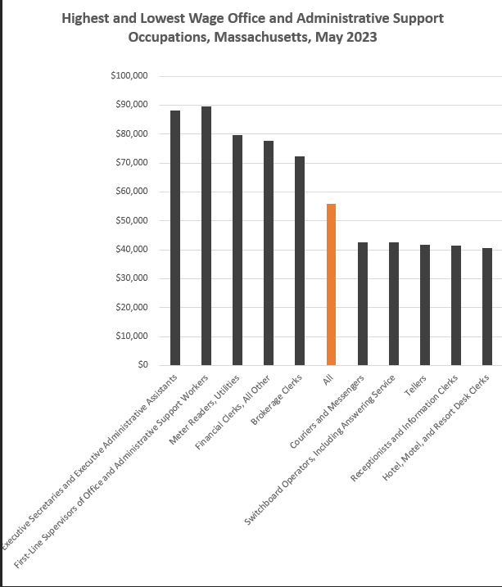

#### Sales and Related Occupations

The Sales and Related Occupations Family as a whole accounts for more than a quarter million jobs in Massachusetts. The average earnings for this family of occupations ($61,060) are almost 20% lower than the state average.

##### Table 5: Employment and Wages, Sales and Related Detailed Occupations, Massachusetts

|  |  |  |  |  |
| --- | --- | --- | --- | --- |
| Occupation | 2023 Jobs | 2023 Mean Wages | Experienced Annual Wages | Typical Education Requirement |
| Total Sales and Related Occupations | 287,260 | $61,060 | $74,710 | None |
| Retail Salespersons | 83,780 | $40,490 | $44,240 | None |
| Cashiers | 66,760 | $34,950 | $36,420 | None |
| Sales Representatives, Wholesale and Manufacturing, Except Technical and Scientific | 27,460 | $85,190 | $103,850 | High school |
| Sales Representatives of Services, Except Advertising, Insurance, Financial and Travel | 25,530 | $89,110 | $108,930 | High school |
| First-Line Supervisors of Retail Sales Workers | 23,290 | $57,210 | $65,790 | High school |
| Securities, Commodities, and Financial Services Sales Agents | 13,610 | $110,510 | $137,290 | Bachelor's |
| Sales Representatives, Wholesale and Manufacturing, Technical and Scientific Products | 10,430 | $114,720 | $141,660 | Bachelor's |
| Insurance Sales Agents | 10,000 | $100,590 | $128,070 | High school |
| First-Line Supervisors of Non-Retail Sales Workers | 4,830 | $120,710 | $146,580 | High school |
| Counter and Rental Clerks | 4,350 | $44,650 | $49,470 | None |
| Parts Salespersons | 3,570 | $45,100 | $50,190 | None |
| Sales Engineers | 2,820 | $126,490 | $148,510 | Bachelor's |
| Travel Agents | 2,110 | $57,920 | $65,740 | High school |
| Advertising Sales Agents | 1,320 | $78,140 | $92,290 | High school |
| Real Estate Brokers | 1,310 | $127,810 | $163,800 | High school |
| Market Research Analysts and Marketing Specialists | 27,020 | $92,260 | $111,180 | Bachelor’s |

While Market Research Analysts and Marketing Specialists are employed by dozens of industries, one industry is specifically defined by its output of marketing services: Marketing Consulting Services (NAICS 541613). This industry is defined by the United States Census Bureau this way:

*This U.S. industry comprises establishments primarily engaged in providing operating advice and assistance to businesses and other organizations on marketing issues, such as developing marketing objectives and policies, sales forecasting, new product developing and pricing, licensing and franchise planning, and marketing planning and strategy.*

Employment in this industry peaked at 8,301 Massachusetts jobs in 2019 and has yet to recover to pre-pandemic levels.

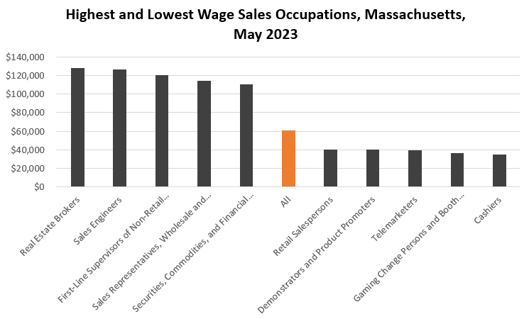

### Employment Trends-Office and Administrative Support, Sales and Related, and Business and Financial Operations OccupationsLine Chart, Total Employment, Key Occupation Families, Massachusetts

### Table 6: Marketing Industry Trends

|  |  |  |  |  |  |  |  |  |  |
| --- | --- | --- | --- | --- | --- | --- | --- | --- | --- |
| **NAICS** | **Description** | **2014** | **2016** | **2019** | **2020** | **2023** | **Change** | **% Change** | **2023 Locations** |
| 541613 | Marketing Consulting Services | 7,398 | 8,252 | 8,301 | 7,989 | 7,676 | 278 | 3.8% | 1,634 |

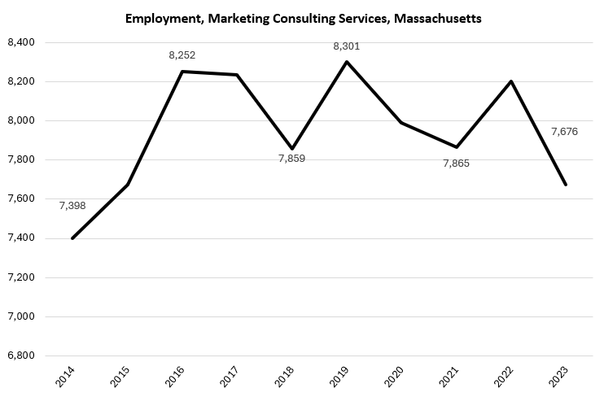

### Key Findings

A detailed analysis of the Programs of study, related industries, and related occupations led to several key conclusions:

1. **Low Wage and High Demand**

The occupations associated with these programs tend to pay lower-than-average wages, but account for a significant portion of the Commonwealth’s workforce.

1. **Career outlooks for the target occupations**

While these occupations tend to be low-wage in and of themselves, they do provide entrée into higher-value career pathways and more sophisticated careers with the addition of experience and/or additional education.

1. **The importance of a driver’s license**

A valid driver's license is by far the most mentioned qualification for careers in these fields, making it not only a value to the individual on a personal level, but also as a career-related asset.

1. **The emergence of project management as a skill**

In the majority of the occupation categories, we found project management certifications listed by employers in their job postings as a qualification for the job.

## Occupation Profiles and Job Postings

### O*Net Occupation Profile-Market Research Analysts and Marketing Specialists

The United States Department of Labor, Employment and Training Administration created and regularly updates more than 800 occupational profiles with characteristics like skills, educational requirements, and daily tasks, based on the inputs of industry experts and people who are employed in the occupations.

#### Description

Research conditions in local, regional, national, or online markets. Gather information to determine potential sales of a product or service or plan a marketing or advertising campaign. May gather information on competitors, prices, sales, and methods of marketing and distribution. May employ search marketing tactics, analyze web metrics, and develop recommendations to increase search engine ranking and visibility to target markets.

#### Top Skills:

* Using logic and reasoning to identify the strengths and weaknesses of alternative solutions, conclusions, or approaches to problems.
* Understanding written sentences and paragraphs in work-related documents.
* Communicating effectively in writing as appropriate for the needs of the audience.
* Giving full attention to what other people are saying, taking time to understand the points being made, asking questions as appropriate, and not interrupting at inappropriate times.
* Identifying complex problems and reviewing related information to develop and evaluate options and implement solutions.
* Talking to others to convey information effectively.
* Considering the relative costs and benefits of potential actions to choose the most appropriate one.
* Understanding the implications of new information for both current and future problem-solving and decision-making.
* Using mathematics to solve problems.

#### Top Detailed Work Activities:

* Prepare research reports.
* Analyze consumer trends.
* Conduct surveys in organizations.
* Establish business management methods.
* Measure effectiveness of business strategies or practices.
* Analyze market conditions or trends.
* Gather organizational performance information.
* Analyze industry trends.
* Monitor business indicators.
* Discuss business strategies, practices, or policies with managers.
* Supervise employees.
* Develop business or market strategies.

#### Professional Associations:

* American Association for Public Opinion Research
* American Bankers Association
* American Marketing Association
* Association of Independent Information Professionals
* ESOMAR
* Insights Association
* News Media Alliance
* Qualitative Research Consultants Association
* Special Libraries Association
* Strategic and Competitive Intelligence Professionals
* The Advertising Research Foundation

#### Job Postings – Market Research Analysts and Marketing Specialists

P2C uses a third-party system that aggregates data from job postings to provide perspective on the skills and qualifications employers are prioritizing in their advertisements for these occupations.

* After controlling for multiple postings that likely referenced the same single opening, over the last year, we identified 6,333 unique job postings for Market Research Analysts and Marketing Specialists.
* We identified 2,430 unique employers who posted openings online.

##### Top Employers Advertising:

* Epsilon
* Harvard University
* Thermo Fisher Scientific
* State Street Corporation
* Amazon
* Boston University
* The Boston Consulting Group (BCG)
* Veralto
* Aquent
* Mass General Brigham
* Klaviyo
* Trinity Solar
* Citizens Bank
* Moxie Management
* Skechers
* DraftKings
* Merck KGaA Darmstadt Germany
* Fidelity Investments
* The Judge Group
* Ford

##### Top Job Titles:

* Business Development Representatives
* Marketing Specialists
* Digital Marketing Specialists
* Business Development Associates
* Marketing Associates
* Business Development Specialists
* Marketing Assistants
* Marketing Interns
* Marketing Analysts
* Social Media Specialists
* Field Marketing Representatives
* Associate Directors of Marketing
* Social Media Coordinators
* Research Engineers
* Content Marketing Specialists
* Product Analysts
* Associate Directors of Business Development
* Email Marketing Specialists
* Field Marketing Specialists
* Influencers

##### Top Skills:

###### Common Skills:

* Communication
* Sales
* Detail Orientation
* Management
* Research
* Writing
* Presentations

###### Specialized Skills:

* Marketing
* Project Management
* Business Development
* Digital Marketing
* Social Media
* Data Analytics

###### Software Skills:

* Microsoft Excel
* Microsoft PowerPoint
* Microsoft Office
* Salesforce
* Google Analytics

##### Top Qualifications:

* Valid Driver's License
* FINRA Series 7 (General Securities Representative)
* Chartered Financial Analyst
* Security Clearance
* Google Ads Certification
* Project Management Professional Certification
* Salesforce Certified Administrator